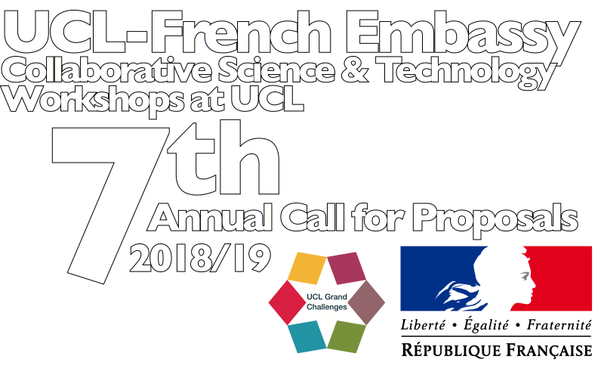
Collaborative Science & Technology Workshops at UCL
A UCL Grand Challenges — French Embassy partnership activity
Seventh Annual Call for Proposals:
Academic Year 2018-19

Application Form
Please complete the following sections:

Lead Applicant names (UCL and France)

Title of proposed workshop:

Aims and objectives. Indicate benefits to Applicants' research programmes at UCL and in France, including potential for future collaborative activity. (minimum 500 words; maximum 1000 words):

Workshop programme structure:

Brief biographies of individual participants from UCL and from France should be provided in separate sections below indicating name, position, departmental affiliation, core research interest, three key relevant publications. Note that explicit commitment from all [i.e. up to 16] potential participants is not required at the time of application. However, brief information should be provided on at least three participants from UCL and three from France. If an application is selected for funding, data on the remaining participants will be required before the date of the proposed workshop.

UCL team biographies, 1st Applicant etc (200 words max per biography)

France team biographies, 2nd Applicant etc (200 words max per biography)

Amount required (maximum award of £7,300 is available)

An itemised estimate of costs for travel (economy class), accommodation, subsistence, dinner, workshop coffees and teas, signed off by the head of department and/or departmental finance manager should be sent as a single pdf file to Kasia Diez (Administrator, OVPR), OVPR [ k.diez@ucl.ac.uk ] along with the application form.

About you (the "First Applicant")
Title:
First name:
Family name:
Position:
Department/Research Centre/Division:
Email address:

About your Second Applicant in France:
Title:
First name:
Family name:
Position:
Department/Research Centre/Division:
Email address:

Once completed please submit this application form using this online application form

