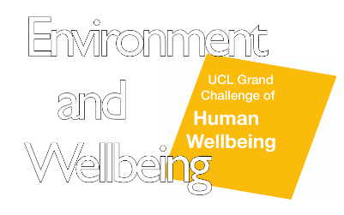
Environment and Wellbeing

A UCL Grand Challenges Activity

Call for Proposals: Academic Year 2018-19

Application Deadline: 12:00 (noon), Friday 22 February 2019

Application Form
Please complete the following sections:

First UCL applicant
Title:
First name:
Family name:
Email address:

Position:
Academic discipline(s):
Department/Research Centre/Division:

Short biography for first applicant (200 words max):

Second UCL applicant
Title:
First name:
Family name:
Email address:

Position:
Academic discipline(s):
Department/Research Centre/Division:

Short biography for second applicant (200 words max):

External Partners
Please fill in names, positions, organisations and email addresses for any external partners:

Short biographies for external applicants (200 words max):

Your Proposed Activity
- Title of your proposed activity

- Summary of your idea (up to 200 words)

- A description of your proposal (up to 850 words)
You should include what do you want to do, and how are you going to do it; what research or activity this work building on, including detail on your research interests and the value of the interdisciplinary (and external, as relevant) collaborations being proposed. When do you hope to deliver you outputs, and what (long, or short-term) changes are you hoping to see as a result of this work

- Tier 1 or Tier 2 Funding?
Tier 1 applications can be led by a doctoral students, and can be for up to £2,500.
Tier 2 applications should be led by a postdoctoral or more senior researcher, and can be up to £5,000, but requests for smaller awards also encouraged.
Tier 1 | Tier 2

- Amount requested

- Budget breakdown
Please detail the costs of the work you are proposing, categorizing the spend (for example materials, equipment, hospitality, travel, production, facilitator costs (e.g. artist), communication (BSL or SLI interpreters), costs of community groups, training*).
Costs should not include HEFCE staff cost replacement or bench fees.
*Training – we will accept costs for training. If this includes visual arts-based participatory methods or youth work methodology, we would encourage working with organisations that already use these methods in order to build external relationships and to gain understanding of best practice.

- Any other details

When you have completed this form please submit it via this form

If you have any questions regarding the application process, please contact Nina Quach (n.quach@ucl.ac.uk).

