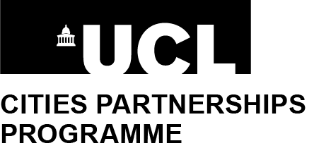
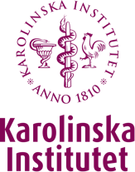

Developing Sustainable Cities: Climate and Health
A two-day research workshop in Stockholm
17-18 April 2023

Save the date

The Cities Partnerships Programme Stockholm, comprising UCL and the Stockholm Trio of Karolinska Institutet, KTH Royal Institute of Technology & Stockholm University, invite you to express interest in two days of workshops in Stockholm.

The workshops will be held in person, in Stockholm, from lunchtime on 17 April 2023. They will conclude the following day.

The workshops will run concurrent sessions focussing on each of the following themes relating to climate and health in urban settings. We welcome compelling suggestions for any additional theme - grounded in excellent work or potential between Stockholm and UCL - with which the workshops could productively engage.

- Mental health:
  - Safety;
  - Risk management;
  - Crisis preparedness.
- Sustainable transportation:
  - Environmental impact;
  - Health impact.
- Digital tools:
  - Decision making;
  - Monitoring;
  - Preparedness;
  - Healthcare accessibility.
- Communicable diseases
- Urban systems:
  - Energy;
  - Consumption;
  - Food;
  - Nature-based resources / biodiversity.

We invite expressions of interest from scholars and practitioners across disciplines to explore collaboration between UCL and Stockholm. Awards of funds for travel and accommodation will be available to colleagues in London. Meals and refreshments will be provided to attendees by the three universities in Stockholm. We will particularly seek opportunities to support early-career scholars and those who are under-represented in this sort of activity.

You can register your interest online before 17 March 2023.

Outline programme:

Time |  | Activity
Monday 17 April | Late morning | UCL colleagues arrive in Stockholm and check into hotels
 | Lunchtime | Registration of Stockholm and London attendees, Welcome and lunch
 | Afternoon | Short presentation on impactful collaboration between London & Stockholm, with practical advice for attendees;  Attendees join their colleagues working in each theme for the rest of the afternoon. Separate rooms, facilitators, note takers and refreshments will be provided.
 | Evening | Dinner for all attendees
Tuesday 18 April | Morning | Coffee and welcome for all attendees;  Themes reconvene.
 | Lunchtime | Session for all attendees:  - to summarize discussions and consider next steps;  - outline fast-track application process to handful of start-up seed funding awards.  Lunch for all attendees
 | Afternoon | Short workshop on research funding environment, consortium practicalities and opportunities;  Optional visit to a leading Stockholm research facility;  London attendees depart.

Queries can be addressed to contacts in each university:

Karolinska Institutet
Lotta Lundqvist - lotta.lundqvist@ki.se

KTH Royal Institute of Technology
Christina Murray - tina@kth.se

Stockholm University
Henrik Smedjegarden - henrik.smedjegarden@su.se

UCL
Bryan Taylor – bryan.taylor@ucl.ac.uk

As well as flights, there should be a train service to Stockholm (daytime from London to Hamburg; overnight to Stockholm). This more sustainable option - within a day and a night - may be an attractive option for colleagues, with desk work possible on the train. The UCL Cities Partnerships Programme team is seeking information on this new service and will provide it on request, as it is released.

