TravelCert: Instructions for Users
Registration and User Profile
To create a User profile, you will need to have access to a UCL domain email address. You cannot create a profile using webmail providers such as gmail, hotmail, yahoo etc. as the system uses the UCL domain name for validation, to receive your registration emails and the One Time Password (OTP) details.
If you do not have access to a UCL email, please contact the Insurance Team at insurance@ucl.ac.uk
TO REGISTER
- Go to https://travelcert.ajg.com/
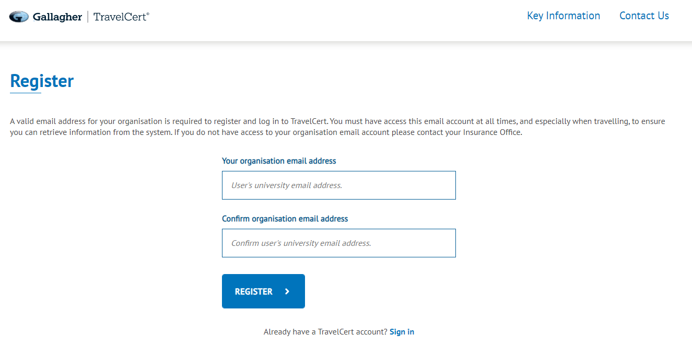
- Click on “Register”
- Enter your UCL email address to receive a registration link.
- Check your emails and click on the link within the email from TravelCert. The link will take you back to the TravelCert website where you can now set up your profile.
- Create a password to enable you to log in each time you access TravelCert. Please take notice of the guidance on the website regarding the use of special characters to create your password.
- Every time you log in, you will be sent a one-time passcode (OTP) to your registered email address, which you will need to access your account. The passcode is valid for 15 mins, after which time if you haven’t used it to log in you will need to request another one.
- If you are locked out of your account, you will need to wait for 2 hours before logging in again or resetting your password.
CREATE YOUR PROFILE
The first time you log in you will need to create your Profile and add at least one Emergency Contact. Follow the instructions on the screen to add your details.
Once you have done this you will not need to enter your details again, unless you wish to update any of your details, which you can do from within your account.
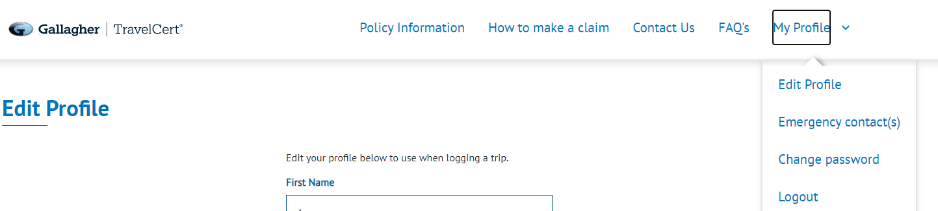
You can also edit your Emergency Contacts and change your password.

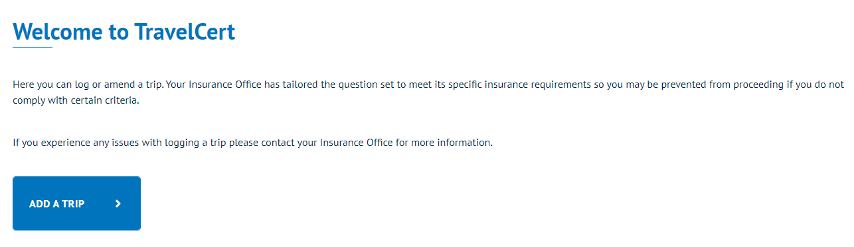
You are now ready to start logging trips.
ADDING A TRIP
Add your start and end dates, select the destination from the drop down list and click “Add Destination”. Trips cannot be backdated and can only be a maximum of 12 months duration.
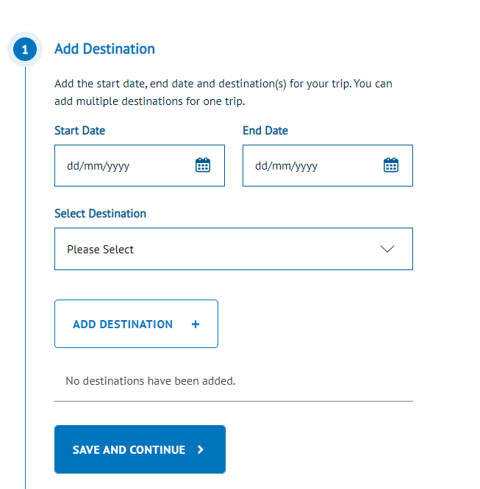

MULTI DESTINATION TRIPS
If you are logging a multi- destination trip repeat the above for each leg of your trip.
Note: multi-destination trip dates must run concurrently, if there are any gaps then you must log as a separate trip.
RESTRICTED DESTINATIONS
Travel is not permitted to some destinations under the terms of UCL’s travel insurance policy. If you receive the notification below, please contact your Insurance Team at insurance @ucl.ac.uk
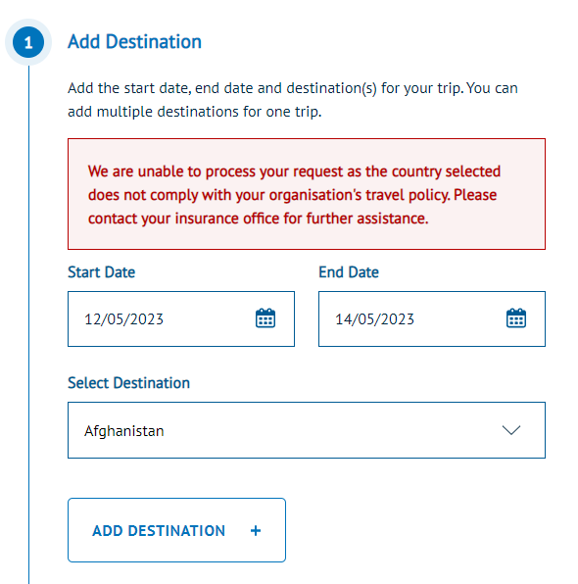

COMPLETE QUESTIONS
Continue to work your way through the question list which include:
- Medical
- Risk & Assessment
- Purpose of trip
- Equipment
- Trip approval

If any of your responses do not comply with UCL’s Travel Policy, you will be referred to the Insurance Team.
ADD EMERGENCY CONTACT DETAILS
Select you chosen Emergency Contact from the drop down list or add a new one for this trip only.
SUBMIT DETAILS
Click on “SAVE AND CONTINUE” to log your trip
If your trip has been logged successfully, you will receive an email confirmation, which includes a link to download your certificate. You can also download your document at any time from your “My Trips” dashboard.
LOCKED OUT OF ACCOUNT If you’ve tried to access the system unsuccessfully and been locked out of your account, you will need to wait for 2 hours before logging in again or resetting your password.
ACCESSING / EDITING YOUR TRIP
You can access and edit your trip details and certificate at any time from your account home page under “MY TRIPS”:
