Return of Goods Process
Return of Goods is done in iProcurement via the Receipt of Goods tab.
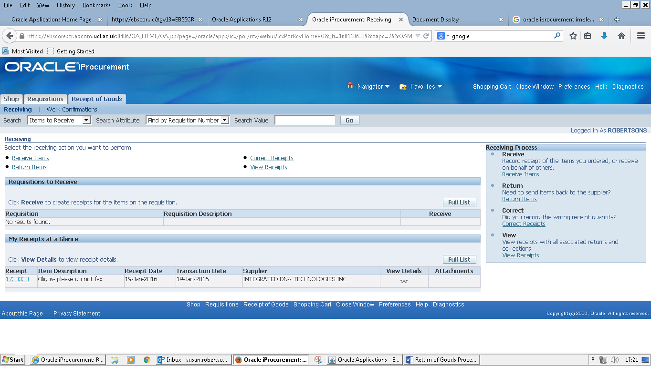
Click on the Return Items link on this page.
Search by PO or requisition number to bring up the items that have been already received in MyFinance.

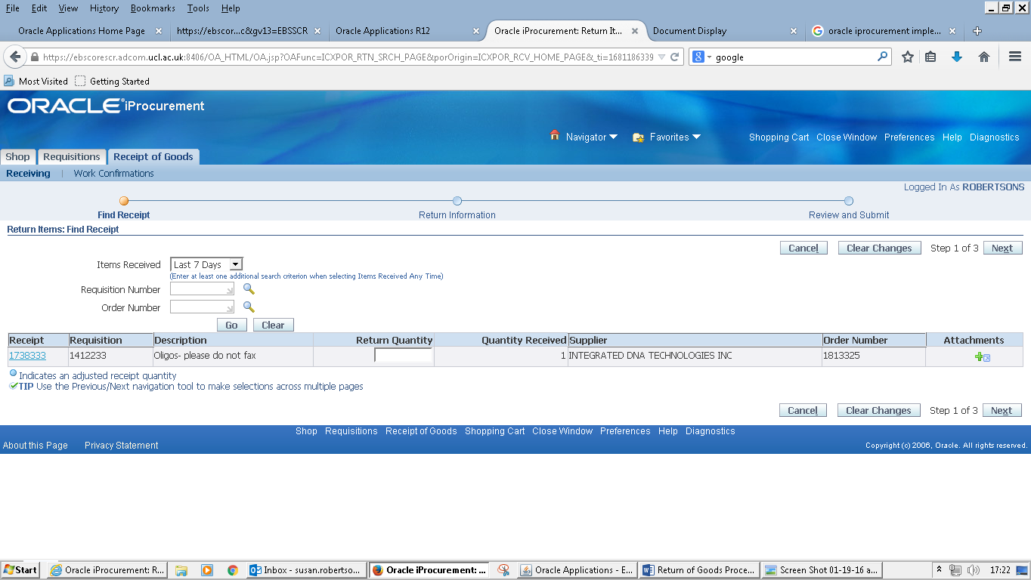
Enter Return Quantity, Click Next.

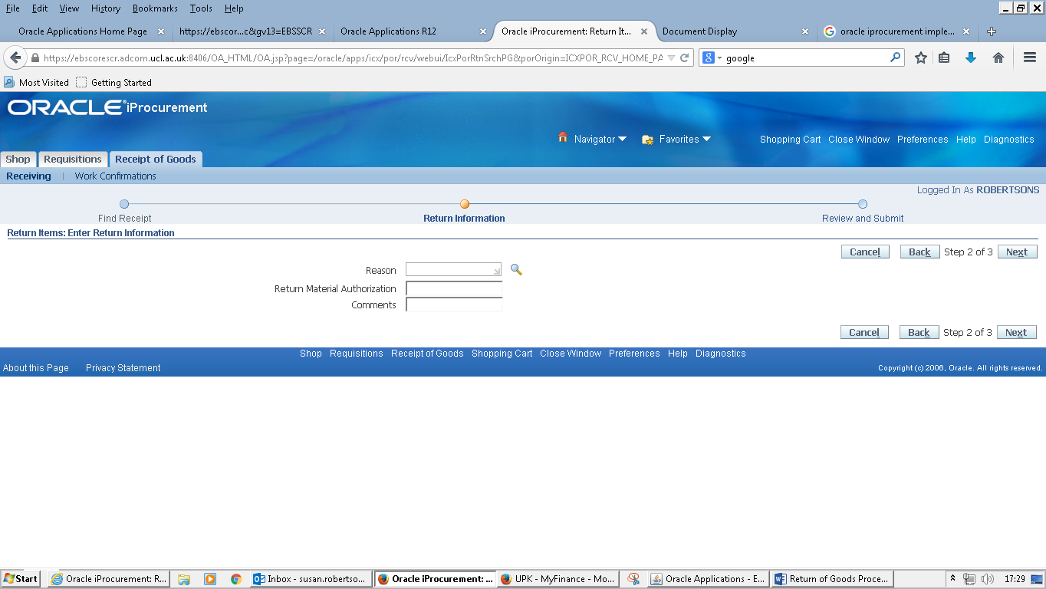
Leave the Reason and Return Material Authorisation fields blank, optionally put a comment as to why goods are being returned (this is a free text field).
Click Next and a confirmation screen is display, if details are correct then click Submit to process the transaction. A message is displayed confirming transaction is being processed.
If you need to amend details click on back button to make changes.
You can cancel the transaction by clicking on Cancel.
