UCL Estates
Estates Development

Washroom Standards Guidelines

Draft Version 1.7

7th April 2022

Department Documentation Standards
Version Control

Version | Date | Nature of Revision | Author | Approved By | Signed
DV1.0 | 24/04/2020 | First Issue
DV1.1 | 28/04/2020 | PJ Comments inc.
DV1.2 | 03/11/2020 | Drawings, Images and Text Updated
DV1.3 | 16/07/2021 | Comments and specifications incorporated.
DV1.4 | 17/09/2021 | Comments incorporated. Specification referencing added.
DV1.5 | 16/03/2022 | Comments incorporated.
DV1.6 | 18/03/2022 | Additional comments added.
DV1.7 | 08/04/2022 | Equality Analysis & Compliance Review.

Note: This document is to remain Microsoft Office Work format to allow for copying and pasting where required.

Contents Page

Section Page

- Introduction 4
- Initial Design Considerations 5
- Washroom Typologies 6
- Design Criteria 8
- Washroom Standards 20
- Specifications 70
- Acknowledgements……………………………………………………………………..105

- Introduction

The UCL Estate is an important and expensive resource and, in terms of costs to provide and maintain, is second only to salary costs.

The estate consists of numerous buildings, many of which are listed, together with a diverse range of modern buildings constructed at various times during the last century.

Improved space efficiency, intelligent design and low energy solutions are vital in reducing emissions and achieving the University’s carbon reduction targets. This applies to not only the primary teaching and study spaces, but also the ancillary accommodation that supports this function.

The purpose of the Washroom Standard is to define preferred spatial arrangements, designs and specifications for a range of different washroom types that will provide inclusive, well-functioning spaces that look good, are robust, easy to clean, easy to maintain and minimise energy usage. This should involve consultation to determine the need on a project-by-project basis.

This guide sets out the following:

- Initial Design Considerations

- Washroom Typologies

- Design Criteria

- Washroom Standards and Specifications

This standard is to be read in conjunction with the following relevant statutory and UCL documents:

- Building Regulations Approved Documents

- British Standards

- UCL Design Guidelines, Standards and Briefing Documents i.e. MEP Design Guide, Water Hygiene, Fire and Asbestos.

- Initial Design Considerations

  - Washroom Provision Key Requirements
The Workplace (Health, Safety and Welfare) Regulations 1992 Regulation 20 states that “suitable and sufficient sanitary conveniences shall be provided at readily accessible places” in the workplace. ACOP 21 states the number of WC facilities needed per number of people at work.

BS 6465-1:2006 Sanitary installations. Code of Practice for the Design of Sanitary Facilities and Scales of Provision of Sanitary and Associated Appliances provides guidance on the WC facilities to be provided in both workplaces and assembly buildings / educational establishments.

When considering the partial refurbishment of an existing building, an assessment, in accordance with Building Regulations, should be undertaken to understand the existing WC provision within the building, and to determine whether this is compliant for the current number of building occupants. Where the provision is not sufficient, consideration should be given to addressing any shortfall.

If the proposed refurbishment will increase the number of building occupants / users, the existing washroom provision will need to be checked to ensure that it can satisfy the increase in demand. Should additional washrooms be required, then consideration should be given to providing these as part of the project to ensure that the correct number of washrooms, in accordance with Building Regulations, are available as soon as the building occupancy increases. The installation of new and refurbished washrooms should not reduce the statutory provision of washroom facilities for the building.

Validation of Existing Services
When washrooms are to be refurbished or new washrooms are to be created, it is vital that the existing building infrastructure is adequate and functioning correctly or is capable of dealing with any additional demand that will be required.
This is particularly important for the above and below ground drainage systems to ensure that there is sufficient capacity, and for ventilation systems to ensure that an adequate volume of supply and extract air can be provided to achieve the required number of air changes.

- Washroom Typologies

  - Washroom Categories
The majority of UCL’s buildings house a broad range of different functions with staff workspaces, teaching spaces, student learning spaces and support spaces often located together.
This means that the majority of washrooms are usually shared between staff, students and visitors rather than being segregated for specific user groups.
A variety of different washroom types are provided across campus, and these include single sex, unisex, gender neutral and accessible washrooms. Recently Changing Places have been provided together with washroom solutions for multi-cultural and multi-faith users.
Recent UCL research has suggested that whilst many people have no issues using gender neutral facilities, some people prefer using single sex washrooms.
UCL’s policy is therefore to provide a mixture of different washroom types to allow all staff, students and visitors to use facilities that they are comfortable using and that satisfy their specific preferred requirements. Whilst the preference is to provide more gender-neutral washrooms on campus, this should not be to the detriment of single sex washrooms. Gender-neutral or accessible toilets to be signposted within the single sex washrooms (or vice-versa) to ensure that everyone can find the washroom type they want to use. Washroom types to be provided are listed below:

- Single Sex Washrooms

- Gender-Neutral Washrooms

- Wheelchair Accessible Washrooms and Ambulant Disabled Person’s Cubicles

- Changing Places Toilets

Whilst several different washroom types are to be provided, finishes, sanitaryware, fixtures and fittings are to be standardised across the different types.

This will allow UCL’s maintenance teams to stock a limited range of replacement items, which will allow any damaged or defective items to be repaired or replaced swiftly, minimising the amount of time that washroom facilities are out of action.

  - Use Categories
The building that a washroom is in can often determine the level of finishes and fittings that are used. For instance, a high-profile building, accessible to the public or a historically significant Grade I listed building, may have a higher level of finishes and fittings within the washrooms than those found in other buildings.

The location of a washroom within a building will also have a significant impact on the level of use and / or abuse that they are subjected to.

Washrooms located next to lecture theatres or amenity / catering functions will be used heavily at specific times such as at lecture changeover / mealtimes.

Washrooms that are located away from busy building functions and circulation routes have significantly fewer people using them.

For these reasons, options for each of the washroom types have been included within this standard for the following different use categories:

Standard Specification (SS)

For washrooms used by staff, students and visitors which are not subject to intense use.

Heavy Duty Specification (HD)

For washrooms that are subject to more frequent / intense use due to their location and need to be more robust and hard wearing.

Enhanced Specification (ES)

For washrooms that are located within prestigious public facing buildings or historically significant listed buildings.

- Design Criteria
  - Space Planning
The space available to accommodate washrooms will differ from building to building, and a one size fits all solution will not work.
For this reason, this standard describes the preferred space requirements and design solutions for the constituent elements of the various types of washroom (with the exception of Ambulant Disabled person’s Cubicle, Wheelchair Accessible WCs and Changing Places).
It is widely acknowledged that people are getting larger, and smaller more compact WC cubicles and spaces can be challenging for larger people to use. Where possible, consideration should be given to providing WC cubicles that are more generous than the recommended minimum space requirements.
  - Durability
UCL has an external company that cleans its buildings. Given the large number of washrooms on campus, it is difficult for specific cleaning methods to be adopted for certain finishes within certain spaces.
For this reason, it is critical that all finishes, fixtures and fittings used in washrooms are durable and hard wearing and do not require extraordinary cleaning methods.
  - Visual Characteristics
Visually impaired people and some neurodivergent individuals will be confused by reflections and glare from shiny surfaces if those surfaces are large in area. Mirrored, high gloss or very shiny surface finishes should be avoided for large areas, e.g. floor, wall, door and ceiling surfaces.
In order to assist visually impaired and neurodivergent people the following visual contrast requirements should be achieved as a minimum:

Wall to floor - 30 LRV points
Wall to fittings - 30 LRV points
Doors to door handles - 15 LRV points

Contrast also must be achieved between fixture and fittings e.g. grab rails need to be apparent, sanitary furniture should be apparent.
  - Wheelchair Accessible Facilities
When new wheelchair accessible WCs are to be provided, consideration is required whether these should be left hand transfer or right-hand transfer.
An audit should be undertaken of the nearest wheelchair cubicle types in order to understand what existing facilities are available, in order to provide a mix of both left hand and right-hand transfer types to suit differing wheelchair users’ requirements.
  - Wall Finishes
Wall finishes should be durable, robust and easy to clean. Where water is likely to splash onto wall surfaces (such as around washbasins and hand driers), these surfaces should be impervious to water and be able to be wiped clean.
Careful consideration should be given to wall surfaces in high traffic areas where people may brush against the walls scuffing them. In these locations, finishes that will withstand impact should be utilised.
Back painted glass panels have been used previously and worked well, however, these are highly reflective and can be disorientating for visually impaired people. Finding a balance between looking good, being robust and easy to clean without large expanses of reflective surfaces is required.

Sheet wall cladding products should be considered for high use areas, although consideration should be given to whether these products can be repaired.
Paint finishes should be avoided in high traffic areas and should only be used in areas that are not subject to heavy use. Whilst wipeable paint finishes can be wet cleaned, these can still get scuffed and require repainting frequently, which can often be a false economy.
  - Floor Finishes
Floor finishes need to be durable, easy to clean and not show dirt easily. They should be a matt finish with a maximum R12 slip resistance (R13 or R14 slip resistance can be problematic for ambulant mobility impaired people).
The floor finish must be able to be repaired locally without having to replace the entire floor covering. Skirtings should be the same material as the floor and there should be a good seal between the two.
Floors are wet cleaned daily, and this can involve a lot of water on the floor surface. For this reason, the floor finish must be impervious to water.
Floor gullies should be provided wherever the floor construction and building drainage system will allow, as they are useful for slopping out when cleaning and to prevent issues if the washrooms flood. The shape and size of the drainage slots to the floor gulley should be small enough so that they do not create movement issues for people with walking aids.
The preference is for large format floor tiles with minimal floor joints as these have found to be the most hard wearing.

Where the floor sub-base is not suitable for a tiled floor or the washroom is small and not subject to intense use, sheet flooring will be acceptable.

  - Cubicle and IPS Systems
Cubicle and IPS systems should be constructed from High Pressure Laminate panels, so they are hardwearing and chemical / water resistant. Panels should reach to the floor or be at a maximum height of 100mm above the FFL.
  - Ceiling Finishes
The preferred finish for ceilings is suspended plasterboard with accessible metal ceiling tiles where access to services above ceilings is required. Ceiling tiles should be easy to remove and replace without having to use specific tools.

Where accessible ceiling tiles are required, these should be installed with a plasterboard margin where the ceiling meets the walls to avoid having cut ceiling tiles.
Ventilation systems that involve using the ceiling as a plenum to extract air through perforated metal ceiling tiles should be avoided, as this results in the perforations in the ceiling tiles getting dirty. Where air is supplied and extracted to and from rooms this should be done using dedicated supply and extract grilles. Grilles should not be placed above baby change table or adult changing tables in Changing Places facilities.
  - Doors & Ironmongery
Main access doors into washrooms should be the same type as installed in the rest of the building for visual uniformity.
Doors within washrooms should be hard wearing, durable and able to withstand the intended use category. Cubicle doors should visually contrast with adjacent wall finishes.

Doors to cubicles should open inwards generally, except for wheelchair accessible, ambulant accessible and Changing Places toilets where doors should open outwards. All cubicle doors should be on rising butt hinges (rather than door closers) so that they are easy to operate, and the doors fall closed.

Doors should feature clear visual indicators so that it is apparent when cubicles are vacant and available to use. Some people find it difficult to differentiate between red and green, so the visual indicators should be green for vacant and white for engaged. If possible, the visual indicators should be combined with the words ‘vacant’ and ‘engaged’.

All ironmongery must be easy to operate for people with limited dexterity. Cubicle door locks should be able to be opened from outside the cubicle in case of an emergency.
  - Access Panels
Access panels should be provided where access is required behind finishes for maintenance, and they should be sized according to the extent of access that is required.
Panels that need to be lifted off are to be avoided as they often get damaged when removed and placed somewhere.
Hinged access panels with a budget lock to prevent unauthorised access should be provided.
Access provision should also consider the potential requirement to replace items in the future (such as cisterns) and not just access for regular maintenance.
  - Storage
Adequate provision for placing bags, laptops, books etc. should be provided within all WC cubicles.
Shelves should be large enough to store items without risk of them falling off.
Integral shelves or recesses rather than wall mounted shelves are preferred as they are more stable and capable of supporting heavy items without breaking / pulling away from the wall.
2 no. coat hooks should be provided to the back of all WC cubicle doors, and should be strong and durable so they don’t break easily. Where these are fixed to thinner cubicle system doors, bolt through fixings hidden behind the sign are to be used to provide a more robust fixing. The coat hooks should be at 1050mm and 1400mm above floor level.
  - Hand Wash Basins
Ceramic basins to be used, large enough to allow both the soap dispenser and hand drier to be located above so that water drips into the basin rather than onto the floor.
Ceramic finger rinse basins are to be used in wheelchair accessible WCs which prevents the hand driers from being installed above the basin.
Strainer waste with no plug to be provided. Basins should have an integrated overflow in case a plug is fitted at a later date.

In the changing places toilet, a power‑operated, height‑adjustable washbasin should be provided to accommodate use by both wheelchair users and assistants.
  - Communal Hand Wash Troughs
Solid surface Corian®-type trough basin to be used for communal basins.
  - Taps
Fittings must visually contrast with the hand wash basin, with obvious means of temperature adjustment, so that they can be used by visually impaired people.
Must be able to be operated by a person with limited manual dexterity using a single clenched fist.
Mains power operated electronic sensor taps preferred. Ensure that the supply voltage for sensor tap solenoid valves is correct for the solenoid used and that the valves are installed correctly, as per manufacturer’s recommendations.

The flow rate on taps should be limited to 4 litres/minute up to a pressure of 5 bar (using new taps or by retrofitting flow control devices). Sensor taps should be set so that they shut off after a maximum of 3 seconds.
Consideration to be given to whether the water supply within the building is a boosted water systems or a gravity fed system, and the tap specification will need to account for this. Electronic sensor taps require high water pressure and where the water pressure is not high enough, these taps often don’t work very well.
In these instances, non-concussive taps (manually operated by pushing a button which delivers a timed flow of water) are to be used. Consideration to be made regarding how much strength is required to operate this type of taps.
  - WCs
Wall hung WCs to allow the floor beneath the WC to be easily cleaned.
WCs to be installed using floor mounted support brackets.

Standard WCs to be installed 400mm AFFL with WCs in all ambulant accessible, wheelchair accessible and Changing Places toilets installed at 480mm AFFL.
Toilet seat to be provided, but no lid.
  - Cisterns
Cisterns should target an effective flush volume of 4.5 litres or less, subject to local drainage infrastructure. Existing systems should be retrofitted where practical. 4.5 litre effective flush volume can be achieved using a 6l/4l dual flush cistern which is generally sufficient for most UCL facilities. Note: some core campus drainage systems may not be able to support lower flush volumes than this. (To be determined by review of waste water infrastructure)

Cisterns should refill completely within a minute with a pumped water system.
Pneumatic cistern flush mechanisms to be used.
Flush mechanisms with large buttons are preferred, as these are easier to operate for people with limited manual dexterity (operable using a clenched fist). Consideration to be made regarding how much strength is required to operate these types of buttons.
  - Urinals
Individual wall mounted ceramic urinals mounted at 500mm AFFL with modesty panels between urinals required.
The wall colour will need to contrast with the urinals so that they can be used by visually impaired people.
Where buildings are accessible to the public, one urinal at the end to be installed at a lower height of 380mm AFFL for children to use.
Where WCs are located in high use areas, where demand occurs at peak times and space is limited, trough urinals may be considered, but this should be discussed and agreed with UCL Estates Operations.
Solenoid valves should be used to flush urinals hourly during the night to prevent smells occurring when buildings are not open 24 hours, and the regular flushing cycle would waste water.
Central cisterns for urinals should be concealed where adequate access provision can be provided. Where this is not possible, exposed cisterns should be used.

  - Showers
Showers are not normally provided within washrooms, however, when washrooms are primarily used by staff, showers are sometimes requested for cyclists to use. If a shower is installed, it should meet the needs of all occupants to avoid discrimination.

Where showers are provided, these should be fully accessible so that they can be used by everyone.
Walk-in, level access wet room type showers are preferred, although it is recognised that this can be a challenge in existing buildings.
Arrangements with solid walls on three sides are preferred as this allows a flip down seat and handrails to be installed if required. To allow this, walls must be strong enough to support adaptations that could impose a load of 1.5kN/m2.
Where a fully accessible walk-in shower is not possible, a low-profile shower tray should be installed to minimise the step up into the shower. Shower wastes should be laid to falls and the use of pumps is to be avoided wherever possible. Should gravity waste drainage not be feasible, the use of pumps should be reviewed with UCL Estates Operations.
In order to cater for a changing demographic where people are getting larger the preferred size is 1000 wide x 1200 deep, with 800 wide x 1000 deep the minimum recommended.
Showers should provide good grip and slip resistance to prevent accidents.
Exposed shower units are preferred rather than individual recessed components with concealed pipework. Adjustable height and ability to lift shower head off the rail required in case some parts of the body need to be kept dry.

Shower to have fully adjustable temperature settings, with scale prevention measures in place.

A Type AUK2 – Domestic tap gap to be always maintained between the showerhead and shower tray.

Flow rate for showers is to be limited to max. 8 litres/minute up to a pressure of 5 bar.
  - Shower Screens
Shower configurations with solid walls on three sides are preferred as this can eliminate the need for a shower screen or curtain.
If screens are required to prevent water from splashing onto adjacent floor surfaces, shower screens should be toughened safety glass. The opening mechanism and screen handle need to allow operation by people with limited dexterity. The screen should have manifestation on it, so it is apparent to visually impaired people.
Shower curtains should be used in all accessible showers, and the colour of these should contrast with the wall.
  - Mirrors
Mirrors should be provided in all WC cubicles located above hand wash basins, except in wheelchair accessible WCs and changing places toilets where the mirror should not be located above the basin.
A full-length mirror should also be provided, preferably located in the lobby area rather than within individual WC cubicles. This is to deter those who do not need to use this facility from using it solely to access the full-length mirrors.
Large expanses of mirrored surfaces should be avoided as these can be disorientating for visually impaired people.
Mirrors should be flush with adjacent wall surfaces so there are no ledges where dust will collect and are therefore easier to clean. Maximum mirror height to be considered, because if to the ceiling, the top section of the mirror may be difficult to clean.
  - Soap Dispensers
Supplied by UCL (Cleaning Contractor provides) and installed by the contractor.

To be installed above wash basins so soap drips into wash basins. In the Changing Places toilet, care should be taken to ensure the soap dispenser does not prevent the sink being raised to its full height. In wheelchair accessible WCs, the soap dispensers to be placed above the sinks as shown in AD M and BS8300.
Need to be operable using a clenched fist for people with limited manual dexterity.
Dispensers should be mechanical rather than power / battery operated.
Soap used should be non-scented and pH neutral preferably so that it is suitable for use by people with allergies.
  - Toilet Roll Dispensers
Supplied by UCL (Cleaning Contractor provides) and installed by the contractor.
Current preference is for double roll toilet roll holders as these require re-stocking less frequently.
Single sheet paper towel dispensers are required in wheelchair accessible and ambulant accessible WCs and in the changing places toilet as they can be used by
people with limited manual dexterity.

  - Waste Bins
Where required (such as in Changing Places and Wheelchair Accessible WCs), bins should be the open metal wire type so that they cannot be filled with fluids.

  - Hygiene Bins
23l (larger size required for Changing Places toilet due to the need to dispose of adult-sized incontinence pads) disposal bins for the disposal of sanitary and incontinence pads supplied by UCL (Cleaning Contractor provides).

Sanitary bins to be provided in male and gender-neutral toilets as well as female.
  - Water Fountains
Where feasible, water fountains should be provided within washroom lobby areas. Water fountains should be operable with a clenched fist so that they can be used by people with manual dexterity. Water fountains should allow individuals to fill a container using only one hand, rather than one hand to hold the container and one to operate the water.

  - Hand Driers
Hand driers are to be used rather than paper towels, except in the wheelchair accessible WC and in the Changing Places toilet where paper towels must be provided.
Hand driers should be energy efficient and Quietmark Certified.
Hand driers to be located above hand wash basins to prevent water spillage on the floor when hands are dried, except in the wheelchair accessible and changing places toilet.
The location of hand driers stipulated in all toilets is important as many neurodivergent people will want to avoid the hand drier if possible.
Where hand driers are not installed above hand wash basins, the wall surface beneath and to the sides of the hand drier where splashing is likely to occur should be protected with a splashback material.
The colour of the hand drier should contrast with the wall (or be applied to a contrasting back plate) so that partially sighted people can see the hand drier.
  - Heated Towel Rails
Sometimes provided in departmental areas where there are showers for staff who cycle to work, and they need to hang towels up to dry.
Preference is for wet system heated towel rails connected to the hot water circuit so that they operate all year, and not just when the heating system / radiators are on. Electric heated towel rails are only acceptable if a wet system is not feasible.
Preferred solution would be for a duo / dual fuel heated towel rails that can be connected to both the heating system as well as the electrical supply.
  - Signage
All signage is to be as per the UCL Signage Guide Manual.

Where required, toilet etiquette signage to be installed. Requirement to be reviewed with UCL Estates Operations on a project-by-project basis.
  - Lighting
Lighting is to be designed to BS8300 with recessed ceiling light fittings preferred. This may be supplemented with wall mounted accent lighting carefully positioned to avoid glare.
Preference is for a warm white light (3500K) unless it is a location where drug use may occur, a blue light should be considered, through risk assessment, to discourage drug use. (cannot see veins to inject under blue light) A blue light cannot be used in wheelchair accessible WC, ambulant disabled person’s cubicles or changing places toilets as these are locations where diabetics should be able to inject with privacy.
Special consideration to be given to lighting Changing Places toilets to ensure that no lighting is placed over the ends of the changing places table that may cause light to shine directly into the eyes of the persons on the table.
  - Lighting Controls
Honeywell Exor MLS System installed across campus in most buildings. This system is fully programmable and can operate with either absence or presence detection, daylight detection, and with fully adjustable timed settings. Dedicated sensor to be installed in each cubicle.
Lighting controls in all accessible WCs and changing places toilets ideally needs to be manual on / off switch operation to prevent the lights from inadvertently going off when someone is inside. Manual on / off switch combined with absence detection so that the light goes off if there is no activity for a long duration permitted.
PIR sensors preferred rather than microwave sensors (MWS), as microwave sensors are too sensitive which cause lights to switch on when they are not actually required.

  - Emergency Assistance Alarms
Visible and audible emergency alarms within accessible washrooms need to be installed in the correct location and with the cord terminated at the correct height, which is often not the case. The preferred location for the alarm cord is in the corner rather than on the transfer side of the WC to prevent it from being activated by mistake. For the location of the emergency alarms in the changing places toilet please refer to BS8300.
Currently the alarms activate local beacons and sounders which then rely on someone in the area responding to the alarm signal.
Alarms to go back to somewhere central, so that they can be monitored and reacted to, rather than providing just a local alarm i.e. outside of the washroom, which may not be acted upon. Alarm signals should be sent to UCL Security via the Gallagher system, although how this is responded to / acted on will need to be confirmed by local arrangement. There should also be a two-way visual and audio response, so that the person who has activated the alarm knows that help is on its way. Showers to also have audio and visual alarms, as these are often used by ambulant users who may need to call for assistance in an emergency.

In leasehold buildings/spaces, there may be a requirement to install an additional alarm system for when UCL leaves the building/space and the Gallagher system deactivated. Discussions with the Landlord, Building Control etc. will prove beneficial in establishing the additional requirements. The additional alarm system is to be tested as part of the handover process, then placed out of service until the lease on the property/space expires and UCL vacates the premises. The system is to be re-instated, tested and proved fully functional, before UCL leaves the premises.

  - Small Power
Non-switched fused spurs with neon indicators should be provided for electrical items such as hand driers and automated taps. These need to be non-switched to prevent students from turning them off.
  - Fire Detection
To be as per UCL Fire Safety design documents for fire detection requirements.

Audible and visual fire alarm indicators to be installed in all WCs and showers.
  - Ventilation
Mechanical ventilation system to provide the required number of air changes required. Where doors to cubicles are full height, doors to be undercut to allow make up air into cubicles rather than using transfer grilles.
  - Pipework
Copper pipework should be used. Using crimped copper pipework (rather than soldered) avoids the need for a hot works permit.
Plastic pipework should be avoided wherever possible. Where plastic flexible pipework is to be used (such as for Changing Places toilets), this must be Water Regulations Advisory Scheme (WRAS) approved.
  - Isolation Valves
Quarter turn lever action e.g. Ballofix® valves to be used to isolate fittings. Where exposed these should be Allen key operated to prevent people tampering with them. Where concealed, lever or screwdriver operated is acceptable.
  - Mixing Valves
UCL utilise a thermal regime to control legionella and the hot water supply is typically 60⁰C. Water above 48⁰C can scald, so to ensure a safe and comfortable temperature, hot water is mixed with cold water at the point of discharge. TMV2 certified mixing valves, to be used.

  - Leak Detection
Using spot detectors or trace cables to detect leaks is typically only done for major water services pipework installations, so is not required in washrooms.

  - Grab rails
Grab rails should be capable of supporting a load of 171 kg applied both vertically and at 45°. Grab rails should visually contrast with the background that they are seen against.

  - Water Supply Isolation

Install flow control devices to isolate the cold water supply to washrooms when unoccupied (to minimise water leaks and wastage). This usually comprises a solenoid valve linked to occupancy sensor, which may also serve lighting. The shut-off system only needs to be applied to the cold water supply for taps, WCs and urinals (not showers).

- Washroom Standards
All building floor plans are to be updated, post-works, so that the plans show the male, female, ambulant accessible, gender neutral, Changing Places, accessible toilets within the building/s affected by the works.
The rendered images below are for illustrative purposes only and appropriate contrast should be part of the design solution.

5.1 Single Sex Washrooms
Single sex washrooms are used by either males or females and consequently, providing high levels of acoustic separation and privacy between adjacent cubicles is less important than in facilities that are shared. This means that free-standing toilet cubicle systems that separate WCs rather than fully enclosing them are often utilised. Not only are these systems cost effective, robust and hard wearing, but they are also space efficient due to the slim thickness of the panels.
In single sex washrooms people feel more comfortable and are accustomed to using a shared hand wash area. This means that hand wash basins do not need to be located within individual cubicles, which reduces the space required for each cubicle, together with the number of soap dispensers and hand driers required.
The typical cubicle size required for this arrangement is 800mm wide x 1500mm long.

    - WC Cubicles - Option 1

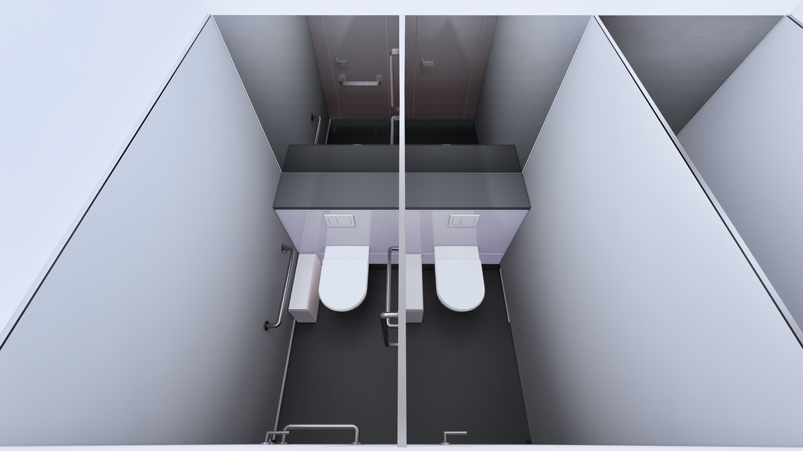
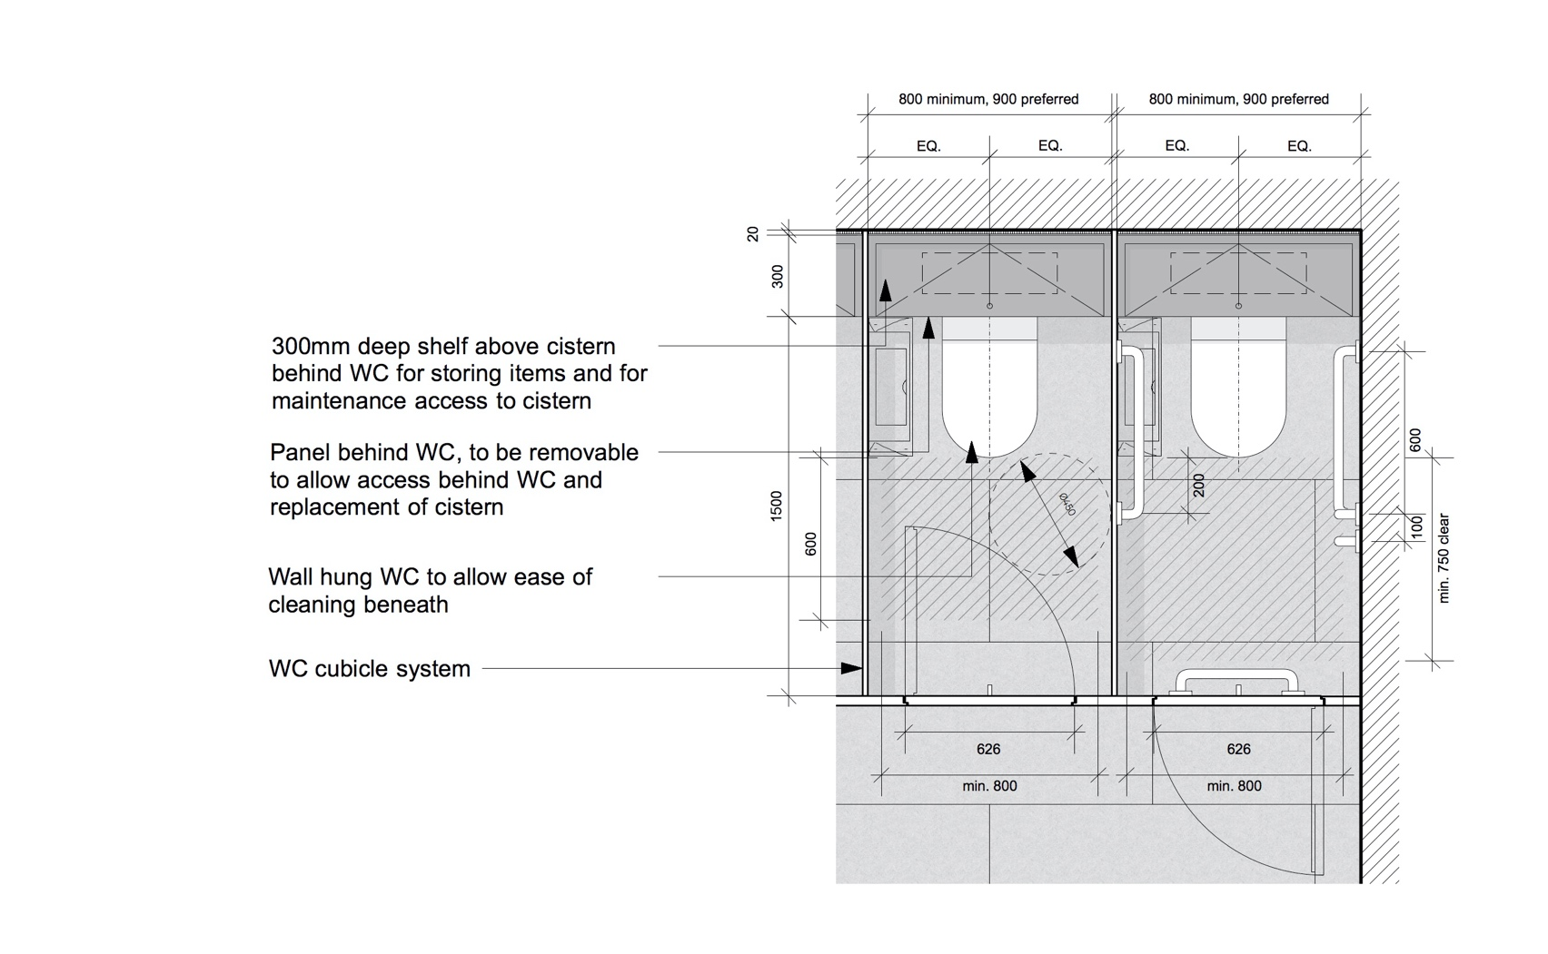
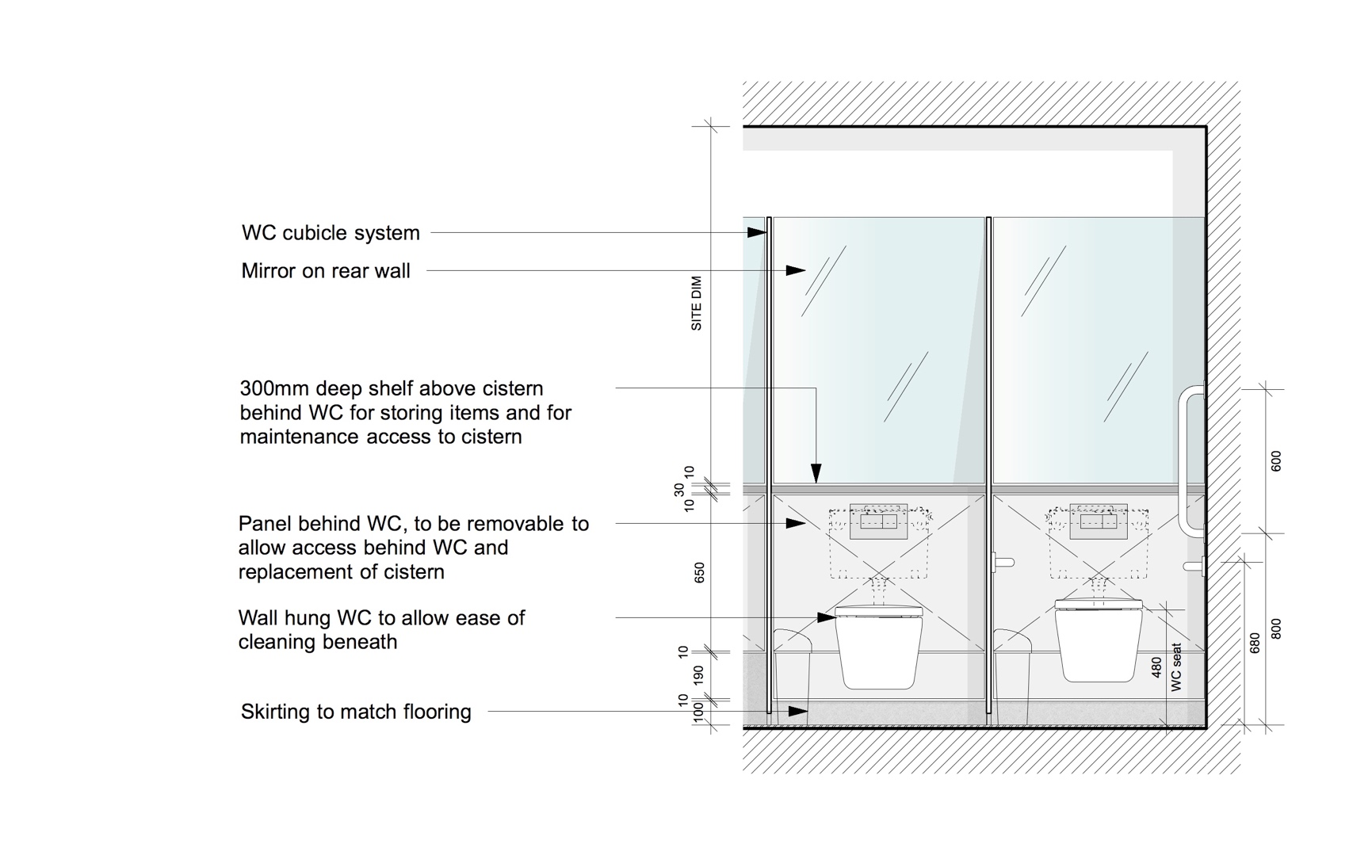
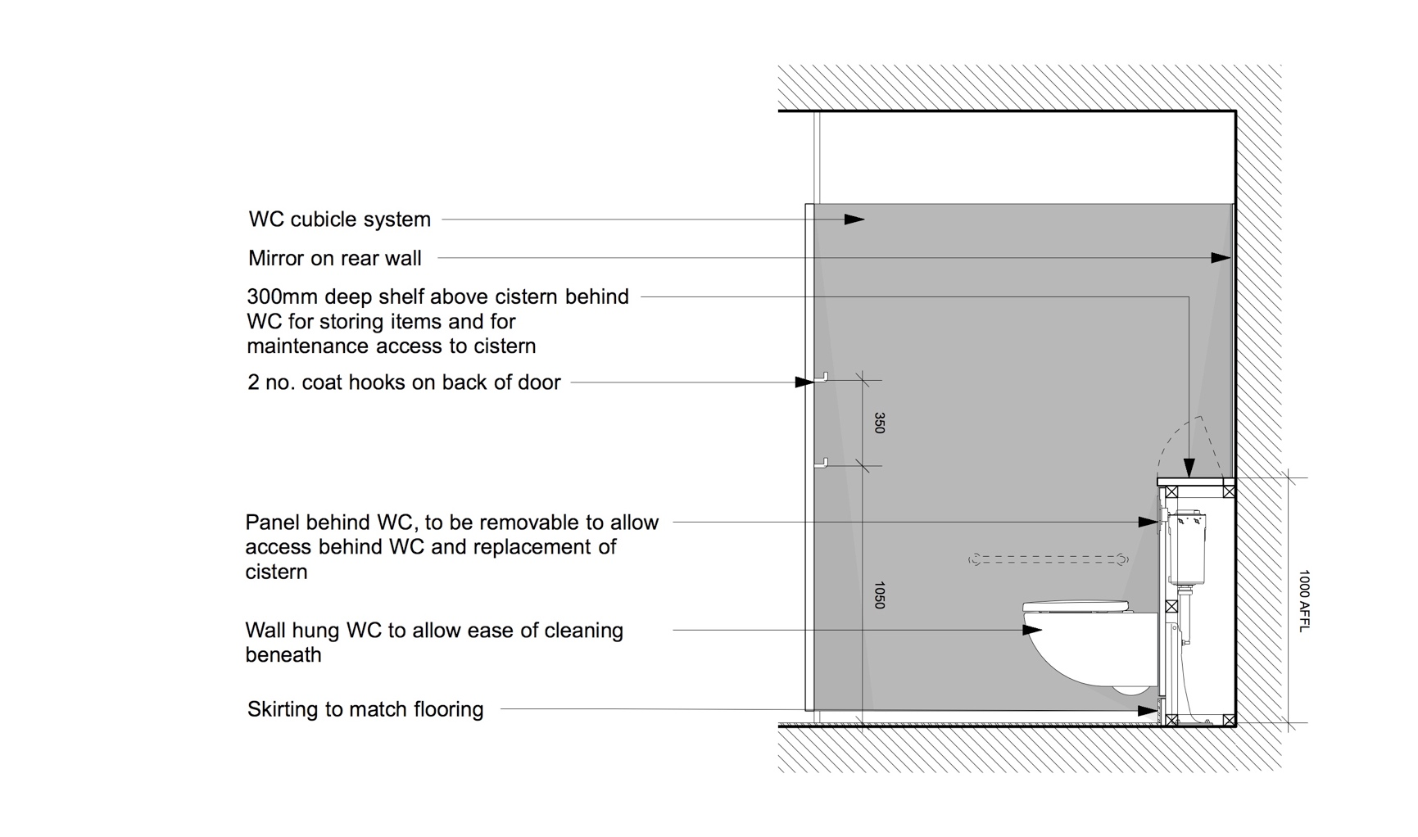
Specification
Floor Finish: Rubber sheeting as NBS clause M50/150
(SS)

Floor Finish: Tiling as NBS clause M40/110
(HD + ES) Where substrate is suitable to receive tiling as NBS clause M40/210 & M40/470

Wall Finish: Plastered masonry and metal stud plasterboard partition walls to be painted as NBS clause M60/110

Ceiling Finish: Suspended MF plasterboard ceiling to be painted as NBS clause M60/110

Suspended ceiling tiles where access to services above is required as NBS clause K40/110

Cubicles: Cubicle System as NBS clause K32/112

WC Wall: Coved rubber skirting as NBS clause M50/150 & M50/770
(SS)
Accessible duct wall lining above skirting to 1000mm AFFL with hinged shelf as NBS clause K32/140

Mirror as NBS clause N13/438

WC Wall: Skirting tiles as NBS clause M40/110
(HD + ES)
Glass panel accessible duct lining above skirting up to 1000mm AFFL with hinged Corian shelf as NBS clause K13/161

Mirror as NBS clause N13/438

WC Pan: WC to standard WCs as NBS clause N13/300

WC to ambulant WCs as NBS clause N13/301

WC Seat: Seat and cover to standard WCs as NBS clause N13/300

Seat and cover to ambulant WCs as NBS clause N13/301

WC Cistern: Cistern to standard WCs as NBS clause N13/300

Cistern to ambulant WCs as NBS clause N13/301

WC Actuator: Flushing arrangement to standard WCs as NBS clause N13/300

Flushing arrangement to ambulant WCs as NBS clause N13/301

Toilet paper disp: Toilet roll dispenser as NBS clause N13/441

Single sheet toilet paper dispenser as NBS clause N13/440

Sanitary Bin: Sanitary towel disposal bins as NBS clause N13/446

Hooks: Clothes hooks as NBS clause N13/429

Grab Rails: Handrails and grab bars for ambulant cubicles as NBS clause N13/436

Lighting: Lighting to be specified in conjunction with the current version of the UCL Design Guidance for Mechanical, Electrical & Public Health Services.

    - WC Cubicles – Option 2
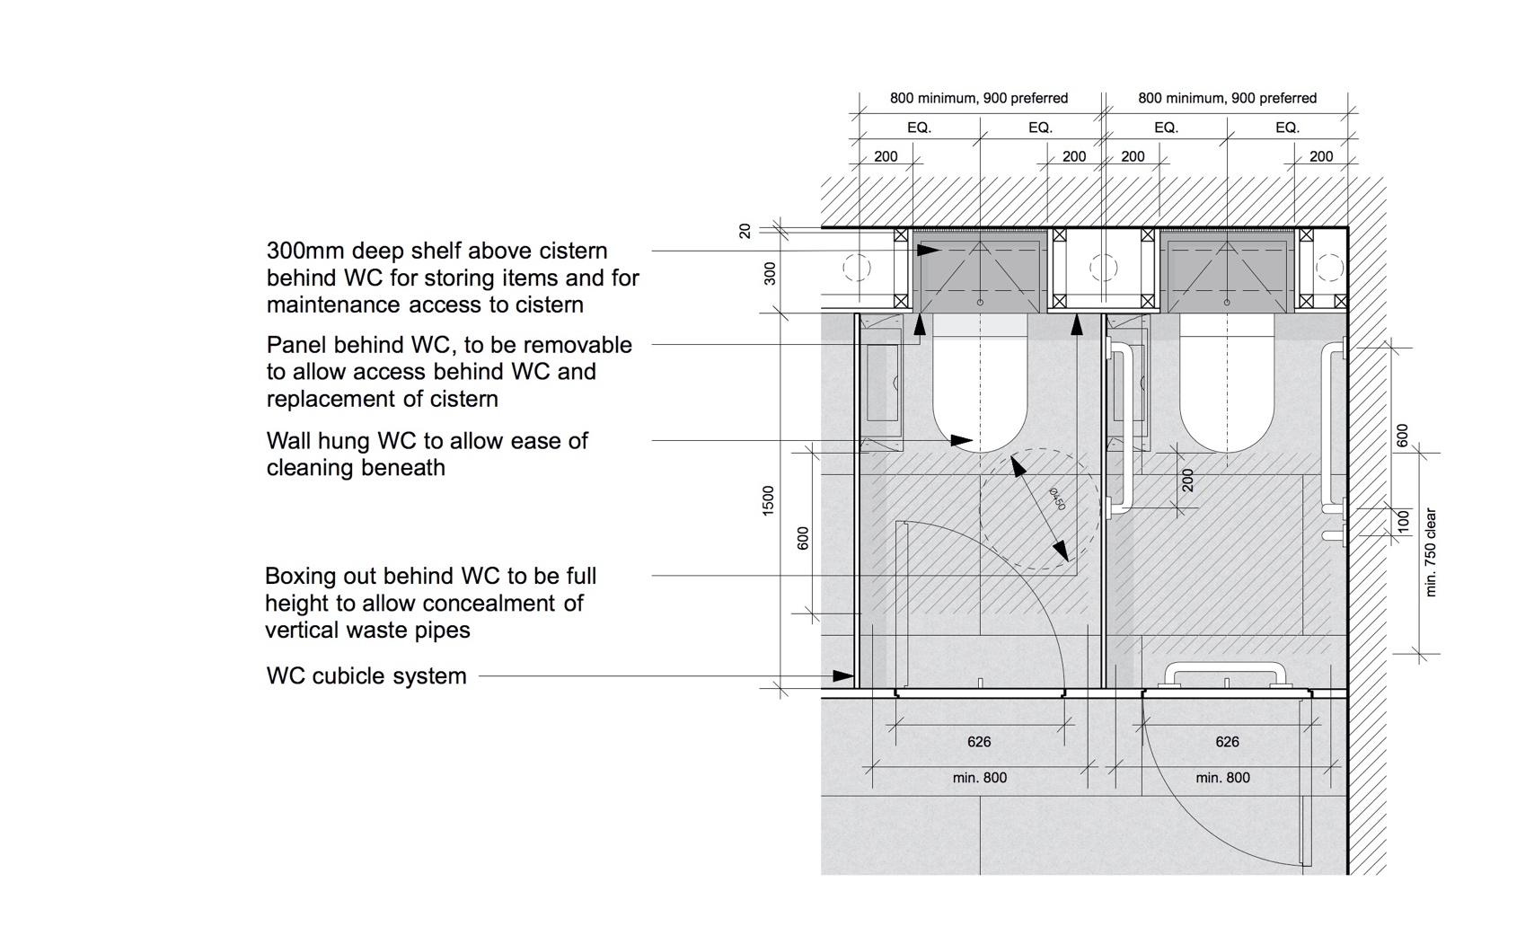
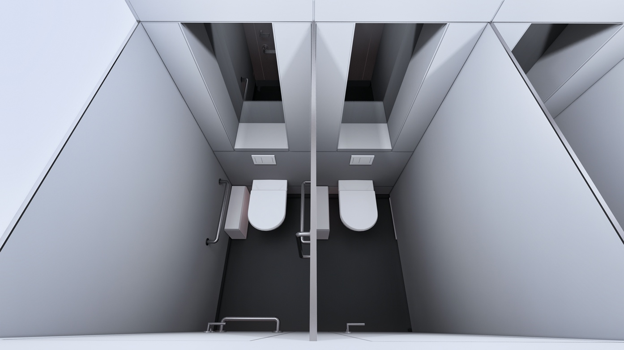
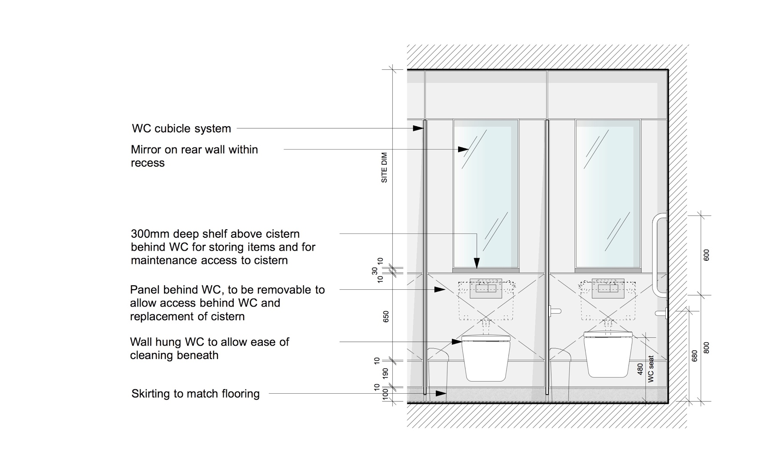
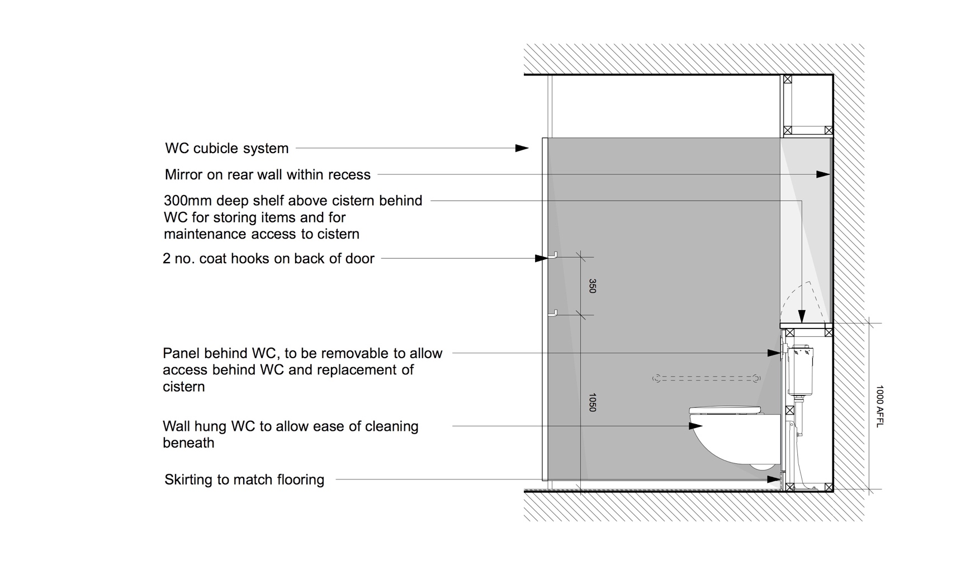
Specification
Floor Finish: Rubber sheeting as NBS clause M50/150
(SS)

Floor Finish: Tiling as NBS clause M40/110
(HD + ES) Where substrate is suitable to receive tiling as NBS clause M40/210 & M40/470

Wall Finish: Plastered masonry and metal stud plasterboard partition walls to be painted as NBS clause M60/110

Ceiling Finish: Suspended MF plasterboard ceiling to be painted as NBS clause M60/110

Suspended ceiling tiles where access to services above is required as NBS clause K40/110

Cubicles: Cubicle System as NBS clause K32/112

WC Wall: Coved rubber skirting as NBS clause M50/150 & M50/770
(SS)
Accessible duct wall lining above skirting to 1000mm AFFL with hinged shelf as NBS clause K32/140

Mirror as NBS clause N13/438

WC Wall: Skirting tiles as NBS clause M40/110
(HD + ES)
Glass panel accessible duct lining above skirting up to 1000mm AFFL with hinged Corian shelf as NBS clause K13/161

Mirror as NBS clause N13/438

WC Pan: WC to standard WCs as NBS clause N13/300

WC to ambulant WCs as NBS clause N13/301

WC Seat: Seat and cover to standard WCs as NBS clause N13/300

Seat and cover to ambulant WCs as NBS clause N13/301

WC Cistern: Cistern to standard WCs as NBS clause N13/300

Cistern to ambulant WCs as NBS clause N13/301

WC Actuator: Flushing arrangement to standard WCs as NBS clause N13/300

Flushing arrangement to ambulant WCs as NBS clause N13/301

Toilet paper disp: Toilet roll dispenser as NBS clause N13/441

Single sheet toilet paper dispenser as NBS clause N13/440

Sanitary Bin: Sanitary towel disposal bins as NBS clause N13/446

Hooks: Clothes hooks as NBS clause N13/429

Grab Rails: Handrails and grab bars for ambulant cubicles as NBS clause N13/436

Lighting: Lighting to be specified in conjunction with the current version of the UCL Design Guidance for Mechanical, Electrical & Public Health Services.

    - Hand Wash Basin – Option 1
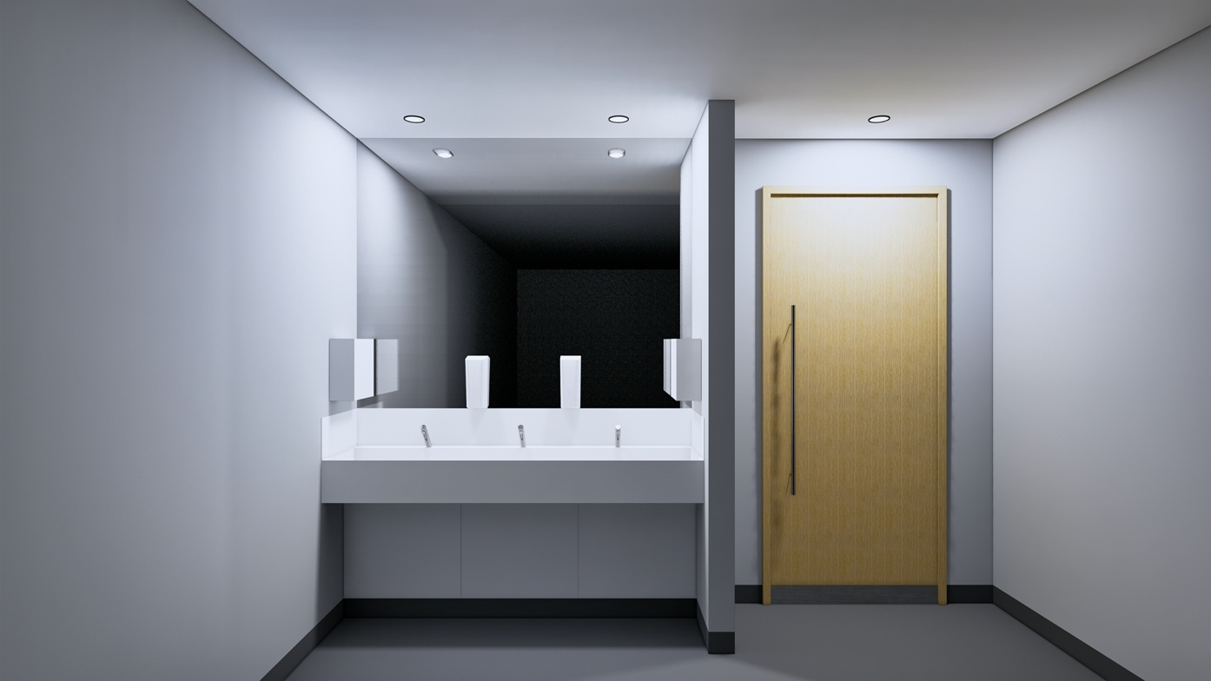
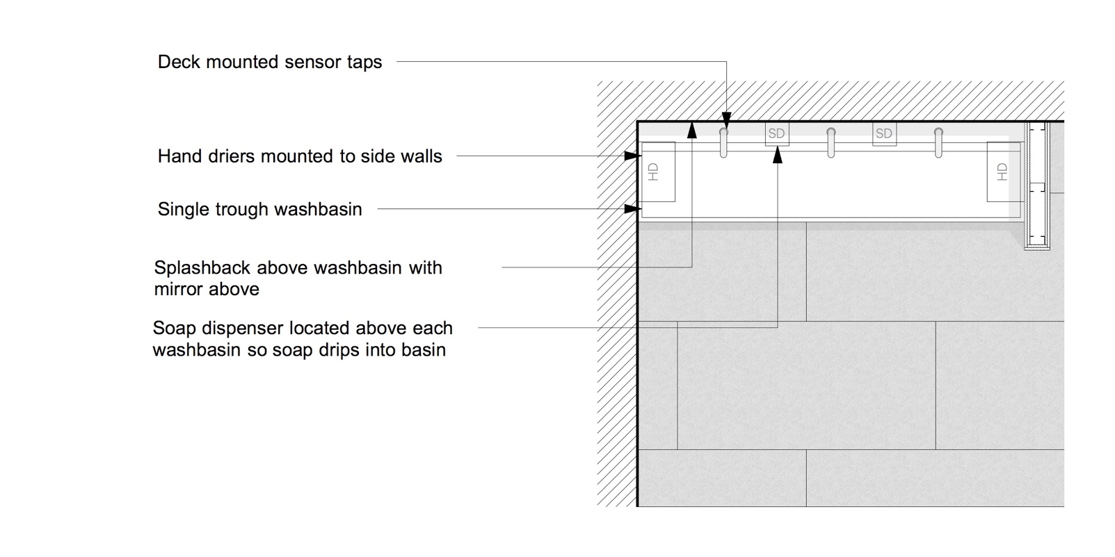
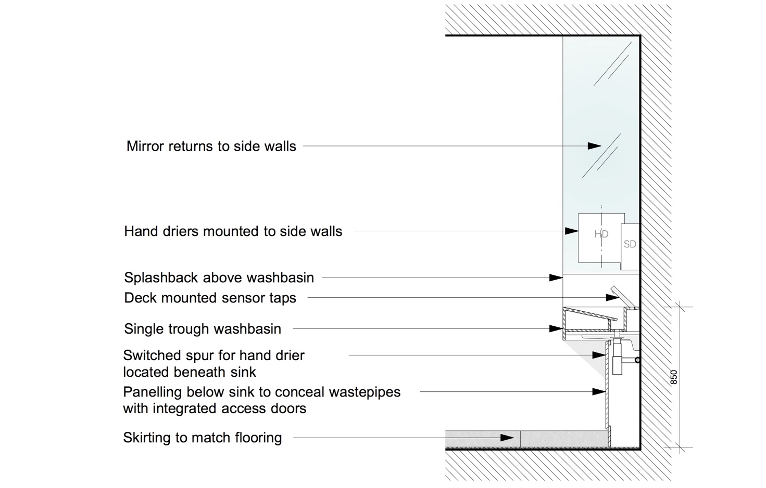
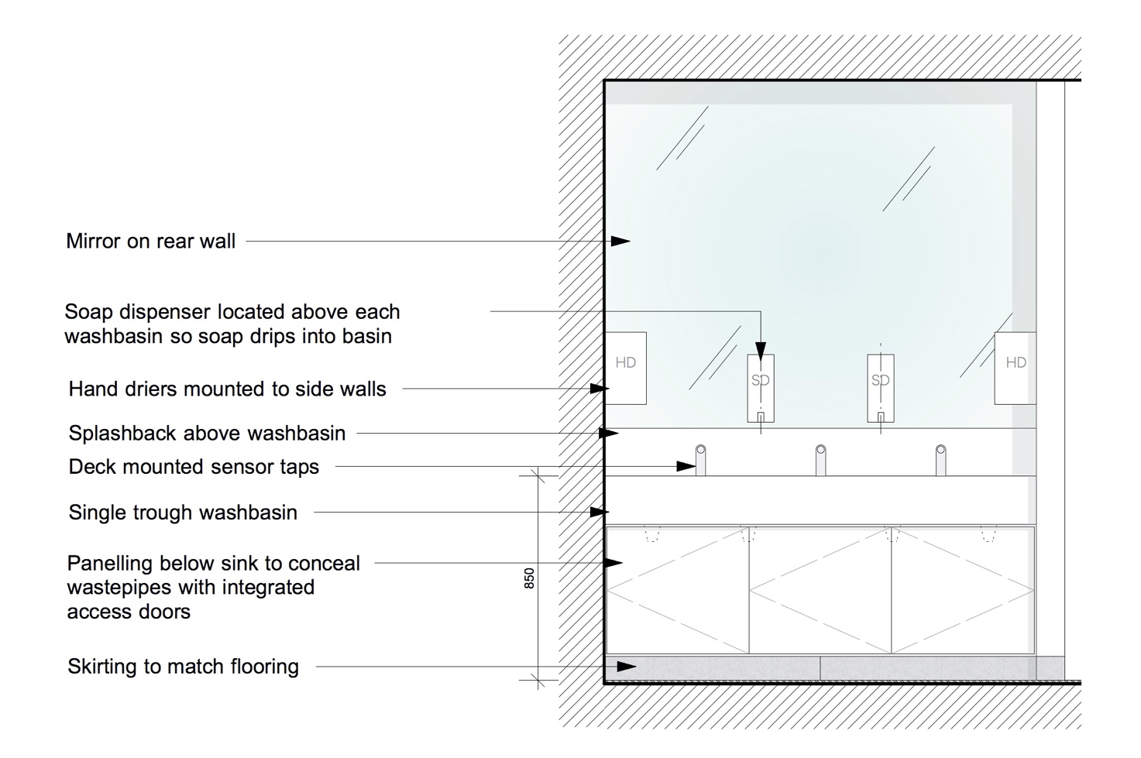
Specification

Washbasin: Washing troughs to communal WCs as NBS clause N13/346

Taps: as NBS clause N13/346

Traps: as NBS clause N13/346

Splashback: 200mm high glass panel lining as NBS clause K13/160

Mirror: Mirror as NBS clause N13/438

Soap Dispensers: as NBS clause N13/458

Hand Driers: as NBS clause N13/472

Floor Finish: Rubber sheeting as NBS clause M50/150
(SS)

Floor Finish: Tiling as NBS clause M40/110
(HD + ES) Where substrate is suitable to receive tiling as NBS clause M40/210 & M40/470

Wall Finish: Plastered masonry and metal stud plasterboard partition walls to be painted as NBS clause M60/110

Ceiling Finish: Suspended MF plasterboard ceiling to be painted as NBS clause M60/110

Suspended ceiling tiles where access to services above is required as NBS clause K40/110

    - Hand Wash Basin – Option 2
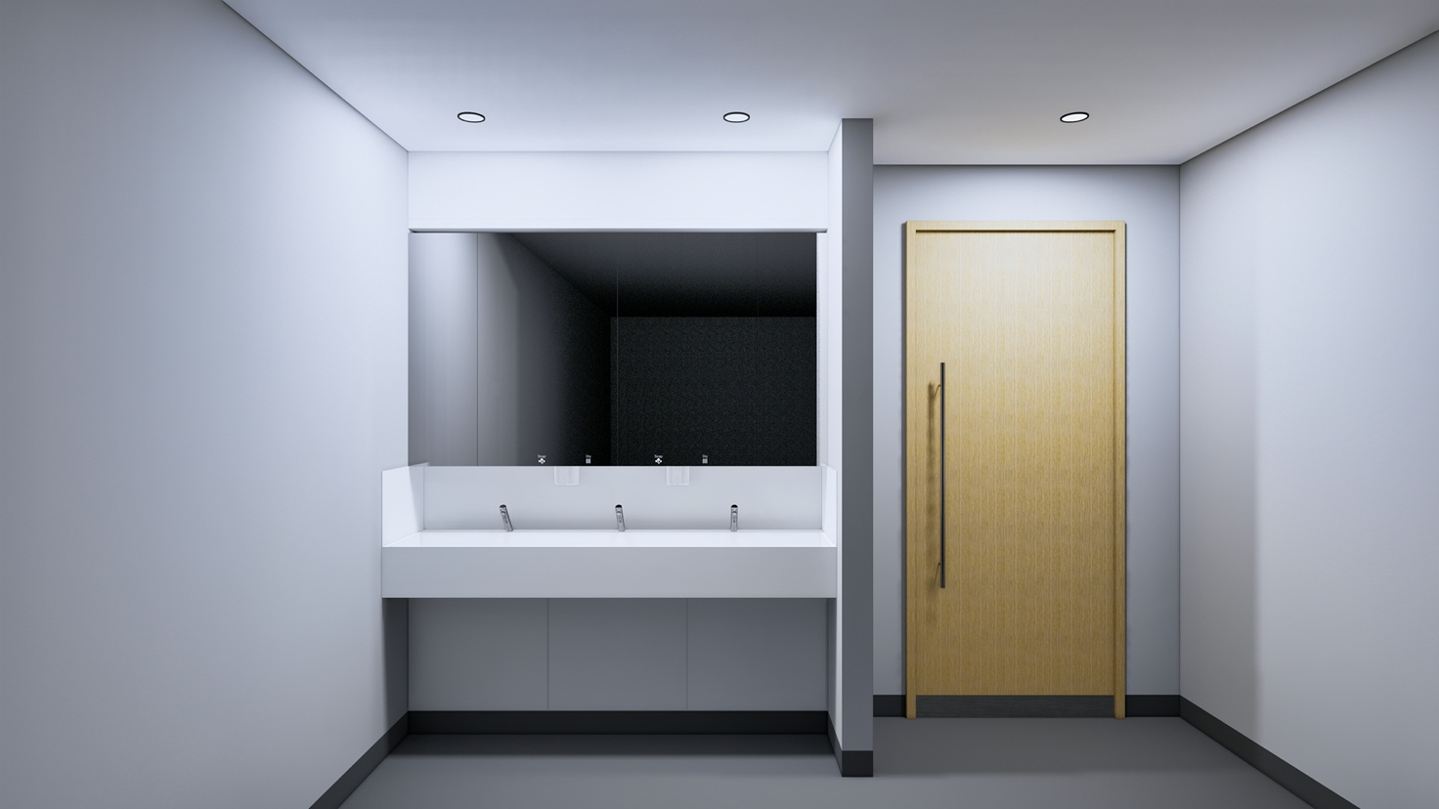

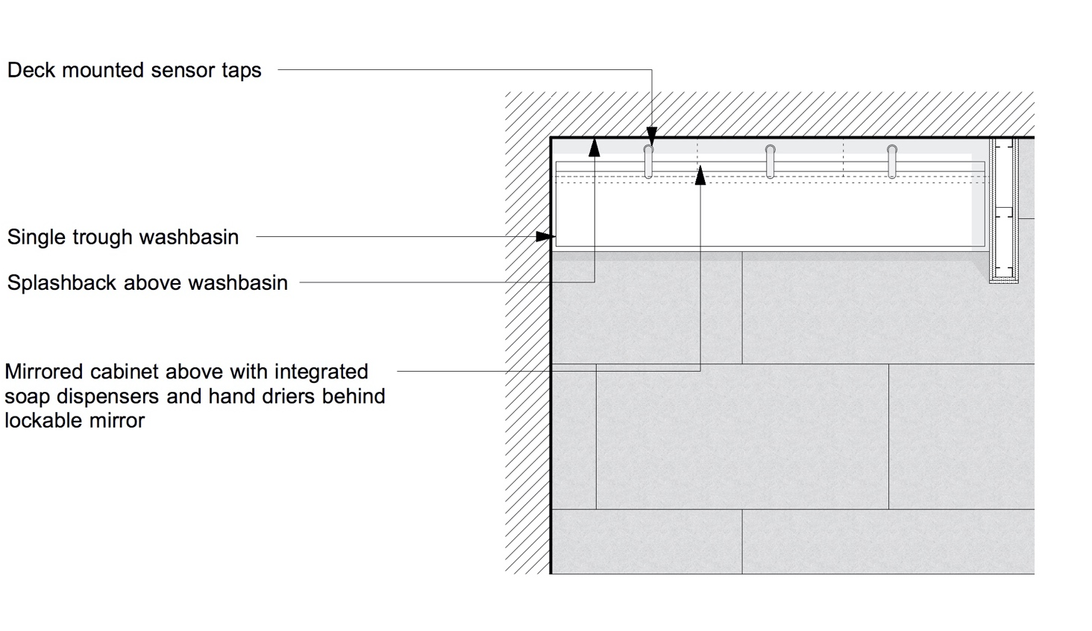
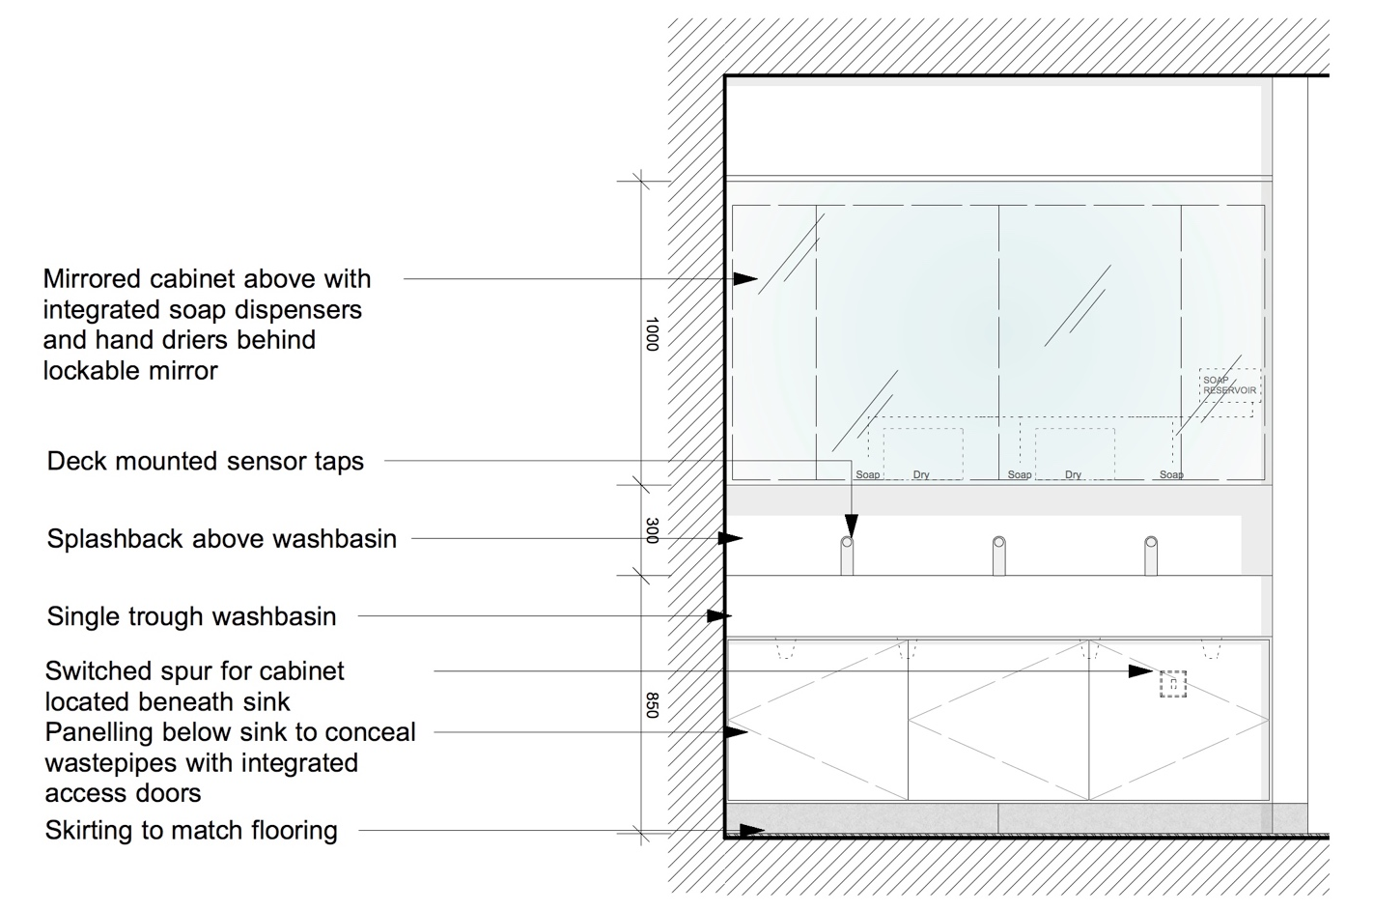
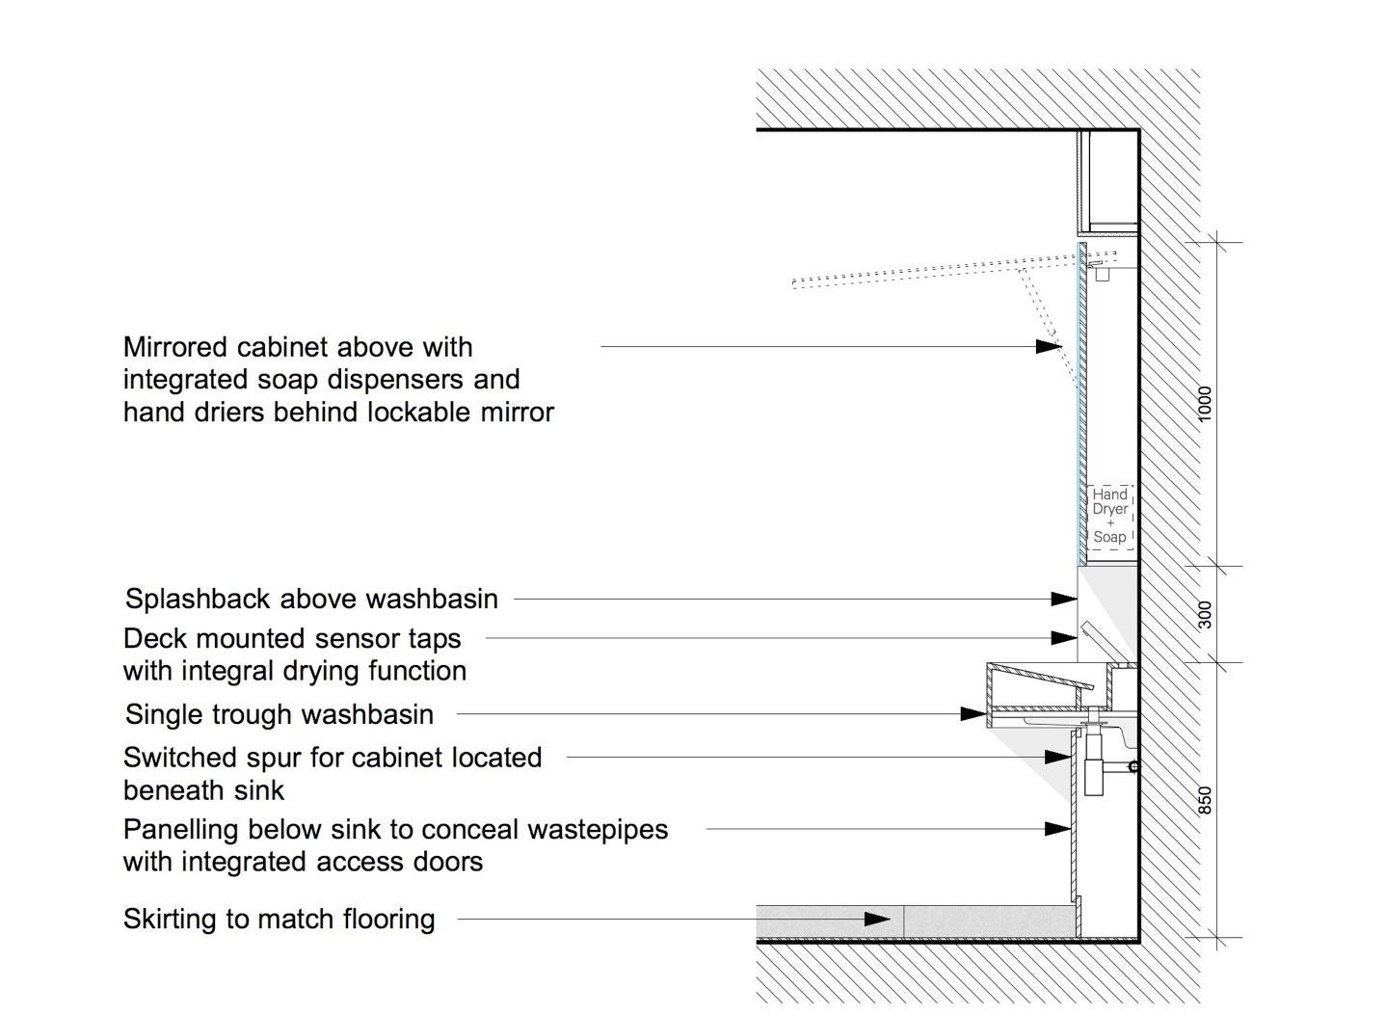
Specification

Washbasin: Washing troughs to communal WCs as NBS clause N13/346

Taps: as NBS clause N13/346

Traps: as NBS clause N13/346

Splashback: 200mm high glass panel lining as NBS clause K13/160

Mirror Unit: Integrated mirror unit N13/439

Floor Finish: Rubber sheeting as NBS clause M50/150
(SS)

Floor Finish: Tiling as NBS clause M40/110
(HD + ES) Where substrate is suitable to receive tiling as NBS clause M40/210 & M40/470

Wall Finish: Plastered masonry and metal stud plasterboard partition walls to be painted as NBS clause M60/110

Ceiling Finish: Suspended MF plasterboard ceiling to be painted as NBS clause M60/110

Suspended ceiling tiles where access to services above is required as NBS clause K40/110

    - Urinals – Option 1
Where washrooms use is concentrated at specific intervals (such as washrooms adjacent to lecture theatres), consideration should be given to providing urinals within male WCs to deal with large numbers of men needing the toilet at the same time.

Where urinals are provided, they should be installed in accordance with BS 6465-2:2017 Sanitary installations Code of Practice for Space Requirements for Sanitary Appliances and be set out at 700mm centres with modesty screens between urinals.

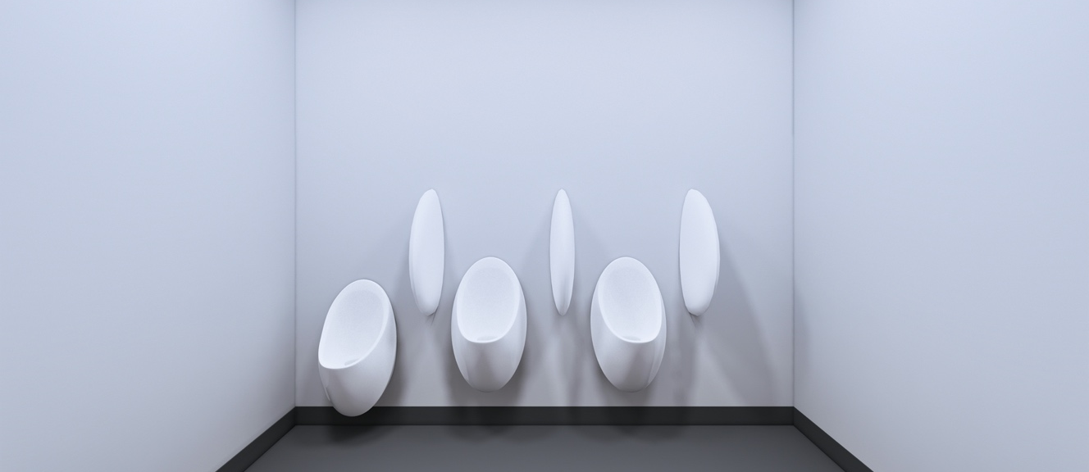
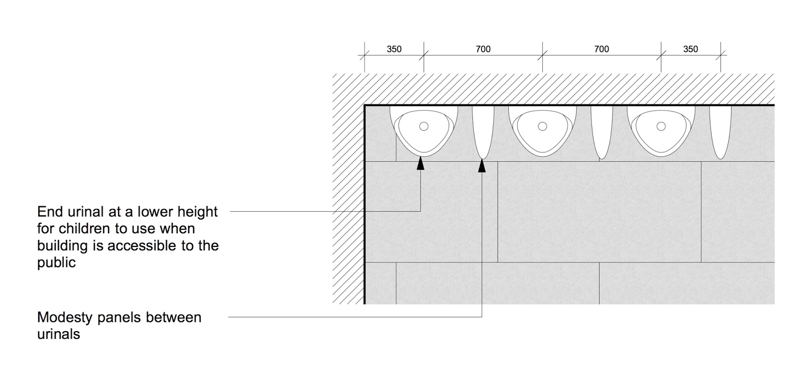

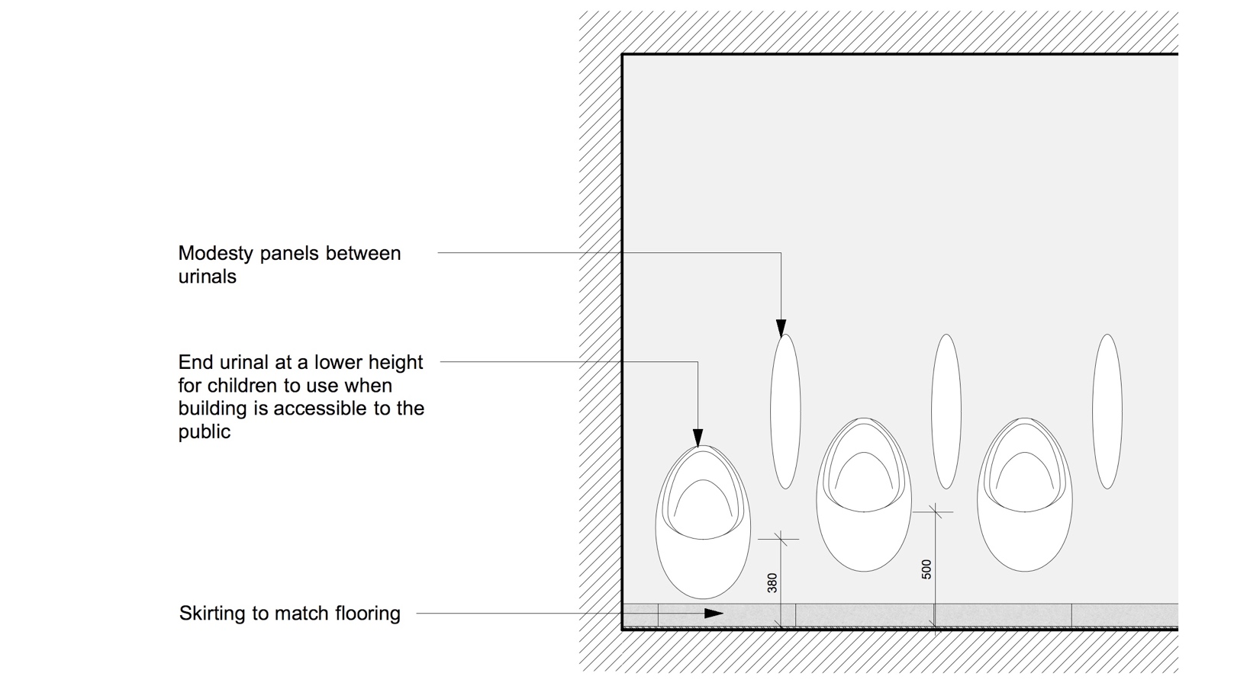

Specification

Urinals: Urinals and auto-flushing cisterns for individual bowls as NBS clause N13/315

Fixings: as NBS clause N13/315

Waste: as NBS clause N13/315

Trap: as NBS clause N13/315

Cistern: as NBS clause N13/315

Actuator: as NBS clause N13/315

Divider: as NBS clause N13/315

Floor Finish: Rubber sheeting as NBS clause M50/150
(SS)

Floor Finish: Tiling as NBS clause M40/110
(HD + ES) Where substrate is suitable to receive tiling as NBS clause M40/210 & M40/470

Wall Finish: Plastered masonry and metal stud plasterboard partition walls to be painted as NBS clause M60/110

Ceiling Finish: Suspended MF plasterboard ceiling to be painted as NBS clause M60/110

Suspended ceiling tiles where access to services above is required as NBS clause K40/110

    - Urinals – Option 2

In some instances, trough urinals may be considered if space is limited, but this should be discussed and agreed with UCL Estates. Trough urinals may be suitable in male WCs adjacent to spaces where WC use is concentrated at specific intervals in order to deal with large numbers of males needing to use the washroom at the same time.

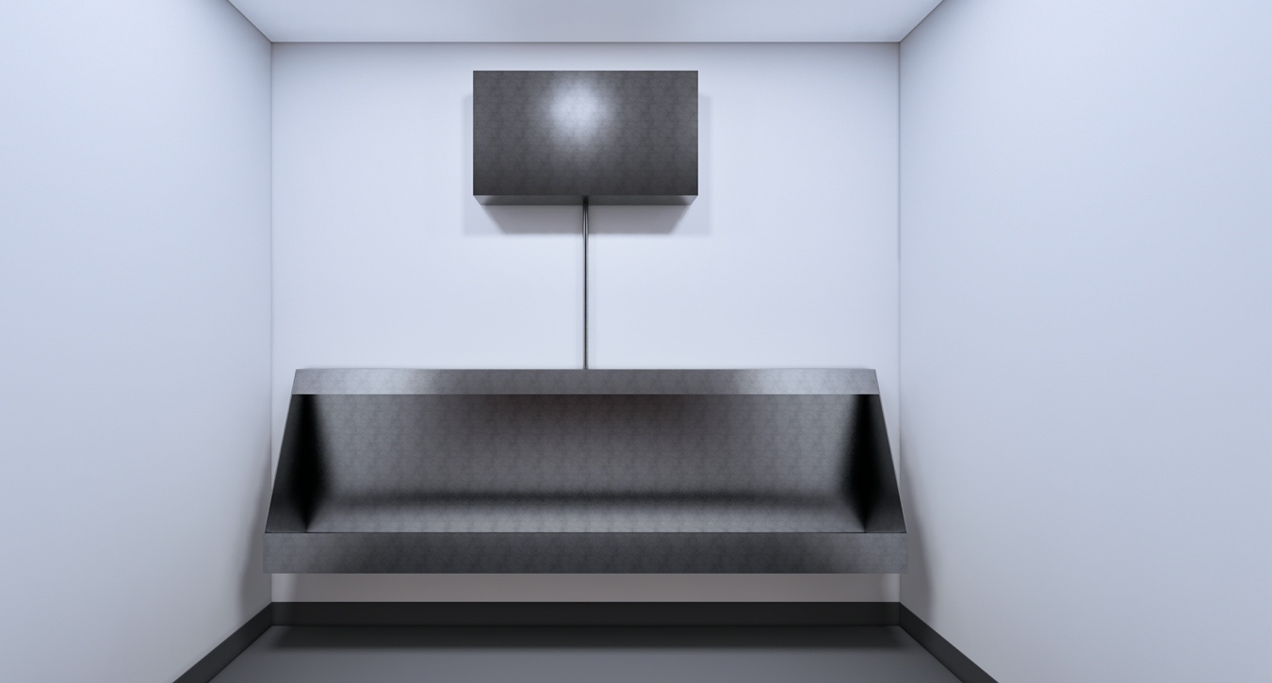

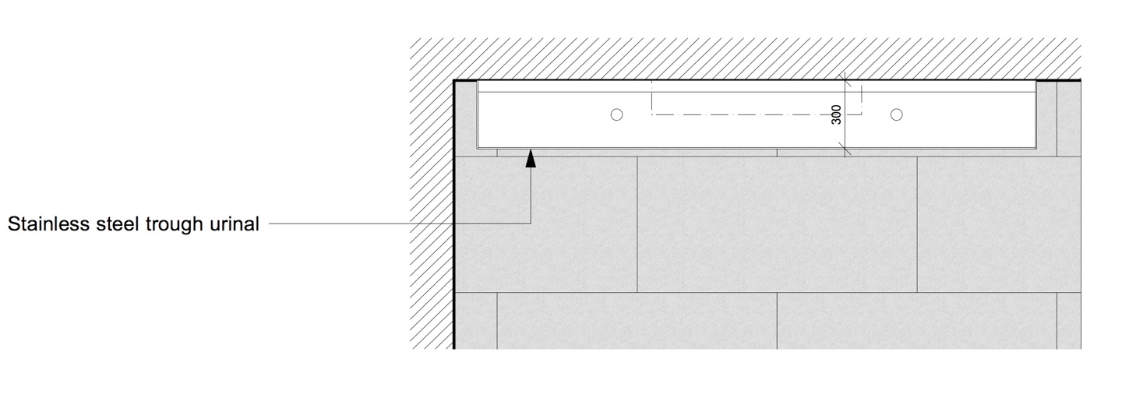

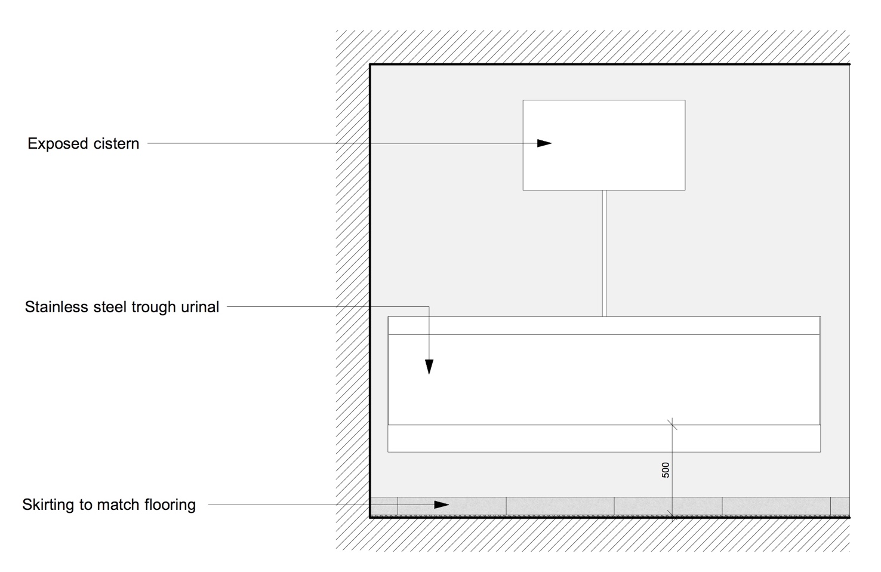

Specification

Urinals: Urinals and auto-flushing cisterns for trough urinals as NBS clause N13/316

Waste: as NBS clause N13/316

Trap: as NBS clause N13/316

Cistern: as NBS clause N13/316

Actuator: as NBS clause N13/316

Floor Finish: Rubber sheeting as NBS clause M50/150
(SS)

Floor Finish: Tiling as NBS clause M40/110
(HD + ES) Where substrate is suitable to receive tiling as NBS clause M40/210 & M40/470

Wall Finish: Plastered masonry and metal stud plasterboard partition walls to be painted as NBS clause M60/110

Ceiling Finish: Suspended MF plasterboard ceiling to be painted as NBS clause M60/110

Suspended ceiling tiles where access to services above is required as NBS clause K40/110

5.1.8 Shower – Option 1 (Level Access)
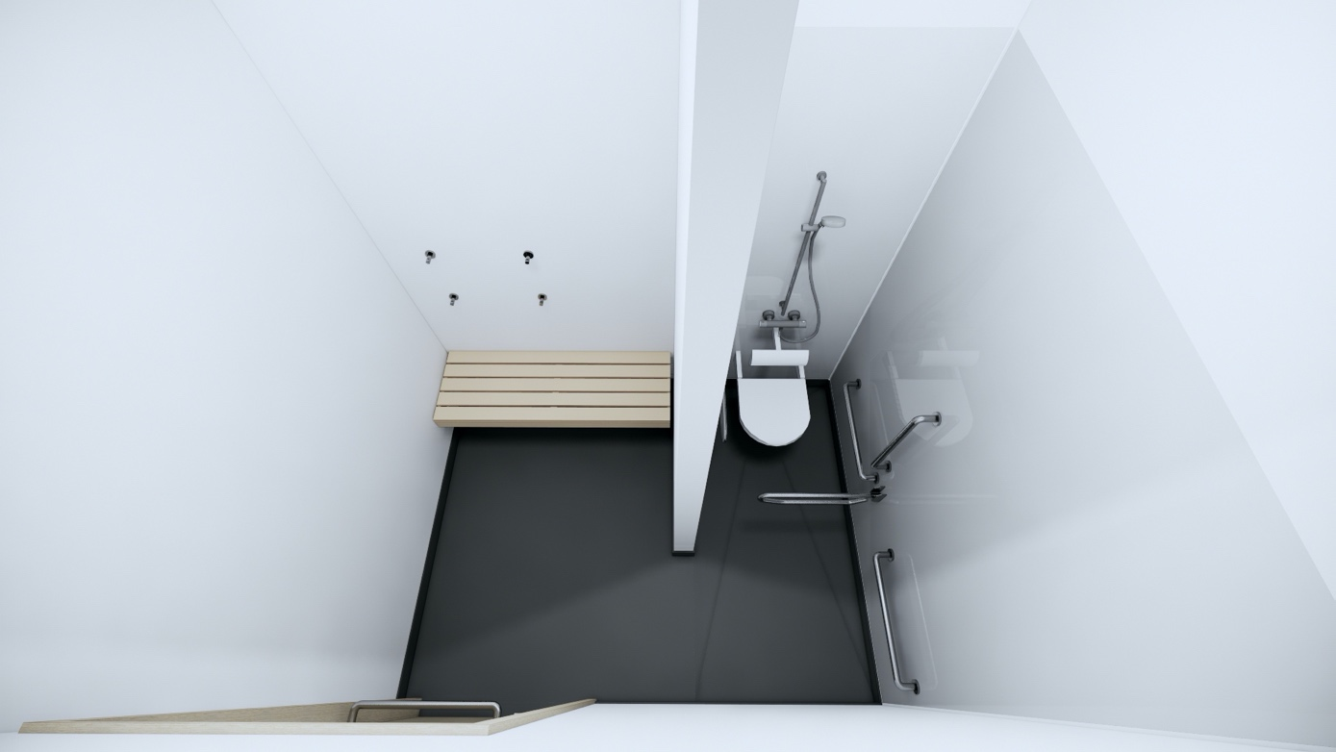

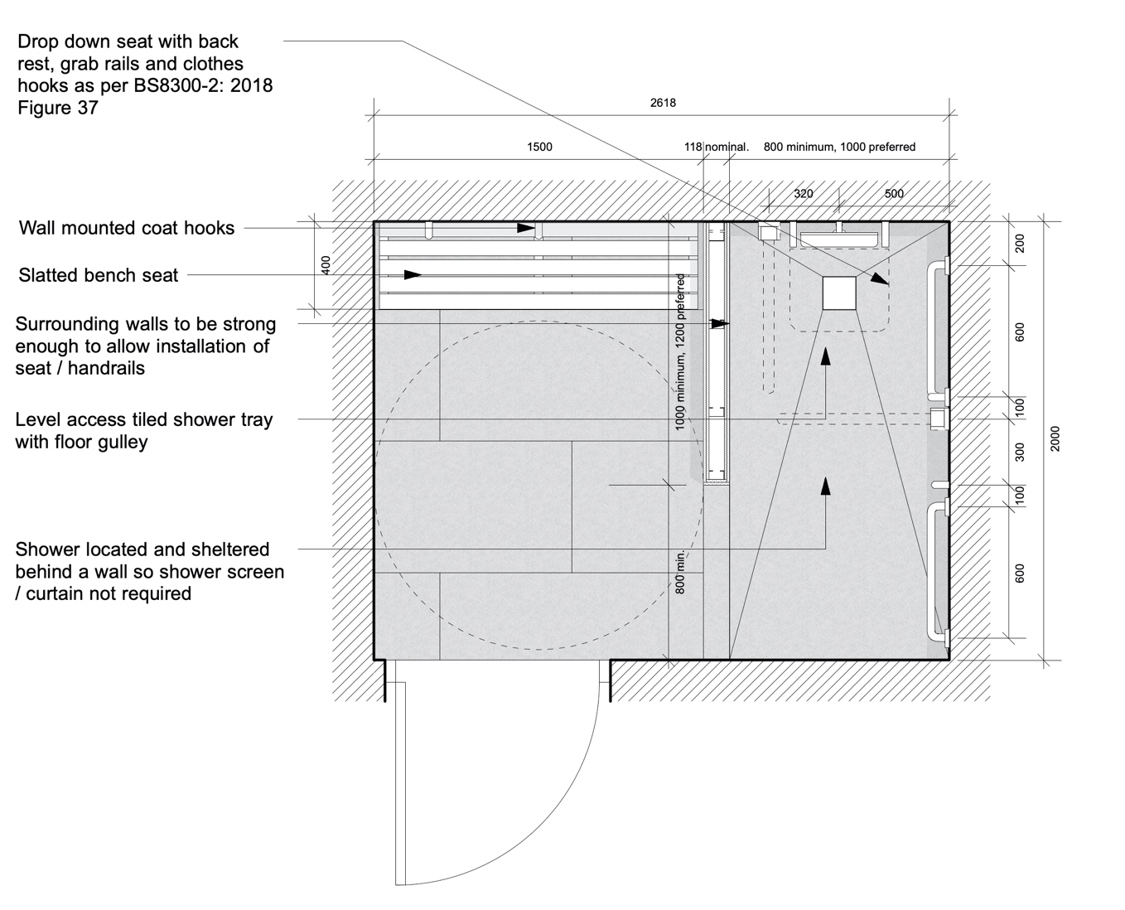
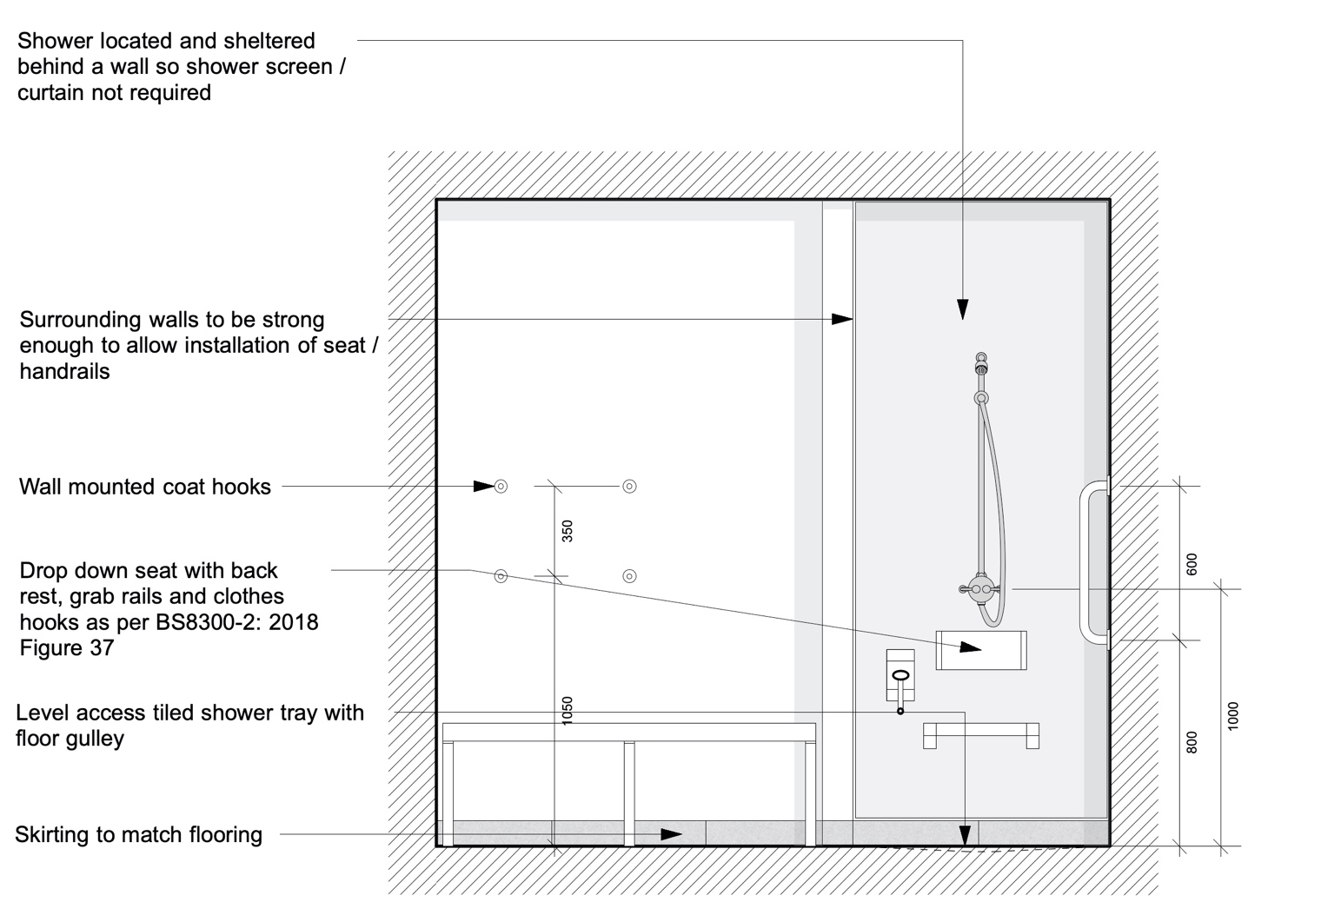

Specification
Floor Finish: Rubber sheeting to shower areas as NBS clause M50/151
(SS)

Floor Finish: Tiling as NBS clause M40/110
(HD + ES) Where substrate is suitable to receive tiling as NBS clause M40/210 & M40/470

Wall Finish: Coved rubber skirting as NBS clause M50/151 & M50/770
(SS)
PVC wall cladding as NBS clause M50/155

In changing area, plastered masonry and metal stud plasterboard partition walls to be painted as NBS clause M60/110

Wall Finish: Skirting tiles as NBS clause M40/110
(HD + ES)
PVC wall cladding as NBS clause M50/155

In changing area, plastered masonry and metal stud plasterboard partition walls to be painted as NBS clause M60/110

Shower Tray: Wet room showers as NBS clause N13/377

Shower: Wet room showers as NBS clause N13/377

Hooks: Clothes hooks as NBS clause N13/429

Lighting: Lighting to be specified in conjunction with the current version of the UCL Design Guidance for Mechanical, Electrical & Public Health Services.

5.1.9 Shower – Option 2 - Non-Accessible (due to drainage)
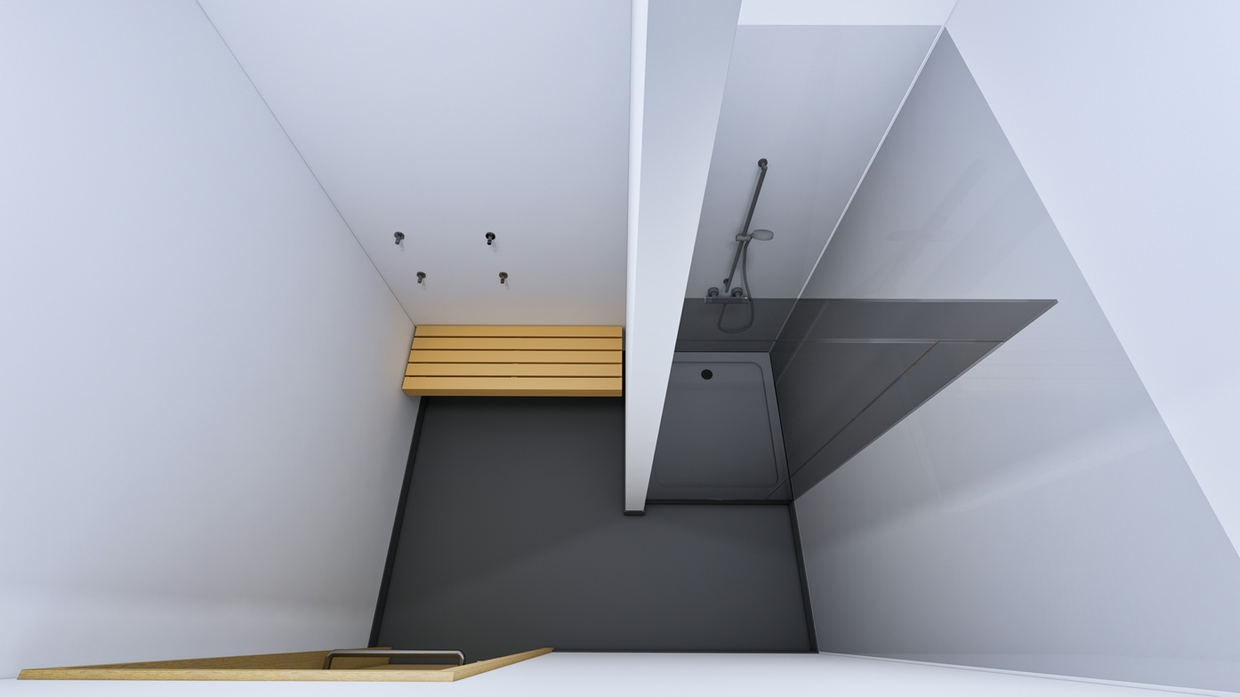
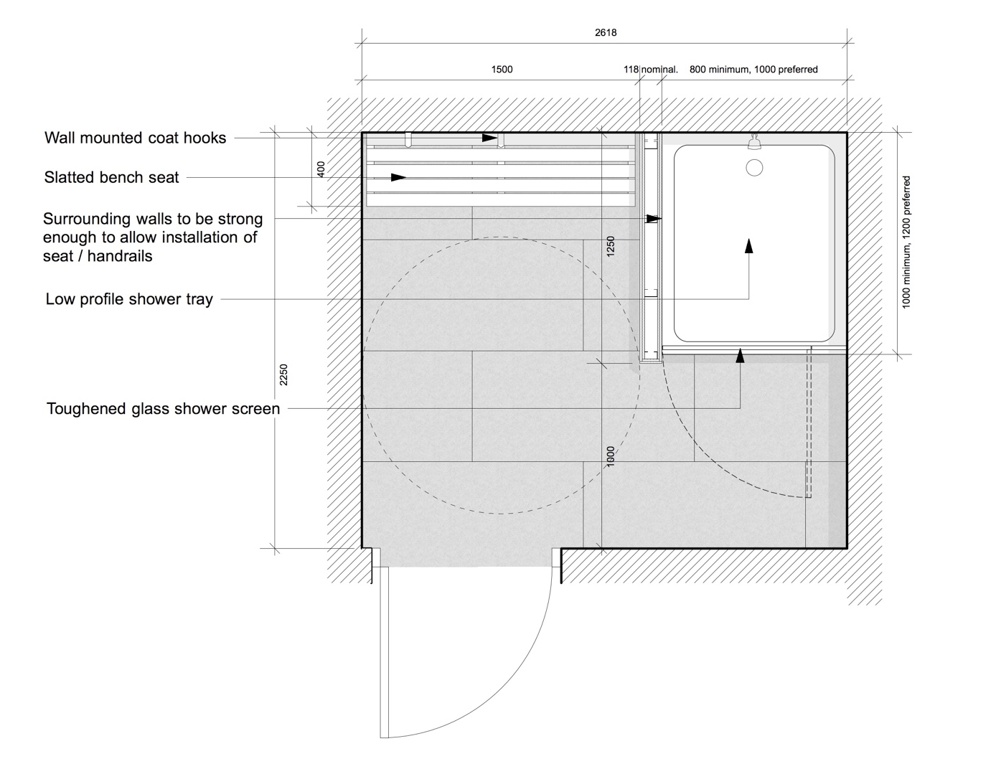
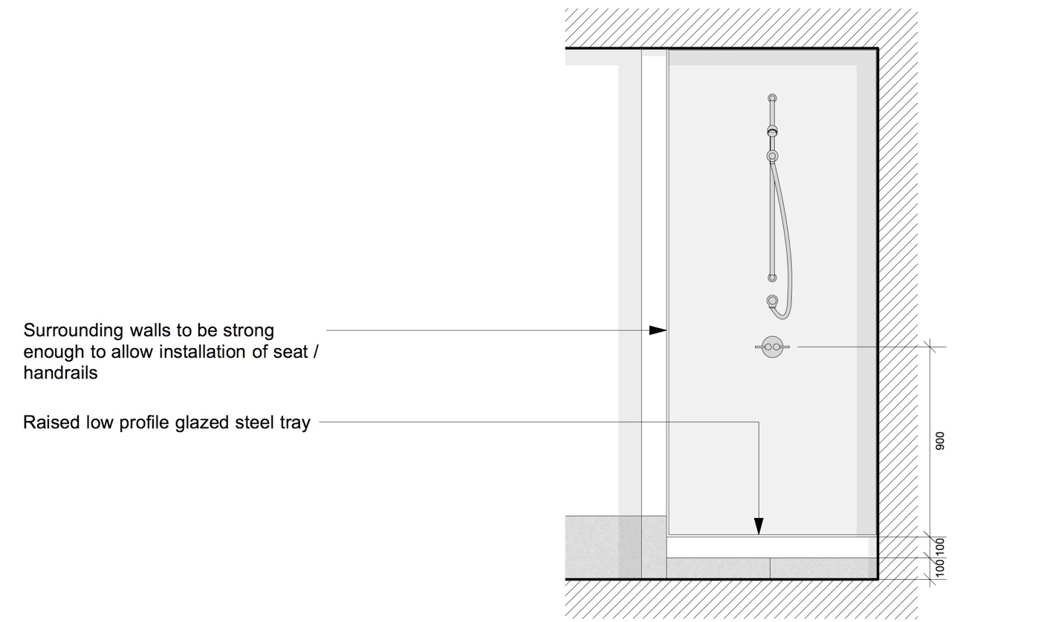
Specification
Floor Finish: Rubber sheeting to shower areas as NBS clause M50/151
(SS)

Floor Finish: Tiling as NBS clause M40/110
(HD + ES) Where substrate is suitable to receive tiling as NBS clause M40/210 & M40/470

Wall Finish: Coved rubber skirting as NBS clause M50/151 & M50/770
(SS)
PVC wall cladding as NBS clause M50/155

In changing area, plastered masonry and metal stud plasterboard partition walls to be painted as NBS clause M60/110

Wall Finish: Skirting tiles as NBS clause M40/110
(HD + ES)
PVC wall cladding as NBS clause M50/155

In changing area, plastered masonry and metal stud plasterboard partition walls to be painted as NBS clause M60/110

Shower Tray: Low profile shower tray as NBS clause N13/378

Shower: as NBS clause N13/378

Screen: as NBS clause N13/378

Hooks: Clothes hooks as NBS clause N13/429

Lighting: Lighting to be specified in conjunction with the current version of the UCL Design Guidance for Mechanical, Electrical & Public Health Services.

  - Gender Neutral Washrooms
Gender Neutral washrooms are used by all regardless of gender identity, and consequently, providing high levels of acoustic separation and privacy between toilet cubicles is important if people are to feel comfortable. For this reason, partition dividing walls are preferred rather than a cubicle type system as these offer greater sound reduction. This type of installation should not sacrifice the number of existing facilities provided unless the building has additional capacity elsewhere within the building.
In this arrangement, washbasins are provided within the WC cubicles so that people can wash their hands before exiting the WC cubicle and entering the shared communal space. This arrangement requires more space per individual cubicle, and the cubicle size will depend on the design. The additional space required within the cubicles is often offset by not needing a communal washing area. The typical cubicle size required for this arrangement is 1200mm wide x 1680mm long.

5.2.1 Option 1

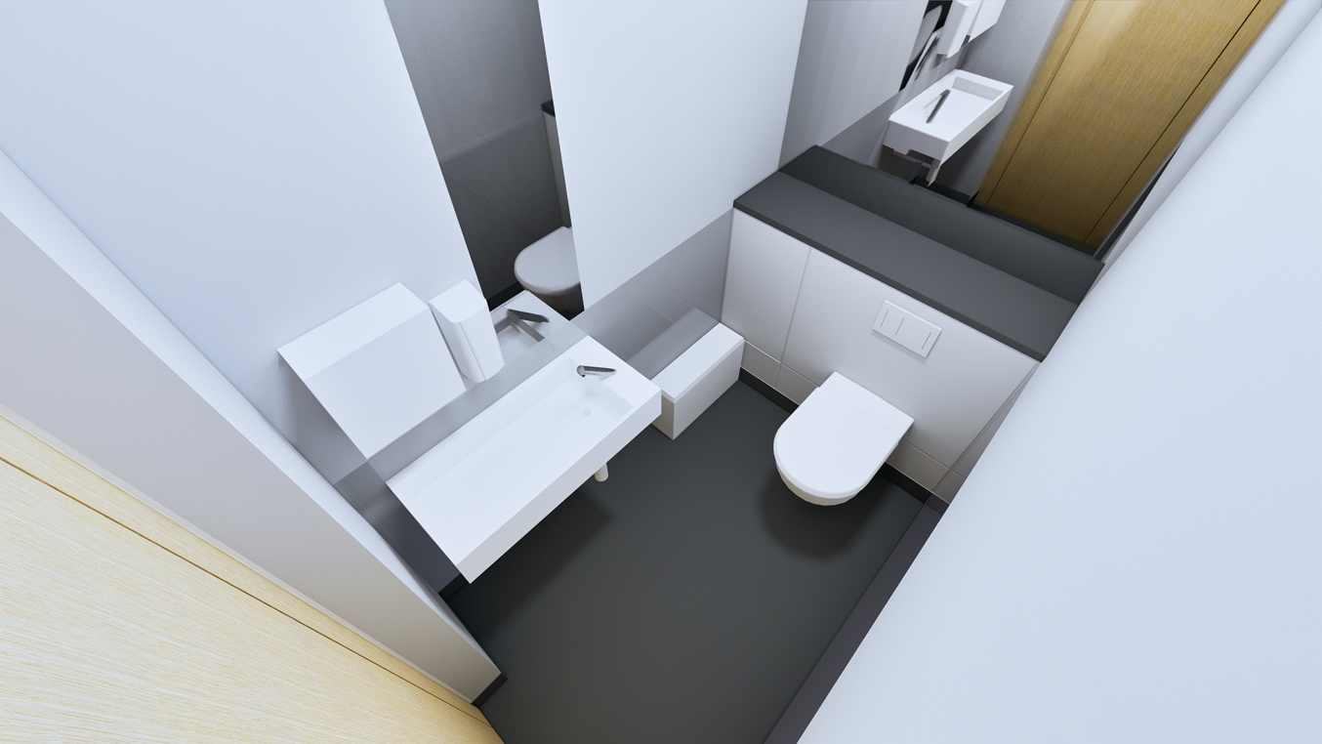

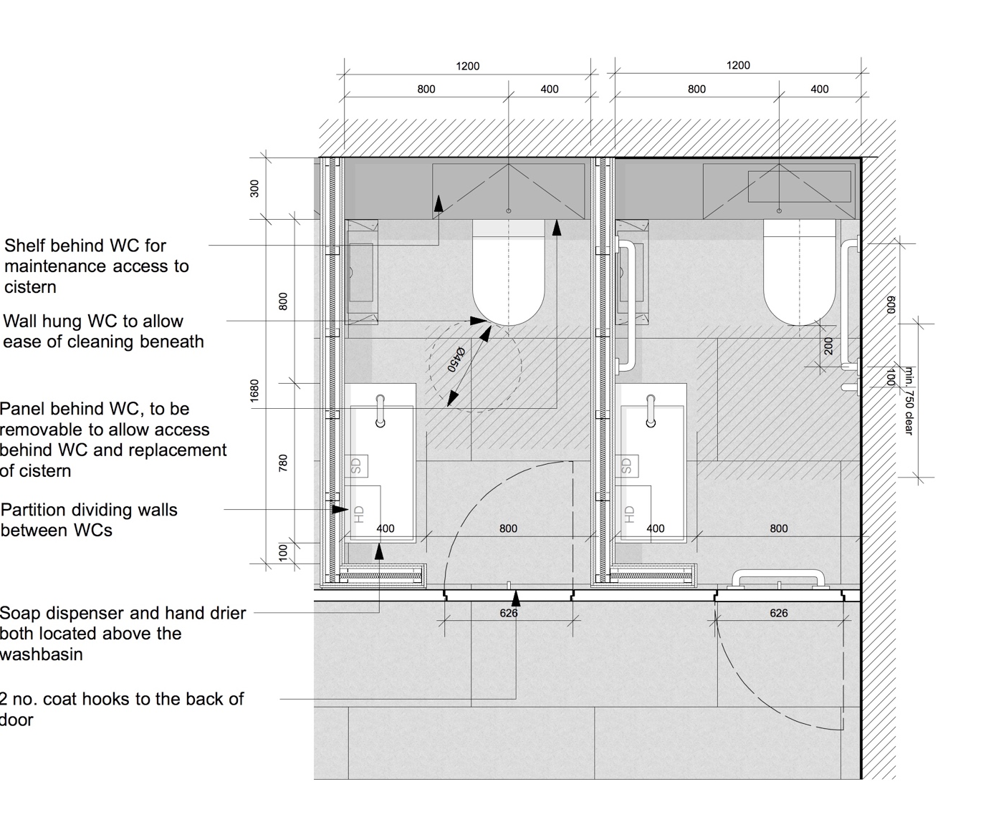
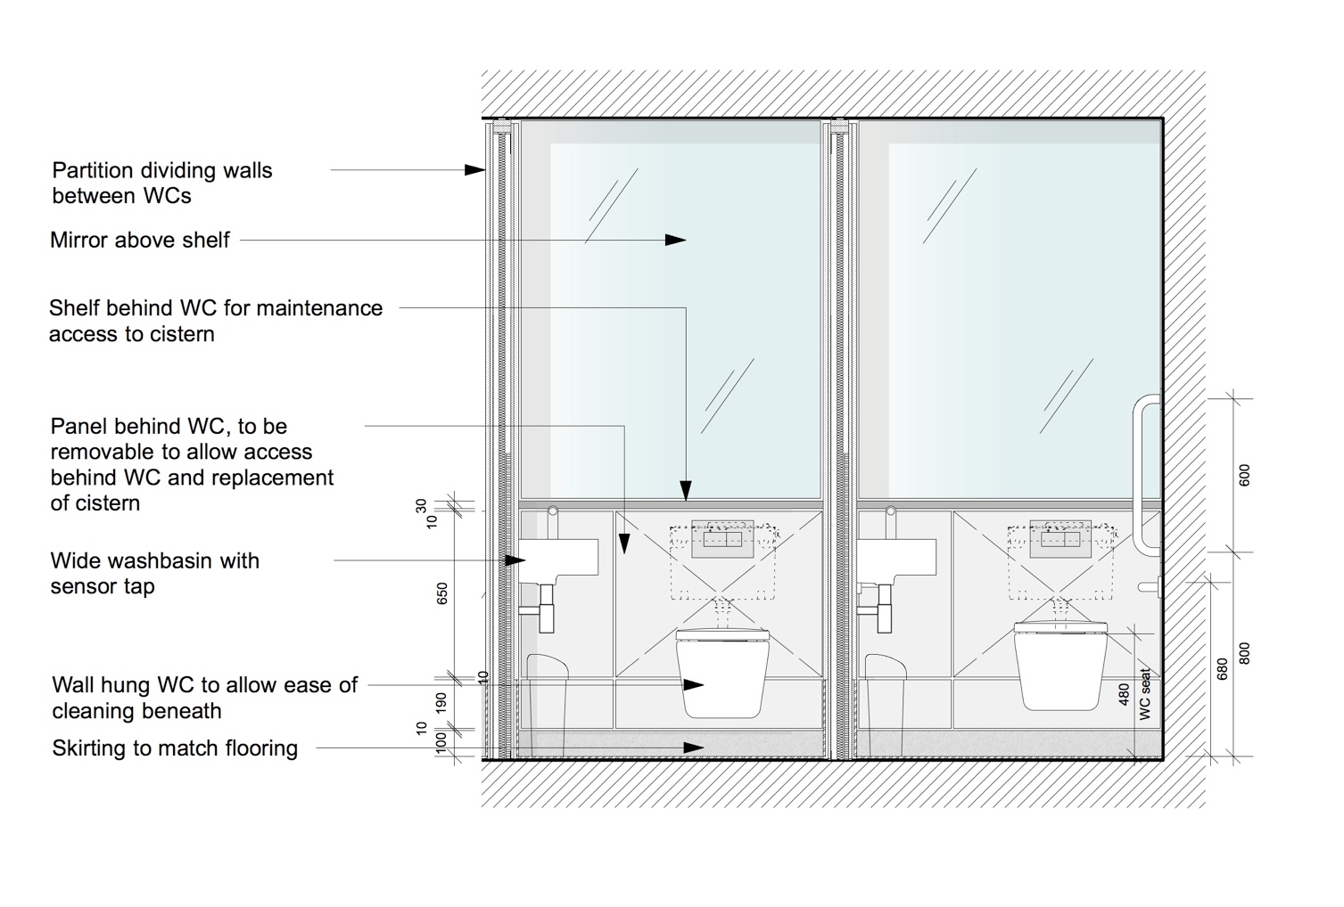
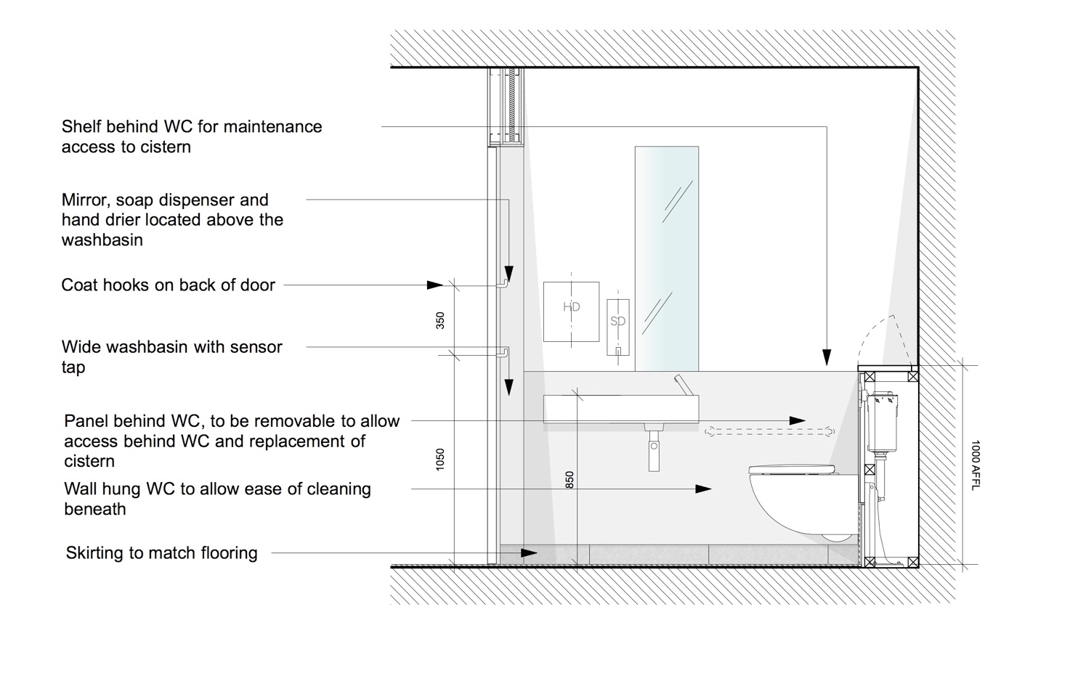

Specification
Floor Finish: Rubber sheeting as NBS clause M50/150
(SS)

Floor Finish: Tiling as NBS clause M40/110
(HD + ES) Where substrate is suitable to receive tiling as NBS clause M40/210 & M40/470

Wall Finish: Plastered masonry and metal stud plasterboard partition walls to be painted as NBS clause M60/110

Ceiling Finish: Suspended MF plasterboard ceiling to be painted as NBS clause M60/110

Suspended ceiling tiles where access to services above is required as NBS clause K40/110

WC Wall: Coved rubber skirting as NBS clause M50/150 & M50/770
(SS)
Accessible duct wall lining above skirting to 1000mm AFFL with hinged shelf as NBS clause K32/140

Mirror as NBS clause N13/438

WC Wall: Skirting tiles as NBS clause M40/110
(HD + ES)
Glass panel accessible duct lining above skirting up to 1000mm AFFL with hinged Corian shelf as NBS clause K13/161

Mirror as NBS clause N13/438

WC Pan: WC to standard WCs as NBS clause N13/300

WC to ambulant WCs as NBS clause N13/301

WC Seat: Seat and cover to standard WCs as NBS clause N13/300

Seat and cover to ambulant WCs as NBS clause N13/301

WC Cistern: Cistern to standard WCs as NBS clause N13/300

Cistern to ambulant WCs as NBS clause N13/301

WC Actuator: Flushing arrangement to standard WCs as NBS clause N13/300

Flushing arrangement to ambulant WCs as NBS clause N13/301

Toilet paper disp: Toilet roll dispenser as NBS clause N13/441

Single sheet toilet paper dispenser as NBS clause N13/440

Sanitary Bin: Sanitary towel disposal bins as NBS clause N13/446

Hooks: Clothes hooks as NBS clause N13/429

Grab Rails: Handrails and grab bars for ambulant cubicles as NBS clause N13/436

Side Walls: Coved rubber skirting as NBS clause M50/150 & M50/770
(SS)
Glass panel lining up to 1000mm AFFL and flush with wall surface above, as NBS clause K13/160

Side Walls: Skirting tiles as NBS clause M40/110
(HD + ES)
Glass panel lining up to 1000mm AFFL and flush with wall surface above, as NBS clause K13/160

Wash Basin: Washbasins to gender neutral washrooms as NBS clause N13/335

Taps: as NBS clause N13/335

Traps: as NBS clause N13/335

Mirror: Mirror as NBS clause N13/438

Soap Dispensers: as NBS clause N13/458

Hand Driers: as NBS clause N13/472

Lighting: Lighting to be specified in conjunction with the current version of the UCL Design Guidance for Mechanical, Electrical & Public Health Services.
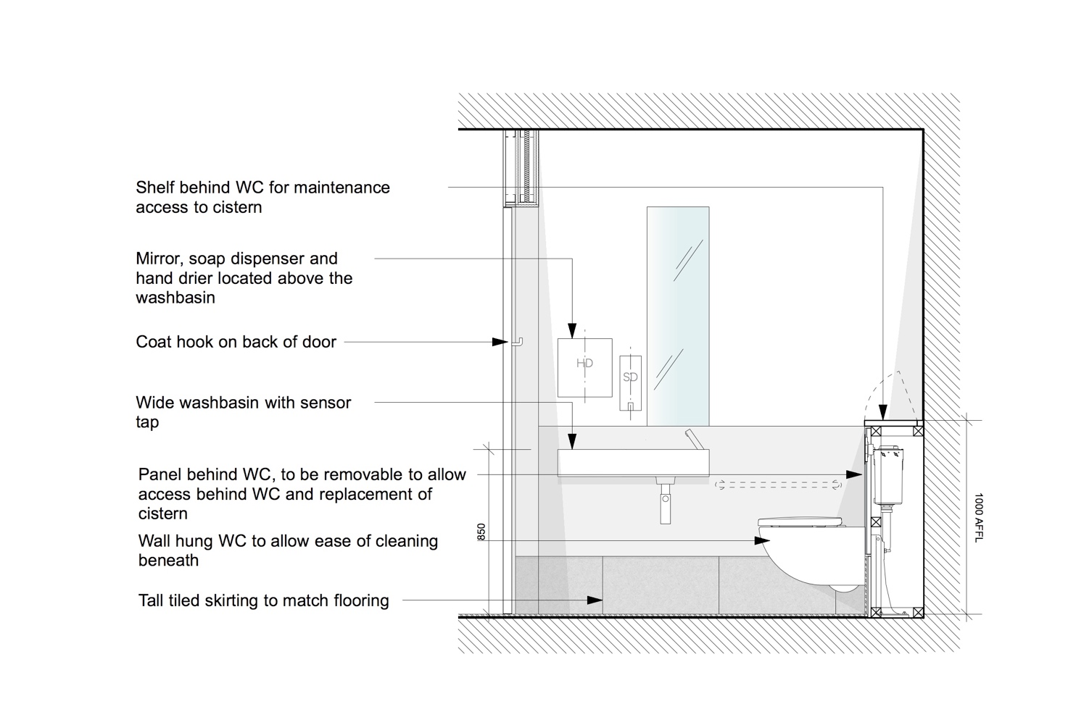
5.2.2 Option 2
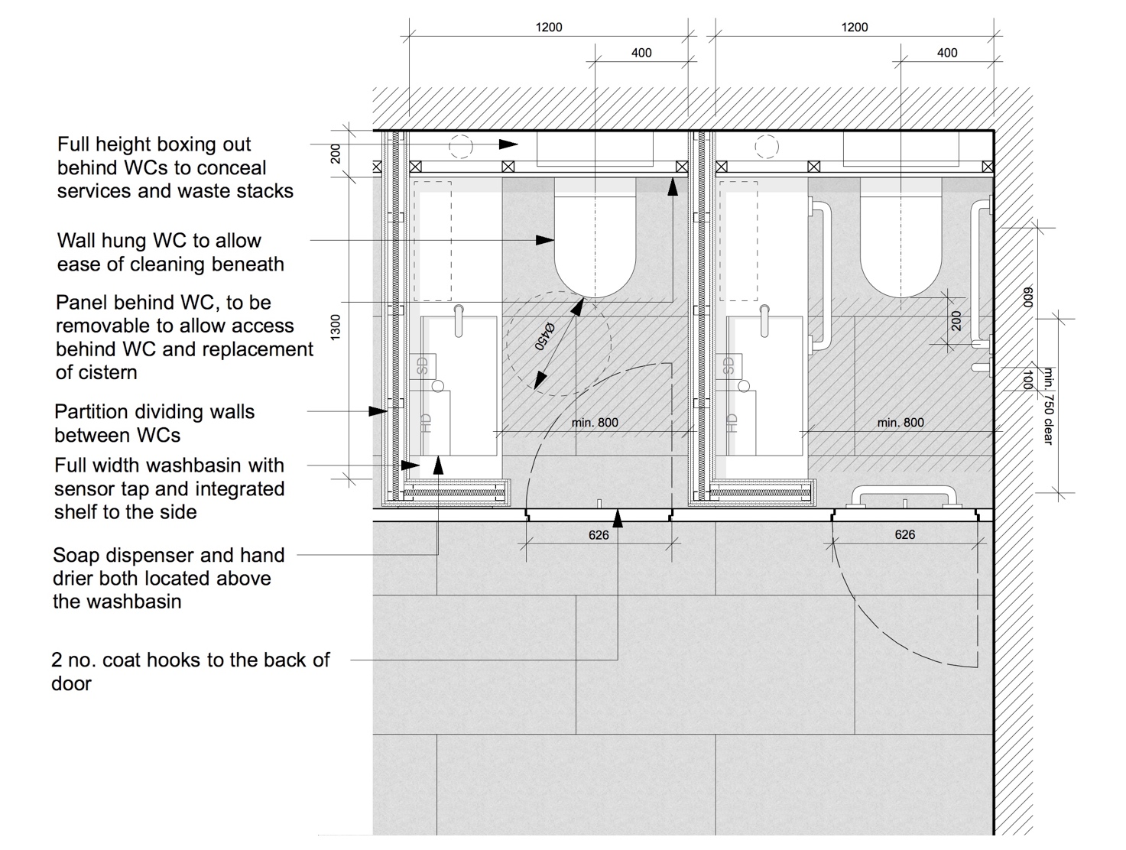
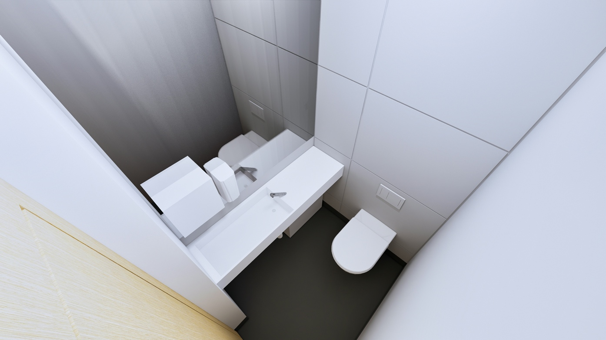
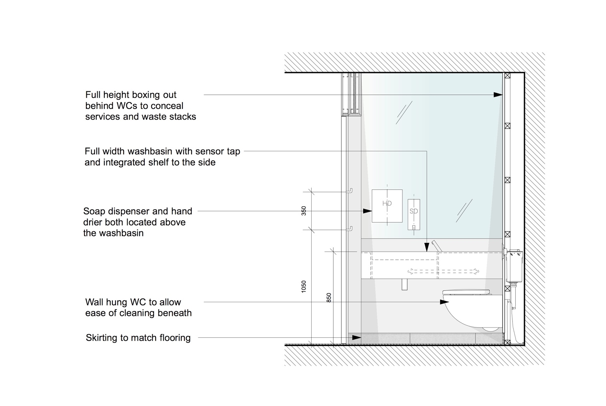
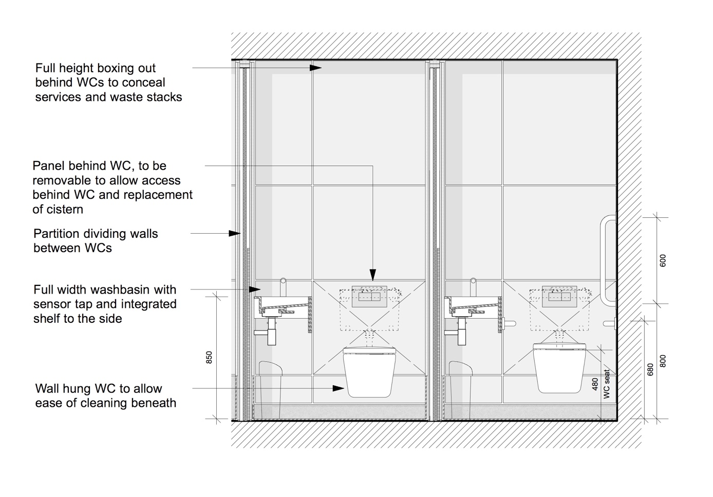

Specification

Floor Finish: Rubber sheeting as NBS clause M50/150
(SS)

Floor Finish: Tiling as NBS clause M40/110
(HD + ES) Where substrate is suitable to receive tiling as NBS clause M40/210 & M40/470

Wall Finish: Plastered masonry and metal stud plasterboard partition walls to be painted as NBS clause M60/110

Ceiling Finish: Suspended MF plasterboard ceiling to be painted as NBS clause M60/110

Suspended ceiling tiles where access to services above is required as NBS clause K40/110

WC Wall: Coved rubber skirting as NBS clause M50/150 & M50/770
(SS)
Accessible duct wall lining above skirting to full height as NBS clause K32/140

WC Wall: Skirting tiles as NBS clause M40/110
(HD + ES)
Glass panel lining to full height as NBS clause K13/161

WC Pan: WC to standard WCs as NBS clause N13/300

WC to ambulant WCs as NBS clause N13/301

WC Seat: Seat and cover to standard WCs as NBS clause N13/300

Seat and cover to ambulant WCs as NBS clause N13/301

WC Cistern: Cistern to standard WCs as NBS clause N13/300

Cistern to ambulant WCs as NBS clause N13/301

WC Actuator: Flushing arrangement to standard WCs as NBS clause N13/300

Flushing arrangement to ambulant WCs as NBS clause N13/301

Toilet paper disp: Toilet roll dispenser as NBS clause N13/441

Single sheet toilet paper dispenser as NBS clause N13/440

Sanitary Bin: Sanitary towel disposal bins as NBS clause N13/446

Hooks: Clothes hooks as NBS clause N13/429

Grab Rails: Handrails and grab bars for ambulant cubicles as NBS clause N13/436

Side Walls: Coved rubber skirting as NBS clause M50/150 & M50/770
(SS)
Glass panel lining up to 1000mm AFFL and flush with wall surface above, as NBS clause K13/160

Side Walls: Skirting tiles as NBS clause M40/110
(HD + ES)
Glass panel lining up to 1000mm AFFL and flush with wall surface above, as NBS clause K13/160

Wash Basin: Washbasins to gender neutral washrooms as NBS clause N13/336

Taps: as NBS clause N13/336

Traps: as NBS clause N13/336

Mirror: Mirror as NBS clause N13/438

Soap Dispensers: as NBS clause N13/458

Hand Driers: as NBS clause N13/472

Lighting: Lighting to be specified in conjunction with the current version of the UCL Design Guidance for Mechanical, Electrical & Public Health Services.

5.3 Accessible Washrooms
Washrooms should be provided for wheelchair users, ambulant disabled people and people of either sex with babies or small children in accordance with Building Regulations Approved Document M Section 5 “Sanitary accommodation in buildings other than dwellings” and BS8300 Volume 2 Buildings – code of practice, “Design of an accessible and inclusive built environment.”.
5.3.1 Wheelchair Accessible WC
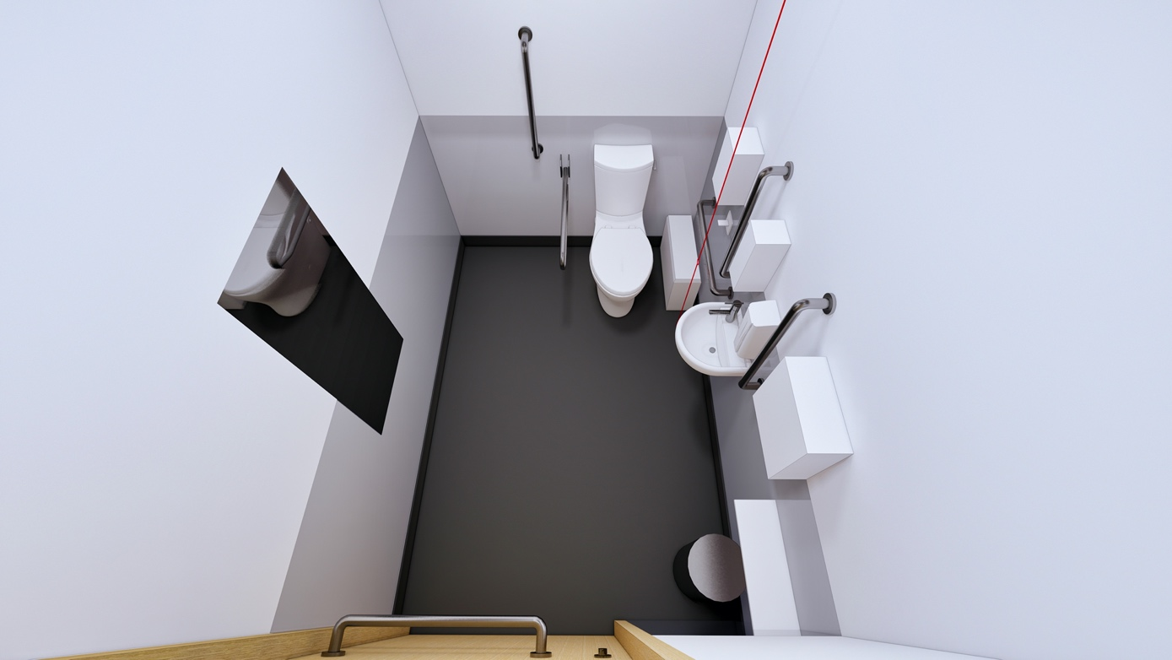

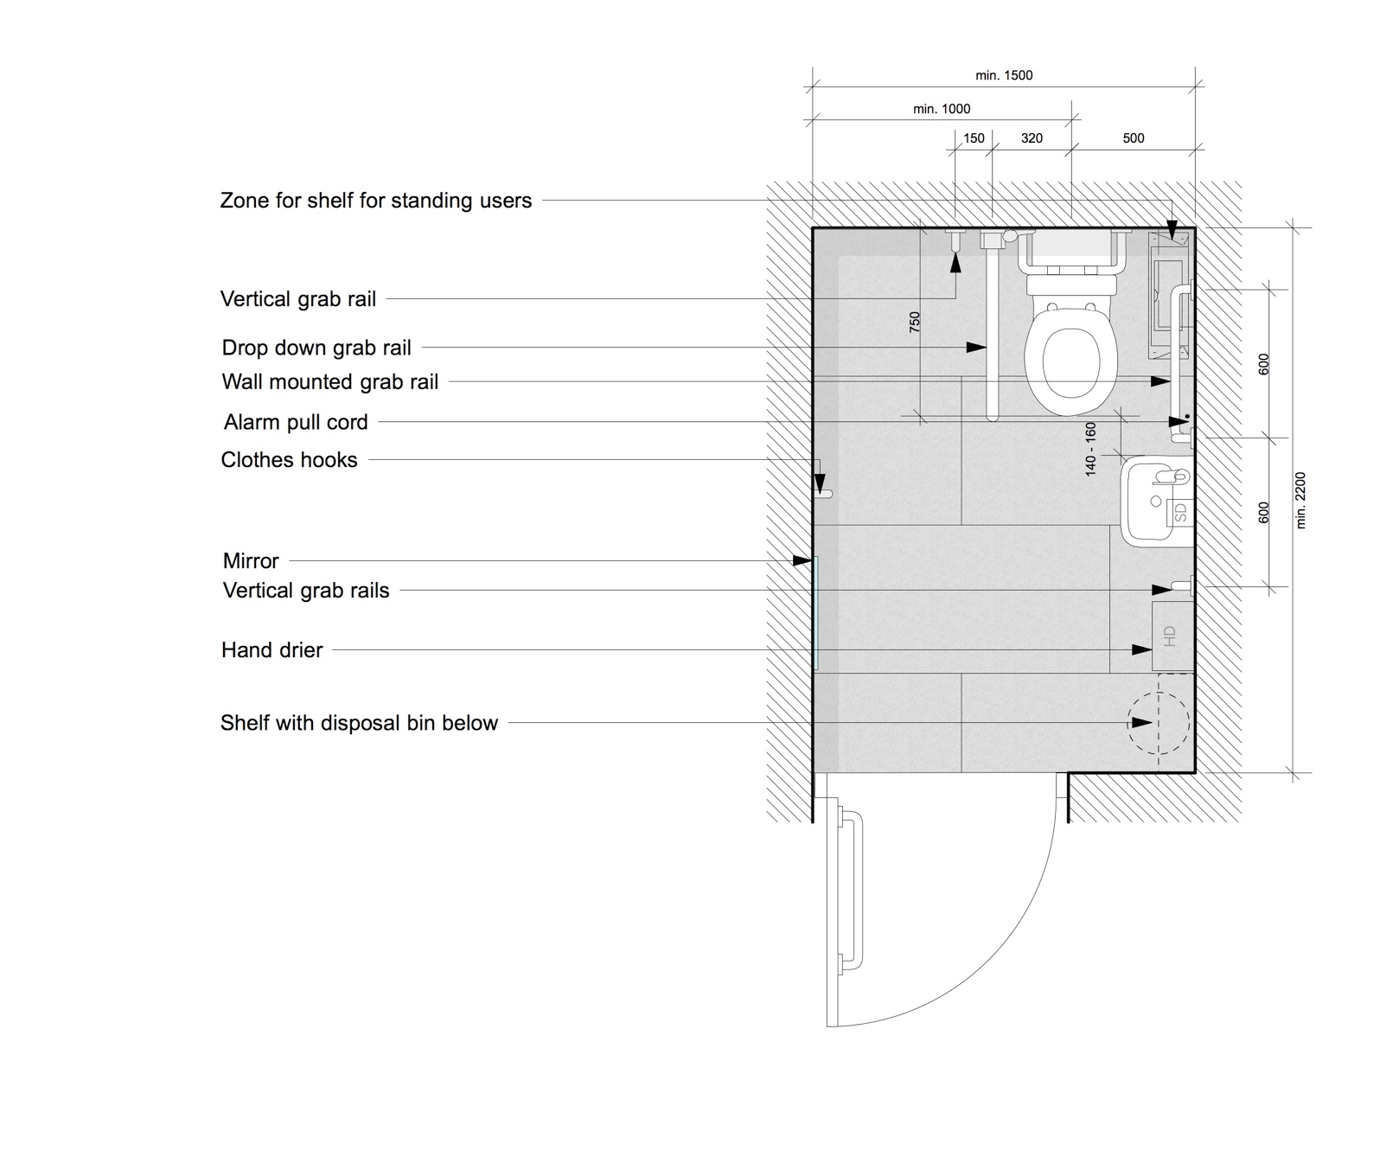
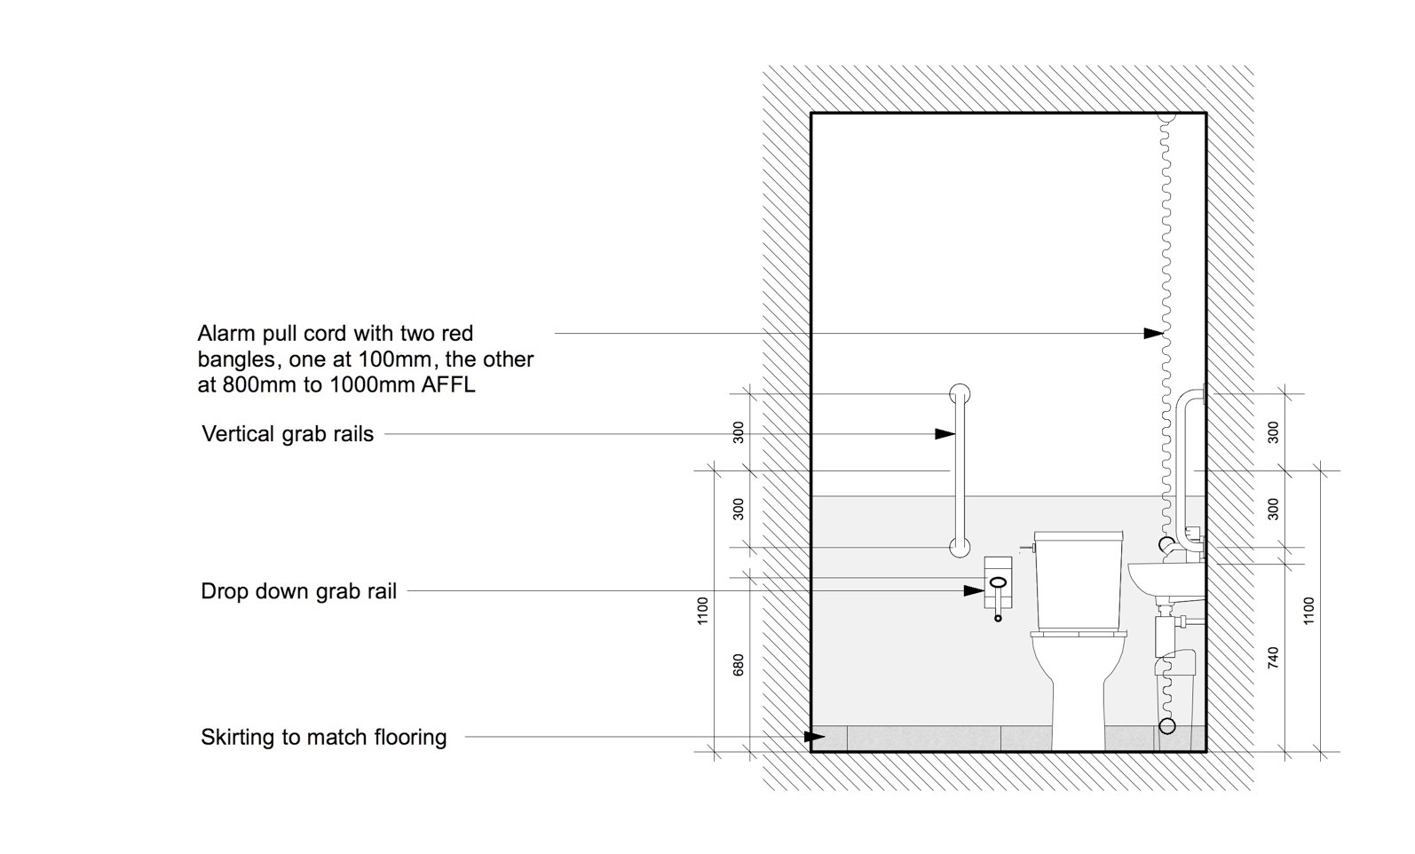
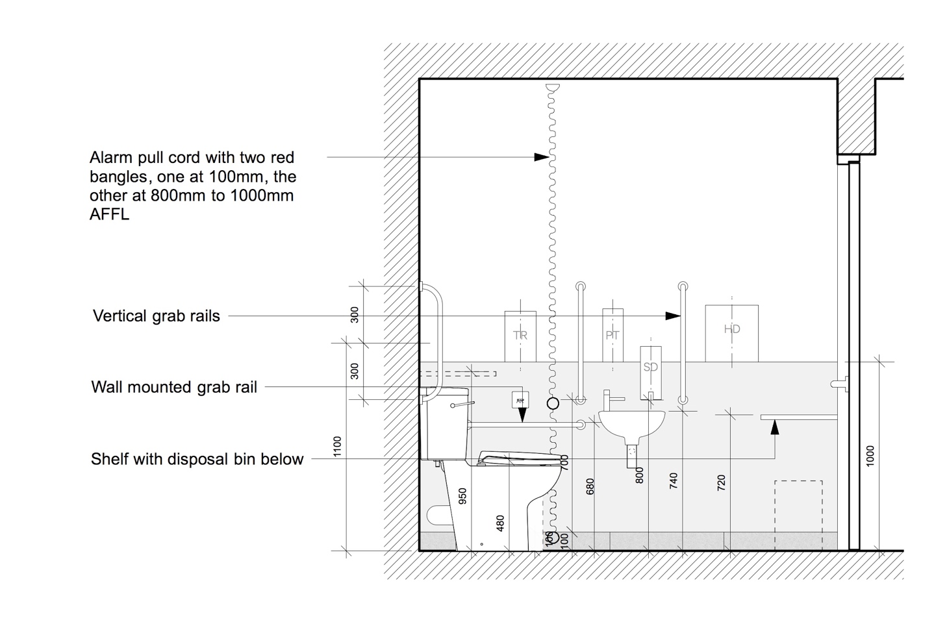
Specification
Floor Finish: Rubber sheeting as NBS clause M50/150
(SS)

Floor Finish: Tiling as NBS clause M40/110
(HD + ES) Where substrate is suitable to receive tiling as NBS clause M40/210 & M40/470

Wall Finish: Coved rubber skirting as NBS clause M50/150 & M50/770
(SS)
Glass panel lining up to 1000mm AFFL and flush with wall surface above, as NBS clause K13/160

Plastered masonry and metal stud plasterboard partition walls
to be painted as NBS clause M60/110

Wall Finish: Skirting tiles as NBS clause M40/110
(HD + ES)
Glass panel lining up to 1000mm AFFL and flush with wall surface above, as NBS clause K13/160

Plastered masonry and metal stud plasterboard partition walls
to be painted as NBS clause M60/110

Ceiling Finish: Suspended MF plasterboard ceiling to be painted as NBS clause M60/110

Suspended ceiling tiles where access to services above is required as NBS clause K40/110

Doc M Pack: Unisex accessible corner WC equipment as NBS clause N13/311

Toilet paper disp: Single sheet toilet paper dispenser as NBS clause N13/440

Sanitary Bin: Sanitary towel disposal bins as NBS clause N13/446

Hooks: Clothes hooks as NBS clause N13/429

Soap Dispensers: as NBS clause N13/458

Hand Driers: as NBS clause N13/472

Paper towel disp: as NBS clause N13/442

Mirror: Mirror as NBS clause N13/438

Lighting: Lighting to be specified in conjunction with the current version of the UCL Design Guidance for Mechanical, Electrical & Public Health Services.
5.3.2 Accessible Baby Changing
Fully inclusive baby changing facilities should be provided for wheelchair users, ambulant disabled people and people of either sex with babies or small children in accordance with Building Regulations Approved Document M Section 5 “Sanitary accommodation in buildings other than dwellings” and BS8300 Volume 2 Buildings – code of practice, “Design of an accessible and inclusive built environment.”.

These facilities should be separate from the WCs.

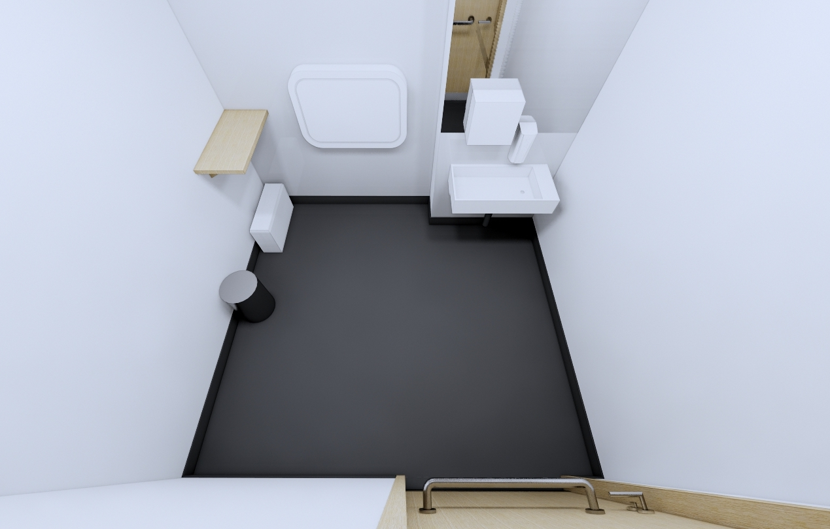
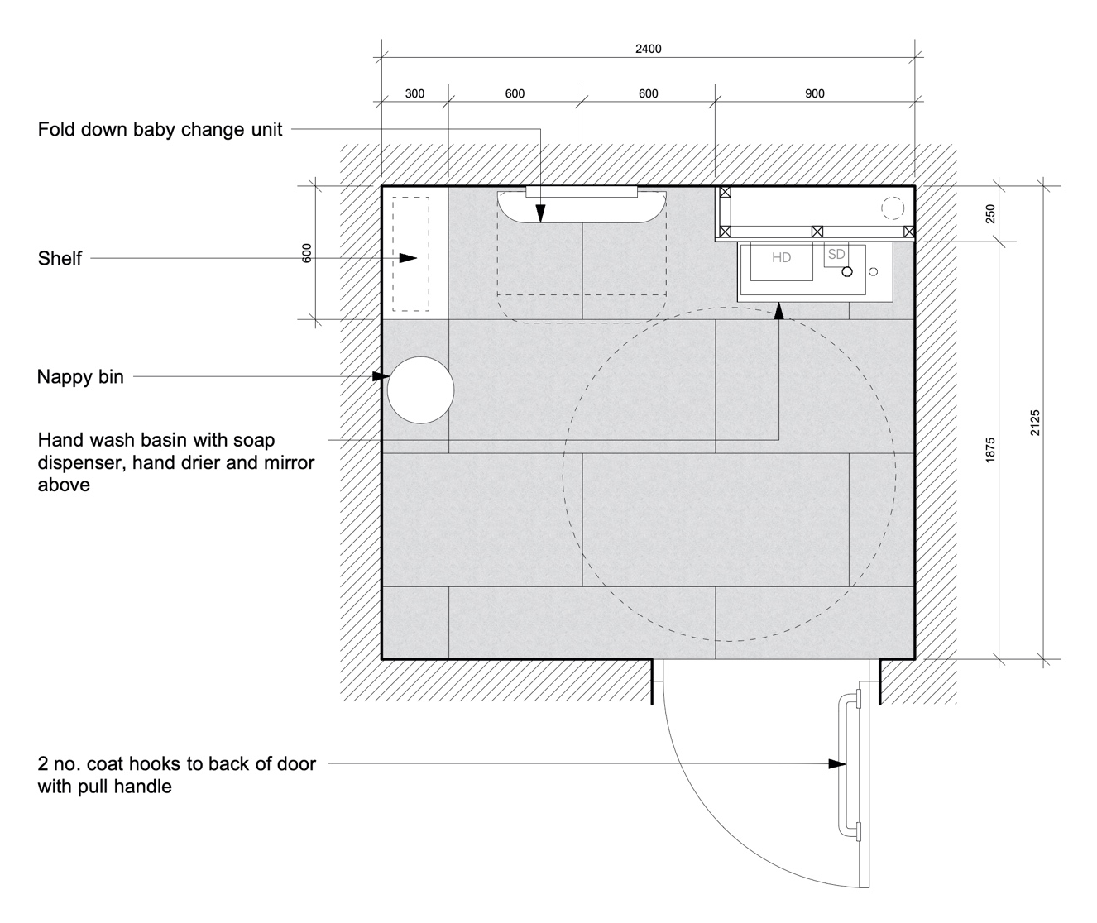
Specification
Floor Finish: Rubber sheeting as NBS clause M50/150
(SS)

Floor Finish: Tiling as NBS clause M40/110
(HD + ES) Where substrate is suitable to receive tiling as NBS clause M40/210 & M40/470

Wall Finish: Coved rubber skirting as NBS clause M50/150 & M50/770
(SS)
Glass panel lining up to 1000mm AFFL and flush with wall surface above, as NBS clause K13/160

Plastered masonry and metal stud plasterboard partition walls
to be painted as NBS clause M60/110

Wall Finish: Skirting tiles as NBS clause M40/110
(HD + ES)
Glass panel lining up to 1000mm AFFL and flush with wall surface above, as NBS clause K13/160

Plastered masonry and metal stud plasterboard partition walls
to be painted as NBS clause M60/110

Ceiling Finish: Suspended MF plasterboard ceiling to be painted as NBS clause M60/110

Suspended ceiling tiles where access to services above is required as NBS clause K40/110

Changer: Changing benches to baby change facilities as NBS clause N13/488

Wash Basin: as NBS clause N13/335

Taps: as NBS clause N13/335

Traps: as NBS clause N13/335

Mirror: Mirror as NBS clause N13/438

Soap Dispensers: as NBS clause N13/458

Hand Driers: as NBS clause N13/472

Sanitary Bin: Sanitary towel disposal bins as NBS clause N13/446

Nappy Bin: Large waste bin as NBS clause N13/447

Lighting: Lighting to be specified in conjunction with the current version of the UCL Design Guidance for Mechanical, Electrical & Public Health Services.

  - Changing Places Toilet
The Changing Places Consortium launched its campaign in 2006 on behalf of the over 1/4 of a million people who cannot use standard accessible toilets. This includes people with profound and multiple learning disabilities, motor neurone disease, multiple sclerosis, cerebral palsy, as well as older people.

To use the toilet in safety and comfort, many people need to be able to access a Changing Places facility, which have more space and the right equipment, including a height adjustable changing bench and a hoist.

In 2007 there were just 140 Changing Places toilets, now there are more than 1,300.

In May 2019, the Ministry of Housing, Communities and Local Government issued a consultation paper regarding Changing Places Toilets, with the objective being for them to become a statutory requirement as part of the Building Regulations, so that Changing Places toilets are provided in all new and significantly refurbished accessible buildings.

UCL is committed to providing Changing Places toilets and has installed three facilities to date, one in DMS Watson, one in the IOE and one at PEARL.

Changing Places toilets should be designed in accordance with The Changing Places Consortium’s “Changing Places: The Practical Guide”. Plans for these spaces should be checked by the CPC, especially where there are any deviations.

Example 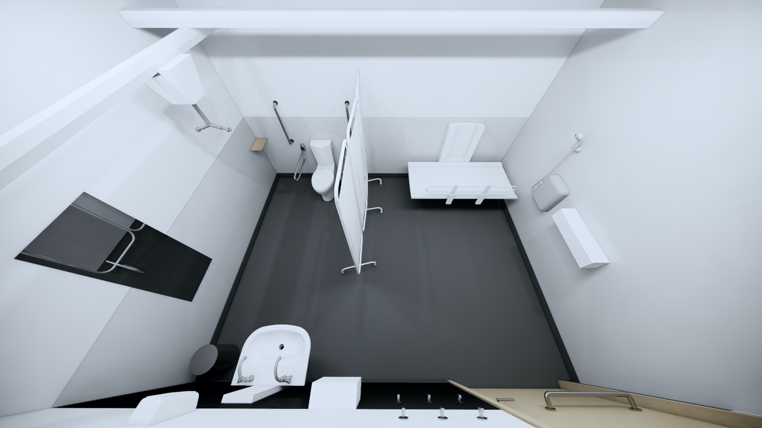
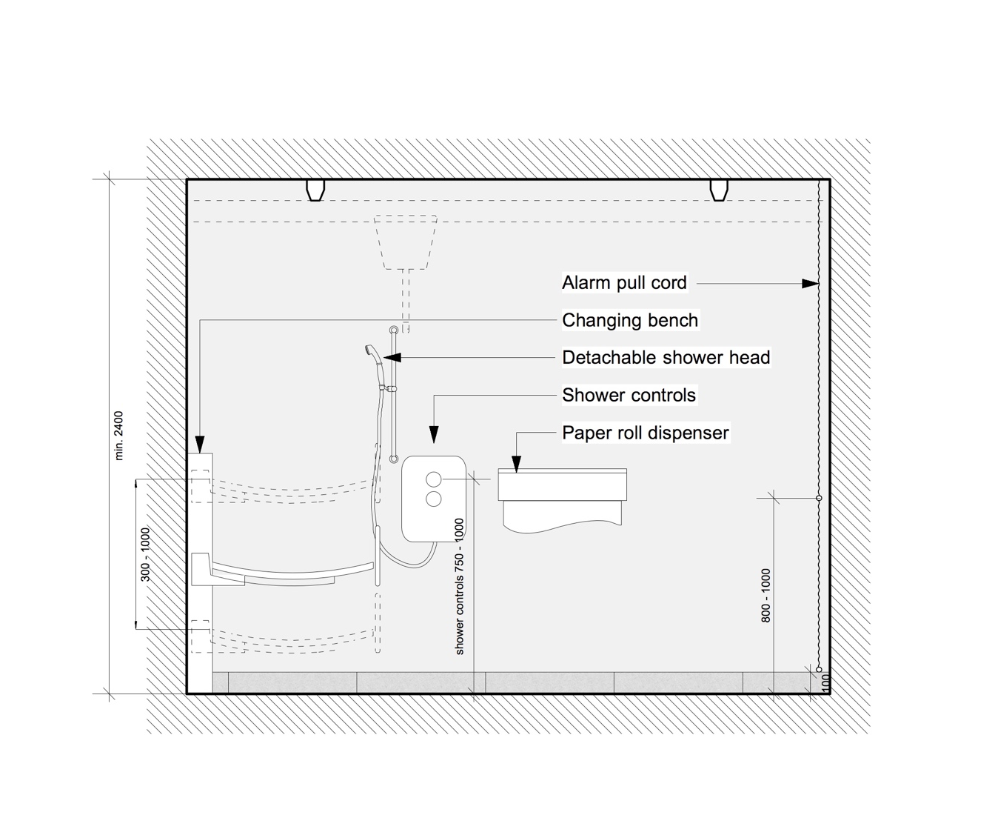
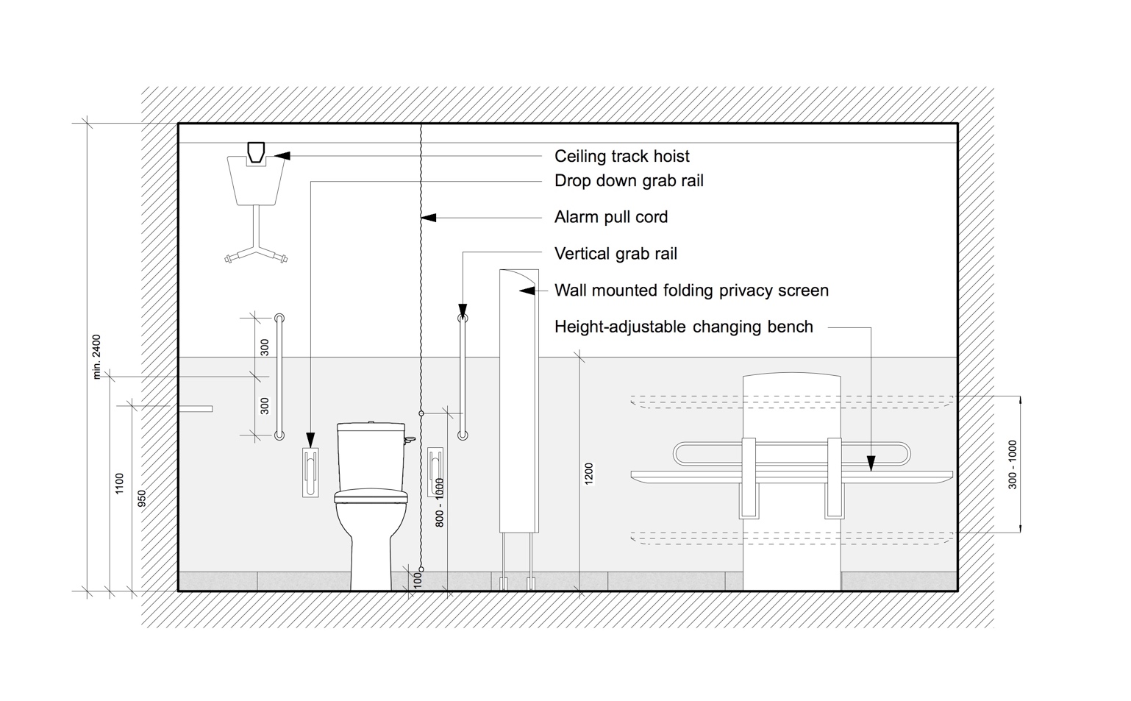

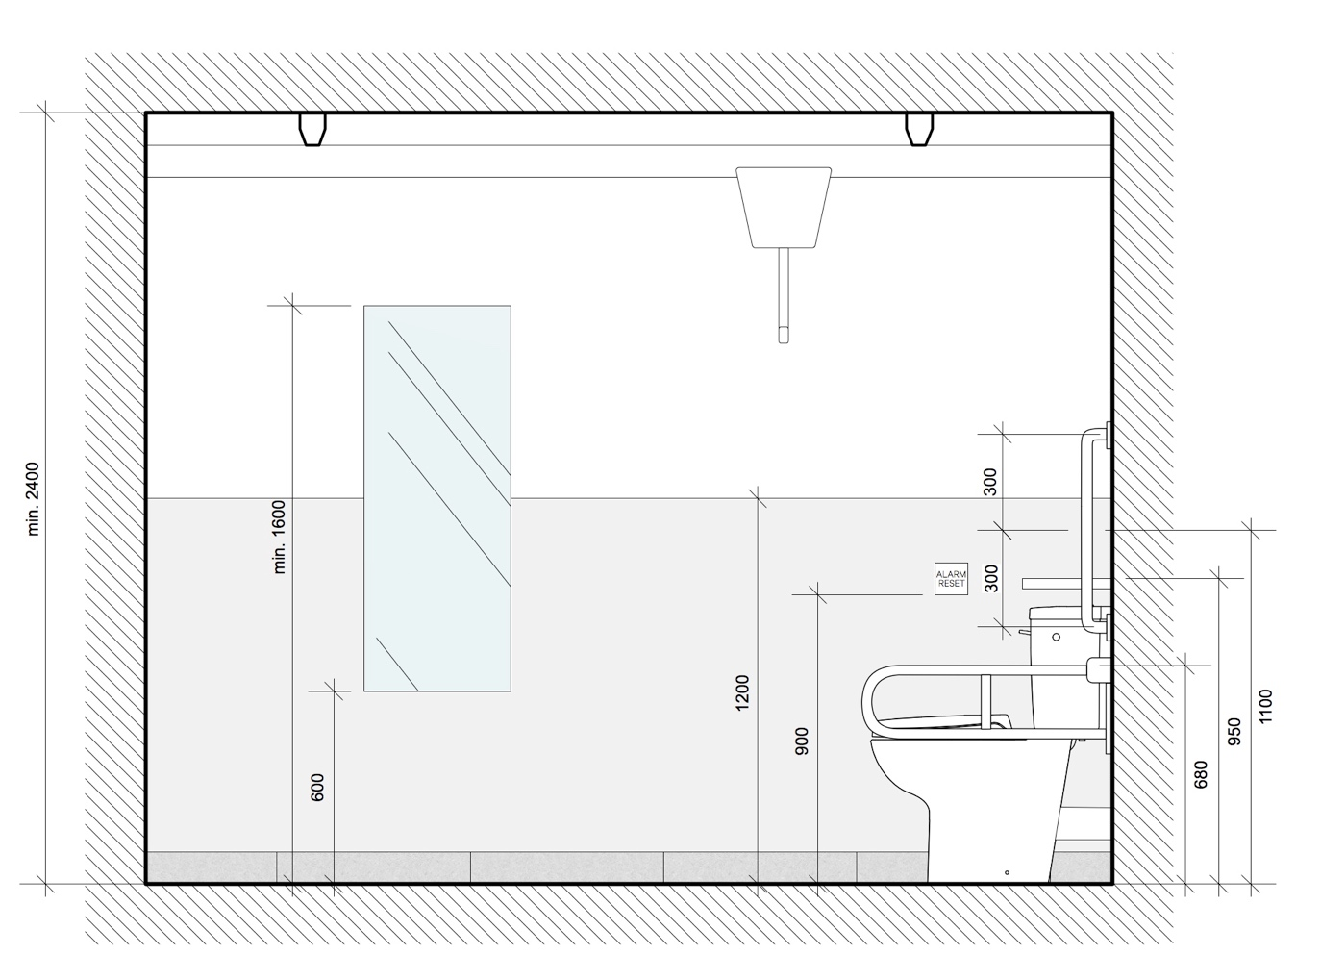
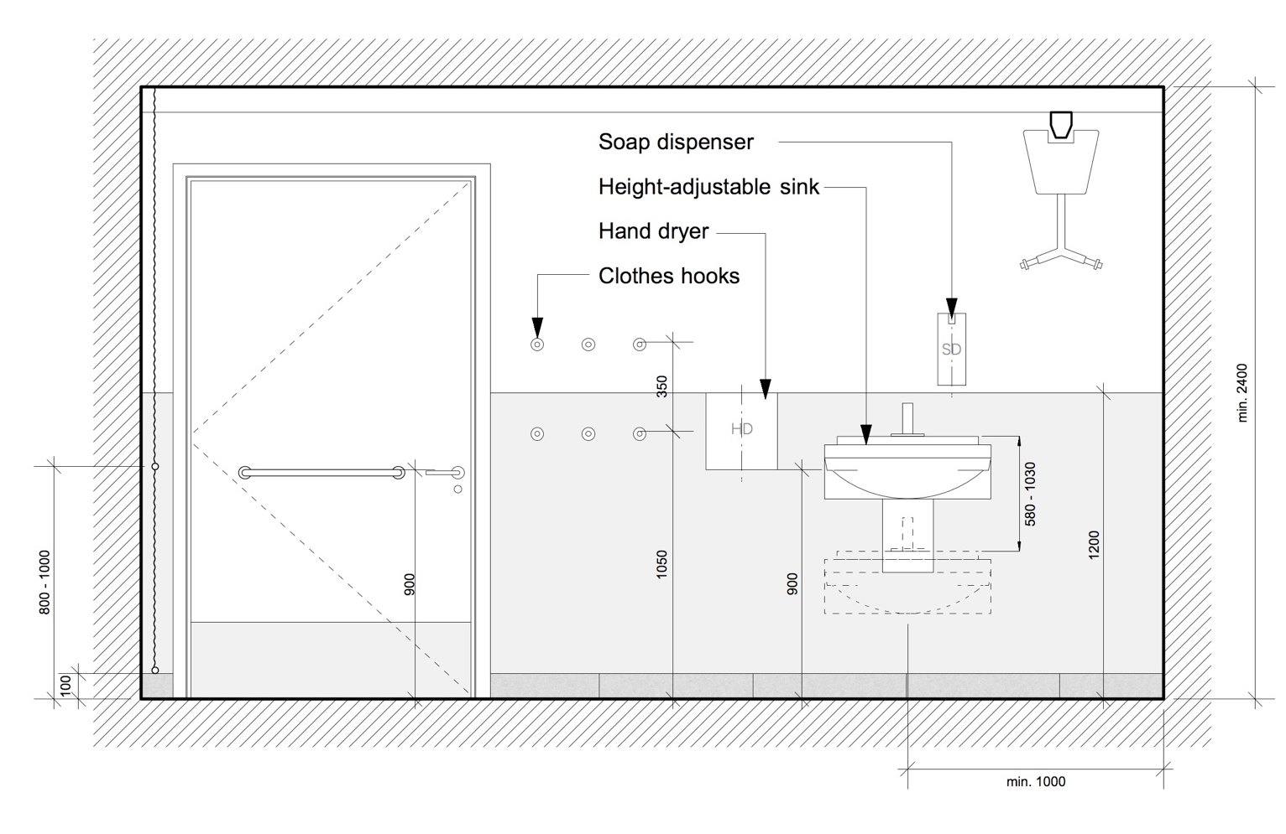
Specification

Floor Finish: Rubber sheeting as NBS clause M50/150
(SS)

Floor Finish: Tiling as NBS clause M40/110
(HD + ES) Where substrate is suitable to receive tiling as NBS clause M40/210 & M40/470

Wall Finish: Coved rubber skirting as NBS clause M50/150 & M50/770
(SS)
Glass panel lining up to 1000mm AFFL and flush with wall surface above, as NBS clause K13/160

Plastered masonry and metal stud plasterboard partition walls
to be painted as NBS clause M60/110

Wall Finish: Skirting tiles as NBS clause M40/110
(HD + ES)
Glass panel lining up to 1000mm AFFL and flush with wall surface above, as NBS clause K13/160

Plastered masonry and metal stud plasterboard partition walls
to be painted as NBS clause M60/110

Ceiling Finish: Suspended MF plasterboard ceiling to be painted as NBS clause M60/110

Suspended ceiling tiles where access to services above is required as NBS clause K40/110

Structural support for ceiling mounted hoist to be considered, may require an independent steel frame if the existing structure is not capable of supporting the additional imposed loads.

Doc M Pack: Unisex accessible corner WC equipment as NBS clause N13/311

Wash Basin: Height adjustable hand wash basin as NBS clause N13/337

Shower: Showers are not a requirement of Changing Places, but should be installed were possible. A shower / floor drain should be considered for specific relevant type of managed buildings such as leisure centres and transport hubs.

Bench: Changing benches to changing place facilities as NBS clause N13/489

Hoist: Hoist systems as NBS clause N13/490

Privacy screen: as NBS clause N13/492

Paper Roll: Paper roll dispenser as NBS clause N13/443 located adjacent to the bench.

Waste Bin: Large waste bin as NBS clause N13/447

Toilet paper disp: Single sheet toilet paper dispenser as NBS clause N13/440

Hooks: Clothes hooks as NBS clause N13/429

Soap Dispensers: as NBS clause N13/458

Hand Driers: as NBS clause N13/472

Mirror: Mirror as NBS clause N13/438
Lighting: Lighting to be specified in conjunction with the current version of the UCL Design Guidance for Mechanical, Electrical & Public Health Services.
Wall mounted is preferred to avoid glare when someone is lying down on the bench.

- Specifications

Supplier / Manufacturer Details

Notes:

- Manufacturers should be as listed below unless an equal alternative has been approved by UCL.
- Items not listed below are to be contractor’s choice of manufacturer

Product | Manufacturer / Supplier
Sanitaryware | Ideal Standard (UK) Ltd  https://www.idealstandard.co.uk  The Bathroom Works  National Avenue  Kingston Upon Hull, HU5 4AS  01482 346461
Gender Neutral Washbasins | Willis Systems  https://www.willissystems.co.uk/solid-surface/  Lamby Industrial Park  Wentloog Avenue  Rumney  Cardiff  CF3 2EX  029 2079 6518  sales@willissystems.co.uk
Automated Taps | Dart Valley Systems Ltd  https://dartvalley.co.uk  Kemmings Close  Long Road  Paignton  Devon  TQ4 7TW  01803 529021  sales@dartvalley.co.uk
Non-Concussive Taps | Franke  https://www.franke.com  Part of Dart Valley Systems Ltd  Kemmings Close  Long Road  Paignton  Devon  TQ4 7TW  01803 529021  sales@dartvalley.co.uk
Cubicle Systems | Kemmlit UK  http://www.kemmlituk.com  Bays Platt  Skirmett  Henley-on-Thames  Oxfordshire RG9 6TD  01491 638606  info@kemmlituk.com
Floor Tiles | Domus  https://domusgroup.com  3 Molesey Business Centre  Molesey  Surrey  KT8 2QZ  service@domusgroup.com
Rubber Flooring  Hoist | Nora, distributed by Interface  https://www.nora.com/united-kingdom/en/products/noraplan-sentica-acoustic  Nora flooring systems UK Ltd, Web: www.nora.com/uk,  Interface Europe Ltd, The Colmore Building, Colmore Circus, Birmingham, B4 6AT  020 7490 3960  interface.uk@interface.com  Arjo Maxi Sky 2 plus  https://www.arjo.com/int/products/safe-patient-handling/ceiling-lift/maxi-sky-2-plus/  Box 48, Hans Michelsensgatan 10, 201 20 Malmö, SWEDEN  Phone: +46 10 335 4500
Coat Hooks | 3V  https://www.3vahl.com/Home.html  3v Architectural Hardware Ltd  Unit F Silwood Park  Buckhurst Road  Ascot  Berkshire  SL5 7PW  01344623600  enquiries@3vahl.com
Lighting | Refer to the UCL MEP Services Design Guide for list of approved suppliers
Electrical | Refer to the UCL MEP Services Design Guide for list of approved suppliers
Mechanical | Refer to the UCL MEP Services Design Guide for list of approved suppliers

K13 RIGID SHEET FINE LININGS AND PANELLING

 | TYPES OF LINING AND PANELLING
160 | PROPRIETARY GLASS PANEL LINING TO WASHROOMS  - Substrate: Project specific, either existing or new walls. Where new walls glass to be bonded to 18mm WBP Plywood.  - Panels:  - Manufacturer: GX Glass, Tel: 01233 642 220 (or equal and approved).  Product reference: ColourX backpainted glass cladding panels.  - Board/ Panel type: Toughened and annealed low iron glass.  - Colour: Project specific TBC with UCL.  - Thickness: 6mm as standard, 4mm – 19mm available.  - Edge treatment: Machine polished edge painted to the back arris.  - Installation:  - Method of fixing panels: Adhesive fixed to a suitable non-absorbent and smooth prepared substrate using a neutral curing silicone from manufacturer’s approved list. Panels to be butt jointed with nominal 3mm gap between panels.  - Joint treatment: Silicone sealant to match the colour of the glass panels.  - Panel Sizes: 160 x 220mm minimum, 1730 x 3150 maximum.
161 | GLASS PANEL ACCESSIBLE DUCT LINING  - Panels:  - Manufacturer: GX Glass, Tel: 01233 642 220 (or equal and approved).  Product reference: ColourX backpainted glass cladding panels.  - Board/ Panel type: Toughened and annealed low iron glass.  - Colour: Project specific TBC with UCL.  - Thickness: 6mm as standard, 4mm – 19mm available.  - Edge treatment: Machine polished edge painted to the back arris.  - Support system: Treated softwood framework site assembled for maximum rigidity (supply and install only)  - Standard dimensions: 300mm deep, height and width to suit site and washroom requirements.  - Panel Sizes: 160 x 220mm minimum, 1730 x 3150 maximum.  - Panel arrangement: Low level or full height panel system, complete with vertical flashgaps and horizontal butt joints.  - Accessories:  - Keku concealed lift off or push on brackets for accessible panels  - To include all cut outs for pans, flush buttons etc.  - Where not full height, top panel above cistern to be hinged and lockable Corian® shelf – Corian® colour Project specific TBC with UCL.
 | GENERAL REQUIREMENTS
220 | MATERIAL SAMPLES  - Representative samples of designated materials: Submit before placing orders.  - Designated materials: Clause 160.
230 | CONTROL SAMPLES  - Sample area: Complete as part of the finished work.  - Clause reference: 160.  - Location: Project specific TBC to suit sequencing of works on site.  - Size (minimum): Project specific TBC.  - Included features: Project specific TBC.  - Approval of appearance: Obtain before proceeding.
260 | ENVIRONMENTAL CONDITIONS  - General requirements prior to starting work specified in this section: Building weathertight; wet trades completed and affected areas dried out.  - Temperature and humidity before, during and after fixing lining/ panelling: Maintained at levels approximating to those which will prevail after building is occupied.
 | FABRICATION/ FIXING/ FINISHING
310 | ACCURACY OF FABRICATION  - Site dimensions: Take as necessary before starting fabrication.  - Discrepancies with drawings: Report without delay and obtain instructions before proceeding.  - Permissible deviations for panels:  - Length: ± 1.5 mm.  - Width: ± 1.5 mm.  - Squareness (taking the longer of 2 sides at a corner as a baseline and measuring the deviation of the shorter side from the baseline perpendicular): ± 1.5 mm in 1 m.  - Flatness (of panels with a core thickness of 12 mm and over, as delivered to site):  ± 1 mm under a 600 mm straightedge.
350 | FIXING LININGS AND PANELLING  - Setting out: Accurate, true to line and level, free from undulations and lipping, with lines and joints aligned, straight and parallel unless specified otherwise.  - Movement allowance: Adequate for future moisture and temperature movement of boards.  - Fixing of panels: Secure, to prevent pulling away, bowing, or other movement during use.  - Methods of fixing and fasteners: As section Z20 unless specified otherwise.  - Trims: Wherever possible, to be in unjointed lengths between angles or ends of runs.  - Running joints: Where unavoidable, submit proposals for location and method of jointing.  - Angle joints: Mitred, unless specified otherwise.

K32 Panel Cubicles / Duct and Wall Linings / Screens

112 | FULLY FRAMED PANEL CUBICLES  - Manufacturer: Kemmlit UK.  - Product Reference: Primon Kn Cubicle System.  - Framework: Proprietary SAA frame running around all sides within the solid grade laminate.  - Doors & Pilaster Panels: All panels are manufactured with a 3mm SGL on both face & back with a foam inlay to give maximum protection against water and vandalism. Overall thickness of panels is 42mm.  - Partitions: All panels are manufactured with a 3mm SGL on both face & back with a foam inlay to give maximum protection against water and vandalism. Overall thickness of panels is 42mm.  - Edge Detail: Edges are machined to a smooth profile finish. Corners to doors are radiused for added safety.  - Panel Colour: Kemmlit Object colour range, Quartz Grey 7708 preferred, or alternative colours if approved by UCL.  - Head Rail: 3-chamber profile, SAA/SS 40 x 30mm.  - Ironmongery: Standard fittings SSA/SS to match framework and panels including: Sprung loaded hinges; ergonomic turn operated handles with circular face plates, integral emergency release facility.  - Standard Dimensions: 2000 / 2135mm overall height including 150mm floor clearance x 1500 (TBC) deep.  - Other Requirements:  - Installation to be floating with legs on partitions.  - Inlays to be incorporated where fixtures are fitted to panels.  - Visual indicators to be green for vacant and white for engaged.  - 2 no. coat hooks to the back of doors, stainless steel/nylon with rubber buffer type SSN1001.
140 | DUCT WALL LINING  - Manufacturer: Kemmlit UK.  - Product Reference: Primo K1 Cistern Duct Panelling for WCs.  - Panels: 12/13mm Fundermax solid phenolic laminate.  - Edge Detail: Edges are machined to a smooth profiled finish.  - Panel Colour: Kemmlit Object colour range, Quartz Grey 7708 preferred, or alternative colours if approved by UCL.  - Edge Colour: Self-coloured.  - Flashgap Colour: Kemmlit Object colour range, Graphite 7808 preferred, or alternative colours if approved by UCL.  - Accessories: Keku concealed lift off or push on brackets.  - Support System: Treated softwood framework site assembled for maximum rigidity (supply and install only).  - Standard Dimensions: 300mm deep, height and width to suit site and washroom requirements.  - Panel Arrangement: Low level or full height panel system, complete with vertical flashgaps and horizontal butt joints. To include all cut outs for pans, flush buttons etc. Top panel above cistern to be hinged and lockable to provide maintenance access.
210 | SAMPLES  - Before placing orders submit representative samples of the following.  - Clause 112 and 140.  - Delivered materials/ products: To match samples.
220 | CONTROL SAMPLES  - General: Complete samples as part of finished work and obtain approval of appearance before proceeding.  - Types: Clause 112 and 140.  - Locations: To be agreed as part of specific project scope.
250 | INSTALLATION  - Programming: Do not install cubicles or duct/ wall panels before building is weathertight, wet trades have finished their work, wall and floor finishes are complete, and the building is well dried out.  - Accuracy: Set out to ensure frames and/ or panels and doors are plumb, level and accurately aligned.  - Modifications: Do not cut, plane or sand prefinished components except where shown on drawings.  - Fixing: Secure components using methods and fasteners recommended by the cubicle/ panel manufacturer. Prevent pulling away, bowing or other distortions to frames, panels and doors.  - Moisture and thermal movement: Make adequate allowance for future movement.

K40 | Demountable suspended ceilings
110 | SUSPENDED TILED CEILING  - Manufacturer: SAS International  - Product Reference: System 130.  - Ceiling:  - Type: System 130 Lay-in tile  - Ceiling Module: 600mmx600mm as per clause 267  - Soffit height above finished floor level: Varies.  - Grid: Alugrid P Cleanseal  - Exposure: Exposed.  - Access: Infill Units fully demountable.  - Suspension system: See clause 250.  - Perimeter trim: See clause 260.  - Accessories: Acoustic infill pads to rear of tiles to Absorbency Class A.  - Integrated services fittings:  - Panels required to receive integrated services to be supplied with factory formed stiffened apertures with upstands and out turned flanges to appropriate dimensions located within a plain (non-perforated) central zone. Circular, non-flanged apertures can be provided for down-lighters, sprinklers etc.  - Additional hangers shall be installed to counteract point loads imposed by luminaires and other services as necessary.  - Other requirements:  - Ceilings to be installed in accordance with AIS (Association of Interior Specialists) Guide No1, Good Practice for the Installation of Suspended Ceilings, BS EN 13964:2004 Annex A Guidance for installation and Annex B Selection of top fixing and perimeter trim fixing.  - Powder paint finishes are to be in accordance with BS 6496 and BS 6497 applied by one manufacturing applicator from a single batch. The Manufacturer /Specialist ceiling contractor is to provide prior to commencement on site, 2 number samples (hand sized) of all polyester paint components to be incorporated in the works.
 | GENERAL
210 | ENVIRONMENT  - Environmental classification to BS EN 13964: Class A.
220 | STRUCTURAL PERFORMANCE  - Loads: The ceiling system must safely support all anticipated loads, including services fittings:  - Class: Project to determine  - Additional loads/ pressures to be sustained by ceiling system: Project to determine.  Ceiling system subject to wind pressure: Project to determine  - Deflection (maximum) between points of support:  - Span under 1200 mm: Span/400.  - Span 1200-1800 mm: Span/500.  - Span over 1800 mm: Span/60  - Test standard: To BS EN 13964.
225 | FIRE PERFORMANCE  - Completed ceiling system: Project to determine.  - Reaction to fire ratings:  - Ceiling soffit surfaces: Project to determine.  - Ceiling void surfaces: Project to determine.  - Fire resistance:  - Overall fire resistance: Project to determine.  - Ceiling resistance: Project to determine.  - Other protection: Project to determine.  - Test reports or assessments: Include details of performance related to the particular elements of construction.  - Ceilings with integrated luminaires: Test/ assess with luminaires in place.
 | COMPONENTS
240 | SAMPLES  - General: Submit representative samples of the following: Infill units.
245 | STANDARDS  - Steel panels: To BS EN 10346.
250 | SUSPENSION SYSTEM TO DEMOUNTABLE CEILING  - Extent of System: The suspension system will be SAS Alugrid 15/16P. This will comprise of a galvanised steel carrier with a polyester powder coated Aluminium capping. The grid shall consist of 3000mm main runner suspended at 1200mm centres. 1200mm and 600mm Cross Tees will be supplied to form a 600x600 module. The Alugrid 15/16P will be suspended via the main runner using an Emac hanger bracket suspended from a rigid Emac hanger  - Top Fixings: Fixings are to be selected and supplied by the appointed specialist ceiling contractor.  - Hangers: Rigid Emac hangers suspended at 1200mm maximum centres. Lengths to be confirmed.  - Grid Type: SAS International Alugrid P 15/16  - Finish: Polyester powder coated  - Colour: White RAL 9010 20% gloss
260 | PERIMETER TRIMS TO TILE CEILING  - Type: Polyester powder coated extruded aluminium section to provide an exposed 20mm profile detail with a 15mm shadow gap detail between the full metal ceiling tile and the plasterboard margin. The extrusion is to be supported by bracket TCB 08 supported from the soffit from a rigid Emac hanger  - Manufacturer: SAS International  - Product reference: TRU-SW-1516 polyester powder coated to RAL 9010 20% gloss.  - Fixings:  - Fasteners: Fixings are to be selected and supplied by the appointed specialist ceiling contractor. The extrusion is to be supported by bracket TCB 08 supported from the soffit from a rigid Emac hanger.  - Fixing Centres (maximum): 1000mm centres
265 | INFILL UNITS TO TILE CEILINGS  - Type: System 130 lay-in ceiling tile  - Manufacturer: SAS International  - Product reference: System 130 Zintec polyester powder coated steel ceiling panels 16mm deep with out-turned flanges on all sides The material will perforated to reference D1522 (1.5mm hole providing 22% open areas) with a 10mm nominal plain border  - Form: Pressed Unit  - Sizes: 600mmx600mm  - Finish: Polyester powder coated.  - Colour: White RAL 9010 20% gloss
285 | NSULATION TO TILE CEILINGS  - Product Reference: The tile shall be backed with an 16mmx80kg/m3 fleece faced rock wool infill aluminium foil back reinforced acoustic pad.  - Performance: Acoustic Pad to achieve 27dB attenuation and Class A acoustic absorption.  - Type: Factory installed, loose laid tissue faced, sealed acoustic Rockwool pad  - Note: Pads to be omitted from certain tiles to suit ventilation system in certain rooms.  - SKA CRITERIA D22: The manufacture and installation of all new or reused insulants only uses products that have a Global Warming Potential (GWP) of less than 5. The criteria apply both to the products that the insulation materials are manufactured from, and any resources, catalysts, materials, recyclate and ingredients, such as blowing agents that are used in their manufacture, but may or may not be present in the final product.  - All insulation materials (fire, thermal and acoustic) meet at least one of the following criteria:  If new:  • are natureplus labelled product;  • composite materials must be able to be separated readily at the end of first use:  – are assembled without the use of adhesives;  – can be demonstrated that materials can be easily separated now; and  – the materials are robust enough to separate and not to disintegrate.  • are manufactured with at least 50% recycled (measured by mass) and 100% recyclable content that is designed for deconstruction, reclaim and reuse with recyclable components;  • are manufactured from at least 50% renewable material, e.g. hemp, flax, newspaper, wool;  • are manufactured with a combination of at least 50% recycled content and 50% Renewable material, e.g. hemp, flax, newspaper, wool;  • 80% of the insulation has an A+ or A rating in BRE’s The Green Guide to Specification.  • 80% of the insulation has an A+ or A rating in BRE’s Green Book Live database; or  • are supplied with an environmental product declaration (EPD), written in accordance with ISO 14025 standards.  Any recycled and recyclable content claims must:  • comply with ISO 14021:2016 Environmental labels and declarations – Self-declared environmental claims; and  • state IAQ emissions.
 | EXECUTION
302 | CONTROL SAMPLES  - General: Complete areas as part of the finished work in the following locations: Project to determine.  - Approval: Obtain before completing areas of similar work.
305 | SETTING OUT  - General: Completed ceiling should present, over the whole of its surface exposed to the room below, a continuous and even surface, jointed (where applicable) at regular intervals.  - Infill and access units, integrated services: Fitted correctly and aligned.  - Edge/ perimeter infill units size (minimum): Half standard width or length.  - Corner infill units size (minimum): Half standard width and length.  - Grid: Position to suit infill unit sizes. Allow for permitted deviations from nominal sizes of infill unit.  - Infill joints and exposed suspension members: Straight, aligned and parallel to walls, unless specified otherwise.  - Suitability of construction: Give notice where building elements and features to which the ceiling systems relate are not square, straight or level.
310 | BRACING  - General: Secure, with additional bracing and stiffening to give a stable ceiling system resistant to design loads and pressures.
315 | PROTECTION  - Loading: Do not apply loads for which the suspension system is not designed.  - Ceiling materials: When necessary, remove and replace correctly using special tools and clean gloves, etc. as appropriate.
320 | TOP FIXING  - Building structure: Verify suitability.  - Structural soffit: Project to determine.  - Suitability to receive specified fixings: Evaluate and confirm.  - Fixing generally: In accordance with BS EN 13964.  - Fixing to:  - Concrete: Drill and insert suitable expanding anchors.  - Aerated concrete: Fix through from the top of concrete units and provide a system of primary support channels.  - Structural steel: Drill or use suitable proprietary clips/ adaptors.  - Metal roof decking: Fix to sides of liner tray corrugations.  - Timber: Fix to side of joists at least 50 mm from bottom edge. If ceiling system is intended for fire protection, fix into top third of joists.  - Hollow structural members: Submit fixing proposals.
325 | INSTALLING HANGERS  - Wire hangers: Straighten and tension before use.  - Installation: Install vertical or near vertical, without bends or kinks. Do not allow hangers to press against fittings, services, or insulation covering ducts/ pipes.  - Obstructions: Where obstructions prevent vertical installation, either brace diagonal hangers against lateral movement, or hang ceiling system on an appropriate rigid sub-grid bridging across obstructions and supported to prevent lateral movement.  - Extra hangers: Provide as necessary to carry additional loads.  - Fixing:  - Wire hangers: Tie securely at top with tight bends to loops to prevent vertical movement.  - Angle/ strap hangers: Do not use rivets for top fixing.  - Spacings: As recommended by system manufacturer.
335 | INSTALLING PERIMETER TRIMS  - Jointing: Neat and accurate, without lipping or twisting.  - External and internal corners: Mitre joints generally.  - Intermediate butt joints: Minimize. Use longest available lengths of trim. Align adjacent lengths.  - Fixing: Fix firmly to perimeter wall, edge battens or other building structure.
340 | EXPOSED GRIDS  - Grid fixings: As recommended by system manufacturer.  - Main runners: Install level. Do not kink or bend hangers.  - Spliced joints: Stagger.  - Wire hangers passing through main runners: Use sharp bends and tightly wrapped loops.  - Angle/ strap hangers: Do not use rivets for bottom fixing.  - Angular displacement of long axis of one runner in relation to next runner in line with it: Not visually apparent.  - Cross members supported by main runners or other cross members: Install perpendicular to intersecting runners.  - Cross tees: Flat and coplanar with flanges of main runners after panel insertion.  - Cross tees over 600 mm long, cut and resting on perimeter trim: Provide an additional hanger.  - Holding down clips: Locate to manufacturer's recommendations.  - Fire protecting/ resisting ceiling systems: Use clip type featured in the fire test/ assessment.
365 | INSTALLING METAL INFILL UNITS  - Sound absorbing pads: Fit to prevent upward air movement through infill units. Cut or fold pads in cut perimeter infill units to full unit size. Reseal cut pads.  - Perimeter infill units: Firmly wedge cut units into perimeter trim, or clip down.
385 | UPSTANDS AND BULKHEADS  - Vertical ceiling systems: Support and brace to provide alignment and stability.  - High upstands: Provide support at base of upstand.
390 | OPENINGS IN CEILING MATERIALS  - General: Neat and accurate. To suit sizes and edge details of fittings. Do not distort ceiling system.
395 | INTEGRATED SERVICES  - General: Position services accurately, support adequately. Align and level in relation to the ceiling and suspension system. Do not diminish performance of ceiling system.  - Small fittings: Support with rigid backing boards or other suitable means. Do not damage or distort the ceiling.  - Surface spread of flame rating of additional supporting material: Not less than ceiling material.  - Services outlets:  - Supported by ceiling system: Provide additional hangers.  - Independently supported: Provide flanges to support ceiling system.
401 | CEILING MOUNTED LUMINAIRES  - Support: By ceiling system within tiles, by soffit when installed between tiles.  - Independently supported luminaires: Suspension adjusted to line and level of ceiling.  - Ceiling supported luminaires: Modifications and/ or extra support required: As recommended by system manufacturer  .  - Surface mounted luminaires: Units installed so that in event of a fire the designed grid expansion provision is not affected.  - Modular fluorescent recessed luminaires: Compatible with ceiling module. Extension boxes must not foul ceiling system.  - Recessed rows of luminaires: Provide flanges for support of grid and infill units, unless mounted above grid flanges. Retain in position with lateral restraint.  - Fire protecting/ resisting ceiling systems: Luminaires must not diminish protection integrity of ceiling system.  - Access: Provide access for maintenance of luminaires.
411 | MECHANICAL SERVICES  - Fan coil units:  - Inlet/ Outlet grilles: Trim ceiling grid and infill units to suit.  - Space beneath: Sufficient for ceiling system components.  - Suspension and connections: Permit accurate setting out and levelling of fan coil units.  - Air grilles and diffusers:  - Setting out: Accurate and level.  - Linear air diffusers: Retain in place with lateral restraint. Provide flanges for support of grid and infill units.  - Grille/ Diffuser ceiling joints: Provide smudge rings and edge seals.
415 | INSTALLING INSULATION  - Fitting: Fit accurately and firmly with butted joints and no gaps.  - Insulation within individual infill units: Fit closely. Secure to prevent displacement when infill units are installed or subsequently lifted.  - Dustproof sleeving: Reseal, if cut.  - Width: Lay insulation in the widest practical widths to suit grid member spacings.  - Services: Do not cover electrical cables that have not been sized accordingly. Cut insulation carefully around electrical fittings, etc. Do not lay insulation over luminaires.  - Sloping and vertical areas of ceiling system: Fasten insulation, to prevent displacement.

M40 Stone/ Concrete/ Quarry/ Ceramic Tiling/ Mosaic

 | TYPES OF TILING/ MOSAIC
 | 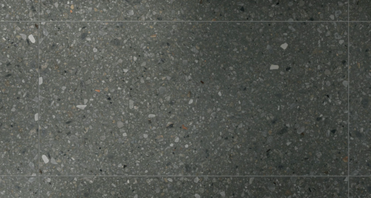 | Use category:  HD + ES
110 | TILING TO WASHROOM FLOORS (WHERE SUBFLOOR IS SUITABLE TO RECEIVE TILING)  - Tiles: Porcelain.  - Manufacturer/ Supplier: Domus.  Product reference: Veneziane.  - Colour: DCVE 04 (LRV 23.12).  - Finish: Natural Grip.  - Size: 1197 x 597 floor tiles with 597 x 100 skirting tiles.  - Thickness: 10mm.  - Slip potential: R9.  - Recycled content: 13.8%.  - Background/ Base: Varies as project specific.  - Preparation: As recommended by tile supplier to suit background/ base.  - Intermediate substrate: As clause 470.  - Bedding: As clause 650 for walls and clause 710 for floors.  - Reinforcement: Not applicable.  - Adhesive to BS EN 12004: Mapei Adhesilex P4 quick drying or equal approved.  - Joint width: 3mm.  - Grout: Mapei Ultracolour Plus.  - Colour: 114 Anthracite  - Movement joints: As recommended by manufacturer to suit flooring area and background/ base.  - Accessories:  - Brushed stainless steel edging trims to junctions with all other floor finishes (Gradus or equal and approved).  - Schluter Schiene brushed stainless steel edging trim to top edge of tiled skirting where exposed.
 | GENERAL
210 | SUITABILITY OF BACKGROUNDS/ BASES  - Background/ base tolerances: To permit specified flatness/ regularity of  finished surfaces given the permissible minimum and maximum thickness of  bedding.  - New background drying times (minimum):  - Concrete walls: 6 weeks.  - Brick/ block walls: 6 weeks.  - Rendering: 2 weeks.  - Gypsum plaster: 4 weeks.  - New base drying times (minimum):  - Concrete slabs: 6 weeks.  - Cement: sand screeds: 3 weeks.
215 | FALLS IN THE BASES  - General: Give notice if falls are inadequate.
250 | SAMPLES  - General: Submit representative samples of the following:  - Clause110.
260 | CONTROL SAMPLES  - General: Complete sample areas, being part of the finished work, in locations as follows: Project to determine.  - Approval of appearance: Obtain before proceeding.
 | PREPARATION
310 | EXISTING BACKGROUNDS/ BASES GENERALLY  - Efflorescence, laitance, dirt and other loose material: Remove.  - Deposits of oil, grease and other materials incompatible with the bedding: Remove.  - Tile, paint and other nonporous surfaces: Clean.  - Wet backgrounds: Dry before tiling.
320 | EXISTING CONCRETE/ SCREEDS  - Loose or hollow portions: Cut out.  - Making good: Material recommended by tiling adhesive manufacturer.
330 | EXISTING PLASTER  - Defective areas: Remove plaster that is loose, soft, friable, badly cracked or affected by efflorescence. Cut back to straight horizontal and vertical edges.  - Making good: Use plaster or non-shrinking filler.
355 | OLD ADHESIVE RESIDUES ON CONCRETE/ SCREED BASES  - Soft or unsound adhesive residues: Remove without damaging base.
360 | EXISTING PAINT  - Paint with unsatisfactory adhesion: Remove so as not to impair bedding adhesion.
370 | NEW IN SITU CONCRETE  - Backgrounds/ bases to be tiled: Remove mould oil, surface retarders and other materials incompatible with bedding.
380 | NEW PLASTER  - Plaster: Dry, solidly bedded, free from dust and friable matter.  - Plaster primer: Apply if recommended by adhesive manufacturer.
390 | PLASTERBOARD BACKGROUNDS  - Boards: Dry, securely fixed and rigid with no protruding fixings and face to receive decorative finish exposed.
460 | SMOOTHING UNDERLAYMENT  - Type: Recommended by adhesive manufacturer.  - Condition: Allow to dry before tiling.
470 | INTERMEDIATE SUBSTRATE  - Type: Decoupling membrane.  - Manufacturer: Schluter®.  Product reference: DITRA 25.  - Thickness: 3mm.  - Fixing system: Bonding adhesive as recommended by Schluter that is appropriate for the sub-base.  - Application: Apply the adhesive using a 3 x 3 mm or 4 x 4 mm notched trowel. The anchoring fleece on the underside of Schlüter®-DITRA 25 must be fully engaged in the adhesive to provide a mechanical bond to the substrate. Please observe the open time of the bonding adhesive. Using the thin-bed method and following all applicable industry standards, set the tile or stone covering directly on the Schlüter®- DITRA 25 in such a way that the tile adhesive becomes mechanically anchored in the square, cut back cavities of the Schlüter®- DITRA 25 matting.  - Substrate surface: Secure, true and even.  - Joints: Close butt.  - Treatment: Seal with waterproof reinforcing tape Kerdi Keba and Kerdi Coll adhesive.  - Penetrations: Seal all penetrations with waterproof reinforcing tape Kerdi Keba and Kerdi Coll adhesive.  - Accessories: None.
 | FIXING
510 | FIXING GENERALLY  - Colour/ shade: Unintended variations within tiles for use in each area/ room are not permitted.  - Variegated tiles: Mix thoroughly.  - Adhesive: Compatible with background/ base. Prime if recommended by adhesive manufacturer.  - Use of admixtures with cementitious adhesives: Only admixtures approved by adhesive manufacturer.  - Cut tiles: Neat and accurate.  - Fixing: Provide adhesion over entire background/ base and tile backs.  - Final appearance: Before bedding material sets, make adjustments as necessary to give true, regular appearance to tiles and joints when viewed under final lighting conditions.  - Surplus bedding material: Clean from joints and face of tiles without disturbing tiles.
530 | SETTING OUT  - Joints: True to line, continuous and without steps.  - Joints on walls: Horizontal, vertical and aligned round corners.  - Joints in floors: Parallel to the main axis of the space or specified features.  - Cut tiles: Minimize number, maximize size and locate unobtrusively.  - Joints in adjoining floors and walls: Align.
FLATNESS/ REGULARITY OF TILING/ MOSAICS
- Sudden irregularities: Not permitted.
- Deviation of surface: Measure from underside of a 2 m straightedge with 3 mm thick feet placed anywhere on surface. The straightedge should not be obstructed by the tiles and no gap should be greater than 6 mm, i.e. a tolerance of + 3 mm.
560 | LEVEL OF TILING ACROSS JOINTS  - Deviation (maximum) between tile surfaces either side of any type of joint:  - 1 mm for joints less than 6mm wide.  - 2 mm for joints 6 mm or greater in width.
600 | SIT-ON TILE SKIRTINGS  - Sequence: Bed solid to wall after laying floor tiles.  - Bedding: Adhesive to suit wall type as recommended by tiling manufacturer.
650 | ADHESIVE BED - NOTCHED TROWEL METHOD (WALLS)  - Application: By 3 mm floated coat of adhesive to dry background in areas of approximately 1 m². Comb surface.  - Tiling: Press tiles firmly onto float coat.
710 | ADHESIVE BED - NOTCHED TROWEL AND BUTTERING METHOD (FLOORS)  - Application: Floated coat of adhesive to dry base and comb surface.  - Tiling: Apply coat of adhesive to backs of dry tiles. Fill any ribbed, deep keyed or button profiles. Press tiles firmly onto float coat.  - Finished adhesive thickness: Within range allowed by manufacturer.
 | MOVEMENT JOINTS/ GROUTING/ COMPLETION
815 | SEALANT MOVEMENT JOINTS  - To suit project specific requirements.
875 | GROUTING  - Sequence: Grout when bed/ adhesive has set sufficient to prevent disturbance of tiles.  - Joints: 6 mm deep (or depth of tile if less). Free from dust and debris.  - Grouting: Fill joints completely, tool to profile, clean off surface. Leave free from blemishes.  - Profile: Flush.  - Polishing: When grout is hard, polish tiling with a dry cloth.
885 | COLOURED GROUT  - Staining of tiles: Not permitted.  - Evaluating risk of staining: Apply grout to a few tiles in a small trial area. If  discoloration occurs, apply a protective sealer to tiles and repeat trial.

M50 Rubber/ Plastics/ Cork/ lino/ Carpet Tiling/ Sheeting

TYPES OF COVERING
 | 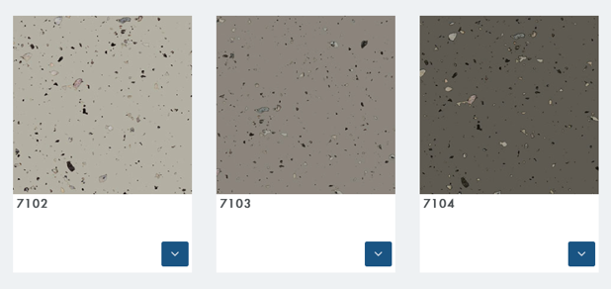 | Use category:  SS
150 | RUBBER SHEETING  (WHERE TILING NOT POSSIBLE DUE TO SUBFLOOR BEING UNSUITABLE)  - Base: Varies depending on project.  - Preparation: Ensure site conditions meet the manufacturers requirements prior to commencing work. Laying of the floor coverings will be deemed as joint acceptance of the suitability of the of the substrate, bases and conditions within the given installation area by the main contractor and subcontractor.  - Flooring Roll: Rubber to BS EN 1817.  - Manufacturer: Nora.  Product Reference: Noraplan Unita.  - BS EN ISO 10874 class 34.  - Slip Potential: Noraplan Unita.  Slip resistance value (SRV) (minimum)/ Pendulum test value (PTV) (minimum) to BS 7976-1, -2 and -3: R9.  - Recycled Content: 100% recyclable.  - Width 1.22m x 15m.  - Thickness: 2mm.  - Colour/ pattern: 7102 (LRV38.69), 7103 (LRV 22.79) or 7104 (LRV 12.46) preferred, or alternative colours if approved by UCL.  - Adhesive (and primer if recommended by manufacturer): Provide Nora recommended, low-emission, solvent-free adhesive for the entire scope of the project in support of the Nora manufacturing warranty. Follow manufacturer’s recommended installation instructions.  - Seam welding: Ensure to follow manufacturer’s recommendations. Heat-weld using hot air welding gun (fitted with high-speed welding nozzle) and Nora welding rod. Select colour of rod to match floor covering from manufacturer standard running line. Cut off surplus weld rod with spatula. Form a neat, smooth, strongly bonded joint, flush with finished surface.  - Accessories: Aluminium floor trim at junction with other floor finishes.  - Finishing: As recommended by manufacturer.  - Other Requirements:  - Floor finish colour to visually contrast with wall to the requirements of the Approved Document Part M and BS8300.  - Doorways: Make joint on centre line of door leaf.
 | 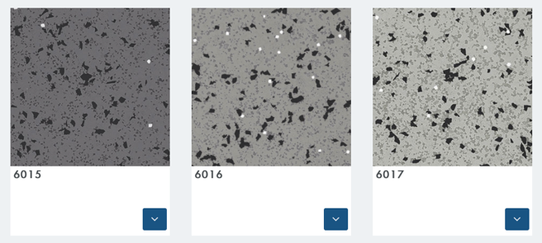 |  | Use category:  SS
151 | RUBBER SHEETING TO SHOWER AREAS  (WHERE ENHANCED SLIP RESISTANCE IS REQUIRED)  - Base: Varies depending on project.  - Preparation: Ensure site conditions meet the manufacturers requirements prior to commencing work. Laying of the floor coverings will be deemed as joint acceptance of the suitability of the of the substrate, bases and conditions within the given installation area by the main contractor and subcontractor.  - Flooring Roll: Rubber to BS EN 1817.  - Manufacturer: Nora.  Product Reference: Noraplan Ultra Grip.  - BS EN ISO 10874 class 34.  - Slip Potential: Noraplan Unita.  Slip resistance value (SRV) (minimum)/ Pendulum test value (PTV) (minimum) to BS 7976-1, -2 and -3: R12.  - Recycled Content: 100% recyclable.  - Width 1.22m x 15m.  - Thickness: 2mm.  - Colour/ pattern: 6015 (LRV 12.72), 6016 (LRV 25.93) or 6017 (LRV 33.86) preferred, or alternative colours if approved by UCL.  - Adhesive (and primer if recommended by manufacturer): Provide Nora recommended, low-emission, solvent-free adhesive for the entire scope of the project in support of the Nora manufacturing warranty. Follow manufacturer’s recommended installation instructions.  - Seam welding: Ensure to follow manufacturer’s recommendations. Heat-weld using hot air welding gun (fitted with high-speed welding nozzle) and Nora welding rod. Select colour of rod to match floor covering from manufacturer standard running line. Cut off surplus weld rod with spatula. Form a neat, smooth, strongly bonded joint, flush with finished surface.  - Accessories: Aluminium floor trim at junction with other floor finishes.  - Finishing: As recommended by manufacturer.  - Other Requirements:  - Floor finish colour to visually contrast with wall to the requirements of the Approved Document Part M and BS8300.  - Doorways: Make joint on centre line of door leaf.
155 | PVCu WALL LININGS TO SHOWERS  - Substrate: Project specific.  - Sheet: Extruded semi-rigid PVCu sheet, EU Grade.  - Maximum service temp: 60ºC.  - Fire rating:  BS 476 Part 7 (1987) surface spread of flame – Class 1.  BS 476 Part 6 (1989) fire propagation – Class 0 (when fixed to a non-combustible substrate).  EN13501-1-B-s3, d0.  - Manufacturer: Altro.  Product reference: Whiterock.  - Width: 1220mm.  - Length: 2500.  - Thickness: 2.5mm.  - Colour: Project to determine.  - Light Reflectance Value: Project to determine.  - Surface Finish: Satin.  - Adhesive (and primer if recommended by manufacturer): Altrofix W139 or W157 depending upon substrate, as recommended by manufacturer.  - Joints: Hot welded with matching colour rod.  - Finishing: As clause 831.  - Other requirements: None.
GENERAL REQUIREMENTS
210 | WORKMANSHIP GENERALLY  - Base condition after preparation: Rigid, dry, sound, smooth and free from grease, dirt and other contaminants.  - Finished coverings: Accurately fitted, tightly jointed, securely bonded, smooth and free from air bubbles, rippling, adhesive marks and stains.
220 | SAMPLES  - Covering samples: Before placing orders, submit representative sample of each type.
230 | CONTROL SAMPLES  - General: Complete sample areas, being part of the finished work, in locations as follows: Project to determine.  - Approval of appearance: Obtain before proceeding.
250 | LAYOUT - ROLL MATERIALS  - Covering samples: Before placing orders, submit representative sample of each type.
270 | EXTRA MATERIAL  - Provision of extra material: At completion, hand to Employer extra material of each type of covering to the extent of: Project to confirm.
330 | COMMENCEMENT  - Required condition of works prior to laying materials:  - Building is weathertight and well dried out.  - Wet trades have finished work.  - Paintwork is finished and dry.  - Conflicting overhead work is complete.  - Floor service outlets, duct covers and other fixtures around which materials are to be cut are fixed.  - Notification: Submit not less than 48 hours before commencing laying.
340 | CONDITIONING  - Prior to laying: Condition materials by unpacking and separating in spaces where they are to be laid. Maintain resilient flooring rolls in an upright position. Unroll carpet and keep flat on a supporting surface.  - Conditioning time and temperature (minimum): As recommended by manufacturer with time extended by a factor of two for materials stored or transported at a temperature of less than 10°C immediately prior to laying.
350 | ENVIRONMENT  - Temperature and humidity: Before, during and after laying, maintain approximately at levels which will prevail after building is occupied.  - Ventilation: Before during and after laying, maintain adequate provision.
355 | ENVIRONMENT: HEAT – PVCu WALL LINING  - Areas where open cooking or open flame equipment is being used should comply with the following:  - Altro Whiterock panels once installed should not be exposed to temperatures above 60ºC.  - Before the testing of equipment, which is likely to expel extreme heat, extraction systems must be operational. Failure to do so may result in expansion problems.  - With the construction of a dry wall system in a kitchen area or where the area has been adapted to form a wall behind cooking ranges. Altro Walls recommend the substrate or dry wall lining should be constructed with a Calcium Silica board. Stainless steel panels should then be used to clad these areas.  - Hot pipes and steam pipes should be insulated and a 3-5mm expansion gap should be created when installing panels around these pipes.
360 | FLOORS WITH UNDERFLOOR HEATING  - Commencement of laying: Not before a period of 48 hours after heating has been turned off.  - Post laying start up of heating system: Slowly return heating to its operative temperature not less than 48 hours after completing laying.
 | PREPARING BASES
410 | NEW BASES  - Suitability of bases and conditions within any area.  - Commencement of laying of coverings will be taken as acceptance of suitability.
420 | EXISTING BASES  - Notification: Before commencing work, confirm that existing bases will, after preparation, be suitable to receive coverings.  - Suitability of bases and conditions within any area.  - Commencement of laying of coverings will be taken as acceptance of  suitability.
430 | NEW WET LAID BASES  - Base drying aids: Not used for at least four days prior to moisture content testing.  - Base moisture content test: Carry out in accordance with BS 5325, Annexe A or BS 8203, Annexe A.  - Locations for readings: In all corners, along edges, and at various points over area being tested.  - Commencement of laying coverings: Not until all readings show 75% relative humidity or less.
431 | DAMPNESS – PVCu WALL LINING  - Where linings are to fitted on new wet-laid bases:  - All substrates to be dried to a minimum of 16% WME (Wood Moisture Equivalent) on Protimeter ‘Surveymaster’ equipment or similar.  - Take readings in all corners, along edges, and at various points over the area being installed.
440 | SUITABLE SUBSTRATES – PVCu WALL LINING  The specifications for finishes to receive PVCu wall cladding require:  - 12.5mm thick plasterboard (do not seal with sealers as for decorating).  If wall affords fire protection, ensure joints between boards are filled with appropriate fillers.  - Plastered surfaces – finish with a steel trowel (pink lightweight plasters generally not suitable).
 | LAYING COVERINGS
620 | COLOUR CONSISTENCY  - Finished work in any one area/ room: Free from banding or patchiness.
640 | ADHESIVE FIXING GENERALLY  - Adhesive type: As specified, as recommended by covering/ underlay manufacturer, or as approved.  - Primer: Type and usage as recommended by adhesive manufacturer.  - Application: As necessary to achieve good bond.  - Finished surface: Free from trowel ridges, high spots caused by particles on the substrate, and other irregularities.
641 | ADHESIVE FIXING – PVCu WALL LINING – BY ALTROFIX W139  - Use Altrofix W139 (Ref: A814) two-part polyurethane or adhesive spread with a 5mm square notched trowel (Ref: A860).  - Support the panel on double sided tape (Ref: A815 or A915 or welded system) whilst adhesive cures (approx 3-5 hours – full sure 24 hours).
641A | ADHESIVE FIXING – PVCu WALL LINING – BY ALTROFIX W157  NB: This adhesive is only suitable for porous surfaces, for non-porous surfaces refer to Altrofix W139.  - Apply Altrofix W157 (Ref: A818) water based synthetic polymer adhesive to back of the sheet using a 3mm deep x 5mm wide square notched trowel (Ref: A860/4).  - On application immediately apply sheet to wall.  - Support the panel on double sided tape (Ref: A815 or A915 or welded system) whilst adhesive cures (can be 24 hours and upwards).  NB: On completion, the installation should not be subject to more than 30ºC until the adhesive is fully cured. Full cure will depend upon the porosity of the substrate.
650 | SEAMS  - Patterns: Matched.  - Joints: Tight without gaps.
680 | SEAM WELDING COVERINGS  - Commencement: At least 24 hours after laying, or after adhesive has set.  - Joints: Neat, smooth, strongly bonded, flush with finished surface.
681 | SEAM WELDING COVERINGS – PVCu WALL LINING  - Do not commence welding of coverings until a minimum of 24 hours after fitting or until adhesive has completely set.  - Use Altro double sided tape (Ref: A915) applied to the wall bridging the joint to be welded. Bring the edges of the sheets to be welded together leaving a 1.5mm – 2mm gap between sheets. Hot weld using hot air welding gun and Altro Witerock welding rod. Clean off flush with sheet face to form a neat, smooth strongly bonded joint. Recommend tool is Mozart trimming knife.  See Altro Whiterock detail drawing W9.
720 | DOORWAYS  - Joint location: On centre line of door leaf.
731 | SEALANT – PVCu WALL LINING  - Manufacturer: Altro..  - Product reference: Whiterock silicone sealant (colour to match wall lining).
770 | SKIRTINGS  - Types: Rubber to match clause 150 & 151.  - Fixing: Secure with top edge straight and parallel with floor.  - Corners: Mitre joints.
773 | ABUTMENTS – TREATMENT TO SERVICES PENETRATIONS  - All holes to be cut to allow 3-4mm silicone seal around all penetrations. Clean with Altro cleaner (Ref: A810/ALU) and seal with Altro Whiterock silicone sealant (Ref: A802 white).
780 | TRAFFICKING AFTER LAYING  - Covering types: Clauses 150 & 151.  - Traffic free period: As recommended by flooring and adhesive manufacturer.
 | COMPLETION
830 | FINISHING RUBBER FLOORING  - Cleaning operations:  - Wash floor with a cleaner recommended by covering manufacturer.  - Wet vacuum or mop up residue.  - Rinse with clean water. Wet vacuum or mop up and allow to dry.  - Final treatment: Follow recommendations of covering manufacturer and spray buff with wetting agent or dry burnish.
831 | FINISHING PVC WALL CLADDING  - Protective film to be removed.  - Wipe off any markes and dirt using Altro Whiterock cleaner/thinner (Ref: A808) or Desolvit wipes) Ref: A817).  - When dry, apply antistatic solution to all surfaces (Ref: A809).
880 | WASTE  - Spare covering material: Retain suitable material for patching.  On completion submit pieces for selection. Hand over selected pieces to Employer.
M60 PAINTING/ CLEAR FINISHING

110 | VINYL MATT EMULSION PAINT TO INTERNAL SURFACES  - Manufacturer: Dulux.  - Product Reference: Trade Diamond Matt washable emulsion.  - Surfaces: New and existing plaster skimmed walls and ceilings.  - Preparation: As clause 400 and 420 and in accordance with manufacturers recommendations.  - Initial coats: Mist coat of Trade Diamond matt emulsion.  - Number of coats: 1 No.  - Finishing coats: Trade Diamond Matt emulsion.  - Number of coats: 2 No.  - Application: Roller or airless spray.  - Colour: RAL 9010 (LRV 84.28).
 | GENERAL
215 | HANDLING AND STORAGE  - Coating materials: Deliver in sealed containers, labelled clearly with brand name, type of material and manufacturer’s batch number.  - Materials from more than one batch: Store separately. Allocate to distinct parts or areas of the work.
220 | COMPATIBILITY  - Coating materials selected by contractor:  - Recommended by their manufacturers for the particular surface and conditions of exposure.  - Compatible with each other.  - Compatible with and not inhibiting performance of preservative/ fire retardant pre-treatments.
280 | PROTECTION  - ‘Wet paint’ signs and barriers: Provide where necessary to protect other operatives and general public, and to prevent damage to freshly applied coatings.
300 | CONTROL SAMPLES  - Sample areas of finished work: Carry out, including preparation, as follows:  Types of coating Nature of sample  Project to determine. Project to determine.  - Approval of appearance: Obtain before commencement of general coating work.
 | PREPARATION
400 | PREPARATION GENERALLY  - Standard: In accordance with BS 6150.  - Refer to any pre-existing CDM Health and Safety File.  - Refer to CDM Construction Phase Plan where applicable.  - Suspected existing hazardous materials: Prepare risk assessments and method statements covering operations, disposal of waste, containment, and reoccupation, and obtain approval before commencing work.  - Preparation materials: Types recommended by their manufacturers and the coating manufacturer for the situation and surfaces being prepared.  - Substrates: Sufficiently dry in depth to suit coating.  - Efflorescence salts: Remove.  - Dirt, grease and oil: Remove. Give notice if contamination of surfaces/ substrates has occurred.  - Surface irregularities: Remove.  - Joints, cracks, holes and other depressions: Fill flush with surface, to provide smooth finish.  - Dust, particles and residues from preparation: Remove and dispose of safely.  - Water based stoppers and fillers:  - Apply before priming unless recommended otherwise by manufacturer.  - If applied after priming: Patch prime.  - Oil based stoppers and fillers: Apply after priming.  - Doors, opening windows and other moving parts:  - Ease, if necessary, before coating.  - Prime resulting bare areas.
420 | FIXTURES AND FITTINGS  - Removal: Before commencing work remove: Project to determine.  - Replacement: Refurbish as necessary, refit when coating is dry.
440 | PREVIOUSLY COATED SURFACES GENERALLY  - Preparation: In accordance with BS 6150, clause 11.5.  - Contaminated or hazardous surfaces: Give notice of:  - Coatings suspected of containing lead.  - Substrates suspected of containing asbestos or other hazardous materials.  - Significant rot, corrosion or other degradation of substrates.  - Suspected existing hazardous materials: Prepare risk assessments and method statements covering operations, disposal of waste, containment, and reoccupation, and obtain approval before commencing work.  - Removing coatings: Do not damage substrate and adjacent surfaces or adversely affect subsequent coatings.  - Loose, flaking or otherwise defective areas: Carefully remove to a firm edge.  - Alkali affected coatings: Completely remove.  - Retained coatings:  - Thoroughly clean to remove dirt, grease and contaminants.  - Gloss coated surfaces: Provide key.  - Partly removed coatings:  - Additional preparatory coats: Apply to restore original coating thicknesses.  - Junctions: Provide flush surface.  - Completely stripped surfaces: Prepare as for uncoated surfaces.
580 | UNCOATED PLASTERBOARD  - Depressions around fixings: Fill with stopper/ filler.
 | APPLICATION
711 | COATING GENERALLY  - Application: In accordance with BS 6150, clause 9.  - Conditions: Maintain suitable temperature, humidity and air quality during application and drying.  - Surfaces: Clean and dry at time of application.  - Thinning and intermixing of coatings: Not permitted unless recommended by manufacturer.  - Overpainting: Do not paint over intumescent strips or silicone mastics.  - Priming coats:  - Thickness: To suit surface porosity.  - Application: As soon as possible on same day as preparation is completed.  - Finish:  - Even, smooth and of uniform colour.  - Free from brush marks, sags, runs and other defects.  - Cut in neatly.  - Doors, opening windows and other moving parts: Ease before coating and between coats.

N13 Sanitary Appliances and Fittings

 | PRODUCTS
300 | WCS AND CISTERNS TO STANDARD WCS  - WC standard: To DEFRA WC suit performance or equivalent approved by relevant water company.  - Type: Back to wall.  - Pan:  - Manufacturer: Ideal Standard.  Product reference: S0433 Contour 21+ wall hung rimless toilet bowl with horizontal outlet and anti-microbial glaze.  - Material: Vitreous china, white.  - Seat and cover:  - Manufacturer: Ideal Standard.  Product reference: S4066 Contour 21 seat, no cover, top fixing hinges and retaining buffers.  - Finish/ Colour: Black.  - Pan connector:  - Standard: To BS 5627.  - Manufacturer: Ideal Standard.  Product reference: S4300 Panekta outlet connector, finned pattern to convert horizontal outlet WCs to S or turned P trap.  - Cistern:  - Manufacturer: Ideal Standard.  Product reference: R0317(67) ProSys 120 depth WC cistern, mechanical (suitable for use with BTW & wall hung bowls at 6/4 or 4.5/3 litre dual flush).  - Material: Mixed material.  - Flushing arrangement: Push button.  - Manufacturer: Ideal Standard.  Product reference: S0858(AA) Septa Pro M1 mechanical metal dual flush plate.  - Operating control: Push buttons, chrome plated.  - Flush volume: Dual flush 6/4 litres.
301 | WCS AND CISTERNS TO AMBULANT WCS  - WC standard: To DEFRA WC suit performance or equivalent approved by relevant water company.  - Type: Back to wall.  - Pan:  - Manufacturer: Ideal Standard.  Product reference: S3057 Contour 21 back to wall rimless raised height WC pan with horizontal outlet.  - Material: Vitreous china, white.  - Seat and cover:  - Manufacturer: Ideal Standard.  Product reference: S4066 Contour 21 seat, no cover, top fixing hinges and retaining buffers.  - Finish/ Colour: Black.  - Pan connector:  - Standard: To BS 5627.  - Manufacturer: Ideal Standard.  Product reference: S4300 Penakta outlet connector, finned pattern to convert horizontal outlet WCs to S or turned P trap.  - Cistern:  - Manufacturer: Ideal Standard.  Product reference: R0317(67) ProSys 120 depth WC cistern, mechanical (suitable for use with BTW & wall hung bowls at 6/4 or 4.5/3 litre dual flush).  - Material: Mixed material.  - Flushing arrangement: Push button.  - Manufacturer: Ideal Standard.  Product reference: S0858(AA) Septa Pro M1 mechanical metal dual flush plate.  - Operating control: Push buttons, chrome plated.  - Flush volume: Dual flush 6/4 litres.
311 | UNISEX ACCESSIBLE CORNER WC EQUIPMENT PACKAGES (DOCUMENT M) FOR ACCESSIBLE WCS  - Manufacturer: Ideal Standard.  - Product reference: S0683(MY) Doc M Contour 21+ Close Coupled left or right hand Packs.  - Type approval certificate: Submit.  - Finish/ Colour:  - Pan: Vitreous china, white.  - Cistern: Vitreous china, white.  - Seat: Black.  - Basin: Vitreous china, white.  - Handrails and grab bars: stainless steel.  - Transfer handing: To be determined following audit of space and access available together with audit of transfer types available in other accessible WCs near to the facility.  - Water supply fittings (basin): thermostatic controlled mixing tap.  - Water supply temperature (maximum): 43 degrees C.
315 | URINALS AND AUTOFLUSHING CISTERNS - INDIVIDUAL BOWLS  - Urinals:  - Standard: To BS EN 13407.  Class: 2.  Type: 3.  Flushing device: B.  - Manufacturer: Ideal Standard.  Product reference: S6110 Contour urinal 67cm, concealed.  - Material: Vitreous china.  - Wastes: Domed.  - Standards: To BS EN 274-1, -2 and -3.  - Manufacturer: Ideal Standard  Product reference: S8770 waste, 11/2” strainer waste brass with stainless steel dome.  - Traps: P type.  - Standards: To BS EN 274-1, -2 and -3.  - Manufacturer: Ideal Standard.  Product reference: S8970 Trap 11/2” plastic P with 75mm seal, multi-purpose outlet suitable for plastic and BS copper pipe.  - Depth of seal (minimum): 75 mm.  - Cistern, complete with automatic siphon, lid, supports and fixings: Concealed.  - Standard: To BS 1876.  - Manufacturer: Ideal Standard.  Product reference: S6216 Conceala auto cistern 9 litre with cover, auto syphon and petcock.  - Material: Plastic.  - Flush volume: 9 litre.  - Operating control: Automatic.  - Flush pipe: Concealed.  - Accessories: SS9275 urinal concealed hangers, steel. S6826 spreader, back inlet for vitreous china urinal. S9276 toggle bolts to suit maximum 25mm panel thickness. 6120 urinal division screen, vitreous china with hangers and screws.
316 | URINALS AND AUTOFLUSHING CISTERNS – TROUGH URINAL  - Urinals:  - Standard: To BS EN 13407.  Class: 2.  Type: 3.  Flushing device: B.  - Manufacturer: Ideal Standard.  Product reference: Kinloch urinal with 2” domed strainer waste, central outlet, complete with flush pipes and autocistern, as options below:  - S6388 Kinloch urinal 120cm long.  - S6389 Kinloch urinal 180cm long.  - S6390 Kinloch urinal 240cm long.  - S6384 Kinloch urinal to special length up to 120cm long.  - S6385 Kinloch urinal to special length up to 180cm long.  - S6386 Kinloch urinal to special length up to 240cm long.  - S6387 Kinloch urinal to special length up to 305cm long.  - Material: Stainless steel.  - Traps: P type.  - Standards: To BS EN 274-1, -2 and -3.  - Manufacturer: Ideal Standard.  Product reference: S8970 Trap 11/2” plastic P with 75mm seal, multi-purpose outlet suitable for plastic and BS copper pipe.  - Depth of seal (minimum): 75 mm.
335 | WASH BASINS TO GENDER NEUTRAL WASROOMS OPTION 01 & BABY CHANGING  - Standard: To BS EN 14688.  - Manufacturer: Willis Systems (Company that make the wash troughs for Ideal Standard).  - Product reference: Bespoke basin similar to Ideal Standard Silhouette wash trough, but with tap located on the end.  - Size: 800 x 400 with 600 long basin area (to catch drips from hand drier and soap dispenser located above).  - Material: Solid surface.  - Configuration: Wall hung.  - Tap/ Chainstay/ Overflow holes: One tap hole, no chainstay hole, overflow hole.  - Water supply fittings: No touch sensor tap.  - Water supply temperature (maximum): 43 degrees C.  - Flow rate (maximum): 5LPM.  - Manufacturer: Dart Valley Systems.  Product reference: Aquarius A45 Doc.M with external TMV.  - Operation: Proximity Sensor  - Water supply fittings: Non concussive push button option when water pressure is inadequate for sensor taps.  - Water supply temperature (maximum): 43 degrees C.  - Manufacturer: Franke.  Product reference: FS3 Self-closing Pillar Tap.  - Operation: Manual  - Traps: Bottle trap.  - Standards: To BS EN 274-1, -2 and -3.  - Manufacturer: Ideal Standard.  Product reference: E0079 1 ¼” chrome plated contemporary bottle trap.  - Depth of seal (minimum): 75 mm.
336 | WASH BASINS TO GENDER NEUTRAL WASROOMS OPTION 02  - Standard: To BS EN 14688.  - Manufacturer: Willis Systems (Company that make the wash troughs for Ideal Standard).  - Product reference: Bespoke basin like Ideal Standard Silhouette wash trough, but with tap located on the end.  - Size: 1300 x 400 with 600 long basin area (to catch drips from hand drier and soap dispenser located above) with large shelf area to WC end.  - Material: Solid surface.  - Configuration: Wall hung.  - Tap/ Chainstay/ Overflow holes: One tap hole, no chainstay hole, overflow hole.  - Water supply fittings: No touch sensor taps.  - Water supply temperature (maximum): 43 degrees C.  - Flow rate (maximum): 5LPM.  - Manufacturer: Dart Valley Systems.  Product reference: Aquarius A45 Doc.M with external TMV.  - Operation: Proximity Sensor  - Water supply fittings: Non concussive push button option when water pressure is inadequate for sensor taps.  - Water supply temperature (maximum): 43 degrees C.  - Manufacturer: Franke.  Product reference: FS3 Self-closing Pillar Tap.  - Operation: Manual  - Traps: Bottle trap.  - Standards: To BS EN 274-1, -2 and -3.  - Manufacturer: Ideal Standard.  Product reference: E0079 1 ¼” chrome plated contemporary bottle trap.  - Depth of seal (minimum): 75 mm.
337 | WASH BASINS – HEIGHT ADJUSTABLE TO CHANGING PLACES  - Standard: To BS EN 14688.  - Manufacturer: Closomat.  - Product reference: Concealed plumbing electric height adjustable wash hand basin (CP WBB 1-6).  - To Include: Powered wash basin lifter, basin with overflow, feed and waste system, installation cover and TMV3 thermostatic sequential lever mixer tap.
346 | WASHING TROUGHS TO COMMUNAL WCS  - Standard: To BS EN 14688.  - Manufacturer: Ideal Standard.  - Product reference: Silhouette washtrough with waste:  - Size: 120, 180, 240 or 300cm long versions available as below:  S0625(01) 1200mm 2-person washtrough with waste.  S0626(01) 1800mm 2-person washtrough with waste.  S0627(01) 2400mm 2-person washtrough with waste.  S0628(01) 3000mm 2-person washtrough with waste.  - Material: Solid surface.  - Configuration: Wall hung.  - Tap/ Chainstay/ Overflow holes: To suit length of trough and number of users  - Water supply fittings: No touch sensor taps.  - Water supply temperature (maximum): 43 degrees C.  - Flow rate (maximum): 5LPM.  - Manufacturer: Dart Valley Systems.  Product reference: Aquarius A45 Doc.M with external TMV and station kit to suit number of taps.  - Operation: Proximity Sensor  - Water supply fittings: Non concussive push button option when water pressure is inadequate for sensor taps.  - Water supply temperature (maximum): 43 degrees C.  - Manufacturer: Franke.  Product reference: FS3 Self-closing Pillar Tap.  - Operation: Manual  - Traps: P type.  - Standards: To BS EN 274-1, -2 and -3.  - Manufacturer: Ideal Standard.  Product reference: S8970 Trap 11/2” plastic P with 75mm seal, multi-purpose outlet suitable for plastic and BS copper pipe.  - Depth of seal (minimum): 75 mm.
377 | WET ROOM SHOWERS - OPTION 01  - Wet room floor former tray:  - Substrate: Project specific.  - Manufacturer: Trade Wetrooms.  Product reference: Tough-X Wetroom Shower Tray.  - Size: To suit project specific requirements.  - Waterproofing/ Tanking: Cold applied liquid damp proofing membrane.  - Drainage: Circular floor drain to be supplied with wet room former tray.  - Shower fittings:  - Manufacturer: Ideal Standard.  Product reference: A5784(AA) CTV EL built-in concentric thermostatic mixer with extended lever & IdealRain M3 shower kit.  - Finish: Chrome.  - Operating control: Manual with extended lever.  - Water supply temperature (maximum): 43 degrees C.  - Flow rate: 8 litres per minute @ 3 bar pressure.
378 | RAISED SHOWER - OPTION 02  - Tray:  - Manufacturer: Ideal Standard.  Product reference: Simplicity Low Profile Rectangular Flat Top Shower.  - Size: Project to determine to suit space.  - Material: Lightweight stone resin.  - Shower fittings:  - Manufacturer: Ideal Standard.  Product reference: A5784(AA) CTV EL built-in concentric thermostatic mixer with extended lever & IdealRain M3 shower kit.  - Finish: Chrome.  - Operating control: Manual with extended lever.  - Water supply temperature (maximum): 43 degrees C.  - Flow rate: 8 litres per minute @ 3 bar pressure.  - Shower screen:  - Manufacturer: Ideal Standard.  Product reference: Connect safety glass shower screen, size and type to suit shower configuration.
429 | CLOTHES HOOKS  - Manufacturer: 3v or equal and approved.  - Product: Vieler 09.ER.GAR.6530.HH  - Material: Stainless steel.  - Finish/ Colour: Satin.
436 | HANDRAILS AND GRAB BARS FOR AMBULANT CUBICLES  - Manufacturer: Ideal Standard.  - Product reference: 3 no. 600mm long grab rails S6454 and 1 no. 450mm grab rail S6452 for back of door. Stainless steel preferred, but colour to be selected to achieve required colour contrast with wall colour.
438 | MIRRORS  - Manufacturer: Contractor’s choice.  - Product: Submit proposals.  - Material: Float glass with metal foil with smooth edges and silvered to  maximum reflection, free from tarnishing, discolouration, scratches and other  defects visible in the designed viewing conditions. All edges to be polished  smooth without distortion.  - Fixings: Fixed to wall with adhesive as recommended by mirror manufacturer and screw fixed with mirror screws and flat chromed caps. Fixing located in each corner 25mm from edges. Position accurately with sides vertical and fix securely, adjusting as necessary to ensure a true undistorted reflection.
439 | INTEGRATED MIRROR UNIT  - Manufacturer: Dolphin  - Product: Alavo wash station.  - Size: Project to determine.  Modular system. Specify to suit the size of the specified wash trough  - Fixings: As recommended by manufacturer  - Other requirements: Touch-free, behind mirror integrated system with soap dispensers and hand dryers concealed behind a back-lit mirror above the wash basin.
440 | SINGLE SHEET TOILET PAPER DISPENSERS  - UCL to supply, contractor to install.
441 | TOILET ROLL DISPENSERS  - UCL to supply, contractor to install.
442 | PAPER TOWEL DISPENSERS  - UCL to supply, contractor to install.
443 | WIDE PAPER ROLL DISPENSERS FOR CHANGING PLACES  - UCL to supply, contractor to install.
446 | SANITARY TOWEL DISPOSAL BINS  - UCL to supply and install.
447 | LARGE WASTE BIN TO CHANGING PLACES  - UCL to supply and install.
458 | SOAP DISPENSERS  - UCL to supply and install.
472 | HAND DRIERS  - Standard: To BS EN 60335-2-23.  - Type: Warm air.  - Manufacturer: Biodrier.  - Product reference: Eco.  - Operation: Automatic.  - Colour: Silver BL09S or White BL09W.  - Fixing arrangement: Wall mounted.  - Electrical Supply: Fused 13A connection unit.
488 | CHANGING BENCHES TO BABY CHANGE FACILITIES  - Manufacturer: Magrini.  - Product reference: MC75 Stainless Steel Baby Change Unit.  - Type: wall mounted fold-away design.  - Material: Stainless Steel.  - Finish/ Colour: Brushed stainless steel.  - Accessories: Front label and inside warning labels to be provided.
489 | CHANGING BENCHES TO CHANGING PLACE FACILITIES  - Manufacturer: Closomat.  - Product reference: Height Adjustable Changing Bench CP CB 3-7.  - Type: Height adjustable wall mounted electrically operated with safety rail.  - Size: 1800mm.  - Material: Aluminium, polyurethane foam, plastics, powder-lacquered steel.
490 | HOIST SYSTEMS TO CHANGING PLACE FACILITIES  - Manufacturer: Arjo.  - Product reference: Maxi Sky 2.  - Electrical supply: Fused switched 13A connection unit.
492 | PRIVACY SCREEN TO CHANGING PLACE FACILITIES  - Manufacturer: Closomat.  - Product reference: Mobile Ward Screen – 4 Sections – CP WS 1*.  - Type: 4 section chrome ward screen with curtains.  - Material: Powder coated steel frame with vinyl curtains.
580 | SEALANT FOR POINTING  - Standard: To BS EN ISO 11600.  - Class: F20 HM.  - Type: High modulus one part silicone sealant with fungicide.  - Manufacturer: Adshead Ratcliffe & Co Ltd.  - Product reference: Arbosil 1081.  - Colour: White.
 | EXECUTION
610 | INSTALLATION GENERALLY  - Assembly and fixing: Surfaces designed to falls to drain as intended.  - Fasteners: Nonferrous or stainless steel.  - Supply and discharge pipework: Fix before appliances.  - Fixing: Fix appliances securely to structure. Do not support on pipework.  - Jointing and bedding compounds: Recommended by manufacturers of appliances, accessories and pipes being jointed or bedded.  - Appliances: Do not use. Do not stand on appliances.  - On completion: Components and accessories working correctly with no leaks.  - Labels and stickers: Remove.
613 | COMPATIBILITY OF COMPONENTS  - General: Each sanitary assembly must consist of functionally compatible components, preferably obtained from a single manufacturer.
620 | NOGGINGS AND BEARERS  - Noggings, bearers, etc. to support sanitary appliances and fittings: Position accurately. Fix securely.
650 | INSTALLING WC PANS  - Floor mounted pans: Screw fix and fit cover caps over screw heads. Do not use mortar or other beddings.  - Seat and cover: Stable when raised.
665 | INSTALLING WET ROOM FLOOR FORMER TRAYS  - Preparation: As recommended by manufacturer to suit sub floor type.  - Waterproofing/ Tanking: Cold applied liquid waterproofing system.  - Other requirements: Reinforce all wall and floor junctions.
670 | INSTALLING CISTERNS  - Cistern operating components: Obtain from cistern manufacturer.  - Inlet and flushing valves: Match to pressure of water supply.  - Internal overflows: Into pan, to give visible warning of discharge.  - External overflows: Fix pipes to falls and locate to give visible warning of discharge. Agree location where not shown on drawings.
710 | INSTALLING TAPS  - Fixing: Secure against twisting.  - Seal with appliance: Watertight.  - Positioning: Hot tap to left of cold tap as viewed by user of appliance.
720 | INSTALLING WASTES AND OVERFLOWS  - Bedding: Waterproof jointing compound.  - Fixing: With resilient washer between appliance and backnut.
725 | INSTALLING HAND DRIERS  - Fused connection units:  - Type: Unswitched.  - Engraving: With ‘HAND DRIER’.  - Location: Location to be agreed to suit project.  - Final connection: Concealed.
755 | SEALANT BEDDING AND POINTING  - Pointing: joints between sanitaryware and walls / floors.

7. Acknowledgements

Many thanks to members of the following for their input in the creation of this standard.

- UCL Estates Development.
- UCL Estates Campus Infrastructure & Operations.
- UCL Institute of Education.
- UCL Student Union.
- Potter Raper Partnership.
- Burwell Architects.

