Version: 6.0
Date: 1 March 2024
Author: Damian Kingsley, Kevin Reitze, Bernice Roy (Planon Ltd)
Emma Day, Monte Jacobs, Magdalena Nieszporek, Darren Perry (UCL)
Document Owner: Magdalena Nieszporek

UCL: Helpdesk and Reactive Maintenance User Guide

Chapters Relevant to the Specific Group of Users within the Helpdesk & Reactive Maintenance Module:

- Requester:
- Self Service (Chapter 1)

- Faculty Estates:
- Self Service (Chapter 1)
- Work Orders Report Gadget (Chapter 2)
- Open Work Orders Gadget (Chapter 3)
- Spaces & Workspaces (Chapter 5)

- University Service Manager:
- Self Service (Chapter 1)
- Spaces & Workspaces (Chapter 5)
- Orders TSI (Chapter 6)

- Department Manager:
- Self Service (Chapter 1)
- Work Orders Report Gadget (Chapter 2)

- Student Accommodation:
- Self Service (Chapter 1)
- Open Work Orders Gadget (Chapter 3)

- Helpdesk:
- Floor Plans (Chapter 4)
- Orders TSI (Chapter 6)
- Managing Requests and Orders in the Orders TSI (Chapter 7)
- Resource Planner (Chapter 8)

- MOT Operative:
- Self Service (Chapter 1)
- PMFS App (Chapter 9)

- MOT Supervisor:
- Self Service (Chapter 1)
- Floor Plans (Chapter 4)
- Orders TSI (Chapter 6)
- Resource Planner (Chapter 8)
- PMFS App (Chapter 9)

- Tier 1 Contractor’s Operative and Administrator:
- Self Service (Chapter 1)
- Floor Plans (Chapter 4)
- Orders TSI (Chapter 6)
- Resource Planner (Chapter 8)
- PMFS App (Chapter 9)

- Tier 2 Contractor:
- Self Service (Chapter 1)
- Floor Plans (Chapter 4)
- Orders TSI (Chapter 6)
- My Orders Gadget (Chapter 10)

- Security Operations Team:
- Self Service (Chapter 1)
- Work Orders Report Gadget (Chapter 2)
- Spaces & Workspaces (Chapter 5)
- Orders TSI (Chapter 6)

- Tier 3 Contractors:
- Job Card (Chapter 11)

Helpdesk & Reactive Maintenance Module:
1. Self Service 5
1.1 Personal Preferences 5
1.2 Breakdown of the Service Request Tiles 6
1.3 How to Raise a Service Request Using a Service Tile 10
1.4 How to Raise a Service Request Using a General Service Request Form 11
1.5 Duplicated Requests 12
1.6 How to View and Edit a Service Request in the My Requests and Orders Gadget 13
1.7 Completed Service Requests 14
1.8 My Campus Support & Feedback 15
1.9 Emergency contacts 16
2. Work Orders Report Gadget 17
3. Open Work Orders Gadget 19
4. Floor Plans 21
4.1 How to view Floor Plans without mapping 21
4.2 How to View Floor Plans with Mappings 22
5. Spaces & Workspaces 26
6. Orders TSI 29
6.1 How to View Requests in the Orders TSI 29
6.2 Understanding Request Tabs 31
6.3 How to View Orders in the Orders TSI 31
6.4 Understanding Order Tabs 32
6.5 How to View Sub-orders in the Orders TSI 33
6.6 How to Assign the Work Order to the Operative in your Team in the Orders TSI 33
6.7 How to Send the Job Card to the Sub-Contractor 35
6.8 How to Use List View and Tree View 36
6.9 Filtering Requests and Orders in the Orders TSI Using the Search Bar 38
6.10 How to Filter by One Property Using the Search Bar 38
6.11 How to Filter by More than One Property Using the Search Bar 39
6.12 How to Filter by Status Using the Filter Bar 40
6.13 How to Filter by Order Group Using the Filter Bar 41
6.14 How to View Attachments and Communication Logs 42
6.15 How to View Property Information Pop Ups 44
6.16 How to Check for Duplicate Requests (only applicable to the Helpdesk) 44
6.17 How to View Order History 45
6.18 How to View Work Assignments 46
6.19 How to Use Colour-Based Priority Option within the Orders TSI 46
7. Managing Requests and Orders in the Orders TSI (only applicable to the Helpdesk) 48
7.1 How to Raise a Request 48
7.2 How to Add a Sub Order to an Existing Request 49
7.3 How to Add a Communication Log to a Request or an Order 49
7.4 How to Set SLAs for Sub Orders 50
7.5 How to Make a Request a “Major” and Linking to Related Requests and Cancelling any Sub Orders 52
7.6 How to Change a Status of a Sub Order to Accepted and Seeing a Change in Request Status 55
7.7 How to Assign a Work Order to a Contractor 56
7.8 Cancelling a request and the associated sub order 56
7.9 Order completion 57
8. Resource Planner 58
8.1 Resource Planner Overview 58
8.2 Assigning a Work Order to a Single Person 58
8.3 Filtering Maintenance Team Member by Skills and Certificates 59
8.4 Filtering and Sorting the Unplanned Order List 59
8.5 Adjusting the Planboard Scale 60
8.6 Viewing Work Order Details 60
8.7 Adjusting the Duration of an Assignment 61
8.8 Planboard Colour Indicators - Completed and On Hold Orders 62
8.9 Work Order Assignments – Switching the Assignment 62
8.10 Moving Work Order Assignments to Unplanned Orders List 63
8.11 Overlapping Work Assignments 63
8.12 Assignments During Non-working Hours 63
8.13 Work Order Assignments with Appointment Bookings 64
8.14 Adding Periods of Unavailability to the Resource Planner 64
8.15 Viewing Actual Time Spent on Work Assignments 66
9. PMFS App 67
9.1 PMFS Configuration 67
9.1.1 Installing MyCampus Live App 67
9.1.2 Logging into the App via QR Code 67
9.1.3 Logging into the App by Typing the URL Manually 68
9.2 Using PMFS 69
9.2.1 Work Assignments 69
9.2.2 Job Icons 70
9.2.3 Searching and Filtering 71
9.2.4 The Search Bar 71
9.2.5 The Filter Bar 71
9.2.6 Viewing, Accepting or Rejecting Work Assignments 72
9.2.7 Work Assignment Actions 73
9.2.8 Travelling before Starting Work 74
9.2.9 Stopping Travelling and Starting Work 74
9.2.10 Last Minute Risk Assessments 76
9.2.11 Adding Comments, Documents, and Photos to a Work Assignment 76
9.2.12 Adding Tradesperson Notes 79
9.2.13 Pausing and Waiting 80
9.2.14 Viewing Time Allocation on a Work Assignment 83
9.2.15 Discontinuing a Work Assignment 83
9.2.16 Setting a Work Assignment to Temporary Fix 84
9.2.17 Completing a Work Assignment 87
10. My Orders Gadget (only applicable to Tier 2 Contractors) 90
10.1 Viewing My Orders and Progressing 90
10.2 Adding Comments, Images and Documents 91
10.3 Putting Orders on Hold 92
10.4 Placing Orders on Temporary Fix 93
10.5 Completing Orders 94
10.6 Viewing Completed Orders 95
11. Job Card (only applicable to Tier 3 Contractors) 97

Self Service

Personal Preferences
You can adjust your personal preferences in MyCampus by:

- Providing your phone number so that is it visible to operatives assigned to your request.
- Specifying a default building, which would always pre-fill your service requests with that building.
- Changing theme to dark mode or high contrast.
- Uploading a photo to your personnel record.
To add phone number, select a default building and upload a photo, please follow the steps below:

- Click on the button with your username.
- Click on ‘My Account’ and then ‘Edit’ button.
- Type your phone number, select a default building, and attach your photo.
- Click Save:

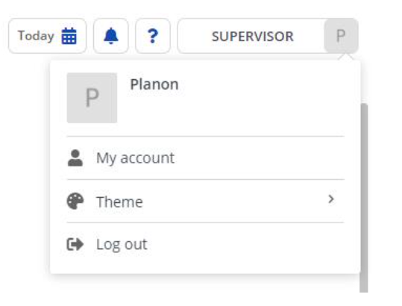

To change the theme to dark mode or high contrast please follow the steps below:

1. Click on the button with your username.
2. Click on ‘Theme’.
3. Select Dark Theme or High Contrast Theme.

MyCampus’s self-service gadgets allow users to submit, view and edit Service requests (detailed in 1.2) from the MyCampus homepage.

Breakdown of the Service Request Tiles
Only selected Contractors, Fire Team and Security Operations Team can raise service requests for residential buildings. If you are a selected Contractor, Fire Team, or Security Operations Team member your Service requests are broken down into two categories: Academic buildings and Residential buildings. Within these categories you will find identical sets of Service Request tiles though which you can raise a variety of requests to the Helpdesk.

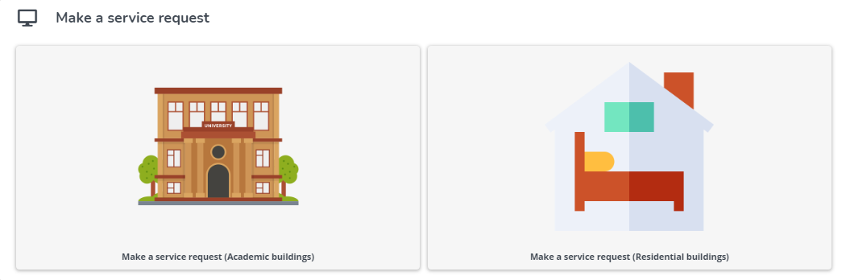

If you belong to the other user’s group than selected Contractors, Fire Team or Security Operations Team, you will be presented with the twelve service requests tiles directly on the homepage.

- Barriers & gates
- Ceiling issues
- Door issues
- Fixture/fittings issue
- Flooring issue
- Furniture repair
- Internal wall issue
- Paint required
- Signage issue
- Stairs issue
- Window issue

- Floor cleaning request
- Pest control issue
- Hygiene item refill request
- Room cleaning request
- Other cleaning request

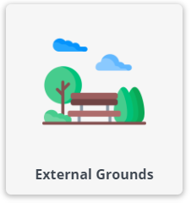

- Bicycle rack issue
- Graffiti
- Landscaping
- Pavement damage
- External building façade
- External drains and guttering
- Roller shutter doors
- Other external grounds issue

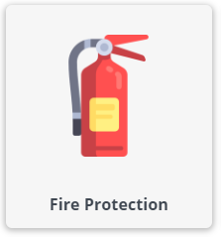
- Call point issue
- Fire door fault
- Fire panel indicating fault
- Fire-fighting equipment
- Sounders/beacons

- Too hot
- Too cold

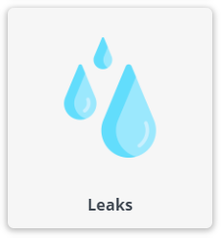

- Floor or drainage leak
- Leak from unknown source
- Leaking radiator
- Sewage leak
- Wall and ceiling leak

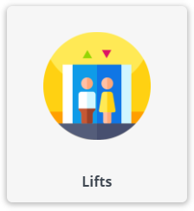
- Lift alarm sounding
- Lift autodialer faulty
- Lift not levelling
- Lift not moving
- Lift not responding to calls
- Other fault with lift
- Person stuck in lift

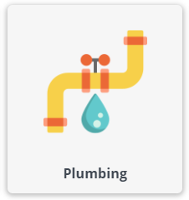

- Noise from pipework
- Sewage smells
- Drinking water taps/faucets
- Hot and/or cold water supply
- Washrooms

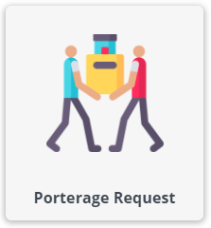

- Moving equipment
- Moving furniture

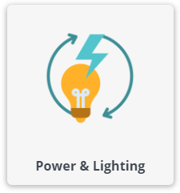
- External lights not working or flickering
- Fitting damaged
- Internal lights not working or flickering
- Report loss of power to chiller/freezer
- Report loss of power to room(s)
- Report loss of power to socket(s)
- Other power or lighting issue

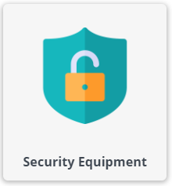

- Access control
- Alarms
- CCTV
- Intercom
- Security incidents

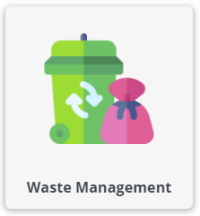

- Request confidential waste removal
- Request external waste bin collection
- Request internal waste collection
- Specialist waste removal

How to Raise a Service Request Using a Service Tile
Only selected Contractors, Fire Team and Security Operations Team can raise service requests for residential buildings. If you are a selected Contractor, Fire Team, or Security Operations Team member:

1. Navigate to the “Make a Service request” gadget on the MyCampus homepage and select the relevant category: Academic buildings or Residential buildings. Once you click on ‘’Make a service request (Academic buildings) or ‘’Make a service request (Residential buildings) gadget, you will be presented with the twelve service request tiles to choose from.

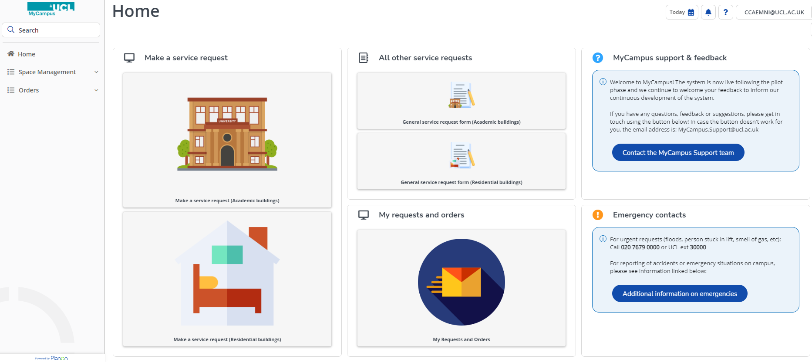

If you belong to the other user’s group than selected Contractor, Fire Team, or Security Operations Team, you will be presented with the twelve service request tiles directly on the homepage.

- Click on the “tile” that relates to the issue that you’d like to report (for example, Waste Management or Heating, Cooling & Ventilation).
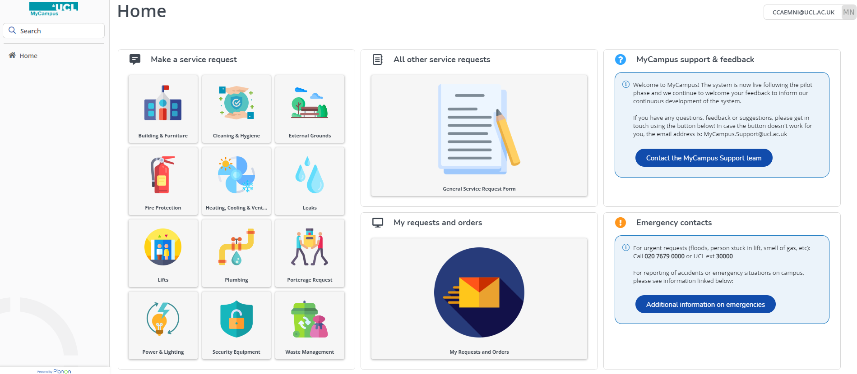

- Depending on the tile you select initially, there may be another sub-set of tiles, or one or more request forms listed.
- Drill down to the required Service request and click on it.
- A pop-up window will launch with a Service request form.
- Populate all the fields, if possible. Fields with red asterisks next to them are mandatory and must be populated before submitting the form. Note that if you are a residences user, you will only be able to populate the property field with residence properties.
- ‘Opt-in to email notifications’ – option ‘Yes’ is selected by default where you will receive email notifications with the updates (‘Work Order Raised’, ‘Work Order Completed’ and ‘Customer Satisfaction Survey’). If you do not wish to receive any email notifications (with exception to the Customer Satisfaction Survey), select option ‘No’.
- Upload any relevant files or images (such as photos of the issue you are reporting).
- Click submit.
- Once you have submitted your Service request, you can close the window.
- Service requests can be viewed and edited (while at the initial “reported” status) in the My Requests and Orders gadget.

How to Raise a Service Request Using a General Service Request Form

If you are not able to identify the Service tile listed on the homepage, you can use the General Service Request gadget instead. You will have to provide a short summary of your request and a brief description of the issue.

Only selected Contractors, Fire Team and Security Team can raise service requests for residential buildings. If you are a selected Contractor, Fire Team, or Security Operations Team member:

- On the MyCampus homepage, under the section titled “General Service Request Form”, select the gadget for either Academic buildings or Residential buildings.

If you belong to the other user’s group than a selected Contractor, Fire Team, or Security Operations Team:

- Click on the “All other service requests” gadget on the MyCampus homepage.

- A pop-up window will launch with a Service request form.
- Populate all the fields, if possible. Fields with red asterisks next to them are mandatory and must be populated before submitting the form. Note that if you are a residences user, you will only be able to populate the property field with residence properties.
- ‘Opt-in to email notifications’ – option ‘Yes’ is selected by default where you will receive email notifications with the updates (‘Work Order Raised’, ‘Work Order Completed’ and ‘Customer Satisfaction Survey’). If you do not wish to receive any email notifications (with exception to the Customer Satisfaction Survey), select option ‘No’.
- Upload and relevant files or images (such as photos of the issue you are reporting).
- Click submit.
- Once you have submitted your Service request, you can close the window.
- Service requests can be viewed (and edited while at the initial “reported” status) in the My Requests and Orders gadget.

Duplicated Requests
If the service request you are trying to submit is a duplicate request, you will receive an alert and you will be able to either dismiss the alert and continue to raise the request or cancel it. The criteria for a duplicate request, is the same request type, submitted in the same room, within the last hour.
You should proceed with submitting the service request if you wish to receive the updates against the issue.

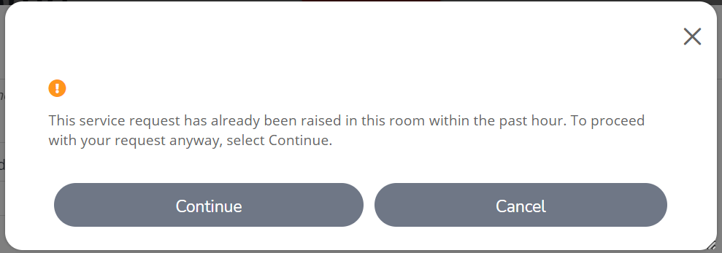

How to View and Edit a Service Request in the My Requests and Orders Gadget
The My Requests and Orders gadget allows you to view (and edit, where still in the initial ‘Reported’ status) any Service requests that you have made. This is also where you are able to track the progress against your requests.

- Go to the “My Requests and Orders’ gadget on the MyCampus homepage.
- Click on it to view a list of Service requests that you have previously submitted.
- The list has filters at the top of the page. Use these to help you find the required Service request.

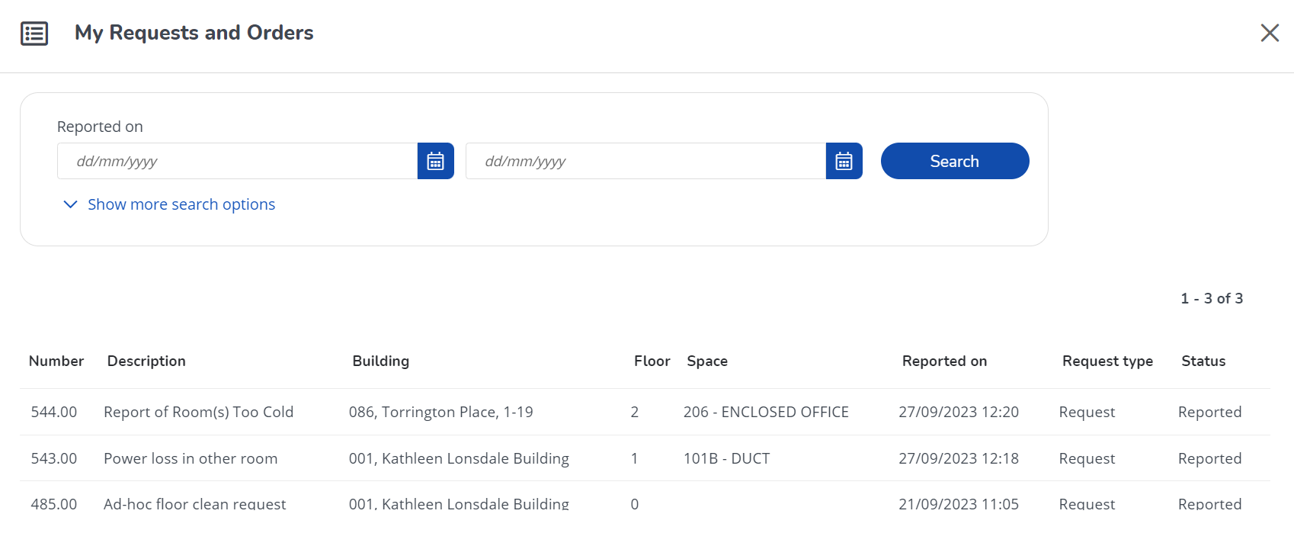

Clicking Show more search options will expand the list of filters:

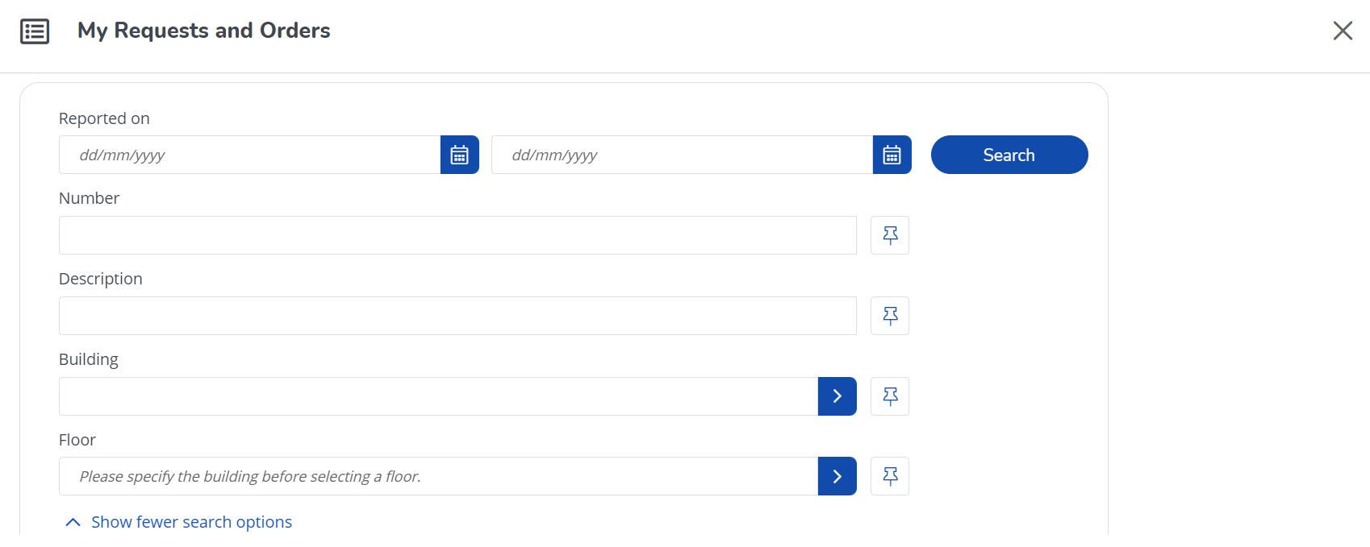

- Click on a Request to view the details. These will include the details that you provided, as well as updates from the operatives assigned to your request.
- There is also a Work orders section which provides some detail on the work orders generated in response to your Service request.
- To edit your request (only possible whilst the request is in initial ‘Reported’ status), scroll to the bottom of the page and click on the blue edit button.
- Make your edits or add additional files or images as required and click Submit. Note
that some fields cannot be edited, such as Number, Reported on and Status.

Completed Service Requests
Completed Service requests will show on My Requests and Orders Gadget for 30 days after the date of completion. If the Service request has been successfully completed and you have confirmed through the feedback form that you are happy with the completed Service request, this request will be removed from My Requests and Orders Gadget even though 30 days haven’t passed by yet. If you have submitted an unsatisfied response to the feedback form, the request will continue to show until the request has been satisfactorily resolved.

Feedback Form

Once your service request has been successfully completed, three days after the service request completion, you will receive the email notification, where you will be able to provide your feedback.

Please follow the steps below:

- Click on one of the following icons: green, orange or red face.
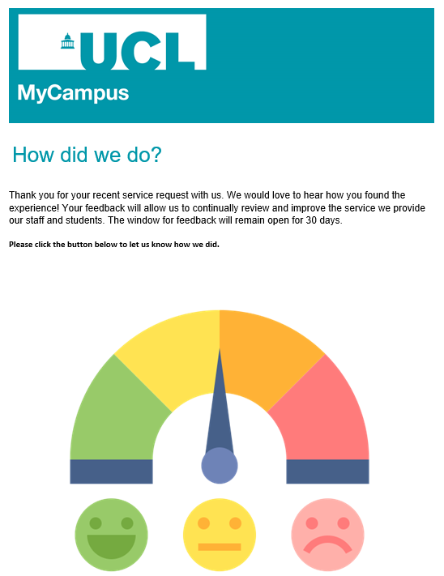

- Click on ‘Satisfied’ or ‘Unsatisfied’ button:

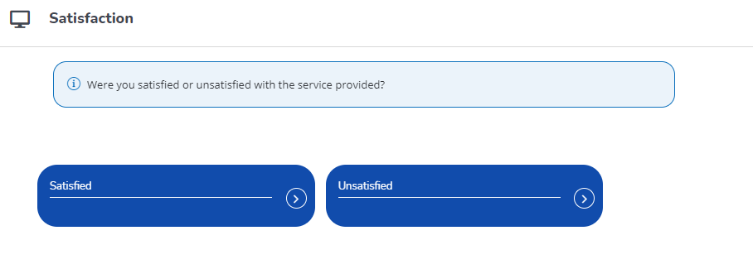

- Provide the feedback within the comments section and click on Submit button:

Re-opening Requests

If for any reason you think that your service request hasn’t been completed even though you have received the email notification that your request has been successfully completed, you can re-open the request by submitting a ‘unsatisfied’ response to the customer-satisfaction form, stating the work is not complete. This will trigger an alert to the Helpdesk team who will raise re-open the request and raise work order for remaining works.

MyCampus Support & Feedback
Click on the ‘Contact the MyCampus Support team’ button if you have any questions or you would like to provide feedback.

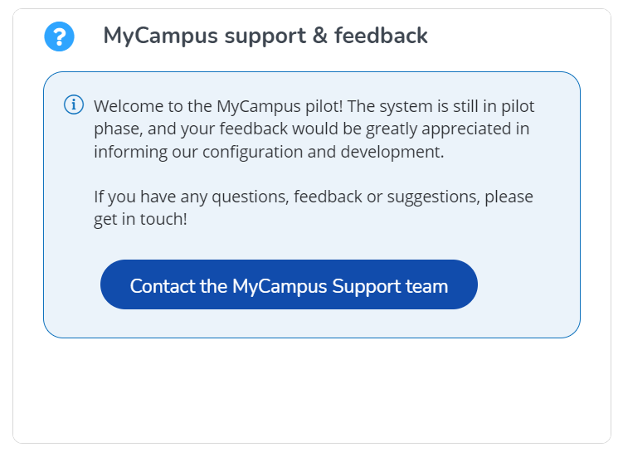

Emergency contacts
The emergency contact details are displayed on the homepage.

By clicking on the ‘Additional information on emergencies’ button, you will be redirected to the UCL page for Accidents and Emergencies:

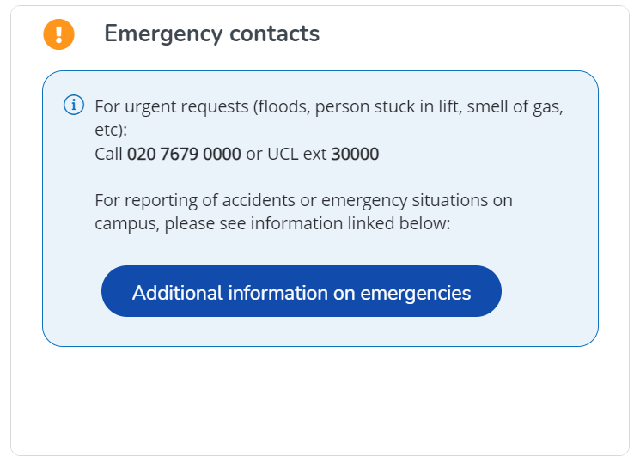

User Guide Journey

To go back to the chapters page, please click here

Work Orders Report Gadget
You can run a report with all the work orders raised across the pilot buildings by using the ‘Work orders report’ gadget located on the homepage.

- Click on ‘Work orders report’ gadget on the homepage:
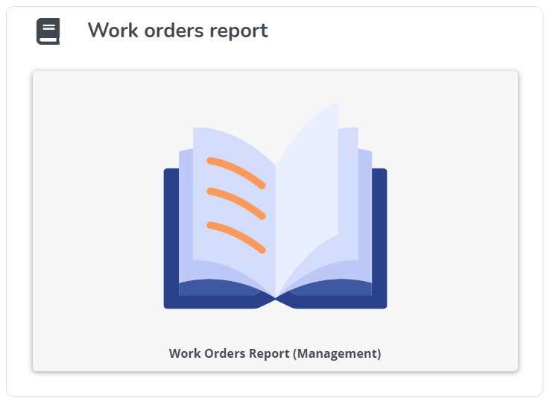

- Use a search function to narrow down your search. You can search by: Reported Between, Building, Floor, Number, Description:

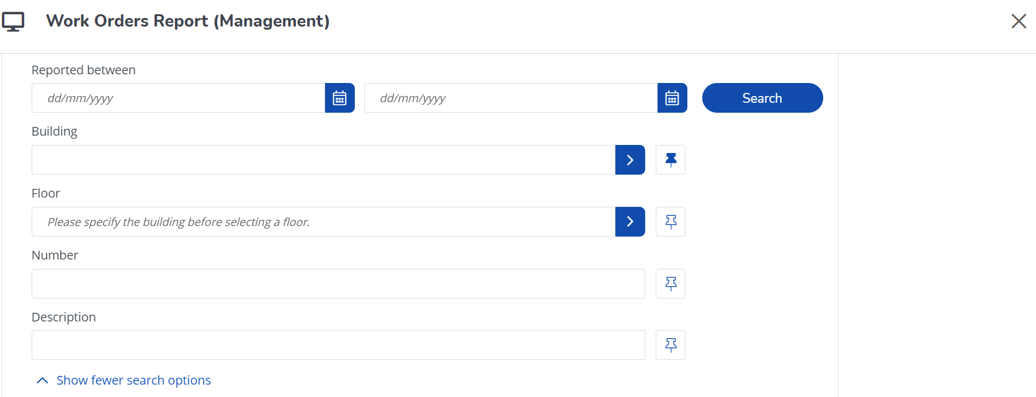

- Click on ‘Search’ button.

- Click on 'Print Results' icon in the top right corner to print the report:

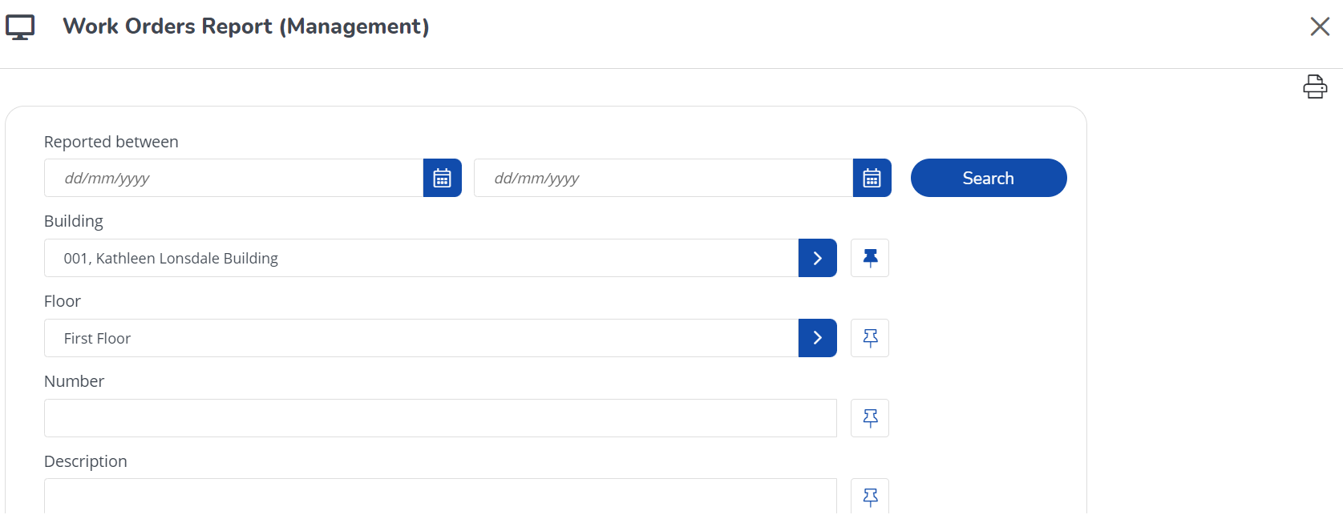

User Guide Journey

To go back to the chapters page, please click here

Open Work Orders Gadget
If you are a part of the Student’s Accommodation Team, you can run a report with all the open work orders raised across the residential buildings by using the ‘Open work orders’ gadget located on the homepage.

- Click on ‘Open work orders’ gadget on the homepage:
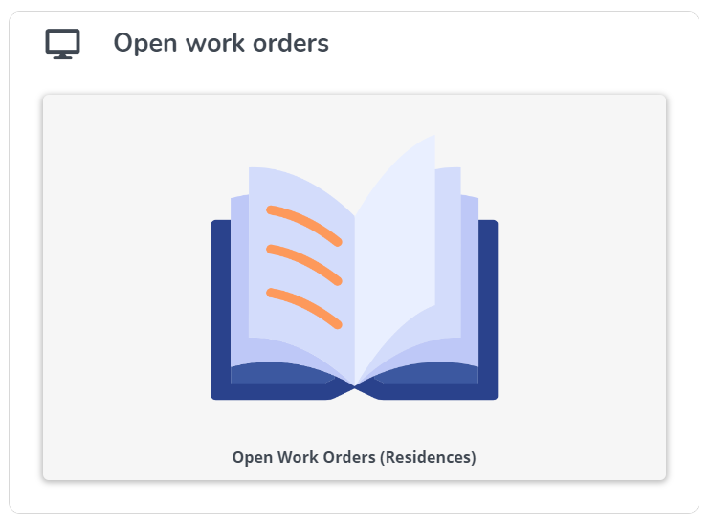

- Use a search function to narrow down your search. You can search by: Building, Service team, Order number and Description:

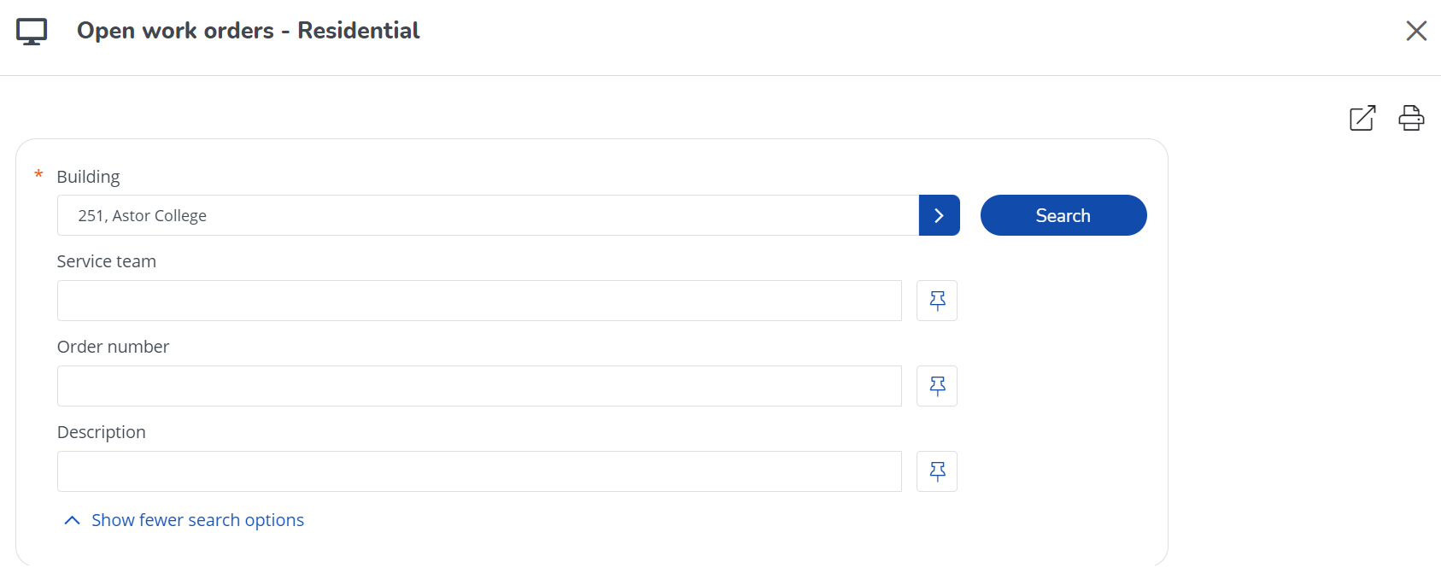

- Click on ‘Search’ button.

- Click on 'Export to Excel' icon in the top right corner to export the report into Excel:

- Click on 'Print Results' icon in the top right corner to print the report:

User Guide Journey

To go back to the chapters page, please click here

Floor Plans

How to view Floor Plans without mapping
- Go to the “Floor plans” gadget on the MyCampus homepage.

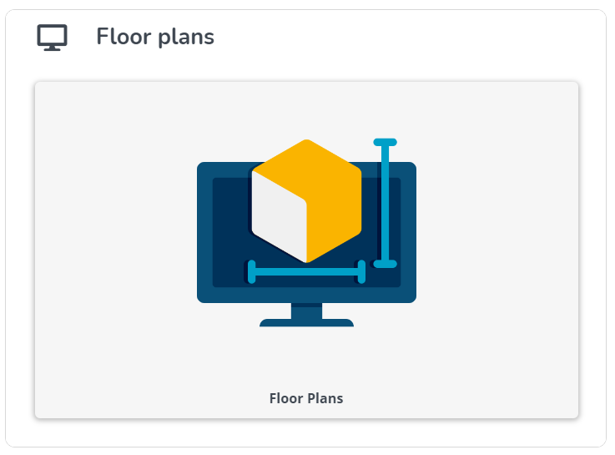

- Click on it to launch the Floor plans window.
- Select a Property and Floor (these are mandatory fields, as indicated by the red asterisk) for the floor plan that you would like to view:

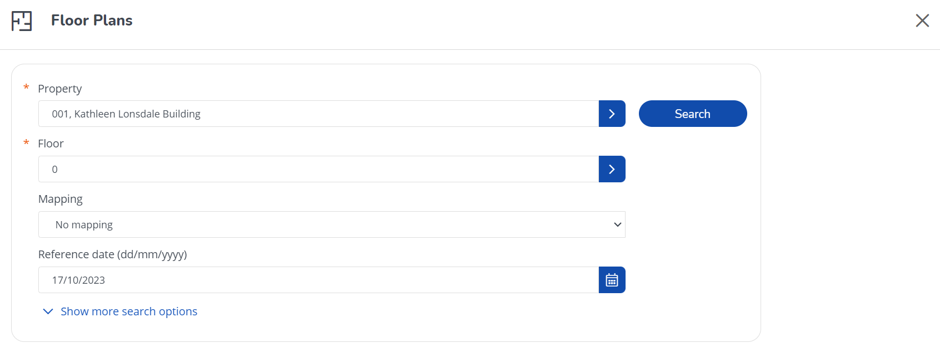

- The mappings field can be left as “No mapping”. For mappings, please refer to the next section.
- The reference date can be used to see past or future versions of CAD plans (if available) or can be left as today’s date, which is the default value.
- Click search and the relevant floor plan will be loaded:

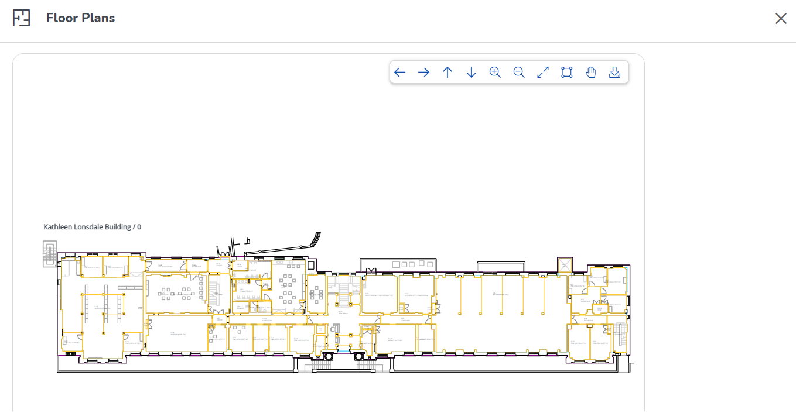

- On the top right of the viewer there is a toolbar, with buttons for moving the floor plan left and right and vertically and horizontally, zooming in and out, zooming to the extents of the drawing, zooming within a selection, panning, and printing to PDF. These buttons are outlined below from left to right:

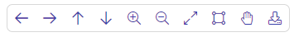
- Move view to the left.
- Move view to the right.
- Move view up.
- Move view down.
- Zoom in.
- Zoom out.
- Return to default zoom.
- Select area to zoom.
- Pan view – move plan around.
- Save plan to PDF.

How to View Floor Plans with Mappings
Mappings can be used to show a floor plan colour-coded by department, Space type etc. A legend is also generated, which lists the total area for each department, space type etc. and the “count” (number of rooms that belong to the department, space type etc.).

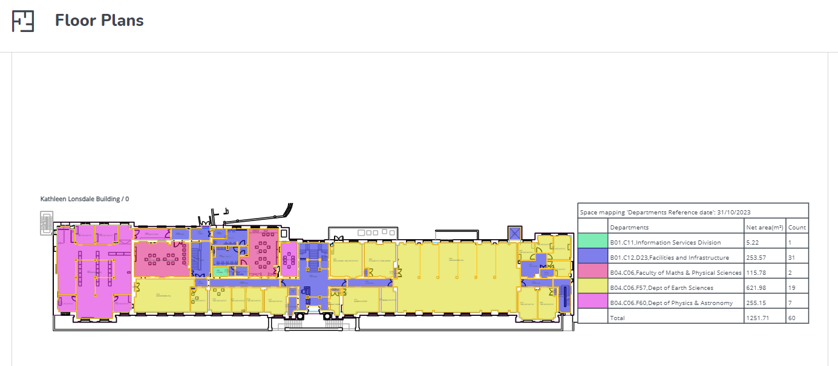

- Go to the “Floor plans” gadget on the MyCampus homepage.

- Click on it to launch the Floor plans window.
- Select a Property and Floor (these are mandatory fields, as indicated by the red asterisk) for the floor plan that you would like to view.

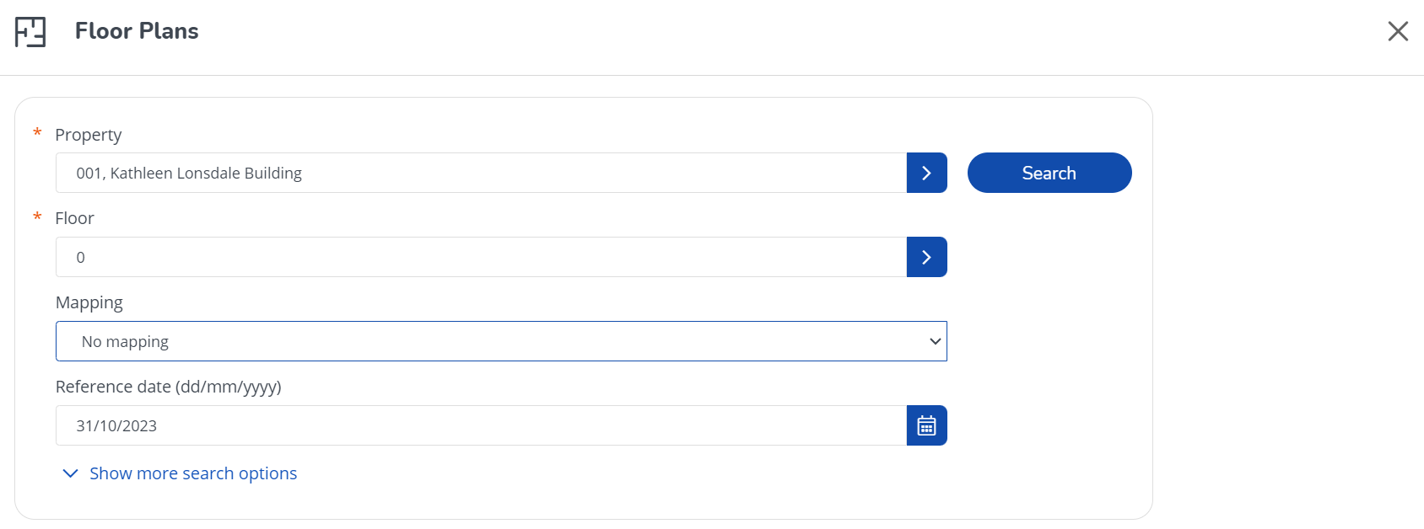

- Select the type of mapping that you would like to view.

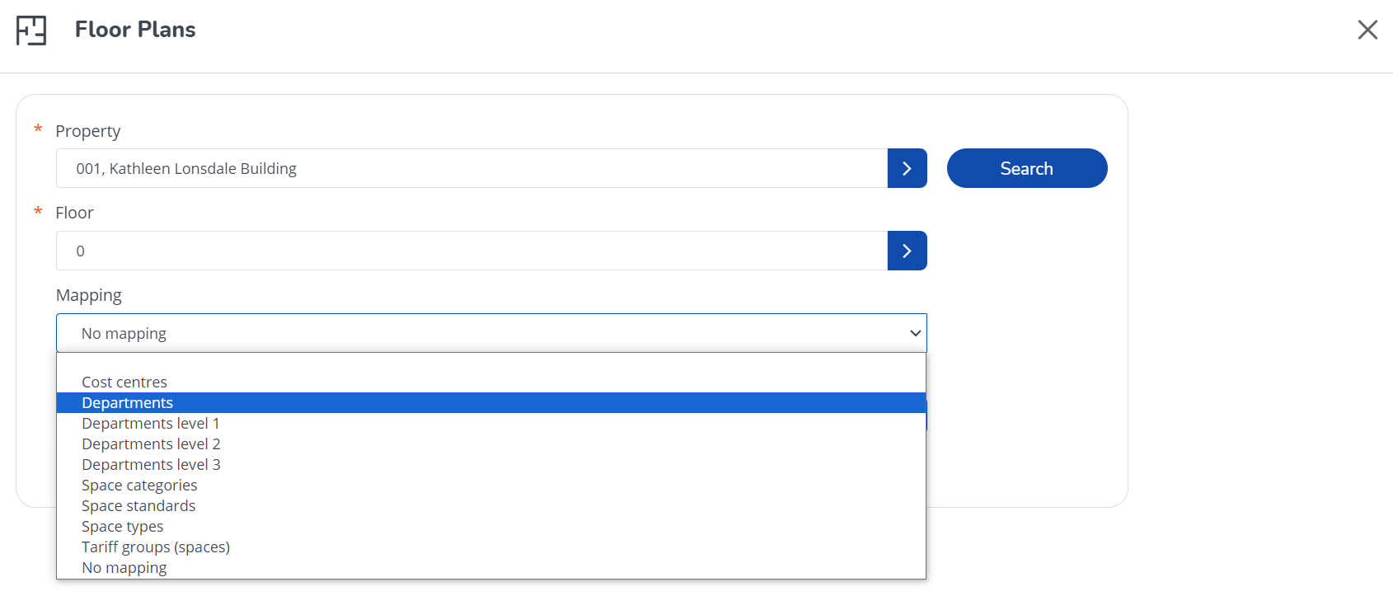

- The reference date can be used to see past or future versions of CAD plans (if available) or can be left as today’s date, which is the default value.
- Click search and the relevant floor plan will be loaded with the selected mapping.

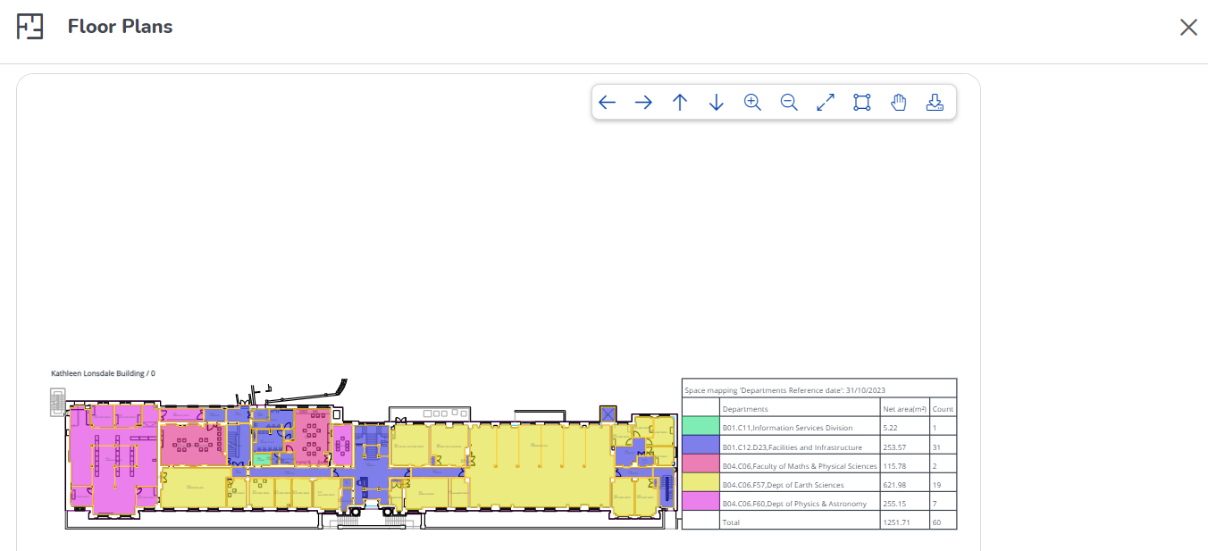

- On the top right of the viewer there is a toolbar, with buttons for moving the floor plan left and right and vertically and horizontally, zooming in and out, zooming to the extents of the drawing, zooming within a selection, panning, and printing to PDF. These buttons are outlined from left to right below:

- Move view to the left.
- Move view to the right.
- Move view up.
- Move view down.
- Zoom in.
- Zoom out.
- Return to default zoom.
- Select area to zoom.
- Pan view – move plan around.
- Save plan to PDF.

User Guide Journey

To go back to the chapters page, please click here

Spaces & Workspaces
Within this section you can view:

- Properties
- Components (Floors, Zones, Space Categories, Space Types, Departments, Cost Centres, Tariff Groups, Space Standards, Free Attributes, Communication Logs – Properties, History – Properties)
- Spaces (Spaces and Floor Attributes)

- Navigate to the ‘Estates Management’ icon on the left-hand side of the homepage and click on the drop-down arrow.
- Click on ‘Spaces & Workspaces’ tab.
- Navigate to the ‘Properties’ selection level.
- Select the property from the list:

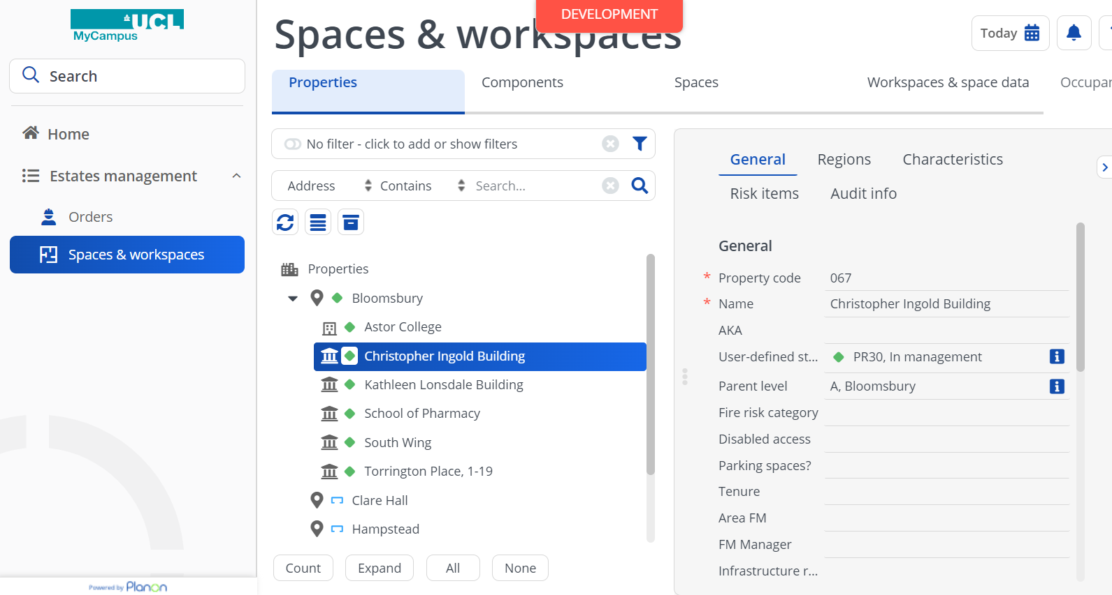

- Navigate to the ‘Spaces’ selection level.
- Select the space and the floor.
- To view the details of the space, click on the Data view icon on the right-hand side:

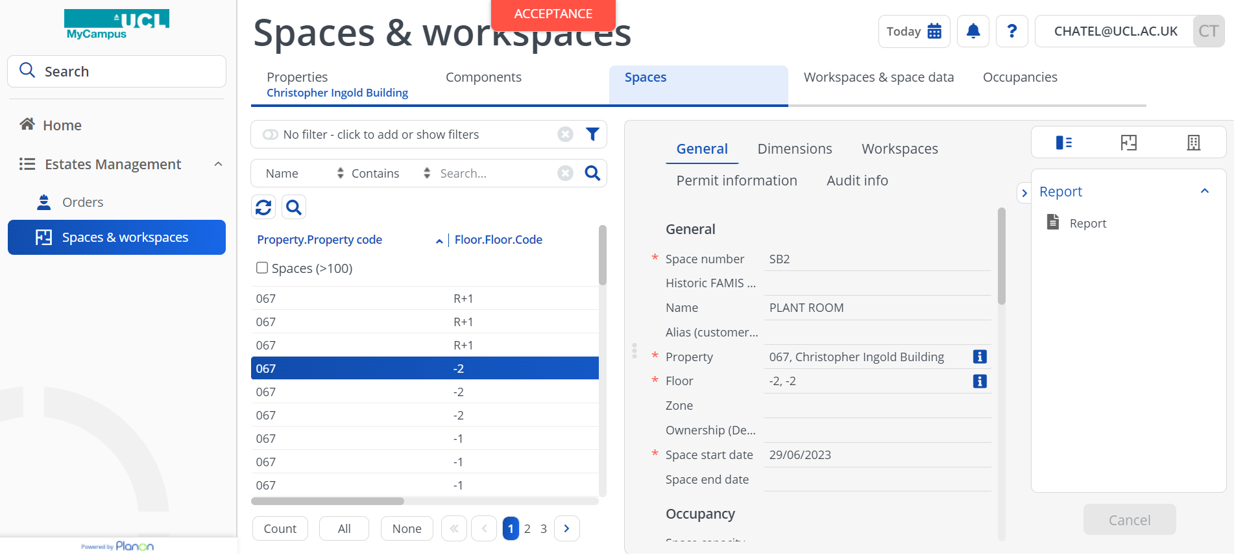

- To view the CAD drawing of the selected space, click on the CAD Integrator icon on the right-hand side:

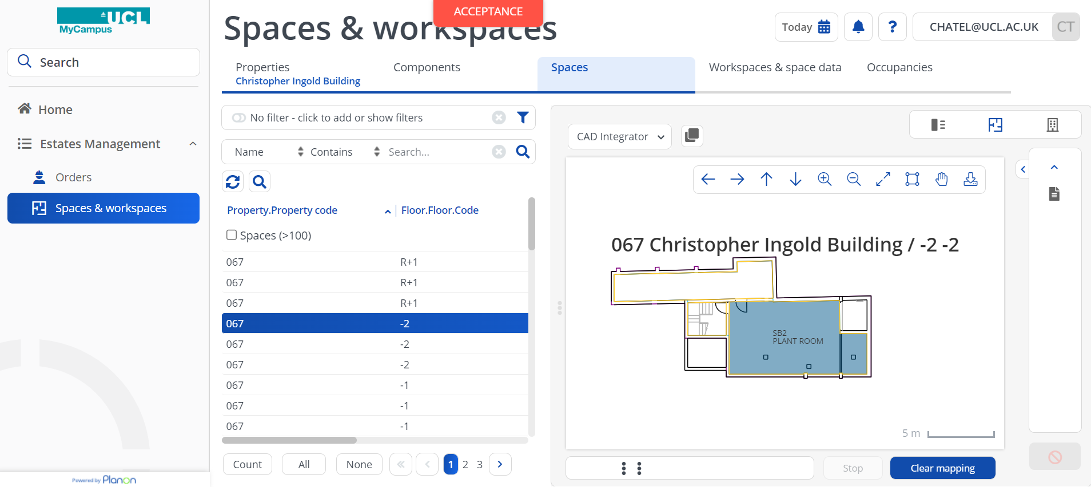

The plan menu can be used to move around, zoom in and out and download the plan, the buttons are outlined below from left to right:
- Move view to the left.
- Move view to the right.
- Move view up.
- Move view down.
- Zoom in.
- Zoom out.

- Return to default zoom.
- Select area to zoom.
- Pan view – move plan around.
- Save plan to PDF.

- To view the Floor attributes, select the ‘Floor attributes’ option within ‘Spaces’ section:

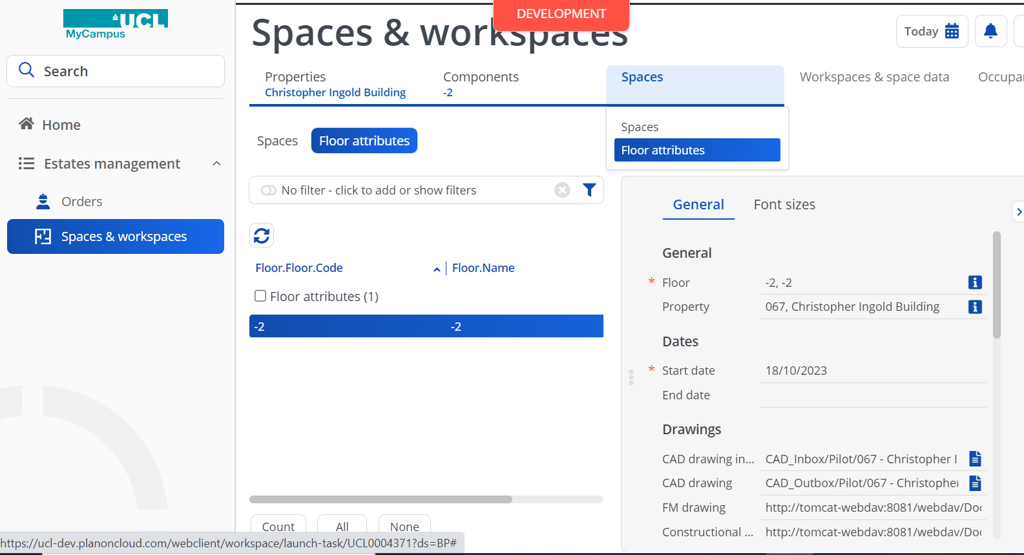

User Guide Journey

To go back to the chapters page, please click here

Orders TSI

How to View Requests in the Orders TSI
The Orders TSI can contain different types of Orders, such as Requests and Work Orders. Requests can have sub orders, which are usually Work Orders. Requests capture the details provided by the UCL member, whereas Work Orders are meant for the tradesperson and may contain more technical details about how the job is to be completed. Please note that in MyCampus, “Work Orders” are called “Orders”. The below describes the process for viewing Requests:

- Navigate to the Orders TSI.
- Navigate to the Orders selection level.
- You can differentiate between different types of orders in the elements list based on their icons. The below is used for Requests:

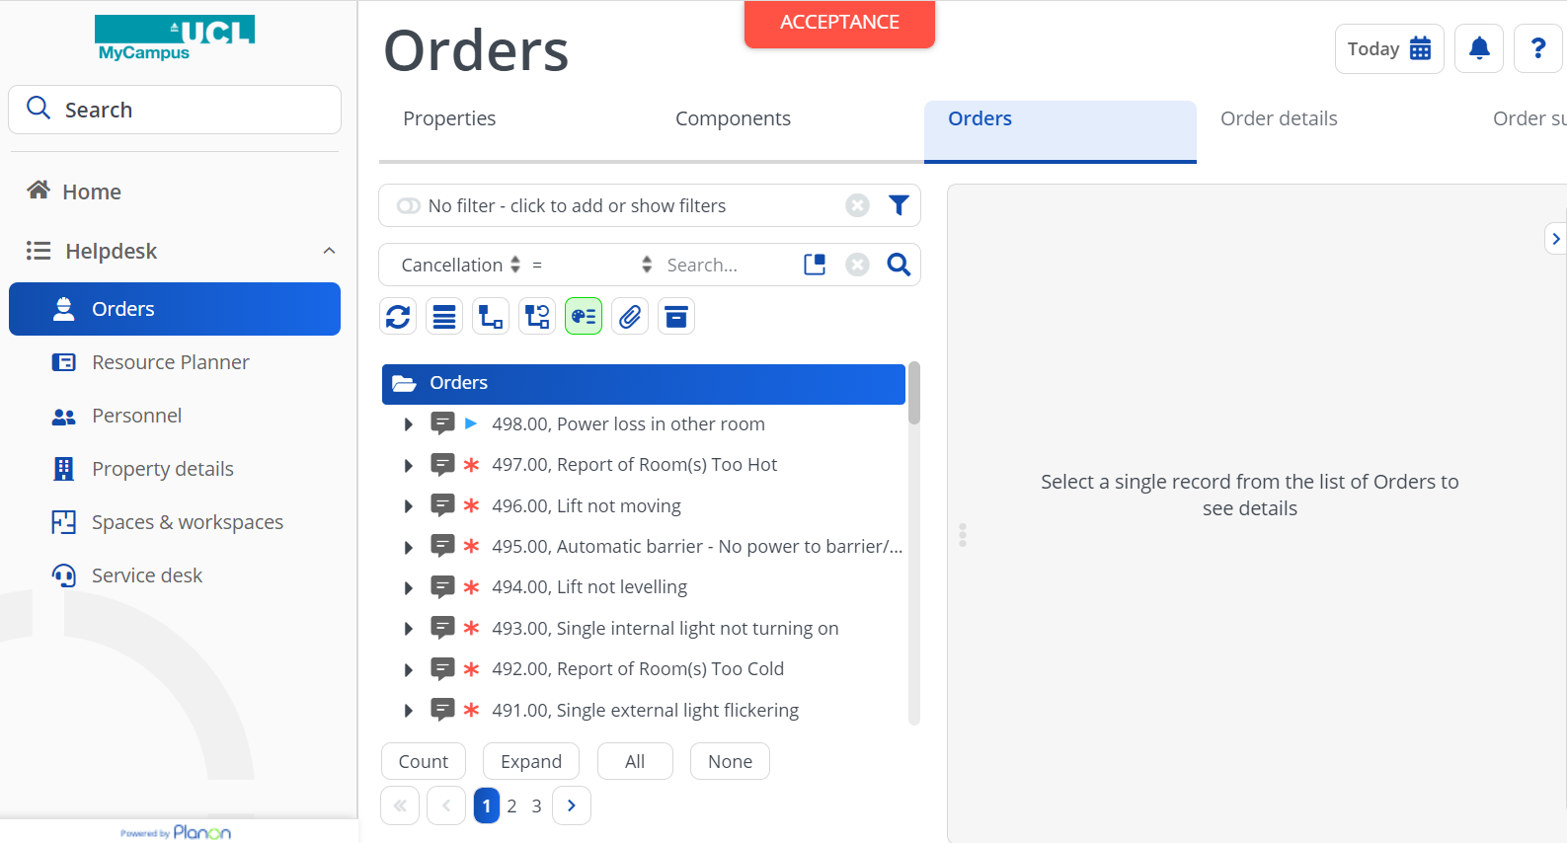

- View the elements list. The elements list has a scroll bar to help you to view the list and a pagination tool at the bottom, which allows you to view Requests (and any other types of Order) on other pages.

- Select the Request that you are looking for by clicking on it in the list.

- View the details of the request in the data view to the right of the selected request. Note that there are several tabs that show different types of information about the Request: General, Actions done/Notes, SLA/Costs, Communication logs, Audit Info.

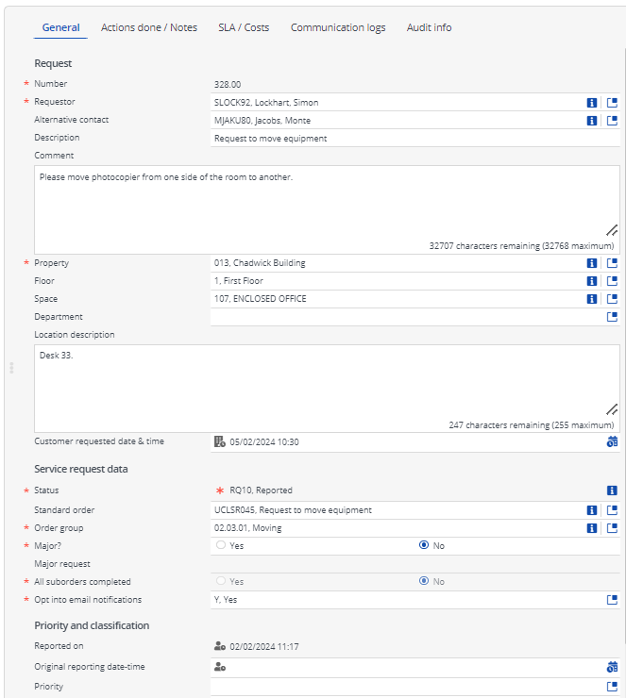

Understanding Request Tabs
There are several tabs containing details of the Request:

- General

This tab is visible when you first select the Request. It contains the main information about the Request, such as the Number, Requestor, Property, Floor, Space, Comment etc.

- Actions done/Notes

This tab allows the helpdesk user to add notes to the Request.

- SLA/Costs

This tab provides details about any costs. It totals all estimated costs that have been added to the sub-orders as well as costs relating to labour hours spent on the job. The SLA related fields are only populated at the Request level if you are using “internal SLAs”. These are SLAs which can be communicated to the customer and can be different to the SLAs communicated to the tradesperson (these show in the SLA tab at the order level).

- Communication logs

This tab provides a summary of any communication logs created at the request level. It can include messages from the Requestor from the MyCampus gadget, messages from the tradesperson carrying out the work etc.

- Audit info

This tab is used to show when the Request was created and who it was created by. It also shows when the Request was last modified and who modified it. For more detailed information about historical changes to values in Request fields, the “History” selection step can be used (at the Order details selection level).

How to View Orders in the Orders TSI
Work orders are simply called “Orders” in MyCampus. They are often (but not always) created as “sub-orders” of a Request and the relationship between them is often described as “parent and child”, with the Request being the parent and the Order being the child. The below describes the process for viewing orders when they are not sub orders:

- Navigate to the Orders TSI.
- Navigate to the Orders selection level.
- You can differentiate between different types of orders in the elements list based on their icons. The work order can be also found by clicking on the arrow to the left of speech bubble. The below is used for Orders:

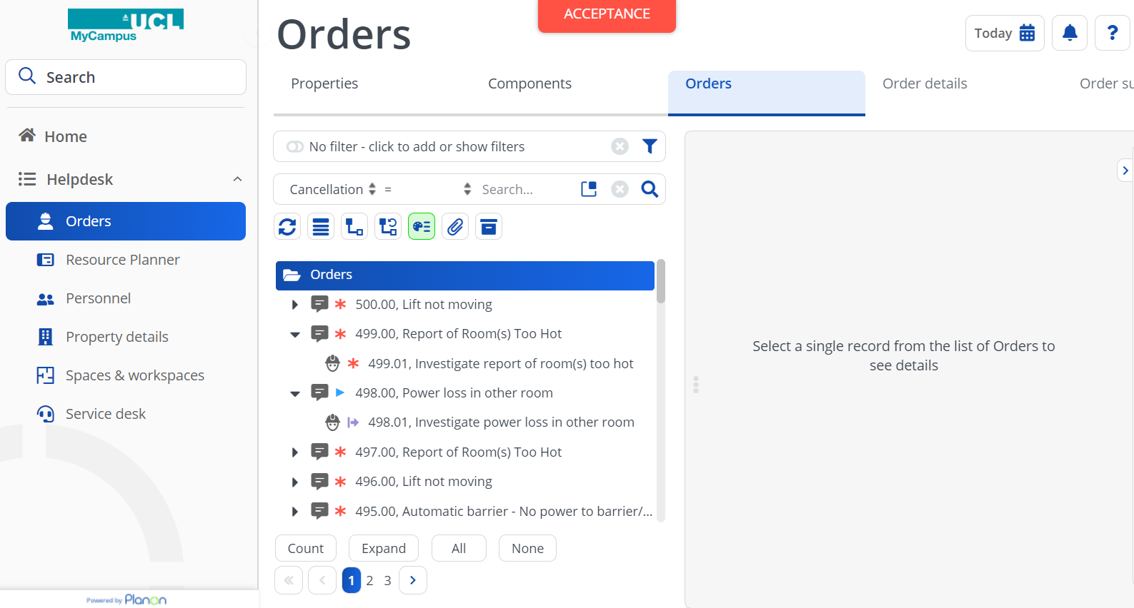

- View the details of the order in the data view to the right of the selected request. Note that there are several tabs that show different types of information about the Order: General, SLA, Duration/Costs, Health and Safety, Internal notes, Communication logs, Audit info.

Understanding Order Tabs
There are several tabs containing details of the Request:

- General

This tab is visible when you first select the Order. It contains the main information about the Order, such as the Number, Requestor, Property, Floor, Space, Comment, tradespersons etc. The comment and description can be used to provide a more detailed (than the request) and more technical explanation of the work to be carried out by the tradesperson.

- SLAS

This tab provides details about any SLAs, which are used to define when certain actions are due to be carried out by the tradesperson/contractor. SLAs at the work order level are called “External SLAs”. The below explains the SLAs shown in the Orders tab:

  - Time To Respond (TTR) – from the Reported on to the first ‘Accepted’ status.
  - Time To Attend (TTA) – time from the Reported on to the first ‘In progress’ status. (The only SLA that is visible to the Requester)
  - Time To Fix (TTF) – time from the Reported on to the first ‘Temporary fix’ status.
  - Time To Complete (TTC) – time from Reported on to the first ‘Technically completed’ status.
- Duration/Labor

This tab provides the details about the duration of the work order (when it was reported on, the date it was accepted, technically completed, and administratively completed) and the total of the labour hours spent on the order.

- Health and safety

This tab provides the details of any work permits linked to the Order.

- Internal notes

This tab allows the help desk user to add internal notes to the Order.

- Communication logs
This tab provides a summary of any communication logs created at the Order level. It can include notes/messages from the tradesperson carrying out the work.

- Audit info

This tab is used to show when the Order was created and who it was created by. It also shows when the Order was last modified and who modified it. For more detailed information about historical changes to values in Order fields, the “History” selection step can be used (at the Order details selection level).

How to View Work Orders Associated to a Service Request in the Orders TSI
The below describes the process for viewing work orders associated to a service request:

- Navigate to the Orders TSI.
- Navigate to the Orders selection level.
- On the left side of the selected Request, you will see an expander arrow, as shown below:

- Select the work order by clicking on it in the list.
- View the details of the order in the data view to the right of the selected request. Note that there are several tabs that show different types of information about the Order: General, SLA, Duration/Costs, Health and Safety, Internal notes, Communication logs, Audit info.

How to Assign the Work Order to the Operative in your Team in the Orders TSI

As a Tier 1 or Tier 2 Contractor’s Administrator, you can assign the work order to one of your team members through the orders TSI without specifying the date and time of the work.

  - Navigate to Orders TSI section.
  - Select the property you would like to see the work orders for.
  - Navigate to the Orders section.
  - Select the work order you would like to assign to.
  - Scroll down to the ‘’Service Data’’ section.
  - Click on the blue icon within the ‘’Internal Tradesperson’’ field and select the contractor from the drop-down list.
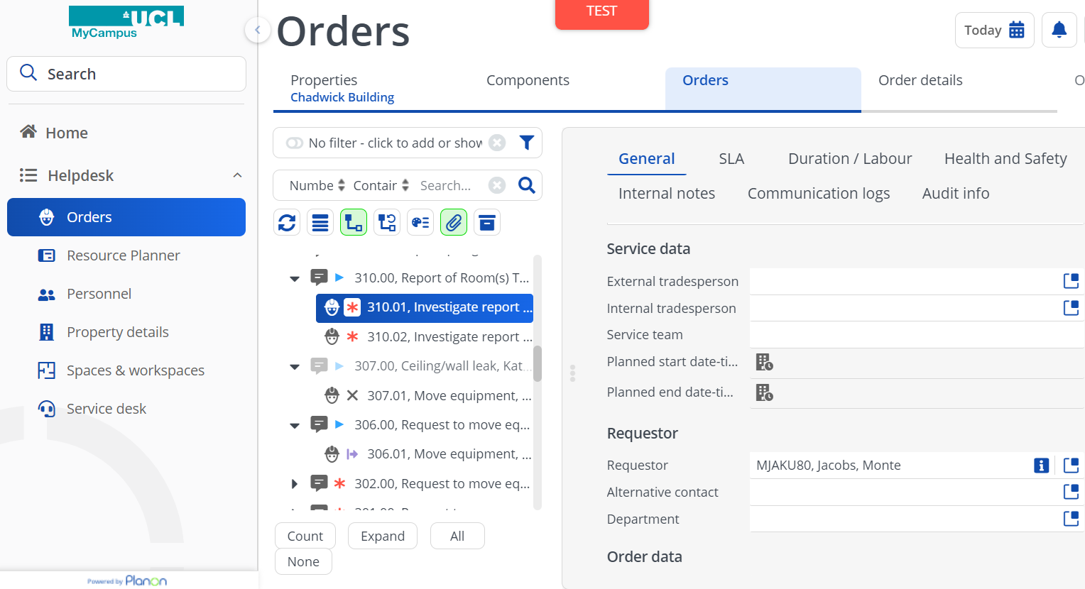

  - Click on ‘’Save’’ button.

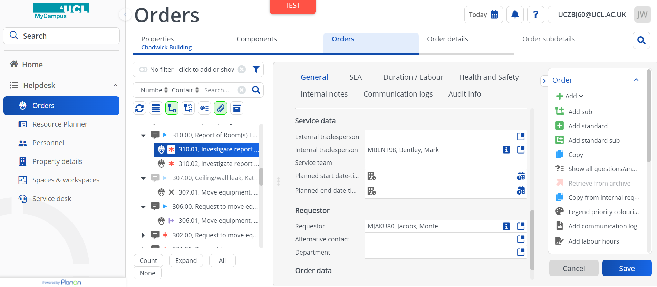

Please note that if you would like to assign the work order within specified period (date and time), use the Resource Planner.

How to Send the Job Card to the Sub-Contractor
As a Tier 1 or Tier 2 Contractor’s Administrator, you can send a job card to the sub-contractor.

- Navigate to Orders TSI section.
- Select the property associated with the work order you would like to send.
- Navigate to the Orders section.
- Select the work order you would like to send as a job card to the sub-contractor and click on the ‘Report’’ within the action panel on the right-hand side to display reporting window:

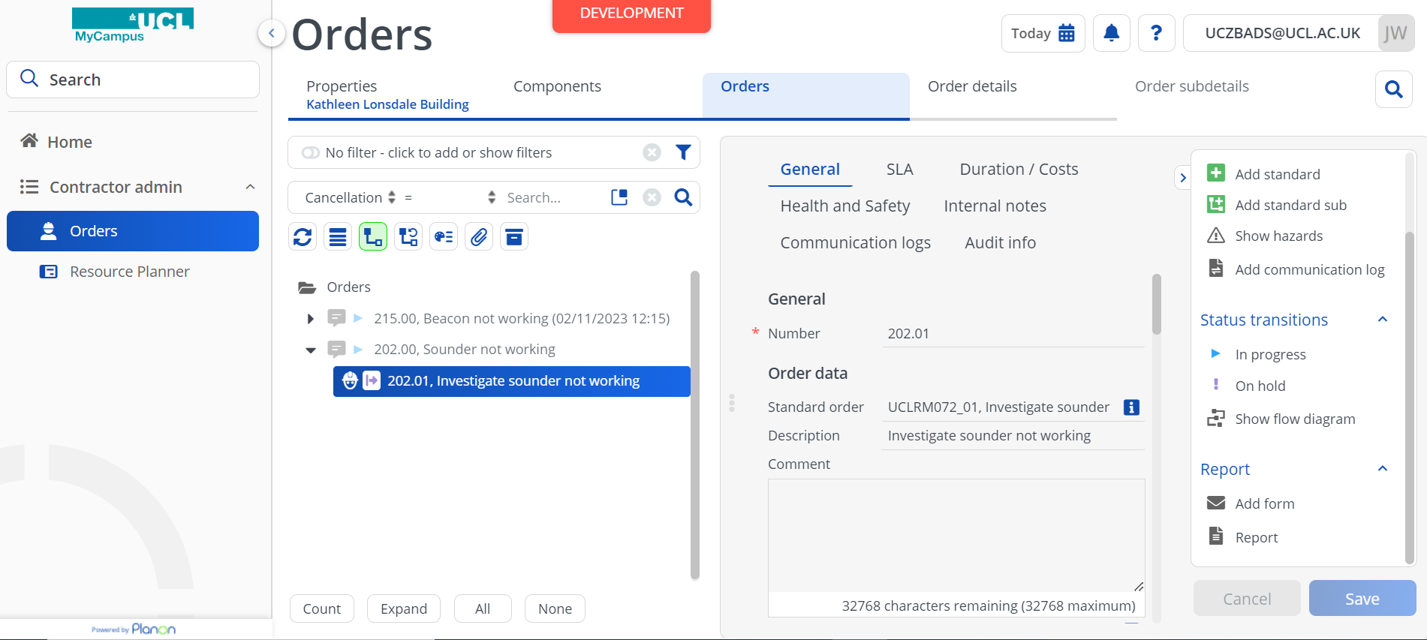

- Select Work Order Assigned – Job Sheet and click on ‘Save as’ button:

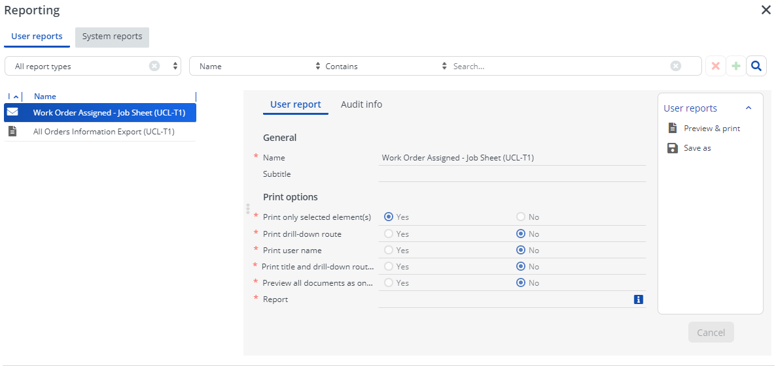

- In the Save As pop-up window, select a type of the document (PDF or Word) and click OK to generate the job sheet and save it on your computer.

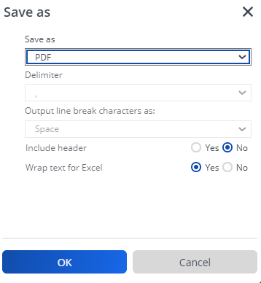

- Email the Job Sheet to the contractor and move the work order to the ‘In Progress’ status within the action panel on the right-hand side.
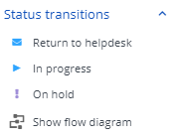

- Change the status transitions upon confirmation from the sub-contractor or Tier 3 contractor in progress of the work order. E.g., Completed.

How to Use List View and Tree View
The Orders TSI allows you to view elements (i.e., all of the Orders and Requests) as a list instead of the “tree view”. The Tree view is the default and has sub orders “hidden” beneath parent requests. Users have to use the expander arrow to see any sub orders that belong to the request, as per the below:

The process for viewing all types of orders in a “flat”, non-hierarchical list is described below:

- Navigate to the Orders TSI.
- Navigate to the Orders selection level.
- Click the “Show list” button at the top of the elements list.

- The list will appear as per the below (you can see all order types and subs with no expander arrows.

- When using list view, the elements list has columns with column headings that can be used to sort the elements in the list, as per the below:

- To sort Orders in list view, click on the column header that you would like to sort the orders by. In the example above, Orders are sorted by start date.
- To return to the “Tree view” click the “Show tree” button shown below, at the top of the elements list:

Filtering Requests and Orders in the Orders TSI Using the Search Bar
Orders (of all types) can be filtered by one criterion (e.g., using the Search bar as per the example below). If you need to filter by more than one search criteria, you can use the filter functionality.

How to Filter by One Property Using the Search Bar

- Navigate to the Orders TSI.
- Navigate to the Orders selection level.
- In the Search bar, change the Search criteria to Property (highlighted in green above).

- If you are only filtering for Orders for one property you can use the “equals” operator, as per the example above.
- Select the property by clicking on the picklist icon (shown below) and then clicking on the required property in the pop-up list.

- The search bar should look similar to the below.

- Click the Search button and the elements list will be filtered to only show orders that have the linked to the property you selected.

- Note that you can achieve the same result by selecting the property at the Properties selection level and then drill down to the orders selection level.

How to Filter by More than One Property Using the Search Bar
Using “In” as an operator instead of “=” allows you to search for Orders for multiple properties. For example, you might want to view all orders for Astor College and the Kathleen Lonsdale building. The below describes the process for this:

- Navigate to the Orders TSI.
- Navigate to the Orders selection level.
- In the Search bar, change the Search criteria to Property.
- If you are filtering for Orders for more than one property you can use the “In” operator.

- To select properties, click the pick list button on the Search bar.

- Clicking the pick list button (when using “In” instead of “=”) will launch the below pop-up window. Select Properties by moving them from the “Available” column, to the “In use” column.

- Click “OK”.
- The Search bar will now look like the below. When the “In” operator is used, instead of “=”, the properties are not named and “Multiple values selected” will be displayed.

How to Filter by Status Using the Filter Bar
The following filters are used in MyCampus ProCenter.

- Personal filters: Filters for personal use can be added, managed, and activated by the end user.

- Temporary filter: As the name suggests, a temporary filter is created for a current search and disappears when you click on any other filter. If you give a name to a temporary filter and save it, it becomes a personal filter.

- Permanent filter: A filter created with search criteria for a quick data selection in the elements list. Typically, your application manager manages permanent filters.
- Navigate to the Orders TSI.
- Navigate to the Orders selection level.
- Just above the Search bar (which is above the elements list), there is Filter bar.

- Click the filter button.
- Select Status as your filtering criteria.

- Select “=” (equals) as your operator (although you can use “In” to filter Orders for more than one particular status).

- Click the pick list button.

- Select the status you wish to filter on from the list displayed in the Status pop up window.
- The list will display statuses for all order types, so it is helpful to know the type of Order you are looking for and to use the search bar in the pop-up window to filter the statuses. In the below example, “Code contains WO” was used to filter the list down to work order statuses, which typically have “WO” as the first letters of their code). Another approach could be to search by business object name, for example.

- Select the status and click “OK”.
- Add a name for the filter if you would like to use it again in future.
- Click “OK”.
- The elements list will now be filtered by the status you selected. In the example below, this is a temporary filter as it has not been given a name.

How to Filter by Order Group Using the Filter Bar
Follow steps 1-4 in the section to above to create a filter.

- Select Order Group as your filtering criteria:

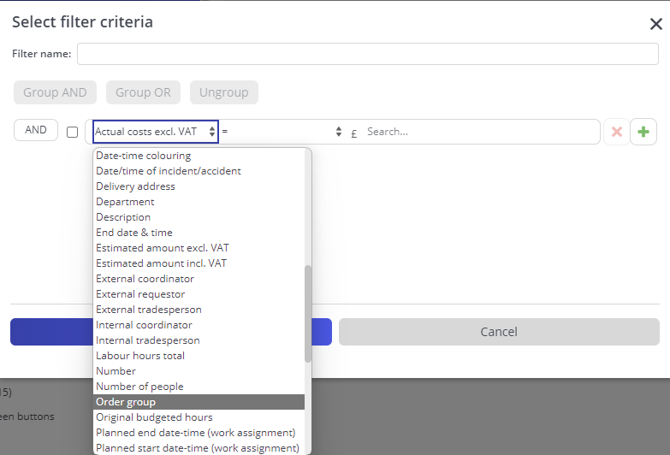

- Select “=” (equals) as your operator (although you can use “In” to filter Orders for more than one particular order group).

- Click the pick list button.

- Select the order group you wish to filter on from the list displayed in the Order Group pop up window.
- Select the required Order Group and click “OK”.
- Add a name for the filter if you would like to use it again in future. Named filters will be available for a use again via drop down from the green search bar. You can use one filter at the time.
- Click “OK”.
- The elements list will now be filtered by the Order Group you selected. In the example below, this is a temporary filter as it has not been given a name.
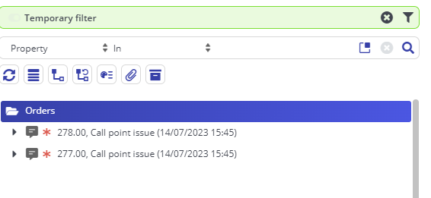

How to View Attachments and Communication Logs
Any documents, images, photographs that have been attached to either a request or a work order can be viewed in the Communications log selection step.

To easily identify orders that have linked documents through communication logs, you can use the Show where documents are attached button located in the element list toolbar (highlighted in green):

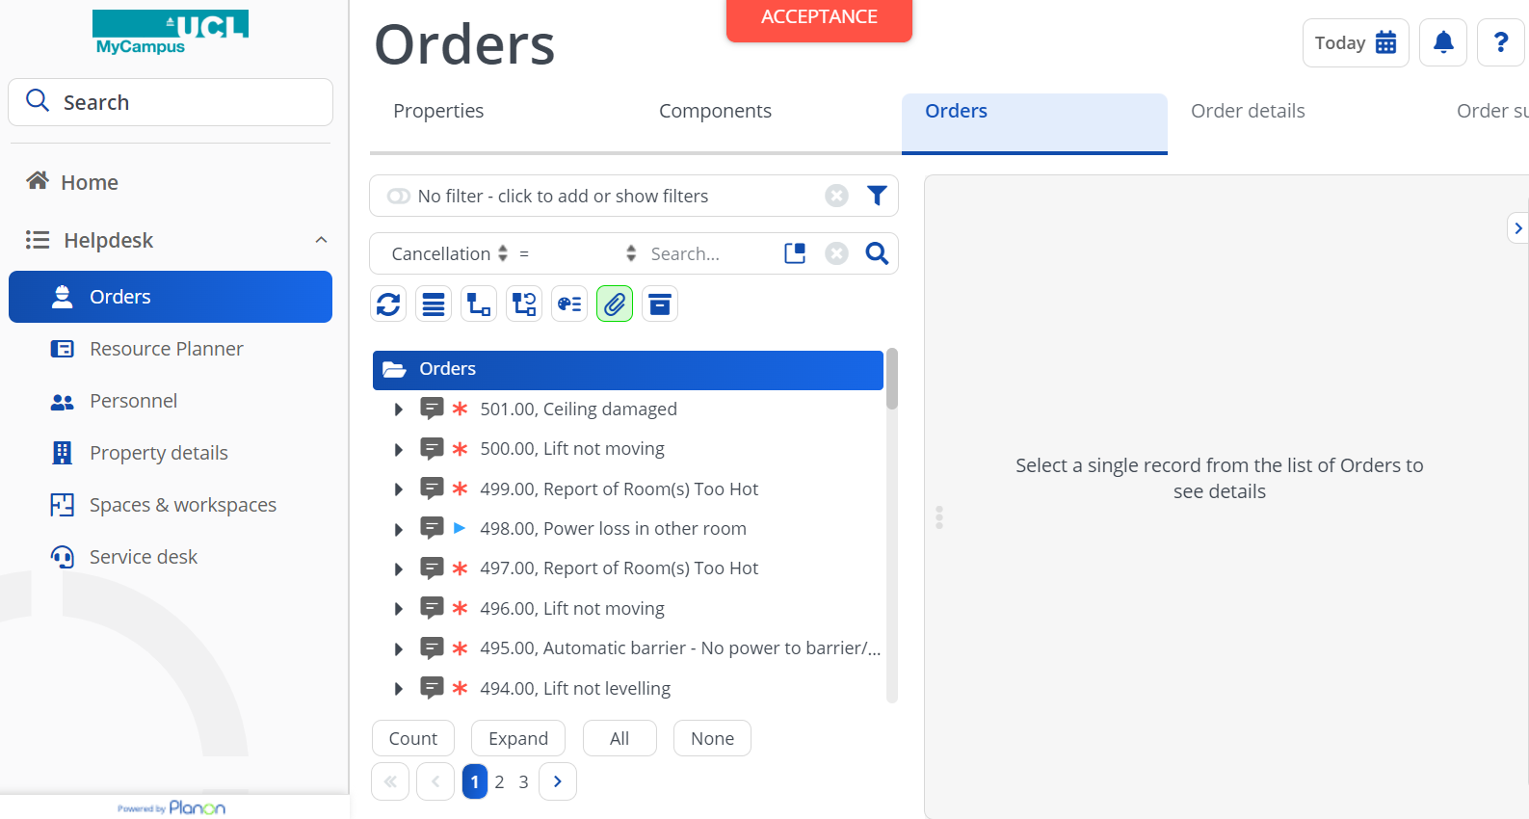

If there are any documents attached, a paperclip icon will be displayed next to the order description:

Navigate to the Orders TSI and to the Orders selection step.

- Select the Request or Order that you wish to view attachments for.
- Navigate to Order details>Communication logs – orders.
- Select the communication log record from the elements list:

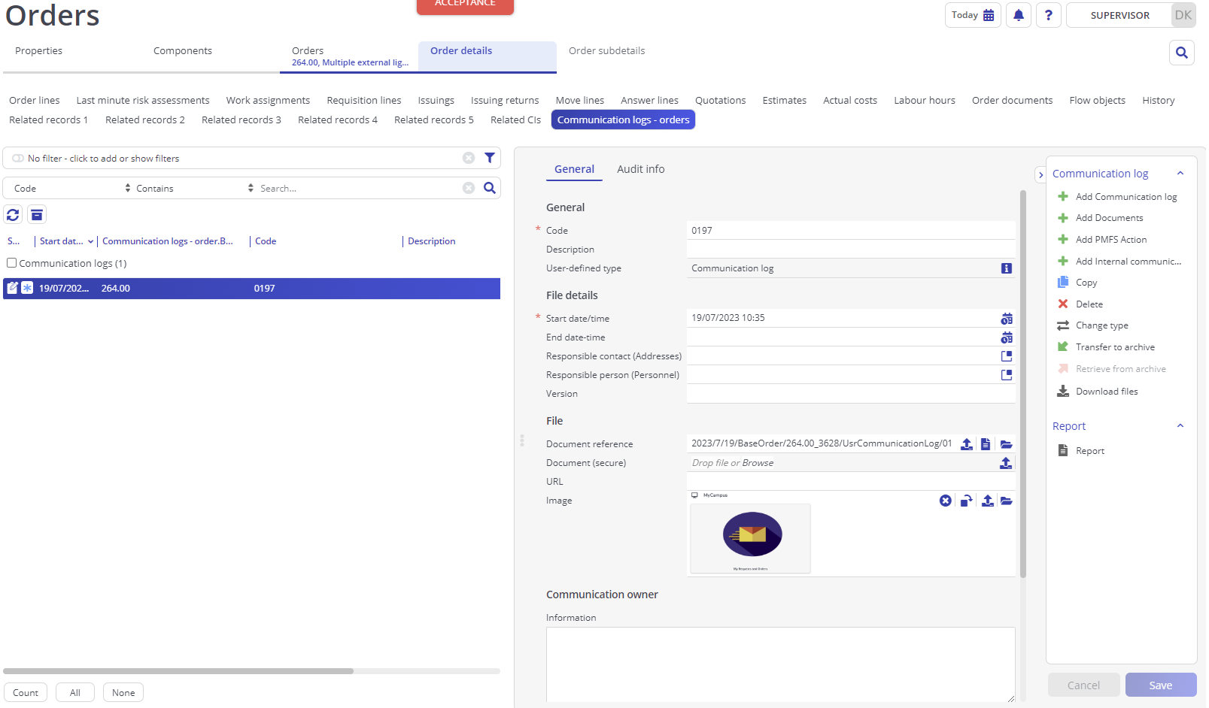
- If you want to download a document, click on the icon next to the Document reference field.
- Click on the photo or image in the image field to view a larger version.

How to View Property Information Pop Ups
If you need see additional information about the property a request or order is for without navigating back to the property step, you can view this by accessing the property information pop up:

- Navigate to the Orders TSI and to the Orders selection step.
- Select the Request or Order and scroll down to the Location section on the General tab.
- Next to the property field, click
- A pop-up will appear showing more information about the property:
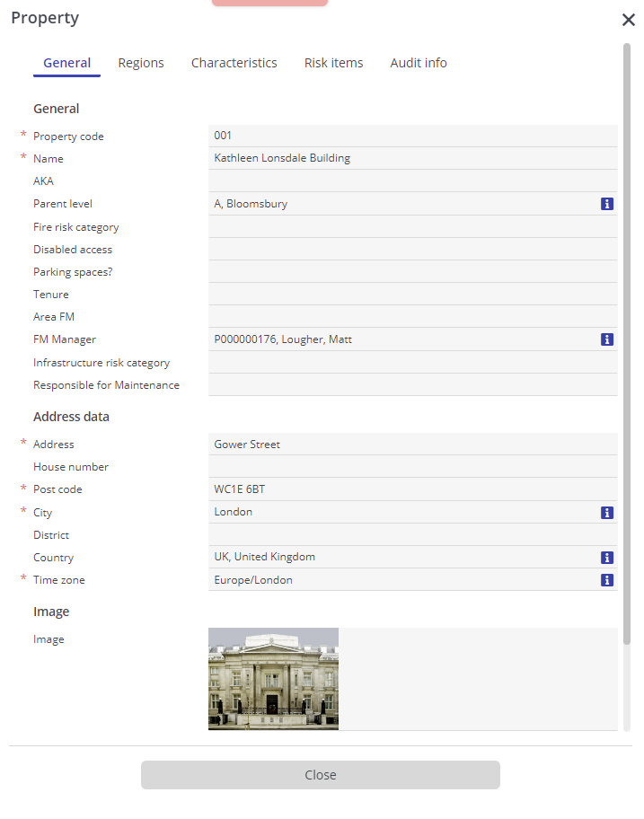

How to Check for Duplicate Requests (only applicable to the Helpdesk)
It is possible to check for duplicate requests that have been logged:

- Navigate to the Orders TSI and to the Orders selection step.

- Select the Request you want to check for duplicates.
Click on the Check for double requests action located on the right-hand side:

- Enter the time frame you want to check:

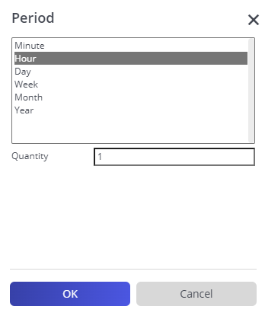

- A pop up will be displayed showing any requests for the same location and fault type logged within the time frame selected:
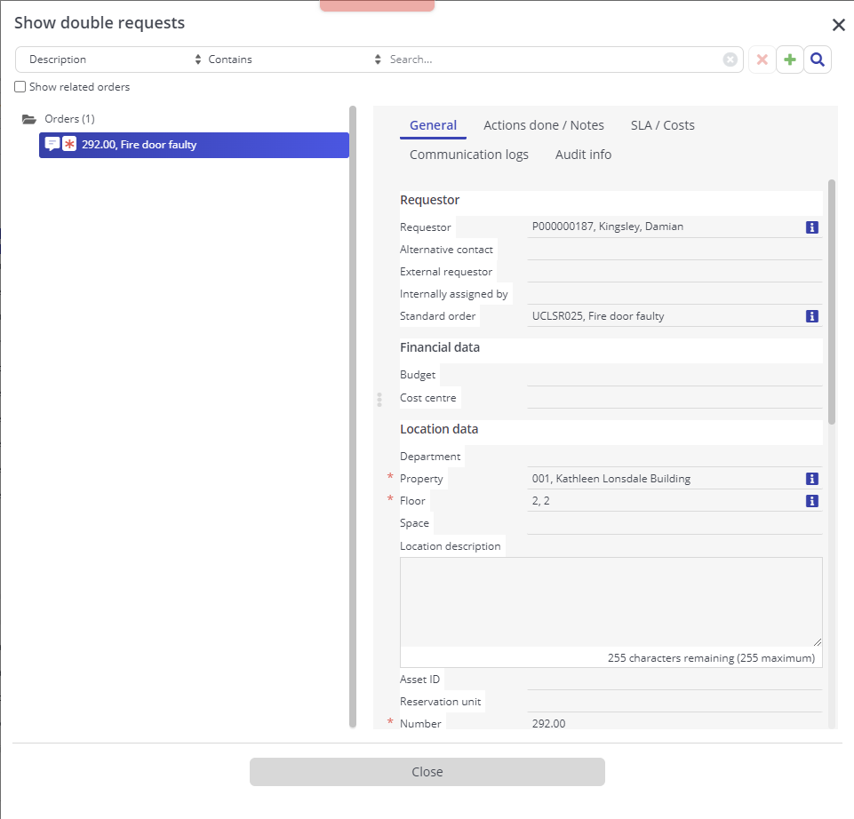

How to View Order History
Any changes made to a request or an order over time can be viewed in the History step.

- Navigate to the Orders TSI and to the Orders selection step.
- Select the Request or Order you want to view the history of.
- Navigate to Order details > History.
- On the History step you can see the date of the change, who made the change, what field has changed and the values before and after:

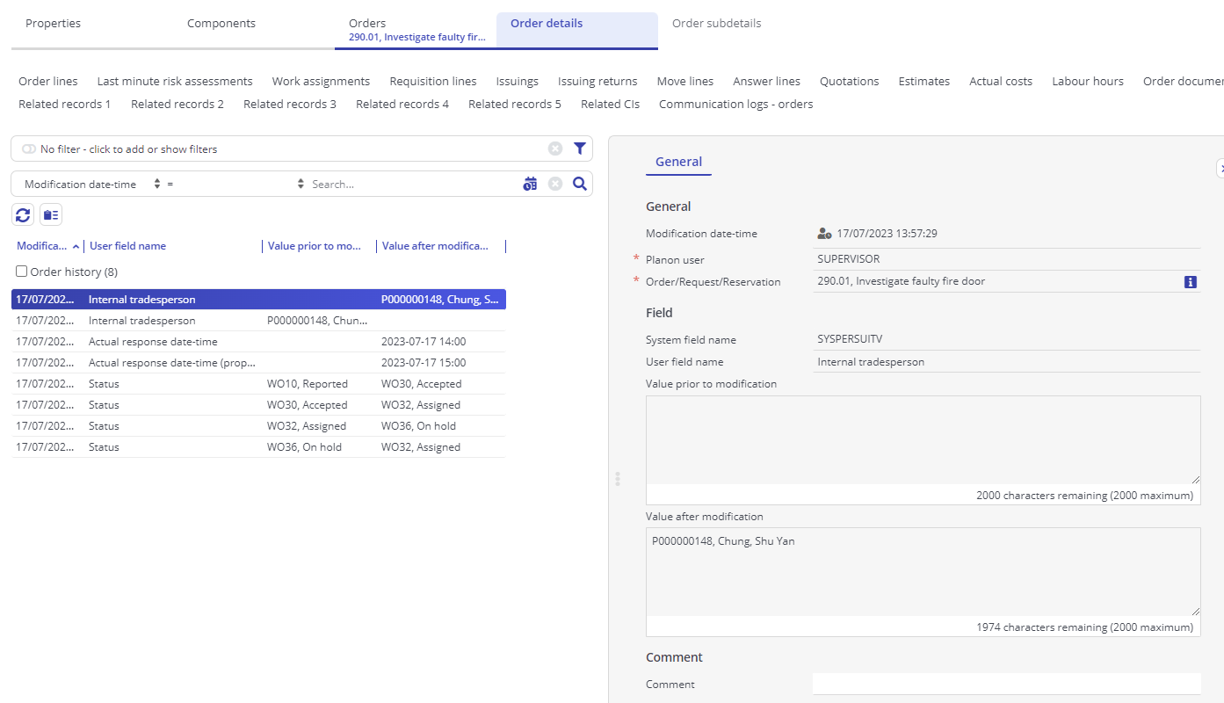

How to View Work Assignments
The difference between order and work assignment is that the order describes WHAT and WHERE work needs to be done. So, the location of the work and the 'job description' will be the same for all work assignments. The Work assignment describes WHEN this work must be done and WHO is carrying it out. So, the person carrying out the work and the time when the work is picked up can differ per work assignment.

As soon as you fill in the Internal tradesperson on the order, a corresponding work assignment will be created automatically.

- Navigate to the Orders TSI and select the order you want to view or create a work assignment for.
- Go to Order details > work assignments to view existing work assignments:

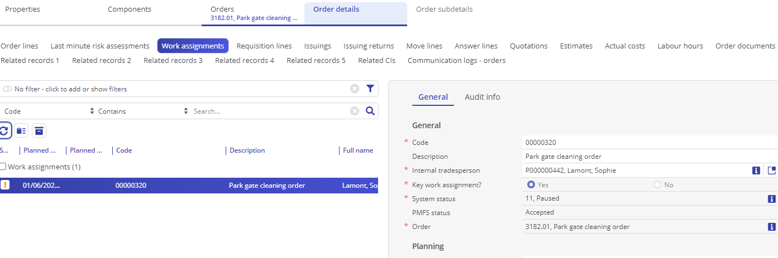

How to Use Colour-Based Priority Option within the Orders TSI
If the Show colour-based priority setting is applied, the order descriptions in the elements list are displayed in different colours.

If you click the Show colour-based priority icon on the toolbar the Colour based priority settings dialog box opens where priority colouring can be enabled for orders.
The settings also determine the range within which order colouring will be applied.

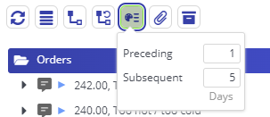
.

User Guide Journey

To go back to the chapters page, please click here

Managing Requests and Orders in the Orders TSI (only applicable to the Helpdesk)

How to Raise a Request
Requests can be raised directly in the Orders TSI.

- Navigate to the Orders TSI and to the Orders selection step.
- On the action panel, click Add and select Request:

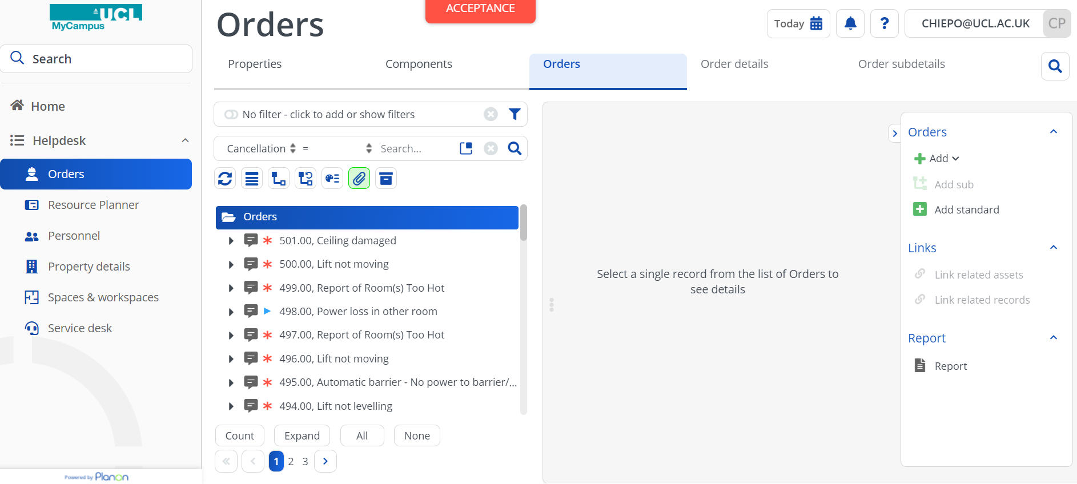

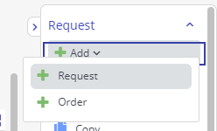

- Complete all the mandatory fields in the data section or you won’t be able to save the request.
- Click Save.
- The newly added order is automatically given an initial status of Reported.
Another way to raise a request using the Orders TSI, and the Add standard action, enabling you to select a standard order to create the request:

- Navigate to the Orders TSI and to the Orders selection step.
- On the action panel, click Add standard and select Request.
- Navigate to the Orders TSI and to the Orders selection step.
- On the action panel, click Add standard and select required standard order:

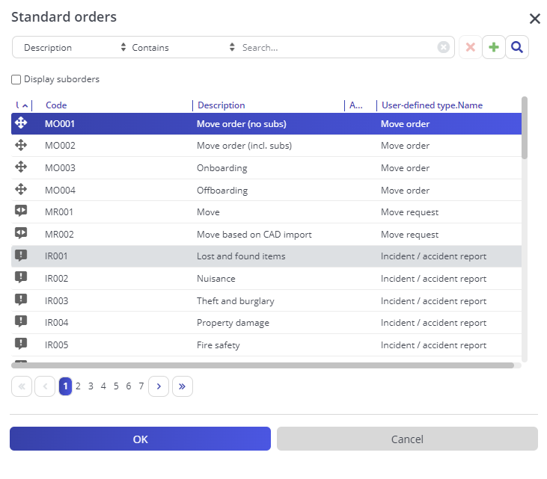

- You may be prompted to add a sub order. Tick all the sub orders that apply and click OK:

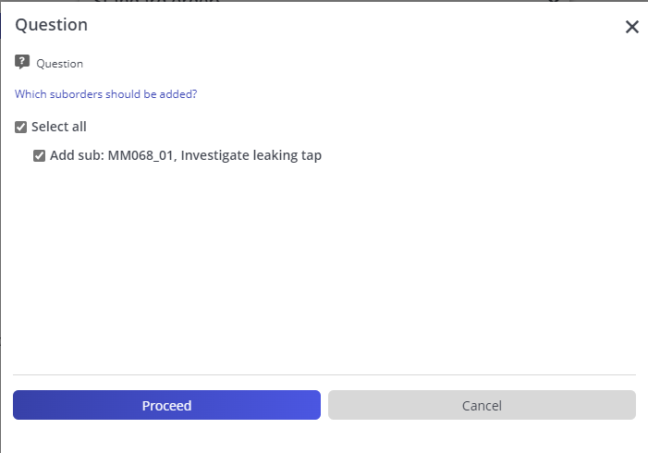

- Complete the fields in the data section.
- Click Save.

How to Add a Sub Order to an Existing Request
There will be circumstances where you need to add a sub order to an existing request. This may be because further work has been identified:

- Navigate to the Orders TSI and to the Orders selection step.
- Find the Request you want to add a sub order too.
- On the action panel, click Add sub.
- Complete the details of the sub order.
- Click Save.

How to Add a Communication Log to a Request or an Order
If you need to add any documents, images, photographs to either a request or a work order this can be done in the Communications log selection step.

- Navigate to the Orders TSI and to the Orders selection step.
- Select the Request or Order that you wish to add an attachment to.
- Navigate to Order details>Communication logs – orders.
Select the add action for the type of log you want to add. For documents & images, select Add Communication log. For notes visible in the PMFS “chat” select Add Internal Communication (see below section for more details).
- Complete the fields as required.
- To upload a document, drag and drop the required file into the “Document reference” field:

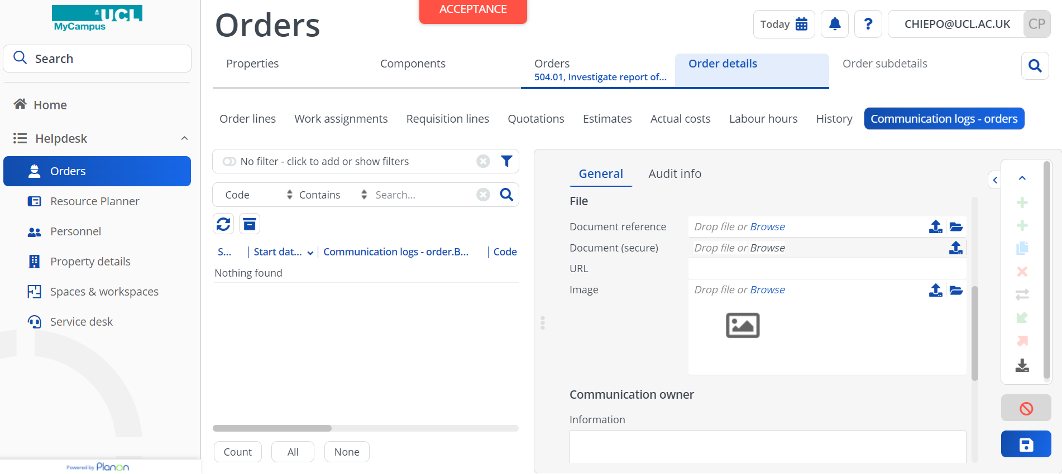

- Alternatively, click on the “Browse” link to select a file.
- To upload an image or a photo, drag and drop the required file into the “Image” field:
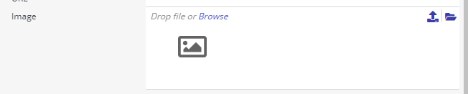

- Alternatively, click on the “Browse” link to select an image.
- Click Save.

How to Set SLAs for Sub Orders
For SLA metrics to be applied to a work order, it will be necessary to ensure that a work order has an SLA service linked. This SLA service will set the priority against the work order and then the subsequent SLA KPIs accordingly.

It is mandatory to have an SLA service on all statuses beyond accepted for a work order, with the exception of cancelled.

To select an SLA Service:

- Navigate to the Orders TSI and select a request that you want to check or add an SLA service to.
- Click on the SLA tab and then the SLA Service field and click the picklist button at the end of the field.

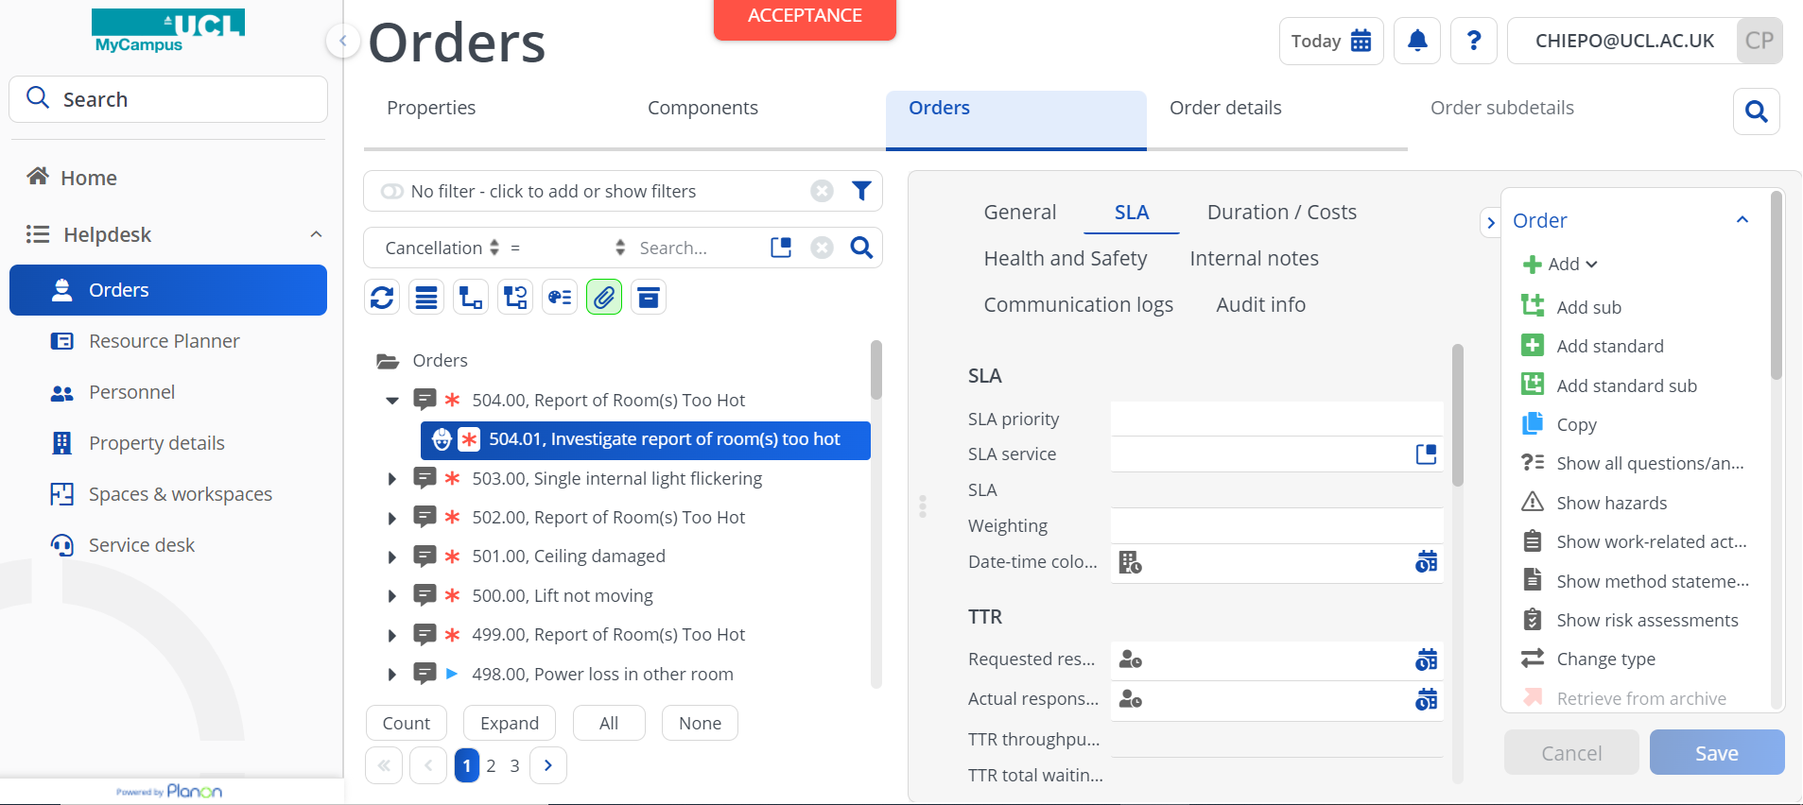

- A pop-up box will appear with the choice of SLAs. Choose the one required by clicking on the appropriate row and then clicking on Ok.
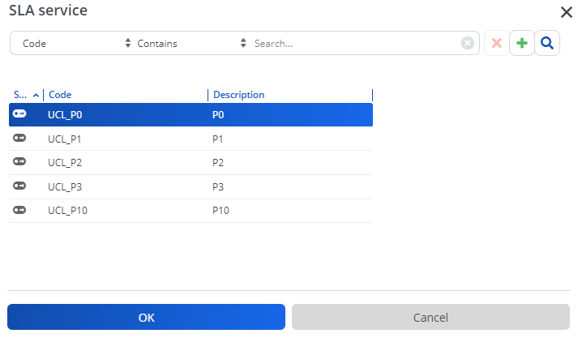

- After selecting the SLA service, the SLA field below and at least one of the KPIs should be populated. In the below example you can see that a Requested time to attend has been applied.

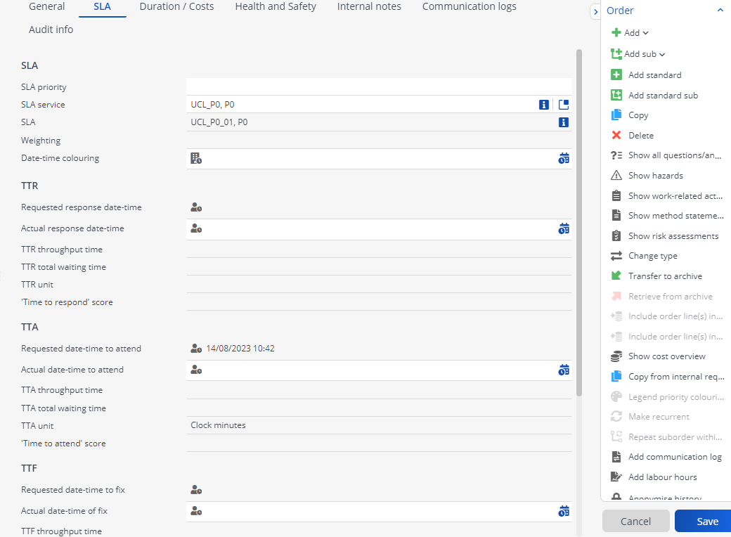

How to Make a Request a “Major” and Linking to Related Requests and Cancelling any Sub Orders
In case where there are multiple similar requests, it is possible to designate one of the incidents as a major request and link all similar requests to this major request. This will enable you to keep related requests together and address them at the same time. Once a request is linked to a major request, any changes (fields / statuses) on the major request are carried through to the related requests.

Changes made to suborders, communication logs and other order details are not carried through from the major request to the related requests.

Before creating a major request, you may want to check for double requests as described in section 6.16.

- Navigate to the Orders TSI and select a request that you want to promote to major request.
- See the Major? Field to Yes:

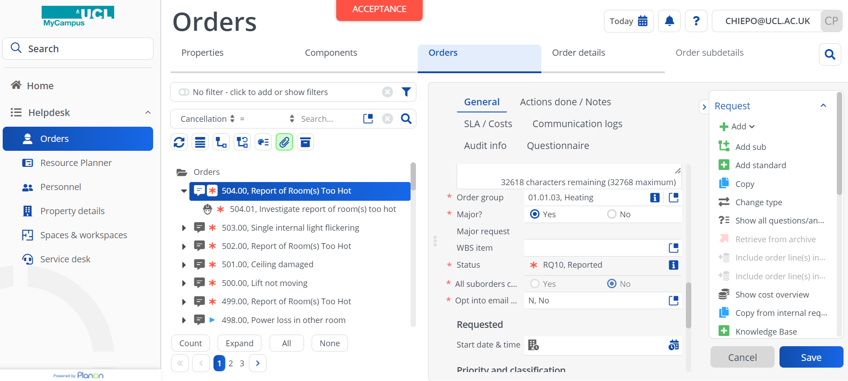

- Click Save.
Now that the major request has been created, the related requests can be linked to it:

The Related requests field on the Major request displays all the linked requests associated with this Major request.

- Navigate to the Orders TSI and select the request(s) that you want to link to the major request. To select multiple requests use CTRL and click.
- Click the Link to major request action:
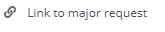
- A warning will be displayed click Proceed to continue:
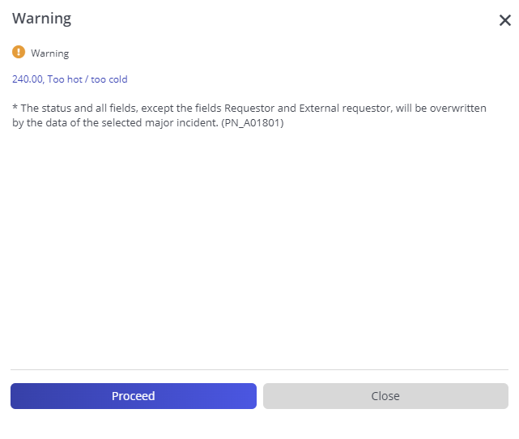

- The Link to major request pop-up will open displaying the available major requests to link to. There is an option ‘Show completed requests’ to display completed requests in the list. Cancelled major requests are not displayed:

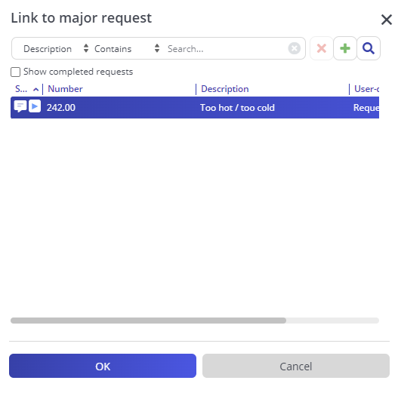

- Click OK.
- After linking, the major request is automatically displayed in the Major request field of all linked requests:

- To unlink a request from a major request, click Unlink from major request on the action panel:

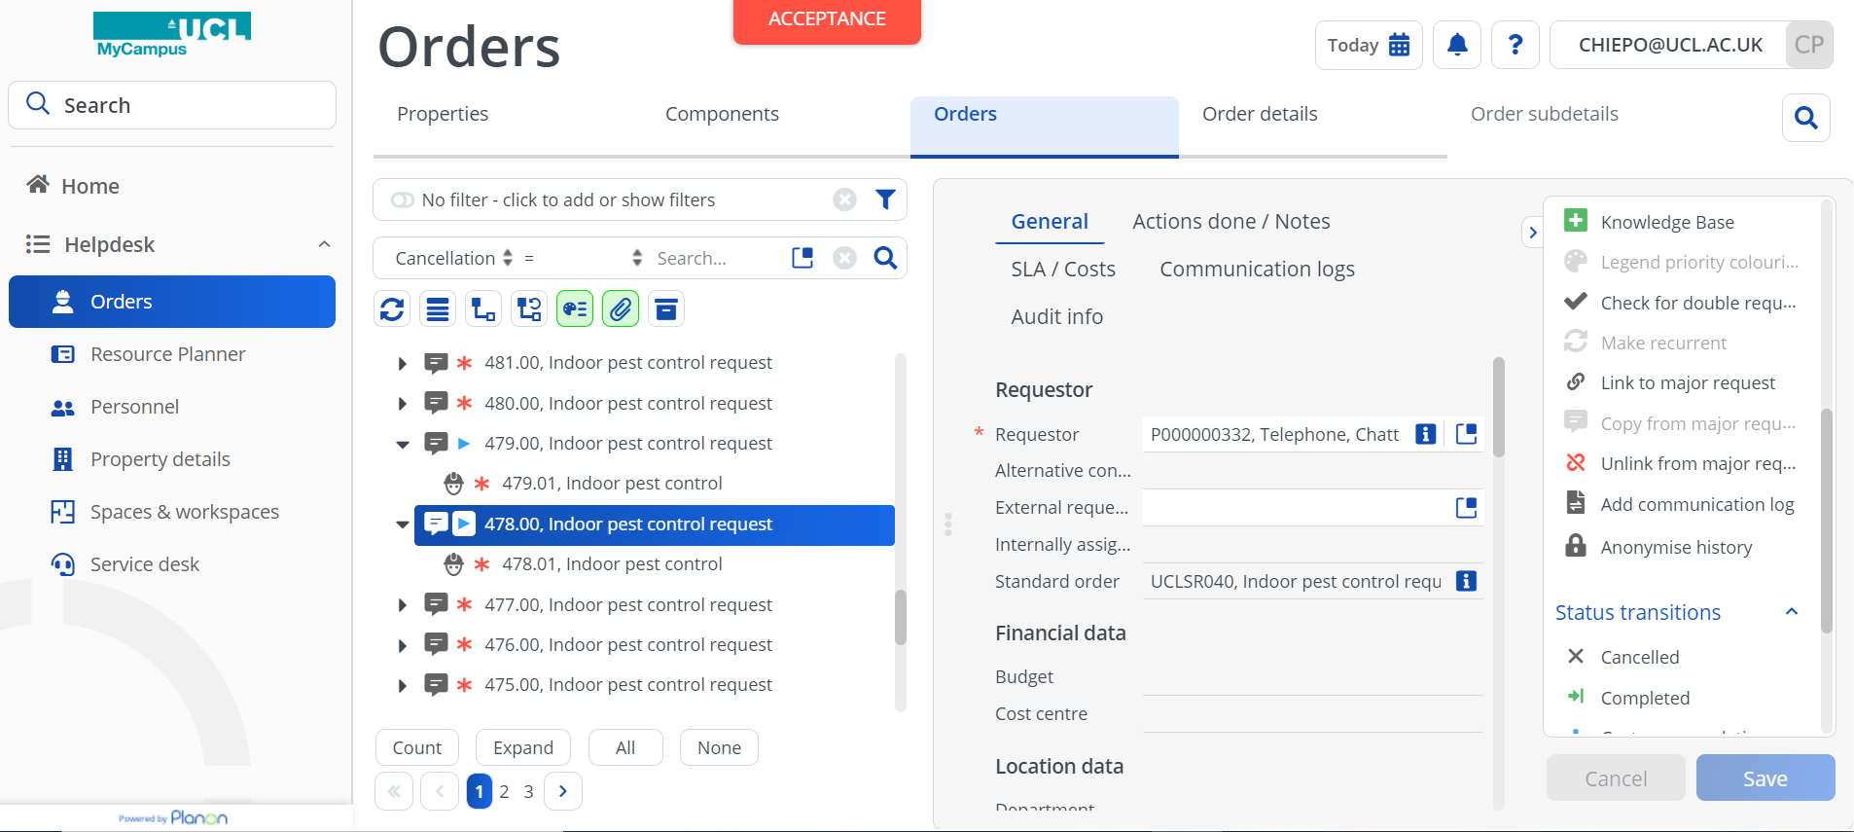

- You can link or unlink multiple requests using the Action on selection option.
- To select multiple requests use CTRL or Shift, then a new window appears on the right-hand side with extra options.

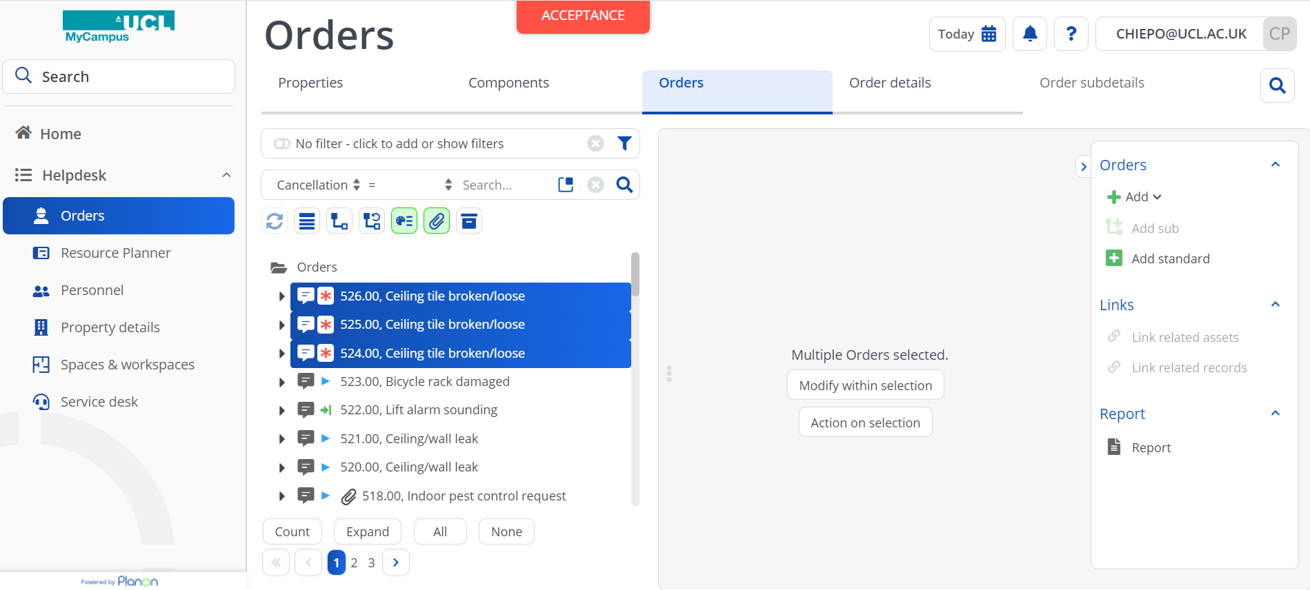

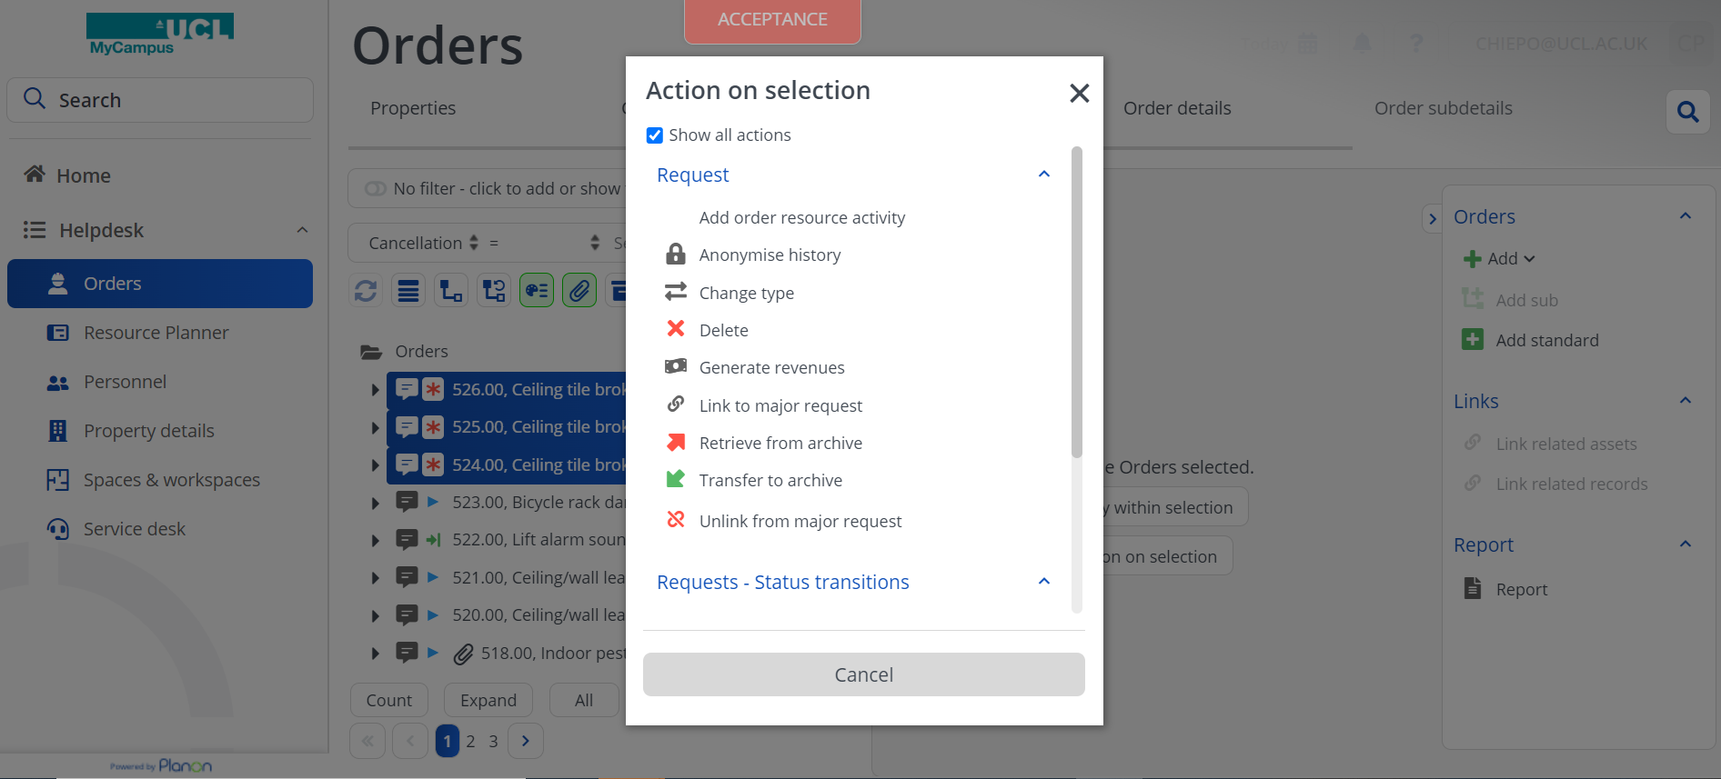

Once a request is linked to a major request, any fields other than Requestor and External requestor can no longer be changed, as they are managed on the major request. The Standard order field is not managed on the major request and is not kept in sync.

Must also ensure the MINOR service requests have their associated work orders CANCELLED. Otherwise, there will be duplicate jobs sent to responding teams, or they will simply be sat dormant on the system.

You can still add suborders, communication logs and any other order details independently, for both major and related requests. However, you may want to manage any suborders from the major request only, in this case, cancel any sub orders for the related requests.

How to Change a Status of a Sub Order to Accepted and Seeing a Change in Request Status
Once a request has been triaged and a suborder added, the status of the sub order can be transitioned to Accepted, this in turn will change the request status to In progress:

- Navigate to the Orders TSI and select the order that you want to progress.
- Click the Accepted status transition in the action panel:

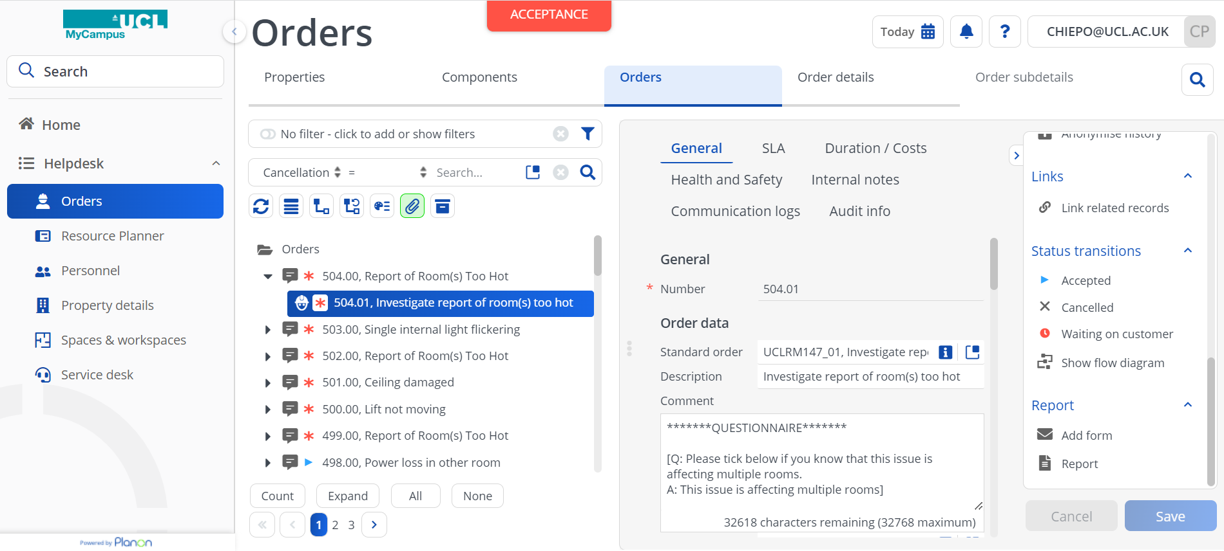

If the request was at the Reported status, it will be moved to the In progress status.

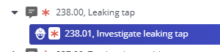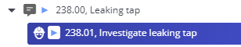

How to Assign a Work Order to a Contractor
To assign a work order to a contractor so work can begin, first make sure the order has been accepted:

- Navigate to the Orders TSI and select the order that you want to assign.
- In the External Tradesperson field, use the pick list to select the required contractor.
- Click Save.
- Change the status of the order to Assigned by clicking the Assigned status transition in the action panel:
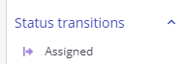

Cancelling a request and the associated sub order
Cancelling a request will also cancel any associated sub orders, similarly, cancelling a sub order will give you the option to cancel the request, if there are no other suborder still in progress (i.e., not cancelled or administratively complete):

- Navigate to the Orders TSI and select the request that you want to cancel.
- Click the Cancelled status transition in the action panel.
- A warning message will pop up:
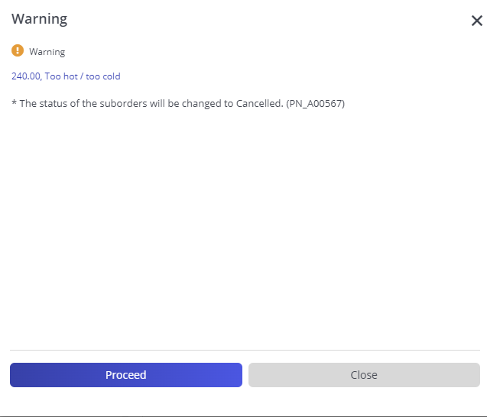

- Click proceed to cancel the request and all related sub orders

Order completion
Orders have a 2-stage completion in MyCampus. Typically, the contractor or tradesperson will mark orders as complete on a self-service form or the PMFS app. The final stage of completion (Administratively completed) can be automated or performed manually in the back office.

Completing a request will mark all related sub orders as administratively completed (provided they are all already at the Completed status). The last sub orders related to a request to be marked as administratively completed will give the option to also complete the request. The system will automatically administratively complete the request after 3 days once the sub orders have been completed and will generate the email notification informing the customer that the request is now completed and asking for the feedback.

User Guide Journey

To go back to the chapters page, please click here

Resource Planner

Resource Planner Overview
The MyCampus Procenter Resource Planner is a graphical planning tool. It gives access to one or more pre-configured Planboards, via which you can assign work to available resources quickly and easily. The key components of Resource planner are as follows and shown on the image below.

- Planboard selector - pre-configured by the system administrator. Click on this field to select alternative Planboards if available.
- Maintenance Team or Teams - One or teams will be linked to the Planboard you are viewing. These teams are also set up by the systems administrator and linked to specific Planboards.
- Unplanned Order List - A pre-filtered list of work orders is defined as part of the Planboard and will only display relevant work orders for the Planboard/Maintenance teams.
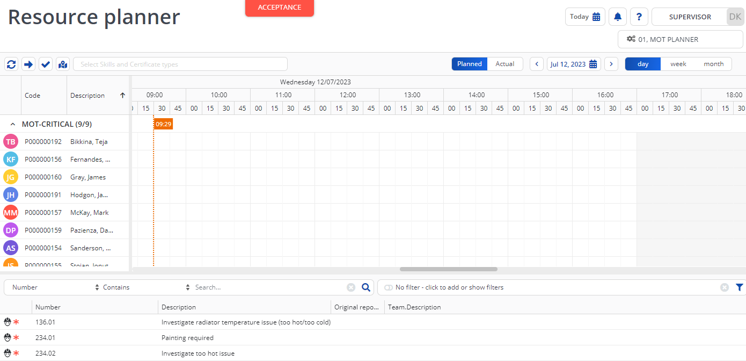
3
2
1

Assigning a Work Order to a Single Person
To assign a work order to a single person, select a work order from the Unplanned Order list then click on the work order and drag it onto the MyCampus against a specific individual and time of day. This will create a Work Assignment for this order, linked to the tradesperson.

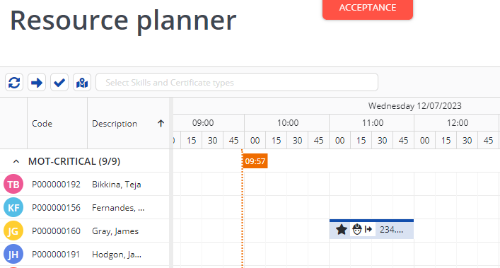

The action can be repeated for multiple work orders against other individuals and when complete. When all work orders have been allocated, click on the Assign action button to confirm the work order assignments.

A pop-up will display requesting confirmation of the period for the work assignments. Adjust values as appropriate and click OK.

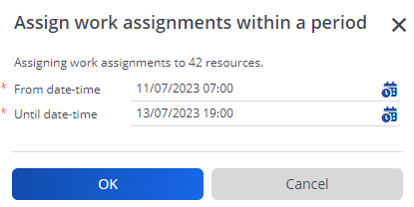
Once assigned the work order status icon will be change to the assigned status icon

Filtering Maintenance Team Member by Skills and Certificates
Against Personnel records details of skills or certificates can be linked to individuals. When using the Resource Planner, if wishing to locate Maintenance team members with a particular skill set or certification, the list of team members can be filtered by clicking in the Select Skills and Certificate types of search bar and selecting one or more item.

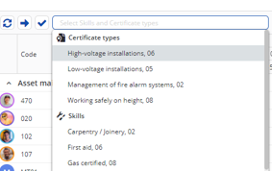

Filtering and Sorting the Unplanned Order List
The field headings displayed in the Unplanned Order list will be defined in the Planboard by the systems administrator.
2
1

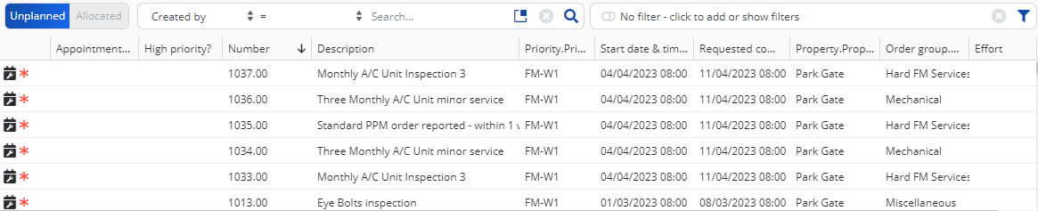

As with any TSI list, the Unplanned Orders list can be filtered on a single field value using the simple search shown above (1). If a more complex search arguments need to be built, filters can be created or selected if pre-defined user’s filters have been created by the systems administrator, shown above (2).

Individual columns can also be filtered by hovering over the column heading and the filter icon will be displayed in the top right corner, as shown below. The icon next to the filter icon allows you the sort of the contents of the list by values in the selected column, by either ascending or descending order.

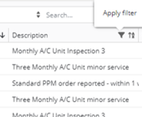

Adjusting the Planboard Scale
Above the Planboard area, the scale can be adjusted for a Day, Week or Month view by selecting the appropriate period as shown below. The date can also be adjusted if wishing to view past or future work assignment data.

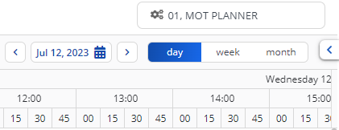.

Viewing Work Order Details
The details of a specific work order can be viewed by selecting a work order in the Unplanned Orders list and then click on the show work order button next to the Planboard scale.

The work order details on the right of the screen as shown below.

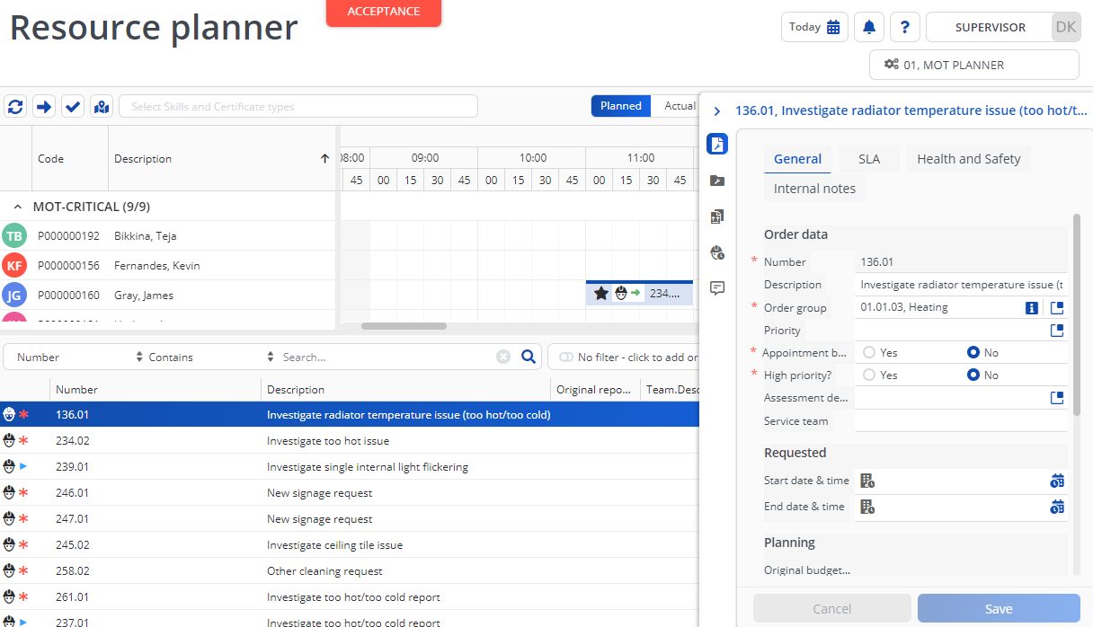

From the work order panel, it is possible to adjust details in the work order if authorised. For example, if the work order is now deemed high priority or requires an appointment booking, these details can be updated in the work order prior to assigning to a maintenance team member.

On the left of the work order panel is a set of icons for viewing different components of the work order, these are outlined below from top to bottom:

Work assignments (only if multiple work assignments are activated)

Order details

Work assignment context

Order lines

Labour hours

Communication logs
It is also possible to open and edit work orders (if authorised) by double clicking on a work order in the Unplanned orders list. This will open the work order record in a new pop-up window.

Adjusting the Duration of an Assignment
When work orders are allocated against individuals on the Planboard, they will be shown as a default one hour duration, unless otherwise specified in the Standard Order. To adjust the start and/or end time of the Assignment, hover the cursor over the bar representing the work assignment and then drag the resizing handles on either end of the bar to adjust the duration.

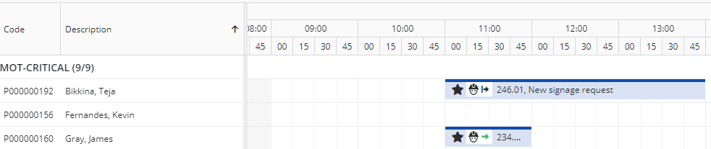

Planboard Colour Indicators - Completed and On Hold Orders
The Resource Planner Planboard uses colour coding to identify completed or on hold work orders as shown below. The default colour for work order assignment bar is blue, but if an assignment is placed On Hold or is Technically completed, then the colours change to Amber and Green respectively.

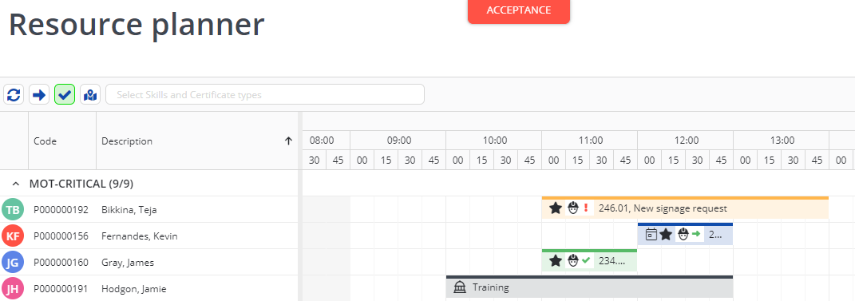

Please note when a work order assignment is completed it will disappear from the Planboard, however these can be shown by clicking the blue tick icon, highlighted in green when active.

On hold orders will be removed from the individuals’ mobile device if using the PMFS app and will need to be re-allocated to another person or back to the prior assignee. Please note the On hold work order assignments will appear back in the Unplanned orders list. If re-allocating back to the same individual both the old and new assignments still show in the Planboard.

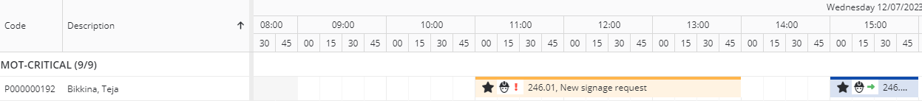

Work Order Assignments – Switching the Assignment
Work order assignments can be moved to other person by dragging the assignment bar to the other person when the assignment is in a pending assignment or assigned status. Once the order is in progress, if attempting to move the order to another person, the current assignment work order will be placed On hold and a reason must be given. The reason values are managed by the systems administrator. Once a reason is selected the original assignment will show as On Hold and the new assignment will be pending assignment.

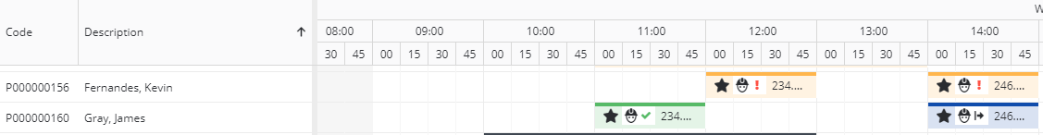

Moving Work Order Assignments to Unplanned Orders List
To move the work order assignment back to the Unplanned order list, simply hover over the work order assignment bar on the planboard and click the red X icon on the bar.

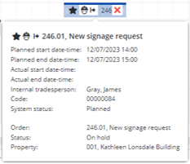

Overlapping Work Assignments
Planboards can be configured to allow overlapping work assignments (by the system administrator), so several work order assignments can be allocated to an individual, for example at the start of the day. If this feature is enabled, simply drag the work orders one at a time to the Planboard against an individual for the same period.

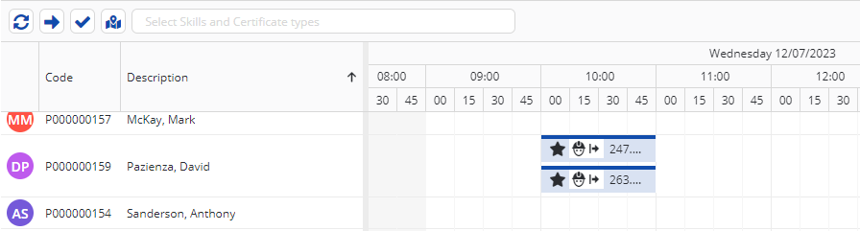

The individual can opt to process the work orders in any order via the mobile app.

Assignments During Non-working Hours
Work can be assigned to individuals during non-working hours if the Planboard configuration setting has been enabled (by the systems administrator) to allow planning of overtime working. Simple drag the work order to the Planboard and allocate against a person and an area where the time period is shown in grey. Please note, the work order assignment is marked with a red border to denote out of hours working.

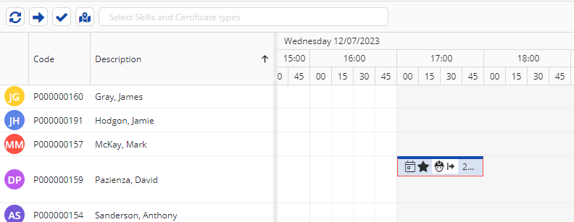

Work Order Assignments with Appointment Bookings
Work orders may be scheduled for a specific date and time, either by updating the work order in the back office or by updating the order in the Resource Planner. If the work order has already been defined as an appointment booking it will display in the Resource Planner with a calendar icon on the Work order assignment bar as shown below. To make a Work order assignment an appointment booking in the Resource Planner, either right click on the Work order assignment bar as shown below and in the small pop-up menu, click on the Appointment booking toggle switch. Or the Appointment booking field can be updated in the work assignment by opening the work assignment details as described earlier.

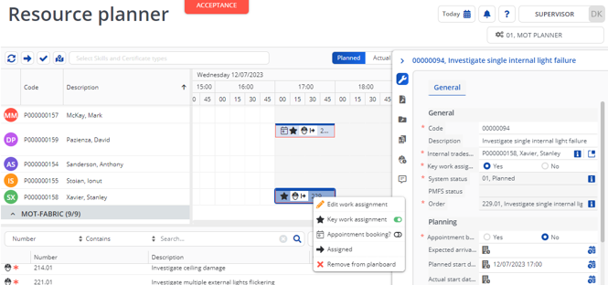

When the assignment is received on the mobile app, there will be icon against the order to indicate the assignment is an Appointment booking.

Adding Periods of Unavailability to the Resource Planner
For specific individuals, periods of unavailability can be defined against the individual in the Personnel TSI. These can also be added via the Planboard, by clicking on at the appropriate time against an individual, keeping the left mouse button held down and drag to the end period of unavailability. Then release the mouse button and a pop-up window will appear to the select the type of unavailability, either Illness, Leave or Training (other types of unavailability can be configured by the systems administrator). Click OK to complete the task.

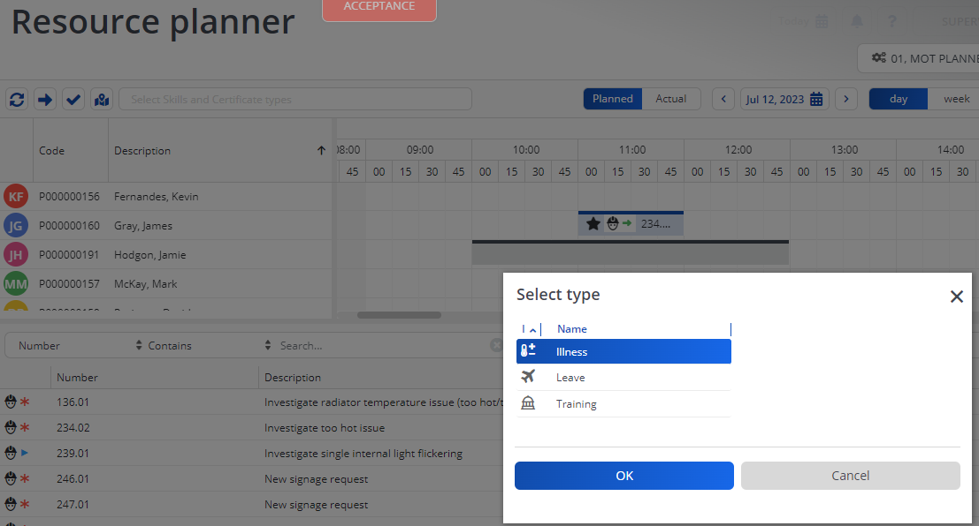

The unavailable period is then shown on the Planboard as below.

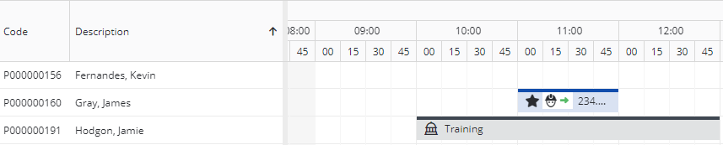

Viewing Actual Time Spent on Work Assignments
The planned view of the Planboard will always show the work assignment times based on what was planned and sent to the mobile device. Once the tradesperson starts work and then completes the work assignment, the actual start and end times are captured and will display in the Actual view.

This enables new work assignments to be accurately planned based on the actual time it is taking to complete each work assignment.

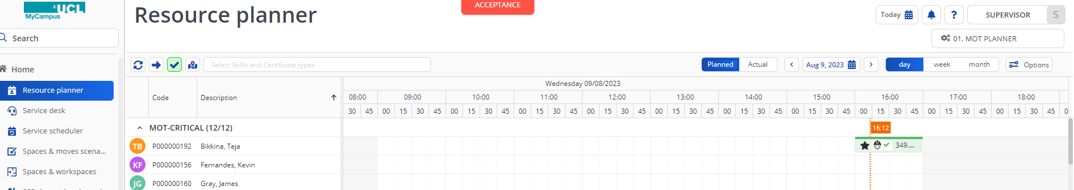

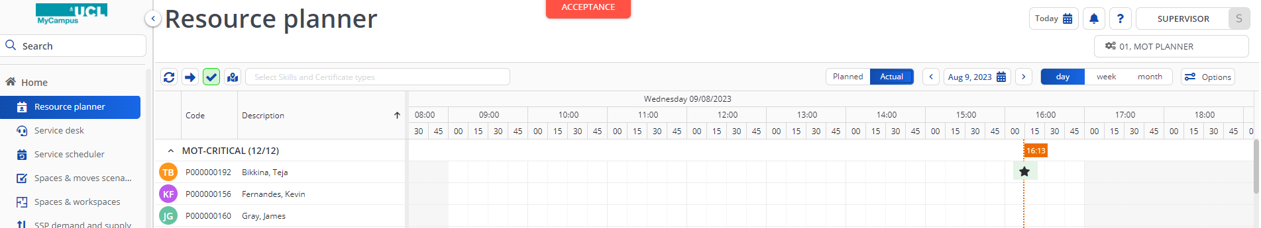

User Guide Journey

To go back to the chapters page, please click here

PMFS App

PMFS Configuration

Installing MyCampus Live App

If you are on an Android device, open Google Play Store and download & install ‘Planon Live 2’.
If you are on an Apple device, open App Store and download & install ‘Planon Live’.

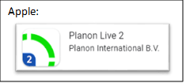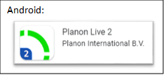

Logging into the App via QR Code

After opening the app, you will have to enter the Company URL. Press the QR button on the right:
This should open the QR code scanner. Please use this to scan the QR code below:

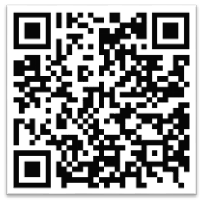

Enter your login details.

Once you’ve reached the UCL Single Sign-on page, you will be required to enter your UCL credentials. If you have any issues signing in, please contact the IWMS Team at:

MyCampus.Support@ucl.ac.uk

Please refer to the detailed user guides as per below:
Detailed guide (Android): Accessing MyCampus Live app (Android).pdf
Detailed guide (iOS): Accessing MyCampus Live app (iOS).pdf

Logging into the App by Typing the URL Manually

Once you have the app installed you will be required to enter the URL for the area you wish to access. The URL’s for both Prod and Acceptance are shown below for your reference:

- https://ucl-prod.planoncloud.com
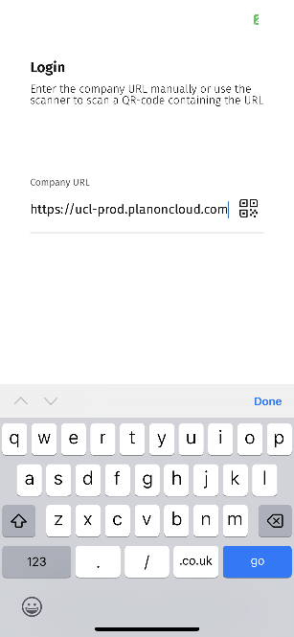
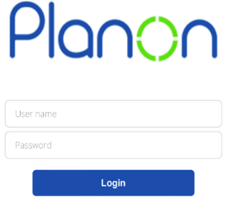

Once you have entered the URL you will be presented with the login screen where you can enter your username and password. Please note that if Single Sign On (SSO) is switched on, you can log in with your e-mail address, and you will be redirected to your network login for any additional authentication.

Using PMFS

Work Assignments

Work assignments that have been assigned to you as an individual will appear listed on the All list. They do not appear in the To Do list until they have been accepted or are in progress. A blue dot to the left of the assignment indicates that a Work assignment has not been opened yet.

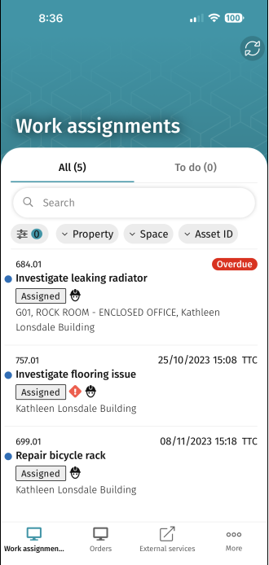

The date and time displayed will be the time planned for you to attend based on the back-office planning, or if no time has been planned, then the date and time that the work assignment should be completed by will show and indicates TTC (Time to Complete) at the end.

Overdue orders (i.e., the start date is in the past) will show Overdue in place of the date and time. High priority orders will have a Red exclamation mark next to the status.

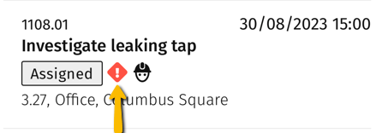

Each job will show a summary of the job number, key dates, description, and location.

Job Icons

Icon/Label | Description | Additional Information
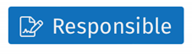 | Key work assignment | If the work assignment that is assigned to a person is marked as ‘key work assignment’, this assignee is the responsible engineer for signing off the work upon completion.
 | High priority | If the back-office marked the work assignment as ‘high priority’ this icon is shown on the work assignment.
 | Appointment booking | If the back-office marked the work assignment as an appointment booking, this icon is included in the work assignment’s date-time information.
 | Linked to work order | This icon indicates that the linked order is a work order.
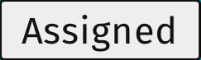  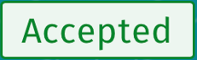  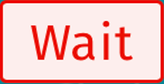 | These labels represent the work assignment’s status | These are different statuses that you can assign to an order you are currently working on.
 | ‘Overdue’ indicator | This label alongside the displayed date-time information indicates that the work assignment is overdue.
TTR  TTA  TTF  TTC | Time to respond  Time to attend  Time to fix  Time to complete | If SLAs are applicable, the label also indicates which SLA (TTR, TTA, TTF, TTC) is linked to the displayed (overdue) date-time.

Searching and Filtering

Jobs can be searched and filtered with your search and filter settings saved until you log off.
When online, you can use the combined search and filter mechanisms to query data from the back-office.

The Search Bar

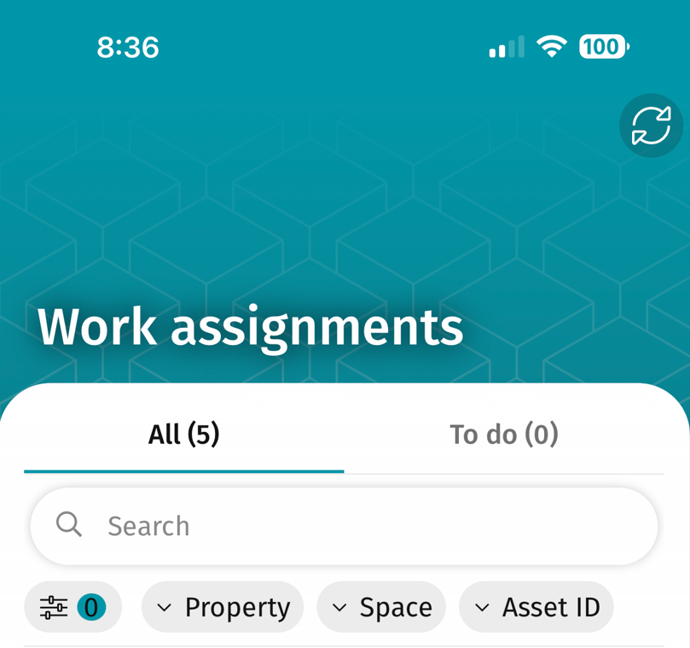

Simply add (part of) a search term, or multiple search terms separated by a space. Your search is not case sensitive and will ignore special characters.

The following criteria can be (partially) entered as search terms:
- Code (of work assignment).
- Description (of work assignment).
- Code (of order).
- Description (of order).

The Filter Bar

The Property, Space and Asset ID quick filters can also be used to filter the list based on specific properties, spaces, or Assets. Only options that are linked to the work assignments will be displayed for selection. To clear any filters applied, click on the Filter button to the left of the Property field and select Clear All and Apply. This filter can also be used to filter by Order type if required.

Viewing, Accepting or Rejecting Work Assignments

To view more details about a work assignment, simply tap on it in the ‘All’ list. The details of the work assignment will then open, with different information displayed on different cards. Cards with no information will be grey in colour but can still be accessed.

Some of the information that might be relevant can be found on the Images card, where any images provided will display, the Order card, where more detail around the work order including any comments raised by the Requestor and the Requestor contact details will display, the Location block where location details including floor are visible, and also the SLA block where times specified for attendance and completion will be visible.

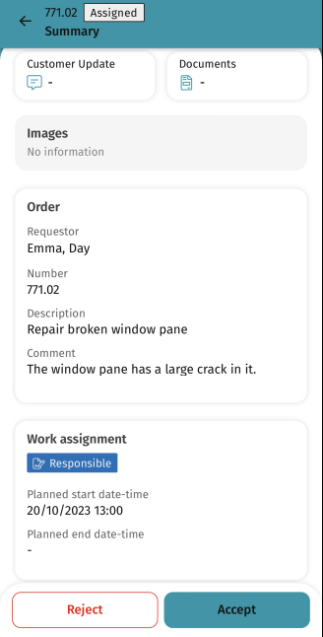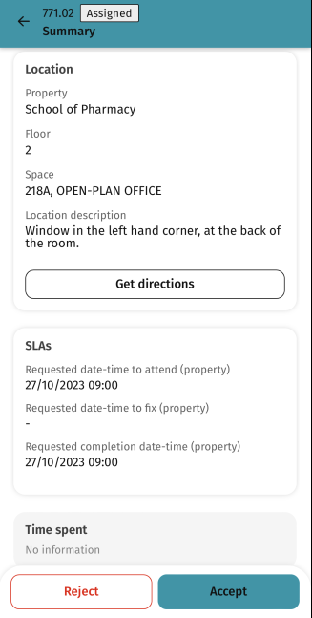

The job should not be rejected without the approval from your Supervisor. Once the job has been accepted, work can begin.

The accepted Work assignment will also be replicated in the ‘To Do’ list on the main Work assignment list page.

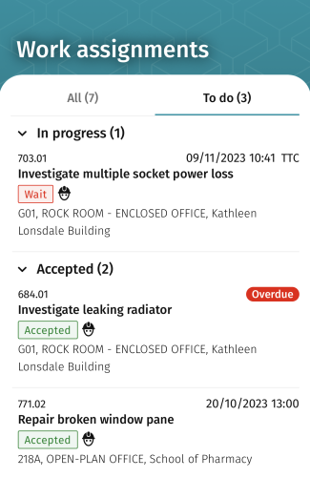

Work Assignment Actions

There are different actions you can perform whilst working on a work assignment.

Please see the table with various actions as per below:

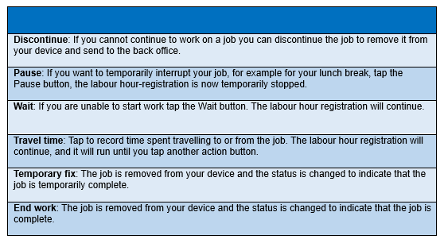

You are able to discontinue the job, once you receive the approval from your Supervisor.

Travelling before Starting Work

Once you have Accepted the Work assignment, the user can record Travel time to the next assignment by clicking on the All button and Travel button. The labour hour registration will continue to run until you click another action button:

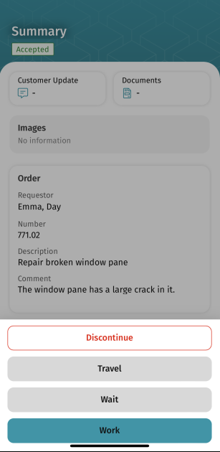

Stopping Travelling and Starting Work

Once the user has arrived at the location they can stop travelling and start work by clicking on the Work button. They will then be presented with the following screen whereby they can start work:

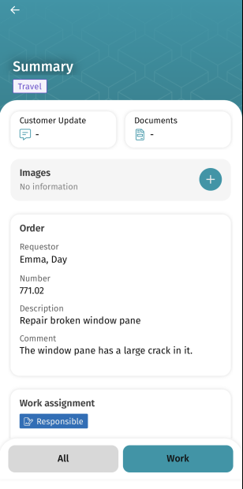

Once the user clicks the Work button, they can enter the time and select Next. This will take them to the ‘Last minute risk assessment’.

Last Minute Risk Assessments

Before you can update your work assignment to the ‘Work’ status, a “Last minute risk assessment” must be completed. Here you will find 5 risk assessment questions that must be completed to safely begin your work. If the answers to any of the question are “No”, please resolve the relevant issue before progressing with the work assignment. To progress, select Submit. The order is now in the ‘Work’ status.

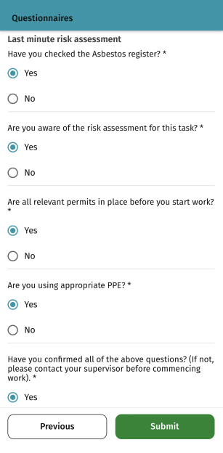

Adding Comments, Documents, and Photos to a Work Assignment

Additional information can be added to the work assignment whilst you are working on it, such as photos and comments.

By clicking on the + button from the Images block you will be asked if you want to take a photo and add or to view the camera roll on your phone. Clicking on Take photo will open the device camera, allow you to take a photo and then click on use photo. A description must be added and a comment can be added as required, allowing the Submit button to then be clicked to register the photo against the work assignment.

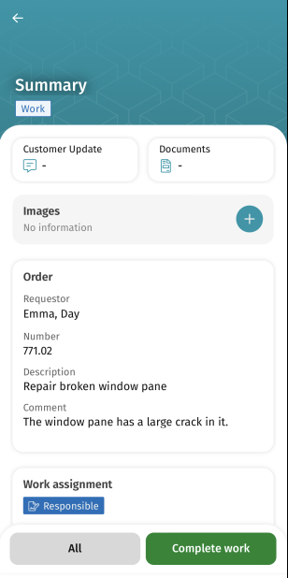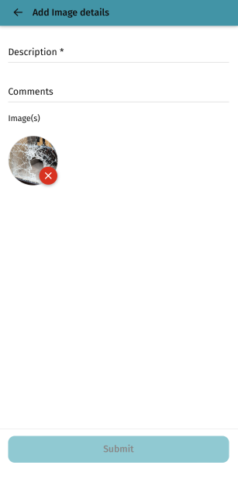

To add an update to the Customer, click on the ‘Customer Update’ block at the top of the screen, which will take you to the Communication Log details area of the App. Here you can see any comments already made, any internal communications from the back office, and also navigate to Images and Documents attached if required.

To add a customer update, enter your comment in the box at the bottom and then click on the blue upload arrow to upload the comment. The comment will be visible to all users that have access to the work assignment and will also create a communication log in the Back office.

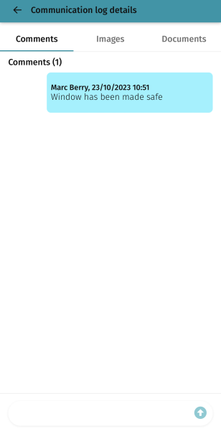

To add a document, click on the Documents link from the top of the summary screen, and then click on the Add document button to open the Add document form. Here click again in the + Add document option, navigate, and find your document and then add a description and any comments before clicking on submit to register the document against the work assignment.

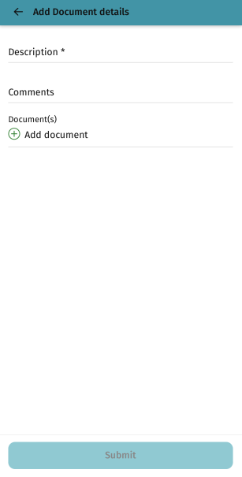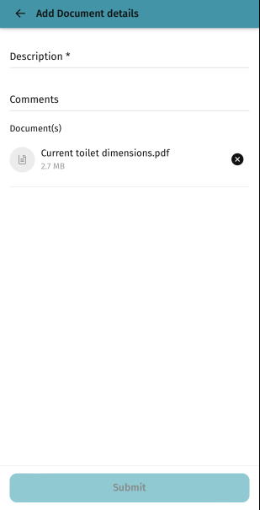

Once uploaded, a document can be selected for viewing, or if you click on the select button, it is then possible to choose more than one document to subsequently download or delete.

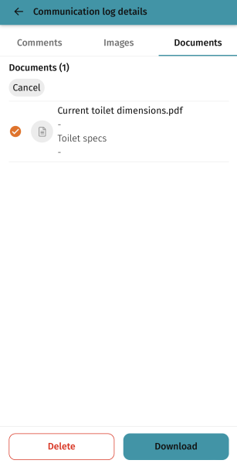

Please note that the customer wouldn’t be able to see or self-serve the Documents or Photos. If the customer wants to see these, they will have to request these from the Helpdesk.

Adding Tradesperson Notes

Tradesperson notes are notes that are visible only to yourself and won’t be seen by other tradespersons that have access to the same work order. If you want the note to be visible, these should be added as comments.

To add a tradesperson note, find the Tradesperson note block and click on the + button to the right. Type in the notes and click submit.

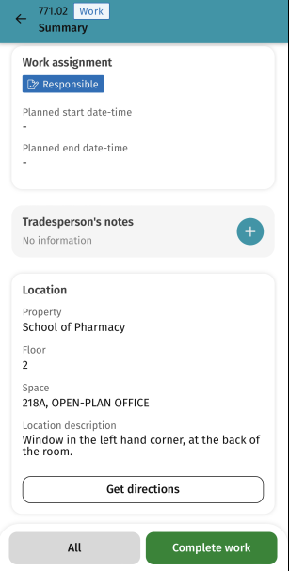

The notes will be sent to the back office as a Communication log.

Pausing and Waiting

To Pause a work assignment the user can simply press the Pause button found within the All button at the bottom of the summary page, and this will temporarily stop the labour registration:

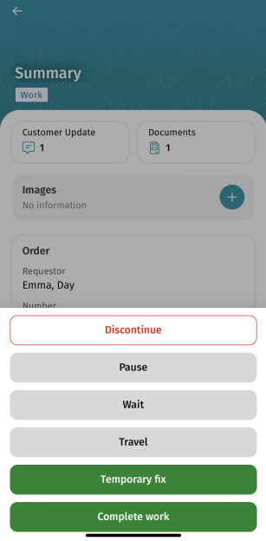

The user can then select the Date and Time and choose a reason and a comment and then press Submit.

The status of the work assignment will then go to Paused and work can be resumed by clicking on the Work button, confirming the details and clicking on the Submit button:

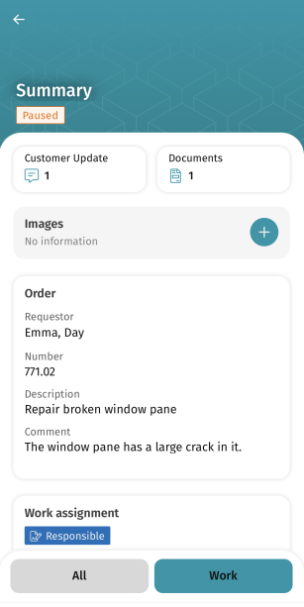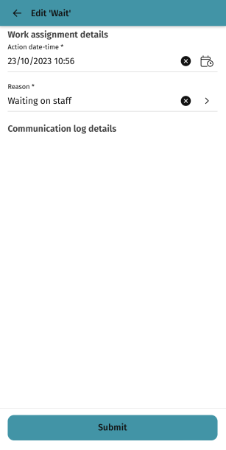

Using the Wait option will continue the labour hour registration but track the labour hours as waiting labour hours instead of working.

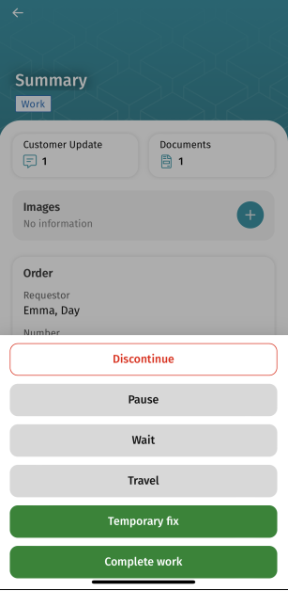

The user can then select the Date and Time and choose a reason and a comment and then press Submit.

The status of the Work assignment will go to Waiting and the user can resume the job by clicking on the Work button, confirming the details and clicking on the Submit button:

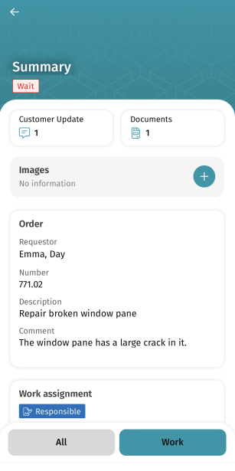

Viewing Time Allocation on a Work Assignment

Time allocation can be viewed in the Time spent block of the work assignment:

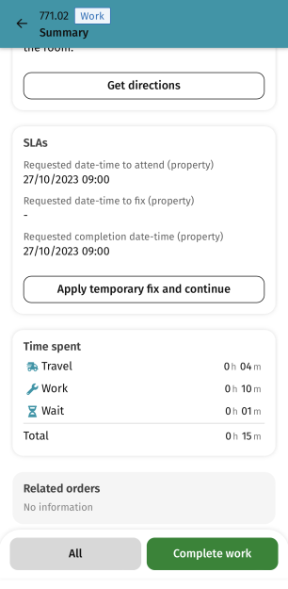

Discontinuing a Work Assignment

If the user needs to discontinue a work assignment the discontinue button can be selected from the All menu. You must get permission from your Supervisor before you discontinue a work assignment. It is essential to add Supervisor’s name and any specific reasons.

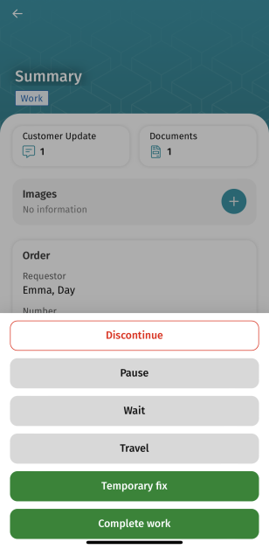

Once Discontinue is selected, the reason should be entered along with any comments in the next screen, and then the Next button clicked.

The Discontinue overview screen will display and once the Submit button is pressed the work assignment will be updated to stopped and will disappear.

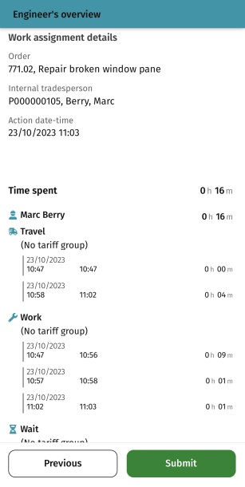

Setting a Work Assignment to Temporary Fix

A temporary fix can be applied to a work assignment, to indicate that some resolution has been made. There are two ways of doing this, either applying a temporary fix and allowing the work assignment to remain on the device, so that the work assignment can be continued to completion, or to apply a temporary fix and remove the work assignment from the device, sending it back to the back office for re-assignment at a later stage.

To carry out the first scenario, click on Apply temporary fix and continue from the SLA block. Please note that this option is only available when the work assignment is in the ‘Working’ status.

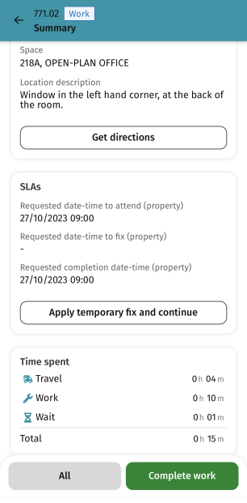

An additional box will appear at the bottom of the screen to allow the user to enter any comments and submit. The work assignment will remain on the device.

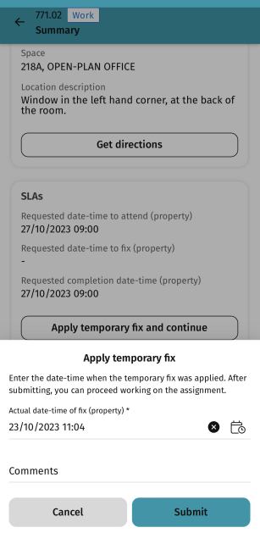

To send the work assignment back to the back office, click on the All button and select Temporary fix from here.

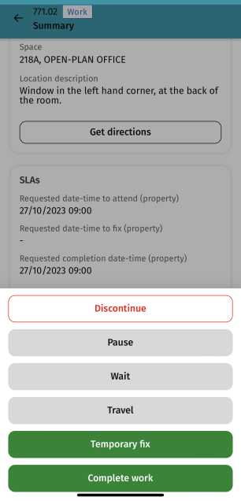

Enter a reason and click Next. The engineer overview screen will display.

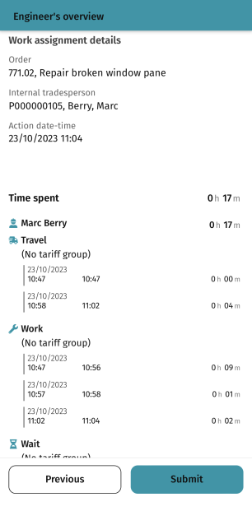

Click on Submit to mark as Temporary Fix. The work assignment is now updated to this status, along with the work order.

Completing a Work Assignment

Before completing a work assignment, users should ensure photo and completion notes are completed.

To complete a work assignment, the user can press the green ‘Complete work’ button to end work:

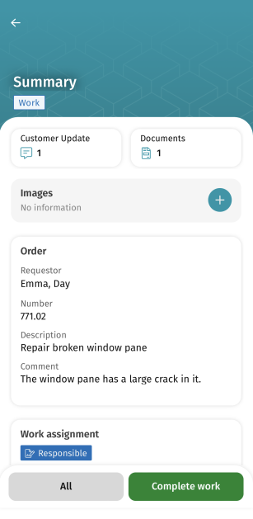

To complete the work assignment, comments can be added, and the answer to the ‘All works completed’ question should be answered. If this work assignment is linked to an order with multiple work assignments, answering ‘Yes’ to this question will stop any remaining work assignments that have not been started. If ‘No’ is answered, any remaining not started work assignments will be left for completion at a later stage.

The work order will not be completed and will remain at an ‘In progress’ status if other work assignments are in progress or move to an ‘on hold’ status.

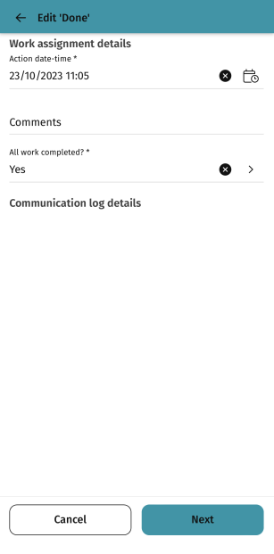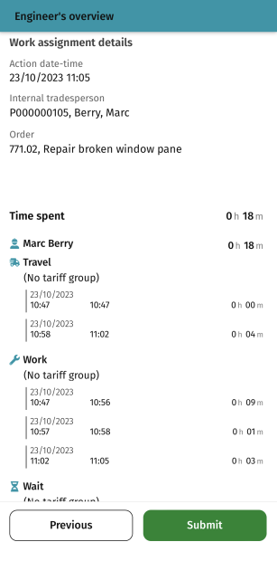

The Engineers overview screen will show and once the user clicks on Submit the work assignment will disappear from the Work assignment list and the status of the work assignment will be Done.

User Guide Journey

To go back to the chapters page, please click here

My Orders Gadget (only applicable to Tier 2 Contractors)

Viewing My Orders and Progressing
Any work orders that have been allocated to you can be viewed in the Contractor – My orders gadget. Orders are listed in number order, smallest first. New orders will have a status of Assigned:

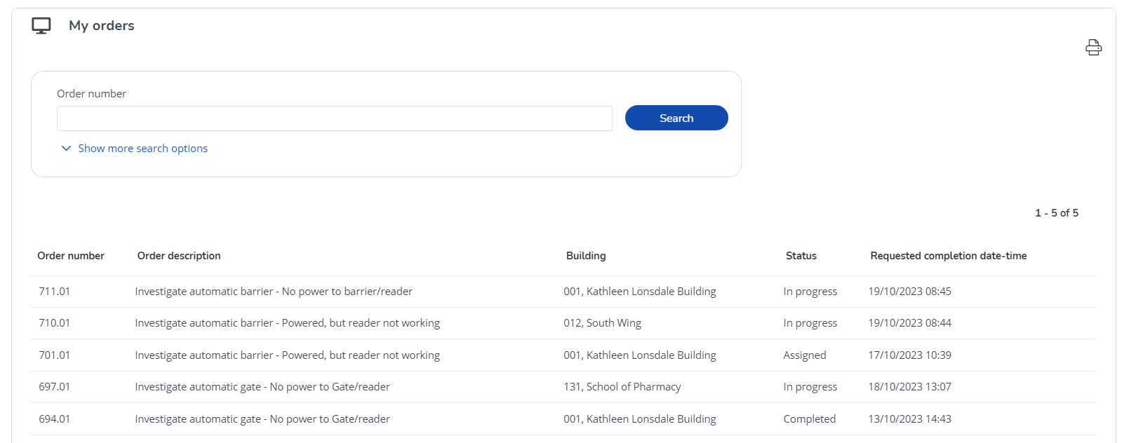

Click on an order to view more details, and to be able to edit and progress:

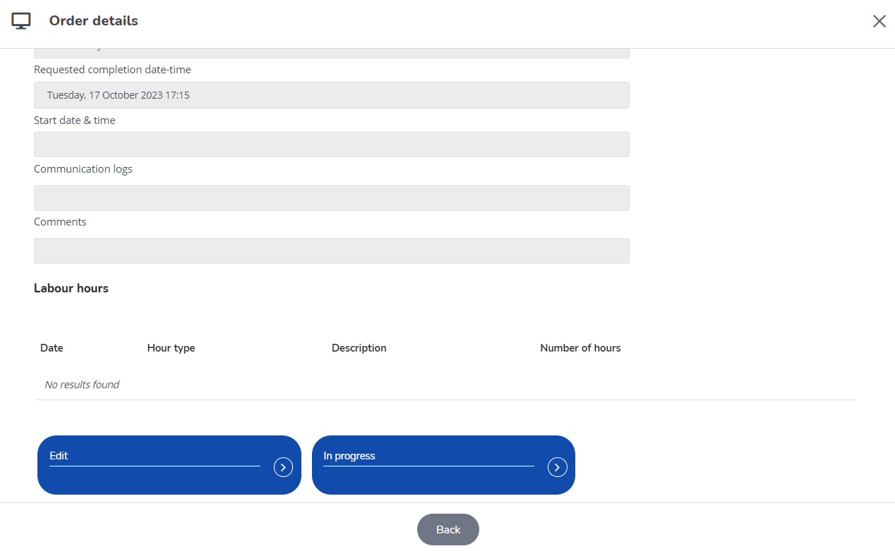

At the bottom of the screen, several buttons will be displayed. What is displayed, and what actions you can perform will depend on the status of the order you are looking at.
To mark that work has started on an order, click the In Progress button.

Adding Comments, Images and Documents
Documents, images, and comments can be added to an order at any time before it is completed.

First, find the relevant order in the Contractor – allocated orders list.
Then click to view more details and scroll down to the bottom of the page:

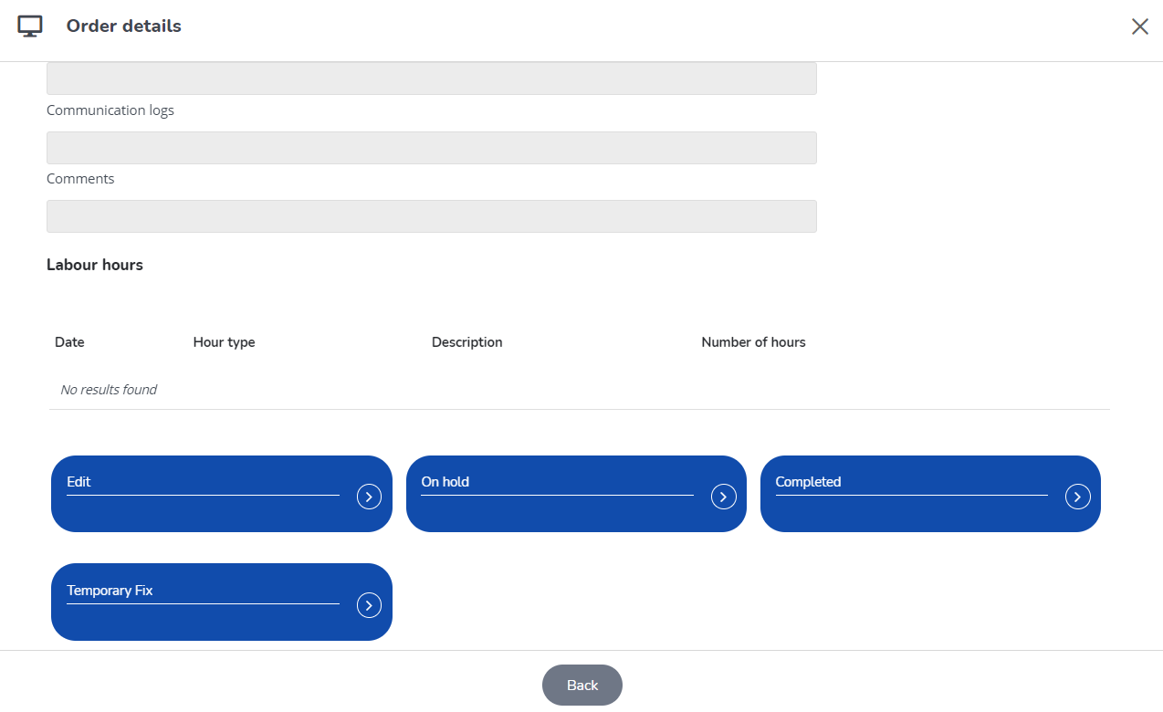

Click on the Edit button and scroll down to the bottom of the page to add any comments and upload documents and/or images:

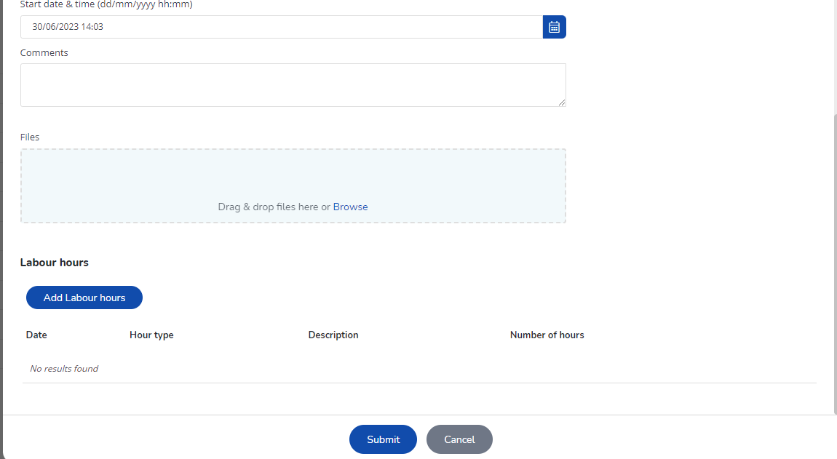

The uploads can be dragged and dropped into the bottom box or click on the Browse link to browse for the file. Click on Submit when you are done.

Putting Orders on Hold
Orders In Progress status can be put on hold:

Click on the On hold button and scroll down to the bottom of the page to add any comments and upload documents and/or images:

The uploads can be dragged and dropped into the bottom box or click on the Browse link to browse for the file. Click on Submit when you are done.

Placing Orders on Temporary Fix
Orders In Progress status can be put on Temporary Fix:

Click on the Temporary Fix button and scroll down to the bottom of the page to add any comments and upload documents and/or images:

The uploads can be dragged and dropped into the bottom box or click on the Browse link to browse for the file. Click on Submit when you are done.

Completing Orders
When you are ready to complete your order, find the relevant order in the Contractor – allocated orders list.
Then click to view more details and scroll down to the bottom of the page:

Click on Completed:

Add any comments into the comment box.
Upload any supporting documents and images by dragging them into the Files box.

Finally, add any labour hours that you need to add by clicking on “Add Labour hours”:

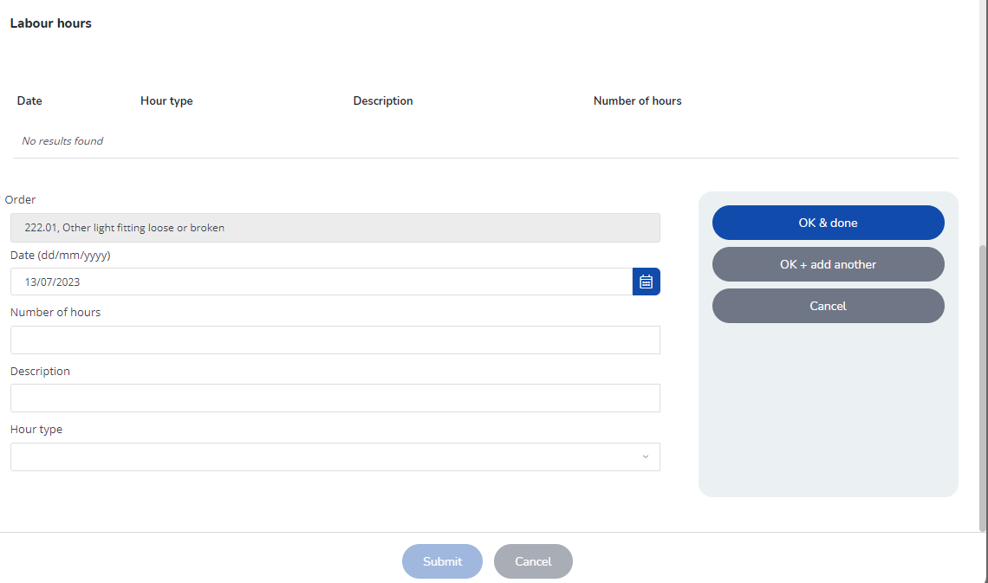

Enter the date, number of hours and a description, then select the type from the drop-down list. Click OK & done if all hours have been entered or OK + add another if there are more hours to add.

Finally, once all hours have been entered, click submit to complete the order.

Viewing Completed Orders
Any orders that have been administratively completed and processed by the UCL helpdesk will be visible in the Contractor – My Orders gadget. Cancelled orders will also show in this gadget:

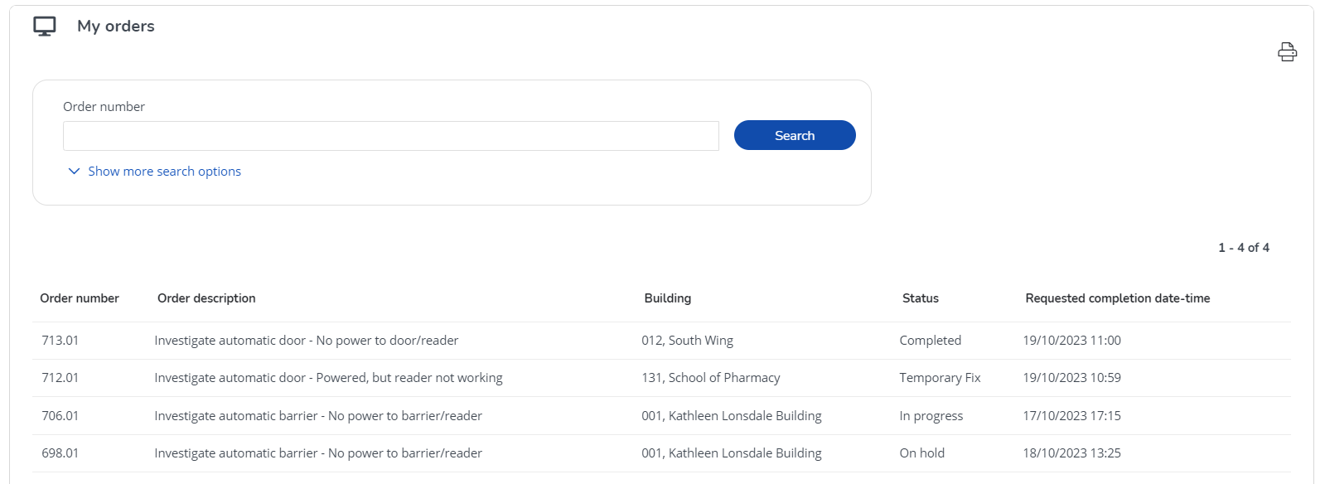

You can search for orders by number or description to help locate an order.

Once you have found the order you need, you can click on it to view related quotations, labour hours, order costs & communication logs.

User Guide Journey

To go back to the chapters page, please click here

Job Card (only applicable to Tier 3 Contractors)

- UCL Estates Helpdesk sends the job to Tier 3 Contractor (the same process as for the other contractors). Moving the work order to the ‘Assigned’ status triggers the email notification to the Tier 3 Contractor.

- The system sends an email containing a job card with the details of the work order to the Tier 3 Contractor’s contact email address.
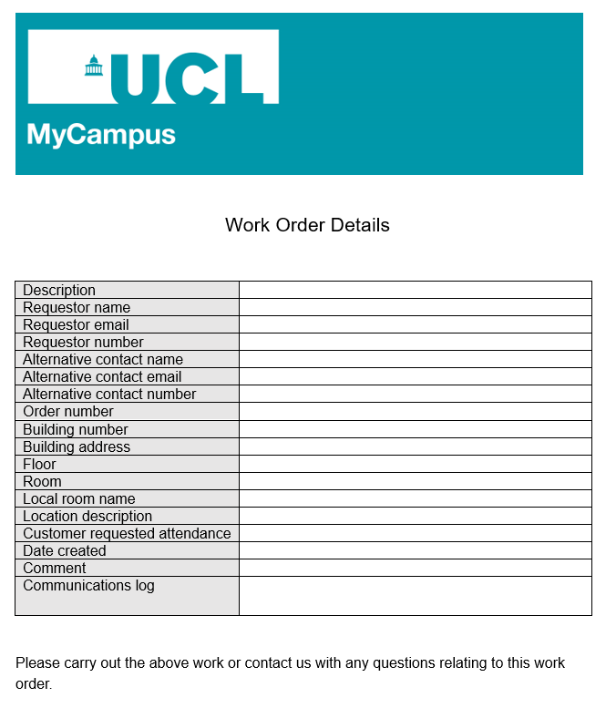

- The Tier 3 Contractor progresses the job and sends updates to UCL Helpdesk on the back of the email received.

- Upon confirmation from the Tier-3 Contractor that the works are complete, UCL Estates Helpdesk completes the work order, transposing the contractor's completion notes to the work order.

User Guide Journey

To go back to the chapters page, please click here

