Information Services Division

Information Services Division

Communications Room Specification Document

This document is updated on a regular basis, readers should always download the latest version from the Employer’s Requirements section of the UCL Estates website under Information Services (Link to Website)

Authors: Andrew Dawson (AD) Allan Fitzwater (AF) Nigel Hayward (NH) Nick Eva (NE)
Date: 10/08/2022
Version: 2.4

Revision History

Version No. | Date Issued | Summary of Changes | Updated by
2.0 | 05/10/20 | Issued | Paul Johnson
2.1 | 22/10/21 | Changes to racks | NH
2.2 | 04/11/21 | Changes to power requirements and room security | NH, AF, AD, NE
2.3 | 04/11/21 | New single leaf doors added to room layouts, appendices updated and grammatical corrections incorporated | NH, AF, AD, NE
2.4 | 31/5/22 | Added data installation sign off and reference to NDD Cat6A spec to communications room checklist | NH, AF

Contents
1. General Information 3
1.1. Introduction 3
1.2. Standards 3
1.3. Approval 4
2. Physical Room Construction 5
2.1. Room Sizing / Location 5
2.2. Security and Safety 6
2.3. Raised Floor 7
2.4. Lighting 8
2.5. Provision and Installation of Network Racks 8
2.6. Communications Room Use 8
3. Provision of Power 9
3.1. Power Installation 9
3.2. Uninterruptable Power Supply (UPS) 10
4. Air Cooling, Humidity and Ventilation 12
4.1. General Guidance 12
4.2. Air Cooling and Humidity 12
5. Appendices 13

General Information

Introduction

Purpose of Document
This document exists to assist project and design teams in planning for new or refurbished communications room(s) including physical room construction, provision of power, air cooling humidity and ventilation. Communications room(s) may be required as part of a new building or a building refurbishment. This document can also be used where additions or refurbishments to an existing communications room are required.
(Note: Network Cabling specifications are covered under separate documents)

Document Role
This document is a specification and not a design, the project and design team(s) must translate these specifications into a final design for approval by ISD.

Document Changes
Changes to this specification document must be approved in writing by the approvers of this document and formally incorporated into this document using change control for changes to be considered valid.

Room Categorisation
Specifications within this document will depend on categorisation of the room as a Main Equipment Room (MER), Sub Equipment Room (SER) or a Student Hall.

Room Type | Description
Main Equipment Room (MER) | An equipment room may be designated as an MER if any of the following criteria apply:  - Contains a Network Router  - Has other building(s) dependent on it  - Is a critical UCL Location
Sub Equipment Room (SER) | - Any other equipment rooms that are not MERs or Student Hall Comms rooms.
Student Hall (Includes Aruba termination point) | - Contains an Aruba termination point for student Wi-Fi.

Standards

Equipment and Materials
All equipment and materials to be used in Communications Room(s) will be from approved contractors and qualified companies using industry standards.

Installations
All installations should meet appropriate and relevant industry standards. Please refer to Appendices (e), (f) and (g) for standards and product guidance and best practice.
Should the Contractor identify any discrepancies between this specification and any design package, this shall immediately be drawn to the attention of ISD.
All components installed must be installed, as a minimum, to the manufacturer’s recommended standards.
All Communication Room installations—including but not limited to physical room construction, provision of power, air cooling humidity and ventilation, and network cabling, must be commissioned at least 2 weeks prior to handover of the site. All documentation and testing certification should be provided on ‘Practical Completion’ of the project.

Approval

Approval
ISD reserves the right to inspect and unilaterally reject installations that do not conform to its standards of workmanship, neatness, and cleanliness. Materials used that do not conform to this specification document or have not received written approval for substitution will be deemed not fit for purpose.

Physical Room Construction

Room Sizing / Location

Room Size
The Communication room should be a minimum size based on the number of network racks that are required. (Room layout drawings can be found in Appendix A)

Number of Communication Rooms
The number of Communications Room(s) within a building should be minimised. The requirement for the number of Communications Rooms will be determined by formal design process and will take into account the number of floors and users/devices per floor.

Location
A Communications Room must be located so that the maximum length of network cables emanating from it does not exceed 90mts
All Communications Room(s) within a building must be located so that they are accessed from a corridor or public space. It must not be necessary to first access another space such as an office, meeting room or plant room in order to gain access. Access to other spaces must not be via the Communications Room(s).
Network racks shall not be installed in areas deemed as:
- Toilet facilities
- Boiler/plant/switch/machine rooms
- Emergency escape ways
- Ceiling or sub-floor spaces
- Areas containing fire hose reels or other fire-extinguishing equipment
- Areas of direct sunlight
- Lift control rooms
Wherever possible Network racks should not be installed below any service pipes carrying water or waste.

Environment
The location of the Communications Room should provide physical and environmental protection for the equipment hosted within. This protection may be achieved either by choice of appropriate location or by specific design and should address the following aspects:
- Temperature
- Humidity
- Vibration
- Exposure to ultraviolet radiation
- Ingress of dust, fluids or other contaminants
- Physical damage (accidental or malicious)
- Security
- Electromagnetic interference

Room Design
The Communications Room shall have no building exterior doors or exterior windows. If external windows must be present, they will be insulated, furred out, and enclosed with drywall boarding.
The door entrance should be a self-closing fire grade door. The door should be 106cm – 122cm wide, single leaf and approximately 244cm high to allow for transportation of cabinets or racking.
The door should be a solid door with no panelling. If panelling has to be provided it should not be glass and should be furred out.
The Communications Room design should have preventative measures if in an area of expected water leakage or in an area that has significant risk of flooding.
All other services should be removed completely from the Communications Room.

Finishing
Walls must be painted white.
Floors should be low dust and anti-static. Carpets are not acceptable and floors should be sealed.
P-finished vinyl tiles should be installed.

Clean-up Requirements
Debris (including packaging and surplus materials) generated during installation and testing of the room’s infrastructure systems (i.e. power, cooling, data cabling and lighting)—must be removed by the corresponding contractor upon conclusion of its work. This should be completed at least two weeks before handover to ISD. The Communications Room(s) will also be professionally cleaned so that all dust and debris are removed. This should also be completed at least two weeks before handover to ISD.

Security and Safety

Security
Communications Room(s) shall be used and accessed primarily by ISD staff. If third parties require access they should be accompanied by an appropriate ISD staff member. If extended access is required (where it is not practical for ISD to be in attendance) then a key permit can be requested. Please contact the DCS team if this is required. (isd-dcs-inf@ucl.ac.uk)
For MER Communications Rooms, access to the room should be controlled using the UCL Gallagher system and CCTV should be installed inside the room to monitor access to the room. MERs must be fitted with a door rated to the LPS 1175 SR2 security rating specification. The current SR2 door set specification shall be requested from UCL Estates Security at commencement of the project.

SER Communications rooms shall be fitted with an Abloy lock mechanism configured to fail secure. No fire alarm interlink is required. A lock barrel from the ISD Communications Room suite (9EA1706 11-xxx) should be fitted within the lock, by agreement between ISD and UCL Estates and Security Access Systems. This lock is to be fitted prior to handover of the room to ISD and forms part of the acceptance criteria. A temporary lock will not be acceptable on completion of the project.

Smoke / Heat Detection
The room should be fitted with at least one heat/smoke detector connected to the main building fire alarm system.

Raised Floor

Specification
Should the Communications Room have a raised floor the following guidelines should be adhered to. A raised floor with a minimum raised height of 20cm, consisting of 60cm x 60cm floor tiles. Vertical stanchions holding the floor up will be anchored to the subfloor with glue and metal anchors. (For larger Communications Rooms with four or more network cabinets, a minimum raised height of 40cm should be provided)
The structure of the raised floor should allow unrestricted access to the void but without enabling access through to adjacent rooms.
For larger Communications Rooms with four or more network cabinets, consideration should be given to the installation of a water detection system in the floor voids.
The raised floor shall consist of high-pressure laminate floor tiles that are 60cm x 60cm. The guidelines below should be used.
For further information, architects, electrical/data consultants, main contractors, suppliers, installers or anyone responsible for the design of the Communications Room should refer to BS EN 12825.
A tile puller should be provided for every Communication Room that is equipped with a raised floor.

Floor Tile Types
The following floor tiles should be provisioned:
Image | Type | Tile Location
 | Cut/Notched | Below network cabinets or racks
 | Blank | All other  floor locations

2.3.3.Mandatory Clearances
There must be at least 322cm from the subfloor to the bottom of the false ceiling. This space allows for a raised floor of a maximum 46 cm, 230cm tall network cabinets, and at least an additional 46cm of clearance from the top of those cabinets to the ceiling or false ceiling.

Lighting

Location
Light fixtures should be located above the aisles and between cabinets.
For purposes of maintenance or interaction with equipment, lighting shall be 500 lux in the horizontal plane and 200 lux in the vertical plane, measured 1 m (3 ft) above the finished floor in the middle of all aisles between cabinets.

Specification
Manual switches should be used to activate lights to ensure lights are not turning on / off while engineers are working in the room. This lighting switch should only control the lighting for that equipment room and should be fed from the dedicated communications room electrical feed. All manual light switches must include signage to turn off lights when leaving the room.
Lighting should be integrated into the emergency lighting system for the building or provided with battery backup.

Provision and Installation of Network Racks

Provision
The preferred network rack is the Excel Environ. Please refer to Appendix A for further information.

Installation
The cabling contractor will install all networking cabinets or racks as per project specification.
The cabling contractor shall be responsible for checking the UCL Asbestos register.
UPS and PDU equipment will be installed by UCL Data Centre Services or contractors appointed by them.
Network cabinets and racks will be installed using a method which effectively utilises space within the room. This will be determined by a physical assessment by the UCL Network Design & Delivery team.

Communications Room Use

In Scope
The Communications Room shall only be used for the housing of ISD networking equipment used to support the delivery of network services to the building. For the avoidance of doubt this excludes anything not in the list below unless approved in writing from the Head of Design & Delivery or Principal Network Designer and UCL Data Centre Facilities Analyst.
- Network Cabinets
- Network Racks
- Structured Cabling
- Fibre Cabling
- Fibre Patch Panels
- UPS and PDU
- Data Switches
- Network routers
- Static switches
- CW1308 Cabling
- Voice Panels
- Electrical Cabling (for the above)

Out of Scope
The following services should not be installed within the equipment rooms to minimise third party access.
- Other building control services (Lift, BMS, access)
- Departmental equipment. This should be hosted in a data centre or in departmental space.

Provision of Power

Power Installation

Building Power Supplies

New Buildings
Where new buildings are deemed critical enough to have generator backup for the building in the event of a power outage, this should be sized to ensure it can support the communication room(s) within the building which must be fed from this essential supply.

Existing Buildings
In existing buildings with generator backup, communications rooms should ideally be fed from the essential supply when feasible.

Distribution Board
A distribution board dedicated to, and housed in, the Communications Room is required. The distribution board should be fed uncontended and directly from the building’s main distribution board(s). The distribution board capacity needs to be based on the room’s usage and as a minimum be sized to allow for the power circuits required in 3.1.3 and 3.1.6 and the spare MCBs in this section. The exact requirement is to be agreed as a project requirement.
Where feasible, MER communications rooms should be provided with dual power feeds, however, this is only anticipated for new communications rooms. Note: For MER Communications rooms this feed should not power the Gallagher entry.
SER communications rooms only require a single power feed as the majority of the equipment deployed to these rooms only includes a single power supply. (If an SER is deemed critical it may be an exception to this requirement).
The distribution board is to be fitted with spare MCBs rated as follows: 1 X 13A, 1 X 16A and 1 X 32A.

Power Provision to Cabinets
Power shall be provided to all network cabinets that house active equipment. A minimum of two each of 16A, 32A, or 63A IEC60309 interlock sockets shall supply each active network cabinet, dependent on equipment load - see Appendix C. Each Commando socket shall be fed direct from the local distribution board.
For MER Communications Rooms, power is to be provisioned in an N+1 configuration. A minimum of 2 X UPS, 2 X PDUs and 1 X Automatic Transfer Switch (ATS) will be supplied to provide redundancy for core network infrastructure. See Appendices E, F and G for equipment models and mounting positions.
For SER Communications Rooms, power is to be provisioned in an N configuration. A minimum of 1 X UPS and 1 X PDU will be supplied. See Appendices E, F and G for equipment models and mounting positions.
All of these requirements should be discussed at the design team meetings as network switch numbers will be a pre-requisite for load calculations.
The positioning of IEC60309 outlets is dependent on the location of the network / computer equipment cabinet(s) and is to be discussed at project planning meetings.
N.B. The provision of the above services is for the use of ISD only. Any departmental use in a shared Communications Room requires separate dedicated power. Departments should not use core network infrastructure and they should provide their own requirements.

Earthing
Each Communications Room should be fitted with a clean earth bar to be located on a wall adjacent to the nearest cabinet.
A single direct earth connection shall be made from the main earth bar to each of the network cabinets housed within the Communications Room. This connection shall be as short as possible and of low impedance and no less than 16mm diameter. The cable shall have crimp lugs at each end.
Equipotential Bonding should be maintained throughout.

Labelling and Signage
Circuits within each distribution board shall be numbered and labelled to match the installed electrical outlets. Panel schedules shall include outlet type and cabinet location.
Receptacles shall be labelled with circuit information indicating its location in the source panel.
An electrical one-line diagram is to be provided for each Communications Room.

Convenience Outlets
4 x BS1363 13A power outlets shall be installed within each Communication Room, 46cm above the floor’s top surface. These outlets will not be connected to the room’s backup power system. Installation should be in a 2 x twin outlet configuration.

Uninterruptable Power Supply (UPS)

Requirement
The UPS should be capable of providing protection against both spikes and loss of electrical supply.
The system will be configured such that, if utility power to the room fails, the load will be supported by the UPS in line with the below.

Room Type | Minimum Run Time
Main Equipment Room (MER) | 1 hour
Sub Equipment Room (SER) | 30 mins
Student Halls study bedrooms | 5 mins

Specification
UPS equipment should follow ISD advised manufacturers and models as referenced in Appendices D-G.

Installation
UPS equipment should be installed in the cabinet using an appropriate shelf or rails, or floor standing if rack mounting within the data cabinet is not possible.
UPS equipment shall not be located below sources of water such as drip trays associated with Air Cooling Systems.
Each UPS shall be provided with a network card and temperature probe which will be configured by ISD Data Centre Services, as referenced in Appendices D-G

Sizing
The sizing of the UPS should be based on the maximum electrical load of equipment in the network cabinet. There are 2 options:
- If you have full details of the equipment going including into the cabinets, including any expected PoE load, then follow the process in Appendix C.
- If full details are not currently known, then follow the process in Appendix D to estimate your UPS requirements.

Air Cooling, Humidity and Ventilation

General Guidance

Requirement / Sizing
It is essential that the project architect, consultant, main contractor or sub-contractor evaluate the current and future ventilation, air conditioning and cooling requirements. Experience has shown that heat dissipation continues to rise as processors become more powerful and, as more and more equipment is becoming IP based such as Telephony and CCTV, this trend looks likely to increase.
The following should be used as a general guide to the heat dissipation per Data Cabinet:
- Approx. 3500 watts maximum
- Approx. 12500 BTU/hour maximum

Installation
Any air conditioning provided to the Communication Room should be independent of the main building air conditioning controls as energy saving features used in the main building could present a risk to the cooling of the Communications Room.
Air conditioning units shall not be mounted above Communication Room racks and must be accessible for maintenance. If there is no other option, then the unit could be installed with a pump and drip tray.

Air Cooling and Humidity

Specification
Every MER Communications Room will be designed with a suitable cooling and air conditioning system in an N+1 configuration, based on the room’s calculated heat load
SER Communication Rooms will be designed with suitable cooling and air conditioning in an N configuration, based on the room’s calculated heat load. These loads should be discussed at the design team meetings.
Room cooling and humidity control should be via an AC system with a return air design point temperature and relative humidity of 22°C (±0.5°C) and 45% (±5%), respectively.
Room design should include appropriate planning for the removal of AC unit condensate (either via gravity or pump). A/C units must be able to run continuously.

Ventilation
There should be sufficient clearance (10cm minimum) between the A/C unit and network cabinets in order to avoid potential damage from water leaks, as well as to allow for maintenance access.

Appendices
Appendix A - Room layouts
Appendix B - Estimating the Number of Racks Required
Appendix C - Calculating Accurate Power Consumption
Appendix D - Estimating UPS Requirements
Appendix E - UPS Design for APC3000 – 16 amp IEC
Appendix F - UPS Design for APC5000 – 32 amp Hard Wired
Appendix G - APC Technical Specification plus Features and Benefits
Appendix H - UCL Communications Room Checklist
Appendix I - Abbreviations

Appendix A – Room Layouts (1 Rack)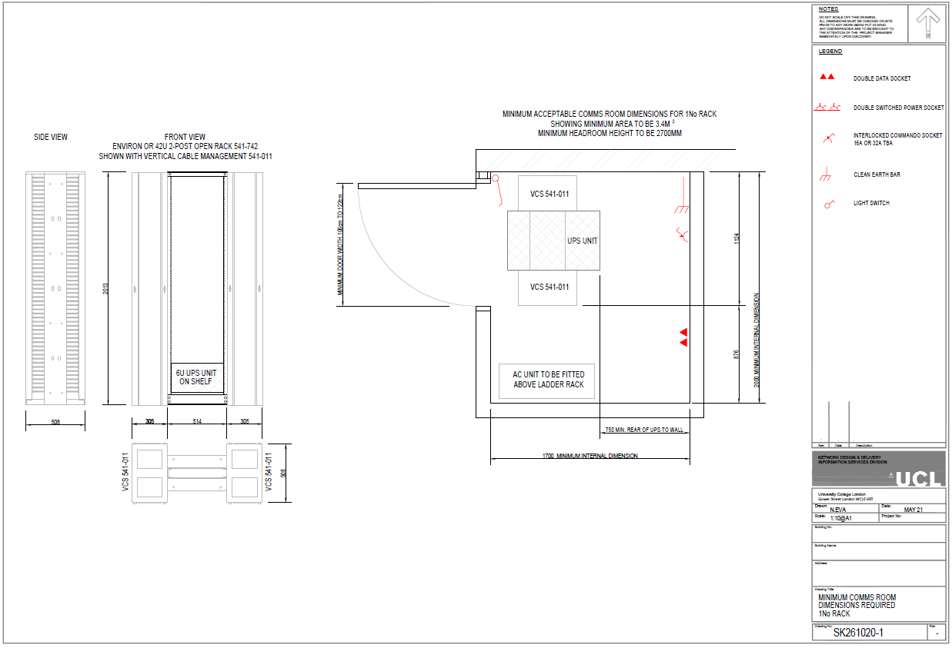
Appendix A – Room Layouts (2 Racks)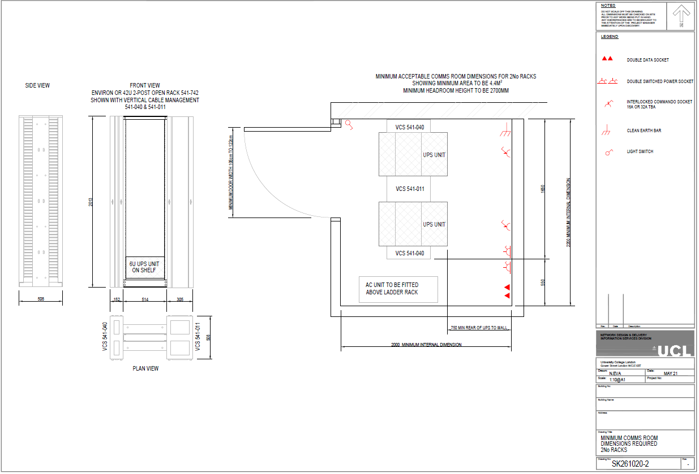
Appendix A – Room Layouts (3 Racks)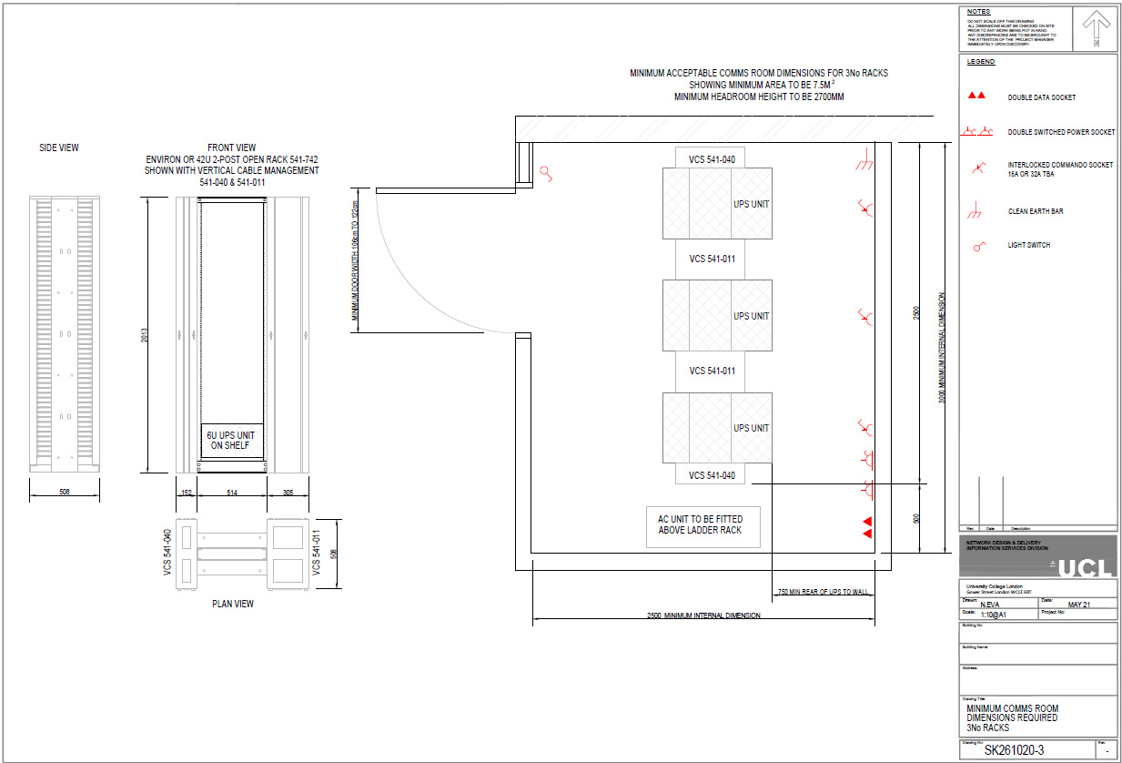
Appendix A – Room Layouts (4 Racks)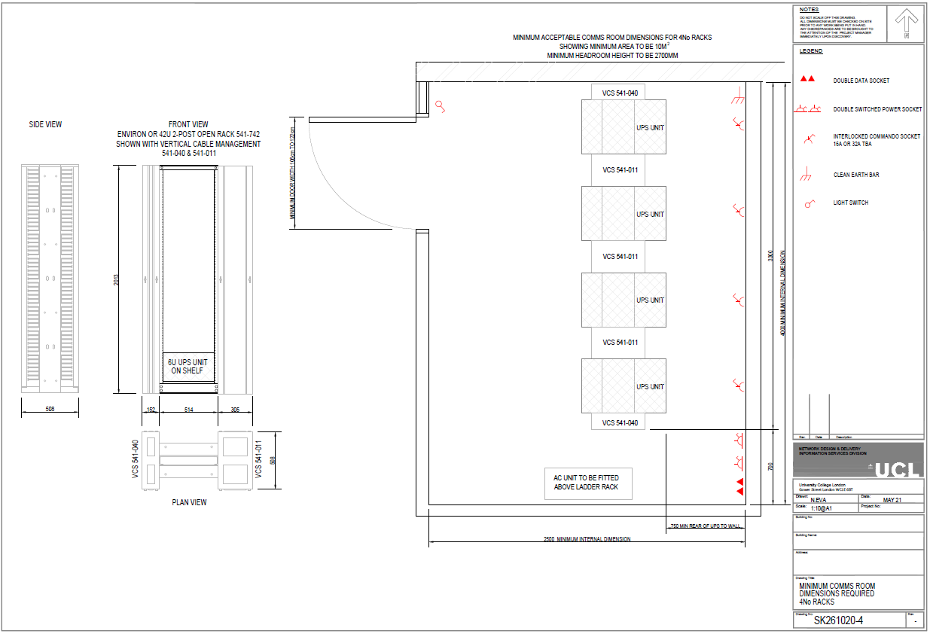
Appendix B - Estimating the Number of Racks Required
The main factor when estimating the number of racks required within a Communications Room is the number of network switches installed.

The following table can be used to estimate the number of racks required.

Number of switches | Number of Racks
1-8 | 1
9-16 | 2
17-24 | 3
25-32 | 4

Note: The suggested number of racks is based on the Excel Environ rack full height model. Wall mounted cabinets should not be used.

Appendix C - Calculating Accurate Power Consumption
To determine an accurate power consumption for the room the Data Centre Services team require an accurate record of all equipment within the rack as well as details of any PoE equipment connected to the switches.
Once calculated, this power consumption can then be used to accurately specify the UPS and cooling requirements.
Please complete the following “DCS Comms room discovery form” template if requirements are fully understood.

DCS Comms room discovery form
Site (Building) code
Site name
Floor
Room no.
Type of cabinet (delete as necessary)
std 800 X 600 / 800 X 800 / Environ open rack / Other (specify)
Cooling – independently controlled 24 X 7 YES /NO
Room under ISD control? YES / NO

Network Equipment
Make | Model | No of PoE ports | No of PSUs fitted | Power input connector type C14, C16, C20 | Estimate PoE ports in use | Estimated power consumption | Rated Power Consumption (Watts)
TOTAL

Telecoms Equipment
Make | Model | No of PSUs fitted | Power input connector type, C14, C16, C20 | Estimated Power consumption | Rated Power Consumption (Watts)
TOTAL

Other Equipment
Make | Model | No of PoE ports | No of PSUs fitted | Power input connector type C14, C16, C20 | Estimated power consumption (Watts) | Rated Power Consumption (Watts)
TOTAL

Other Info
Results
Based on the above information DCS can specify the following equipment

Equipment type | Make | Model | Manufacturer p/n | Quantity | Cost | Notes
UPS
Battery pack
Shelves
Web card
Other
TOTAL

Appendix D - Estimating UPS Requirements

UPS types
There are 3 different UPS types that could be deployed to provide emergency power. These are:
- SRT3000 - 3000VA (Lead acid)
- SRT5K - 5000VA (Lead acid)
- SRTL3000 (Lithium-ion)

The following tables provide an estimate of the UPS required based on the estimated power load and the UPS run time.

Runtime (Mins) | IT Load (Watts)
 | 500 | 1000 | 1500 | 2000 | 2500 | +2500
30 with a/c @ 22 degrees | SRT3000 | SRT5000 | SRT3000 +1BP | SRT3000 + 1BP | SRT5000 + 1BP | Contact DCS to discuss.
30 with no a/c | SRTL3000 | SRTL3000 | SRTL3000 + 1BP | SRTL3000 + 1BP | SRTL3000 + 2 x BP
60 | 2 X SRT5000 | 2 X SRT5000 + 2 X BP | 2 X SRT5000 + 2 X BP | 2 X SRT5000 + 4 X BP | 2 X SRT5000 + 4 X BP

Appendix E - UPS Design for APC3000 – 16 amp IEC

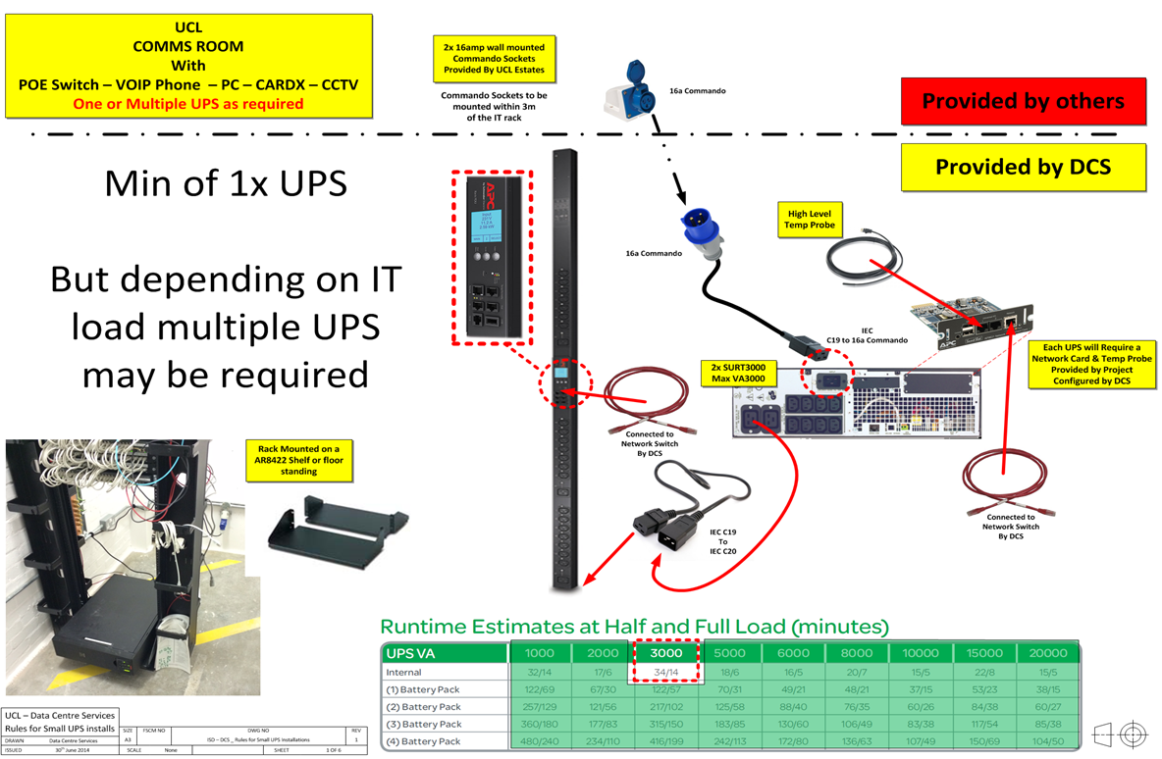
Appendix F - UPS Design for APC5000 - 32 amp Hard Wired

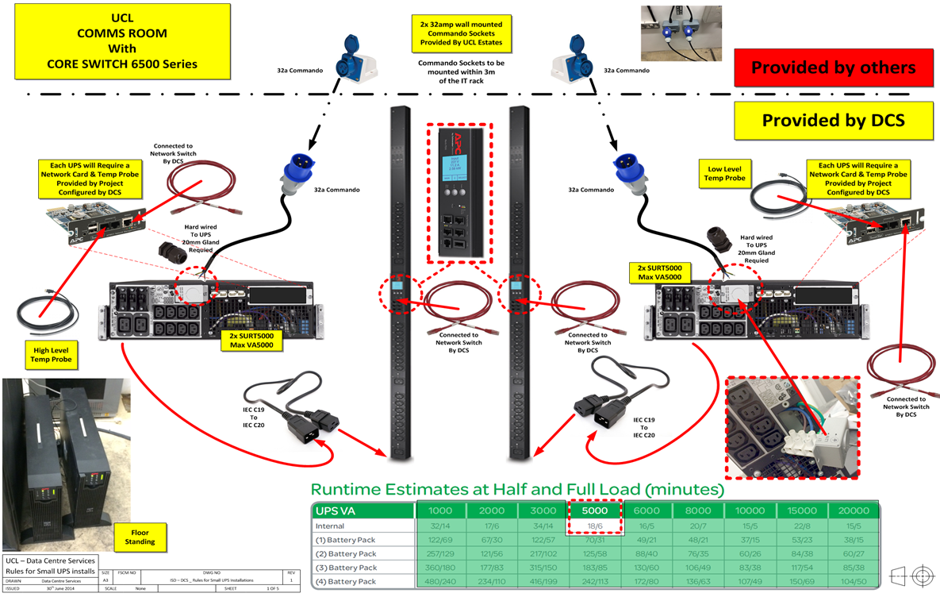
Appendix G - APC UPS Technical Specifications
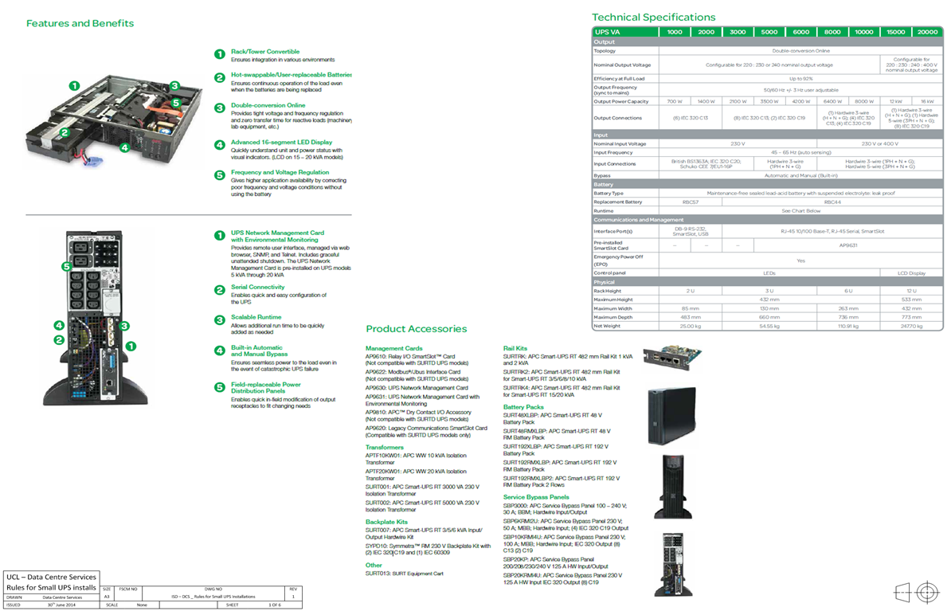
Appendix H - UCL Communications Room Check List

- Document Information
Document Name | UCL Communications Room Check List
Author
Issue Date

- Document History
Version | Date | Summary of change

INSTRUCTIONS

This checklist is to be used in conjunction with the ISD specification for Communications Room Requirements Specification Version 2.4 and UCL NDD Cat 6A Spec v3.4

Location and suitability of the Communications Room are to be agreed before works commence.

All other items to be complete 2 weeks prior to handover to allow ISD staff to commence installation of UPS equipment and network switches. This will be required for commissioning of services such as emergency lighting, BMS, door access and network cameras.

All documentation and testing certification to be available upon practical completion.

 | Description | Specification Reference | Compliant  Y/N | Comments
1 | Physical Room Construction
 | Room Size | 2.1.1, Appendix A, Appendix B
 | Number of Communication Rooms | 2.1.2
 | Location | 2.1.3
 | Environment | 2.1.4
 | Design | 2.1.5
 | Finishing | 2.1.6
 | Room Cleaning | 2.1.7
 | Security and Safety | 2.2.1, 2.2.2
 | Raised Floor | 2.3.1, 2.3.2
 | Lighting | 2.4.1, 2.4.2
2 | Provision of Network Cabinets
 | Provision | 2.5.1
 | Installation | 2.5.2
 | Communication Room Use – In Scope | 2.6.1
 | Communication Room Use – Out of Scope | 2.6.2
3 | Provision of Power
 | Building Power Supplies | 3.1.1
 | Distribution Board | 3.1.2
 | Power Provision to Cabinets | 3.1.3
 | Earthing | 3.1.4
 | Labelling and Signage | 3.1.5
 | Convenience Outlets | 3.1.6
3 | UPS
 | Requirement | 3.2.1, Appendix C, Appendix D
 | Specification | 3.2.2, Appendix G
 | Installation | 3.2.3, Appendix E, Appendix F
 | Sizing | 3.2.4, Appendix C, Appendix D
4 | AC Equipment
 | Requirement / Sizing | 4.1.1
 | Installation | 4.1.2
 | Specification | 4.2.1
 | Ventilation | 4.2.2
5 | Data Installation
 | Structured cabling first fix | Ref UCL NDD Cat 6A Spec V3.4 available on request
 | Structured cabling second fix
 | Testing and labelling

Communications Room ID …………………………..
Completion Date …………………………..
ISD Representative …………………………..

Appendix I - Abbreviations

The following acronyms and abbreviations are used in this document:
- SM—Single mode fibre
- MM—Multimode fibre
- PDU—Power Distribution Unit
- PoE – Power over Ethernet
- UPS—Uninterruptible Power Supply
- ATS – Automatic Transfer Switch
- RPS – Redundant Power Supply

