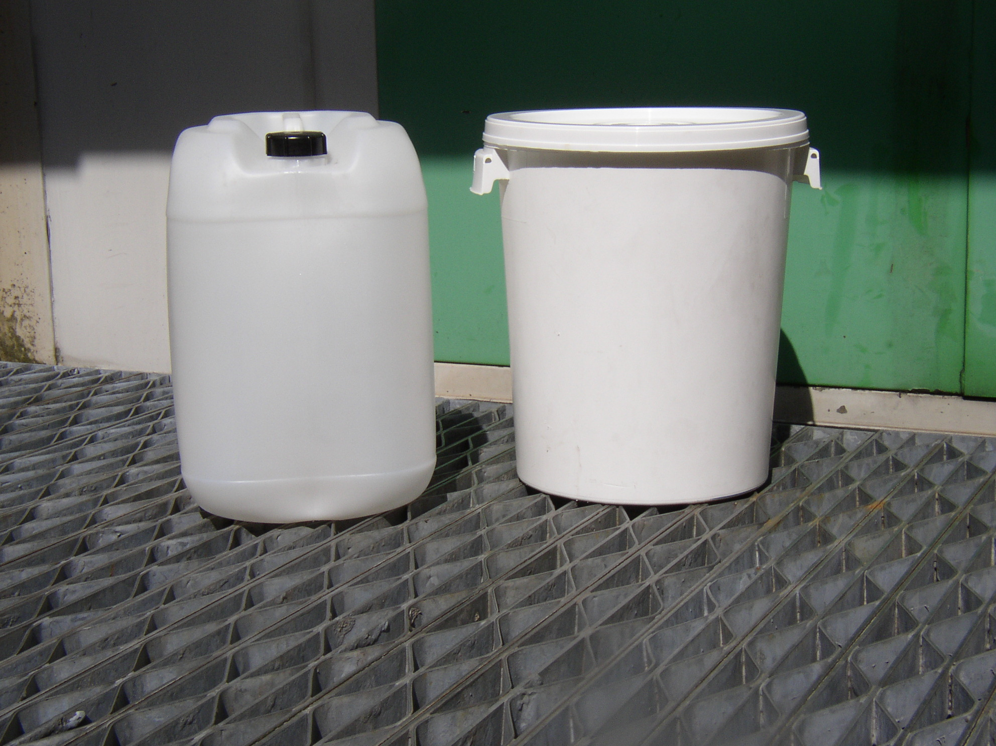
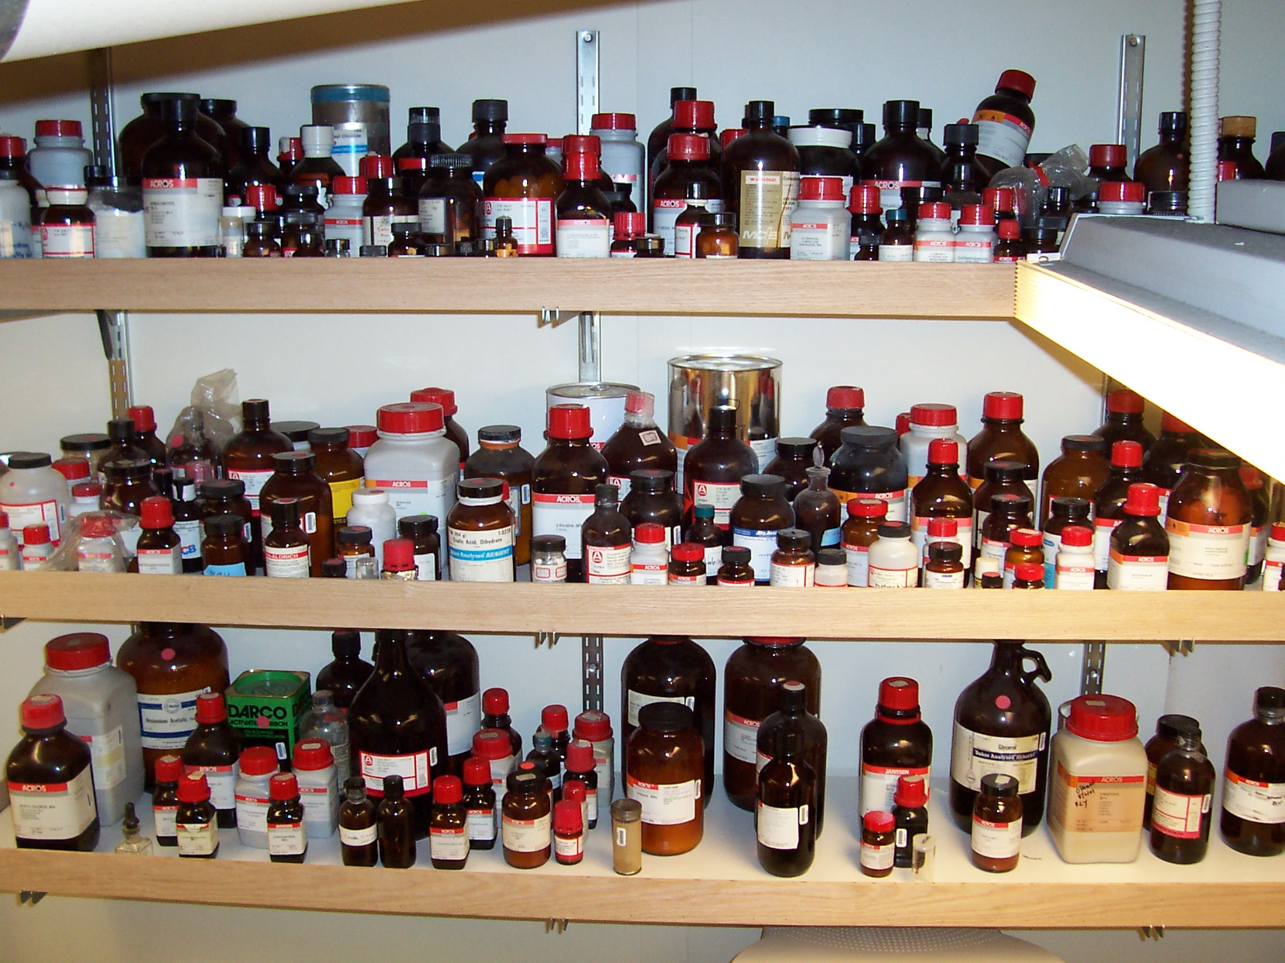
Chemical Waste Disposal Procedures

Document Control
Document Created by
Shane McAteer | Ver. 1.0 23/07/2012
Last Updated by
Gary Stratmann | Ver. 2.1 08/01/2013
Paul Monk | Ver. 2.2 01/10/2020
Paul Monk | Ver. 2.3 20/02/2021
Paul Monk | Ver. 2.4 21/03/2022

Introduction

This chemical waste procedure document covers the safe disposal of chemical wastes whilst implementing industry best practice in waste management.

Underpinning this document are UCL’s commitments to three core values: the prevention of pollution, compliance with legislative requirements and continual improvement.

The list of parties involved in chemical waste disposal referred to in this document:

All waste producers have a legal responsibility to ensure that waste is produced, stored, transported and disposed of without harming the environment. This is your “duty of care”.

UCL Facilities and Workplace Services, a division of Estates, supplies a wide range of business support services such as cleaning, domestic and special waste management, security, mail services and telephony services.

Waste managers working from within UCL Facilities and Workplace Services have the responsibility to advise waste producers and manage waste contractors and suppliers in delivering required service standards.

Contractors and suppliers are employed to deliver safe and compliant collection, transport and disposal of wastes produced by UCL as requested by Facilities and Workplace Services waste managers.

Roles and Responsibilities

ROLE | RESPONSIBILITIES
Departmental Users | Classify and segregate their waste correctly according to the advice in this procedure and the UCL Waste Manager.
 | Adhering to requirements set out in this procedure and compliance with local rules and notices.
 | Waste is produced, stored, transported and disposed of without harming the environment.
Departmental Safety Officer | Ensure that the requirements of the Chemical Waste Disposal Procedure are effectively implemented and monitored.
UCL Waste Manager | Maintain and update the Chemical Waste Disposal Procedure
 | Ensure that disposal processes available to departments are fit for purpose and are compliant.
 | Resolve any issues arising from following this procedure.
 | Advise waste producers and manage waste contractors and suppliers in delivering required service standards.
 | To compliance audit UCL waste disposal providers on a regular basis.
UCL Safety Services | To ensure waste services are compliant with all health and safety legislation and to advise UCL Waste Manager if they are not.
 | To follow up on any accident or incident reports related to the processes in this procedure.
External Waste Provider | To deliver safe and compliant collections, transport and disposal of wastes produced by UCL as requested by the UCL Waste Manager.
 | To complete compliance audits on any third party disposal facilities on behalf of UCL.
Estates Customer Service Helpdesk | Logging requests for chemical collections and collecting chemical lists.
 | Informing customers of the date of collection of their chemicals.

Classification of Chemical Wastes

UCL Routine Chemical Waste Collections

For the process of arranging collections, Chemical wastes produced at UCL are classified as either Bulk solvents or Laboratory smalls. In order for UCL to reduce the cost and environmental impact from this disposal service both bulk solvents and lab smalls are collected on the same vehicle where possible.

A list of chemical collection dates for each building is available on the UCL website.

Bulk Chemical Collection

Bulk chemicals are solvents and other substances contained within UN approved 25L plastic drums for liquids and 30L plastic lidded drums for solids. These are provided on request and exchanged upon collection of the full ones on the scheduled collection day. The bulk collection takes place on Tuesdays, Main Campus one week and Off Campus the other week. Bulk waste from Chemistry will be taken on the Thursday of the Main Campus collection week. The schedule is available on the UCL Estates Website

Bulk solvents are either stored within the laboratory for direct collection or stored centrally. Consult with your chemical waste disposal (building) representative for clarification.

Laboratory Smalls collection

Laboratory smalls are described as any chemical in a jar or a bottle that would routinely be used in lab. For instance 50g to 500g for solids.

In order for laboratory smalls to be transported safely they must be correctly listed and packaged in UN approved containers according to their hazardous properties. For this reason a contracted waste disposal chemist will complete this. Once packed securely for transport the waste will remain where it is until the next bulk chemical collection in which it will be collected and transported to the disposal site.

Role of the Waste Producers: How to request a chemical waste collection?

- Fill in a copy of the New Chemicals & Solvents Form v3.xlsx.
This form should be available on the Estates Website.
If not then it can be requested from The Estates Customer Service Centre or by emailing the Waste Manager p.monk@ucl.ac.uk. Once you have the form downloaded you can use the file for every chemical disposal request.
- The top part of the form consists of drop down menus where you can select bulk chemicals such as solvents etc. If your chemical is not on the drop down list add it to the bottom section of the form
- If you have small containers of lab chemicals to dispose of, list them in the bottom part of the form. In the Volume/Weight column just list the volume or weight quoted on the container. You do not need to estimate how much chemical is left.
- If you require empty containers, for waste solvents for example, then please enter this in the space provided.
- Raise a chemical disposal request with the Estates Customer Service Centre using the online form https://www.ucl.ac.uk/estates/customer-helpdesk/raise-service-request.
- They will send you a W number for your request. Please add this to your New Chemical and Solvent Form list. This number will be used to track your request.
- Email your New Chemical and Solvent Form file back to the Estates Customer Service Centre efdservices@ucl.ac.uk
- Your request will be added to the next available collection provided your list has been sent to the Estates helpdesk by noon on the Thursday before the collection .
- Collections always happen on a Tuesday, and alternate between Campus (Bloomsbury area) and Non-Campus (more remote sites such as Institute of Child health and Institute of Neurology. If you are in Chemistry your collections will be on Thursdays every other week.
- You will be contacted by the Estates Customer Service Centre with the date of your collection. Someone must be available on that date to show the chemist where the waste is.
- On the day of the collection, the disposal chemist will contact you or one of the people nominated on your form to arrange a time to collect your waste.
- The disposal chemist will only collect the exact chemicals on the list submitted.
- When the waste is collected the disposal chemist will ask you to sign a printed copy of your disposal form as a receipt for the waste.
- You will also need to sign a waste consignment note for your collection. This is a legal document and you must keep a copy of this for 3 years. You may be asked to produce these by an Environment Agency Inspector. Details about Consignment Notes can be found here:
https://www.gov.uk/guidance/hazardous-waste-consignment-note-supplementary-guidance
- Your waste will be taken away and any empty containers requested will be left behind.
Role of the Estates Customer Service Helpdesk
- After receiving the email from the waste producer containing their filled in New Chemicals & Solvents Form, the customer service centre should save the forms in the following folder:
S:\EFD_5.4.5 Hazardous Waste\Customer Service Work Orders
- Once the External Waste Provider contacts the Estates Customer Service Helpdesk with the collection dates for each W number, they update the request on the system with the actual date.
- Once the collections have been confirmed by email as completed by the External Waste Provider, the Estates Customer Service Helpdesk should close the jobs.
- The Estates Customer Service Helpdesk should be the first point of call for Waste Producers to enquire about their jobs and for the External Waste Provider to gain extra information about the jobs.

Role of the External Waste provider
- The External Waste Provider, once it has been provided with the New Chemical and Solvent Forms, will schedule the jobs according to the agreed timetable.
- Each week the External Waste Provider will provide the Estates Customer Service Helpdesk with a list of jobs that will be collected that week by listing their W numbers.
- They will provide UCL logistics with details of the vehicle arriving on site so that it can be booked.
- On the collection day the External Waste Provider will contact the person listed on the New Chemical and Solvent Form and arrange the specifics of the collection.
- After collecting the waste the External Waste Provider will ensure that the Waste Producer signs the New Chemical and Solvent Form and a waste consignment note A copy of both will be left with the waste producer as proof of collection. Consignment notes need to be legally kept for 3 years
- The External Waste Provider will remove the waste from site in a way that is compliant with the Carriage of Dangerous Goods and Use of Transportable Pressure Equipment Regulations (CDG) 2009.
- The External Waste Provider will then ensure that the waste is disposed of in a compliant way to a permitted waste disposal facility.
- After collecting the waste, the External Waste Provider will ensure that all jobs with W numbers that have been collected are closed off on the UCL Estates Maintenance Portal.
- The External Waste Provider will scan in and send all completed consignment notes to the Waste Manager.

Role of the Waste Manager
- The Waste Manager is responsible to facilitating the process. They will ensure that chemical lists are sent to the External Waste Contractor.
- The Waste Manager will be responsible for resolving any issues that occur during the process.
- The Waste Manager will ensure that all electronic and paper consignment notes are kept for the required 3 years.
- The Waste Manager will ensure that the External Waste Contractor is audited on a regular basis, is compliant and meets all Health and Safety Requirements.

Specific Controls for Certain Chemical Categories

Certain chemicals pose unique challenges when presented for disposal due to either their specific chemical or physical properties, or because of legislative controls in place related to the nature of the individual substances. The following categories of chemicals must be identified by the waste producer in advance of being entered onto the Chemicals & Solvents Form v3.xlsx, and the UCL Waste manager must be made aware of their presence. This will allow the UCL Waste Manager to discuss the appropriate disposal options with the External waste provider to ensure that the appropriate additional controls are in place to facilitate safe collection and disposal. Categories of chemicals are :

Controlled substances and precursors
Possession and use of these categories of chemicals are restricted due to their use as a narcotic or in the production of narcotic substances. The appropriate licence must be in place for each of these substances. Please notify the UCL Waste Manager of the requirement for disposal of this category of substance before being presented for disposal as their disposal cannot take place until the licensing arrangements have been verified.
A list of these substances can be obtained from UCL Safety Services.

Explosives, Self Reactive substances and Temperature Sensitive substances.
These categories of substance will require specialist storage, transport and disposal processes.Their storage in the laboratory should have been assessed prior to purchase and use and they should therefore be safely stored. Please notify the UCL Waste Manager of the requirement for disposal of this category of substance before being presented for disposal as their disposal cannot take place until they have been fully assessed for storage, transport and disposal.

Unknown Chemicals.
The disposal of unknown chemicals are difficult to dispose of because without knowing what the components of a chemical waste are, it is difficult to identify a suitable, compliant disposal route. Any unknown chemicals must be characterised prior to being presented for disposal. If this is not possible in the lab, please notify the UCL Waste Manager of the requirement for the disposal of unknown lab chemicals, so that arrangements can be made to adequately characterise them using a third party.

Hydrofluoric Acid
The disposal of Hydrofluoric Acid must be carried out with extreme care due to the uniquely hazardous properties of the substance. Prior to it’s handling, whether by the UCL lab staff or by the external waste provider, it must be confirmed that all parties are in possession of an adequate supply of a suitable HF treatment (either Hexafluorine or Calcium Gluconate gel), and have appropriate PPE for handling this waste. Please notify the UCL Waste Manager prior to presenting this material for disposal s that it can be verified with all parties that adequate precautions are in place prior to the handling of this waste.

SIGNING CONSIGNMENT NOTES

Each waste collection is accompanied by the relevant paperwork. Either waste transfer notes or waste consignment notes, or both, where appropriate.
These documents need to be signed by the consignor (UCL) and kept for a minimum of three years.
The following outlines the procedure that needs to be followed in order for consignment notes to be signed compliantly.

- Each location must have a designated person or people trained in how to sign consignment notes. They shall be known as the Responsible Person for that location. The Gower Street campus and surrounding buildings all count as one place.
- Training will be provided by the Waste Manager or a UCL contractor on behalf of the Waste Manager
- After each chemical waste collection UCL’s External Waste Contractor will ask the Responsible person to sign the consignment note before they leave site.
- The Responsible Person must check that the details on the note and ensure that the waste description and the quantity of waste is correct before signing. Information on how to do this will be provided during training.
- At this point a physical copy of the note may be left with the Responsible Person. These must be stored somewhere safe and kept for a minimum of 3 years.
- If a paper note is signed by the Responsible Person and a copy is not given, the Responsible Person must ask the waste contractor for it.
- The consignment note may be electronic in which case it will still need to be signed but an electronic copy will be sent via email instead of being left behind.
- Current documents are held in the UCL Estates Offices at Bidborough House, Bidborough Street and older documents are held at the UCL Archive store.
- The Waste Manager and the External Waste Contractor maintain an issue log where any issues with collections are recorded and any actions taken are noted. This information is collated and reported on in monthly meetings.

After the collection of hazardous waste.

In addition to retaining the copies of the consignment notes, once the waste collection has taken place, UCL are also required to hold copies of the quarterly hazardous waste returns issued by the disposal site that the waste was delivered to. The quarterly return can take the form of either a fully completed copy of the consignment note (including section E), or alternatively, a document detailing the specified information in The hazardous Waste (England and Wales) Regulations 2005. These returns will be held centrally by the UCL Waste Manager.

Auditing

Auditing of waste is a legal requirement. There are two types of auditing that need doing with chemical collections.

- Duty of Care Audits
UCL audits its waste contractors to ensure compliance. This may include a visit to the waste facility itself.

- Consignment Note Audits
Once every 2 months a selection of transfer notes will be audited and the results noted in an audit log. Any actions arising from these audits will be resolved before the next audit.

Missed collections from specific locations.

In the event that your chemical collection is missed the Customer Service Helpdesk will contact you and arrange another date for your collection to be made.

Ongoing Monitoring and Issues:

Continual compliance monitoring of the site is in operation. The Waste disposal contractor records any issues the driver experiences on an online issue log shared between the disposal contractor and the UCL waste manager.
The waste manager also uses this log to record issues and they are reviewed once a month.

Training

Information and resources needed for booking a chemical waste collection are available, to all staff, from the UCL Waste Manager and the Estates website. This information can then be translated into introductory information and training for new starters.

The external Waste Contractor trains all of the staff involved in collection of chemical waste from UCL.

Information regarding all waste disposal procedures and contacts can be found on UCL’s waste website. This website is kept up to date as new information, procedures and resources are available. http://www.ucl.ac.uk/estates/waste/

Waste Reporting

The types of waste disposed of, quantity of each waste stream and the method by which it is disposed is reported on a monthly basis by the waste contractor. This report is made available to Facilities and Workplace Services managers.

Incidents and Accidents

In the event that a member of staff has an accident or incident involving chemical waste they must report it their departmental Safety Officer and fill in the Risknet Incident form details of which can be located on the Safety Services website.
https://www.ucl.ac.uk/estates/customer-helpdesk/report-incident

In the event that a waste disposal contractor has an accident or incident involving chemical waste they must report it the UCL Waste Manager and fill in the Risknet Incident form details of which can be located on the Safety Services website.
https://www.ucl.ac.uk/estates/customer-helpdesk/report-incident

