**Traffic Management Plan**

**BLOOMSBURY CAMPUS**

**Document Owner**

Director, Sustainability is the Owner of this document.

**Distribution**

This document is to be formally distributed to:

|  |  |  |  |
| --- | --- | --- | --- |
| **Name** | **Title** | **Date of Issue** | **Version** |
| ELT |  | 31/10/14 | V2.3 |
| All UCL Estates Staff |  | 19/12/14 | V2.3 |
| ELT |  | 05/08/15 | V3 |
| All UCL Estates Staff & Contractors |  | 21/07/16 | V4.1 |
| Estates Employers Requirements  All UCL Estates Staff |  | 07/09/18 | V5.0 |
| Estates Employers Requirements  All UCL Estates Staff |  | 04/03/19 | V6.0 |
| All cyclists  Those arranging departmental deliveries |  | 24/11/19 | V6.33 |

**Revision History**

|  |  |  |  |
| --- | --- | --- | --- |
| **Date** | **Version** | **Author** | **Author Nature of Revision** |
| 25-05-11 | V0.1 | Emma Shirbon | First Issue – for Approval |
| 31-10-14 | V2.3 | Emma Shirbon | Reviewed to update and include construction logistics provider and revise risks. |
| 05-08-15 | V3.0 | Emma Shirbon & Bev Cook | Revisions to include Gower Court segregation, amendments to 5.3, update to risk assessment and new Appendix 4. |
| 17-12-15 | V3.1 | Emma Shirbon | Revision to update arrangements for Front Quad, 1-19 Torrington Place. Update risk register and include a new summary table 5.1 |
| 17-02-15 | V3.2 | Emma Shirbon | Amendments to vehicle numbers to reflect interim welfare and changes to 1-19 Torrington Place. |
| 07-07-16 | V4.1 | Emma Shirbon | Gordon Street closure July 16 – Dec 16  1-19 Torrington Place change  Inclusion of Bedford Way |
| 06-09-18 | V5.0 | Emma Shirbon | Amendment to reflect changes to BAU Logistics, opening of Wilkins Terrace Service yard logistics area and include IoE |
| 04-03-19 | V6.0 | Stephen Shine | Revision to update arrangements to the Front Quad, 1/19 Torrington and IoE including the opening of the Gordon St Gate |
| 06-09-19 | V6.33 | Tony Overbury | Comprehensive revision following change of logistics provider |
| 04-06-20 | V7.0 | Steve Shine | Temporary update to reflect urgent requirement to restrict vehicle movements in Front Quad and Malet Place in order to prioritise pedestrian distancing following Covid-19 outbreak. |

**Approved By**

**Estates Leadership Team**

**CONTENTS**

|  |  |  |
| --- | --- | --- |
| 1.0 | Introduction | 5 |
| 1.1 | Purpose | 5 |
| 1.2 | Scope | 6 |
| 2.0 | Abbreviations | 7 |
| 3.0 | References | 7 |
| 4.0 | Roles & Responsibilities | 7 |
| 5.0  6.0 | Traffic Management Rules  Parking | 10  14 |
| 7.0 | Logistics | 15 |
| 8.0 | Emergency Arrangements | 15 |
| 9.0 | Monitoring & Review | 15 |
| 10.0 | Failure to comply with the plan | 15 |
|  | Appendix 1 – Bloomsbury Campus – Deliveries Map | 17 |
|  | Appendix 2 – Risk Assessment | 18 |
|  | Appendix 3 – Drivers Briefing | 23 |
|  | Appendix 4 – Examples of Vehicle Types | 24 |
|  | Appendix 5 – IOE Logistics Plan | 25 |

1. **INTRODUCTION**

UCL Bloomsbury campus has a high volume of pedestrian and vehicle movements every day. Pedestrian safety is the top priority. Vehicle access and directing of vehicles must be strictly controlled.

The activities involving vehicles at UCL Bloomsbury Campus are;

Normal Activities

Business as Usual

* Deliveries of materials and equipment for departments and events.
* Deliveries of gas cylinders or piping of gases to departments.
* UCL Service Vehicles – Portering, Waste Collection, Postal Services
* Deliveries of perishable goods for catering facilities.
* Deliveries of bulk cleaning materials and non-perishable catering supplies
* Bulk deliveries of fuels/oils
* Parking permit, pop – up catering / events

Construction and Maintenance

* Deliveries and unloading of materials and equipment for EM&I / capital projects
* Deliveries/unloading of scaffolding
* Deliveries of and allocation of space for skips, decontamination units
* Planned and reactive maintenance
* Waste Collection
* Use of Mobile Elevated Work Platforms, Cranes, Hi-abs

Abnormal Activities

* Business critical emergencies – Lift entrapment, door failure or business critical air con or chilling failure.

Emergency Arrangements

* Emergency vehicles
  1. **PURPOSE**

This is a temporary amendment to reflect the urgent requirement to restrict vehicle movements on campus and in particular in the Front Quad and Malet Place in order to prioritise pedestrian distancing following the Covid-19 outbreak.

The purpose of this Traffic Management Plan is to describe the control measures in place to ensure vehicle movements and logistics around the Bloomsbury Campus do not adversely affect the health and safety of students, staff or others. The TMP is relevant to all UCL drivers, cyclists, service, trade and construction contractors, and other delivery drivers.

Failure to comply with this plan may result in campus access restrictions. The plan is enforced by UCL Security and UCL Logistics Services.

The intent of this document should be borne in mind when interpreting it for a given situation and it should be interpreted reasonably.

**1.2 SCOPE**

The scope of this document covers the UCL Bloomsbury Central Campus, 1-19 Torrington Place, the Institute of Education, Woburn Square, the Logistics Zone, Clare Hall and the Gospel Oak storage facility.

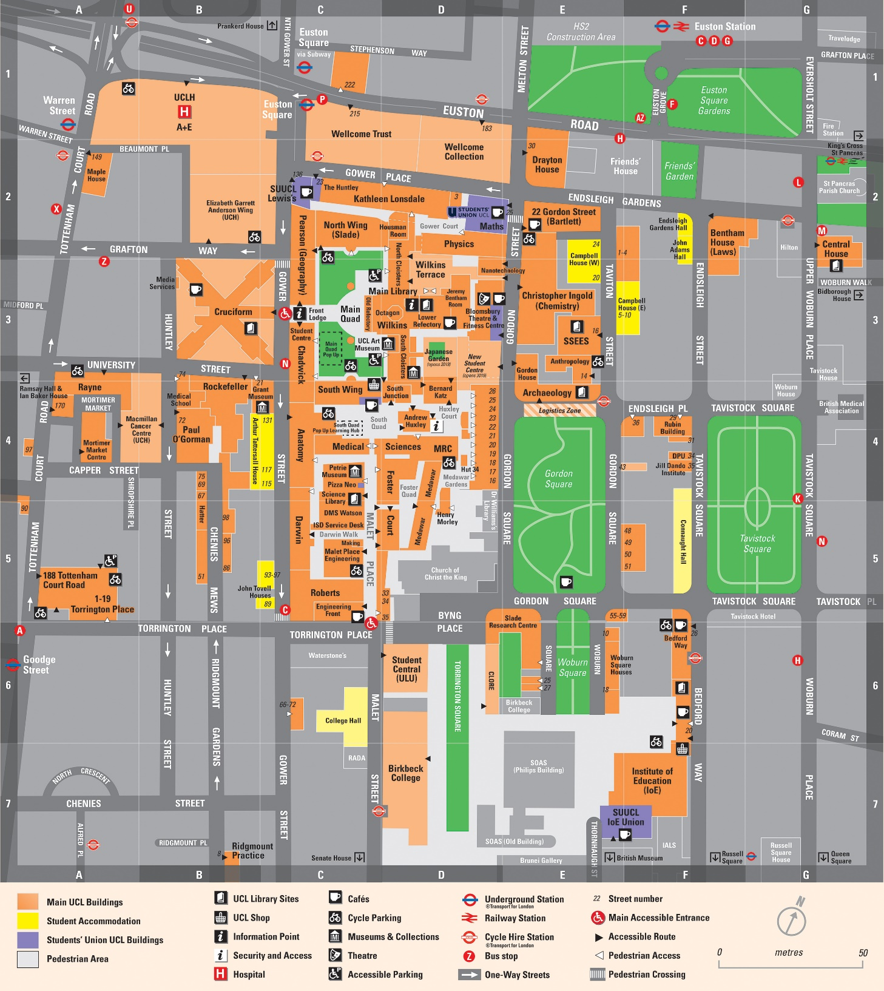

There are four main entrances to the Bloomsbury Campus that are currently used by vehicles & pedestrians:

1. Front Quad Entrance – Gower Street (WC1E 6BT)
2. Malet Place Entrance – Torrington Place (WC1E 7BJ)
3. Gower Court / Physics Yard Entrance – Gower Place (WC1E 6BN)
4. Gordon St gate (WC1H 0AW)

In addition to this, there are other managed access points;

1. Logistics Zone in Gordon Square North (WC1H 0PY)
2. Roberts / Darwin ramp, off Torrington Place access to Roberts Building.(WC1E 7JB)
3. 1 – 19 Torrington Place – an entrance and an exit ramp. (WC1E 7HB)
4. IOE / Bedford Way Service Area – BAU Logistics Area (WC1H 0AL)
5. Woburn Square
6. Gospel Oak store
7. Clare Hall

**2.0 ABBREVIATIONS**

BAU Business as Usual

CLOCS Construction Logistics and Cyclist Safety

ESG Estates Safety Group

FORS Fleet Operator Recognition Scheme.

HSC UCL Health & Safety Committee

LC Logistics Centre situated in IoE

LGV Large Goods Vehicle

LZ Gordon St Logistics Zone

MIP Mobility Impaired Persons

TMP Traffic Management Plan

UCL University College London

VIP Very Important Person

VMMS Logiscope Vehicle Management and Monitoring System

WJ Wilson James

**3.0 REFERENCES**

Iceni, Delivery and Service Management Plan - UCL Student Centre, Gordon Street, London, February 2019

**4.0 ROLES & RESPONSIBILITIES**

The principal responsibilities for the management of health and safety are stated in the UCL Safety Policy. Specific responsibilities relating to traffic management are stated below;

**4.1 UCL Estates**

UCL Estates as the controlling department for access, safety, security, logistics & construction activities will take appropriate action to ensure the health and safety of staff, students and others who may be affected by the risks associated with vehicle movements and logistics onto and around the Bloomsbury Campus.

**4.2 UCL Logistics Manager**

The UCL Logistics Manager is responsible for;

* Providing an assurance role in ensuring compliance with the TMP.
* Review of this plan periodically
* Report to Estates Safety Group and Logistics Board on improvements and concerns.

### 4.3 UCL Security Manager

The UCL Security Manager is responsible for the implementation of this plan within the Bloomsbury Campus. The UCL Security Manager will ensure that the contents of this plan are briefed to the Security Team and that the Security Team comply with its requirements.

Should any Security Officer or supplier not comply with this plan, the contract manager for that supplier will be contacted by the UCL Security Manager and advised of the requirement to comply.

**4.4 UCL Security Officers**

The UCL Security Officers are responsible for:

* Booking vehicles in and out of the campus using the handheld electronic vehicle management and monitoring system (VMMS) and to record accurate details of all vehicles.
* Notifying the UCL Logistics Services if the VMMS is not working and reverting to paper records whilst the system is fixed.
* Enforcing the maximum number of vehicles on campus identified for each gate. (Section 5.3)
* Refusing entry if it is not safe for a vehicle to enter or if by permitting the vehicle the maximum number allowed will be exceeded.
* Refusing entry for any non-booked vehicle. During the hours 07:00 to 18:00 (M-F) redirect these vehicles to the Logistics Zone.
* Investigate vehicles staying on site for longer than 30 minutes unless previously authorised to do so by UCL Security or UCL Logistics Services
* Brief drivers to ensure vehicles entering the site understand the site rules details in 5.2.
* Reporting any vehicle that fails to comply with the UCL site rules to their supervisor who will escalate to the UCL Security Management
* Work with the logistics operatives via mobile phone and face to face communication to safely manage the vehicle movements.
* Communicating with the Logistics Supervisor via mobile phone to facilitate the access of booked vehicles from the Logistics Zone.
* During Malet Place lunchtime closure – allow a vehicle to leave if it is safe.
* hould they be a requirement cny ndescalate to supervisor / manager. plan and emergency lighting in place and checked. In the event of deviation from this plan, escalate to their supervisor / manager.
* Out of Out of hours (M-F) 18:00-07:00 and all day on Sat and Sun, Security Officers are responsible for directing all vehicle movements.

**4.5 UCL Security Control Room**

When there is an incident requiring Emergency Arrangements or for certain Abnormal Activities on UCL Bloomsbury campus, the Security Control Room must notify the appropriate Security Officer and UCL Logistics Services to ensure all vehicle movements are stopped or appropriately managed.

**4.6 UCL Logistics Operatives**

UCL Logistics Operatives will:

* Be deployed within each gate area as required to provide marshalling of vehicles from the security gate to the point of unloading.
* Work with and liaise closely with the Security Officers via mobile phone and face-to-face communication to safely manage vehicle movements.
* When possible, turn vehicles to face the exit route prior to parking.
* Instruct all vehicles to await a Logistics Operative or Security Officer instruction and escort from campus. Reinforce the site rules to the driver of the vehicle.
* Provide clear, consistent and approved banksman signals to the driver of the vehicle under their control.
* Work with Security to ensure any vehicle on site for longer than 30 minutes is investigated unless previously authorised by Security or Logistics.
* To work in compliance with their safe systems of work.

**4.7 UCL Logistics Supervisor**

UCL Logistics Services provides logistics services to UCL from 07:00 to 18:00. The Logistics Zone may receive deliveries and consolidated loads from 07:00 to 18:00. The UCL Logistics Supervisor is responsible for the following in relation to this TMP include:

* Control of all logistics in shared spaces on campus.
* Traffic marshalling and assisting with unloading (where requested) of all vehicles during 07:15 to 18:00 (M-F).
* Managing the Logiscope Vehicle Management and Monitoring System for vehicle bookings.
* Running the Logistics Zone from 07:00 to 18:00 (M-F) and managing the release of vehicles onto campus by direct liaison (via mobile phone) with UCL Security Officers.
* Managing access to Roberts Ramp as required 08:00 to 18:00 (M-F).

**4.8 All Departments, Employees & Contractors**

All departments**,** employees and contractors will;

* Comply with this plan.
* Advise suppliers / contractors and subcontractors of the delivery rules for UCL. (section 5.0)
* Comply with the rules when cycling or driving on Bloomsbury campus. (section 5.0)

1. **TRAFFIC MANAGEMENT RULES**

**5.1 GENERAL RULES**

* A maximum stay of 30 minutes is enforced for loading and unloading activities, unless authorised in advance.
* No parking on campus (other than arranged VIP or MIP).
* Vehicle drivers must comply with directions of UCL Security and UCL Logistics Operatives .
* When possible, vehicles will be turned to face the exit route prior to parking.
* Vehicles must NOT park or unload anywhere in a manner that reduces the walkway for pedestrians to 1 metre or less or restrict emergency vehicle access.
* Double parking when offloading/delivering is NOT permitted.
* All loads must be secured prior to moving.
* Cycling is NOT allowed on Campus - cyclists must dismount and walk with their bikes at all times.
* All delivery vehicles must book a delivery slot via the Logiscope Vehicle Management and Monitoring System (VMMS)
* All deliveries that are not on the delivery schedule are to be redirected to the Logistics Zone between 07:00 and 18:00.
* Deliveries outside of 07:00 to 18:00 Monday to Friday should be notified in advance to security – securitysystems@ucl.ac.uk

**5.2 DRIVERS SAFETY BRIEFING**

All drivers when arriving at UCL will be given a briefing sheet (Appendix 3) by the UCL Security Officer;

* Site speed limit is walking pace only (3mph)
* Hazard warning lights must be switched on when driving on site
* Drivers must await instruction from a logistics operative or security officer prior to manoeuvring.
* All reversing must be under the instruction of a Logistics Operative, or Security Officer.
* Engines must be switched off when stationary unless operationally essential.

**5.3 LOCATION SPECIFIC RULES & RESTRICTIONS**

|  |  |  |  |  |  |  |  |
| --- | --- | --- | --- | --- | --- | --- | --- |
| Location | Vehicle Limit | | Restriction Applies | 10 to 10 past rule applies | Lunchtime restrictions | Height Restrictions | See Section |
| Front Quad | 4 | | 06:00 to 07:00 | NO | NO | NO | 5.3.1 |
| Malet Place | 4 | | 06:00 to 0:700 | YES | YES | YES | 5.3.2 |
| Roberts Ramp | 1 | | 07:00 to 18:00 | NO | YES | YES | 5.3.3 |
| Gordon Street | 1 | | 06:00 to 07:00 | YES | NO | YES | 5.3.4 |
| South Quad | 0 | | 08:00 to 19:00 | NO | NO | NO | 5.3.5 |
| Gower Court | 2 | | 08:50 to 18:50 | YES | NO | YES | 5.3.6 |
| Lower Terrace Service Area | 2 | | 07:00 to 19:00 | NO | NO | YES | 5.3.7 |
| Torrington Place (West Entrance) | 2 | 07:00 to 19:00 | | NO | NO | YES | 5.3.8 |
| IOE Bedford Way / Service Road | 5 | | 07:00 to 19:00 | NO | NO | YES | 5.3.9 |

* + 1. Front Quad – Gower Street

During normal operations.

* + Vehicle access between 06:00 – 07:00 will be restricted to 4* vehicles at a time. (This limit excludes Sodexo mobile catering vehicle.)
  + Vehicle access between 07:00 – 06:00 is prohibited
  + Except for Emergency vehicles
  + Except by special arrangement via UCL Logistics Team for MIP permit holders or VIP parking
  + Taxis are only admitted where collecting or dropping off an MIP or a VIP.

During events or busy periods i.e. graduation ceremonies, open days.

* + ALL VEHICLE ACCESS to the front quad will be restricted during the event.

5.3.2 Malet Place – (includes Foster Court, Anatomy Yard, Darwin Walk)

* + No more than 4* vehicles at any one time. (This number excludes the generator and security vehicles that are stationary in Foster Court)
  + Monday to Friday 07:00 to 19:00 - vehicle access or movement will NOT be permitted between 10 minutes before the hour and 10 minutes past the hour.
  + No vehicle access during lunch period - 11:50hrs until 14:10hrs (except for emergency vehicles and business critical deliveries)
  + Vehicles will be allowed to leave during the lunch period provided that the area has minimal pedestrian traffic
  + Height restriction through Foster Court Arch - 3.7 metres
  + No vehicle to pass through Anatomy Arch to South Junction.

5.3.3 Roberts/Darwin Ramp

* + No more than 1 vehicle at any one time.
  + Access is for pre booked deliveries
  + Vehicles book via the Logiscope VMMS from 08:00 to 18:00 and attend the logistics zone. Booking outside these hours is through security by email at [securitysystems@ucl.ac.uk](mailto:securitysystems@ucl.ac.uk).
  + Hoarding gates are kept locked and are controlled by UCL Logistics Services from 08:00 to 18:00 Monday to Friday and by Security at all other times. Keys will not be issued to individuals.
  + No vehicle access during lunch period - 11:50hrs until 14:10hrs (except for emergency vehicles and business critical deliveries)
  + There is an incline on this ramp.
  + Height restriction – 2.5 metres.
  + Vehicle length restriction 5.5 metres.

5.3.4 Gordon Street Entrance

* + This entrance is pedestrian access only
  + Exception include for Emergency vehicles and special arrangement for events.
  + These arrangements to comply with;
    - Gates are unlocked from 07:00 to 19:00, Monday to Friday, and controlled by security at all times. Keys will not be issued to individuals.
    - Vehicles requiring entrance to book via the Logiscope VMMS.
    - Request to book within the allocated hours require special permission requested by email via [Logistics@ucl.ac.uk](mailto:Logistics@ucl.ac.uk). Booking outside these hours is through security by email at [Securitysystems@ucl.ac.uk](mailto:Securitysystems@ucl.ac.uk), accompanied by an [out of hours request form](https://www.ucl.ac.uk/estates/our-services/security-ucl/out-hours-working).
    - No more than one vehicle permitted at any one time.
  + Height Restriction – 4m
  + The main loading area at the base of the ramp is restricted to 12m

NO PARKING IS ALLOWED IN THIS AREA.

5.3.5 South Quad

* + This entrance is pedestrian access only
  + Except for Emergency vehicles
  + Except by special arrangement for events.

NO PARKING IS ALLOWED IN THIS AREA.

5.3.6 Gower Court RAMP– Gower Place (rear of KLB / Slade)

* + No more than 2* vehicles at any one time.
  + There will be no pedestrian thoroughfare.
  + Height restriction – Gower Court 4 metres.

5.3.7 Lower Terrace Service Yard – Logistics Area

* + Height restriction – Lower Terrace service yard 3.5 metres.
  + **This area is for BAU deliveries only.**
  + All other deliveries to this area will be booked onto site via a delivery management system, the delivery schedule will be provided daily to the Security Team at Gower Court.
  + There is no pedestrian thoroughfare across Lower Terrace Service Yard.

5.3.8 Torrington Place

* Apart from BAU, only previously booked vehicles are permitted.
* Height restriction to service yard via exit ramp is 4.2 m
* Weight restriction to exit ramp is 2.5t
* No more than 2* vehicle at any one time including parked vehicles
* Entry and exit to Torrington Place for BAU is via the exit ramp (west end)
* There is no vehicular access to the sub-basement

5.3.9 IOE Bedford Way / Service Road

* Height restrictions to service road is 3.8m
* Speed Limit is 5mph
* Weight restriction to services road to be confirmed after door barrier improvements
* Entrance via Russell Square
* Exit via Woburn Square
* 5 DELIVERIES AT ANY ONE TIME
* 5 POSTAL VEHICLES
* See layout drawing – Appendix 5
* The service road is owned by University of London. Vehicle access is shared with the Landlord UoL, as such it is impossible to limit the number of vehicles

*Note: Lorries count as two vehicles & articulated lorries count as three vehicles – see appendix 4.

**5.4 UCL DRIVERS**

* All UCL & contracted partner drivers must comply with this TMP.
* All drivers must be in possession of a valid driving licence which must be shown to line managers annually
* All drivers of UCL vehicles must be not be driven under the influence of alcohol or drugs, or when they have had insufficient sleep and are suffering from tiredness, or any health ailments that will affect safe driving. It is their line manager’s responsibility to enforce this.
* All UCL drivers must attend regular driver screening with UCL Occupational Health and maintain records of this screening.
* All UCL drivers must check that vehicles are in good safe order before setting off.
* All UCL Vehicles and Partner Vehicles should have up to date, daily log books to record driver and state of the vehicle.

**5.5 OPERATION OF RISING BOLLARDS (Front Quad, South Junction & Malet Place)**

The operating procedure for the bollards is:

* Pedestrians have priority over vehicles.
* Security staff must engage with pedestrians to make them aware when bollards are being raised.
* If view is restricted because of pedestrian numbers, then bollards will remain lowered.
* The operator must operate the bollards from outside the lodge/office maintaining a clear view of the bollard, standing beside the switch.
* The personnel operating the bollard must NOT allow themselves to be interrupted.
* Only Security Officers trained in the operations of the bollards must do so. A record must be kept by Security Manager of those who have been instructed and trained to use the bollards.

**5.6 Operation of Vehicle Barriers**

The vehicle barrier is controlled by Security Officers and access is allowed once the VMMS has been completed. The Security Officer will ensure no pedestrians are on the roadway when the barrier is being raised or lowered.

At peak pedestrian times between 10 minutes before the hour and 10 minutes past the hour, the vehicle barrier may be raised to allow pedestrians to use the ramp. A sign will be placed at the top of the ramp to prevent vehicles accessing at this time.

**6.0 Parking**

A restricted number of parking spaces are located at Woburn Square. These are available between the hours of 07:00 to 19:00, Monday to Friday only. Woburn Square parking area is not under UCL jurisdiction outside of these hours and vehicles parked during this time may be subject to parking penalties. The following restrictions apply when using the Woburn Square parking facility:

* A 3mph speed limit applies at all times
* Vehicles must not cause obstruction or danger to traffic or pedestrians, for example by double-parking or stopping on corners
* Vehicles must not park on the cross-hatched road markings

**7.0 LOGISTICS**

UCL Logistics Services manage the on-site logistics for the capital construction programme, EM&I works and Estates trade constructor works in accordance with the information provided in the Logistics Information Pack.

* All construction and maintenance activity deliveries including plant must be pre-booked using the Logiscope VMMS.
* All construction and maintenance activity deliveries will be received at the Logistics Zone in Gordon Square North, which operates from 07:00 to 18:00. Any non-booked construction, EM&I or maintenance or trade vehicle arriving at UCL gates will be directed to the Logistics Zone.
* Space, Skip and container location application are to be approved by the UCL Logistics team prior to the works. <https://www.ucl.ac.uk/estates/our-services/security-ucl/security-forms/application-space-skip-or-container>
* Any contractor unloading by HIAB or crane must be planned, supervised and marshalled by the receiving contractor at all times. UCL Logistics Servicer can offer assistance if requested, and this is recommended in congested areas. Unloading may involve closing off the area associated with the lift. If this is to be done then the principal contractor in liaison with UCL Logistics Services must clearly signpost alternative pedestrian routing taking into account the requirements of people with disabilities. Refer to Estates Lifting Procedures Standard for further information.

**8.0 EMERGENCY ARRANGEMENTS**

* If there is an emergency on campus vehicle movements in the affected areas must be stopped or managed to allow safe pedestrian escape and allow fire brigade vehicles to access the site.
* Security Control Room will inform the Security Officer at the relevant gate and the UCL Logistics Operative will manage vehicle access / movements.
* Minimum 3.2m width access is required at all times for the Fire Brigade.

**9.0 MONITORING & REVIEW**

Ongoing monitoring of this plan will be carried out by the UCL Logistics Manager.

This TMP and arrangements will be reviewed as required (as least annually) to ensure it remains in date.

Any near miss / incidents relating to traffic management must be reported via Risknet and will be investigated and if appropriate the TMP reviewed.

**10.0 FAILURE TO COMPLY WITH THE PLAN**

Any failure to comply with this TMP will be reported as follows:

Failure of the Security Officers to comply with this plan will be reported to the UCL Logistics Coordinator with UCL Security Manager to investigate.

Failure of UCL Logistics Operatives to comply with this plan will be reported to the UCL Logistics Coordinator to investigate.

Failure of others to comply will be escalated by either the Security Officer or Logistics Operative to their supervisor and the Security Manager or UCL Logistics Coordinator, either of whom will investigate. Where the failure involves a contractor, this will be escalated via the relevant Project or Contract Manager.

Any abusive behaviour towards the Logistics Operatives or Security Officers will be treated as a failure to comply with the plan, it will be reported and investigated.

Failure to comply with this plan may result in campus access restrictions.

**Appendix 1 - Bloomsbury Campus – Deliveries Map**

**Appendix 2 – Risk Assessment**

|  |  |  |  |  |  |
| --- | --- | --- | --- | --- | --- |
| **Severity (S)** | **Likelihood (L)** | | | | |
| **Remote (1)** | **Unlikely (2)** | **Possible (3)** | **Likely (4)** | **Certain (5)** |
| **Trivial (1)** | 1 | 2 | 3 | 4 | 5 |
| **Minor (2)** | 2 | 4 | 6 | 8 | 10 |
| **Lost Time (3)** | 3 | 6 | 9 | 12 | 15 |
| **Major (4)** | 4 | 8 | 12 | 16 | 20 |
| **Fatal (5)** | 5 | 10 | 15 | 20 | 25 |

| Hazards | Who might be harmed | S  1-5 | L  1-5 | Risk | Control Measures | Residual  S  1-5 | Residual  L  1-5 | Residual Risk | Further Action?  *By whom* | Date for Completion |
| --- | --- | --- | --- | --- | --- | --- | --- | --- | --- | --- |
| Increased Construction / traffic pressure in surrounding areas due to HS2 and West End Project construction programmes.  Vehicle / Person collision / Bike off site  Access/ Egress around external programmes to UCL Buildings  Lack of awareness to risks to public infrastructure changes including Gower St going two-way traffic | Students, Staff, Members of the public | 4 | 3 | 12 | HS2 Traffic Management Plan  UCL Estates appointed person Tony Overbury to continue close liaison with HS2 to understand the impact of works on UCL.  Tony Overbury now chairs the External Programme Impact Assessment and Mitigation Group. This group meets monthly, focusing on identifying and mitigating potential risks within the public realm.  Group to ensure assurance, dialogue and comms plan is circulated to all students, staff and involved members of the public. | 4 | 2 | 8 | External Programme Impact Assessment and Mitigation Group to continue meet and evaluate works which potentially effect the public realm | ongoing |
| Inadequate pedestrian / vehicle segregation on UCL property causing pedestrians to walk into the pathway of vehicles  Vehicle / Person collision | Students, Staff, members of the public, contractors | 4 | 3 | 12 | Restricting access times - see 5.0 Traffic Management Rules  No Cycling on campus  Creation of service areas - back of house areas– *Wilkins Terrace Service Yard.*  No pedestrian access across Wilkins Terrace service yard logistics area.  Providing segregated walkways from traffic at entrances or control traffic with marshals where this is not possible.  Restricted pedestrian access will remain in place to Gower Court.  Restricted vehicle access to Gordon Street gate. | 4 | 2 | 8 | *UCL Logistics*  *Planned relocation of cycle racks away from the service road. To limit pedestrian access to the road*  *IOE - Planned removal of motorcycle parking – to limit pedestrian access to the road*  *IOE – planned relocation of waste bins to reduce Cleaning staff crossing the road.* | Summer 2019 |
| Demobilisation of current previous Logistics structure due to the completion of the capital construction programme.  Obliviousness to the changes to construction practice within estates. | Students, Staff, Members of the public | 3 | 3 | 9 | Construction logistics provider employed (Wilson James) until September 2019.  All vehicles requiring access for to book via to be booked onto site via Logiscope delivery management system  Marshalling and the continual operation of the LZ to continue.  Logistics Information Pack has been produced and presented to Estates staff | 4 | 1 | 8 | UCL Logistics to implement demobilisation strategy.  For IOE – A separate logistics management plan will be in place.  Logistics to control vehicle access to the IOE service road alongside the management of the Goods In. | Summer 2019 |
| Vehicles reversing in a student area | Students, Staff, Members of the public | 3 | 3 | 9 | Restricting access times see – 5.0  Marshals employed to reverse construction vehicles. see 5.2  UCL Security officers given banksman training  Logistics Operatives to marshal all traffic movements, where resources allow, Security to be notified where TM resource is to be removed from the gate. | 3 | 2 | 6 | Where Logistics Operatives are not present, Security need a safe system of work for marshalling vehicles. | Winter 2019  Request Process ongoing |
| Vehicles reversing onto a main road – collision with vehicle / bike or person. | Members of public, other road users | 3 | 3 | 9 | Vehicles must avoid reversing out of UCL campus. Wherever possible they should be turned around on site.  UCL Security officers trained as banksmen to assist vehicles.  If a vehicle has come to the incorrect gate, if safe to do so, security to allow them to come in and turn round to reduce reversing onto the road.  Hoarding and gates installed on Roberts Ramp to prevent uncontrolled vehicles using this ramp and reversing back out. | 3 | 2 | 6 | Consider the installation of permanent gates at the top of Roberts Ramps to prevent unauthorised vehicle access / turning.  UCL Estates | Current hording to remain erect until project request for permanent solution |
| Vehicle / Property collision | Damage to structure | 3 | 3 | 9 | Height signage in place at all archway and tunnels and protective barriers on the corners of building.  Vehicles reversing should be marshalled.  Temporary structures and scaffolding to be highlighted to traffic marshals as these could be struck.  *Survey entrances for height limits, width limits etc has been completed*  *Gordon Street SPA has been completed by NSC project*  *Gower Court SPA has been completed to Wilkins Terrace Project.* | 3 | 2 | 6 | *Confirm vehicle protection to structural columns underneath Wilkins Terrace*  *Incident in 2016 – bike hit by vehicle near Haldane Room* | Summer 2019 |
| Vehicles speeding in a crowded areas of students | Students, Staff, Members of the public | 4 | 2 | 8 | Restricting access times - see 5.0  Speed limit at walking pace - see 5.2  No Cycling on campus  Logistics Operatives walking vehicles onto campus.  UCL Security monitor effectiveness of access times and speed limits.  Reduction in the number of vehicles coming onto campus by establishing a courier & BAU drop off point at IoE Logistics Hub – Winter 2019  Staged approach to working with remaining trade and business as usual deliveries to review feasibility of them using the system. | 4 | 1 | 4 | *IOE – improvement of speed bumps* | ongoing |
| Unsecured loads | Students, Staff, members of the public | 4 | 1 | 4 | All loads must be secure before moving. | 4 | 1 | 4 |  | ongoing |
| Vehicle Barrier hitting person Gower Street | Students, Staff, members of the public | 2 | 3 | 6 | Security Trained to use the bollards and barriers  UCL Security encourage people to use of the pavements rather than roadway.  Increased width of pavements to Gordon Street reducing the need for people to walk down the road way | 2 | 2 | 4 |  | ongoing |
| IOE Ramp becomes slippery during freezing weather | Vehicle Drivers | 3 | 2 | 6 | IOE – ensure grid / salt off IOE road takes place in cold weather. | 3 | 1 | 3 | UCL Logistics | ongoing |
| Bollards causing trip hazards (Malet Place & Front Quad) | Students, Staff, members of the public | 1 | 4 | 4 | Security Trained to use the bollards and barriers  Reduction in vehicles entering Malet Place & Front Quad equals a reduction in the bollard use. Operate bollard in manual mode only. | 1 | 2 | 2 |  | ongoing |
| Vehicle / vehicle collision | Students, Staff, members of the public | 2 | 2 | 4 | Speed limit at walking pace - see 5.2  Mirrors in Gordon Street and Physics Yard - check  Limited number of vehicles allowed into the campus at one time. See 5.3  No Cycling on campus | 2 | 1 | 2 | IOE – inclusion of mirrors on the exit ramp | ongoing |
| UCL vehicles being driven by unqualified persons | Students, Staff, members of the public | 3 | 1 | 3 | See 5.4 UCL Vehicles  HR Guidelines on UCL Drivers  <http://www.ucl.ac.uk/hr/docs/college_drivers.php> | 3 | 1 | 2 |  | ongoing |
| Insufficient illumination | Students, Staff, members of the public | 3 | 1 | 3 | All walkways and roadways have adequate illumination at night.  Maintenance programme to ensure lighting and emergency lighting in place and checked. | 2 | 1 | 2 |  | ongoing |

**Appendix 3 – Delivery Drivers Leaflet**

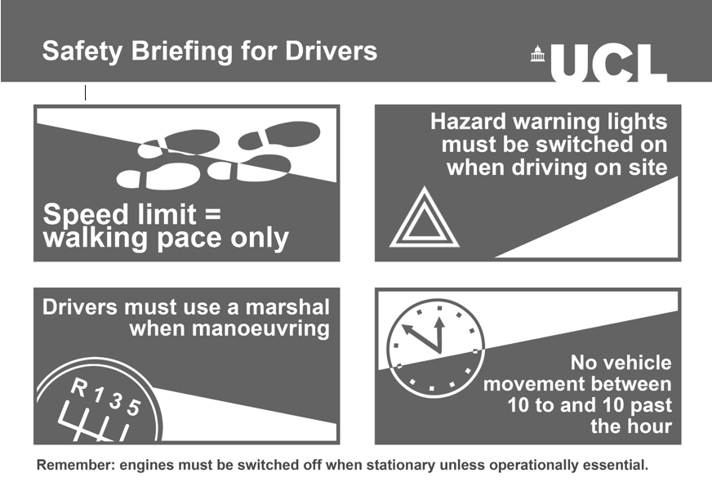

**Appendix 4 – Example of Vehicle Types**

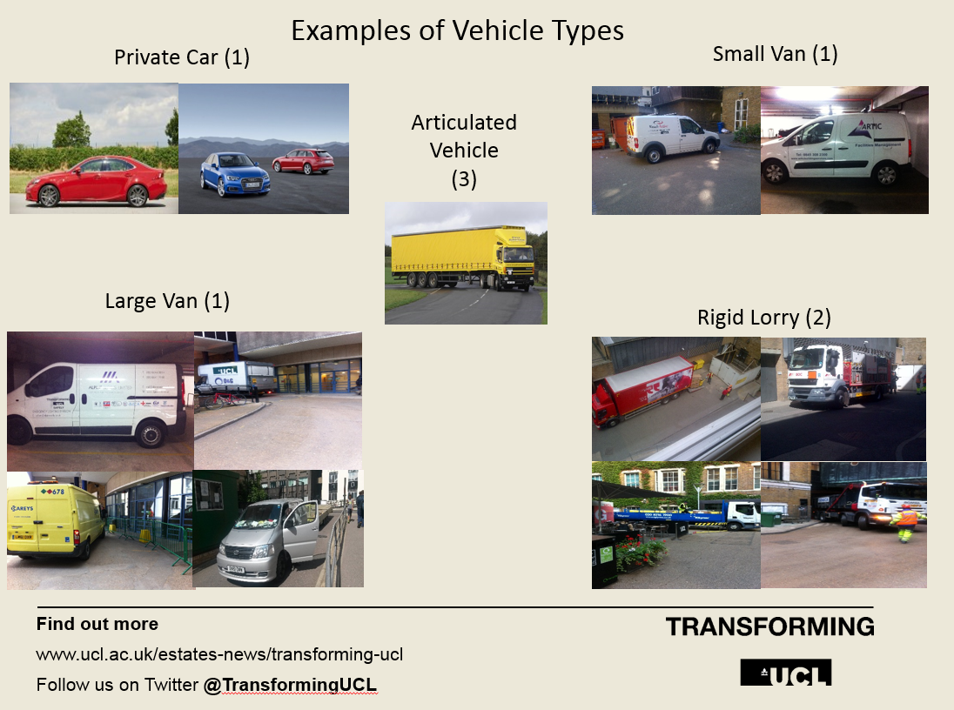

Appendix 5 – Institute of Education Layout Plan

