RISKNET User Guide – Accessing & Closing FRA Actions

Introduction
The purpose of this document is to provide a single point of reference for users of the riskNET system to be able to access, update, complete and close Fire Risk Assessment actions.
This document is not aimed at a technical audience and does not provide technical support but rather describes the administration procedures in layman’s terms. It does not provide guidelines for users.

Accessing risknet
RISKNET is accessed by the following web link https://ucl-safety.co.uk/Login/Default.aspx it is important that RISKNET is accessed using Google Chrome, Microsoft Edge or Safari for best performance.
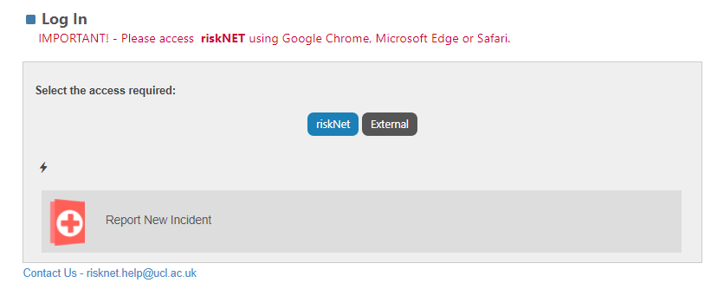
To access RISKNET you will need to log into the system using your UCL sign on credentials by clicking RISKNET as shown above.

risknet home page
Once you have logged in using your UCL credentials you will then see the below home page which will allow you to access multiple areas within the system. You will need to click onto Risk Assessments as shown below in order to access the actions associated to the Fire Risk Assessment.
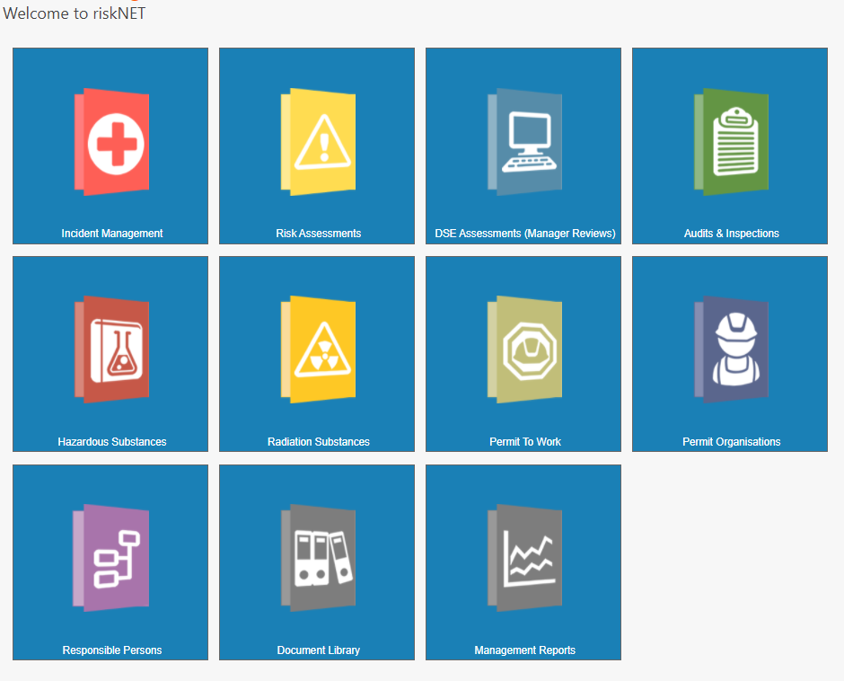

SEARCHING / ACCESSING fire risk assessmentS
Once you have clicked into Risk Assessments you will then be given the below 4 options, you will need to click onto Search Assessments as shown below. 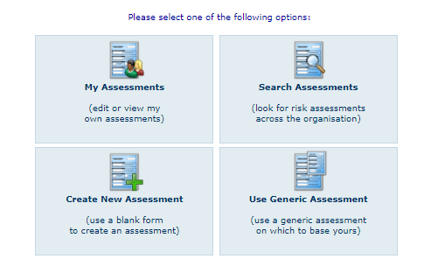
Once you have clicked into Search Assessments you will then need to provide the following information the click on Search.
- SELECT BUILDING (Building of choice)
- SPECIALIST ASSESSMENT TYPE – PAS79
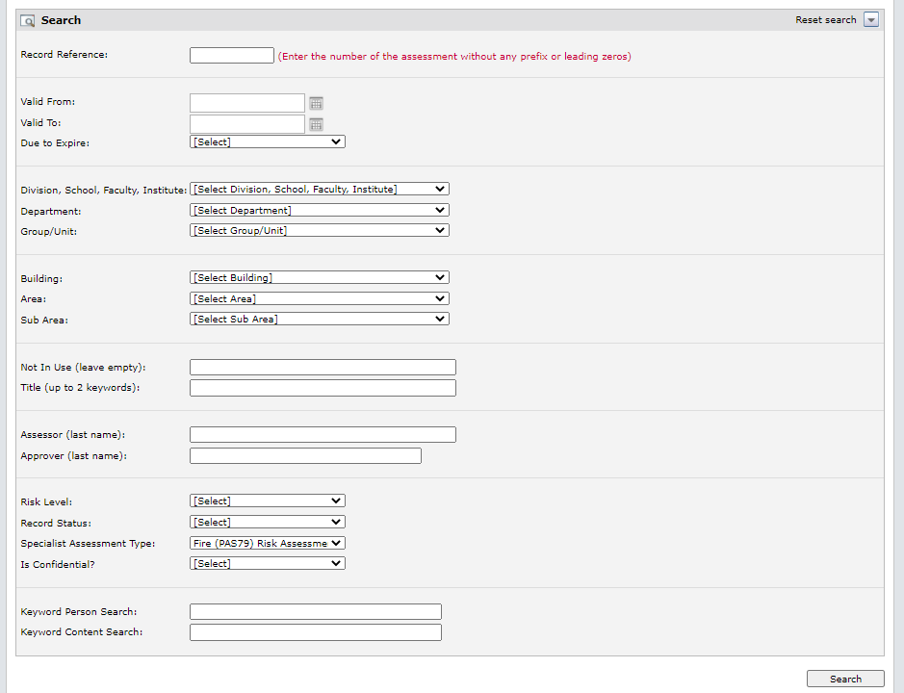
You will then be provided with a list of Fire Risk Assessments to choose from. You will need to click the latest Fire Risk Assessment to be carried out – in this case it would be RA043254/1.
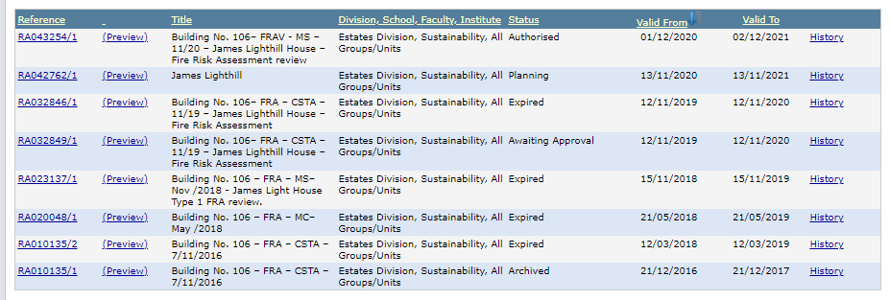

ACCESSING ACTIONS
Once you have selected the Fire Risk Assessment you would like to access you then need to click on Actions.
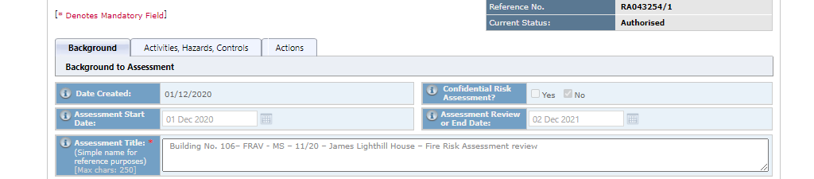
You will then have a choice of actions to select from (shown below)
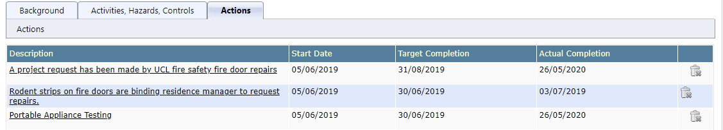
Click onto the action of your choice.
You will then see the below screen.
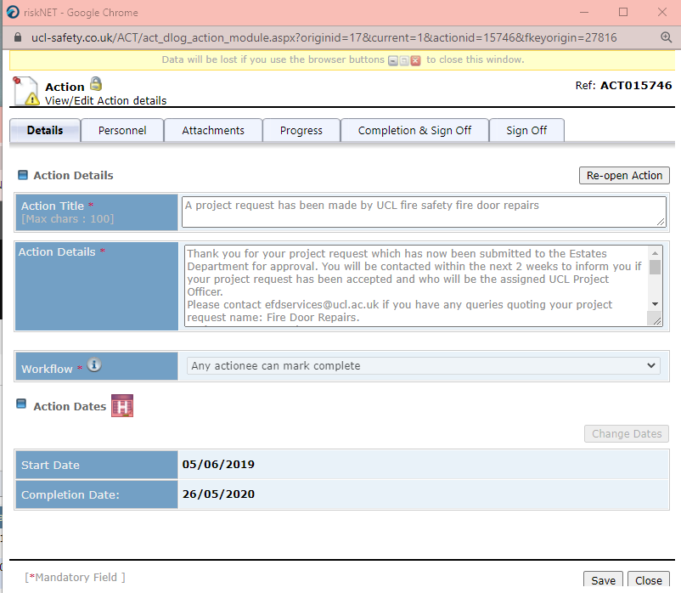

Completion and sign off of actions

The above screen will show you the details of what is required to happen in order to complete and sign off the action. You will also have access to when the action was assigned and the target completion date.
You can then select Personnel which will show you who the action has been assigned to as the action owner (responsible person) and the actionees who can complete said actions.
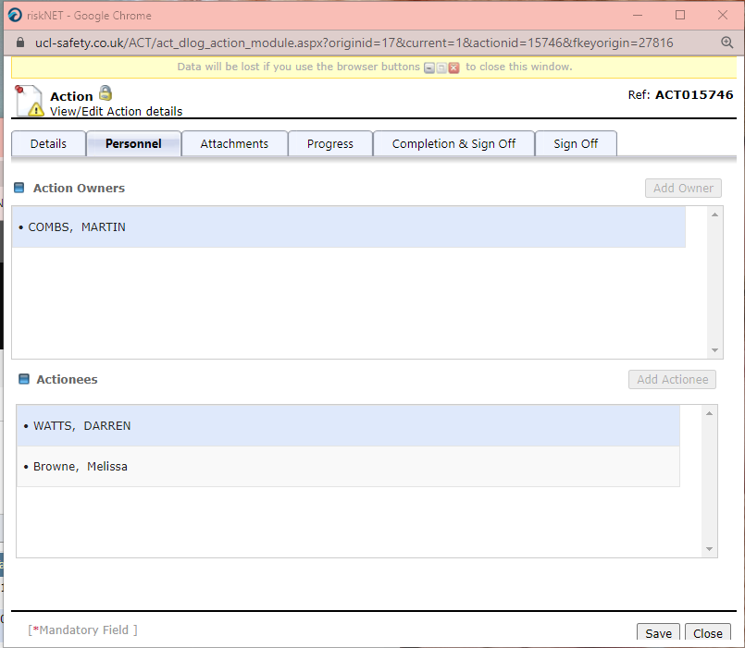

You will then be able to click into completion and sign off in order to close the action on the system. You will need to describe the action taken, complete the date the action was completed, click the tick box in order to state you are satisfied that the action has been completed and then finally save. The action is then completed.
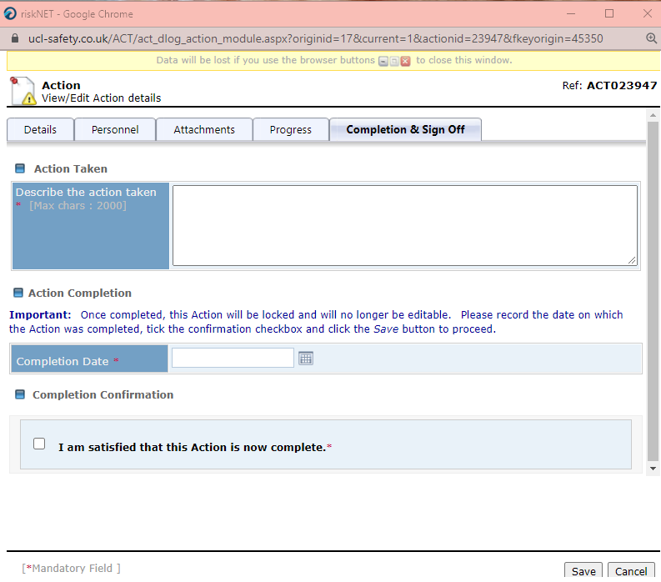

If you have any further questions, then please contact me on the below.

AMY XUEREB
Fire Safety Business Manager
UCL Estates – Fire Safety
University College London (UCL)
E: a.xuereb@ucl.ac.uk: T:0203 108 8562 Internal: 58562 M: 07771 431343
W: https://www.ucl.ac.uk/safety-services/fire

