Return to campus external route – Red route
The main entrance to the red zone is via Malet Place Gate Entrance (Torrington Place). Buildings to be accessed via this route include; Roberts Building, DMS Watson Building, Egyptology, Electrical Transfer Chamber, Engineering Front Building, Foster Court, Malet Place Engineering Building, 1-4 Malet Place, South Quad Pop-up, Darwin Building, Medical Sciences and Anatomy and 33-35 Torrington Place. The what3words address for this gate is mile.cure.teach.
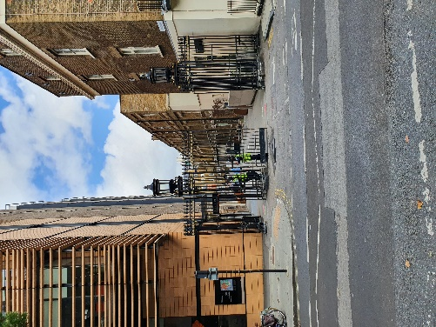 Image from Torrington Place looking at gates into Malet Place.
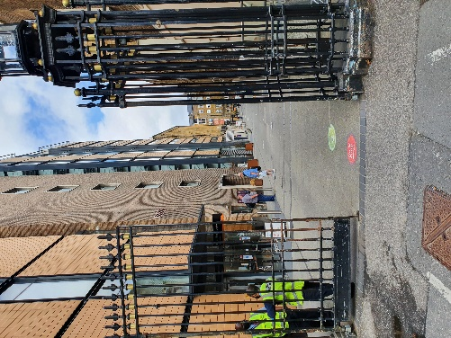 Image of gates into Malet Place, showing exit onto Torrington Place, access in is on the left hand side.
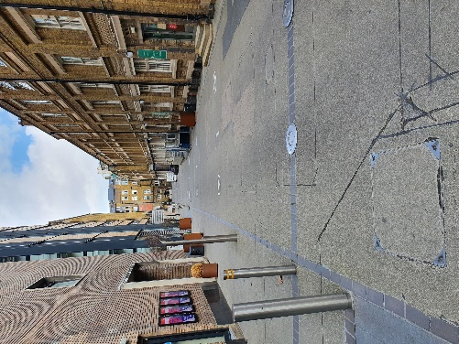 Image of Malet Place looking towards Medical Science building taken by Engineering Front Building.
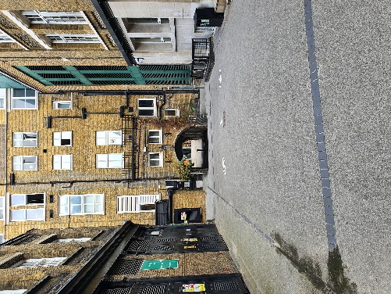 Image of Malet Place looking towards the underpass under the Medical Science building.
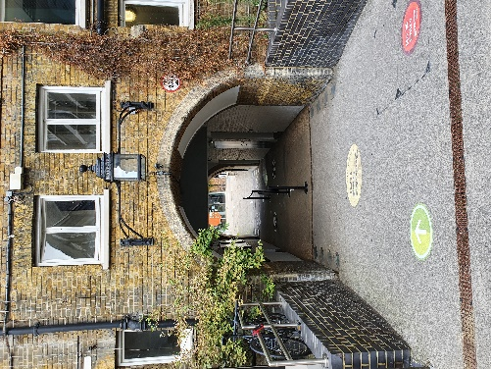 Image of underpass under the Medical Science Building looking through to the south quad and Print room Café. This is where users may switch from the red zone route to the blue zone route. Although if you wish to access a blue zone building you are advised to enter via the blue zone from Gordon Street.
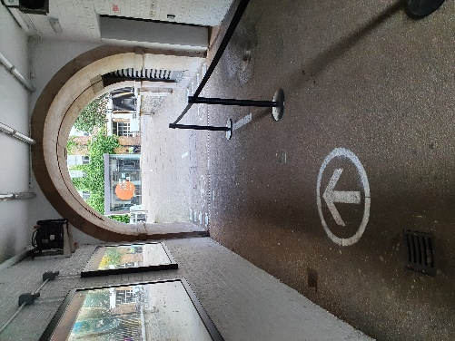 Image taken in underpass under medical Science building looking towards the Print room Café. Image shows barriers in underpass.

