PSO
Handbook

Introduction
Portfolio Services is a new Estates function supporting project and programme management teams in the delivery of the Estates Portfolio of projects, programmes and activities.
Our aim is to:
- Capture and report all projects and programmes to increase visibility across the Estates Portfolio;
- Provide a structured approach to managing interdependences across the Estates team and wider UCL stakeholders;
- Standardise the way UCL Estates plan, manage finance, risk & issues;
- Champion best practise;
- Manage requests from customers and stakeholders.
In order to ensure all of the above is achieved, the Project Procedures document has been put in place to support the project and programme management teams.
Project Procedures
The project procedures seek to provide processes and guidance for staff managing construction based projects across UCL Estates.
The project procedures can be located here.
Strategy
UCL Estates are responsible for developing and implementing the transformational estate strategy, aligned with the UCL 2034 Institutional Strategy and Objectives. The Division is leading major initiatives to support and enable the Academic Mission and Institutional growth, and improve the infrastructure of the Institution.
There are four schools through which the proposed projects are reviewed, these being;
BEAMS – UCL Built Environment, UCL Engineering Sciences and UCL Mathematical & Physical Sciences
SLMS – School of Life and Medical Sciences
SLASH – UCL Arts & Humanities, UCL Laws, UCL Social & Historical Sciences, the UCL School of Slavonic and East European Studies
IOE – Institute of Education
Once funding has been approved for a project, a Strategy Manger will work alongside the lead academic stakeholder of the proposed project to create a Strategic Brief and a PID/PAR (Project Initiation Document / Project Account Request).
Capital Programme/Strategic Maintenance Programme
A range of projects are taking place across the Campus as part of the 2034 vision to transform UCL’s built environment into a more vibrant and student focused place to teach and learn and to improve the overall student experience.
There are two divisions that manage the delivery of projects, programmes and activities across UCL Estates, these being;
Capital Programme and SMP (Strategic Maintenance Programme).
Both Capital and SMP projects are allocated corresponding project categories and both must seek approval at each stage of the project life-cycle. The project category determines the documentation that is required to pass through each Stage Gate of the project life-cycle.
Project Categories
There are four categories;
Works under £50k are categorised as Minor Works.
Projects between £50k-£250k incl. VAT are categorised as Small Works.
Projects between £250k-£2m incl. VAT are categorised as Medium.
Projects over the value of £2m incl. VAT are categorised as Large.

Project Lifecycle

UCL Estates has adopted the following 7 stage lifecycle process for its projects:

1 - Need
2 - Initiation
3 - Development
4 - Procurement Planning and Budgeting
5 - Implementation
6 - Operations
7 - Post Project

Stage 1 is managed by the Strategy Manager and they will begin the process of creating a PID/PAR for the project.

Each project/programme must seek approval at each stage of the project life cycle.

For ‘Minor Works, Small and Medium’ projects an email requesting approval from stakeholders can be circulated. (See Stage Gate section for procedure).

For ‘Large’ projects a Stage Gate meeting including all stakeholders must be set up.
(See Stage Gate section for procedure).

PSO Inbox Email Management

All PSO staff have access to the Portfolio Services inbox and are responsible for management and ownership of the inbox.
All PSO staff should check the inbox and meeting responses on a regular basis. Where possible, if you read an email/meeting response and it is not for you to action, please mark the email/meeting response for attention by categorising with the appropriate PSO member’s category colour, as per below;
- It is then their responsibility to action.
Incoming Mail

Each PSO staff member has a colour coded category as follows:

Blue | Brian |  | Orange | Kayleigh
Pink | Davina |  | Yellow | Kimberley
Dark Purple | Elizabeth |  | Olive Green | Lucia
Aqua | Jackie |  | Purple | Paul
Green | James |  | Dark Green | UCL East

Once an email has been actioned please ‘mark as complete’ and file away in the appropriate file.
Once a meeting response has been actioned, it can be deleted from the file.
PIDs/PARs
To ensure data for all projects/programmes are captured across UCL Estates, a PID and a PAR will be produced by the UPO and submitted to the Portfolio Services Office for review.
When reviewing the PID/PAR it is important to ensure the following divisions are complete;
- Must have start/finish dates
- Minor Works PID must have Contractor details
- SAFETY - Check Safety Advisor name, check ‘Checklist and Guidance’ tab, if so the UPO must liaise with Safety Advisor, if not query with UPO.
- Risks must be listed
The PID then requires a PSO number and to be imported to the Projects/Minor Works Register.
Assign PSO Number
The category of the project will determine whether the PID is imported to the Projects Register or the Minor Works Register.

‘Minor Works’ must be saved in the Minor Works Register.
‘Small, Medium and Large’ projects must be saved in the Projects Register.

Open Master Projects Register or Minor Works Register as appropriate:

W:\14.0 Portfolio Services\14.1_Online-Register

Assign a PSO number and enter in PID in ‘Unique Project Reference’ box.

If Minor Works save PID in:

W:\14.0 Portfolio Services\14.3 Minor Works

If Project create a project folder and save PID in:

W:\14.0 Portfolio Services\14.13_Projects

Close PID.

Import to Project Register / Minor Works Register

Return to Master Projects List or Minor Works List and click ‘Import PID’

Select the newly saved PID and click OK (NB: make sure you do these in numerical order)

Save.

As soon as the project has been assigned a PSO number, a monthly report should be created for the project and should be updated on the capital projects monthly report checklist located here.

Note: The UPO should begin reporting on the project as soon as spend has begun on the project.

It is the Strategy UPO’s responsibility to update the monthly report, until Stage Gate 2 has been approved, when the project is handed over to the delivery team.

A Project Board should be set up for the project.
A meeting should be arranged with the Project Manager to discuss the dates for the future Project Boards, completion of the ToR (Terms of Reference), Agenda and list of attendees for each Project Board.

The templates for the Project Board documents can be located here:

W:\14.0 Portfolio Services\14.15 Current Templates\3. Board and Meeting Templates

Stage Gates

Stage Gates are designed as a management and assurance tool at each stage of the project lifecycle.

A Stage Gate checklist and the listed templates are placed in each Stage Gate folder. It provides a list of templates that require completion at each applicable Stage Gate of the project.

The Stage Gate checklist and templates can be located here.
A project should not pass on to the next stage until the previous Stage Gate has been approved.
Minor Works, Small and Medium Projects will require an email to be issued to the relevant stakeholders for approval. The process for this is listed below;
Approval
Create a new email and attach the PID.
Send as attachment to the relevant approvers.
- Depending on the category of the project, will determine which approval contact group you will require. (The contact groups have already been set up in the Portfolio Services Inbox).
Attach voting buttons to the email and send from Portfolio Services Inbox.
- Approvers should respond in 3 working days (as per email), if no response received please chase the approver
- Add a chaser reminder in your diary for 3 working days when the stage gate approval deadline is.
Record Project Approvals
Open new projects spreadsheet:
W:\14.0 Portfolio Services\14.0 PMO Admin\06. SG Tracker and Comms
Copy & Paste required information over and save.
Approval/Reject
Approved - An email can be issued to the UPO approving the stage gate.
Approved subject to comments – Comments to be issued to the UPO for review and action where necessary.
Reject – Comments to be issued to the UPO and actioned, providing all issues are resolved the project will require approval sent out again.
Note: For Stage Gate 1, once approved the PAR will be submitted to the Estates Finance team to set up a Project Account Code.
All project documentation must be filed in the correct project folder located in;
W:\14.0 Portfolio Services\14.13_Projects
Large projects require a Stage Gate Meeting for approval.
The Project Sponsor must be contacted to find a suitable date for the Stage Gate Meeting to be held.
Once this has been confirmed, a meeting with the Project Manager is to be set up to ensure the Stage Gate documents are complete; to agree an agenda for the Stage Gate meeting and confirm the list of attendees.
PSO are required to attend the Stage Gate meeting to provide a Secretariat function.
- All minutes must be reviewed by a line manager before circulating to attendees.
Templates for the agenda and Stage Gate minutes can be in the templates folder located here.
Project Reporting
Each month the UPO submits a monthly report to the Portfolio Services Office, this includes updates on Programme, Risk and Cost of the project.
The information is used to provide key updates to the Heads of Service and Leadership Teams.
The monthly report template and guidance can be found here.
Axiom Reports
My Finance is the financial system used by UPOs to check the ‘spend to date’, ‘orders raised’ ‘commitments’ and ISD (internal IT costs) on their projects.
The Axiom Reports are downloaded by PSO on the last working day of the month and are saved in the relevant project folders, for the UPOs to access.
The Axiom Reports are downloaded by visiting:
http://www.ucl.ac.uk/finance/myfinance
Select MyFinance Reports Login - Log in with username and password
Cost To Date Report
On the left hand side of the My Finance home page select ‘Estates Report’
Scroll down and enter ‘Task Name’
‘Task Name’ will be the task code set up by Finance when the PAR is submitted and in most cases begins C0XXX and ends with the PSO Number.
For Example:
PS00044 KLB, the task code set up is C0044.

The report will display as per below:

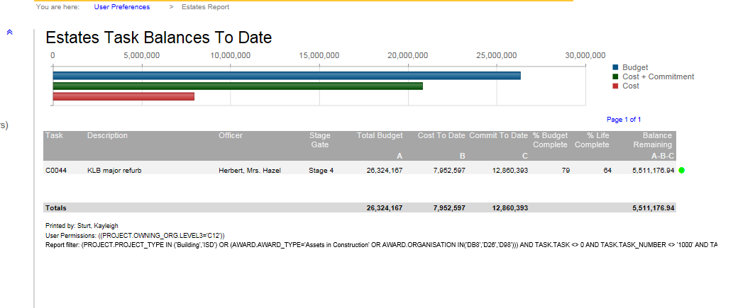

Select ‘Cost to date’ figure

Select ‘Download’

The report will export to an Excel document.

Select ‘Open’

Select ‘Enabling Edit’

Change the ‘Estates Transaction Report’ text to the Project Name and the report

For Example:
PS00044 KLB Cost to date

Format the report so that it can be easily viewed and select a filter to the top row of data.

Create a Pivot Chart

Highlight all of the data (do not include the Total)

Insert – Pivot Chart

Select ‘Choose existing workbook’, select a cell and OK

Select ‘Employee/Supplier’ and drag down to the ‘Rows’ division
Select ‘Accounted/Amount’ and drag down to the ‘Values’ division

Save the TAB as ‘Cost to date’ and save in the project file.

Commitments Report

Follow as above but select the ‘Commitments’ figure

Rename the TAB as Commitments

Save to a different TAB on the same document as the CTD report.

Orders Raised Report

Select the PO Transactions on the left hand side of the My Finance home page

In the ‘Transaction Dates’ section enter date: 01/01/1999

To

The date you are running the report

‘Task Name’ enter to C00XXX number (same as the CTD/Commitments Report)

‘Project Owning Org’ enter ‘C12’ – C12 Estates Division

Select ‘Download’ and follow the above steps

Rename the TAB as Orders Raised

Save to a different TAB on the same document as the CTD and Commitments report.

ISD Costs

Select ‘ISD Report’ on the left hand side of the My Finance Homepage

Select and enter ‘Project Name’ (do not include PSO number)

Or

Select ‘Task Name’ and change the ‘C0’ to ‘E0’

For Example:
PS00044 KLB, C0044, E0044

Note: The codes in some cases do not match the PSO number and therefore can only be searched by project name.

Select ‘Project Owning Org’ C12

Scroll down to find the ‘Award Description’ as Capital Programme ISD

The report should look similar to the below:

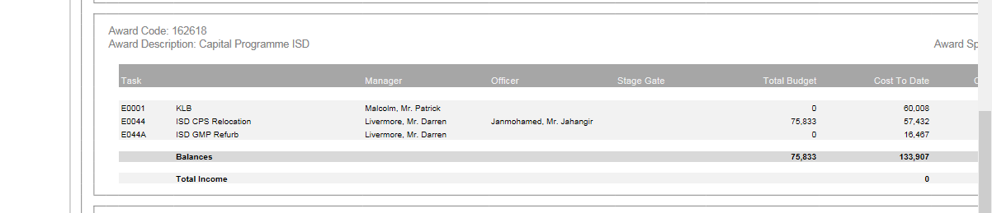

Select the ‘Cost to date’ figure and ‘download’ the report

Follow the steps as above

Rename the TAB as ISD Costs

Save to a different TAB on the same documents as the CTD, Commitments and Orders Raised Report.

Once the reports are complete, an email to the UPO will need to be issued to advise the report is available to use and is saved in the project file.

Reporting Closure

When the UPOs submit their monthly reports to Portfolio Services it is imperative to check the following aspects:

Project Highlight Report:
- Date (Correct date has been submitted)
- RIBA stage is updated
- The ‘RAG’ status has been updated – If reporting ‘RED’ RAG for current month, an Exception Report must be complete.
- The Exception Report is only completed when requesting authorisation from the ES & Capital Programme Board, ie. Additional funds.
- Executive Summary – has been updated
- Project Phases are complete and match to the RIBA stage
- ‘LAB’ ‘AFC’ and ‘CTD’ cells are pulling through from the correct cells on the cash-flow
- Key Activities and Achievements are updated
- Only in construction (RIBA 5) Health and Safety updated
- Sustainability

Cashfow:
- Orders Raised matches Orders Raised Axiom Report
- Cost to date matches for the ‘Paid’ column for the current month
- AFC matches the ‘Total Forecast’
- Remaining balances are forecast

Exception Report:
- Only to be completed if requesting authorisation from the ES & Capital Programme Board and reporting ‘RED’ RAG.

Risk Register & Lessons Learnt:
- Complete

Following Q&A of the monthly reports, any updates or changes to the monthly reports should be recorded by email and discussed with the UPO in person, to ensure prompt completion and submission of updated reports.

If there are reports that have not been received by UPOs, it must be followed up with the UPO in person.

This must be updated to the Capital Projects Monthly Report Checklist located here:

W:\14.0 Portfolio Services\14.2 Reporting\05 Reporting Process

Once all reports have been received, upcoming stage gates must be checked.

Upcoming Stage Gates

Open ‘Master Tracker V1’ saved here:

W:\14.0 Portfolio Services\14.2 Reporting\03 Master Database

Select ‘Capital Projects’ as per your search requirements

Scroll across to ‘PH1 Stage XXX’

Select each of that stages

Select current month and month ahead

The list of projects will require a stage gate folder set up with the stage gate checklist and the relevant templates, depending on which Stage Gate the project is approaching.

The UPO must then be emailed advising that the Stage Gate documentation has been set up in the Stage Gate folder and requires completion.

The project category will determine whether the project will require a Stage Gate approval email circulation or a Stage Gate Meeting. (As per Stage Gates above).

Monthly Work Maps

The monthly work maps have been put in place to highlight interdependent projects across the Campus and to visibly demostrate key information such as which projects are taking place in which building, when the project is due to commence/complete, and the Project Manager that is working on the project.

The Monthly work maps can be created by following the below;

- Open Tracker – Full List Data
- Scroll across to SOS Forecast (Column AX)
- Filter all previous months/years up to and including current month.
- Remove filter for future months/years
- Scroll across to Completion Forecast (Column AZ)
- Filter all from current month to future months/years
- Remove filter for previous months/years

- Open the monthly works maps template located;

14.0 Portfolio Services/14.2 Reporting/10 Monthly Work Maps/Templates

- Copy and paste the information from the tracker as per the template headings
Note: Make sure you include the building name and number for each project.
- Close Tracker
- Open the Minor Works Register
- Scroll across to Construction Start (Column Z) filter all previous month/years from including current month
Once the list has been collated, Please email it to Mark Angliss – who will create the monthly work maps.
Once Mark has issued them back, please send them out to the Heads of Service and Team Leaders.

