UCL Estates
Estates Development

Post Project Review Guidelines

PM&T A001

Version 1.8

20/08/2020

Department Documentation Standards
Version Control

Version | Date | Nature of Revision | Author | Approved By | Signed
V1.0 | 20/03/2018 | Initial draft | Mark Dowson
V1.1 | 10/05/2018 | Revised draft | Mark Dowson
V1.2 | 01/06/2018 | UCL comments | David Stevens
V1.3 | 14/06/2018 | Revised draft | Mark Dowson
V1.4 | 27/07/2018 | Revised draft | Mark Dowson
V1.5 | 02/08/2018 | UCL Comments | DStevens & BStubbs | David Stevens
V1.6 | 03/01/2019 | Comments on questionnaires | DStevens | David Stevens
V1.7 | 16/01/2020 | Minor Amendment | DStevens | David Stevens
V1.8 | 20/08/2020 | Minor Amend | B Stubbs | David Stevens

Note: it is policy to convert all procedural documentation in PDF format once complete and signed off. This document is to remain Microsoft Office Work format to allow for copying and pasting where required.

Contents Page

Section Page

- Introduction 4
- Project Implementation Review (PIR) guidance 7
- Post Occupancy Evaluation (POE) guidance 12

Annexes – Word templates
Annex A A002 – PIR questionnaire: design/construction team feedback form
Annex B A003 – PIR/POE questionnaire: UCL staff feedback form
Annex C A004 – PIR workshop agenda
Annex D A005 – PIR lessons learnt report template

Annexes – Additional
Annex E A006 – PIR workshop slides (PowerPoint format)
Annex F A006 – POE utilities data collection spreadsheet (Excel format)

- Introduction

UCL is committed to undertaking a Post Project Review (PPR) on all registered projects. The aim of the PPR is to ensure that buildings are performing as intended and to ensure that the lessons learnt throughout the project lifecycle are documented so that this learning can be applied to future UCL projects.

The scope of the PPR will vary based on project value, scope, scale and criticality.

For all projects, the PPR will include a Project Implementation Review (PIR) to evaluate how effectively the process of conceptualising and delivering the project was carried out. This exercise shall be managed by the University Project Officer (UPO) who may choose to appoint an impartial Project Manager (PM), and will consist of capturing feedback from the design/construction team and relevant UCL staff, as well as undertaking structured lessons learnt workshop(s) when agreed it is important.

For building projects that are large or business critical, the PPR may also subject to a full Post Occupancy Evaluation (POE) in addition to the PIR requirements. The POE should be led by an independent (BREEAM / SKA requirement) POE consultant and will consist of a functional evaluation of the building in the form of user surveys, as well as technical evaluation of the building in-use (e.g. energy performance evaluation, site audits etc).

The table below shows where PIR and POE are typically applicable:
 |  | PPR
 |  | PIR | POE
Minor Works | Up to £50K  (including low risk, low complexity & <25 construction days) |  | -
Small Project | £50K - £250K |  | -
Medium Project | £250K to £10m |  | -
Large Project | >£10m
BREEAM Project

Overseeing PIR and POE studies shall be the remit of the UCL Mobilisation and Transition Team (MTT). The Mobilisation and Transition team will be the custodians of the completed PIR and POE reports and lessons learned. They will ensure that recommendations are cycled into future projects and a culture of continuous improvement ensues.

The Mobilisation and Transition Team will maintain a tracker of all projects and PPR status. Lessons learned will be collated by building, project and RIBA stage. Quarterly reviews of the Lessons Learned and Recommendations will be carried out by Estates Development and Major Projects senior leaders.

The process for PIRs and POEs will be initiated and project managed by the relevant UCL Estates UPO, but the templates and guidance for both kinds of study will be owned by the Mobilisation and Transition Team. The UPO shall ensure that any identified defects / incomplete works shall be added to relevant defects / latent defects lists / trackers. Overall lessons learnt and critical action points for future UCL projects shall be fed forward onto a central tracker managed by MTT.

The diagram below provides a summary of the key components of the PPR, PIR and POE, together with a summary of activities and supporting templates.

For each activity guidance has been set out in this report. All supporting Word templates have been appended and are also available as separate documents.

UCL Post Project Review (PPR)
Project Implementation Review (PIR) |  |  |  |  |  |  |  |  |  |  | Post Occupancy Evaluation (POE)
Minor works and Small/Medium/Large projects |  |  |  |  |  |  |  |  |  |  | Business critical or Large >£10m projects
Process evaluation |  |  |  |  |  | Functional evaluation |  |  |  |  |  |  |  | Technical evaluation
RIBA Stage 1-7 review |  |  |  |  |  | Capturing user feedback |  |  |  |  |  |  |  | Data analysis & site investigation
Activities (led by UPO / External PM)  - RIBA stage 1-6 lessons learnt PIR workshop 6-8 weeks after handover  - RIBA stage 1-7 lessons learnt PIR workshop 11 months after handover (prior to the end of the defects period)  Supporting UCL templates  - UCL staff feedback form  - Design/construction team feedback form  - PIR workshop agenda  - PIR reporting template  - PIR workshop slides (PPT) |  |  |  |  |  | Activities (led by POE consultant)  - UCL staff/student survey 11-18 months after handover  - UCL staff/student survey 24-30 months after handover  Supporting UCL templates  - UCL staff feedback form  - POE guidance on requirements for user surveys (e.g. content and scoring scales) |  |  |  |  |  |  |  | Activities (led by POE consultant)  - Quarterly and/or annual reporting over a 1-3 year period after handover  - Site audit and review of usage vs. design intent (e.g. space utilisation)  - Review of maintenance strategy and commissioning approaches  - Review of energy performance, water usage and waste data (e.g. monthly)  - Review of predicted (TM54) energy use vs. in-use performance  - Review of internal environmental quality (e.g. BMS data, site measurements)  Supporting UCL templates  - Utilities data collection template (Excel)
Project specific lessons learnt and short/long term actions captured
What went well or could be improved? What is the learning or recommendation for UCL to take forward?
Most important items captured on central tracker managed by UCL MTT
Items categorised by building, project and stage. UCL standard processes & procedures updated
The diagram below gives a high level summary of when key activities in the PIR and POE should be carried out.

 |  | PIR |  | POE  (with PIR review prior  to defects period ending) |  |  |  |  | POE |  |  |  | POE
RIBA Stage 6: Handover |  | RIBA Stage 7: In use
 |  | Year 1  (defects liability period) |  |  |  | Year 2 |  |  |  | Year 3
 |  | Q1 | Q2 | Q3 | Q4 | Q1 | Q2 | Q3 | Q4 | Q1 | Q2 | Q3 | Q4
 |  | PIR workshop 1 |  |  | PIR workshop 2.  User Survey 1.  POE Reporting. |  |  |  | User Survey 2.  POE Reporting |  |  |  | POE reporting

The PIR should take place within the first year after handover.

The first PIR workshop should take place within 3 months after handover to capture initial feedback from the design/construction team and relevant UCL staff involved in the project across RIBA Stages 1-6.

The second PIR workshop should take place within 11 months of occupation and prior to the issue of ‘Certificate of Making Good’. This session shall cover RIBA Stages 1-7. The rationale for having the second workshop is that it allows a natural shift in emphasis towards ‘in-use’ feedback, as well as greater reflection on the initial brief and budget. The timing also enables any outstanding snags and defects to be identified and escalated.

The POE activities will be structured over a 1-2 / 3 year period following handover. As part of this exercise, user surveys should take place 12-18 months and 24-30 months after handover to capture feedback about the building in use. Annual reporting on technical items (e.g. energy use) should take place together with reporting on lessons learnt.

The POE shall be carried out by an external individual(s)/organisation(s) able to demonstrate independence from the design process. Overall responsibility for POE lies with the UPO, with oversight by estates Mobilisation & Transition team. Note that BREEAM projects are likely to require reporting at a more granular level and the specific requirements of the relevant version of BREEAM must be followed.

Note, it is UCL’s preference that the POE should be completed over 2 years, however this may be extended to 3 years upon agreement.

- Project Implementation Review (PIR) guidance

This section provides guidance for the PIR reporting process in the form of “what to do”, “when to do it”, “who to involve” and “how to implement and report”.

  - What to do
The key steps for undertaking a PIR are illustrated in the diagram below. As shown, there are 5 steps revolving around capturing feedback and documenting outcomes with a number of templates to support the process. It is intended that the PIR will be organised and managed by the UPO, or an external project manager on their behalf who has a credible level of independence.

Step 1. Issue pre-workshop PIR questionnaires (2-3 months after implementation) and identify provisional date for PIR workshop to take place
Questionnaire for design/construction team  T |  |  |  |  |  |  |  | Questionnaire for UCL staff involved in the project  T
Step 2. Review & collate questionnaire responses and agree with Mobilisation and Transition team if PIR workshop is required / beneficial.
Agreed with MTT that workshop should take place |  |  |  |  |  |  |  | Agreed with MTT that workshop is not needed
Step 3. Where agreed to be appropriate the UPO / PM shall facilitate the structured lessons learnt PIR workshop (ideally held at the building)
Agenda issued to attendees |  |  |  |  |  |  |  | Categorise what has worked well and what could be improved in RIBA Stage 1-6, as well as the learning / recommendations for  UCL to take forward
 |  |  |  |  |  | T
 |  |  |  |  |  |  |  |  |  |  |  |  |  | T
PIR workshop takes place
 |  |  |  |  |  | T
Step 4. Prepare & circulate the final PIR report.
(Mobilisation Team to agree actions & database all PIR outcomes)
Step 5. Repeat process 11 months after handover (including RIBA Stage 7)
T
= Template available

  - When to do it

The typical timescales for undertaking the initial PIR are as follows:

Week 0 | Week 8 | Week 9 | Week 10 | Week 12
Occupation of building by end user | Questionnaire issued (with placeholder workshop invite) | Questionnaire  responses received back  and reviewed | Lessons learnt PIR workshop takes place  (if required) | UPO completes the final PIR report

As shown, PIR questionnaires should be issued 1-2 months after handover, with the workshop scheduled to take place 2-3 months after handover. This is to capture immediate feedback from the design/construction team and relevant UCL staff involved in the project. A second PIR workshop should be planned to take place 11 months after handover, with similar pre-planning allowances as above.

  - Who to involve

The participants in the PIR process will vary depending on the scope and scale of the project. As a minimum requirement, the collective group must be able to provide feedback across the lifecycle of a project from its initial inception to handover.

For a typical project the attendees should include:
- UPO and a scribe to support the UPO
- UCL Project Board Members
- Lead Assistant Director / Director of Capital Programme
- Project Manager
- Project Architect
- Cost Consultant
- Principal Contractor
- Contractor Design Team
- Building Services Engineer
- Sustainability Consultant
- Structural Engineer
- Civil Engineer
- BIM Leader
- UCL Estates consultees (inc Mobilisation, Maintenance Management, Maintenance Operations, Fabric Management, Security, Fire, Safety Services, Soft Services, Logistics, Sustainability, Accessibility, Area Facilities Manager, PSO – email addresses typically as recorded in the Project RASCI Matrix / Communications Plan)
- UCL Building Users (including student representatives)
- UCL Faculty Director of Operations (to nominate Faculty / Depart attendees)
- ISD Project Manager
- Specialist consultants (e.g. Acoustics, Fire, AV, Security, Access, etc)
- Specialist sub-contractors (e.g. BMS, Commissioning advisor, Laboratory designer, Workshop specialist etc).

  - How to implement and report

To support the PIR, a number of appendices have been prepared, including:
- PIR questionnaire for design/construction team
- PIR questionnaire for UCL staff
- PIR workshop agenda
- PIR workshop slides (in PowerPoint)
- PIR reporting template

Two PIR questionnaires have been developed. One is for the external design/ construction team. The other is for UCL staff. The questionnaire for the design/construction team asks for feedback across the RIBA 2013 Plan of Work (which coordinates with UCL Stage Gates). Prompting questions are included and respondents are asked to comment on the main things that went well, as well as the main things that could have been done better.

The UCL staff questionnaire is structured in a different way and asks:
- Were you involved in the project? If yes, what was your role?
- Were you able to make any suggestions during the consultation stages and were they used? If not involved, what would you have suggested?
- What is best about the building? (and why)
- What is worst about the building? (and why)
- How can the current operations of the building be improved?

On both questionnaires at the end of the form respondents are asked if they would like to discuss any items further. If required by sponsors or senior stakeholders, additional questions may be added, however please note that excessive questions may distract from the questionnaires being completed. SurveyMonkey, Microsoft Forms (free) or similar maybe used as an alternative - which may encourage responses and collate the responses - however not all building users such as cleaners or external contractors may have ready access to UCL Wi-Fi or internet devices.

Where it is agreed between the UPO and Mobilisation Team that the PIR workshop is required or beneficial, the PIR workshop agenda sets out the overall structure for the session with timescales included. The workshop expected to last between 2 to 4 hours depending on project complexity, so a half day should be allowed for.

For the PIR workshop, a set of PIR workshop slides in PowerPoint are available together with the PIR reporting template in Word. The UPO may use (and adapt) the slides to facilitate the workshop session, whilst using the PIR report template to take notes on the day, which can be written up fully once the session is complete.

The slides and report contain prompting questions across all RIBA Stages. Note RIBA stages 2-4 have been grouped for ease in the workshop. However, these can be reviewed individually if more detail is required. The report should be written by individual stage.

The structure of the workshop shall be as follows:

- The workshop should begin with the lead party from each organisation giving a brief introduction to their team, plus a summary of their collective thoughts on “what went well?” and “what could have been done better?”. The UPO shall aim to ensure this exercise takes no more than 15-30 minutes.

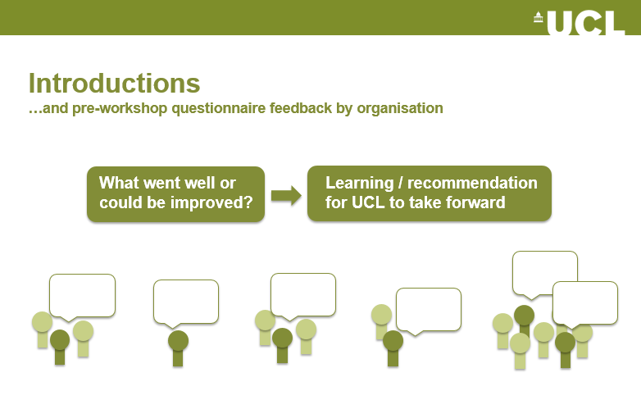

Where there has been insufficient questionnaires returned, or insufficient comments, each participant should be provided with post it notes, and invited to write two or three comments per RIBA Stage on “what went well” and “what could have been done better”. These can then be used as the basis for discussion

This initial feedback shall be summarised in Section 4.0 of the PIR Template Report, as per the table below.

Organisation | Primary responses for  “what went well” | Primary responses for “what could have been done better”

- Following this session the UPO shall facilitate the main workshop activity. The slides include prompting questions besides each RIBA Stage for guidance (whereby RIBA stages should be grouped together if deemed appropriate). For each item the group should also consider what the learning/recommendation UCL should take forward is so this can be documented by the UPO.

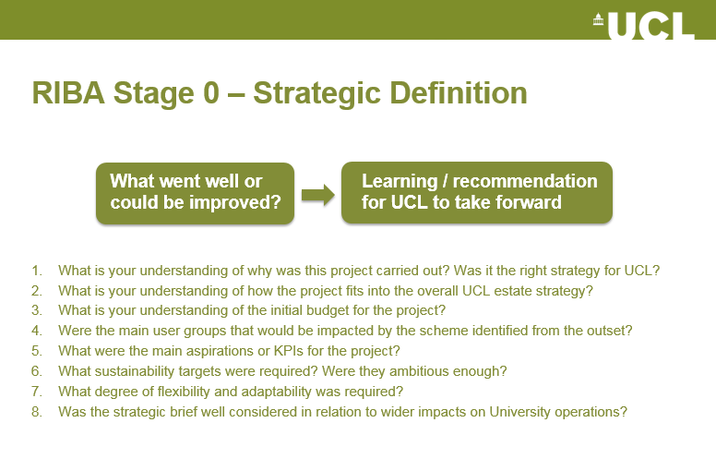

In terms of facilitation, the UPO shall ensure that all relevant questions are covered and adequately documented. The questions act as a guide only and the UPO shall ensure that any pertinent issues not included in the templates are covered.

It should be noted that the discussion points may be the same as those issued in pre-workshop questionnaires or post it notes, so it may not be necessary to spend as much time explaining certain (non-critical) issues again in the workshop. It is also recommended that the UPO re-issues the PIR questionnaires at the end of the workshop to capture any additional feedback.

The feedback gathered throughout the process shall be summarised in the Section 5.0 of the PIR Template Report, as per the table below. Any pressing issues captured that were not specifically listed in the PIR Template shall be included at the end of each RIBA Stage section. The comments should be developed and written up fully by the UPO after the workshop.

No. | Item | What went well or could be improved upon | Learning / recommendation for UCL to take forward
RIBA STAGE 0 – STRATEGIC DEFINITION
3.1 | Project inception

- In the closing session the group shall reflect upon the key talking points from the workshop and collectively agree on the key issues they feel most strongly about.

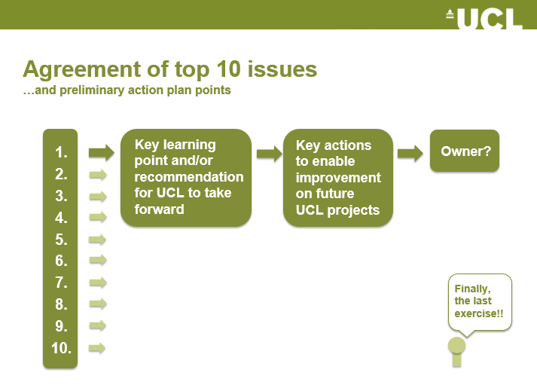

Initial findings can be scribed in Section 5.0 of the PIR Template Report, as per the table on below. These should be developed and written up fully by the UPO after the workshop.

 | Key learning and/or recommendations  for UCL to take forward | Key actions to enable improvement on future  UCL projects | Owner
1
2

Once the PIR report has been drafted, a handover meeting shall then be arranged between the UPO and Mobilisation and Transition team to discuss and agree critical outcomes, next steps and ownership of actions. The UPO shall circulate the PIR report and next steps to the PIR attendees and Estates Development Team Leadership.

- Post Occupancy Evaluation (POE) guidance

This next section provides guidance for the POE reporting process applicable to Large (generally >£10m) and business critical projects, plus those targeting BREEAM certification. Guidance covers roles and responsibilities, timescales, learning objectives, structure, a checklist of activities and additional guidance including energy reporting and user surveys.

  - Roles and responsibilities

At the appropriate time, the UPO shall be responsible for identifying the requirement for POE and for making arrangements to appoint an external POE consultant.

The individual(s)/organisation(s) carrying out the POE must be able to demonstrate independence from the design process. Where the independent party’s organisation was involved with the design of the building, then the consultant must robustly demonstrate objectiveness and no conflicts of interest.

Overall responsibility for the completing the POE lies with the UPO, however governance lies with the Estates Mobilisation & Transition Team.

  - Timescales

For the POE the timing shall take place after the building is substantially occupied, e.g. when approximately 80% of each building function area is occupied.

As a minimum requirement, the POE appointment shall begin within 11 months of occupation and prior to the issue of ‘Certificate of Making Good’. This is to ensure that any early issues identified that may hinder the POE (e.g. access to metering data) can be raised to the relevant party during the defects period.

The length of the POE appointment should be for at least one year to allow the building usage across all seasons and a full annual cycle of activities to be assessed.

Where agreed beneficial (and/or required for BREEAM or other compliance purposes), the POE shall extend to 2 or 3 year as required.

Where applicable (e.g. refurbishment projects), a “pre” occupancy evaluation shall also be carried out to gather user feedback and benchmark data for comparison in the “post” occupancy evaluation. This exercise would be programmed in as appropriate for the project (e.g. RIBA Stages 1-2).

  - Learning objectives

The POE shall be guided by the following overarching questions:
- What did the client and building users want?
- How did this project fit into the overall estate strategy?
- How well did the design team translate these aspirations?
- Does the constructed building meet these aspirations? Is it fit for purpose?
- On reflection, has the completed project met UCL’s strategic objectives?
- Does the building provide the optimal environment for users and activities?
- Have the in-use sustainability targets been achieved?
- Is any additional or remedial work required?

Key outcomes that must be achieved are an understanding of:
- What to do better next time
- How to improve the current building and project delivery processes
- Specific lessons or opportunities directly applicable to similar UCL buildings
- Measures that maintain or improve end users’ comfort and productivity
- Re-commissioning activities, health and safety issues, etc.

  - Structure of the POE

The overall structure of the POE should include the following:
- Review of design intent, design strategy, procurement, construction and handover processes. This should be partially informed by a review of outcomes from the PIR workshop(s).
- Gathering in-use feedback from building users, including facilities staff. This should account for technical operation and maintenance issues, as well as health and wellbeing factors.
- Measurement, profiling and benchmarking of in-use performance data, including comparison against design models/predictions and similar UCL buildings.
- Review of the maintainability of systems and recommendations for re-commissioning.
- Documented lessons learnt and transferable knowledge gathered over the entire POE process referring to the learning objectives above.

  - Dissemination of information

UCL Estates commits to carrying out appropriate dissemination of information on the building’s post occupancy performance. This will be done to share good practice and lessons learned and inform changes in user behaviour, building operational processes and procedures, and system controls. The UPO shall ensure that this is carried out.
  - Checklist of POE activities

Activity | Approach | Supporting material | Year
 |  |  | 1 | 2 | 3
Review of design intent | Document the following:  - Why was this project carried out?  - What was the initial budget for the project?  - Who were the main user groups that would use the building?  - What were the main aspirations or KPIs for the project?  - What sustainability targets were required?  - What degree of flexibility and adaptability was required? | - PIR workshop outcomes  - RIBA Stage 0-1 reports  - Briefing documents  - Business plan  - Interviews with UCL project board members |  | - | -
Review of design strategy | Determine if the initial design intent has been met, as well as the requirements in relation to:  - Internal conditions (temperature, light, noise, ventilation)  - Controls, operation and maintenance  - Facilities and amenities  - Access and layout  - Energy and carbon performance  - Other sustainability features (e.g. water, waste, materials)  - Specialist facilities/ uses  Where possible, identify reasons for any departure from the original design intent (e.g. technical, financial, changing stakeholder requirements). | - PIR workshop outcomes  - RIBA Stage 2-4 reports  - BREEAM / SKA tracker  - Design stage modelling results (e.g. Part L / BRUKL, TM54, comfort, daylight).  - UCL design standards  - Interviews with design team members |  | - | -
Review of procurement & construction | Provide a summary construction information to determine:  - The as-constructed cost for the project, identifying any significant discrepancies from the initial budget  - The extent of any value engineering impacting on building performance, operation and/or function  - The quality of construction detailing (e.g. through thermal imaging and/or air tightness inspection reports, or similar)  - The extent of the quality review process to check the procurement process meets design intent  - Any ambiguity or lack of clarity relating to building performance  - Departures from UCL standards and procedures | - PIR workshop outcomes  - Tender proposals  - Construction information  - Cost plan and VE schedule  - Site inspection records  - Thermal imaging reports  - Air tightness reports  - Acoustic testing reports  - VOC testing reports  - Interviews with construction team members |  | - | -
Review of handover processes | Review the project handover processes, to determine:  - Has the Soft Landings process been adequate through the life of the project and upon handover?  - Have all relevant facilities staff been adequately trained on all systems including the BMS?  - Have all building services systems, including the metering and BMS, been adequately commissioned?  - Have fully operational connections to UCL Estates monitoring systems (e.g. EMON) been established?  - Is the building user guide ‘jargon’ free and ‘user friendly’ and does it adequately describe how to operate the building? (NB – UCL standard template available.)  - Was there an appropriate training and communication strategy for non-technical users to ensure familiarity with new systems/procedures? | - PIR workshop outcomes  - Soft Landings (or similar) meeting minutes / tracker  - Training records  - Building user guide  - Commissioning pack  - Seasonal commissioning plan and records  - Interviews with facilities staff and UCL staff in the building |  | - | -
In-use evaluation of the building | Complete a walk-through audit of the building with the UPO, FM, design team member and/or EM&I representative to determine:  - If spaces are being used as intended (e.g. utilisation, function)  - The quality of the works and internal finishes  - The set-points of controls and their usability  - The building fabric wear and tear  - The overall cleanliness and safety within the building | - Site audit  - Utilisation studies  - Set-point schedules  - Interviews with facilities staff and UCL staff in the building
Analysis of energy, water and waste data | Complete an analysis of utility data (available from the UCL Energy Manager), to determine:  - How the building is performing in terms of energy, carbon, water, waste and running costs?  - Is the building achieving its sustainability targets, e.g. minimum requirements set out in the UCL Sustainable Building Standard?  - What is the predicted (TM54) vs. in-use energy performance?  - What are the contributing factors to any energy performance gaps?  - How can the current performance be improved? | - Utility bills  - Sub-metering data  - UCL POE template for energy, water and waste data recording  - Operational energy and water calculations  - Waste sizing figures  - DEC certificate
Internal environmental monitoring | Where deemed useful to the project, review BMS data, install monitoring equipment and/or engage with academics, or similar, to determine:  - Is the internal temperature, daylighting, relative humidity, air quality (CO₂), noise, within acceptable limits all year round?  - What are the contributing factors and potential consequences associated with any deviations in performance? | - BMS data  - Engagement with UCL researchers  - Interviews with facilities staff and building users
In-use feedback from building users | Undertake a building user survey to capture holistic feedback across a range of issues (e.g. thermal comfort, light, noise, air quality, controls, space, needs, design, lighting, health, productivity, safety, maintenance etc).  For expert uses (e.g. facilities staff & academics) the PIR staff feedback form can also be used to capture additional feedback on:  - Were you involved in the project? If yes, what was your role?  - Were you able to make any suggestions during the consultation stages and were they used? If not involved, what would you have suggested?  - What is best about the building? (and why)  - What is worst about the building? (and why)  - How can the current operations of the building be improved? | - User survey templates (pre-agreed with UCL MTT)  - PIR staff survey template  - Interviews / focus groups with building users |  | (Second user survey 24-30 months after occupation)
Maintenance & ongoing  commissioning | Review the maintainability and commissioning approaches to determine:  - What are the most frequent maintenance issues and complaints?  - Is the building easy to maintain?  - Could any spatial restrictions have been avoided?  - Is there a preventative maintenance strategy in place?  - What re-commissioning activities should take place?  - Identify any business critical maintenance or replacement requirements | - PIR outcomes  - Site audit  - Asset register  - Maintenance logs  - Seasonal commissioning reports and actions  - Interviews with FM staff
Lessons learnt & transferrable knowledge | Provide a lessons learnt report in relation to the stages above. Feed forward critical learning and/or recommendations for UCL to take forward into the UCL MTT central tracker for capturing lessons learnt. Refer back to the overall POE learning objectives from Section 3.3. | - UCL MTT central tracker

  - Additional guidance

POE techniques

Recognised POE techniques to support the aforementioned processes include (but are not limited to) undertaking Higher Education Design Quality Framework (HEDQF) workshops, undertaking user surveys via the Building Use Studies (BUS) methodology and undertaking energy auditing activities (e.g. following guidance in CIBSE TM22, CIBSE Guide F).

Further guidance on post occupancy evaluation techniques is available from the following sources:
- The BCO guide to Post Occupancy Evaluation, British Council for Offices, 2007
- BRE Digest 478, Building performance feedback: getting started, BRE, 2003
- BSRIA Building Performance Evaluation in Non-Domestic Buildings (BG63/2015)
- Guide to Post Occupancy Evaluation Report and Toolkit, HEFCE, AUDE & University of Westminster, 2006

BREEAM and SKA

Where applicable, the POE processes should support compliance towards BREEAM credit (Man 05 in the 2014 version) and SKA HE (D71), or equivalent. Where BREEAM requires reporting to the BRE as part of ongoing monitoring over a 2/3 year period, all externally issued information should be approved by UCL MTT prior to release.

Energy reporting

The consultant shall make a clear distinction between ‘compliance’ models and ‘operational prediction’ models when comparing to actual performance in-use. Whole building energy modelling compliant with CIBSE TM54, or equivalent, is a requirement of the UCL Sustainable Building Standard. Comparing TM54 predictions vs. actual performance is the preferred approach.

The collection and monitoring of energy, water and waste consumption data may be coordinated or carried out by the UCL Engineering, Maintenance & Infrastructure; sustainability or area facilities management team – if requested sufficiently far enough in advance and sufficient resource is available, or preferably, by a dedicated aftercare team.

Where building does not have a valid Display Energy Certificate (DEC), this should be raised to the UCL Energy Team for corrective action.

A UCL POE template for collecting energy performance data has been created and is available from UCL MTT. The spreadsheet allows monthly energy use by fuel type and end-use to be entered. Annual figures can also be entered where monthly data is not available.

The interface of the POE data collection tool is shown below. In addition to collecting energy data, the tool also includes data entry fields for water and waste. It also includes a series of tick-boxes to provide an indication of data accuracy and highlight the wider POE studies that have been conducted.

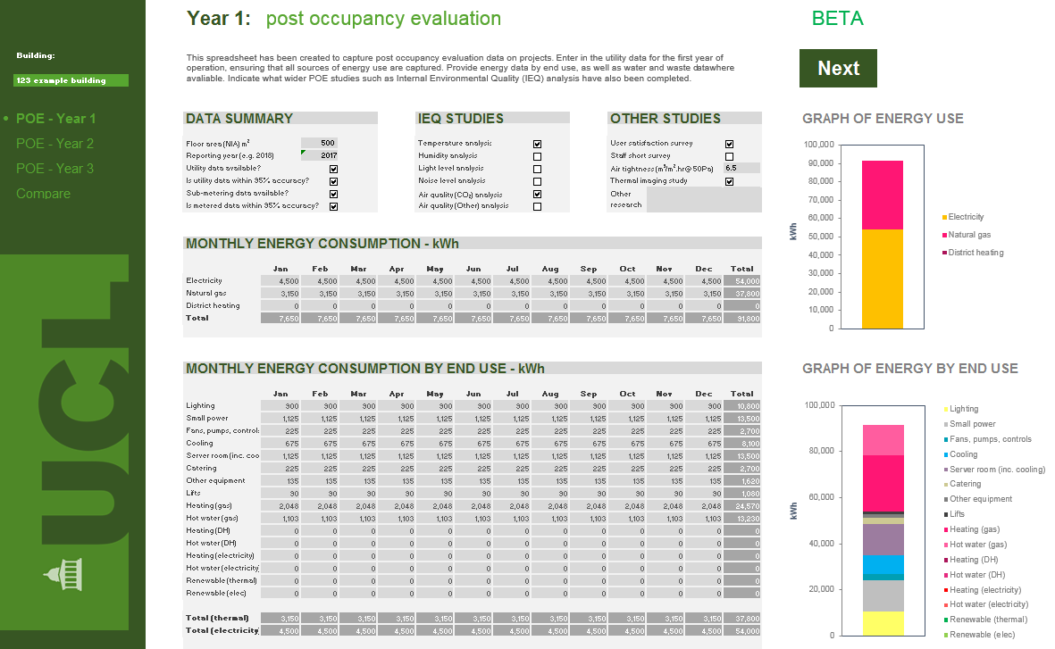

The spreadsheet includes functionality to compare the POE energy data to design stage TM54 predictions, as illustrated below.

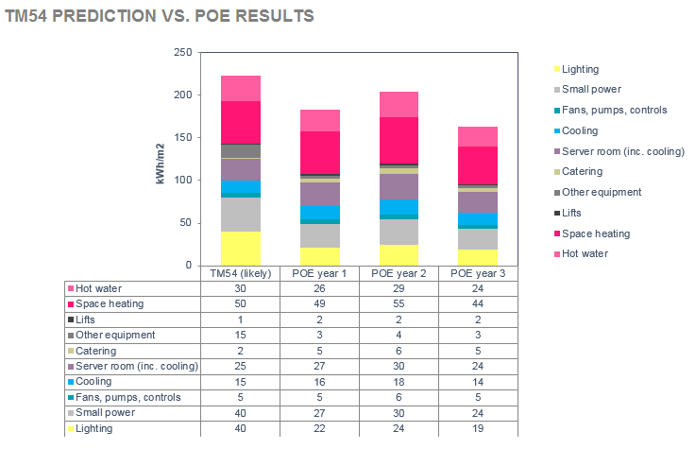
The spreadsheet also includes functionality to compare CO₂ emissions arising from the POE energy data to that of three (user selected) similar UCL buildings.

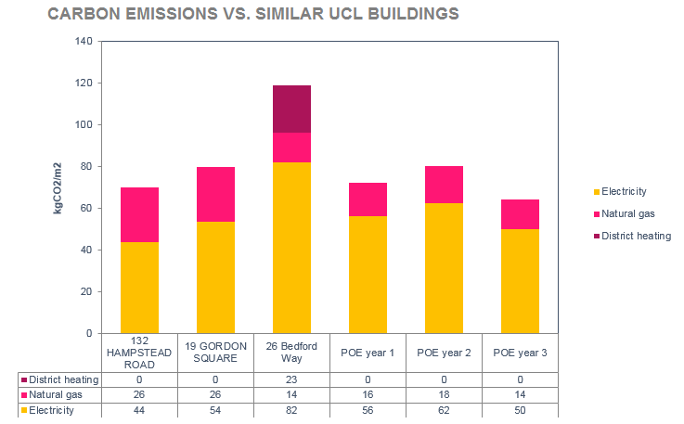

User surveys

In relation to gathering user feedback, the consultant shall capture feedback at an appropriate level of detail in an anonymous and ‘no blame’ manner. The approach should aim to allow identification of specific problem areas (e.g. areas of thermal discomfort) and result in actionable insights.

When undertaking the holistic building user survey, a 7-point scale is preferred to allow UCL to have a consistent approach to comparing survey results. The survey should use non-emotive language (e.g. phrases such as ‘satisfied / dissatisfied’, rather than ‘happy / unhappy’).

As a minimum, the following elements must be included in the user survey:
- Thermal comfort (summer and winter)
- Lighting (daylighting and electric lighting)
- Air quality
- Acoustics
- Space
- Needs
- Productivity
- Health
- Safety
- Overall design & image
- Operation & maintenance
Additional information that is beneficial to capture includes (but is not limited to):
- Space utilisation
- Flexibility and adaptability
- Collaboration
- Social value
- Public realm
- Transport
- Waste management

The survey should include entry questions such as ‘what floor are you typically based on?’ and ‘what department are you in?’, in order to allow survey results to be diagnosed at a greater level of detail if required.

In addition to presenting the quantitative survey data, written comments should also be captured as part of the building user survey. The comments should be reviewed by the POE consultant and presented by theme in terms of what works well and what could be improved, as per the table below:

Air quality comments

+ | - I like that I can open the windows  - The ventilation in the basement is surprisingly good
- | - It’s too stuffy in the summertime!  - The ventilation system in my office is broken

The POE consultant shall aim to achieve a statistically valid sample size, e.g. achieving a 90% or 95% confidence level following Yamane’s formula, or similar:

Yamane’s formula  (n = N / (1 + Ne²) | Where:  n = sample size  N = population size  e = margin of error (0.1 for 90% confidence interval, 0.05 for 95% confidence interval)

The POE consultant shall comply with all data protection regulations and not capture or disclose any personal data without written consent.

Any health & safety issues and/or snagging items identified through the user survey shall be raised immediately to UCL MTT.

UCL prefers the use of the Arup Building Use Studies (BUS) methodology, or the BSRIA Occupant satisfaction surveys.

UCL Estates
Estates Development & Major Projects

Appendices

Name______________________________ Organisation _________________________ Role _________________________ Email ______________________________________________________

Which stages were you involved in? Mark an ‘X’ in all that apply

RIBA STAGE 0 STRATEGIC DEFINITION | RIBA STAGE 1 PREPARATION & BRIEF | RIBA STAGE 2 CONCEPT DESIGN | RIBA STAGE 3 DEVELOPED DESIGN | RIBA STAGE 4 TECHNICAL DESIGN | RIBA STAGE 5 CONSTRUCTION | RIBA STAGE 6 HANDOVER

Please provide feedback below regarding the overall delivery of the project. UCL is committed to undertaking a Post Implementation Review (PIR) on all projects, however small. The aim of the PIR is to understand what has worked well and what could have been done better to identify any learning and recommendations for UCL to act upon and apply on future projects. Your feedback in this process is invaluable. Please only comment on any stage, or stages you feel strongly about. Additional sheet may be used if required

Stages that went particularly well were… (please underline) |  |  |  |  |  |  | Stages that could have been better were… (please underline) |  |  |  |  |  |  | How to improve future UCL projects
0 | 1 | 2 | 3 | 4 | 5 | 6 | 0 | 1 | 2 | 3 | 4 | 5 | 6
These good things were enabled by… |  |  |  |  |  |  | In particular I was concerned with… |  |  |  |  |  |  | On the next similar project, UCL should consider…
Some items to consider
- The brief - suitability, clarity and consistency,
- Level of project ambition - context, budget and UCL strategic needs
- Consultation processes – before, during and after completion
- Design – appropriateness, changes, understanding of user needs
- Construction – quality, supervision of detail, experience of team
- Handover – clarity, timeliness, documentation, use of Soft Landings

Space for any additional comments on what you think UCL should learn from this project (Please note this section is not mandatory).

Would you like to discuss any of these issues further? (please underline) YES NO |  | Thank you for your time! The UCL Project Mobilisation and Transition team will be the custodians of the lessons learnt. They will ensure that recommendations are cycled into future projects and a culture of continuous improvement ensues.

INSERT PROJECT NAME
POST PROJECT REVIEW QUESTIONNAIRE

Name
Role
Email

Q1. | Were you involved in the project? If yes, what was your role?
Q2. | Were you able to make any suggestions during the consultation stages and were they used? If not involved, what single thing would you have suggested?
Q3. | What is best about the building? (and why)
Q4. | What is worst about the building? (and why)
Q5. | How can the current operations of the building be improved?

Space for any additional comments on what you think UCL should learn from this project
(Please note this section is not mandatory).

Would you like to discuss any of these issues further? (please underline) YES NO

Thank you for your time! UCL is committed to undertaking a post project review on all projects. The aim is to understand what has worked well and what could have been done better to identify any learning and recommendations for UCL to act upon. The UCL Project Mobilisation and Transition team will be the custodians of the lessons learnt reports and resultant action trackers. They will ensure that recommendations are cycled into future projects and a culture of continuous improvement ensues.

Meeting Name | Insert Project Name  Project Implementation Review
Meeting Place
Date
Attendees
Apologies

Item | Description | Lead
1 | Welcome, introductions and context  Summary of the PIR process given by UPO. Organisations are asked to introduce themselves and say the single thing that they felt went well & could have been improved. Expected timing between 15-30 minutes | UPO
2 | Facilitated discussion to establish what went well and what could have been improved.  RIBA Stage 0-1: The business case & brief  Expected timing 15-30 minutes  RIBA Stage 2-4: Concept, developed and detailed design  Expected timing 30-60 minutes  RIBA Stage 5: Procurement and construction  Expected timing 15-30 minutes  RIBA Stage 6: Handover  Expected timing 15-30 minutes | UPO
3 | In-use feedback  Expected timing between 15-30 minutes | UPO
4 | Summary and action plan  Agreement on most important lessons learnt and recommendations for UCL to take forward. Expected timing between 15-30 minutes. | UPO

Expected workshop length 2-4 hours depending on complexity.

UCL Estates
Estates Development

Project Implementation Review – Lessons Learnt Report
Insert Project Name

PM&T A005

Version 1.5

Date to Suit

UCL Project Reference :

Department Documentation Standards
Annex D

Version Control

Version | Date | Nature of Revision | Author | Approved By | Signed
V1.0 | 20/03/2018 | PIR Report Template | Mark Dowson
V1.1 | 10/05/2018 | Formal issue | Mark Dowson
V1.2 | 14/06/2018 | Formal issue with PPR | Mark Dowson
V1.4 | 27/07/2018 | Rev number alignment | Mark Dowson
V1.5 | 02/08/2018 | UCL Estates Changes | David Stevens
Note: it is policy to convert all procedural documentation in PDF format once complete and signed off. This document is to remain Microsoft Office Work format to allow for copying and pasting where required.

Contents Page

Section Page

- Project details 4
- Project programme 4
- Project Team 5
- Contributors 5
- Outcomes from Lessons Learnt Workshop 7
- Summary and Action Plan 14

Annexes
Pre Workshop Questionnaire Responses

- Project Details

Project name
Floor area | m² GFA
Date of meeting | dd/mm/yyyy
Procurement route
Project Value
Practical completion | dd/mm/yyyy
Project type | e.g. refurbishment, new-build
Key uses | e.g. offices, workshop, laboratories, student accommodation

- Project Programme

 | Start date | End date
RIBA Stage 0 | dd/mm/yyyy
RIBA Stage 1
RIBA Stage 2
RIBA Stage 3
RIBA Stage 4
RIBA Stage 5
RIBA Stage 6

Insert an image of the project

- Project Team

Name | Organisation | Role | Contribution
 |  |  | Workshop | Questionnaire
 |  |  | ☐ | ☐
 |  |  | ☐ | ☐
 |  |  | ☐ | ☐
 |  |  | ☐ | ☐
 |  |  | ☐ | ☐
 |  |  | ☐ | ☐
 |  |  | ☐ | ☐
 |  |  | ☐ | ☐
 |  |  | ☐ | ☐
 |  |  | ☐ | ☐
 |  |  | ☐ | ☐
 |  |  | ☐ | ☐
 |  |  | ☐ | ☐
 |  |  | ☐ | ☐
 |  |  | ☐ | ☐
 |  |  | ☐ | ☐

- Contributors (Non Project Team)

Name | Organisation | Role | Contribution
 |  |  | Workshop | Questionnaire
 |  |  | ☐ | ☐
 |  |  | ☐ | ☐
 |  |  | ☐ | ☐
 |  |  | ☐ | ☐
 |  |  | ☐ | ☐
 |  |  | ☐ | ☐
 |  |  | ☐ | ☐
 |  |  | ☐ | ☐
 |  |  | ☐ | ☐
 |  |  | ☐ | ☐
 |  |  | ☐ | ☐
 |  |  | ☐ | ☐
 |  |  | ☐ | ☐
 |  |  | ☐ | ☐
 |  |  | ☐ | ☐

- Outcomes from Pre Workshop Questionnaire

Organisation | Primary responses for  “what went well” | Primary responses for  “what could have been done better”
 | Provide a brief summary of the overall feedback raised by each organisation. Note that all questionnaire responses shall be appended to this report for further detail.

- Outcomes from Lessons Learnt Workshop

No. | Item | What went well or could be improved upon | Learning / recommendation for UCL to take forward
RIBA STAGE 0 – STRATEGIC DEFINITION
0.1 | Project inception | The items in this table and on the supporting PIR workshop slides are provided as a guide only. Discuss the relevant items write up a summary of the feedback. Aim to spend approximately 15-20 minutes discussing each RIBA Stage, covering all items including discussion on the learning/recommendation for UCL to take forward.  Note that RIBA stage 0-1 can be combined into a single ‘briefing’ section and 2-4 can be combined into a single ‘design’ section.
0.2 | Alignment to UCL estate strategy
0.3 | Initial budget
0.4 | Identification of user groups
0.5 | Aspirations and KPIs
0.6 | Sustainability ambitions
0.7 | Flexibility & adaptability considerations
0.8 | Impacts on wider University operations
RIBA STAGE 1 – PREPARATION AND BRIEF
1.1 | Translation of strategic brief into project brief
1.2 | Clarity of project brief
1.3 | High level leadership
1.4 | Adequacy of budget and programme
1.5 | Project Execution Plan
1.6 | Clarity over roles and responsibilities
1.7 | Identification of risks, opportunities and user needs
1.8 | Timing and adequacy of surveys
1.9 | Overall project organisation and management
1.10 | Impact of initial feasibility studies
1.11 | Use of Soft Landings at the start of the project
1.12 | Other
RIBA STAGE 2 – CONCEPT DESIGN
2.1 | Changes to the brief
2.2 | Design response to the brief
2.3 | Stakeholder consultation with users, experts and 3rd parties
2.4 | Timing of input from stakeholders
2.5 | Layout, usability and controllability
2.6 | Planning and Building Control issues
2.7 | Embedding of sustainability into the designs
2.8 | Security, accessibility maintenance and AV
2.9 | Team spirit
2.10 | Client approval process
2.11 | Alignment of emerging design to cost plan
2.12 | Other
RIBA STAGE 3 – DEVELOPED DESIGN
3.1 | Co-ordination between consultants
3.2 | Consideration for fabric and service replacement and maintenance
3.3 | Adequacy of specialist input during the project
3.4 | Design changes impacting on time/cost
3.5 | Procurement strategy and tender timetable
3.6 | Unresolved design issues impacting on tender process
3.7 | Adequacy of Employers Requirements to generate accurate costs
3.8 | Mechanisms for stakeholder feedback
3.9 | BIM implementation and execution plan
3.10 | Client and project manager engagement / understanding of BIM
3.11 | Other
RIBA STAGE 4 – TECHNICAL DESIGN
4.1 | Robustness of specifications and design information
4.2 | Deadlines and impact on quality
4.3 | Pre-construction programme and cost plan
4.4 | Appropriateness of the selected form of contract
4.5 | Contractor selection process
4.6 | Post tender review and negotiation
4.7 | Change management process
4.8 | Impact of value engineering on building performance/function
4.9 | Client approvals prior to construction
4.10 | Other
RIBA STAGE 5 – CONSTRUCTION
5.1 | Understanding of construction complexity and logistics
5.2 | Monitoring of construction progress & management of issues
5.3 | Supply chain experience
5.4 | Extent of changes and management of change
5.5 | Quality of the final product and alignment to specs/standards
5.6 | Construction team resources
5.7 | Health & safety
5.8 | Delays to construction programme
5.9 | Does the constructed building meet the original brief?
5.10 | Other
RIBA STAGE 6 – HANDOVER AND CLOSE OUT
6.1 | Implementation of Handover Strategy/Plan
6.2 | Use of formal Soft Landings process
6.3 | Commissioning process and witnessing
6.4 | Functional BMS, display screens and metering
6.5 | Training of personnel to right level of detail
6.6 | Snagging issues and corrective action
6.7 | Design team involvement in handover and document approvals
6.8 | Document production of quality issues
6.9 | Ease of achieving Practical Completion
6.10 | Clarity over client acceptance criteria
6.11 | Understanding and planning of servicing and maintenance
6.12 | Other

- Summary and Action Plan

 | Key learning and/or recommendations  for UCL to take forward | Key actions to enable improvement  on future UCL projects | Owner
1 | Reflect on the feedback received in the questionnaire and from the workshop and detail the top 10 learning and/or recommendation points for UCL to take forward. | For each item identify any action(s) needed to enable improvement on future UCL projects.
2
3
4
5
6
7
8
9
10

The Key items identified should be transferred on to the Blank Lessons Learned Tracker / Database, for later copying onto the master database. This blanbk document can be found at this location; S:\EFD_23.0_Mobilisation&Transition\Post Project Reviews\Post Project Reviews\PIR Templates\Blank lessons Learned Tracker.xls‬‬‬‬

Annexes to PIR report:
Questionnaire Responses
Append the questionnaire responses (consisting of design/construction team feedback forms, as well as the UCL staff feedback forms). The UPO may wish to issue the questionnaires before and after the workshop to get the maximum number of responses.

Full POE is unlikely to be required on projects <£10m, although a ‘lite’ approach may be appropriate depending on the project scope, criticality or user profile. This is to be agreed with the Estates Mobilisation & Transition Team on a case-by-case basis.
Full POE is unlikely to be required on projects <£10m, although a ‘lite’ approach may be appropriate depending on the project scope, criticality or user profile. This is to be agreed with the Estates Mobilisation & Transition Team on a case-by-case basis.
In addition to the specific BREEAM credit for POE, the process should also be planned to support and/ or link with separate credits for aftercare support and seasonal commissioning. These three separate credits fall under ‘Man 05 – Aftercare’ in the BREEAM 2014 schemes.

