LESSONS LEARNED
Often overlooked, lessons learned play a key role in the life cycle of a programme/ project. Being able to document lessons learned after a project is complete (or even in the middle of it) is crucial. If the mistakes and successes of a project are captured and well documented, it can help shape the successes of future projects/ other projects within a programme.

The purpose of the lessons learned document for UCL Estates and Capital Projects is to capture any insights gained during a project that can be usefully applied on future projects. Capturing lessons learned is an integral part of every project and can serve as an important tool in ensuring Programmes and Projects follow best practice, are delivered on time and delivered within budget.

Organising the lessons learned in a formal document serves as a valuable tool for use by other UPOs and Project Managers within the organisation who are assigned similar projects. The document may also be used as part of new project planning in order to determine what problems occurred and how those problems were handled and may be avoided in the future. Additionally, this document details what went well with the project and why, so that other project managers may capitalise on these actions. UPOs and Project Managers may also use this document to determine which project team members are able to feed into planning of their projects in the future. The lessons learned document should be formally communicated across UCL project teams and become a part of UCL project archives.

How to approach Lessons Learned
The lessons learned approach should be established at the initial stages of project planning, specifying the method of capturing lessons (project journals, project risk register, information from stakeholders and users etc.) plus the frequency and reason for the suggested approach. The lessons learned log should be maintained for the duration of the project and can be used to complete stage gate reports and project closure documents. Lessons learned provide value for future use and the contents should be consistent with other lessons learned documents across the UCL project portfolio.

Input from all parties involved in the project should be encouraged. This input can be from other UPOs / Project Managers, Contractors or even Users of the service can feed into the lessons learned log. All of the opinions and viewpoints gathered as soon as possible after a project success or error. It is often a good idea to hold project Lessons Learned debriefs with the key stakeholders and feed into a centralised project lessons learned Register (LLR).

Determine potential pathways to what led to a particular success or failure in a work stream, stage of a project. Determination should be carried out the UPO / Project Manager by of what led to the success/failure and what would have prevented it. Proposing a series of “What if” questions will lead to a good understanding of what happened and the lessons to be carried forward:
- What if …the project schedule had been created before the end date was decided upon?
- What if …the risk had been mitigated instead of accepted?
- What if…

Validate the lessons learned and the determinations with those who put forward the lessons where possible. The validation exercise helps to understand how situations arise in projects that can lead to either the success or failure of a project.
Communicate the information and conclusions gathered on the project log should become part of the knowledge to be considered going forward for other stages, projects or programmes that are likely to encounter similar issues or problems to those faced by your project.

Categorising Lessons
How we categorsie lessons in the lessons log will help with organising information. It will help steam line areas of focus and ensure the data is searchable on agreed key attributes.

Other Knowledge Areas:
- Procurement Management
- Finance
- Scope Management
- Communication Strategy
- Scheduling
- Contractors
- Quality Management
- Risk Management
- Scope Management

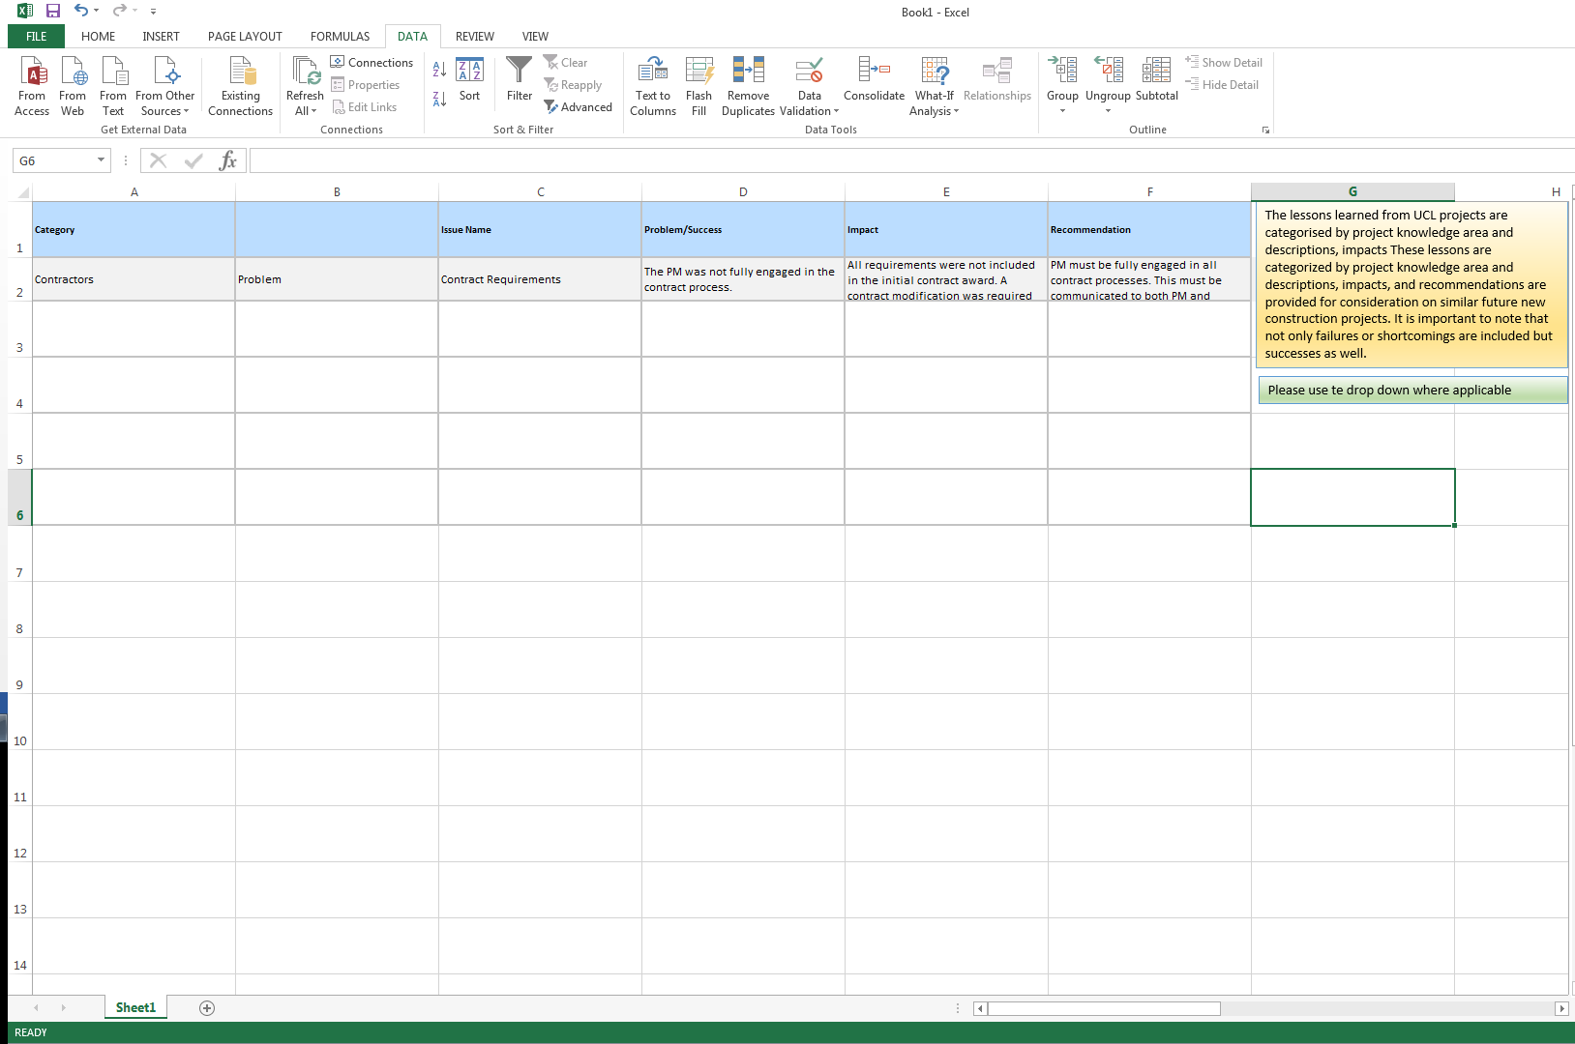
Lessons Learned Log

It is important that once lessons learned are collected and documented that UCL approves and implement any process improvements identified.

Recording Lessons Learnt

Recording lessons learned should be a regular part of project management and needs to be included in the weekly and monthly processes. It is important to make sure that it is published (on the W: Drive) so that everyone involved in the project is aware of the lessons learned, both positive and negative. It is also vital that this information be preserved so that the organisation and the project teams can have it the next time a similar project is being executed. Without the lessons learned from previous projects, future projects will fall into the same routines and pitfalls that occurred in previous projects.

Changes tasks and checks or the sequence of certain activities can greatly improve project outcome

This makes it easier to identify recurring issues, to update the data and to maintain the accuracy and relevancy of the data

Such as staff, risk, scope, contractors any other attributes relevant to the project
Programme lessons learned ideally should be surmised and stored centrally.
Recording Lessons learned will ultimately lead to more successful projects and consequently financial advantage for the majority of UCL project.

