Return to campus external route – Green route

The main entrance to the green route is via the Main Quad Gate Entrance (Gower Street). Buildings that can be accessed from the green route include; Chadwick Building, North West Building, Physics Building, Slade School, Wilkins Building, Wilkins Terrace, Pop-up Building, Front Lodges, 25 Gordon Street, 23 Gower Place, Student Union & Bar (134-136 Gower Street), Health Centre and Kathleen Lonsdale Building. Bloomsbury Theatre, Nanotechnology and the Student Centre are access direct from the street. The [what3words address](https://what3words.com/how-to-use-the-what3words-app/) for this gate is builds.pushes.ideal.

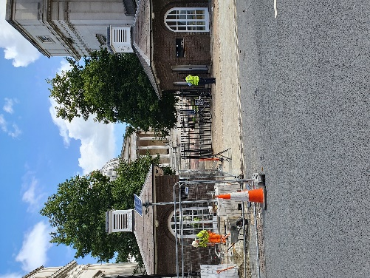 Image taken from Gower Street looking at entrance to UCL. Currently there are roadworks to the left of the gates but these images were taken in August so they should be gone by the start of term.

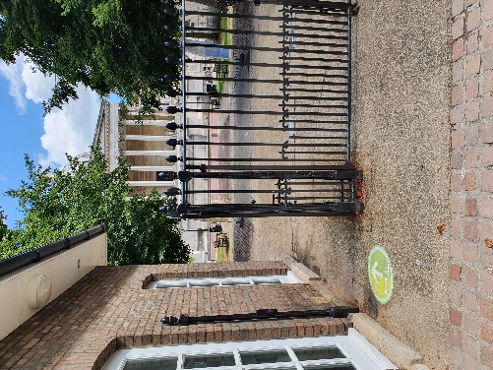 Image of gates into UCL showing that left-hand side is the side to enter. Note the green arrow sticker on the floor.

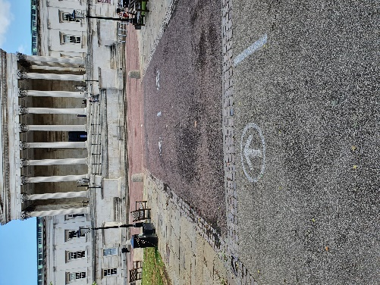 Image taken by Chadwick Building looking up Main Quad, entry route is to the left. Note white arrow on floor.

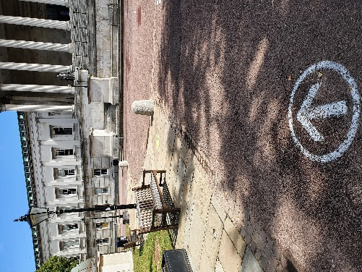 Image looking from Main Quad towards North Cloisters, note white arrow on floor.

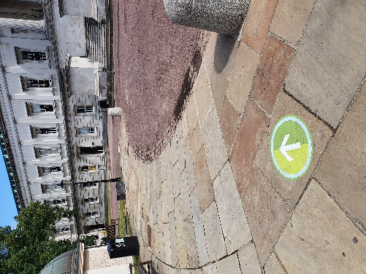 Image looking from Main Quad towards North Cloisters, Note green arrow sticker on floor.

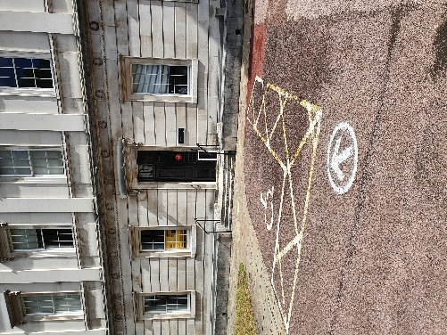 Image looking at North Cloisters by accessible car parking bay.

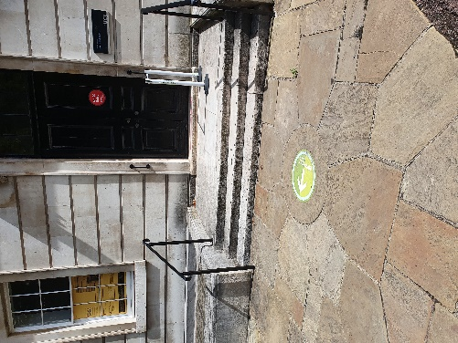 Image looking at North Cloisters from accessible car parking bay showing first entrance (which is closed), note green arrow sticker on floor directing users to walk along to entrance at corner of North Cloisters and Slade buildings. If you need a step free entrance, at this point turn left and go up the ramp to the side of the portico. Security staff should be on hand to assist with this route.

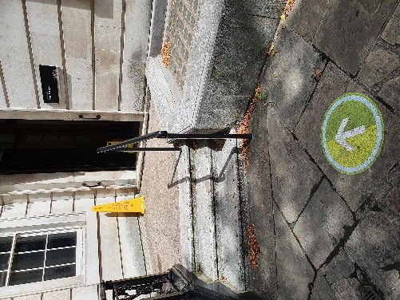 Image of three steps and doorway into North Cloisters (entrance by junction of North Cloisters and Slade building).

Users then pass through the North Cloister, Octogan and South Cloisters and can access other buildings off this route. Exit to Gower Street is via the South Cloisters.

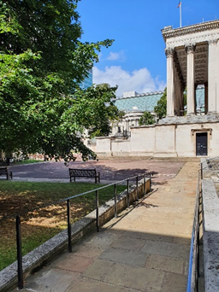 Image taken from South Cloisters looking down ramp to Main Quad.

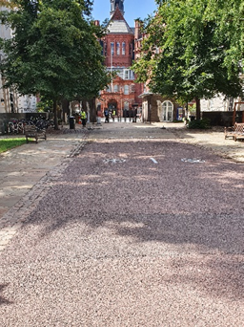 Image taken from Main Quad looking towards gates to Gower Street.

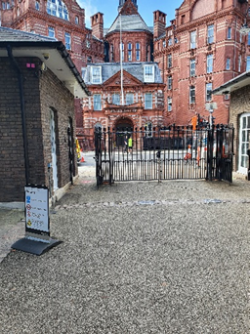 Image of gates on to Gower Street showing left hand exit gate.