Return to campus external route – Blue route
The main entrance to the blue route is via the Gordon Street Gate Entrance. Buildings that can be accessed from the blue route include; Andrew Huxley Building, Anechoic Room, Bernard Katz Building, Henry Morley Building, MRC Building, Medawar Building and South Wing. Buildings that can be accessed straight from the street include; 16-18 Gordon Square, 19 Gordon Square, 20 Gordon Square, 21 Gordon Square, 22 Gordon Square, 24, Gordon Square, 25 Gordon Square and 26 Gordon Square. Please note all the Gordon Square Houses have stepped entrance and so step free access will need to be discussed with the department. The what3words address for this gate is zones.renew.post.
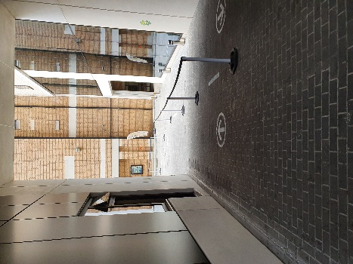 View from Gordon Street between Gordon Square Houses and Student Centre looking towards Bernard Katz Building. Entry to left, exit to right.
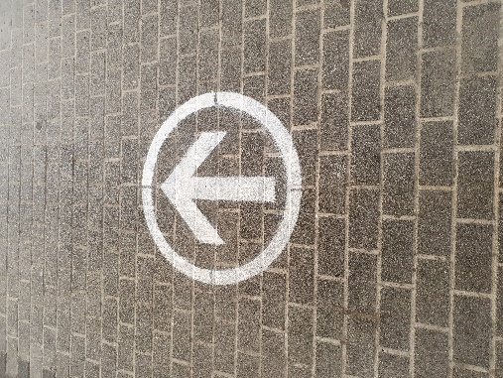 Image of arrows that appear on paving along this route.
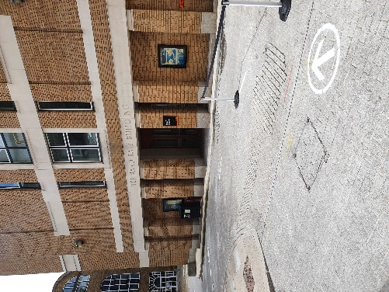 Image from bottom of slope between Gordon Square Houses and the Student Centre looking towards the running circle, with Bernard Katz building on the right.
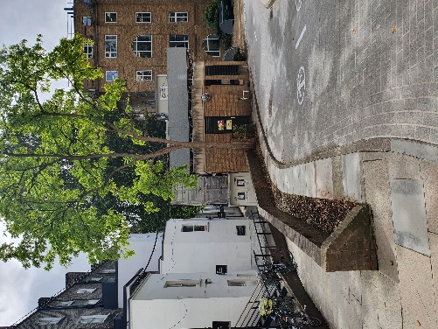 Image from bottom of slope between Gordon Square houses and Student Centre looking towards turning circle with back of Gordon Square houses on left of image. To access Gordon Square Houses, Henry Morley or Medawar please take the route along the back of Gordon Square Houses.
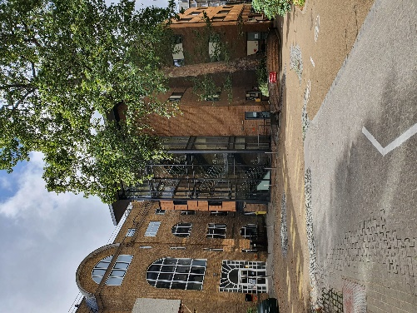 Image of turning circle between Bernard Katz building and MRC building.
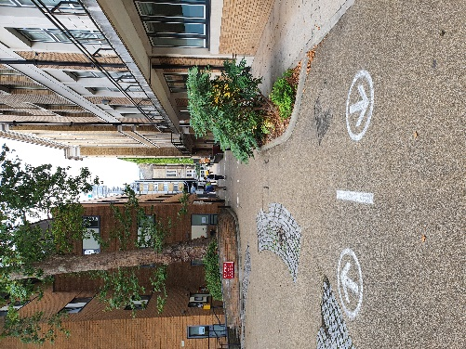 Image from corner of Bernard Katz building looking towards the print café.
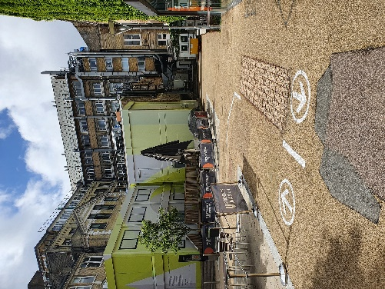 Image looking from between Andrew Huxley Building and South Junction looking towards South Quad. To move between the blue and green zones you can enter the south junction and follow the one way route through there to access the green zone.
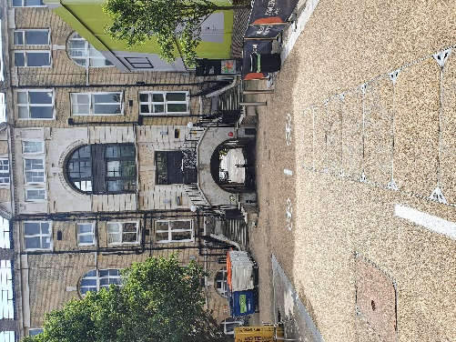 Image from Print room café looking towards Medical Sciences Building, showing tunnel into Malet Place. This is where you can move between the Blue and red route although it is encouraged that you enter via the street gate assigned to the building you wish to visit where possible.
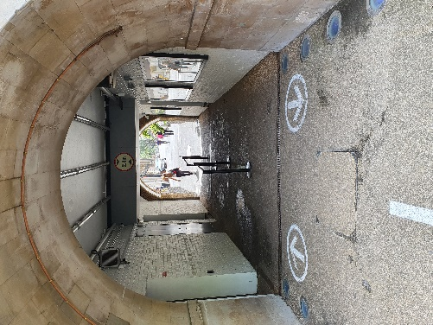 Image of tunnel under Medical Science building leading into Malet Place. Note barriers splitting route in two.

