GLOSSARY OF ABBREVIATIONS
A
A: Answers
ACF: Academic Career Framework
AP: Athena SWAN Action Plan
AS: Athena SWAN
AWC: Academic Writing Centre
B
BA: Bachelor of Arts
BAME: Black, Asian and Minority Ethnic
BME: Black and Minority Ethnic
BSc: Bachelor of Science
C
CDE: Centre for Doctoral Education

D
DoO: Director of Operations
E
E&D: Equality and Diversity
ECN: Early Careers Network
EDI: Equality, Diversity & Inclusion
EG: Executive Group
ERC: European Research Council
F
F: Female
FT: Full-time
FTC: Fixed-term contracts
H
HEIDI: Higher Education Information Database for Institutions
HESA: Higher Education Statistics Agency
HOD: Head of Department
HR: Human Resources
HRBP: HR Business Partner

I
IOE: UCL Institute of Education
ITE: Initial Teacher Education

J
JD: Job Description
K
KEI: Knowledge Exchange and Impact
L
LGBTQ+: Lesbian, Gay, Bisexual, Transgender & Questioning
M
M: Male
MPhil: Master of Philosophy
O
OEC: Open-Ended Contract
P
PD: Pro Director
PDAD: Pro-Director Academic Development
PGDip: Postgraduate Diploma
PGR: Postgraduate Research
PGT: Postgraduate Taught
PhD: Doctor of Philosophy
PS: Professional Services
PT: Part-time
Q
Q: Questions
QS: Quacquarelli Symonds
R
REF: Research Excellence Framework
RG: Russell Group
RTP: Research Training Programme
S
SAT: Athena SWAN Self-Assessment Team
SEG: Senior Executive Group
SLT: Senior Leadership Team
SMT: Senior Management Team
U
UCL: University College London
UG: Undergraduate

2. DESCRIPTION OF THE DEPARTMENT
Recommended word count 500
The UCL Institute of Education (IOE) is a world-leading centre for research and teaching in social science and education. It has a long history of commitment to equality, social justice and widening participation.
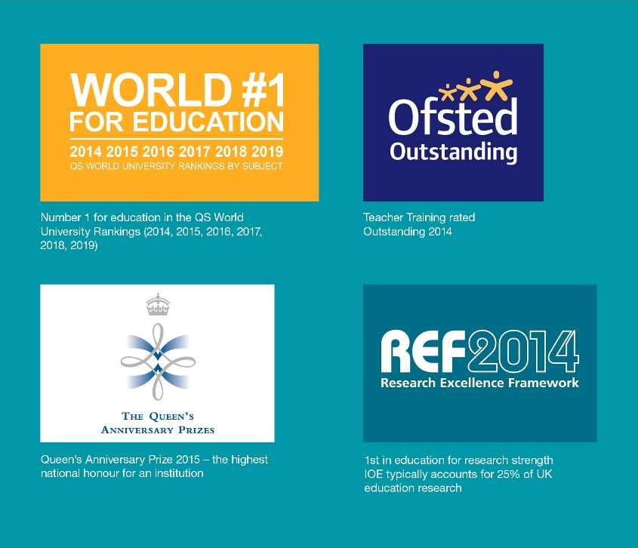
In December 2014 the IOE merged with UCL, to become the UCL Institute of Education and this provides an important context for our application. The period of assessment is the academic years 2015/2016 to 2017/2018, a time of profound change for staff and students alike. We wish to acknowledge that fully in our application. Due to the complex process of harmonisation of data systems since 2015, it has not always been possible to access full, reliable data. Our diagnosis of gender equity, therefore, is enhanced by strong participatory and consultative activity across the large IOE community. The Action Plan (AP) reflects our commitment to address inequality, and for Athena SWAN work to impact positively on structural and cultural change.

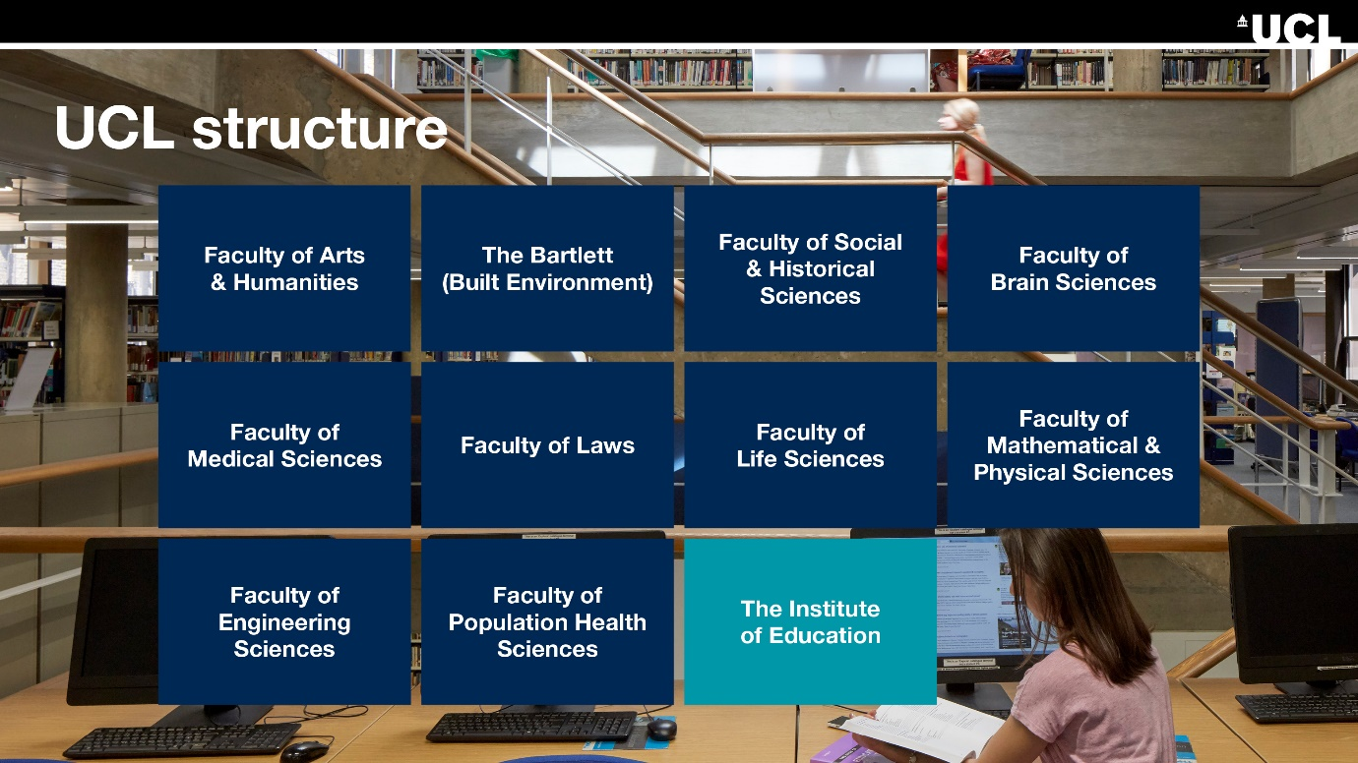

The main IOE building is located in close proximity to UCL. Due to its size, the IOE is both a school and one of eleven faculties within UCL. Satellite buildings are located within a mile of the main building housing Social Science, Psychology and the UCL Knowledge Lab.


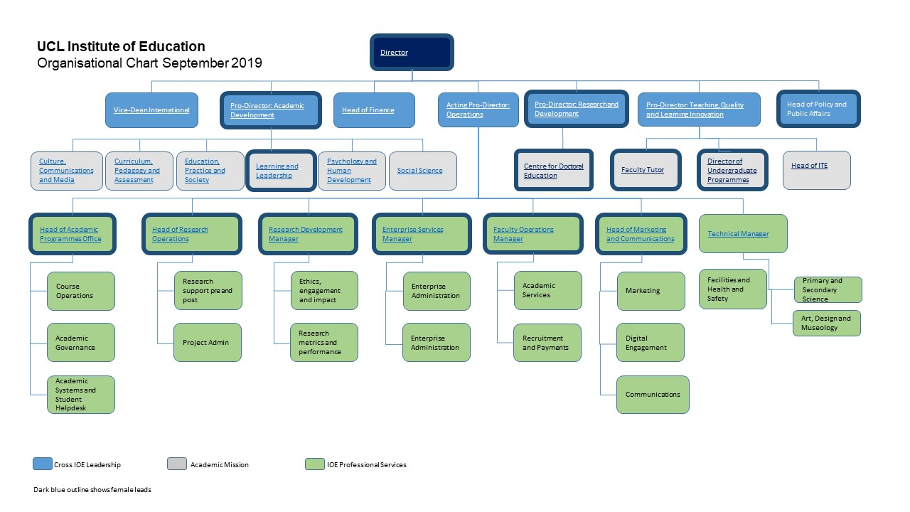

The IOE is led by the first female Director in its history, herself a distinguished scholar of gender equality and social justice. Her appointment in 2016 marked a step change in the leadership of the Executive Group (EG), currently comprising 7 members of whom 4 are female (57%). The Pro-Director Academic Development (PDAD) is co-Chair of the IOE’s Athena SWAN application. The EG work with 6 Heads of Department and comprise the IOE Senior Management Team (SMT). The IOE Equalities and Diversity Committee, established in 2015-2016 has representatives from each department. Contribution to equalities work is recognised as ‘enabling’ activity in promotion applications. Athena SWAN SAT works closely with this Committee. Until merger with UCL, the IOE was a post-graduate institution, offering Masters and post-graduate Initial Teacher Education (ITE). UG programmes in Education Studies, Psychology for Education, and Social Science have since been developed. The gender imbalance of around 70/30 (almost three females for every male) is evident across our institution, with the highest representation of females in undergraduate students (83% female, 17% male), and the lowest gender imbalance among academic staff (65% female, 35% male).

Table 1: Total number of students (UG, PGT (PGT, ITE), and PGR), professional service staff (PS), and academic staff (Academic, Teaching and Research) by gender and benchmarking (HESA) data 2017/18

Students |  | F | %F | M | %M | T
Students | UG | 461 | 83 | 92 | 17 | 553
Students | HESA UG | 64755 | 98 | 1288 | 2 | 66043
Students | PGT | 2528 | 79 | 672 | 21 | 3200
Students | HESA PGT | 46585 | 69 | 20605 | 31 | 67190
Students | ITE | 1360 | 71 | 565 | 29 | 1925
Students | PGR | 492 | 68 | 233 | 32 | 725
Students | HESA PGR | 4200 | 68 | 1975 | 32 | 6175
Staff | PS | 212 | 68 | 100 | 32 | 312
Staff | HESA PS | 720 | 74 | 255 | 26 | 975
Staff | Academic | 234 | 65 | 127 | 35 | 361
Staff | HESA Academic | 625 | 59 | 435 | 41 | 1060
Staff | Teaching | 94 | 80 | 23 | 20 | 117
Staff | HESA Teaching | 625 | 69 | 275 | 31 | 900
Staff | Research | 84 | 76 | 26 | 24 | 110
Staff | HESA Research | 275 | 75 | 90 | 25 | 365

Total number of students (UG, PGT (PGT, ITE), and PGR), professional service staff (PS), and academic staff (Academic, Teaching and Research) by gender and benchmarking (HESA) data 2017/18
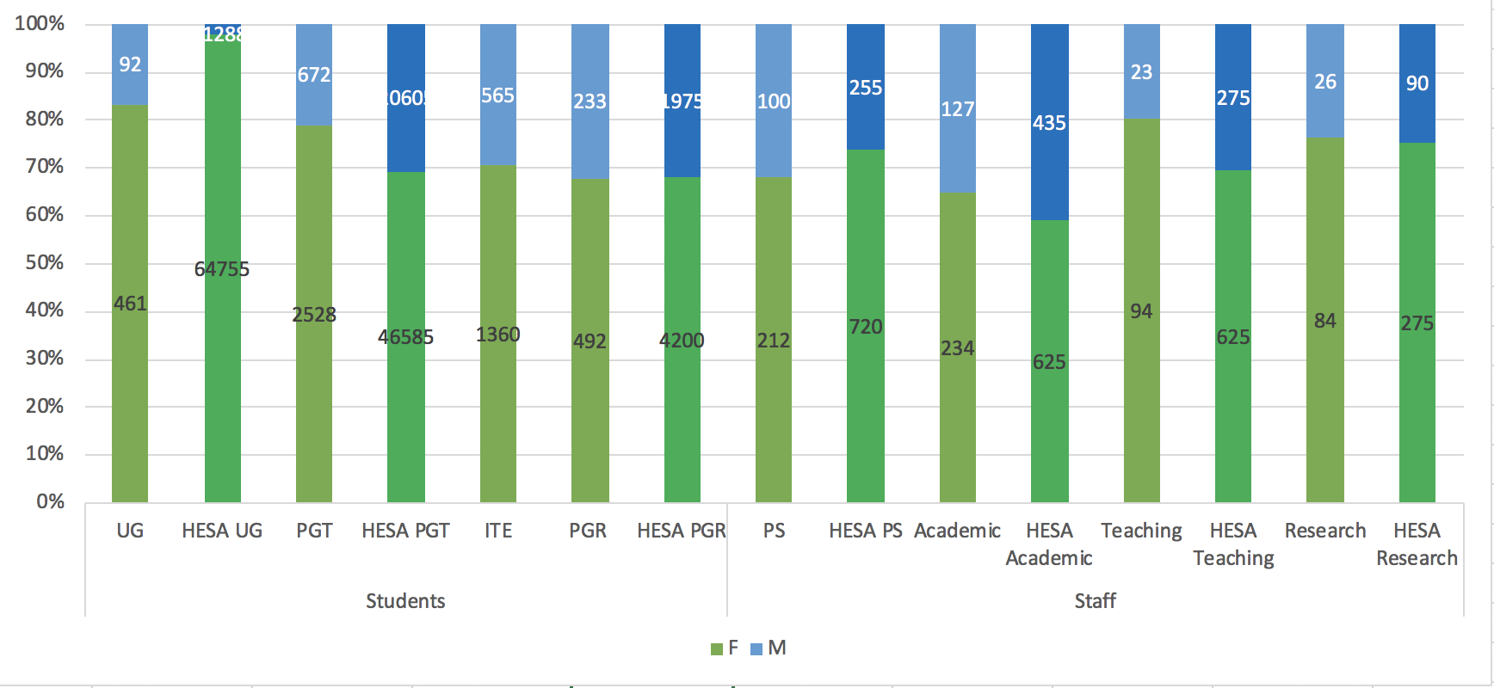

Overall student (UG, ITE, PGR), and staff (PS, Academic, Teaching and Research) gender difference is 74% females, 26% males, in line with national figures for Education reported by Russell Group (RG) Universities HESA, except for UG, where the gender imbalance is less than HESA UG benchmark. Focusing on staff, teaching has a higher gender imbalance than the HESA benchmark.

Word Count: 447

3. THE SELF-ASSESSMENT PROCESS

Table 2: The Self-Assessment Team (SAT) Table

Initiated in April 2018, the SAT met 7 times as a whole (average attendance 80%). Members agreed to work with Task and Finish subgroups to develop key areas of the application, co-ordinated by the co-chairs. The SAT reflects the IOE’s gender balance (70% who identify as female, 30% who identify as male). 41% of the SAT are BAME.
Name | Title/Lead role |  | Academic/  Professional | Task and Finish Working Groups *(see key below)
Ahmed Atteyeh | Student Services |  | Professional Staff | B, C, F
Dr Alice Bradbury | Associate Professor, Department of Education, Practice & Society |  | Academic | D, E
Professor Becky Francis | Director IOE |  | Senior Leadership Team | E, F
Dr Bernie Munoz | Senior Research Fellow, AS Quantitative data analyst |  | Academic | A, C
Craig Orr | HR Business Partner, AS Quantitative data analyst |  | Professional Staff | A, C
Cyprian Kumwaka | Masters Student Representative |  | Student | B, C
Dan Sinclair | Senior Team |  | Senior Leadership Team | B, C
Dr Farid Panjwani | Director, Centre for Research and Evaluation in Muslim Education (CREME) |  | Academic | B, C, E
Fiona Vaz | Doctoral Student Representative |  | Student | B, C
Florence Liaigre | Executive Assistant to Professor Sue Rogers |  | Professional Staff | A, B, C, E
Georgina Merchant | Lecturer, IOE – Department of Learning & Leadership, |  | Academic | A, B
Hazel Croft | MPhil/PhD UCL Centre for Doctoral Education Programme administrator |  | Professional Staff | B, C, E
Dr Joanne Pearce | Director on the MA in Education, Academic Head of Learning and Teaching for the Department of Curriculum, Pedagogy and Assessment |  | Academic | B, C,
Dr Laura Crane | Deputy Director and Senior Lecturer at the Centre for Research in Autism and Education (CRAE) |  | Academic | B, C, E
Loleta Fahad | Research Operations Manager, AS Quantitative staff data |  | Professional Staff | A, C, E
Professor Martin Oliver | Head of Department Culture, Communication & Media, AS Women’s careers |  | Academic | A, B, C
Min-Ju Kang | Undergraduate Student Representative |  | Student | A, B, E
Nadia Ali | Recruitment and Payments Coordinator, |  | Professional Staff
Professor Phil Jones | Professor of Child Rights and Wellbeing, Joint Chair of SAT |  | Academic | B,C,D,E,F
Dr Preethy D'Souza | Research Associate |  | Academic | B, C, E
Raksha Bhalsod | Programme Services Manager, |  | Professional Staff | A, B, E
Professor Sue Rogers | Director IOE; Pro-Director Academic Development, Professor of Early Childhood Education Joint Chair of SAT, AS Women’s careers |  | Senior Leadership Team | A, D,E, F
* Task and Finish Group Key |  | - A Quantitative Data (6 meetings)  - B Questionnaire and Focus Groups (5)  - C Survey (4)  - D Policy (4)  - E Communications (5)  - F Action Plan Workshop Planning and Facilitation (3)

Forming the SAT
The SAT consists of 22 people. Membership was open to all staff and students. A pro-forma application allowed the SMT to monitor SAT representation for: (i) all IOE Departments; (ii) the range of professional services; (iii) undergraduate, masters and doctoral students. Staff members had 5 days’ allocation per academic year within the IOE workload model and, after meeting with student representatives, the agreement was that students would be given a detailed affidavit.

We were able to recruit successfully in relation to the above aims for the SAT. Additionally, the group represented BME, disabled, LGBTQ++ staff, covered a range of ages (21-61) experiences of parental leave, carers and a range of length of service at the IOE. We worked with two mentors within UCL who supported the co-chairs and Kevin Coutinho, UCL Athena SWAN Manager, who attended the SAT meetings.

Diagram: How the SAT relates to UCL IOE Committees and Departments

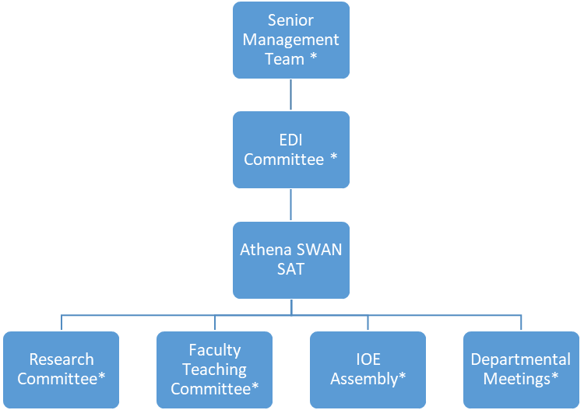

*Athena SWAN standing item on meeting agenda

Committee | Relationship | Frequency
Equality and Diversity | Direct line management of Athena SWAN SAT, with reports on progress | Termly
Executive Group and Senior Management Team | Co-Chairs report on progress and Action Plan developed in dialogue with the EG and SMT | Termly
Research Committee, Faculty Teaching Committee and Enterprise Board, IOE Assembly and Departmental Meeting | Co-Chairs presented and discussed Action Plan and Action Plan review will feature in future. | Twice each academic year

Communication
The SAT ran: 5 presentations to the IOE assembly with PowerPoints which were placed on the intranet and shared via IOE announcements. SAT members and the co-chairs visited departmental meetings each term with updates.

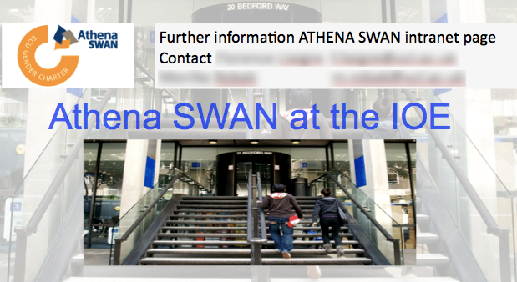

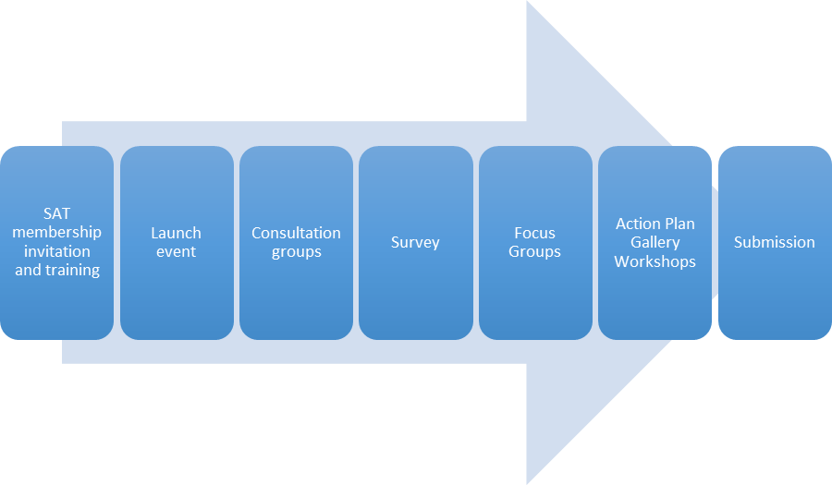

Diagram: Working Together

Launch May 2018
The launch event was attended by 128 people. This consisted of a presentation by the IOE Director and SAT co-chairs; SAT members’ video diaries about their hopes for AS; input from another SAT lead who had successfully applied for AS gold.

Launch: Video Diaries

Consultation Phase June-July 2018
Groups of staff and students met to: i) share ideas about key areas that the SAT should work on through the survey and focus group ((ii) additional input was invited through anonymous forms and 1-1 meetings.). The consultation groups were co-facilitated by academic and professional staff and included the use of Mentimeter, an online process to anonymously share themes.
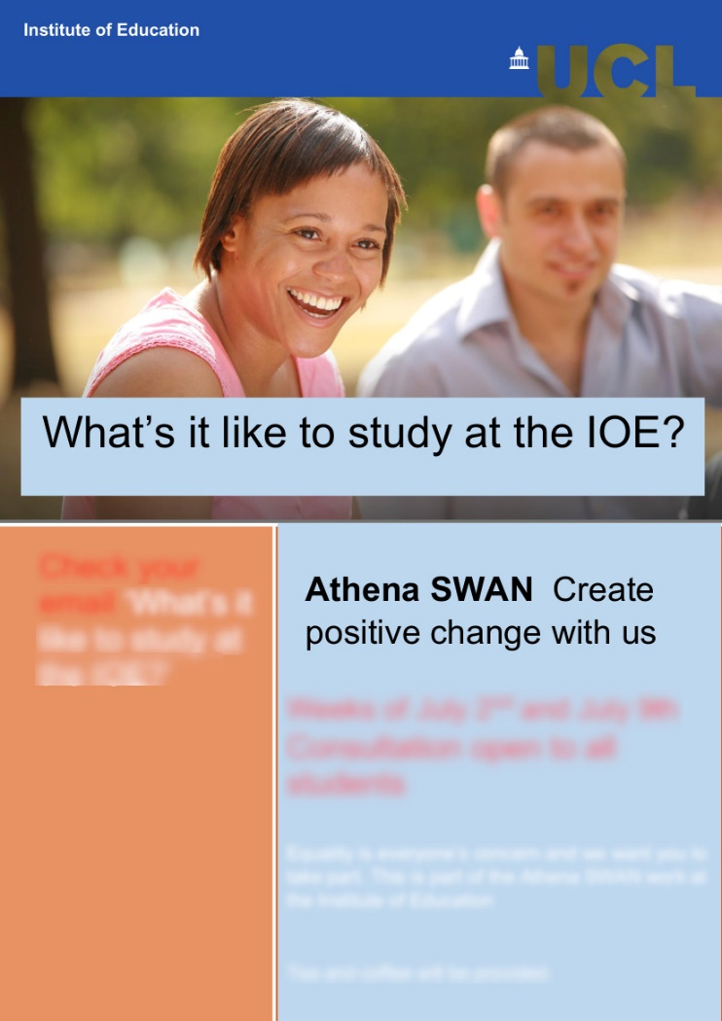

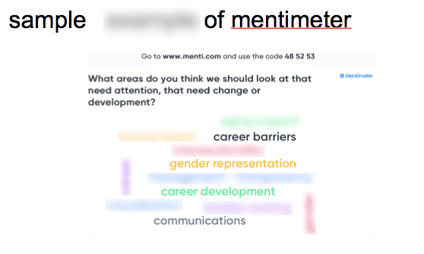
Sample of consultation advertising and mentimeter
We ran six groups over a two-week period at different times of the working day. Four open consultation groups for students were offered. In all 76 people attended. In terms of participation 62% were women, 48% men and 35% were from black and minority ethnic groups. For the student groups 66% were women, 34% men and 42% were from black and minority ethnic groups. The SAT collated the material and this was shared via the IOE assembly and intranet.

Samples consultation group impact on action plan

Action 4.2 | Review and develop induction process of all management staff to address issues identified in the Athena SWAN gathering of data concerning the implementation of gender and intersectional policies concerning line management | Survey and focus groups revealed lack of consistency in management implementation of policies concerning flexible working, maternity and paternity leave and carer’s leave  For example our survey revealed that only 55% of female and 55% of male respondents understood the promotion process and criteria with BME female respondents being the least likely to understand the promotion process and criteria (45% ).Another example is that 40% of female respondents who had taken maternity leave said that they were not supported by the IoE before, during and after return from maternity leave
Action 8.1 | To clarify and articulate the implementation of flexible working at the IOE | This was an area of particular concern to staff. It emerged in the consultation work as an issue to explore in terms of a lack of consistency and its impact on women's careers. We followed this up in our survey which indicated that academics are much more likely to work flexibly than professional services staff (81% compared to 35%). Academics are much more likely to feel that flexible working is supported and encouraged than professional services respondents (85% compared to 60%) The focus group on this was the most attended (25 people). Professional staff especially raised this as an issue. The absence of clarity on how flexible working was implemented across academic and professional staff was seen as an equity issue and negatively affecting staff in terms of parenting and caring responsibilities.

Survey
The response rates were 64% for staff and 25% for students. The IOE Director offered a contribution of five hundred pounds to the student fund if the response rate for staff was over 45%. The response rate for the staff survey was as follows: academic staff 61%; professional staff 39% ; female 70% ; male 25% ; non-binary 1%; preferred not to say 4%; BME 29 %; Disabled 11% ; LGBTQ+ 12% For the student: female 51%; male 21%, non-binary 0.3%; not answered 27%; BME 28%; Disabled 4%; LGBTQ+ 9%.

The survey helped the SAT identify issues and develop specific action (e.g. AP3.2 and AP 9.2).

Focus groups
115 people participated in focus groups. We ran male-only and BME-only groups; overall participation involved 67% women, 33% men and 15% BME.

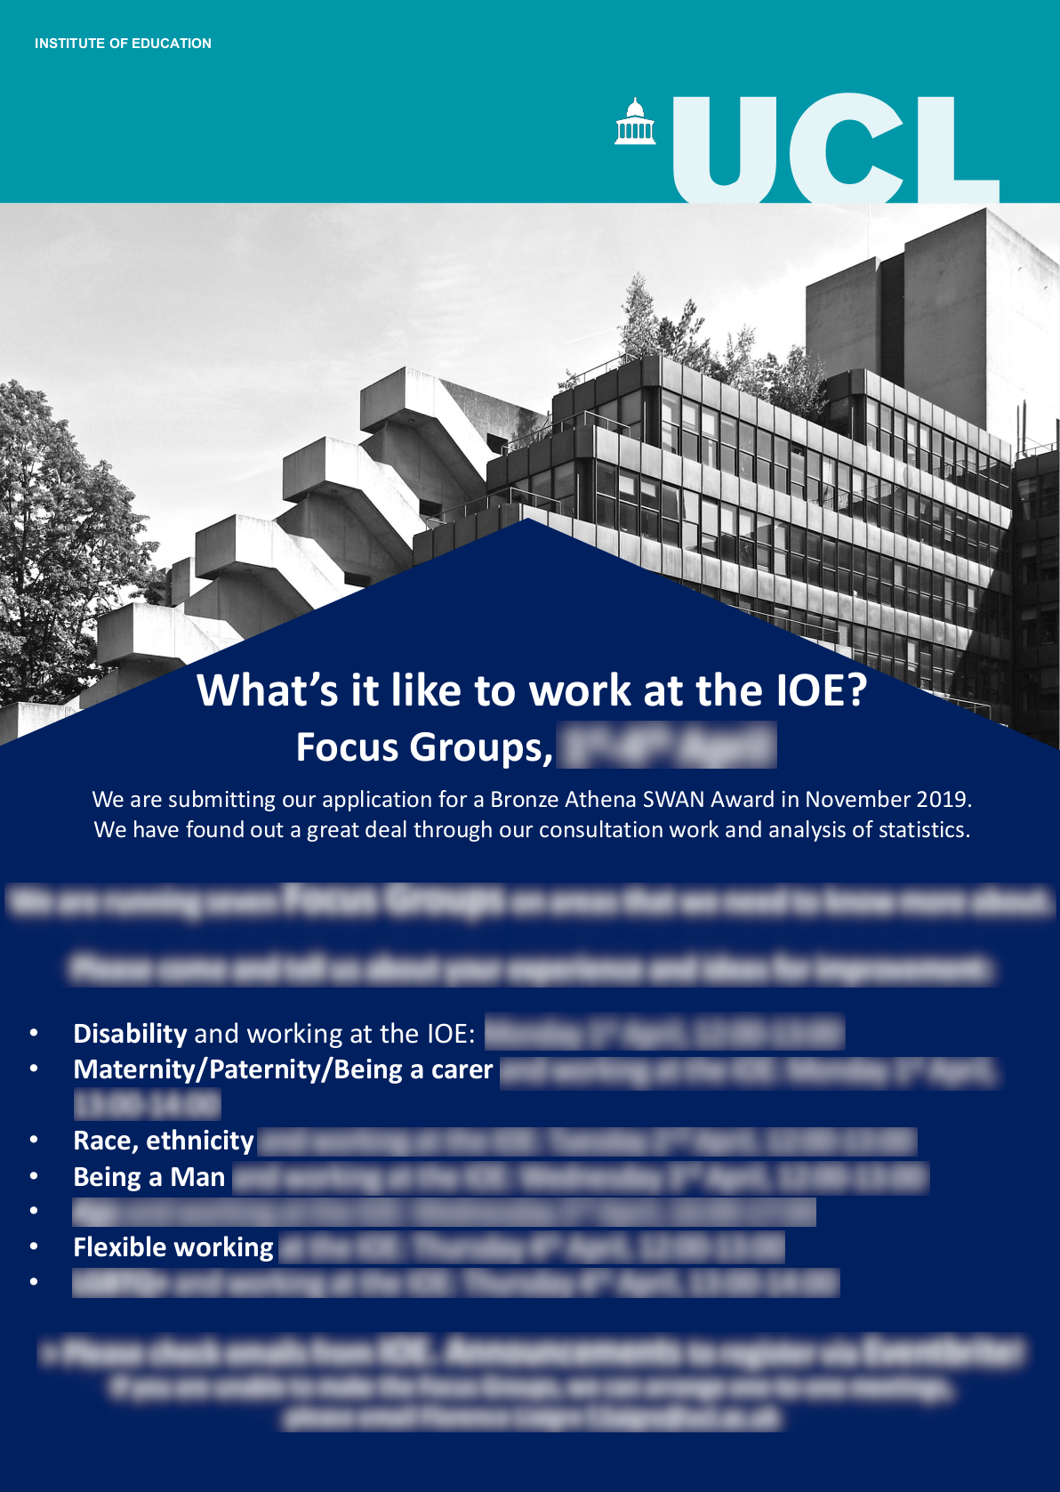

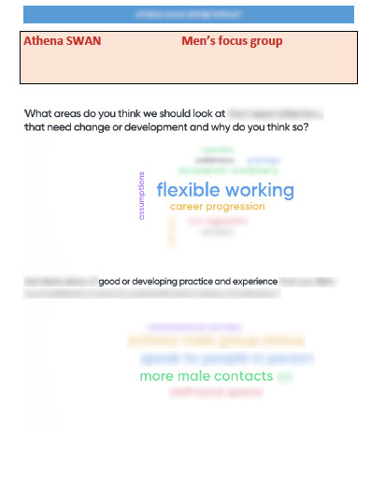
Material from focus group advertising, sample of men’s focus group Mentimeter

The focus groups supported the development of the Action Plan including AP 3.4, AP4.2, AP6.2 and AP6.3.

Draft Action Plan Gallery
The co-chairs and the IOE Director invited all staff and students to a gallery of the draft action plan and were invited to give feedback and suggestions which was incorporated into the final action plan. Individuals could also request to be sent the gallery and feedback form.

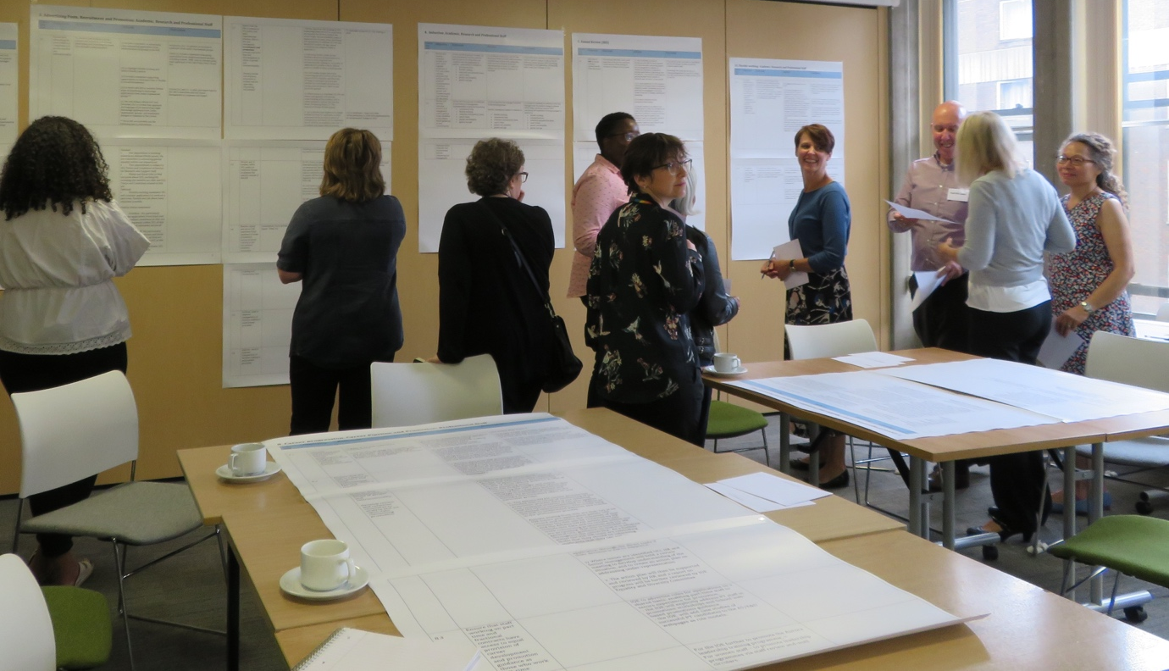
Professor Becky Francis co-facilitating an Action Plan Gallery Workshop

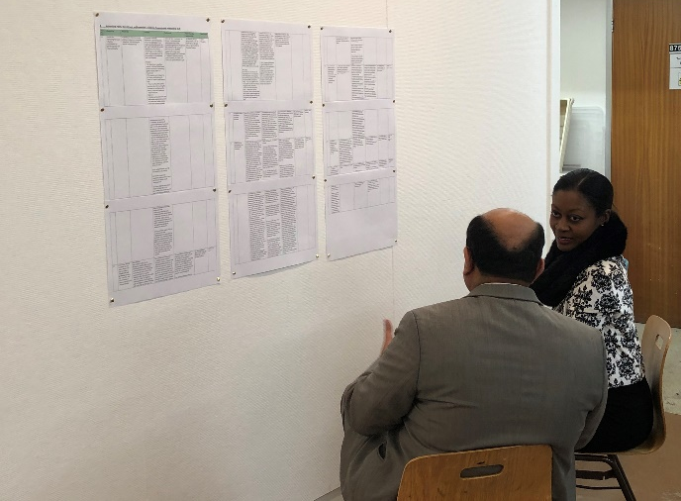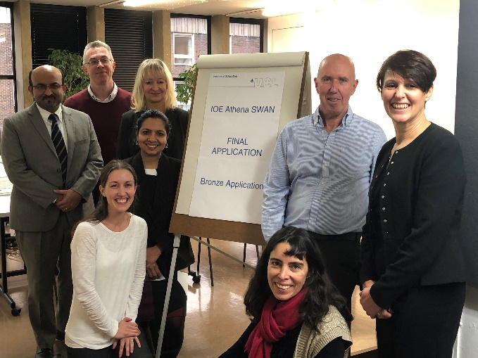
One of 3 final application galleries presented by the SAT

Future
The Action Plan addresses the future development of the Self-Assessment Team, how the Self-Assessment Process will continue as we support and formatively evaluate the implementation of the Action Plan (AP 1.2); how Athena SWAN continues to feature in its relationships with management and committees (AP 1.1 and 1.2) and how we will continue our successful participatory work with staff and students (AP 1.3).

Action 1.1 | (ii) to (a) report and review the progress of the SAT Action Plan as part of the SMT termly meetings and to think critically at this senior level concerning: (b) any as yet unidentified barriers to the plan implementation; (c) any further unexpected outcomes from the Plan; and (d) additional resourcing needs which the enactment of the Action Plan reveals
Action 1.2 | (ii) (a) to continue to update and review the IOE Athena SWAN Action Plan in every IOE Equality, and Diversity Committee as an agenda item and IOE Athena SWAN SAT co-chairs to continue be members of the Committee

Action 2.1 | ii) To ensure vitality and critical engagement of the SAT with the Action Plan and its role in engaging with Gender Equality and Equality and Diversity at the IOE  - to continue to operate SAT meetings, though to reduce the number of full groups and fine tune working groups  - to continue SAT work after application through to hearing result to ensure planning and implementation
Action 2.1 | (i) To ensure and develop SAT resources -to create and recruit a new role of Athena SWAN IOE Manager with 0.5FT workload allocation  - to continue the workload allocation for the chair or co-chairs. This is currently at 0.2 FT for one co-chair and 0.2 for the other co-chair  -to continue workload allocation for SAT members at 5 days per academic year  - to increase allocation of administrative resources by the creation of an Athena SWAN manager from 0.2 to 0.5 FT  - to continue training of SAT members
Action 2.1 | Continue to (i) recruit students into the SAT (ii) issue briefings to students on Athena SWAN and progress of the Application (iii) undertake further work through analysis of existing surveys and feedback processes at the IOE and add specific targeted survey and focus group work building on that undertaken to date

Word count: 963
4. A PICTURE OF THE DEPARTMENT

4.1. Student data

Numbers of men and women on access or Foundation course
The IOE no longer offers a FD due to falling numbers and new undergraduate programmes.

Numbers of undergraduate students by gender

Table 3: Enrolled Undergraduate students part-time and full-time by gender over three cohorts (2015/16-2017/18)

Cohort | FT/PT | Female | Male | % Female | % Male | Subtotal | Total
2015/16 | FT | 309 | 38 | 89% | 11% | 347 | 356
2015/16 | PT | 8 | 1 | 89% | 11% | 9 | 356
2016/17 | FT | 384 | 71 | 84% | 16% | 455 | 857
2016/17 | PT | 2 | 0 | 100% | 0% | 2 | 857
2017/18 | FT | 461 | 92 | 83% | 17% | 553 | 553
2017/18 | PT | 0 | 0 | 0 | 0 | 0 | 553
HESA | FT | 16020 | 5170 | 76% | 24% | 21190 | 21190
Enrolled Undergraduate students part-time and full-time by gender over three cohorts (2015/16-2017/18)

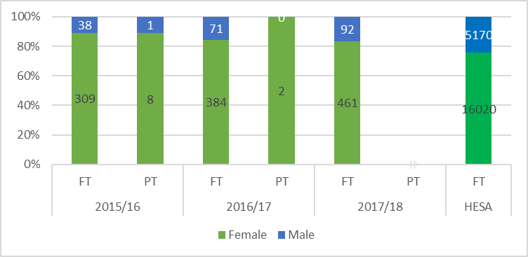

The proportion of full-time females enrolled at the IOE is higher (83% in 2017/18) than the 76% provided by HESA data. The proportion of full-time males enrolled at the IOE is lower (17% in 2017/18) than 24% HESA (AP 10.1-10-4).

Table 4: Applications undergraduate students by programme and gender over three cohorts (2015/16-2017/18)

Programme | 2015/16 |  |  |  | 2016/17 |  |  |  | 2017/18
Programme | F | M | T | %F | F | M | T | % F | F | M | T | % F
BSc Social Sciences | 0 | 0 | 0 | 0% | 293 | 104 | 397 | 74% | 300 | 65 | 365 | 82%
BSc Social Sciences with Quantitative Methods | 0 | 0 | 0 | 0% | 81 | 47 | 128 | 63% | 65 | 63 | 128 | 51%
BSc Psychology with Education | 106 | 15 | 121 | 88% | 159 | 24 | 183 | 86% | 162 | 24 | 186 | 87%
BA Education Studies (Honours) | 227 | 26 | 253 | 90% | 388 | 52 | 440 | 88% | 326 | 47 | 373 | 87%
TOTAL | 333 | 41 | 374 | 89% | 921 | 227 | 1148 | 80% | 853 | 199 | 1052 | 81%

Applications undergraduate students by programme and gender over three cohorts (2015/16 2017/18)
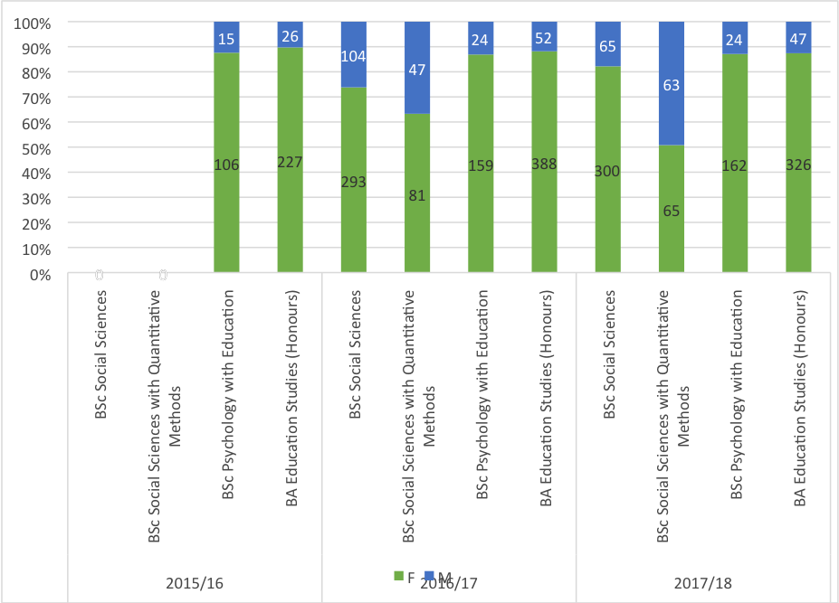

Our UG programmes show over representation of female students in all programmes, with some increase in male students on the BSc Social Sciences with Quantitative methods. The remainder of the programmes show a fairly consistent picture with high female representation. The AP responds to this by investigating how to attract more men onto our UG programmes through gender aware marketing and recruitment, and deploying male ambassadors to recruitment campaigns (AP 10.1-10.4).

Table 5: FT UG course applications, offers and acceptance rates by gender over time (2015/16-2017/18)
Full-time | 2015/16 |  |  |  |  | 2016/17 |  |  |  |  | 2017/18
 | F | % | M | % | Total | F | % | M | % | Total | F | % | M | % | Total
Applications | 409 | 94 | 26 | 6 | 435 | 977 | 82 | 219 | 18 | 1196 | 888 | 83 | 185 | 17 | 1073
Offers | 309 | 89 | 39 | 11 | 348 | 594 | 83 | 119 | 17 | 713 | 620 | 81 | 142 | 19 | 762
Acceptances | 229 | 90 | 25 | 10 | 254 | 337 | 84 | 64 | 16 | 401 | 349 | 82 | 75 | 18 | 424

FT UG course applications, offers and acceptance rates by gender over time (2015/16-2017/18)

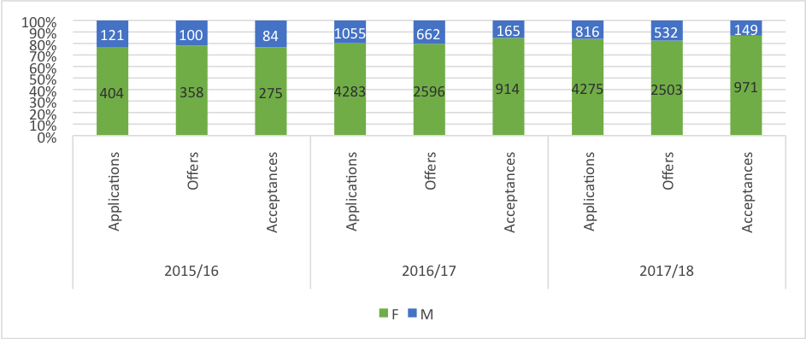

Table 5a: FT UG degree attainment (high marks) by gender over time (2015/16-2017/18)
 | 2015/16 |  |  |  |  | 2016/17 |  |  |  |  | 2017/18
 | F | % | M | % | Total | F | % | M | % | Total | F | % | M | % | Total
High marks: 1st | 11 | 92 | 1 | 8 | 12 | 22 | 88 | 3 | 12 | 25 | 27 | 87 | 4 | 13 | 31
High marks: 2:1 | 31 | 82 | 7 | 18 | 38 | 65 | 96 | 3 | 4 | 68 | 64 | 86 | 10 | 14 | 74
Other: 2:2 3rd and pass | 13 | 87 | 2 | 13 | 15 | 32 | 89 | 4 | 11 | 36 | 33 | 92 | 3 | 8 | 36

FT UG degree attainment (1st, 2(i) and other) by gender over time (2015/16-2017/18)
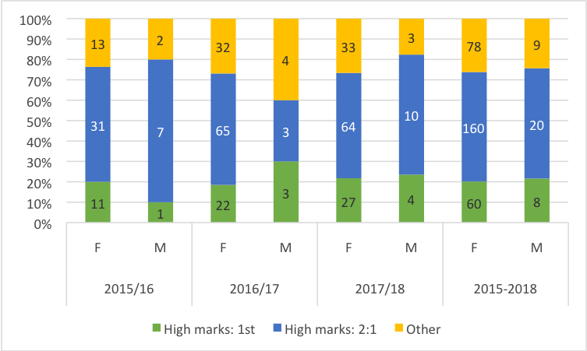
Table 5 shows no gender difference in full-time undergraduate distinctions, 2(i) awarding and other (2:2 and 3rd passes) good degree attainment over time.

Table 5b: PT UG course offers and acceptance rates by gender over time (2015/16-2017/18)
Part-time | 2015/16 |  |  |  |  | 2016/17 |  |  |  |  | 2017/18
 | F | % | M | % | Total | F | % | M | % | Total | F | % | M | % | Total
Offers | 0 | 0 | 0 | 0 | 0 | 4 | 50 | 4 | 50 | 8 | 6 | 100 | 0 | 0 | 6
Acceptances | 0 | 0 | 0 | 0 | 0 | 3 | 100 | 0 | 0 | 3 | 6 | 100 | 0 | 0 | 6

PT UG course offers and acceptance rates by gender over time (2015/16-2017/18)
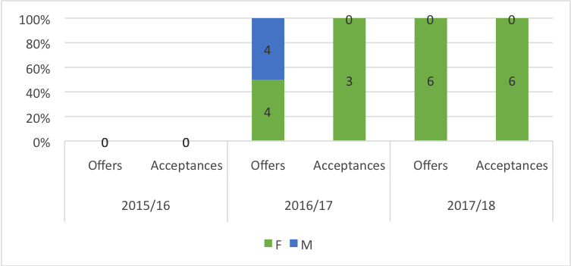
We no longer offer a PT route on UG programmes due to low applications, therefore the data presented is incomplete and student numbers so small as to be insignificant. As the overall UG figures show, there is no evidence that closing this route has impacted on the numbers of female students on our UG courses.

Table 5 shows significant gender variance in full-time students’ applications, offers, acceptances and degree attainment (high marks 1st and 2:1) in favour of females. Over the assessment period, however, we have seen a small reduction in the imbalance in almost all measures. More precisely, the gender imbalance of applications decreased from 2015/2016 (94% female, 6% male) to 2017/2018 (83% female, 17% male); on offers, gender imbalance decreased from 2015/2016 (89% female, 11% male) to 2017/2018 (81% female, 19% male); the acceptance gender imbalance decreased from 2015/2016 (90% female, 10% male) to 2017/2018 (82% female, 18% male); and the proportion of females achieving 1st. class marks decreased from 2015/2016 (92% female, 8% male) to 2017/2018 (87% female, 13% male).

Numbers of men and women on postgraduate taught degrees

Table 6: FT PGT course applications, offers and acceptances rates by gender over time (2015/16-2017/18)

 | 2015/16 |  |  |  |  | 2016/17 |  |  |  |  | 2017/18
FT | F | % | M | % | Total | F | % | M | % | Total | F | % | M | % | Total
Applications | 404 | 77 | 121 | 23 | 525 | 4283 | 80 | 1055 | 18 | 5338 | 4275 | 84 | 816 | 16 | 5091
Offers | 358 | 78 | 100 | 22 | 458 | 2596 | 80 | 662 | 20 | 3258 | 2503 | 82 | 532 | 17 | 3035
Acceptances | 275 | 63 | 84 | 27 | 359 | 914 | 85 | 165 | 15 | 1079 | 971 | 87 | 149 | 13 | 1120

FT PGT course applications, offers and acceptances rates by gender over time (2015/16-2017/18)

As presented in table 6, there is a gender difference in postgraduate taught applications, offers and acceptances with a higher proportion of females in all categories. This gender difference has increased over time in applications, offers and acceptances. More precisely, the gender imbalance increased from 2015/2016 (75% female, 25% male) to 2017/2018 (83% female, 17% male) in applications; the offers gender imbalance increased from 2015/2016 (78% female, 22% male) to 2017/2018 (83% female, 17% male). The acceptance gender imbalance increased from 2015/2016 (63% female, 27% male) to 2017/2018 (79% female, 21% male). The percentage of men to women accepting offers has consistently been higher in proportion to women, which may be read as a change to the imbalance with this group consistently underrepresented. We are focusing on attracting more men onto our programmes through gender aware marketing and recruitment, and deploying male ambassadors to recruitment campaigns (AP 10.1-10.4).

Table 6a: FT PGT degree attainment by gender over three cohorts (2015/16-2017/18)
 | 2015/16 |  |  |  |  | 2016/17 |  |  |  |  | 2017/18
FT | F | % | M | % | Total | F | % | M | % | Total | F | % | M | % | Total
High marks: Distinctions | 158 | 77 | 47 | 23 | 205 | 204 | 81 | 49 | 19 | 253 | 239 | 79 | 65 | 21 | 304
High marks: Merit | N/A |  | N/A |  |  | N/A |  | N/A |  |  | 530 | 80 | 132 | 20 | 662
Passes | 642 | 77 | 195 | 23 | 837 | 710 | 77 | 211 | 23 | 921 | 333 | 80 | 83 | 20 | 416

FT PGT degree attainment by gender over three cohorts (2015/16-2017/18)

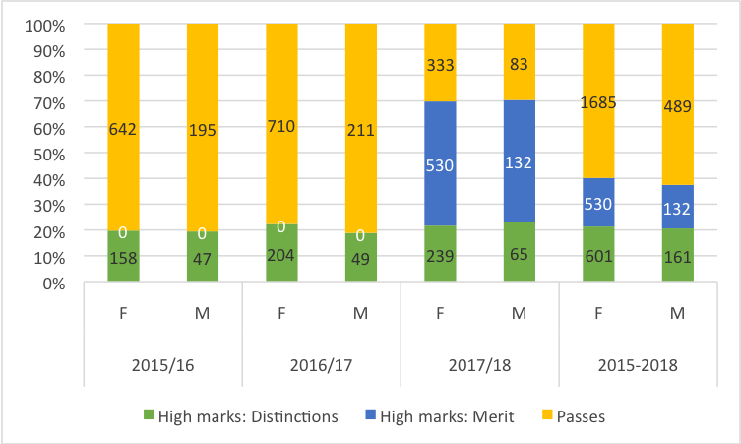

As presented in Table 6a, when comparing the relative performance of females and males attaining distinctions, merits and passes, no gender attainment gap was found, as the proportion of both genders attaining different degree awards are similar over time (around 70% females, 30% males).

Table 7: ITE course applications, offers and acceptance by gender over three cohorts (2015/16-2017/18)

 | 2015/16 |  |  |  | 2016/17 |  |  |  | 2017/18
 | F | M | Other | T | F | M | Other | T | F | M | Other | T
Applications | 5728 | 2551 | 5 | 8284 | 4917 | 2131 | 62 | 7110 | 4372 | 1857 | 1 | 6230
Offers | 1743 | 704 | 2 | 2449 | 1747 | 656 | 60 | 2463 | 1722 | 643 | 1 | 2366
Acceptances | 1395 | 594 | 0 | 1989 | 1282 | 521 | 6 | 1809 | 1277 | 497 | 0 | 1774

PT ITE course applications, offers and acceptances rates by gender over time (2015/16-2017/18)
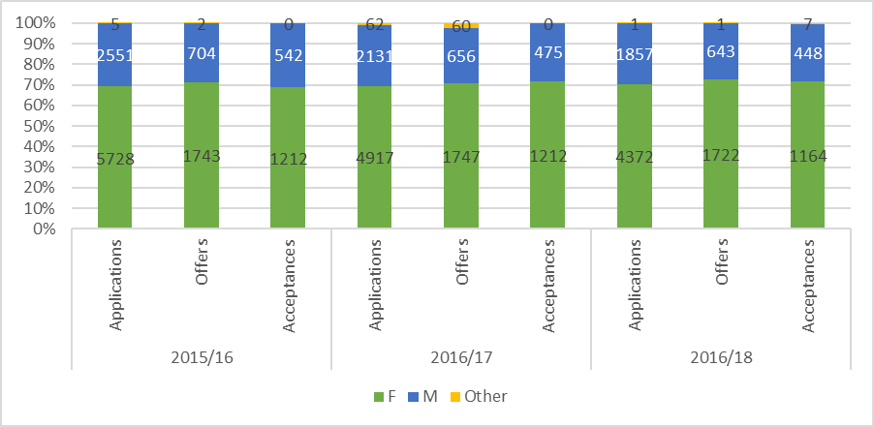

Table 7 shows a constant gender difference in initial teacher education (ITE) taught applications, offers and acceptances in favour of females (around 70% females, 30% males), but whilst having this difference there does not appear to be a gender bias in the student recruitment process with men and women receiving offers and accepting on a par with the proportion of applications. Reflecting a sector wide picture of gender balance in teacher training, we are focusing on attracting more men onto our ITE programmes through gender aware marketing and recruitment, and deploying male ambassadors to recruitment campaigns (AP 10.1-10.4). Recruitment of male students is linked to our efforts to increase male staff on ITE programmes (AP. 3.4).

Numbers of men and women on postgraduate research degrees

Table 8: PGR course applications, offers, acceptance rates and degree attainment by gender over three cohorts (2015/16-2017/18)

 | 2015/16 |  |  |  |  | 2016/17 |  |  |  |  | 2017/18
 | F | % | M | % | Total | F | % | M | % | Total | F | % | M | % | Total
Applications | 69 | 69 | 31 | 31 | 100 | 1142 | 80 | 284 | 20 | 1426 | 1450 | 82 | 312 | 18 | 1762
Offers | 24 | 65 | 13 | 35 | 37 | 158 | 72 | 61 | 28 | 219 | 142 | 67 | 71 | 33 | 213
Acceptances | 11 | 52 | 10 | 48 | 21 | 124 | 70 | 53 | 30 | 177 | 126 | 69 | 57 | 31 | 183

PGR course applications, offers, acceptance rates and degree attainment by gender over three cohorts (2015/16-2017/18)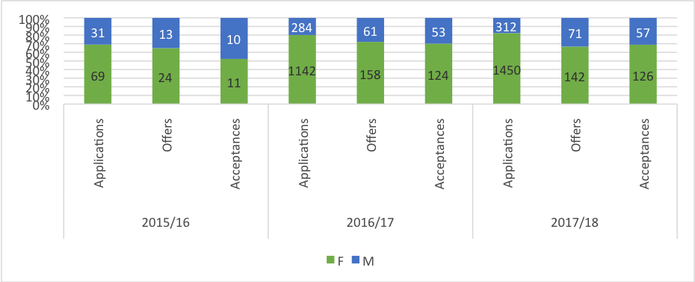

It has been challenging to source reliable data for PGR programmes in the immediate post-merger period. Information about cohorts from around the merger is either unavailable or unreliable, due to changes around that time in the ways students were linked with departments and faculties; different regulations about the length of programmes; and different possible outcomes from the viva. These were harmonised in 2015/2016, making analysis possible from 2016/2017 onwards. Additionally, these cohorts have not yet finished their programmes (up to 4 years for FT and 7 years for PT), so completion rate data are as yet unavailable (AP 10.5). For AS we have undertaken an analysis of local data held on upgrade from MPhil to PhD, a key transition point within the doctoral programme. This showed that proportions of females and males submitting, passing and passing after one referral were consistent, providing no evidence of gendered differences in progression. Data were unavailable about ethnicity for this progression point. We are working towards achieving more comprehensive and reliable data for PGR application through to completion (AP 10.5).

Progression pipeline between undergraduate and postgraduate student levels

Within our current doctoral programme, the ‘median’ profile for a student is a mid-career female professional, studying part-time alongside work and caring responsibilities. However, the proportion of full-time students is increasing steadily (from 41% in 2015 to 44% in 2018), and is monitored annually. Under-represented groups, such as home students identifying as part of an ethnic minority are also monitored (AP 10.4 -10.5). In addition, we provide 3-4 bursaries per year for a PGDip that has been designed as an access route to doctoral study, widening the participation of these groups. Our Research Training Programme is offered in a variety of formats (in office hours, weekends, in intensive weeks and online) to meet our diverse students’ needs for flexibility.

Since merger, we have developed two new UG programmes: A BSc Social Sciences and BSc Psychology with Education. The data is therefore limited on the progression of undergraduate students to postgraduate courses and the numbers available are too small to draw any meaningful conclusions at this stage. However, evidence shows that education programmes in the national sector attract more females, and our intention is to monitor trends as the data becomes available and consider means to address the gender imbalance through raising gender awareness in our marketing and recruitment work (AP 10.1-10.5).

Action 10.1 | Redress gender imbalance manifest in Undergraduate, PGT, ITE and PGR Student Populations, through gender aware recruitment and marketing strategies
Action 10.3 | Hold a one day colloquium on recruiting male students and follow this with an action plan
Action 10.4 | Provide additional support to encourage students from under-represented groups to consider and engage in progression in their studies
Action 10.5 | Create more effective systems for gathering data on students
Action 10.6 | Continue to develop IOE gathering data better to understand and enhance student experience
Action 10.7 | Build on positive responses concerning student feedback on their experience of the IOE
Action 10.8 | Improve transparency and accessibility for students, regarding policies on matters relating to gender equality and intersectional issues and where to take issues that affect them in a negative way

4.2. Academic and research staff data

Academic staff by grade, contract function and gender: research only, teaching and research and teaching only
Look at the career pipeline and comment on and explain any differences between men and women. Identify any gender issues in the pipeline at particular grades/job type/academic contract type

The proportion of female to male academic staff (70% female and 30% male) remains stable over three years. Staff fall into three contracts: academic (teaching and research), research and teaching.

Table 9: Academic, teaching and research staff by grade and gender over time (2015/16-2017/18)

 | 2015/16 |  | 2016/17 |  | 2017/18
 | F | M | F | M | F | M
Grade 6 | 6 | 0 | 7 | 2 | 8 | 1
Grade 7 | 29 | 10 | 43 | 10 | 65 | 18
Grade 8 | 156 | 49 | 169 | 59 | 214 | 70
Grade 9 | 75 | 43 | 74 | 45 | 78 | 45
Grade 10 | 41 | 34 | 2 | 4 | 1 | 7
Grade 10.1 | 41 | 34 | 15 | 6 | 14 | 6
Grade 10.2 | 41 | 34 | 20 | 16 | 22 | 15
Grade 10.3 | 41 | 34 | 11 | 13 | 10 | 14

Academic, teaching and research staff by grade and gender over time (2015/16-2017/18)

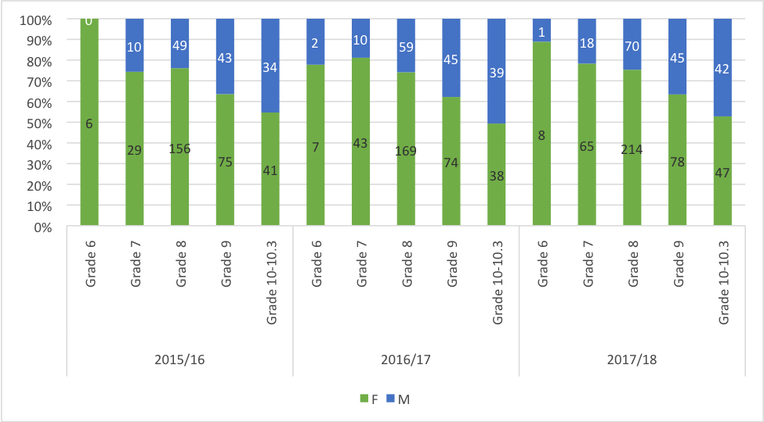
Key: G6: Research Assistant, G7: Teaching Fellow, Research Fellow, Lecturer; G8: Senior Teaching Fellow, Senior Research Fellow, Lecturer; G9: Principal Teaching Fellow, Principal research Fellow, Associate Professor: G10: Professorial Teaching Fellow, Professorial Research Fellow, Professor (Bands 1-4).

Proportionally there are more females in the lowest grades, and more males in the highest grades over three years. Benchmarking staff grade data against HESA is challenging because HESA uses a different category (payment) to measure career progression and is not directly comparable with our grade system. We will work with similar departments of Education e.g Kings College London, for benchmarking purposes (AP 10.3).

Table 10: Academic, teaching and research staff by contract function and gender over time (2015/16-2017/18)

 | 2015/16 |  |  |  |  | 2016/17 |  |  |  |  | 2017/18 |  |  |  |  | HESA*
 | F | % | M | % | T | F | % | M | % | T | F | % | M | % | T | F | M
Research | 71 | 76 | 23 | 24 | 94 | 72 | 74 | 25 | 26 | 97 | 84 | 76 | 26 | 24 | 110 | 275 | 90
Teaching | 19 | 95 | 1 | 5 | 20 | 50 | 82 | 11 | 18 | 61 | 94 | 80 | 23 | 20 | 117 | 675 | 275
Academic | 217 | 66 | 112 | 34 | 329 | 219 | 65 | 119 | 35 | 338 | 234 | 65 | 127 | 35 | 361 | 625 | 435
Total | 307 | 69 | 136 | 31 | 443 | 341 | 69 | 155 | 31 | 496 | 412 | 70 | 176 | 30 | 588 | 1575 | 800
*HESA: Russell Group 2017/18

Academic, teaching and research staff by contract function and gender over time (2015/16-2017/18)

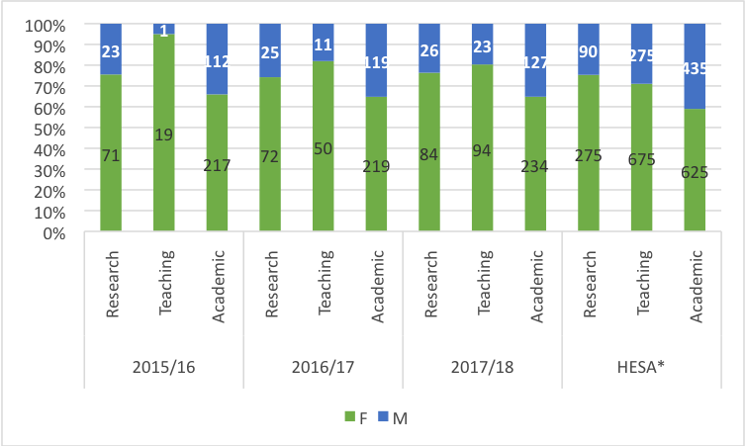

Academic (65% female, 35% male) and research (76% female, 24% male) gender imbalance remains stable over time (Table 10). Teaching contracts are the group with the highest proportion of female staff, although we have seen an increase of men on teaching contracts since 2017/2018. The proportion of females on teaching contracts decreased from 2015/2016 (95% female, 5% male), to 2017/2018 (80% female, 20% male). There is a higher proportion of women on these contracts which may be because teaching features more strongly in part-time contracts and/or provides greater flexibility to women who take career breaks due to maternity leave. We need to know more, therefore, future actions will aim to collect better data (AP 3.5 & 6.4) and ensure that part-time and flexible working is considered an option across all contract types and for both male and female staff (AP 8.1-8.2). Importantly, until relatively recently, teaching did not carry the same weight in promotion applications, and progression routes for those on teaching only contracts were less clear. The UCL Academic Careers Framework (ACF) introduced in 2016, is a positive step forward in this respect, where those who excel in teaching may follow an equivalent career path to a mixed academic or research-focused portfolio (AP 6.5). Indeed, several female staff members have recently progressed to Principal Teaching Fellow (Grade 9) and we will soon see our first Professorial Teaching Fellows, both female and male. We will monitor the impact of the ACF on staff data annually (AP 6.5). To ensure greater representation of men on teaching contracts we will develop ways to improve the attractiveness of this type of work in recruitment materials, highlighting career progression opportunities offered by the ACF, showcasing successes/role models in marketing materials (AP 3.1, 3.7 & 6.5). We will review the language of job advertising taking into consideration underrepresented groups, and the impact on recruitment against the data presented in this application (AP 3.1; 3.2).

Action 3.1 | Ensure that advertising for posts reflects a commitment to gender equality and intersectionality. UCL IOE HR will work with Athena SWAN SAT and IOE E & D Committee to review how approach and language of job advertising might discourage applicants from underrepresented groups and implement changes in response to the review
Action 3.2 | Ensure that the IOE in relation to UCL policy and local, Departmental practice, offers a fair and transparent recruitment and promotion process, free from bias and discrimination in terms of gender and intersectionality.
Action 3.3 | To improve clarity of information concerning promotion
Action 3.4 | Address the low percentage of men within the IOE workforce
Action 3.5 | To develop more effective means of collecting data on areas that the Athena SWAN process has revealed as currently limited concerning recruitment and promotion (staff on open-ended contracts for the duration of funding (OEC) and other forms of open ended contracts)
Action 3.7 | To monitor and review IOE communications on the internet and intranet in terms of gender and intersectionality
Action 6.5 | To continue to monitor the impact from gender and intersectional perspectives of the new Academic Career Framework in relation to career progression concerning staff on teaching contracts
Action 8.2 | To identify whether and how flexible and part time working impacts on career progression at the IOE
Action 10.3 | Hold a one day colloquium on recruiting male students and follow this with an action plan

Despite significantly more female than male academic staff there is uneven progression by gender. Whilst there are proportionally more females than males in lower grades (from grade 6 up to Grade 8), there are relatively more males than females in higher grades (Grades 9 and 10). Whilst only 11% (47/412) of females reached grade 10 in 2017/2018, 24% (42/176) of males reached this level. At this point, males had more than twice the chance to reach grade 10 than females. These differences magnify in the highest levels, particularly in Grade 10, band 3, where males had 4 times more chance than females of achieving the highest band (8% of males vs 2% of females). These proportions have remained stable over the previous 3 years (2018-2015). We have identified progression as a priority in our AP. Our actions will ensure a gender aware approach to recruitment, appraisal, mentoring, promotion, and progression to leadership roles (AP 3.2; 6.1-6.3).

Action 3.2 | Ensure that the IOE in relation to UCL policy and local, Departmental practice, offers a fair and transparent recruitment and promotion process, free from bias and discrimination in terms of gender and intersectionality
Action 6.1 | To develop access to opportunities for career development courses
Action 6.3 | To review current provision of career mentoring across the IOE, identify good models of practice for academic and professional staff, develop and implement recommendations for mentoring provision and resourcing

Table 11: Academic, teaching and research staff by gender and full/part-time over time (2015/16-2017/18)

 |  | F | F% | M | F% | T
2015/16 | Full-time | 167 | 63 | 100 | 37 | 267
2015/16 | Part-time | 146 | 80 | 37 | 20 | 183
2016/17 | Full-time | 184 | 63 | 107 | 37 | 291
2016/17 | Part-time | 163 | 76 | 51 | 24 | 214
2017/18 | Full-time | 217 | 66 | 114 | 34 | 331
2017/18 | Part-time | 204 | 76 | 64 | 24 | 268

Academic staff by gender and full/part-time over time (2015/16-2017/18)
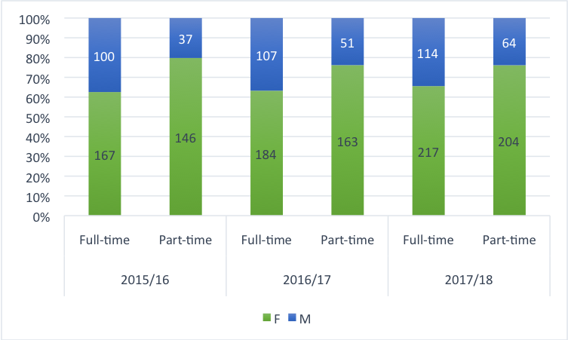

Currently our data does not differentiate contract type within ‘Academic’ by gender and full/part-time. We will act to address this (AP 3.5). Taken collectively, the proportion of academic females working full-time and part-time remained stable over three years (around 53% full-time, 47% part-time). However, during the same period 9% of academic males moved from full- to part-time. Part-time male academics increased from 27% in 2015/2016 to 36% in 2017/2018. This can partly be explained by an increase in senior male academics taking flexible retirement opportunities in 2017/2018. We will examine the impact of flexible retirement on our part-time data and have identified actions to analyse and monitor data on gender by age group (AP 8.2). Nevertheless, there are proportionally many more academic females on part time contracts. Actions to understand this are identified in relation to strengthening gender awareness in appraisal, mentoring and recruitment (AP 8.2; 5.1; 6.2 & 6.3). The number of part-time females may also be explained in part by women taking career breaks and contract changes to undertake caring roles, both child and elder care. To ensure that such breaks do not impact negatively on career progression, we currently offer a term’s study leave following maternity leave. But we will continue to monitor this group, and highlight their needs in staff appraisal and mentoring arrangements (AP 5.1). Currently, we do not know the extent to which women at later stages of career are affected by elder care responsibilities, menopause and health-related concerns, although we know it exists from our qualitative data. The subject of ‘ageing in the workplace’ was raised in our staff survey and focus groups work, and is becoming increasing relevant as retirement age increases. Although we have not focused on this aspect of intersectionality in this application we have committed to investigate further and seek to improve our understanding of the impact of age on gender equality (AP 4.2; 6.4 & 5.1). We need to understand more about the lower percentage of men on part-time contracts and how we can promote this type of flexible working through gender aware recruitment. For both men and women, the central task, however, is to ensure that part-time work is not perceived to be a barrier to promotion, through better communication of our promotion policies and through improvement in practices (AP 3.1-3.4; 6.1-6.3).

Action 3.1 | Ensure that advertising for posts reflects a commitment to gender equality and intersectionality
Action 3.4 | Address the low percentage of men within the IOE workforce
Action 3.6 | To develop more effective means of collecting data on areas that the Athena SWAN process has revealed as currently limited concerning recruitment and promotion (staff on open-ended contracts for the duration of funding (OEC) and other forms of open ended contracts)
Action 4.2 | Review and develop induction process of all management staff to address issues identified in the Athena SWAN gathering of data concerning the implementation of gender and intersectional policies concerning line management
Action 5.1 | To revise our appraisal process to make it more effective in its support of staff in terms of gender and intersectionality
Action 6.1 | To develop access to opportunities for career development courses
Action 6.2 | Review and enhance continuing professional development in line management to address areas concerning gender and intersectionality
Action 6.3 | To review current provision of career mentoring across the IOE, identify good models of practice for academic and professional staff, develop and implement recommendations for mentoring provision and resourcing
Action 8.2 | To identify whether and how flexible and part time working impacts on career progression at the IOE

Professional staff data
Although not required for this application, we believe it is important to include a section on PS staff as a way to highlight the broader cultural patterns and issues emerging post-merger. In particular, the strong representation of female staff across all contract types for academics is reflected across our professional staff data.

Table 12: Professional staff by grade and gender over time (2015/16-2017/18)
 | Grades | F | % | M | % | T
2015/16 | 1 to 6 | 97 | 72 | 37 | 28 | 134
2015/16 | 7 to 8 | 89 | 75 | 29 | 25 | 118
2015/16 | 9 to 10 | 31 | 57 | 23 | 43 | 54
2016/17 | 1 to 6 | 103 | 75 | 35 | 25 | 138
2016/17 | 7 to 8 | 84 | 76 | 26 | 24 | 110
2016/17 | 9 to 10 | 26 | 59 | 18 | 41 | 44
2017/18 | 1 to 6 | 102 | 69 | 45 | 31 | 147
2017/18 | 7 to 8 | 89 | 71 | 37 | 29 | 126
2017/18 | 9 to 10 | 21 | 54 | 18 | 46 | 39

Professional staff by grade and gender over time (2015/16-2017/18)
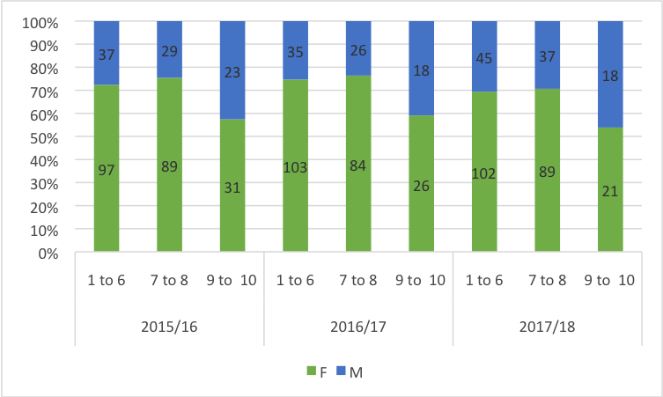

In in 2017/2018, 68% of PS were female the differential slightly reducing over time (2016/2017 -73%F and 2015/2016 - 71%F) across all grades. Considering the relative numbers of female and male PS staff, there is an uneven progression by gender, with proportionally more females than males in lower grades (from grade 1 up to Grade 8), and more males than females in higher grades (Grades 9 and 10). Only 10% (21/212) of females and 18% (18/100) of males reached grades 9 and 10 in 2017/2018. In other words, male PS have almost twice the chance to reach grade 9 and 10 than female PS. These proportions have worsened for both genders from 2015/2016 when 15% of females reached the highest grades (compared to only 10% in 2017), and 26% of males did so in 2015 in comparison with 18% in 2017/2018 (AP 6.1-3).

Table 13 Professional staff by contract (Full-time/Part-time), grade and gender over time (2015/16-2017/18)

 | 2015/16 |  |  |  |  | 2016/17 |  |  |  |  | 2017/18
Full-time | F | % | M | % | T | F | % | M | % | T | F | % | M | % | T
1 to 6 | 68 | 69 | 31 | 31 | 99 | 71 | 70 | 30 | 30 | 101 | 69 | 64 | 38 | 36 | 107
7 to 8 | 57 | 71 | 23 | 29 | 80 | 58 | 73 | 21 | 27 | 79 | 49 | 63 | 29 | 37 | 78
9 to 10 | 18 | 55 | 15 | 45 | 33 | 19 | 61 | 12 | 39 | 31 | 13 | 54 | 11 | 46 | 24
Total | 143 | 67 | 69 | 33 | 212 | 148 | 70 | 63 | 30 | 211 | 131 | 63 | 78 | 37 | 209
Full-time | F | % | M | % | T | F | % | M | % | T | F | % | M | % | T
1 to 6 | 29 | 83 | 6 | 17 | 35 | 32 | 86 | 5 | 14 | 37 | 33 | 83 | 7 | 18 | 40
7 to 8 | 32 | 84 | 6 | 16 | 38 | 26 | 84 | 5 | 16 | 31 | 40 | 83 | 8 | 17 | 48
9 to 10 | 13 | 62 | 8 | 38 | 21 | 7 | 54 | 6 | 46 | 13 | 8 | 53 | 7 | 47 | 15
Total | 74 | 79 | 20 | 21 | 94 | 65 | 80 | 16 | 20 | 81 | 81 | 79 | 22 | 21 | 103

Professional staff by contract (Full-time), grade and gender over time (2015/16-2017/18)
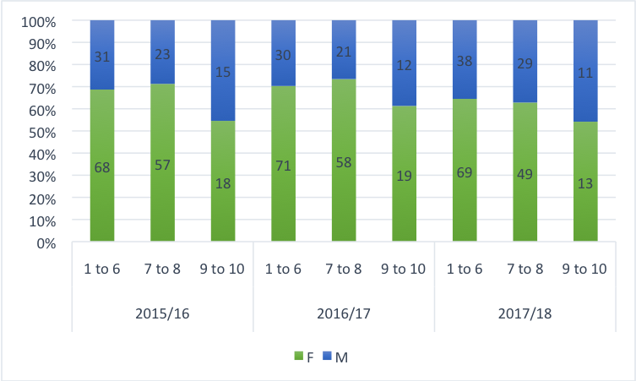

Professional staff by contract (Part-time), grade and gender over time (2015/16-2017/18)
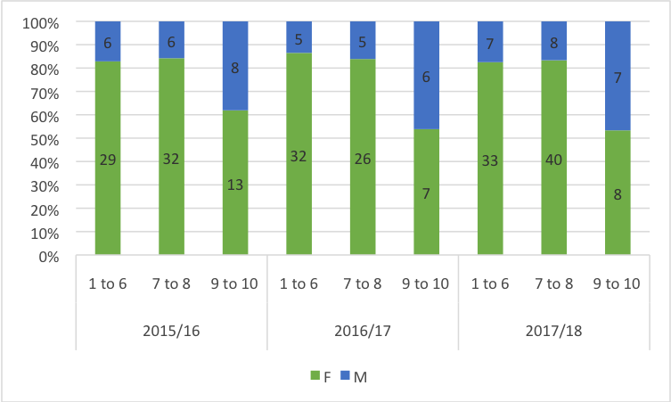

The proportion of part-time PS staff has increased from 31% and 28% in 2015 and 2016 respectively, to 33% in 2017/2018. Whilst the proportion of females and males part-time has remained stable over three cohorts (80% female, 20% males), the gender imbalance has changed among full-time professional staff. Fewer females were working full-time in 2017 (63% in comparison with 67% in 2015), males working full-time have increased (37% in 2017 versus 33% in 2015). This change could be associated with HR policy oriented to support flexible working arrangements by, for example, reconfiguring roles without reducing capacity within teams. The policy may impact on the gender differential as more females are working part-time whilst more males are working full-time. Promotion for PS is restricted to progression within grade, and attached to a specific JD. To progress PS may apply for internal roles, seek secondments across UCL, or leave the organisation. UCL are currently reviewing career progression for PS staff to retain talent. Our AP commits to similar actions for our PS staff as our academic staff in relation to gender aware approaches to recruitment, staff review and development and opportunities to move to higher grade internal roles (AP 3.1-3.4; 6.1-6.3).

Action 3.1 | Ensure that advertising for posts reflects a commitment to gender equality and intersectionality
Action 3.2 | Objective Ensure that the IOE in relation to UCL policy and local, Departmental practice, offers a fair and transparent recruitment and promotion process, free from bias and discrimination in terms of gender and intersectionality
Action 3.4 | Address the low percentage of men within the IOE workforce
Action 6.1 | To develop access to opportunities for career development courses
Action 6.2 | Review and enhance continuing professional development in line management to address areas concerning gender and intersectionality
Action 6.3 | To review current provision of career mentoring across the IOE, identify good models of practice for academic and professional staff, develop and implement recommendations for mentoring provision and resourcing

ii) Academic and research staff by grade on fixed-term, open-ended/permanent and zero-hour contracts by gender.
Comment on the proportions of men and women on these contracts. Comment on what is being done to ensure continuity of employment and to address any other issues, including redeployment schemes.

UCL do not use zero hour contracts, but we occasionally use ‘as and when’ contracts for work of under 3 months. During the period of assessment we have moved away from fee paid contracts to OEC wherever possible. Research staff are employed on open-ended contracts for the duration of funding. Staff on OEC have access to training and progression/promotion opportunities, staff support services, and parental leave policies. We offer redeployment opportunities to research staff on contracts with a funding end date and aim to improve career development support, for the duration of contracts (AP 6.1). Recent system change will allow us to gather reliable data currently unavailable, particularly in relation to gender and intersectionality (AP 3.5 & 3.7).

- Academic staff leavers by gender, full/part-time and grade
Comment on the reasons academic staff leave the department, any difference by gender and the mechanisms for collecting this data.

Table 15: Academic staff leavers by gender, full/part-time (FT/PT) and grade over time (2015/16-2017/18)

 | Gender |  | FT/PT |  | Contract |  | Grades
Year | F | M | FT | PT | F | O | 6 | 7 | 8 | 9 | 10
2015/16 | 16 | 7 | 7 | 16 | * | * | 1 | 6 | 11 | 2 | 3
2016/17 | 35 | 14 | 20 | 29 | * | * | 0 | 15 | 22 | 8 | 4
2017/18 | 31 | 14 | 27 | 18 | 25 | 19 | 4 | 20 | 17 | 1 | 3

Academic staff leavers by gender, full/part-time (FT/PT) and grade over time (2015/16-2017/18)
* Data was not available
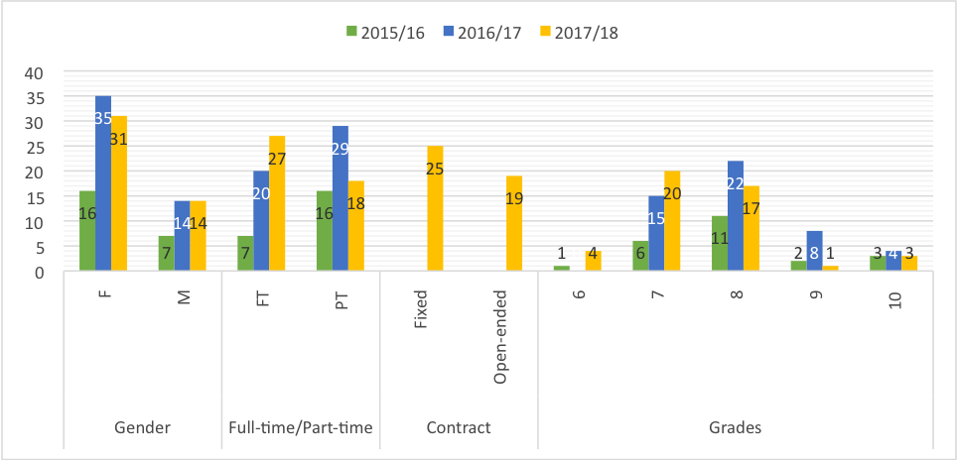

117 academics showed as leavers between 01/01/2015 and 31/12/2017: 45 in 2017 (31 females, 14 males); 49 in 2016 (35 females, 14 males) and 23 in 2015 (16 females, 7 males), around 8% of the total number of academics per year. Analysis is limited since not all ‘leavers’ have left. Internal movement of staff to management roles is common. Where a member of staff changes role or JD it currently appears on the system as a ‘leaver’. Internal appointment enables us to retain talent and build capacity within the organisation, but we identify a need for better data to inform our knowledge about career progression in relation to gender and intersectionality (AP 3.5, 6.4; 6.5).

Overall, the proportion of leavers by gender has remained stable over three years (around 70% females, 30% males), which reflects the overall institutional gender profile. Most of the academic leavers worked part-time (54%). However, in 2017/2018 some unexpected changes occurred. For example, more full-time than part-time academics (60% vs 40%) left the institution. One lecturer sadly died. When exploring 2017/2018 leavers’ in more depth (not presented in the table) 65% of the full-time leavers were Non-UK nationals, which contrasts sharply with the overall proportion of 24% of Non-UK academics working during 2017/2018 at the IOE. These contrasting patterns might be associated with the uncertainty brought about by Brexit. When focusing on 2017/2018 leavers’ type of contract, it is clear that 25 (56%) were on contracts with an end date, and 19 (43%) were on OEC. When looking at the proportion of females and males on these contracts, a differential pattern by gender emerges. Whilst half of the female leavers were on contracts with end date (15), 71% of male leavers (10) were contracts with end date. Half of the female academic leavers were on OEC, whereas only 29% of male academic leavers were on OEC. We will review our practice in gathering and recording exit interviews and questionnaires to improve understanding (AP 6.4; 3.6).

Focusing on grades, in 2017/2018 most academics that left the institution were at Grade 7 (44%), which is a different pattern from previous years, where the majority of academics that left, were Grade 8 (48% in 2015 and 45% in 2016, respectively). It may be the case that in 2017 researchers on Grade 7 contracts with a funding end date found employment elsewhere, highlighting further the need to monitor this group carefully, to ensure we are supporting research staff to take up redeployment and career development opportunities (AP 6.1). Actions are identified to address the absence of data for this group, to gain insight into and to monitor data with regard to gender and intersectionality, paying particular attention to key career transition points. Additionally, we aim to understand better the reasons why staff leave the organisation, and improve response rates to exit interviews. Better information on the destination of our staff who leave the organisation may positively enhance networks and relationships across the sector (AP 6.4).

Action 3.6 | To develop more effective means of collecting data on areas that the Athena SWAN process has revealed as currently limited concerning recruitment and promotion (staff on open-ended contracts for the duration of funding (OEC) and other forms of open ended contracts)
Action 6.1 | To develop access to opportunities for career development including (a) HR reviewing application areas of need in terms of IOE staff and career development training relating to current offer and identify which courses are over subscription for both academic and professional staff (b) SAT and SLT agree areas to prioritise in relation to training and Athena SWAN's concerns with career, gender and intersectionality building on areas identified by the Athena SWAN focus groups (see below) and (c) liaise with UCL and IOE to resource and implement more targeted training (d) monitor Grade 7 more effectively, to ensure we are supporting research staff to take up redeployment and career development opportunities
Action 6.4 | To review and develop IOE practice in relation to more effective exit interviews and staff questionnaires to gain deeper understanding of the reasons staff leave the IOE.
Action 6.5 | To continue to monitor the impact from gender and intersectional perspectives of the new Academic Career Framework in relation to career progression concerning staff on teaching contracts

Word Count: 2955

5. SUPPORTING AND ADVANCING WOMEN’S CAREERS

5.1 Key Career Transition Points: academic staff

i) Recruitment
Break down data by gender and grade for applications to academic posts including shortlisted candidates, offer and acceptance rates. Comment on how the department’s recruitment processes ensure that women (and men where there is an underrepresentation in numbers) are encouraged to apply.

External vacancies are advertised on relevant websites and on rare occasion executive search firms are used for the most senior roles. The process is supported by HR and the recruitments team located at the IOE. In preparation for new posts, HR advise on the JD and process. Applicants are asked to submit applications electronically with reference to clearly defined criteria for the post. The agreed criteria are used to score applications for shortlisting and interview. Potential applicants are invited to discuss the post before applying with a named contact on the advert. An interview panel is convened following strict guidelines from UCL recruitment policy about constitution, which includes gender balance, representation from BME staff and relevant level of seniority. Panels for professorial posts are chaired by the Director and include 3 external members, one from wider UCL and two external to the university. Where is it is not possible to identify a BME member of staff to serve on recruitment panels, we deploy the UCL Fair Recruiters scheme which consists of a pool of BME staff from across the University who are available to attend. All panel members should complete the Unconscious Bias and Diversity in the Workplace training and a database of completions developed for future reference (AP 3.5; 3.6).

All internal vacancies for roles (e.g. HOD, Programme Leader) are advertised to the whole staff by expression of interest, with clear criteria for application and subject to the UCL recruitment policy. All roles advertised from 2017/2018 have been time limited, typically to 3 years (or up to 5 in the case of Heads of Department and Pro Directors), to allow for career development and succession planning. We recognise that in the past, some roles have been occupied by staff members for many years and that this has limited opportunities for progression. All job adverts, external and internal, include a statement encouraging applications from underrepresented groups. Where we have identified that men are significantly underrepresented as on teaching contracts, we will explore options for highlighting this and reference our ACF which offers parity with academic contracts for career progression (AP 3.1; 6.5).

Table 16: Applications, shortlisted and appointed academics by gender over time (2014/15—2017/18)

 |  | F | F% | M | M% | T
2014/15 | Applications | 305 | 57 | 229 | 43 | 534
2014/15 | Shortlisted | 44 | 61 | 28 | 39 | 72
2014/15 | Appointed | 14 | 67 | 7 | 33 | 21
2015/16 | Applications | 213 | 56 | 168 | 44 | 381
2015/16 | Shortlisted | 38 | 64 | 21 | 36 | 59
2015/16 | Appointed | 10 | 59 | 7 | 41 | 17
2016/17 | Applications | 219 | 52 | 206 | 48 | 425
2016/17 | Shortlisted | 32 | 59 | 22 | 41 | 54
2016/17 | Appointed | 9 | 60 | 6 | 40 | 15
2017/18 | Applications | 285 | 52 | 259 | 48 | 544
2017/18 | Shortlisted | 44 | 62 | 27 | 38 | 71
2017/18 | Appointed | 10 | 53 | 9 | 47 | 19

Applications, shortlisted and appointed academics by gender over time (2014/15—2017/18)
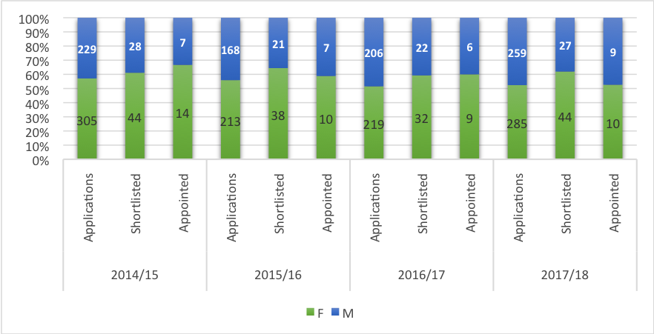

Academic jobs are competitive, as shown by the significant difference between number of applications and number of appointments for both men and women. During 2017/18 of 285 females applicants, 15% (44) were shortlisted and 3% (10) were appointed. Of 259 males applicants, 10% (27) were shortlisted and 3% (9) were appointed. The proportion of appointed females in the previous years fluctuated from 4% to 4.6%, whereas appointments of males were relatively lower and varied slightly more from 2.9% to 4.1% respectively. Female applicants are therefore slightly more successful in gaining posts than male applicants. To understand this data better, our AP commits to monitor our advertising and recruitment approach (AP 3.1, 3.2. 3.3).

Action 3.1 |  | Ensure that advertising for posts reflects a commitment to gender equality and intersectionality.
Action 3.2 |  | Ensure that the IOE in relation to UCL policy and local, Departmental practice, offers a fair and transparent recruitment and promotion process, free from bias and discrimination in terms of gender and intersectionality
Action 3.3 | To improve clarity of information concerning promotion
Action 3.5 | To develop more effective means of collecting data on areas that the Athena SWAN process has revealed as currently limited concerning recruitment and promotion (staff on open-ended contracts for the duration of funding (OEC) and other forms of open ended contracts)
Action 3.6 | To monitor unconscious bias training for staff involved in interviews to consolidate the rate of completion of the training
Action 6.4 | To obtain, analyse and gain insight from exit data on academic, research and professional staff data on reasons for leaving and destinations of leavers
Action 6.5 | To continue to monitor the impact from gender and intersectional perspectives of the new Academic Career Framework in relation to career progression concerning staff on teaching contracts

- Staff induction
UCL provide termly induction opportunities for new staff. On arrival at the IOE, new staff meet with their line manager/HOD to discuss workload, research objectives where relevant and support needed. New staff are also introduced to key UCL and local policies, equipment and mandatory training requirements including Diversity in the Workplace and Unconscious Bias Training. A research induction workshop is available to all new staff where research is part of their contract, at the beginning of each term. Although we have thought carefully about support for new staff, our survey, consultation and focus groups revealed a continued lack of familiarity with key policies and showed that induction for new staff is variable across the organisation. We have identified key actions to address this (AP 4.1, 4.2), and further training will be developed for line managers to support new staff (AP 8.1). During the period of assessment, two initiatives have been developed to support the process of induction further:

a) an Early Careers Network, to support induction and career development needs of early career staff across all contract types. Representatives meet regularly with senior advocates for the group.
b) Head of Department induction and support project established by the PDAD and HHR to identify needs and promote good leadership practice, EDI, knowledge of key policies (i.e. flexible working, maternity) and their implementation.

Action 4.1 | To review and develop induction process for staff and to highlight awareness of UCL and, where relevant, particular IOE policies and the practical implementation of policies connected to gender and intersectionality
Action 4.2 | Review and develop induction process of all management staff to address issues identified in the Athena SWAN gathering of data concerning the implementation of gender and intersectional policies concerning line management
Action 8.1 | To clarify and articulate the implementation of flexible working at the IOE

- Promotion

Promotions and incremental progression schemes run annually. Information about each scheme is circulated to staff via the intranet and through line managers. For UCL Senior Academic Promotions HOD are required to convene representative departmental panels to consider each draft application and provide feedback before final submission or for a future submission. The IOE requires that a PD attends each departmental panel to provide guidance, and moderate applications where required. A School Promotions Committee is convened with a Professorial representative from each department, Chaired by the IOE Director and attended by HR and the UCL Head of Rewards. All staff have the right to apply by the ‘Direct Route’, without the approval of the HOD. Such applications are considered by the Director, referees and School Committee members. All unsuccessful candidates for Senior Promotion receive detailed written constructive feedback from the promotions panel and a face-to-face meeting with the Director to discuss feedback and support needed to progress. This is followed up by the PDAD and relevant HOD. We invite applications for senior reward, incremental progression, and additional contribution points annually. Panels are carefully constructed to ensure appropriate diversity (gender and race), experience and expertise. Academic panels are Chaired by a PD, and the DoO in the case of PS staff. Panels consider carefully each applicant’s case, paying special attention to time of last application and salary progression, personal circumstances such as maternity leave or illness and contribution to service which may be less visible than academic outputs. For academics, HOD provide feedback to applicants and a supporting statement where appropriate. If a HOD does not feel the applicant is ready for progression, constructive feedback is provided.

Table 17a: UCL data on academic promotions by gender and full-time/part-time (FT/PT) applications and success over time (2015/16-2017/18)
 | Gender | Full-time/Part-time | Applied | Succeeded
2015/16 | Female | Full-time | 8 | 8
 | Female | Part-time | 3 | 3
 | Male | Full-time | 2 | 2
 | Male | Part-time | 0 | 0
2016/17 | Female | Full-time | 11 | 10
 | Female | Part-time | 0 | 0
 | Male | Full-time | 4 | 2
 | Male | Part-time | 1 | 1
2017/18 | Female | Full-time | 14 | 13
 | Female | Part-time | 1 | 1
 | Male | Full-time | 6 | 6
 | Male | Part-time | 1 | 1

UCL data on academic promotions by gender and full-time/part-time (FT/PT) applications and success over time (2015/16-2017/18)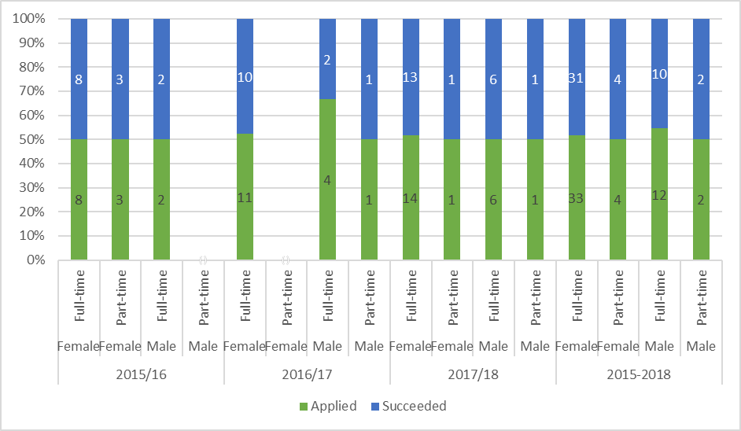

Table 17a shows that there is a significant difference in those working Full-time and Part-time applying for promotion, as the great majority of applicants (89% of females and 86% of males) are full-timers. However, those part-timers that apply have a higher success rate of getting promoted (100%) than full-timers (91%). Focusing on gender, there is a higher rate of success for females. Whilst 95% of females that applied were promoted, 86% of males that applied, did so.
Table 17b: Academic promotions by gender and grade applications and success over time (2015/16-2017/18)
 | Gender | Grade | Applied | Succeeded
2015/16 | Female | 8 | 5 | 5
 | Female | 9 | 4 | 4
 | Female | 10 | 2 | 2
 | Male | 8 | 0 | 0
 | Male | 9 | 2 | 2
 | Male | 10 | 0 | 0
2016/17 | Female | 8 | 7 | 6
 | Female | 9 | 3 | 3
 | Female | 10 | 1 | 1
 | Male | 8 | 3 | 1
 | Male | 9 | 0 | 0
 | Male | 10 | 2 | 2
2017/18 | Female | 8 | 0 | 0
 | Female | 9 | 10 | 10
 | Female | 10 | 5 | 5
 | Male | 8 | 0 | 0
 | Male | 9 | 5 | 4
 | Male | 10 | 2 | 2

Academic promotions by gender and grade applications and success over time (2015/16-2017/18)
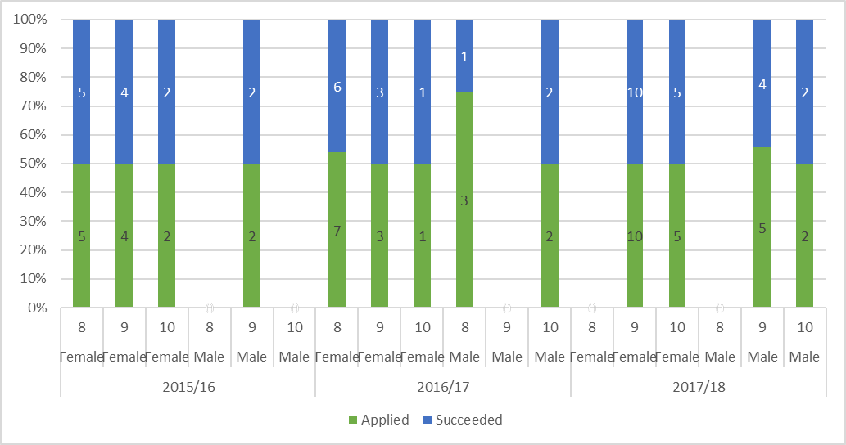

Table 17b shows that overall there is a similar success rate for females and males applying for promotion across grades. Over the period of assessment, more females have applied and been successfully promoted at the most senior level (grade 10). Whilst in 2015/16 2 females were successfully promoted to grade 10, in 2017/18 there were 5 new Grade 10 Professors.

It is encouraging to see more females applying for and being successful in promotion in recent years but more work needs to be done to ensure that proportionally more women progress and that more part time staff apply for promotion. Recent changes to the UCL Maternity Leave policy, which includes a period of study leave upon return to work is helping full and part time female staff to maintain the level of scholarship required for progression. This has been applied to each case of maternity leave for female academic staff since 2016/17. But we need also to consider ways in which flexible working and mentoring for part-time staff can support progression. Our AP identifies actions around part-time promotions (AP 4.1; 6.5; 8.2). The vast majority of applications are from full-time staff and we are developing ways to understand the low numbers of applications from part time staff. It is a priority to address this through our AP (AP 3.2; 3.5; 5.1; 6.3).

Our AS survey showed that:
- Male respondents were more likely than female respondents to agree that they received support and encouragement in seeking promotion (59% M compared to 54% F).
- White respondents were more likely than BME respondents to agree that they received support and encouragement in applying for promotions/new roles (56% n.283 compared to 52% n.77).
- Academic respondents were very slightly more likely than professional services respondents to agree that they received support and encouragement in applying for promotions/new roles (55% n.237 compared to 54% n.134).

The AS survey also showed 55% of female and 55% of male respondents did not fully understand the promotion process and criteria, with BME respondents being the least likely to understand the promotions process (45%). Focus groups identified that courses for career development were constantly oversubscribed and therefore were inaccessible and that this had a negative impact on career progression and the degree to which people felt supported in making an application. We want to improve these figures and make improvements in supporting progression. We have identified actions to address this (AP 3.2; 3.3; 5.1), specifically to understand barriers to making promotion applications and better communicating the role of mentoring for promotion support (AP 6.3). Action to enhance our appraisal approach will ensure greater transparency about the promotions process (AP 5.1). Moreover as part of HOD induction we will develop additional guidance on what makes a strong application and how to provide constructive feedback (AP 6.2). For 2020/21 HOD will be required to monitor progression annually with particular reference to gender and race and ensure all promotion panel members have completed the Unconscious Bias and Diversity in the Workplace training (AP 3.6).

We are determined to understand better the factors that have led to disparities and undertake positive action to address it. To ensure that no staff member (whatever contract type, gender or intersectional profile), is disadvantaged in promotion applications and has equal access to research time (pro rata), mentoring, training opportunities and support from line managers in managing workload we have identified the following actions.

Action 5.1 | To revise SRD to make it a more effective process to support staff in terms of gender and intersectionality
Action 4.1 | To review and develop induction process for staff and to highlight awareness of UCL and, where relevant, particular IOE policies along with the practical implementation of policies connected to gender and intersectionality
Action 6.3 | To review current provision of career mentoring across the IOE, identify good models of practice for academic and professional staff, develop and implement recommendations for mentoring provision and resourcing. Promotion discussions will be included and recorded as an agreed aspect of meetings between staff and mentors
Action 6.5 | We will monitor data annually on promotion and salary progression around gender and intersectionality and part-time staff.
Action 3.2 | Ensure that the IOE in relation to UCL policy and local, Departmental practice, offers a fair and transparent recruitment and promotion process, free from bias and discrimination in terms of gender and intersectionality.
Action 3.6 | To monitor unconscious bias training for staff involved in interviews to consolidate the rate of completion of the training
Action 8.2 | To identify whether and how flexible and part time working impacts on career progression at the IOE

- Department submissions to the Research Excellence Framework (REF)

Table 18: Submissions to the REF by gender (2014)

 | F | F% | M | M% | T
Staff eligible | 263 | 65 | 143 | 35 | 406
Staff that submitted | 155 | 62 | 95 | 38 | 250

406 staff members were eligible for entry into the REF 2014. Of these, 250 produced outputs that were submitted. From the total eligible, 263 (65%) were females and 146 (35%), males. These proportions remained similar in the submission, as 155 (62%) were females, and 95 (38%) males, but a gender imbalance of 3% (3% less for females vs 3% more for males) remained when comparing the submitted vs the eligible. Furthermore, of the 795 outputs submitted by 250 academic staff, 474 (60%) were submitted by females, and 321 outputs (40%) were submitted by males. Despite more females submitted to the REF, the number of outputs per staff, shows a gender imbalance. Males submitted on average 3.5 outputs whilst females submitted on average 3 outputs. We recognise that more work needs to be done to understand the factors that might account for the gender difference in research outputs and the impact of this on career progression, in relation also to maternity leave, caring responsibilities, fractional contracts and service roles. The AS Co-Chairs are working closely with the PDRD leading REF 2021. Placing EDI at the heart of the REF process also fully meets the requirement of REF 2021 Equality and Diversity guidance (AP 7.1).

Action 7.1. | Ensure there is no gender bias in the IOE submission to the Research Excellence Framework (REF2021).

5.3 Career development: academic staff

- Training

A range of training is available for all academic and PS staff including mandatory training on Diversity in the Workplace and Unconscious Bias at the point of induction. Training opportunities are communicated on the IOE intranet, by whole staff communications and via line managers. The uptake of mandatory courses offered for staff increased significantly from 40 staff in 2015/2016 to 170 in 2017/2018. The gender proportion of uptake has changed from 80% females vs 20% males in 2015, to 66% females vs 34% males in 2017. Our aim is to achieve a much higher level of engagement with training across all staff groups and in particular those in leadership and appraiser roles (AP.5.1; 6.1). The low percentage of males completing standard training is highlighted in the data. The AS process has sought to engage male staff to understand better barriers to participation. Nevertheless, further work is needed to understand how we can encourage more men to participate in areas where they are underrepresented in the organisation. (AP 3.1; 3.4).

A range of Leadership and Management Programmes are offered by UCL. Uptake and completion from IOE staff has been positive although the process for applications was initially unclear and reliable data for the years 2015-2017 is unavailable. Since 2017/2018 the process has been revised and a database established. Candidates are nominated by HOD and PS leads and considered by a panel which includes a member of HR and the equalities lead. In 2018 3 staff (grade 9, two academic, 1 PS, all female), completed the ‘Future Leaders’ Programme; 3 females (grades 9 and 10, 2 academic, 1 PS) completed ‘Senior Women in Leadership’ and 10 females (grades 6-8, 4 academic, 6 PS) completed ‘Women in Leadership’. We will systematically monitor data uptake and progress for those who take part in relation to gender and intersectionality (AP 3.6). During the assessment period significant work has been undertaken, via HOD, to assign mentors to all academic members of staff and in particular to early career academics. How this is arranged varies across the seven academic departments and an action for us is to collect data and monitor take up and impact (AP 6.3). Early career academics are encouraged to apply for financial support for conference attendance from departmental development accounts, and sponsorship for career development programmes, including the UCL Women in Leadership, Women in Senior Leadership, and The Future Leaders scheme (AP 6.3). We continue to support participation in recent UCL initiatives Inclusive Advocacy and B-MEntor scheme aimed specifically at supporting the career development of our BAME staff and monitor take up by gender and race.

Table 19: Standard training available to staff and uptake by gender (2017/18-2015/16)

 | 2015/2016 |  |  |  |  | 2016/2017 |  |  |  |  | 2017/2018
Courses | F | %F | M | %M | T | F | %F | M | %M | T | F | %F | M | %M | T
Diversity in the Workplace – Online | 14 | 82 | 3 | 18 | 17 | 22 | 61 | 14 | 39 | 36 | 76 | 67 | 37 | 33 | 113
Recruitment and Selection HR Policy Briefing | 16 | 80 | 4 | 20 | 20 | 9 | 43 | 12 | 67 | 21 | 24 | 73 | 9 | 27 | 33
Unconscious Bias Training – Online | 2 | 67 | 1 | 33 | 3 | 1 | 100 | 0 | 0 | 1 | 6 | 67 | 3 | 33 | 9
Using Recruitment Essentials | 0 | 0 | 0 | 0 | 0 | 0 | 0 | 0 | 0 | 0 | 27 | 77 | 8 | 23 | 35

Standard training available to staff and uptake by gender (2015/16-2017/18)
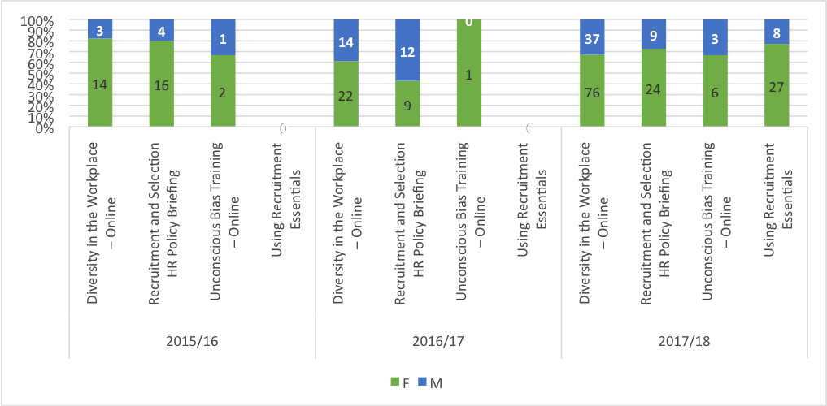

- Appraisal/development review
All staff members on open-ended contracts are required to attend an appraisal meeting with their line manager or nominee. Departmental administrators record completion. HOD keep oversight of developmental requirements of staff in communication with PDAD and the DoO. HOD and PS leads submit data to the HR system for collation centrally. We deploy a scheme that is focused on staff development rather than performance management (which has a separate policy). Reviewers are required to attend a training session and reviewees are also offered this opportunity. In 2018 we commissioned external consultants to hold workshops designed to help both parties get the most out of appraisal and we are currently reviewing our scheme to ensure that diversity and part-time working are highlighted. We take staff appraisal very seriously and view it as the key mechanism by which we can gain insight into and harness colleagues’ achievements and aspirations, identifying appropriate ways to support fulfilling careers and progression. Reliable data on appraisal by gender across the organisation is unavailable currently but we have identified a set of actions to work with UCL to gather accurate data on appraisal take up and in relation to diversity (AP 3.4-3.6; 6.5). Actions to understand better staff experience of appraisal will enable us to build case studies of good practice and positive impact on career progression (AP 5.1).

- Support given to academic staff for career progression
We are proactive in seeking opportunities and initiatives to support the career progression of staff and particularly women via leadership programmes (AP 6.1), mentoring schemes and our policies around maternity leave, and promotions and progression schemes. But as we have seen the AS survey showed that some staff do not feel supported or clear about progression. In 2017/2018 the IOE set up a seed-funding scheme specifically designed to support staff to develop their research ideas and build capacity in early career staff across the Faculty in collaboration with a more senior colleague. The success of this scheme has prompted a second scheme currently under development for 2020. The criteria explicitly state that an early career academic must be part of the research team. There is also a smaller fund to support networking events and small-scale work towards a larger project, which is aimed particularly at early career academics. A newly formed network will also help in identifying needs in early career staff. We will monitor applications, collect and scrutinise data on application by gender and intersectionality and success rates (AP 3.5).

Action 3.4 | To address the low percentage of men within the IOE workforce
Action 3.5 | To develop more effective means of collecting data on areas that the Athena SWAN process has revealed as currently limited concerning recruitment and promotion (staff on open-ended contracts for the duration of funding (OEC) and other forms of open ended contracts)
Action 3.6 | To monitor unconscious bias training for staff involved in interviews to consolidate the rate of completion of the training
Action 5.1 | To revise SRD to make it a more effective process to support staff in terms of gender and intersectionality
Action 6.1 | To develop access to opportunities for career development courses
Action 6.2 | Review and enhance continuing professional development in line management to address areas concerning gender and intersectionality
Action 6.3 | To review current provision of career mentoring across the IOE, identify good models of practice for academic and professional staff, develop and implement recommendations for mentoring provision and resourcing

- Support given to students (at any level) for academic career progression

Table 20: Training options provided to PGR and uptake by gender over time (2016/17-2017/18)
PGR Attendance | 2016/17 |  |  |  |  |  | 2017/18
Training options | F | F% | M | %M | T | F |  | F% | M | M% | T
Academic Career Planning (1) | 8 | 89 | 1 | 11 | 9 | 9 |  | 90 | 1 | 10 | 10
Effective Academic Applications (2) | 5 | 83 | 1 | 17 | 6 | 5 |  | 83 | 1 | 17 | 6
Effective Academic Interviews (3) | 7 | 100 | 0 | 0 | 7 | 7 |  | 100 | 0 | 0 | 7
Life and Health Sciences Careers week: Careers in Academic & non-Academic Research (4) | 3 | 75 | 1 | 25 | 4 | 0 |  | 0 | 0 | 0 | 0
Total | 23 | 88 | 3 | 12 | 26 | 21 |  | 91 | 2 | 9 | 23

Training options provided to PGR and uptake by gender over time (2016/17-2017/18)
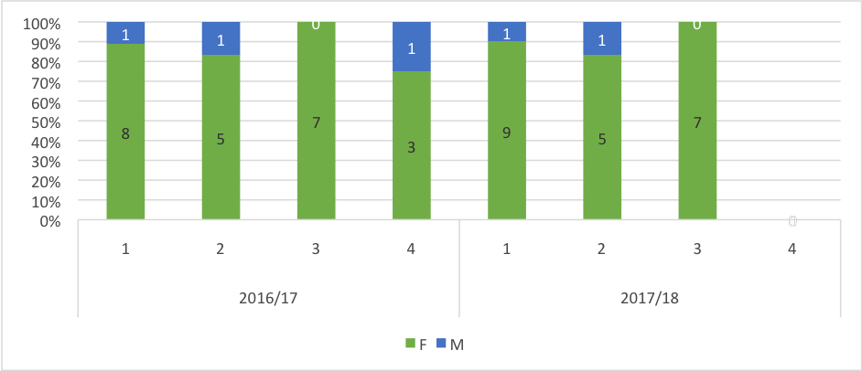

Table 20 presents the attendance of IOE PGRs at UCL Careers Researchers' Academic Progression workshops and from the small numbers shows higher female than male attendance. We will address absence of males through the AP (AP 10.1-2).

(v) Support offered to those applying for research grant applications
Comment and reflect on support given to staff, who apply for funding and what support is offered to those who are unsuccessful.

A Research Induction Workshop offers a comprehensive introduction to all aspects of research including grant application processes. This is accompanied by a handbook. We see this as closely linked to improvements in induction and mentoring arrangements for new and early career staff. The following measures are already in place and we have identified additional actions to address this area:
- The Head of Research in each department offers a department induction to outline what support is available. All colleagues have access to a research mentor and membership of a research centre.
- Colleagues have access to the research operations team administrator named for their department who supports the development of budgets and gives advice on funder requirements. The research operations team run regular drop in sessions/coffee mornings for staff thinking about bidding for funding.
- All grant applications are peer reviewed at department level (organised by Head of Research or delegated mentor/line manager). There is also a requirement for large bids over £750k and bids to research councils (including ERC) to be peer reviewed at faculty level, overseen by the PDR.
- Staff are encouraged to seek advice from the OVPR research facilitation team for the IOE both in the development of their bids and for discussion about unsuccessful bids and possibilities for recycling.
- Department Heads of Research are available to discuss unsuccessful bids or to delegate this to the relevant mentor
We will review induction processes and gather data on attendance at research induction, and take up of mentoring after unsuccessful bidding in relation to gender and intersectionality (AP 4.1; 4.2; 6.3).

Action 4.1 | To review and develop induction process for staff and to highlight awareness of UCL and, where relevant, particular IOE policies and the practical implementation of policies connected to gender and intersectionality
Action 4.2 | To review and develop induction process of all management staff to address issues identified in the Athena SWAN gathering of data concerning the implementation of gender and intersectional policies concerning line management
Action 6.3 | To review and develop career mentoring

5.5 Flexible working and managing career breaks
Note: Present professional and support staff and academic staff data separately

- Cover and support for maternity and adoption leave: before leave
- Cover and support for maternity and adoption leave: during leave

UCL maternity policy sets out provision for maternity leave. Line managers are encouraged to set up support processes for female staff throughout the maternity leave journey. Our staff survey found that 40% of female respondents did not feel supported before, during or after maternity leave. Additionally, 46% of respondents felt that taking maternity leave would damage their career and that 32% felt taking maternity leave had already damaged their career. From our survey and consultative qualitative work, maternity leave has emerged as a significant issue for our female staff. We have prioritised this area in our action plan with the objective to make significant improvements in the number of females who feel supported throughout the process of taking maternity leave. This included awareness of policies and good practice; gathering further information on perceptions of current practice; creating an action plan for change in this area; and creating more effective resources for women returning from maternity leave (AP 9.1; 9.2; 9.4).

- Cover and support for maternity and adoption leave: returning to work

We follow the UCL Parental Leave Policy, and offer a term (3 months or more) of study leave to academic staff on returning to work to support career progress of female academic staff (AP 6.3). We encourage good practice where HOD and/or line managers and HR business partners ensure that staff returning from maternity leave are able to discuss workload, flexible working, part-time work and any changes that have taken place in their absence (AP 8.1-2). However, our survey showed that 40% of females did not feel supported on return, highlighting a lack of consistency in the implementation and management of leave policies. We have identified actions to directly address this (AP 9.1; 9.2; 9.4; 9.5) and actions that will improve line management induction and develop good practice guidance for line managers, including considerations of flexible and part-time working arrangements where requested (AP 4.1; 4.2). Additionally, the survey indicated a need to redress arrangements for breast-feeding. Currently, we do not have an official dedicated space for breast feeding, but have identified a ‘family area’ for this purpose. However, communication of this, and identification of a more suitable dedicated space has been identified as an urgent priority (AP 9.4).

Action 4.1 | To review and develop induction process for staff and to highlight awareness of UCL and, where relevant, particular IOE policies and the practical implementation of policies connected to gender and intersectionality
Action 4.2 | Review and develop induction process of all management staff to address issues identified in the Athena SWAN gathering of data concerning the implementation of gender and intersectional policies concerning line management
Action 6.3 | To review and develop career mentoring
Action 8.1 | To clarify and articulate the implementation of flexible working at the IOE
Action 8.2 | To identify whether and how flexible and part time working impacts on career progression at the IOE
Action 9.1 | To improve access to information for those applying for maternity and paternity leave
Action 9.2 | To explore and respond to perceptions and experiences of staff that maternity leave damages career
Action 9.3 | To increase awareness of and take-up of paternity leave and shared parental leave
Action 9.4 | Create more effective resources for women and men returning from maternity, paternity and parental leave
Action 9.5 | To address special guardianship provision

- Maternity return rate

Table 21: Maternity/Paternity leave and return of academic staff by grade and gender over time (2015/16-2017/18)
Year | Maternity | Maternity grades | Paternity | Paternity grades | Total
2015/16 | 3 | 1 grade 9 | 2 | 1 grade 9 | 5
2015/16 | 3 | 2 grade 8 | 2 | 1 grade 8 | 5
2016/17 | 16 | 2 grade 10 | 0 | N/A | 16
2016/17 | 16 | 3 grade 9 | 0 | N/A | 16
2016/17 | 16 | 6 grade 8 | 0 | N/A | 16
2016/17 | 16 | 4 grade 7 | 0 | N/A | 16
2016/17 | 16 | 1 grade 6 | 0 | N/A | 16
2017/18 | 5 | 1 grade 10 | 0 | N/A | 5
2017/18 | 5 | 2 grade 9 | 0 | N/A | 5
2017/18 | 5 | 1 grade 8 | 0 | N/A | 5
2017/18 | 5 | 1 grade 7 | 0 | N/A | 5
2018/19 | 17 | 3 grade 9 | 1 | 1 grade 9 | 18
2018/19 | 17 | 11 grade 8 | 1 | 1 grade 9 | 18
2018/19 | 17 | 3 grade 7 | 1 | 1 grade 9 | 18
Total | 41 |  | 3 |  | 44

From January 2015 to December 2018, 41 academic staff took maternity leave and 3 took paternity leave. Looking at leave take up and grades, half of the females that took maternity leave were grade 8, whereas 2 of the academics that took paternity leave were grade 9 and one in 8, respectively. During the period of assessment, 100% of academic female and male staff that took either maternity or paternity leave returned to work.

Table 22: Maternity/Paternity leave of professional staff by grade and gender over time (2015/16-2018/19)
Year | Maternity | Maternity grades | Paternity | Paternity grades | Total
2015/16 | 3 | 1 grade 8 | 1 | 1 grade 7 | 4
2015/16 | 3 | 2 grade 7 | 1 | 1 grade 7 | 4
2016/17 | 6 | 6 grade 6 | 2 | 2 grade 9 | 8
2017/18 | 6 | 1 grade 9 | 6 | 1 grade 10 | 12
2017/18 | 6 | 2 grade 8 | 6 | 2 grade 8 | 12
2017/18 | 6 | 3 grade 7 | 6 | 3 grade 6 | 12
2018/19 | 5 | 1 grade 8 | 4 | 1 grade 9 | 9
2018/19 | 5 | 1 grade 7 | 4 | 3 grade 6 | 9
2018/19 | 5 | 3 grade 6 | 4 |  | 9
Total | 20 |  | 13 |  | 33

From January 2015 to December 2018, 20 PS took maternity leave and 13 took paternity leave. For leave take up and grades, almost half of females that took maternity leave were grade 6 (6, 45%), and most of the PS that took paternity leave were grade 6 (6, 45%).

Table 23: Maternity/Paternity leave and return of professional staff by gender over time (2015/16-2017/18)
 | Leave |  | Return
 | F | M | F | M
2015/16 | 2 | 0 | 2 | N/A
2016/17 | 3 | 1 | 3 | 1
2017/18 | 4 | 3 | 4 | 3

Maternity/Paternity leave and return of professional staff by gender over time (2015/16-2017/18)
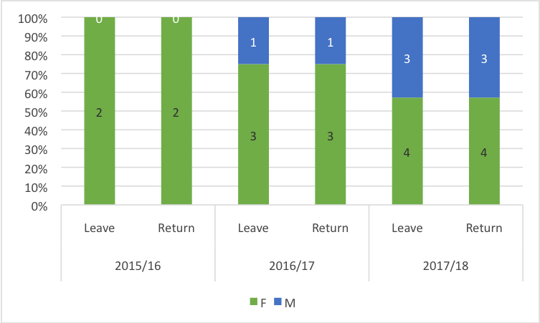

From January 2015 to December 2017, 9 PS took maternity leave and 4 paternity leave. All 9 (100%) have returned to work. One PS was recorded as going on adoption leave. Most staff taking maternity leave were either grade 7 or 8, whereas most males who took paternity leave were grade 6. There has been a steady increase in the number of staff taking maternity and paternity leave over the assessment period, with an increase from 2 maternity leaves in 2015 to 4 in 2017, and no paternity leave taken in 2015 to 3 in 2017. Upon return to work PS meet with their line manager and HR business partner to discuss work load, including flexible working, and any changes in work that may have occurred in their absence. However, the AS survey results suggested inconsistent practice, so we have identified actions to ensure improvements are made (AP 4.1; 4.2; 9.1-5).

Action 4.1 | To review and develop induction process for staff and to highlight awareness of UCL and, where relevant, particular IOE policies and the practical implementation of policies connected to gender and intersectionality
Action 4.2 | Review and develop induction process of all management staff to address issues identified in the Athena SWAN gathering of data concerning the implementation of gender and intersectional policies concerning line management
Action 9.1 | To improve access to information for those applying for maternity and paternity leave
Action 9.2 | To explore and respond to perceptions and experiences of staff that maternity leave damages career
Action 9.3 | To increase awareness of and take-up of paternity leave and shared parental leave
Action 9.4 | Create more effective resources for women and men returning from maternity, paternity and parental leave
Action 9.5 | To address special guardianship provision

- Flexible working

Our AS survey indicated that flexible working is a key issue for staff at the IOE and that there is a lack of knowledge and understanding about it. 57% of female respondents and 52% of male respondents said that they were unaware of the UCL Flexible Working policy. In terms of the UCL Policy for Domestic and Personal Leave 53% of female and 35% of male respondents are aware of the policy. Currently we lack reliable data on numbers of staff who work flexibly. We also recognise that practices vary between academic and professional staff, with professional staff having less flexibility than academic staff. Our AP commits to improvements in staff awareness of the policy (AP. 4.1), and to line managers training on the application of the policy and its positive impact on gender and intersectional equality (AP 4.2; 8.1; 8.2).

Action 4.1 |  | To review and develop induction process for staff and to highlight awareness of UCL and, where relevant, particular IOE policies and the practical implementation of policies connected to gender and intersectionality
Action 4.2 |  | Review and develop induction process of all management staff to address issues identified in the Athena SWAN gathering of data concerning the implementation of gender and intersectional policies concerning line management
Action 8.1 |  | To clarify and articulate the implementation of flexible working at the IOE
Action 8.2 | To identify whether and how flexible and part time working impacts on career progression at the IOE

5.6 Organisation and culture

i) Culture
The appointment of the first female Director in 2016 was significant for the IOE and signalled a new emphasis on gender equality and building an inclusive workplace. In 2017 she enhanced the role of the PDAD to include an explicit strand for leadership in EDI; became Chair of the EDI committee, and made clear her commitment to EDI in Directors’ addresses. She has also raised awareness of this agenda and has elevated its importance across the organisation, including taking on the role of Chair for the UCL Sexual Misconduct Committee. As part of our collective commitment to staff well-being and to improving work/life balance, SMT agreed to introduce the IOE email etiquette policy, which sets out the IOE’s expectations in relation to how colleagues conduct their email correspondence – its volume, its content, and its responsiveness. Staff are advised not to send work-related emails in the late evening and at the weekend. Colleagues are under no obligation to respond to messages outside normal operating hours, at weekends, or on public holidays. Informal feedback suggests significant reduction in email traffic out of office hours. SMT reviewed and approved the policy again in November 2019 (AP 1.2).
We recognise that much more can be done to increase the confidence of our staff in our ambition to implement equitable practice, particularly for senior female academics, lower grade professional posts, early career academics and our BAME staff. Annual monitoring of progression data and effective communication is imperative if it is to have tangible impact. We will continue to use the Director’s address, IOE Assembly, departmental meetings and the EDI webpage, to communicate initiatives and Athena SWAN (AP 1.1-1.3; 2.1-2.2). We will continue through strengthening links with our EDI committee and continued engagement with the IOE SMT.
Action 1.1 | To continue to build the relationship we have developed between Athena SWAN and IOE Senior Leadership
Action 1.3 | To build on the processes we have developed to involve staff and students and communicate the mission and work of Athena SWAN at the IOE
Action 2.1 | To continue to undertake and develop the work of the IOE SAT
Action 2.2 | Continue to engage students in Athena SWAN process

(ii) HR policies
Describe how the department monitors the consistency in application of HR policies for equality, dignity at work, bullying, harassment, grievance and disciplinary processes. Describe actions taken to address any identified differences between policy and practice. Comment on how the department ensures staff with management responsibilities are kept informed and updated on HR polices.

HR policies are available on the staff intranet. Each Department has dedicated HR Business Partner. The IOE also has a dedicated UCL EDI Manager. HOD and PS have regular meetings with their HR Business Partner for information on HR policies and staff issues arising in departments. Staff are encouraged to approach their line manager and/or HR colleagues if they have a concern or are experiencing difficulties in the workplace. We take all concerns and complaints seriously and wherever possible endeavour to resolve informally.

The relationship between the PDAD and HHR is essential in progressing EDI. The PDAD meets monthly with individual HOD and fortnightly with the HHR to ensure consistency in application of HR policies, discuss staffing issues, including complaints, progression and reward and recruitment. In managing relationships in the workplace, the HHR and PDAD support informal resolutions through line management routes and/or mediation wherever possible. Our recent UCL staff survey data showed significant improvement in response rate, from 25% in 2015 to 66% in 2017 (of 543 respondents, 65% identified as female, 28% identified as male, broadly in line with our gender balance of 70/30). The 2017 survey showed progress in support for bullying and harassment, but more work is needed to improve communication of policies and reporting. We have provided UCL training on bullying and harassment to all our line managers (‘Taking the Lead’ and ‘Where do you draw the line’), promoted the UCL ‘Report and Support’ programme and a programme on effective management of complaints and grievances is in development for HOD. We are committed to improve staff confidence in reporting discriminatory behaviour without fear of negative consequences for their jobs (AP 4.1; 9.1).

- Representation of men and women on committees

Our governance structure has undergone significant change since merger with UCL and since the appointment of our current Director. We do not have a complete data set on committee membership over the assessment period due to changes in the governance/committee structure following merger, but the table below reflects the position over the past 12-24 months. Athena SWAN is a positive presence within committee work and development (AP1.1; 1.2). Committee membership partly reflects role-holders associated with the remit of the particular committee. There is stronger representation from our female staff than from male staff as Chairs and members, with the exception of the IOE Masterplan Staff Advisory Board.

Table 24: Committee representation by gender 2017/18

Committee | Chair | Female | %F | Male | % Male
IOE Innovation & Enterprise Committee | Male | 7 | 50 | 7 | 50
IOE Research Committee | Female | 16 | 72.7 | 6 | 27.3
IOE Faculty Teaching Committee | Female | 14 | 67 | 7 | 33
IOE Executive Group | Female | 4 | 57.2 | 3 | 42.8
IOE Equality & Diversity Committee | Female | 10 | 66.7 | 5 | 33.3
IOE Senior Management Team meeting | Female | 8 | 53.3 | 7 | 46.7
IOE Masterplan Staff Advisory Board | Male | 3 | 42.8 | 4 | 57.2

Committee representation by gender 2017/18
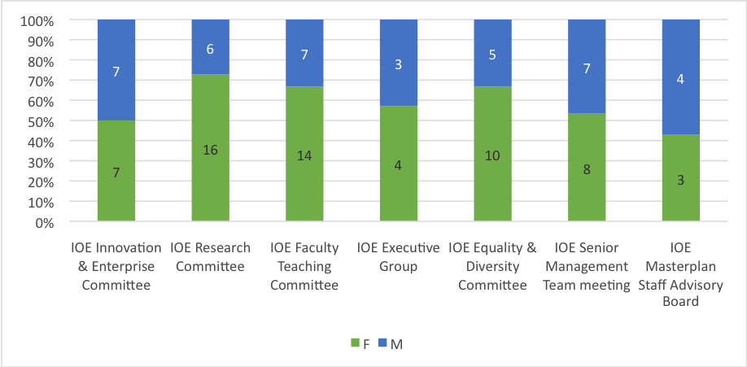

We view the proportion of female Chairs of and members on key committees as positive. However, we will work with SMT to ensure we gather and monitor data on diversity of membership on an annual basis (AP 1.4) to ensure that men are also proportionally represented in service roles (AP 3.4).

Action 1.1 |  | To continue to build the relationship we have developed between Athena SWAN and IOE Senior Leadership
Action 1.2 |  | To continue to maximise the potential value of working relationships between IOE Athena SWAN and existing UCL and IOE management, committees and roles concerning equality and diversity in relation to synergy between the development and implementation of policy and practice
Action 1.4 | To gather, monitor and respond to data on committee membership concerning gender and intersectionality
Action 3.4 | Address need to address the low percentage of men within the IOE workforce

- Participation on influential external committees

As a research intensive department, many of our staff are members of journal editorial boards, and research funding review panels though we do not hold data on this currently due to the volume of activity across the IOE academic community. We have significant representation women on groups in UCL for example, the Director (F) sits on 8 influential committees in the wider University, and chairs the UCL Prevention of Sexual Misconduct Strategy Group and a recently promoted female Professor is co-Chair of the UCL Ethics Committee. We view this service work as positively contributing to progression and career development (AP 5.1), but as yet we do not systematically collect data on this work. We will develop ways to record service activities in order to monitor gender and wider intersectional representation more systematically (AP 1.4). Currently gender balance is positive, but we recognise that we are still significantly underrepresented on external committees by our BAME staff and this is also linked to recruitment and progression (AP 1.4).

- Workload model

Since 2011, the IOE has operated a workload management system (WMS) for academic staff, agreed by the UCU and SMT. Time is allocated for teaching programmes and supervision, with 0.05 FTE for service activity, and 0.2 FTE for research to staff on academic contracts. Using the time allocation for tasks contained in the WMS, HOD have responsibility to allocate work in a fair, equitable and transparent way in discussion with individual staff members and in such a way that is responsive to the changing shape of our business need, individual progression and interests. HOD are required to keep records of staff workload and these are made available to the individual and to the PDAD for monitoring purposes. Our workload model is currently subject to review in order to accommodate our growing UG provision and the newly established Teaching Fellow career route. All leadership roles are allocated FTE on staff workload and are subject to the UCL recruitment policy. With SMT we will explore ways to monitor staff perception of workload allocation around gender and intersectionality (AP 1.2).

- Timing of departmental meetings

Currently all key management meetings and committees are held within office hours 9am-5pm, and where possible between the core hours of 10am and 4pm, but our action on improving knowledge and understanding of flexible working and leave policies, will enable further scrutiny of how this is working in practice (AP 8.1; 8.2; 9.1). Key management and committee meetings are scheduled for the full academic year in the previous summer term to allow for staff to make appropriate arrangements to attend if they are part-time, working flexibly or with caring responsibilities. Our postgraduate teaching programmes mainly take place in the evenings, as many of our students are part-time and working during the day. Increasingly we are developing blended and online programmes to facilitate more flexible study options. For staff working on UG and ITE programmes teaching and school supervision takes place during the day, so we will ensure that flexible working arrangements are taken into account when planning meetings (AP 8.1). Events are held throughout the day and evening to allow for the wide range of student attendance and external visitors to the organisation, and to allow for optimum access.

- Visibility of role models

We actively promote role models of both genders through our various channels of communication and will monitor intersectional engagement in activities, which provide diverse role models (AP 3.7). Research successes are routinely celebrated at SMT, on the IOE website and intranet; teaching fellowships, promotions, external recognition and awards are shared widely via the website, the Director’s termly whole staff address and departmental newsletters. The IOE Assembly includes staff from across the organisation highlighting key projects and initiatives, paying attention to gender and intersectional characteristics in speakers. On gender equality work, it has been challenging to recruit male colleagues to the EDI committee and the AS SAT and AS Extended SAT. The appointment of a senior academic male co-Chair for AS is a strong positive role model, but we have identified the need for more male role models particularly in the area of equalities work, on promoting our teaching career routes, and at lower grade PS, supported by further work on gender aware recruitment and career mentoring (AP. 3.4; 6.3). In line with our mission and values, we strive to act as a good role model for gender equality and diversity in our events programme. The events team pay meticulous attention to diversity and inclusion in relation to panellists, as well as to framing debates in such a way that they can say something new whilst catering to a wide and non-specialist audience. As well as researchers and students in education and social science, the events attract a diverse audience of teachers, parents, the wider public, as well as generating very productive and positive coverage across mainstream and social media which we keep under review (AP 3.7).

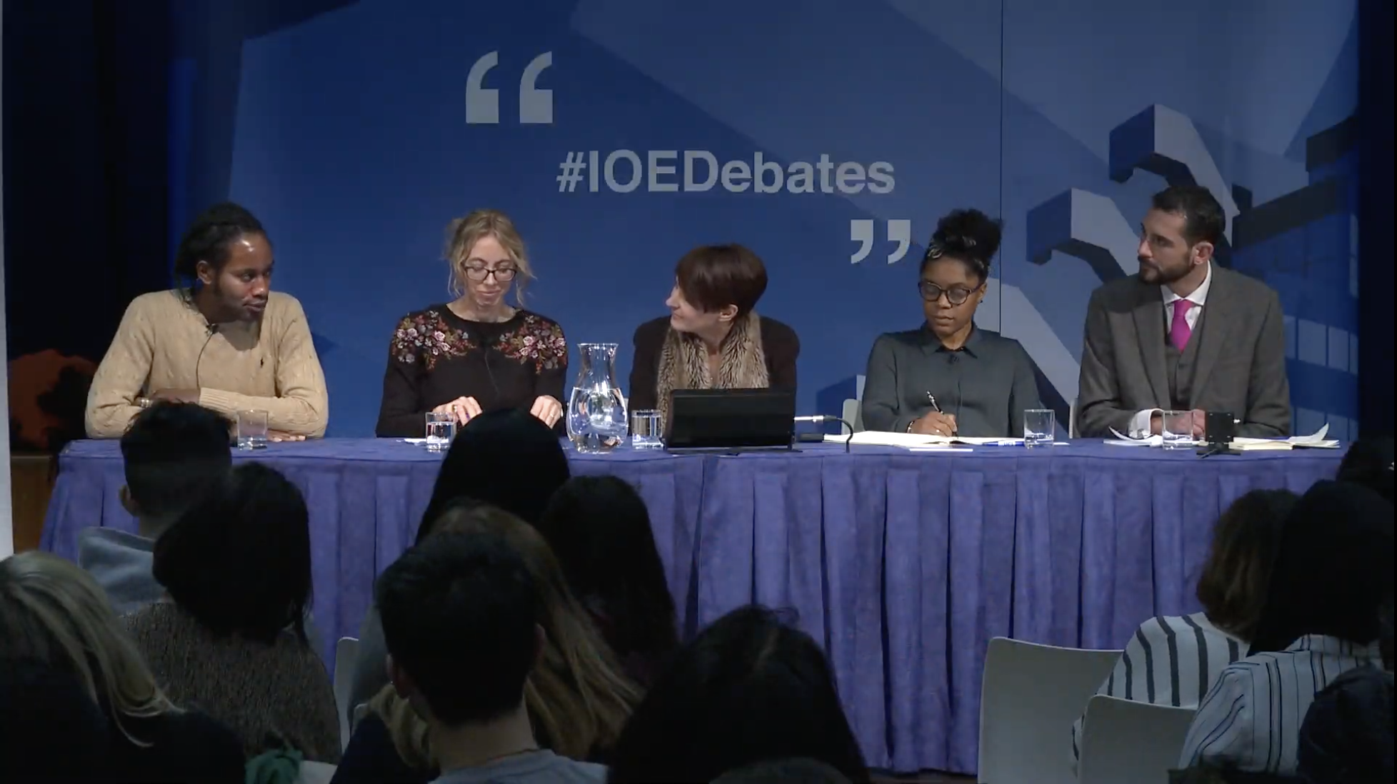

The events team prioritise accessibility, for those with mobility and hearing impairments (e.g. using subtitling, etc. – in the process improving awareness of such provisions across the IOE), building a two-way dialogue with the audience, supporting dialogue across the audience and speakers for each event, in person and via social media. In our public debate series, our ‘flagship’ public engagement forum, we aim to achieve diversity as well as excellence in our speakers. The panel is chaired by the Director, and we ensure at least one female and one BME panellist for each event. For example, the panel for ‘What if our main objective of education was to build wisdom?’ included one female and one BME male. For the debate ‘What if we wanted our kids to be happier?’ the panel included 3 females (2 BME). In terms of further intersectionality, beyond gender and ethnicity, we have also included speakers with disability, ‘out’ LGBTQ+ speakers and broad age profile. Additionally the Chair of the panel, ensures gender balance is reflected in the Q&A segment. Our Marketing and Communications team select images for the event webpages and marketing, with diversity as a high priority.

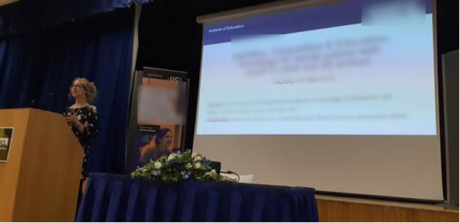

Our Professorial lecture series also pays careful attention to visibility for female and BME colleagues. In 2017-19, five out of eight speakers were female, one BME (who launched the series). For the 2019/20, out of five speakers we have one male BME and one female BME speaker. Women and BME speakers have been well represented at occasional and one off events (e.g. at the Centre for Teachers and Teaching Research launch), and women have also been well represented – the two female Global Teachers of the Year, for instance (with BME respondents) (AP 3.7).

Action 3.4 | Address need to address the low percentage of men within the IOE workforce
Action 3.7 | To monitor and review IOE communications on the internet and intranet in terms of gender and intersectionality in key areas such as:  Research successes; awards; public and internal seminars and lectures; teaching fellowships; student success; teaching fellowships  To identify and redress imbalance of representation concerning gender and intersectionality

- Outreach activities

Provide data on the staff and students from the department involved in outreach and engagement activities by gender and grade. How is staff and student contribution to outreach and engagement activities formally recognised? Comment on the participant uptake of these activities by gender.

Table 25: Percentage of students and staff involved in open days by gender (2018/19)
Staff and student ambassadors involved in IOE Events 2018-2019.

 |  | Students |  | Staff
Event | Event Date | F | M | F | M
ITE Open Evening | 10/10/2018 | 100% | 0 | 56% | 44%
UCL-wide Graduate Open Evening | 05/12/2018 | 0 | 100% | 62% | 38%
Offer Holder Day - Social Sciences | 12/02/2019 | 100% | 0 | 50% | 50%
Offer Holder Day - Psychology of Education | 26/02/2019 | 71% | 29% | 80% | 20%
IOE Graduate Open Evening | 06/03/2019 | 100% | 0 | 50% | 50%
Taster Day - Social Sciences | 13/03/2019 | 100% | 0 | 50% | 50%
UCL-wide Undergraduate Open Day | 28/06/2019 | 100% | 0 | 56% | 44%
UCL-wide Undergraduate Open Day | 29/06/2019 | 100% | 0 | 90% | 10%
Taster Day - Psychology of Education | 15/05/2019 | 80% | 20% | 83% | 17%
UCL-wide Undergraduate Open Day | 07/09/2019 | 88% | 12% | 40% | 60%

Percentage of students and staff involved in open days by gender (2018/19)
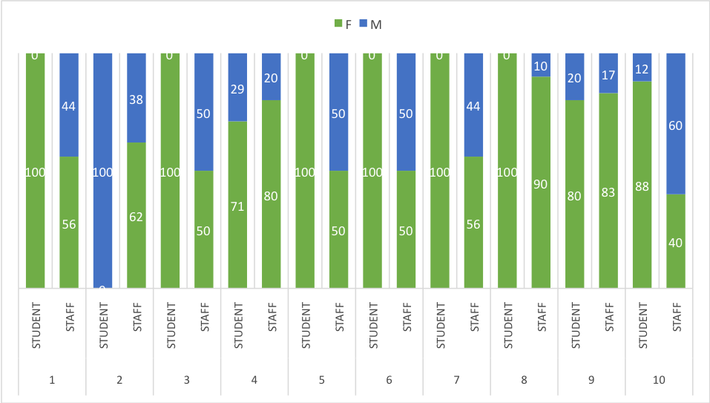
1: ITE Open Evening; 2: UCL-wide Graduate Open Evening; 3: Offer Holder Day-Social Sciences; 4:Offer Holder Day - Psychology of Education; 5: IOE Graduate Open Evening; 6: Taster Day - Social Sciences; 7: UCL-wide Undergraduate Open Day; 8: UCL-wide Undergraduate Open Day; 9: Taster Day - Psychology of Education; 10: UCL-wide Undergraduate Open Day

Staff are encouraged to attend outreach events on their specific programmes. Events are held both in the evening and during the day to allow for maximum accessibility and reach. We do not have a complete data set of outreach events by gender over the application period, due to changes in systems following merger (AP 10.1). However, from the data recorded in the past academic year, we can see that there is more work to be done on attracting male students to our open day events. In relation to our overall staff gender balance of 70/30 in favour of females, attendance of male staff at outreach events is positive at 42% overall. Our action plan identifies ways in which we intend to further attract men onto our undergraduate programmes and monitor attendance (AP 10.1; 10.4; 10.5).

Action 10.1 | Redress gender imbalance manifest in Undergraduate, PGT, ITE and PGR Student Populations, through gender aware recruitment and marketing strategies
Action 10.4 | Provide additional support to encourage students from under-represented groups to consider and engage in progression in their studies
Action 10.5 | To create more effective systems for gathering data on students

Word Count: 5694

