**Policy Research Unit in Cancer Awareness, Screening and Early Diagnosis**

|  |  |  |  |  |  |
| --- | --- | --- | --- | --- | --- |
| barts_white_large |  | |  | | KCL_no UoL_letterhead_3#21D |
| HYMS_logo_small.JPG | | logounidurham | |  | |

**Policy Research Unit Work Programme** **Theme: Early Diagnosis**

# 

# eCREST feasibility trial

Research protocol

Protocol Version 4: April 2019

Research Governance Sponsor: University College London

Protocol Number:

IRAS number: n/a

UCL Data protection no: Z6364106/2016/09/51

UCL ethics registration no: 9605/001

Funders: NIHR Policy Research Unit in Cancer Awareness, Screening and Early Diagnosis, The Health Foundation and CLAHRC North Thames.

**VERSION HISTORY**

Protocol version 4

Date April 2019

*Previous versions:*

Version 1 2016 – approved by UCL ethics, 31st October 2016

Version 2 2017 - – amendment approved by UCL ethics 31st October 2016, UEA and Barts

Version 3 2018 – includes plan to develop new clinical reasoning measures – developed 12th December 2017

Version 4 2019 – minor amendments to format, references.

**ABBREVIATIONS & GLOSSARY OF TERMS**

|  |  |
| --- | --- |
| **eCREST** | electronic Clinical Reasoning Educational Simulation Tool |
| **GP** | General Practitioner |
| **MBBS** | Bachelor of Medicine, Bachelor of Surgery (professional medical degree) |
| **OPS** | Online patient simulations |
| **PI** | Principal Investigator |
| **PRU** | The NIHR Policy Research Unit in Cancer Awareness, Screening and Early Diagnosis |
| **UCL** | University College London |
| **UEA** | University of East Anglia Medical School |

Text in red used to highlight significant changes to the protocol since ethics was obtained.

**CHIEF INVESTIGATOR**

I accept ultimate responsibility for the contents of this protocol.

Signed

Date

Jessica Sheringham (UCL)

|  |  |
| --- | --- |
| **Other Policy Research Unit investigators** | **External collaborators that developed eCREST** |
| Dr Angelos Kassianos – led development of the eCREST learning resource  Ruth Plackett – led evaluation - development of data collection measures, recruitment strategy  PRU executive committee Co-PI: Prof Rosalind Raine (UCL)  Prof Stephen Duffy (QMUL) : Statistical oversight  Prof Willie Hamilton (Exeter) : Clinical input on development of eCREST | Silver District web developers   * Michael Rybarczyk * Sam Huby   **GP registrars**   * Shani Gray * Jenny Hopwood * Natasha Kay * Sophie Mylan * Patricia Schartau * Jessica Thomas   UCL Medical School   * Sarah Bennett * Christopher Valerio |

**STUDY SITES:** University College London, Barts & The London School of Medicine, University of East Anglia Medical School

**RESEARCH GOVERNANCE SPONSOR**

University College London

**STUDY CONTACT**

Dr Jessica Sheringham

Department of Applied Health Research, UCL

1-19 Torrington Place, London WC1E 7HB

T: +44(0)207 679 8286; E-mail: [j.sheringham@ucl.ac.uk](mailto:j.sheringham@ucl.ac.uk)

Contents

[eCREST feasibility trial 1](#_Toc5264731)

[1. Summary 7](#_Toc5264732)

[2. Background 8](#_Toc5264733)

[3. Study aims and objectives 9](#_Toc5264734)

[4. Design and Methods 9](#_Toc5264735)

[4.1 Study design 9](#_Toc5264736)

[4.2 Recruitment strategy 9](#_Toc5264737)

[4.2.1. Inclusion criteria 10](#_Toc5264738)

[4.2.2. Exclusion 10](#_Toc5264739)

[4.2.3. Consent 10](#_Toc5264740)

[4.3 Data collection instruments 10](#_Toc5264741)

[4.3.1. Registration 10](#_Toc5264742)

[4.3.2. Knowledge 10](#_Toc5264743)

[4.3.3. Reported clinical reasoning skills survey 10](#_Toc5264744)

[4.3.4. Online patient simulation cases 11](#_Toc5264745)

[4.3.5. Post completion survey on acceptability and perceived value of eCREST to support students’ learning 11](#_Toc5264746)

[4.4 Statistical considerations 12](#_Toc5264747)

[4.4.1. Sample size 12](#_Toc5264748)

[4.4.2. Outcome measures 12](#_Toc5264749)

[4.5 Analysis 13](#_Toc5264750)

[4.5.1. Main analysis 13](#_Toc5264751)

[4.5.2. Secondary analyses 13](#_Toc5264752)

[5. Study procedures 13](#_Toc5264753)

[5.1 Recruitment and consent 13](#_Toc5264754)

[5.3 Data collection 14](#_Toc5264755)

[6. Assessment of safety 16](#_Toc5264756)

[7. Direct access to data and documents 16](#_Toc5264757)

[8. Ethical and legal issues 16](#_Toc5264758)

[9. Committees and oversight 16](#_Toc5264759)

[10. Side effects and adverse events 16](#_Toc5264760)

[11. Financing and insurance 17](#_Toc5264761)

[12. Administrative aspects 17](#_Toc5264762)

[13. Documentation 17](#_Toc5264763)

[14. Publication policy 17](#_Toc5264764)

[Reference List 18](#_Toc5264765)

[Appendix 1. Summary of clinical cases 19](#_Toc5264766)

[Appendix 2: Study documentation 20](#_Toc5264767)

[Email advertisement and RUMS bulletin advert (mailing list) to take part online 20](#_Toc5264768)

[Facebook adverts and posts 21](#_Toc5264769)

[Information sheet 23](#_Toc5264770)

[Acceptability questionnaire 26](#_Toc5264771)

[Self-report clinical reasoning measure. 27](#_Toc5264772)

# Summary

**Background:** Flaws in clinical reasoning – thought processes required to identify likely diagnoses, formulate appropriate questions and reach decisions during patient consultations - are important causes of diagnostic errors amongst qualified doctors. It is therefore recommended that clinical reasoning skills are integrated into medical education. Online patient simulations enable students to practise such skills in a safe environment. However, there are gaps in our understanding of optimal designs, impacts on learning and effective application to clinical reasoning tasks faced in primary care. We developed a new online resource, eCREST (electronic Clinical Reasoning Educational Simulation Tool) to support future doctors to make decisions when faced with patients with common symptoms that could be cancer.

**Aim and objectives:** This feasibility study aims to inform the design of a full trial to evaluate the effectiveness of eCREST in improving future doctors’ clinical reasoning skills. Through the feasibility trial we will:

1. Develop recruitment strategies for use in a trial
2. Estimate the likely uptake and completion of eCREST in a trial setting
3. Assess the usability, acceptability and perceived value of eCREST to medical students
4. Develop and validate measures to assess clinical reasoning skills
5. Explore potential impacts of eCREST on clinical reasoning skills

**Methods:** Final year medical students will be recruited in three medical schools. A feasibility trial will useparallel intervention and control groups, with individual level randomisation. Feasibility will be assessed through: student uptake, completion and acceptability.

Clinical reasoning will be measured in both groups before and after participation.

Descriptive statistics will be generated on overall uptake, completion and acceptability. Variations by student characteristic (university, gender, age, cohort) will be investigated by stratifying analyses into these groups. Exploratory analysis will be conducted on changes in clinical reasoning, comparing intervention and control groups and changes over time.

# Background

The Policy Research Unit in Cancer Awareness, Screening and Early Diagnosis (PRU)-funded interactive GP vignettes study (2011-2015) used lung cancer as an exemplar to understand variations in decision-making and factors associated with GPs’ readiness to investigate patients. Each vignette ‘patient’ had two symptoms that are common in patients diagnosed with lung cancer. One symptom was volunteered at the beginning of the consultation; the other was only shared if the GP asked about it. Our study showed that GPs are more likely to make appropriate decisions when they have elicited sufficient appropriate information on symptoms. However, in 40-50% of cases, GPs did not ask ‘patients’ questions about common, non-specific symptoms and therefore did not find out all of the symptom information available. For example, when GPs did find out that vignette patients had lost weight, in 91% of cases they ordered an appropriate investigation (as opposed to 46% of cases when they did not elicit this information).(1) One implication from this study was that prompting doctors to elicit potentially pertinent information in consultations on non-specific symptoms could improve decision-making.

A further literature review, co-development of a prototype e-resource (Case of the Month) with medical students, consultation with doctors, trainees and experts in medical decision making suggested that an educational resource could be beneficial. It also led us to:

* focus on clinical reasoning rather than cancer diagnosis. Clinical reasoning can be influenced by cognitive biases, inherent errors in thinking that deviate from rational thinking (2). The learning resource will target three particular biases of most relevance to diagnostic errors: confirmation bias, refers to the tendency to seek information to confirm a hypothesis rather than refute it; anchoring refers to the tendency to stick to an initial hypothesis despite new contradictory information and the unpacking principle refers to the tendency not to elicit all the necessary information to make an informed judgement.(2, 3)
* target medical students, to influence the skills of future doctors, which was recommended by the Institute of Medicine report on reducing diagnostic error.(4)
* Experience with the prototype e-resource (Case of the Month) indicated that final year medical students would have sufficient clinical knowledge to benefit from such a resource.

We co-developed eCREST (electronic Clinical Reasoning Educational Simulation Tool) featuring four online patient simulations with GP registrars, UCL medical school faculty and UCL medical school students. The development of eCREST will be described elsewhere. eCREST can also be viewed at: <http://silverdistrict.uk/ecrest/>

Username: admin Password: silverECREST2017

# Study aims and objectives

Aim: This feasibility study aims to inform the design of a full trial to evaluate the effectiveness of eCREST in improving future doctors’ clinical reasoning skills.

**Objectives**

We will conduct a feasibility trial to:

* Develop recruitment strategies for use in a trial
* Estimate the likely uptake and completion of eCREST in a trial setting
* Assess the usability, acceptability and perceived value of eCREST to medical students
* Develop and validate measures to assess clinical reasoning skills
* Explore potential impacts of eCREST on clinical reasoning skills

# Design and Methods

## Study design

A feasibility trial will be undertaken using parallel intervention and control groups, with individual level randomisation. Clinical reasoning will be measured in both groups before and after participation.

## Recruitment strategy

We will recruit final year medical students. These students are in GP placements. eCREST will not be a mandatory part of that module. The module lead for the GP placement module will also promote the research study to participants verbally, through Moodle and through email. Students will receive £20 Amazon gift voucher for their participation.

Initially we planned to recruit in 2016/7 in UCL and Barts Health medical schools in terms 2 and term 3 of their course using face to face methods during teaching days. In May 2017, after poor recruitment using this strategy, we obtained an amendment to ethics permission to revise the recruitment strategy in the following ways:

* Extend the period of recruitment to include the academic year 2017/8
* Revise invitation materials
* Share information about the study on social media as well as student bulletins
* Introduce a final £10 gift voucher at completion of the full study
* Recruit from a third medical school, University of East Anglia.

The process of recruitment is described in Section 5.

## Inclusion criteria

All medical students within eligible year group (final year) in 2016/7 and 2017/8 will be invited to participate.

## Exclusion

There are no exclusions.

## Consent

Students will tick a box once they log onto eCREST to confirm they consent to participation.

## Data collection instruments

## **Registration**

A short online registration form collects information on participants’ age, gender and previous degrees. It also requests students to generate a username and password.

## Knowledge

A respiratory medicine knowledge quiz is presented to both groups before and after the intervention. This comprises five single best answer questions, developed by GP trainees with validation from medical school faculty. The quiz serves two purposes: it enables students to ensure they have sufficient clinical knowledge before starting the cases and it provides the evaluators with an indicator of students’ prior knowledge levels as a covariate, so we can examine whether this affects students’ reasoning ability. The questions are not included in the protocol to prevent those using eCREST from seeing them in advance.

## Reported clinical reasoning skills survey

A survey on clinical reasoning will be administered before and after the students have completed all the online patient simulations. An adapted version of the Flexibility in Thinking (FIT) Scale of the Diagnostic Thinking Inventory will be used to assess self-reported clinical reasoning skills. This subscale aims to measure the variety of thought processes that can be applied in the diagnostic process. It was developed by Bordage, Grant and Marsden in 1990.(5) RP has adapted this measure based on feedback from experts and medical students regarding the content and face validity of the measure. (see Appendix 2 for a copy of the scale).

## Online patient simulation cases

Four patient cases have been developed by GP registrars; three of them use videos generated for the GP vignettes research study. The fourth case required a new set of videos. A summary of the cases are given in Appendix 1 and a screen grab shown in Figure 4.1. Students in the intervention group work through three cases. Students in both the control and intervention groups work through a final case. Each key stroke performed in completing the cases is automatically stored, enabling detailed analysis of students’ journey through the cases. From 2018, we agreed to develop an adapted Key Feature Test measure of clinical reasoning from students’ completion of simulated cases that is specific to the cognitive errors that eCREST targets. The development of an additional reasoning measure followed the recognition that the FIT scale clinical reasoning measure is normally used to measure changes in reasoning over years of study, rather than hours, so may lack sensitivity to detect changes in eCREST. It is also a self-report measure so unlike Key Features measures, it may not capture actual reasoning. The Key Features will be focused on the thought processes involved in making clinical decisions, including the gathering and interpretation of data, and not on the final consultation outcomes e.g. diagnostic accuracy.

## Post completion survey on acceptability and perceived value of eCREST to support students’ learning

All intervention students will invited to complete a short survey consisting of seven questions to capture their opinions on the value of eCREST and their motivation for taking part in the study. Six of the questions require students to respond on a five point Likert scale from strongly agree to strongly disagree, one question is open-ended, with the opportunity to leave free text comments at the end. (see Appendix 2)

Figure 4-1. Screen grab showing eCREST “waiting room”

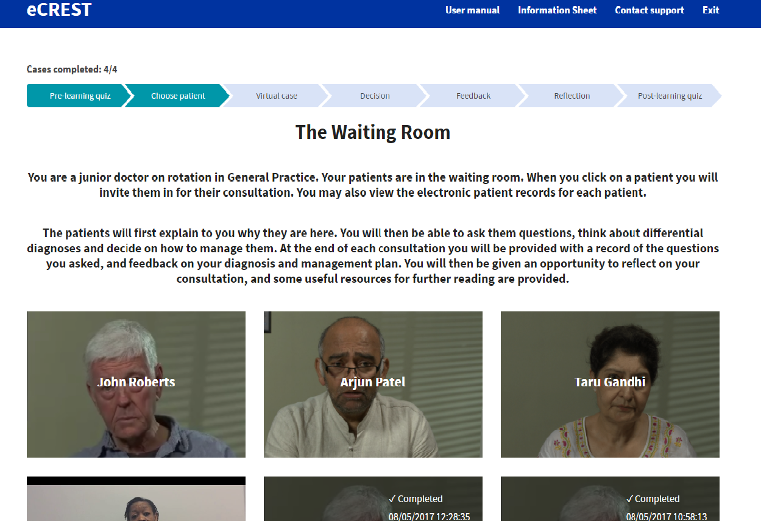

## Statistical considerations

## Sample size

This is a feasibility study, so the main study objective is to determine the sample size required and the numbers of students we would need to approach to detect significant improvements in clinical reasoning.

## Outcome measures

Outcomes for the feasibility trial

* Uptake: % of all those eligible for eCREST that register
* Completion: % of all those registering for the tool that complete a) three cases and b) all cases
* Perceived value: Scores on Likert scale on self-reported learning, views on eCREST, collected through feedback free text.

Primary outcome (for the full trial): in the feasibility trial we will develop measures of students’ clinical reasoning. Data will be collected in two ways:

* Flexibility in thinking scale (reported reasoning)
* Performance on the online simulations (observed reasoning) (adapted Key Features Test) developed as part of the feasibility trial.

## Analysis

## Main analysis

Descriptive statistics will be generated on overall uptake, completion and acceptability. Variations by student characteristic (university, gender, age, cohort) will be investigated by stratifying analyses into these groups.

## Secondary analyses

Reported clinical reasoning: An exploratory analysis will be conducted on changes in clinical reasoning. A Mixed ANOVA will be conducted to determine how the Flexibility in Thinking Scale (clinical reasoning) changes over time between the intervention and control group and any interactions between time and group, controlling for pre-intervention knowledge (if necessary).

Key features-assessed clinical reasoning: Further analyses will be informed by the measure of clinical reasoning developed but we envisage we will compare:

* clinical reasoning scores between intervention and control groups on the final patient case
* clinical reasoning in the intervention group on the first and later cases, to see if there is a practice effect.

# Study procedures

# Recruitment and consent

We will recruit students through three medical schools. Medical school faculty with responsibility for teaching final year medical students have agreed that students may be approached to participate in the study. Participation is voluntary, not a requirement of course completion.

The process by which recruitment to the study takes place is shown in Figure 5.2.

Figure 5.2 Recruitment process

## Randomisation

Students will be randomised by the computer using a single sequence (simple) randomisation and there will be equal allocation with a ratio of 1:1 between the two conditions. Randomisation will be performed following registration, consent and baseline assessment.

### Data collection

A flowchart (Figure 5.3) shows how students will progress through the study. All participants will first need to register online and complete a 15 minute online quiz about their respiratory medicine knowledge and a standardised survey of clinical reasoning, The Flexibility in Thinking Scale of The Diagnostic Thinking Inventory (DTI). Those in the intervention group will receive eCREST and have 1 week to complete 3 patient cases. Each patient case in eCREST will take approximately 20-30 minutes and should be completed individually. Students can ‘Exit’ eCREST at any point and return by logging in. The control group will not receive eCREST but will have an opportunity to access the cases after the study is over. One week after registering all students will be sent a follow-up online quiz about their clinical reasoning and the intervention group will also receive a short user experience survey. One month later all students will be sent a final follow-up online quiz of respiratory medicine knowledge, the DTI and the intervention group will also receive a fourth patient case to complete in eCREST. If students complete the intervention and the first follow-up quiz they will receive a £20 Amazon online gift voucher. If students also complete the final follow-up quiz they will receive an additional £10 gift voucher.

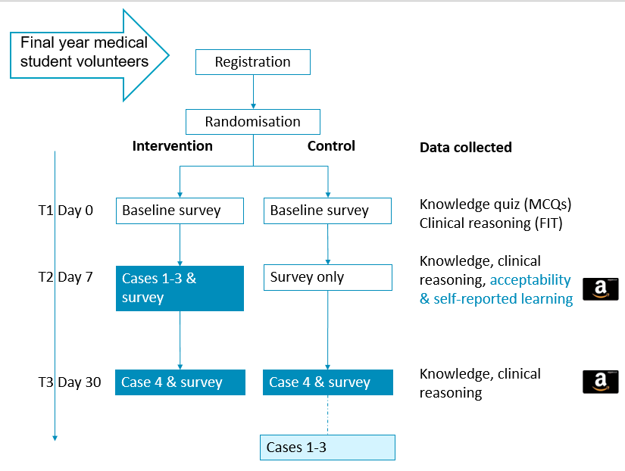

Figure 5.3. Flowchart of participants & data collection points through the study

# Assessment of safety

There are no safety issues attached to this study since there will be no intervention in individual cases.

# Direct access to data and documents

The investigator(s)/institution(s) will permit study-related monitoring, audits, and review by authorised governance bodies, and will allow direct access to source data/documents if required.

UCL recognise that there is an obligation to archive study-related documents at the end of the study (as such end is defined within this protocol).  The Chief Investigator confirms that he/she will archive the study master file at UCL for insert 20 years from the study end.

# Ethical and legal issues

University ethics approval was obtained from all participating medical schools (UCL Research Ethics Committee, ref: 9605/001 31st October 2016; Institute of Health Sciences Education review committee at Barts and The London medical school, ref: IHSEPRC-41 31st January 2017 and the Faculty of Medicine and Health Sciences Research Ethics Committee at Norwich medical school University of East Anglia, ref: 2016/2017 – 99 21st October 2017). All data will be processed according with the General Data Protection Regulation (GDPR) and the Data Protection Act (2018) ‘*data protection legislation’*. The Data Controller for the study will be University College London.

# Committees and oversight

Updates on the project will be shared with the PRU through the regular PRU meetings. Since this study does not involve intervention in patients, a data monitoring and safety committee is unnecessary.

# Side effects and adverse events

Not applicable

# Financing and insurance

The study will be financed by the PRU Programme Grant. There are no serious insurance/indemnity issues.

# Administrative aspects

Other administrative aspects will be co-ordinated by the PRU and will adhere to current regulations concerning Research Governance.

# Documentation

The following documentation (documents in bold in Appendix 2) have been approved by ethics.

* Recruitment materials, including online invitation text, Facebook advertisement and RUMS bulletin announcement
* Participant information sheet
* Clinical reasoning self-report measure
* Post-completion survey on eCREST’s acceptability and perceived value to support learning

**Investigator file**

In addition, the co-ordinator and PI will maintain an investigator file, which will include the following study documents:

* Correspondence
* Data log
* PI/Staff details

# Publication policy

Results will be published in peer-reviewed journals, after submission to and approval by the Policy Liaison Officer responsible for the PRU.

# Reference List

1. Sheringham J, Sequeira R, Myles J, Hamilton W, McDonnell J, Offman J, et al. Variations in GPs' decisions to investigate suspected lung cancer: a factorial experiment using multimedia vignettes. BMJ Qual Saf. 2017;26(6):449-59.

2. Norman GR, Eva KW. Diagnostic error and clinical reasoning. Medical education. 2010;44(1):94-100.

3. Lyratzopoulos G, Vedsted P, Singh H. Understanding missed opportunities for more timely diagnosis of cancer in symptomatic patients after presentation. Br J Cancer. 2015;112 Suppl:S84-91.

4. Institute of Medicine. Improving Diagnosis in Health Care. Balogh EP, Miller BT, Ball JR, editors. Washington, DC: The National Academies Press; 2015. 472 p.

5. Bordage G, Grant J, Marsden P. Quantitative assessment of diagnostic ability. Medical education. 1990;24(5):413-25.

6. Singh H, Giardina TD, Meyer AN, Forjuoh SN, Reis MD, Thomas EJ. Types and origins of diagnostic errors in primary care settings. JAMA internal medicine. 2013;173(6):418-25.

# Appendix 1. Summary of clinical cases

|  |  |  |
| --- | --- | --- |
|  | **Key features** | |
| **Case 1** | **Key patient info** | John Roberts, Caucasian, male, 82 years old, retired. |
|  | **Initial presenting symptom** | Long duration cough despite having flu jab. Family have also encouraged him to see the GP. |
| **Case 2** | **Key patient info** | Arjun Patel, Asian, male, 64 years old, security guard. He has history of hypertension, high cholesterol and pre-diabetes. |
|  | **Initial presenting symptom** | Feeling tired all the time. Tired when wakes up. |
|  |  |  |
| **Case 3** | **Key patient info** | Taru Gandhi, Asian, female, 58 years old, dinner lady. History of sharing living space with family from India. |
|  | **Initial presenting symptom** | Chest pains described as annoying and preventing her from doing everyday things |
| **Case 4** | **Key patient info** | Zoya Akintola, African, female, 51 years old, cleaner. Smoker 44 pack years. |

|  |  |  |
| --- | --- | --- |
|  | Initial presenting symptom | Requests flu jab as prone to chest inflections in winter and getting more breathless |

# Appendix 2: Study documentation

## Email advertisement and RUMS bulletin advert (mailing list) to take part online

**6th years – Take part in a study to improve your clinical reasoning**

Clinical reasoning skills are increasingly recognised as essential for practice. You can practise your clinical reasoning on simulated online patients by taking part in this randomised controlled feasibility trial. This trial, funded by the Department of Health and The Health Foundation, is exploring whether a new **online patient simulation** training tool ([eCREST](https://www.facebook.com/ecrestucl/)) can improve clinical reasoning.

**Taking part**

* [REGISTER HERE](http://silverdistrict.uk/ecrest/?page=register).
* Complete a **15 minute online quiz** about your knowledge and clinical reasoning skills
* You will then be randomised to one of two groups:
  + The intervention group will have **1 week to complete 3 patient cases online**;the control group will complete the quizzes only and get feedback, they will have access to the simulations after the study has ended.
* Both groups need to complete an online quiz 1 week after you register to receive a **£20 Amazon e-gift card.** An **extra £10** will be given if you complete another online quiz 1 month later.
* **This study will take** **~ 1.5 hours in total and can be completed at a time of your choosing. You can save your work and come back to it.**

**Benefits**

* Improve your clinical reasoning
* Add skills and experience to your CV e.g. participating in research
* Revise and apply knowledge and skills in respiratory and general practice
* **£30 gift voucher**
* Certificate of completion for your e-portfolio

A recently qualified medical student who tested eCREST said:

*“Instead of worrying about what to ask, it [eCREST] helps you to focus on “what might be relevant”. Even if your question is irrelevant, you can still hear patient’s response and see the outcome…Loved it!"*

This research is supported by **UCL Medical School Research** Team and has been approved by **UCL Research Ethics Committee**.

Contact [dahr.ecrest@ucl.ac.uk](mailto:dahr.ecrest@ucl.ac.uk) for more information.

## Facebook adverts and posts

See link to Facebook page <https://www.facebook.com/ecrestucl/>

Facebook picture adverts:

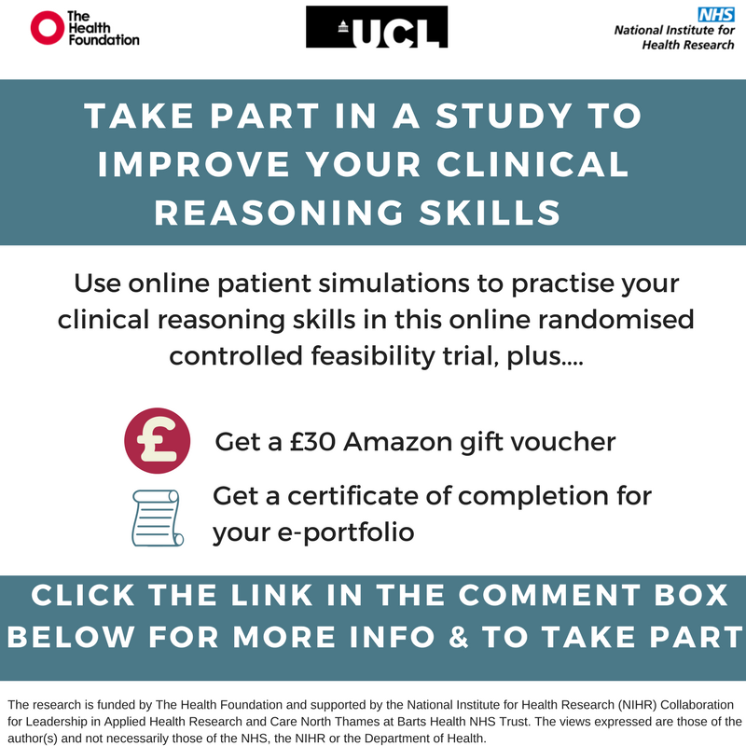



Facebook text adverts:

Final year medical students – take part in research to improve your clinical reasoning skills, get a £30 Amazon gift voucher and a certificate of completion for your e-portfolio.

This is a randomised controlled feasibility trial exploring whether a new online patient simulation training tool ([eCREST](https://www.facebook.com/ecrestucl/)) can help to improve clinical reasoning.

Take part by registering here: <http://silverdistrict.uk/ecrest/?page=register>

Slideshow on Facebook showing a demonstration of the tool: <http://www.photosnack.com/RuthPlackett/ecrest.html>

Quote used as post for the Facebook page: A recently qualified medical student who tested eCREST said:

“Instead of worrying about what to ask, it [eCREST] helps you to focus on “what might be relevant”. Even if your question is irrelevant, you can still hear patient’s response and see the outcome…Loved it!"

## Information sheet

**LONDON’S GLOBAL UNIVERSITY**

Thank you for considering to take part in this study, **funded by the Department of Health and The Health Foundation.**

This study has been approved by the UCL Research Ethics Committee (Project ID Number): **9605/001.**

We would like to invite medical students in their **final year** of study to participate in this research project.

Please discuss the information below with others if you wish, or ask us if there is anything that is not clear or if you would like more information.

**Details of Study**

*What is the purpose of the study?*

This research seeks to evaluate a newly developed online learning tool using patient simulations called eCREST. ECREST was developed by a multidisciplinary team including UCL medical school tutors, GP registrars, health psychologists and experts in public health; with input from medical students, experts in medical education, primary care diagnostics and health care evaluation. ECREST simulates real consultations between a junior doctor and a patient in General Practice, in which the ‘patients’ are presenting to their GP with respiratory symptoms. The overall aim of the project is to test whether using eCREST can improve clinical reasoning in this context. This study aims to test the feasibility of conducting a randomised controlled trial of eCREST.

*Why is it important?*

The reason this study is being conducted is to address the need for the development of more specific training on clinical reasoning in medical education. Clinical reasoning refers to the thought processes you use to make clinical decisions, such as making a diagnosis and a management plan. Training on clinical reasoning is being increasingly recognised as essential in reducing diagnostic errors, which affect around 5-10% of patients, and can have devastating consequences for patients (4, 6).

*What do I have to do?*

All participants register to take part in the study which requires providing your name, email address, date of birth, and creating a username and password.

All participants will complete an online quiz about your knowledge and clinical reasoning skills, which will take approximately 15 minutes. All participants will then be randomised to one of two groups:

1. The intervention group, will have **1 week to complete 3 patient cases online.** For each virtual patient case you will have opportunity to ask ‘patients’ questions using a drop down menu and receive their patient history. You will also be asked at several points throughout the consultation to provide a differential diagnosis and management plan. At the end of each case we will provide you with feedback on how a GP and GP Registrar would have managed the case and ask you to complete the ‘My Learning’ page after you’ve completed the 3 cases. Each patient case in eCREST will take approximately 20-30 minutes and should be completed individually. You can ‘Exit’ eCREST at any point and return by logging in using your username and password.
2. The control group, will complete the **online quizzes** **only** and get feedback. The control group will have access to the simulations after the study has ended if you wish.

Finally, all participants complete an **online quiz 1 week after** registration to receive a **£20 Amazon e-gift card**. An **extra £10** will be given if you complete another **online quiz 1 month later**.

*What happens next?*

If you are willing to take part in the study, click on the ‘I agree’ button at the bottom of the sheet. You’ll then be directed the registration page and after you register you can start the study.

*Will anyone else (e.g. my tutors/UCL medical school) see my scores/performance?*

No. Only the researchers will have access to this data. Your data will only be used for research purposes and it will not contribute to your final grades, be used as an assessment, or shared with any third parties. You have the option however of printing all your responses as a pdf for your own record and/or to store in your e-portfolio.

*Risks and benefits*

We don’t anticipate there to be any risks by participating.

Participating in this research will help you to prepare for clinical practice by giving you the chance to practise making diagnostic decisions and apply your respiratory knowledge and General Practice training. You will also receive a certificate of completion, which you can add to your e-portfolio to show your involvement in research. If you complete the first 2 online quizzes you will receive an Amazon e-gift card worth £20 and if you complete the third online quiz as well, you will be given an extra £10.

*Anonymity and confidentiality*

We will collect some personal information such as your name and email address when you register to take part in the study but your data will then be anonymised and only the researchers will have access to this data. All data will be collected and stored in accordance with the Data Protection Act 1998. I may use some of the things you write in the free text responses as quotes but these will also be anonymised, with any identifying comments removed.

It is up to you to decide whether to take part or not; choosing not to take part will not disadvantage you in any way. If you do decide to take part, you are still free to withdraw at any time and without giving a reason.

*Consent*

* I consent to take part in the study and confirm that I am over the age of 18 and understand what is required of me in this study.
* I understand that I can withdraw from the study at any time without giving a reason.
* I understand that any personal information will be treated as strictly confidential and handled in accordance with the provisions of the Data Protection Act 1998.
* I agree that the research project named above has been explained to me to my satisfaction.

I agree

If you have questions or concerns, please contact the:

**Student researcher**: Ruth Plackett; Department of Applied Health Research University College London 1-19 Torrington Place London WC1E 6BT; Tel. 020 3108 3242; [ruth.plackett.15@ucl.ac.uk](mailto:ruth.plackett.15@ucl.ac.uk).

**The staff researcher**: Dr Angelos Kassianos; Department of Applied Health Research University College London 1-19 Torrington Place London WC1E 6BT; [angelos.kassianos@ucl.ac.uk](mailto:angelos.kassianos@ucl.ac.uk); Tel. 020 7679 3291.

**If you don’t get a satisfactory response from the researchers please contact The Chair (Academic Services)**: UCL Gower Street London WC1E 6BT; [ethics@ucl.ac.uk](mailto:ethics@ucl.ac.uk).

**Thank you for reading this information sheet and for considering taking part in this study.**

## Acceptability questionnaire

Please let us know what you thought about eCREST by rating how strongly you disagree or agree with the statements below on a scale from 1 to 5, using the following scale:

1. Strongly disagree
2. Disagree
3. Neither agree or disagree
4. Agree
5. Strongly disagree
6. It was easy to navigate through eCREST
7. The level of difficulty of the material was appropriate
8. eCREST should be used to supplement traditional teaching
9. eCREST helped me to learn clinical reasoning skills that I could apply to my clinical work.
10. I would use eCREST in the future without an incentive.
11. What was your main reason for using eCREST?

A) to be a better doctor B) to help me prepare for clinical practice C) to receive a voucher

1. Overall, using eCREST enhanced my learning.
2. Any suggestions for ways to improve eCREST: (open text)

## Self-report clinical reasoning measure.

**Diagnostic Thinking Inventory, Flexibility in Thinking Subscale**

**Please read the following instructions before starting the survey:**

The following questions are about your diagnostic thinking. Each item contains two accompanying statements and a rating scale. The scale refers to a continuum between the two statements. Please put a cross in the box which best describes your position on the continuum.

Do not try to work out any underlying meaning to each item; there is no right or wrong answer. Simply respond as spontaneously as you can by indicating how you actually diagnose and not how you think you should (even for those with little clinical experience). You will often find that you actually do things associated with both statements for a given item; your selection will indicate which one you do most often. If you hesitate between the two statements, please decide which one reflects what you do most often. You may think that there are other alternatives beside the two statements given (and there can be more than two in many instances), please make a choice on the basis of the two statements provided. It will take you about 5 to 10 minutes to complete the inventory.

|  |  |  |  |  |  |  |  |
| --- | --- | --- | --- | --- | --- | --- | --- |
| 1. When considering each differential diagnosis on my list, |  |  |  |  |  |  |  |
| I try to prioritise the diagnoses |  |  |  |  |  |  | I try to give the diagnoses equal weighting |
| 2. In thinking of diagnostic possibilities, |  |  |  |  |  |  |  |
| I think of diagnostic possibilities early on in the case |  |  |  |  |  |  | First I collect the clinical information and then I think about it |
| 3. When I am taking a history from the patient, |  |  |  |  |  |  |  |
| I often seem to get one idea stuck in my mind about what might be wrong |  |  |  |  |  |  | I usually find it easy to explore various possible diagnoses |
| 4. Throughout the consultation, |  |  |  |  |  |  |  |
| If I follow the patient’s line of  thought, I tend to lose my own thread |  |  |  |  |  |  | I can still keep my own ideas clear even if I follow the  patient’s line of thought |
| 5. When it comes to making up my mind about a diagnosis, |  |  |  |  |  |  |  |
| I do not mind postponing my  diagnostic decisions about a case |  |  |  |  |  |  | I feel obliged to go for one diagnosis or another even if I am not very certain |
| 6. When I cannot make sense of the patient’s symptoms, |  |  |  |  |  |  |  |
| I move on and gather new information to trigger new ideas |  |  |  |  |  |  | I ask the patient to define those symptoms more clearly |
| 7. When I am taking a history from the patient, |  |  |  |  |  |  |  |
| I cannot bring myself to dismiss any information as irrelevant |  |  |  |  |  |  | I am quite happy to dismiss some information as irrelevant |
| 8. When I cannot make sense of the patient’s symptoms and signs, |  |  |  |  |  |  |  |
| I can readily see the information in new ways |  |  |  |  |  |  | I find it difficult to see the information in new ways |
| 9. When I cannot make sense of the patient’s symptoms and signs, |  |  |  |  |  |  |  |
| I move on to get new information |  |  |  |  |  |  | I try to reinterpret the data before moving on |
| 10. When I am taking a history, I find that, |  |  |  |  |  |  |  |
| I can get new ideas just by going over the existing information in my mind |  |  |  |  |  |  | I need to have new information to make me have a new idea about the case |
| 11. When a piece of information comes along and makes me think of a possible diagnosis, |  |  |  |  |  |  |  |
| It often makes me go back to  previous information to see if things fit together or not |  |  |  |  |  |  | It rarely makes me review the  information that I gathered previously |
| 12. In relation to the diagnosis I eventually make, |  |  |  |  |  |  |  |
| I usually have very few doubts |  |  |  |  |  |  | I often feel too uncertain for my own comfort |
| 13. In considering diagnostic possibilities, |  |  |  |  |  |  |  |
| I compare and contrast the possible diagnoses |  |  |  |  |  |  | I consider each diagnosis separately on its own merits |
| 14. In making a diagnostic decision, |  |  |  |  |  |  |  |
| I decide by considering each possible diagnosis separately on its own merits |  |  |  |  |  |  | I decide by comparing and contrasting the various possible diagnoses |
| 15. As the case unfolds, |  |  |  |  |  |  |  |
| I do not find it useful to summarize as I go along |  |  |  |  |  |  | I periodically take stock of the data and my ideas |
| 16. When I have got an idea about what might be wrong with the patient, |  |  |  |  |  |  |  |
| I feel most comfortable if I can follow it up without being diverted |  |  |  |  |  |  | I feel happy to go off on another tack and come back to my original ideas later |
| 17. When I am taking a history from the patient, |  |  |  |  |  |  |  |
| I manage to test my ideas even if I let the patient control the interview |  |  |  |  |  |  | I am only successful if I can control the direction of the interview |
| 18. When it comes to choosing the most likely diagnosis from my list of differential diagnoses |  |  |  |  |  |  |  |
| I usually find it difficult to rule out any of my diagnoses |  |  |  |  |  |  | I usually find it easy to rule out most of my diagnoses completely |
| 19. Once I have made up my mind about a patient, |  |  |  |  |  |  |  |
| I am prepared to change my mind |  |  |  |  |  |  | I really do not like to change  my mind |
| 20. When I am taking a history from the patient, |  |  |  |  |  |  |  |
| I usually ask all the questions that I think are necessary during in the consultation |  |  |  |  |  |  | Quite often I do not ask all the  necessary questions in the time |
| 21. When the patient uses imprecise or ambiguous expressions, |  |  |  |  |  |  |  |
| I let them go on to maintain the flow of the interview |  |  |  |  |  |  | I make them clarify precisely what they mean before going on |