Plain language summaries: Guidance for applications
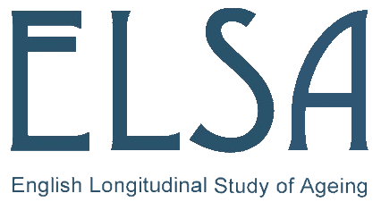

A well written plain-language summary (PLS) is an important part of the application and approval process. The PLS will be published on the ELSA website where it will be made available to study participants, the public, media, other researchers and funders.

What is a plain language summary?
The plain language summary is a stand-alone summary of the proposed research project. It should not simply be copied from other project descriptions but needs to be written afresh. As the goal of writing in plain language is to enable readers from all backgrounds to understand the content the first time they read it, the PLS should convey clearly the key question and purpose of the project using plain English aimed at a reading age of 12 years and for a non-English speaking audience. Consider using a readability checker such as https://readable.io/. Avoid technical terms and jargon or explain them clearly if they are unavoidable. Examples of jargon are clinical and methodological terms, as well as words that have slightly different meanings in science than in common use (e.g., local, blind, control). Consider using a plain language glossary such as https://www.lib.umich.edu/taubman-health-sciences-library/plain-language-medical-dictionary.

What should the summary include?
Your summary needs to address the following questions:
- What is the research question? Why is it important?
- How will the participants’ data be used to investigate the research question?
- What is the method, in plain language?
- What are the potential benefits or implications of your proposed research? This may include short term outcomes or longer-term impact.
- You must make sure the plain language summary is consistent with the scientific project description submitted for approval.

Who is the plain language summary for?
- The PLS explains the project for the ELSA-GDAC Committee members, who all have different types of expertise.
- The study’s Management board reads the summaries, to learn how the resource is used and to inform future strategy.
- The funders want to know the scope and potential impact of the work that is being proposed.
- The PLS for approved projects can be viewed online by other researchers. The research themes and broad methodology show what areas of research are already under investigation.
- Study participants can see how their personal data contributes to current knowledge. They need to understand what questions are being researched, how their data are contributing to this, and the potential benefits of the work – without getting bogged down in technicalities.

Tips for writing in plain language
- Limit sentences to one key point.
- Be careful with words or phrases with dual or nuanced meanings (e.g., drugs; diet).
- Avoid technical words, jargon or words that are long or have many syllables. Consider those who do not have English as a first language.
- Avoid unnecessary technical details if you can make the same point in plain language.
- If you must use technical vocabulary, provide a short definition of your term when it is first introduced and do not use too many technical words together in one sentence.
- Do not include citations to research literature.
- Avoid more than two technical words in a sentence unless you explain them.
- Consider introducing an acronym or shorter term for repeated use.
- Write for an international audience. Avoid words or terms that are region-specific (A&E versus ER).

