Application Assessment criteria
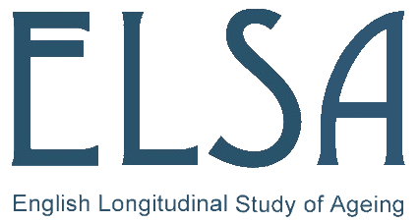

The ELSA Genetic Data Access Committee (ELSA-GDAC) will discuss all applications and decide whether to approve, seek further information, request revisions or to reject the application. Approval may be subject to conditions.

The ELSA-GDAC will assess whether applications meet the following criteria:
[All criteria must be met if research proposal is to be approved]
- The application has been submitted by bona fide researchers with sufficient experience to carry out the work proposed.
- The application meets the criteria on the application form for seniority of the principal applicant.
- There is negligible risk that the application will produce information that may allow individual study participants to be identified.
- The application does not violate (or potentially violate) any of the consent given by the participants or their guardians.
- The application does not violate (or potentially violate) any of the ethical permissions granted to the study from which data or samples are requested.
- The application addresses topics that fall within the acknowledged remit of the study, as understood by participants.
- There is no substantive risk that the application might upset or alienate study members or of reducing their willingness to continue as participants.
- There is no substantive risk that the application might harm individuals in the study, or the study as a whole.
- The application does not require access to a depletable finite resource (whole blood extracted DNA, blood, saliva and urine).

