Incidental findings of clinical significance and potential benefit
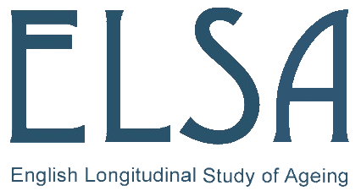

In signing their original consent forms, ELSA participants agreed that they would not receive feedback about any individual genetic results. To date, most informed commentators have seen this position as ‘good practice’ because nobody has really known how to interpret the clinical relevance of the genetic variants that have been identified. Their effects have typically been rather small and there has been no agreed way in which to respond to the limited increases in risk they may convey. Nonetheless, in line with many of the world’s major cohort studies and biobanks, the ELSA-GDAC recognises that national and international views of what constitutes ‘best practice’ might be about to change. For example, as outlined by a senior international commentator in the field, it is possible that in the future it may become mandatory to report genetic results to participants if they satisfy three key requirements:

(i) scientific validity (the genotyping is of adequate quality);
(ii) clinical significance (the disease or condition caused by the genetic variant is potentially serious), and
(iii) potential benefit (i.e., a valid approach exists to prevent or cure the condition/disease of concern and that early knowledge of the genetic risk to which an individual is exposed could enhance the efficacy of that prevention/cure).
At present, a change in what is seen as best practice remains no more than a hypothetical possibility, but findings that satisfy the three stated criteria are likely to become more common as the global scientific focus moves to full sequencing of genes and/or longer segments of DNA. The ELSA-GDAC therefore wishes to help contribute to the national and international evidence-base on which any future strategic decisions might be made regarding policy for feeding back genetic results.
For this reason, the ELSA-GDAC now requires that if in the course of any analysis of DNA from any participant, a genetic variant is found that could potentially be viewed as meeting all three of the criteria stated above, that information must be communicated to the ELSA-GDAC Secretariat.
At this stage this is no more than an exercise in collection of key data to assist us in developing an appropriate future strategy – transmission of any information in this manner does not absolve the research group which generates the relevant finding from having their own internal policy to deal with this globally recognised issue. It is also important to ensure that your research group policy is consistent with the facts that: (1) at present NO genetic information can be returned to participants; and (2) even if that policy were to change, all such contacts with study participants would necessarily be undertaken by the ELSA-GDAC secretariat and not by its applicants. These requirements are immutable under any circumstances – even at the direction of an ethics committee that has reviewed your (the research group’s) project.

Knoppers BM, Joly Y, Simard J, Durocher F. The emergence of an ethical duty to disclose genetic research results: international perspectives. Eur J Hum Genet 2006;14(11):1170-8.

