Disclosure of conflicts: user guidance (version 1.0)
Contents

1 Overview 3
2 Disclose a conflict of interest 5
2.1 Access Disclosure of Conflicts Function 5
2.2 Disclose a new conflict 6
2.3 Add conflict details 6
2.3.1 Start and end dates 6
2.3.2 Conflict type 7
2.3.3 Conflict description 8
2.3.4 Reviewer 9
2.4 Save a conflict 10
2.5 Submit a conflict 11
2.6 Update an existing conflict 12
2.7 View a conflict 12
2.8 What happens when a conflict is submitted 13
2.8.1 Request for additional information 13
2.8.2 Conflict is closed (reviewer has determined no conflict) 13
2.8.3 Conflict is identified (management plan required) 13
2.8.4 Conflict is approved (management plan agreed) 13
2.8.5 Conflict review date is assigned 13
2.8.6 Conflict management plan is amended 14
2.8.7 Conflict is closed – not approved 14
2.9 Notifications 14
3 Review and manage conflicts 16
3.1 Access Review and Manage Conflicts Function 16
3.2 Notifications 17
3.3 Search conflicts 18
3.4 View a conflict 18
3.5 Refer a submitted conflict 20
3.6 Review a referred conflict 21
3.7 Request more information about a submitted conflict 22
3.8 Close a submitted conflict (no conflict identified) 23
3.9 Confirm conflict (pending Conflict Management Plan) 25
3.10 Approve a conflict with a management plan 27
3.11 Amend an existing management plan 30
3.12 Assign or amend a review date for an approved conflict 30
3.13 Close the conflict (management plan cannot be agreed) 31
4 More information 33

Overview
The UCL Disclosure of Conflict and Declaration of Interest Policy states that all members of staff and relevant students must make a disclosure if there is an actual, potential or perceived conflict of interest.
Conflicts of interest include:
- Business positions (e.g. Executive and non-Executive Directorships, partnerships, ancillary employment in other businesses)
- Appointments (e.g. trustee in charitable organisation, school governor, appointment with a funding body or in other organisations)
- Consultancies (whether through UCL Consultants or any other route)
- Investments (e.g. shareholdings (including spin out companies) or beneficial interests in shareholdings, trusts/nominee companies, other assets or significant sources of income)
- Gifts (e.g. reportable gifts such as substantial travel, hospitality or other forms of valuable benefit)
- Other personal interests which could constitute a potential conflict of interest situation
This list is not exhaustive, and other situations could constitute potential conflicts.
A conflict of interest must be disclosed via the ‘UCL Manage Conflicts and Declare Interests’ system. This can be accessed via www.ucl.ac.uk/myhr
A disclosed conflict will be submitted for review and approval. The Approver/Reviewer for your conflict(s) is normally your Head of Department (HoD) or equivalent. The full escalation route list for disclosure and review of conflicts is outlined in the policy.
When submitted for review, a conflict is automatically sent to the Reviewer. A Reviewer has the following options:
- Refer the conflict to another reviewer. This will occur if the original reviewer has an interest in the conflict themselves or if they want to escalate it for review/approval to the next level of authority.
- Request the discloser to provide additional information in order to effectively review the conflict, and submit the conflict again.
- Determine that there is an actual, potential or perceived conflict, agree a conflict management plan with the discloser and approve the conflict.
- Close the conflict if the reviewer decides that there is no actual, potential or perceived conflict or a management plan cannot be agreed.
If it is agreed that there is a conflict, the conflict record will be set to pending and the reviewer will develop and agree a conflict management plan with the discloser outside of the system. Guidance on conflict management plans can be found on the policy and guidance web pages.
Once agreed, the conflict management plan must be uploaded to the conflict record within the system and the conflict approved. A review date should be added to the conflict to monitor and manage the conflict appropriately. Once the Conflict Management Plan is uploaded and the conflict approved by the reviewer, the discloser is notified.
The Conflict Management Plan can be amended at any time on agreement between the discloser and the reviewer. If the plan is amended, the new plan will become the active plan and the previous plan will become inactive. If at any point, agreement on a Conflict Management Plan cannot be reached between the discloser and the reviewer, the conflict cannot be approved and must be closed and the discloser notified that the activity from which the conflict arises must cease.
There are several automatic notifications throughout to ensure that all parties are informed and all required actions taken.
For those who do not have access to the ‘UCL Manage Conflicts and Declare Interests’ system via ucl.ac.uk/myhr (e.g. some students, contractors and staff of UCL subsidiaries), please contact us via RemedyForce.

Disclose a conflict of interest
A conflict of interest must be disclosed via the ‘UCL Manage Conflicts and Declare Interests’ system.

Access Disclosure of Conflicts Function
Go to ucl.ac.uk/myhr and login using your UCL credentials. Click the Menu button in the top left-hand corner. From the list of options, select ‘UCL Manage Conflicts and Declare Interests’ and then ‘Disclosure of Conflicts’. This will take you to the Disclosure of Conflicts homepage.
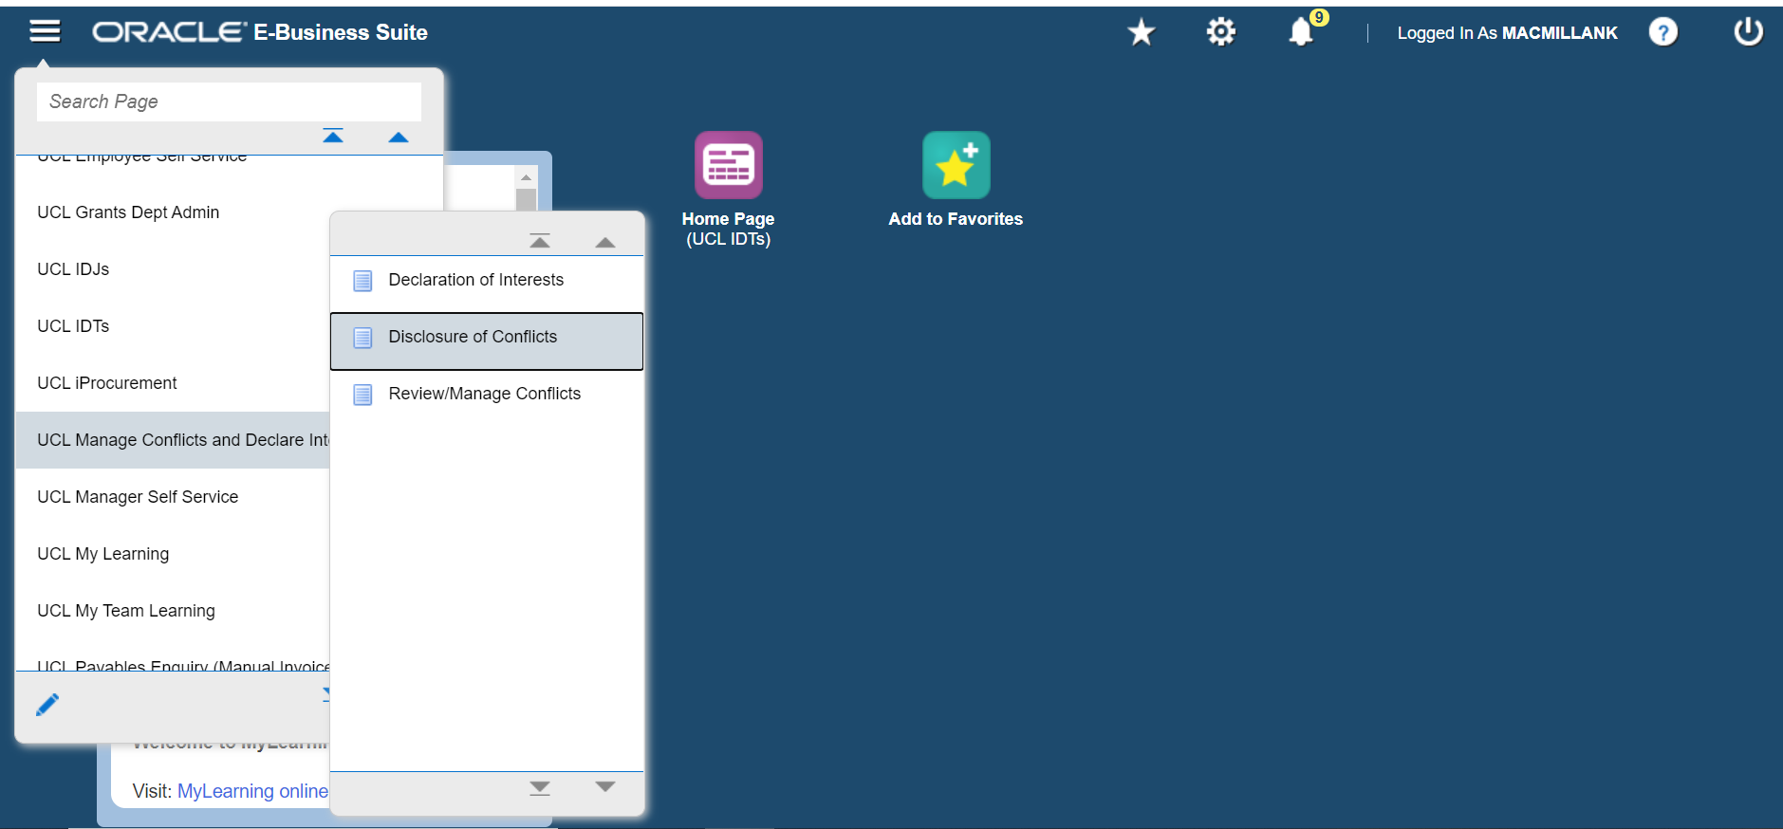

Disclose a new conflict
You can add a conflict from the Disclosure of Conflicts homepage. Select ‘Disclose New Conflict’. This will open the new conflict record where you can add the details of the conflict.
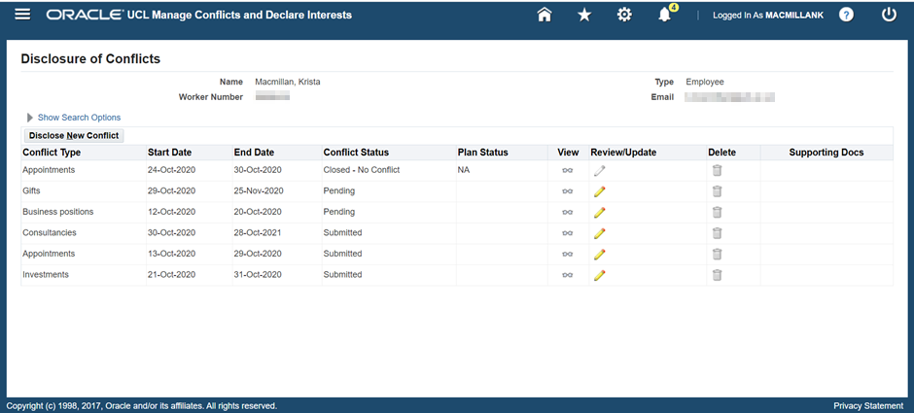

Add conflict details
Follow the process in section 2.2 to create a new conflict record. Please add as much information as possible to the conflict details. When you submit the conflict, this will enable the reviewer to make an informed and effective decision in relation to the conflict. If the reviewer does not have enough information, the conflict may be returned to you for more information and the conflict will have to be resubmitted.

Start and end dates
Select a ‘Start Date’ and ‘End Date’ for the conflict. If the conflict is long running and open ended, an end date must still be provided. A notification will be sent out when the end date is approaching and you will be able to extend the end date if required. This will ensure the conflict will continue to be managed appropriately.
Note: A conflict will automatically be closed when an end date passes. If the conflict is ongoing, the end date must be updated and the conflict submitted again for review.
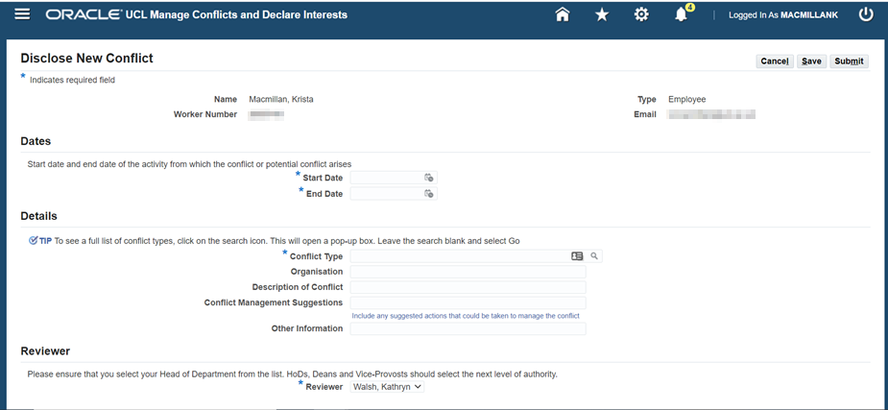

Conflict type
‘Conflict Type’ is a required field. There are a number of options available for conflict type and two ways to select the relevant conflict type.
- Start typing the conflict and it will match as you type if the conflict type is recognised in the system.
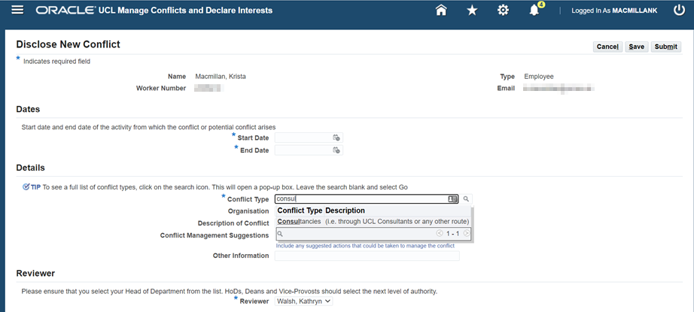
- Use the search function. Click on the magnifying glass icon next to the conflict type field.
Once in the search and select pop up box, leave the search box blank and click ‘Go’ to see all available options. Choose the relevant conflict type and click ‘Select’.
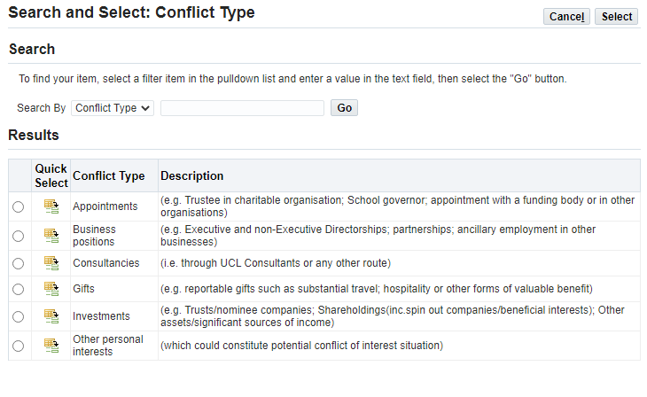

Conflict description
Enter a description of the conflict in the ‘Description of Conflict’ field, any suggested actions to manage the conflict in the ‘Conflict Management Suggestions’ field, and any other relevant information relating to the conflict in the ‘Other information’ field. This will help the reviewer to make an informed decision when reviewing and approving conflicts.

Reviewer
In the ‘Reviewer’ section, select the reviewer from the drop-down box. Please ensure that you select your Head of Department from the list. HoDs, Deans and Vice-Provosts should select the next level of authority.
Note: The full escalation route list for disclosure and review of conflicts can be found in section 6.2 of the policy.

Save a conflict
At any point before submitting a conflict it may be saved. You can then return to it later to update and submit. This can be done by selecting ‘Save’ in the top in the top or bottom right hand corner of the screen.
The conflict will appear on your Disclosure of Conflicts homepage with the conflict status ‘Saved’ and you can update and submit the conflict at any time.
Note: Once a conflict has been submitted it can no longer be saved.
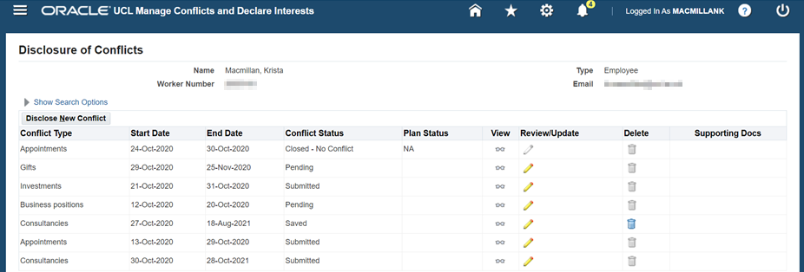

Submit a conflict
Once you have added all the details and selected a reviewer then the conflict can be submitted. This can be done by selecting ‘Submit’ in the top in the top or bottom right hand corner of the screen.
A pop up confirmation box will appear. Select ‘Yes’ to confirm that you want to submit the conflict.
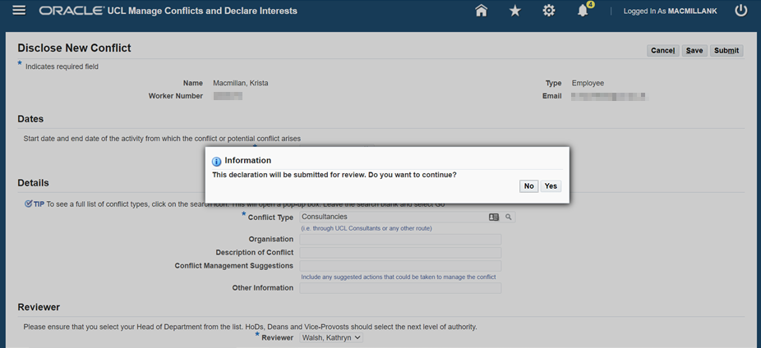
The conflict will appear on your Disclosure of Conflicts homepage with the conflict status ‘Submitted’ and an email notification will be sent to your selected reviewer.
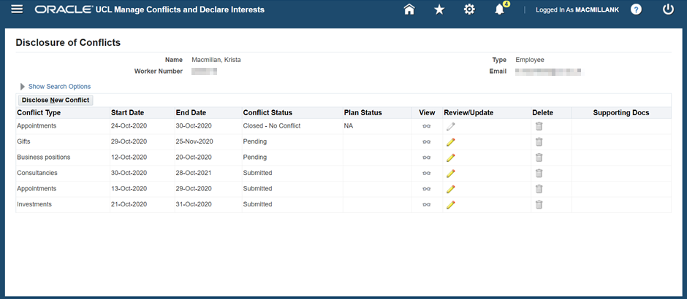

Update an existing conflict
Once a conflict has been saved or submitted, it will appear on your Disclosure of Conflicts homepage where your conflicts are listed. In order to update a conflict, select the pencil icon under ‘Review/Update’ to make any required amendments.
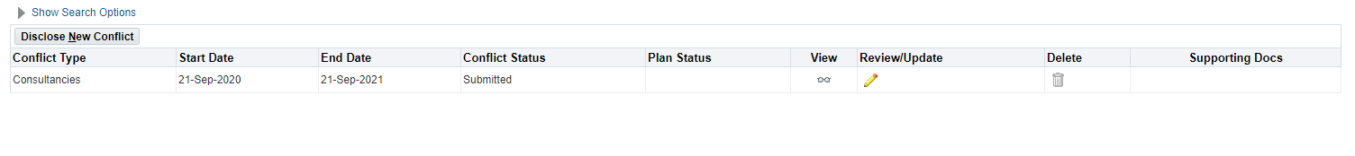 Once you have made your amendments, click on ‘Submit’ in the top in the top or bottom right hand corner of the screen, and then ‘Yes’ when prompted. A notification will be sent to your selected reviewer to review the amended conflict.
Note: If you do not click ‘Submit’ and ‘Yes’, any changes made will not be saved. Also, please be aware that you cannot make amendments to a conflict once it has been closed.

View a conflict
On your Disclosure of Conflicts homepage where your conflicts are listed, select the glasses icon under ‘View’ to see the full details of the conflict.
Note: This will include any conflict management plans that have been put in place to manage the conflict. See section 2.8.4 for more information.

What happens when a conflict is submitted
There are several things that may happen when your conflict is submitted and reviewed.

Request for additional information
The reviewer may require additional information in order to determine if there is a conflict. You will receive an email notification and will have to update your conflict accordingly and submit again for review. See section 2.6 for information on how to do this.

Conflict is closed (reviewer has determined no conflict)
The reviewer may determine that there is no conflict and will close the conflict accordingly. You will receive an email notification and the conflict will appear on your Disclosure of Conflicts homepage with Conflict Status ‘Closed – no conflict’.

Conflict is identified (management plan required)
The reviewer may determine that there is a conflict. In order for a conflict to be approved, a conflict management plan must be put in place. You will receive an email notification that a management plan is pending and the reviewer should contact you to develop and agree the conflict management plan outside of the system. During this process the conflict will appear on your Disclosure of Conflicts homepage with Conflict Status ‘Pending’.

Conflict is approved (management plan agreed)
Once the conflict management plan has been agreed, it will be uploaded to the conflict record by the reviewer and the conflict will be approved, at which point you will receive an email notification confirming this and the conflict will appear on your Disclosure of Conflicts homepage with Conflict Status ‘Approved’.

Conflict review date is assigned
When a conflict management plan is uploaded the reviewer may assign a review date. You will receive notification when a review date is approaching.
Note: If the review date passes without any action, the conflict will be closed and the activity from which the conflict arises must cease. The reviewer is responsible for taking action when the review date is approaching.

Conflict management plan is amended
When a conflict is reviewed it may be necessary to put in place a new management plan. This will follow the same process as section 2.8.4. During this process the conflict will appear on your Disclosure of Conflicts homepage with Conflict Status ‘Pending’.

Conflict is closed – not approved
If a management plan cannot be agreed the conflict cannot be approved. In this case you will receive an email notification and must cease the activity from which the conflict arises.

Notifications
When you submit or update a conflict, an email notification will be sent to the reviewer for action.
As a discloser, you will receive an email notification in the following circumstances:
- The reviewer requires additional information in order to determine if there is a conflict
- The conflict has been closed because the reviewer has determined there is no conflict
- The reviewer has determined there is a conflict and a management plan is pending
- A management plan has been agreed and the conflict approved
- A management plan has been amended and agreed
- A management plan cannot be agreed and the conflict is not approved (in this circumstance you must cease the activity from which the conflict arises)
- A review or end date is approaching (if the review date passes without action or the end date is reached, the conflict will be automatically closed).
You can see a list of notifications on the homepage when you login. Click on the bell icon and ‘Go to full worklist’. Change the View to ‘All notifications’ and click ‘Go’. Click on the Worklist item and it will open the notification.

Review and manage conflicts
The reviewer/approver for conflicts is normally Head of Department (HoD) or equivalent. For HoDs, Deans and Vice Provosts the reviewer/approver will be the next level of authority. The full escalation route list for disclosure and review of conflicts is outlined in the policy. If you have been designated as a HoD or higher level of authority in UCL HR systems, you will have access to review and manage conflicts.
As a reviewer, you will be able to view all the conflicts that have been submitted or referred to you for review. You will be notified by email of submitted conflicts and when any action is required. You can search for, view and update conflicts. There are several options available when reviewing a conflict, including: refer a conflict, request more information, close a conflict, confirm a conflict (management plan pending) and approve a conflict with a management plan.
Note: In a small number of cases the incorrect reviewer will be selected by the discloser to review a conflict. This will primarily be as a result of the underlying HR data and assignment of the HoD role. If you receive a conflict in error, please contact us via RemedyForce to re-route the conflict to the correct reviewer.

Access Review and Manage Conflicts Function
Login via https://www.ucl.ac.uk/myhr and click the Menu button in the top left-hand corner. From your list of options, select ‘UCL Manage Conflicts and Declare Interests’ and then ‘Review/Manage Conflicts’.
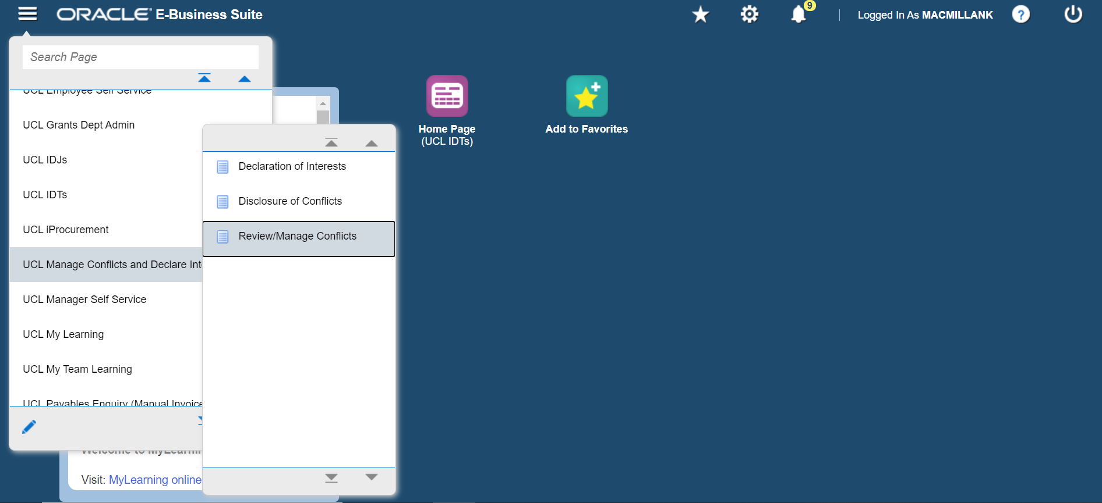
This will take you to the Review/Manage Conflicts homepage where you will be able to view a list of all employees who have submitted conflicts to you for review and access the conflict records.

Notifications
As a reviewer, you will receive an email notification in the following circumstances:
- A conflict has been disclosed (or amended) and needs to be reviewed
- A conflict has been referred to you by another reviewer and you must now review the conflict
- The review date or the end date of a conflict is approaching
- A conflict has been closed because the review date or the end date has passed.
You will also receive reminder notifications if an action has not taken place within 2 weeks and again after 4 weeks.
You can also see a list of notifications that may require action or attention on the homepage when you login. Click on the bell icon and ‘Go to full worklist’. Change the View to ‘All notifications’ and click ‘Go’. Click on the Worklist to open the notification.
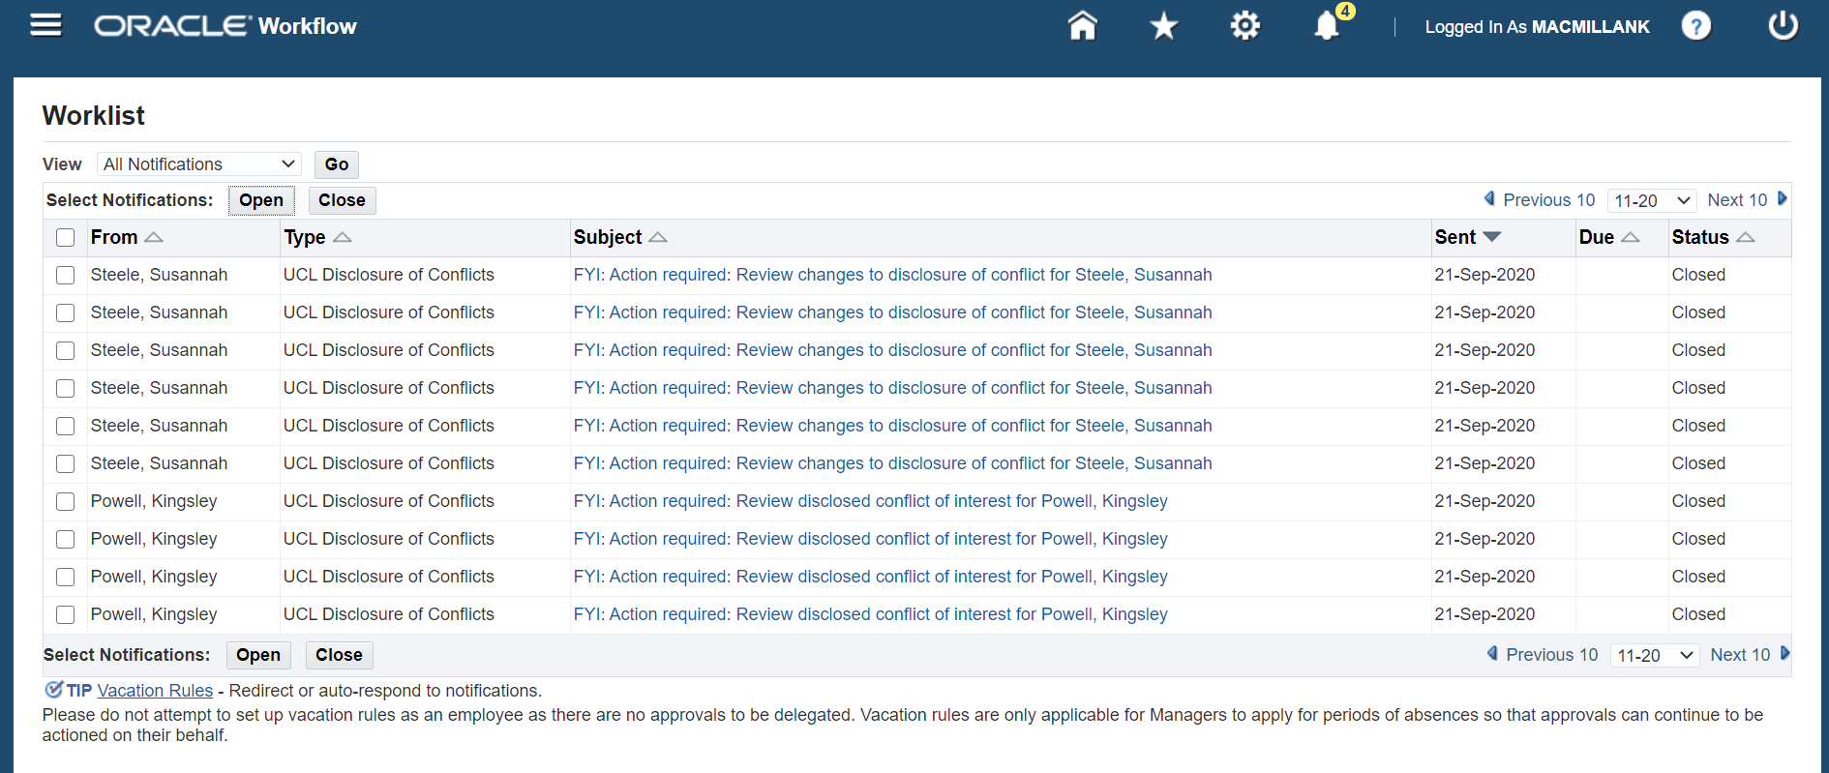
The notification includes a link to review the disclosure and to the Disclosure of Conflicts and Declaration of Interests Policy and guidance.
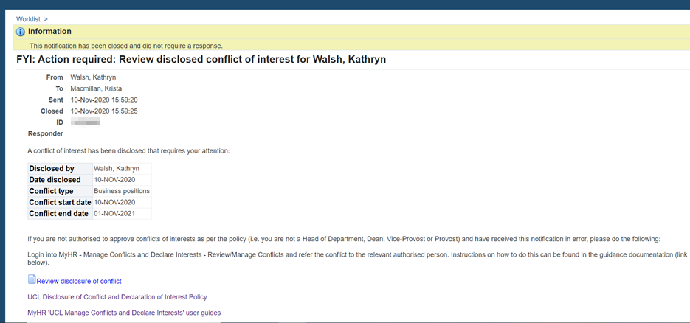

Search conflicts
You can search by name for individuals who have disclosed conflicts for to you review. On the Review/Manage Conflicts homepage use the ‘Person Search’. Enter the discloser’s information and click ‘Go’.
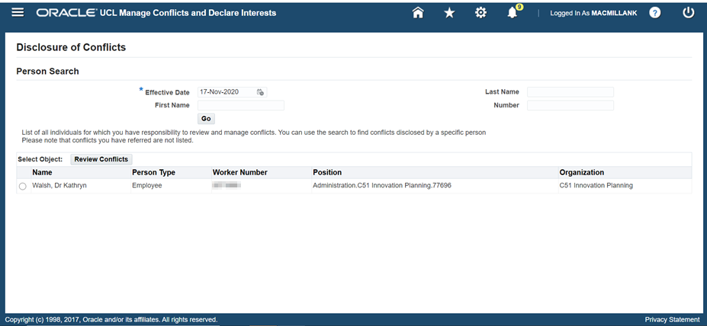

View a conflict
To view disclosed conflicts for a specific person, select the name from the list on the Review/Manage Conflicts homepage and click on 'Review Conflicts'.
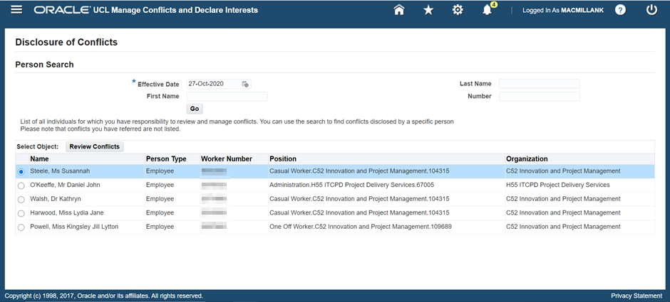
This will display a list of conflicts disclosed by that individual. To review the conflict and take any actions, select the pencil icon under ‘Review/Update’.
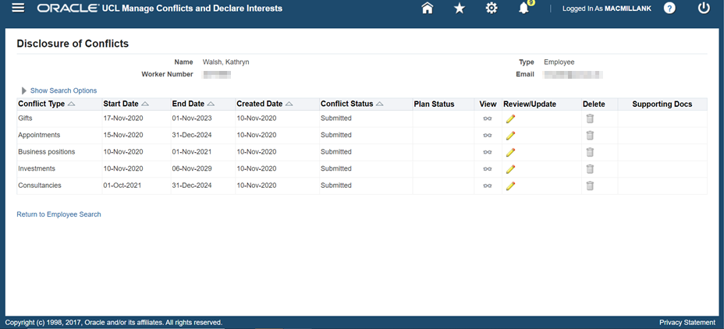
This will display the conflict for review.
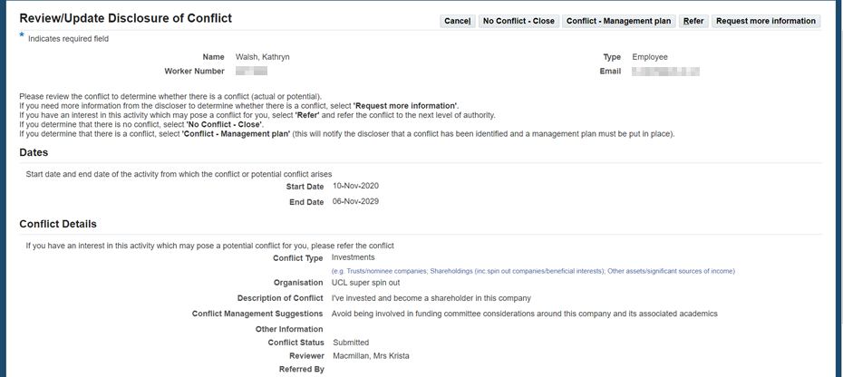

Refer a submitted conflict
Sometimes you will need to refer a conflict to another reviewer. This could be because you have an interest in the conflict that precludes you from approving it or because you want to escalate the conflict to the next level of authority.
To refer a conflict, follow the guidance to ‘View a conflict’ in section 3.4. This will open the conflict record. Select ‘Refer’ in the top or bottom right hand corner of the screen.
This will display the referral options on the conflict record. Select a Reviewer from the drop-down list, then select a reason from the ‘Referral Reason’ drop-down list. Enter notes to Reviewer and select ‘Apply’.
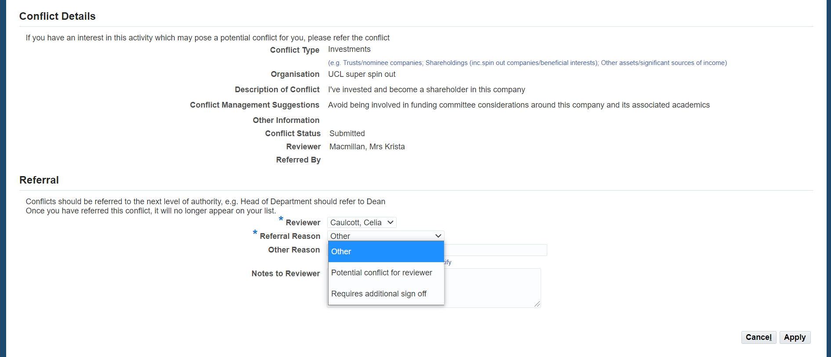
The conflict will be sent to the reviewer you have selected and they will receive a notification.
Note: The conflict you have referred will no longer appear on your list of conflicts for that employee, but details of the referral will be retained on the conflict record and viewed by the subsequent reviewer.

Review a referred conflict
If a conflict has been referred to you, you will receive an email notification and the conflict will appear on the list of conflicts for that employee with conflict status ‘Referred’.
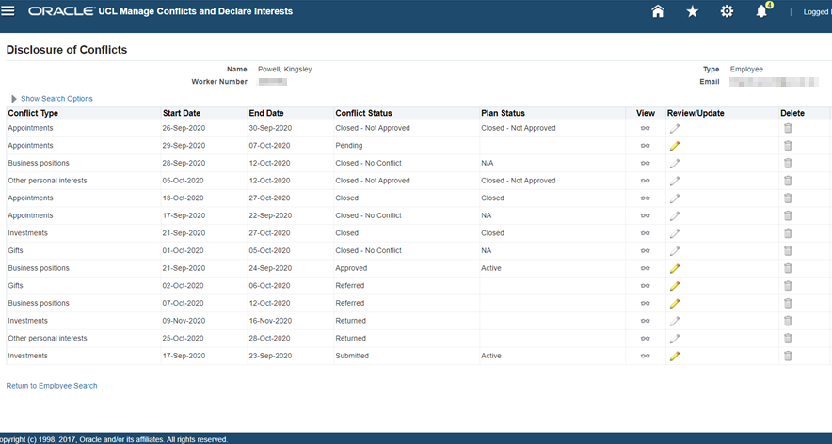
Once a conflict has been referred to you, the conflict can be reviewed and managed like any other submitted conflict. (More details about how to review/manage a submitted conflict can be found in the following sections.)
Once you have reviewed the conflict, the conflict status will change accordingly on the list of conflicts for the employee but details of the referral will be retained on the conflict record.

Request more information about a submitted conflict
Sometimes you will need more information about a disclosed conflict in order to make an informed decision about whether there is an actual, potential or perceived conflict that requires a Conflict Management plan. To request more information from the discloser, follow the guidance to ‘View a conflict’ in section 3.4. This will open the conflict record and you can then select 'Request more information' from the top or bottom right hand corner of the screen.
This will display the request more information options on the conflict record. Enter notes for the discloser about any additional information you require and then select ‘Apply’.
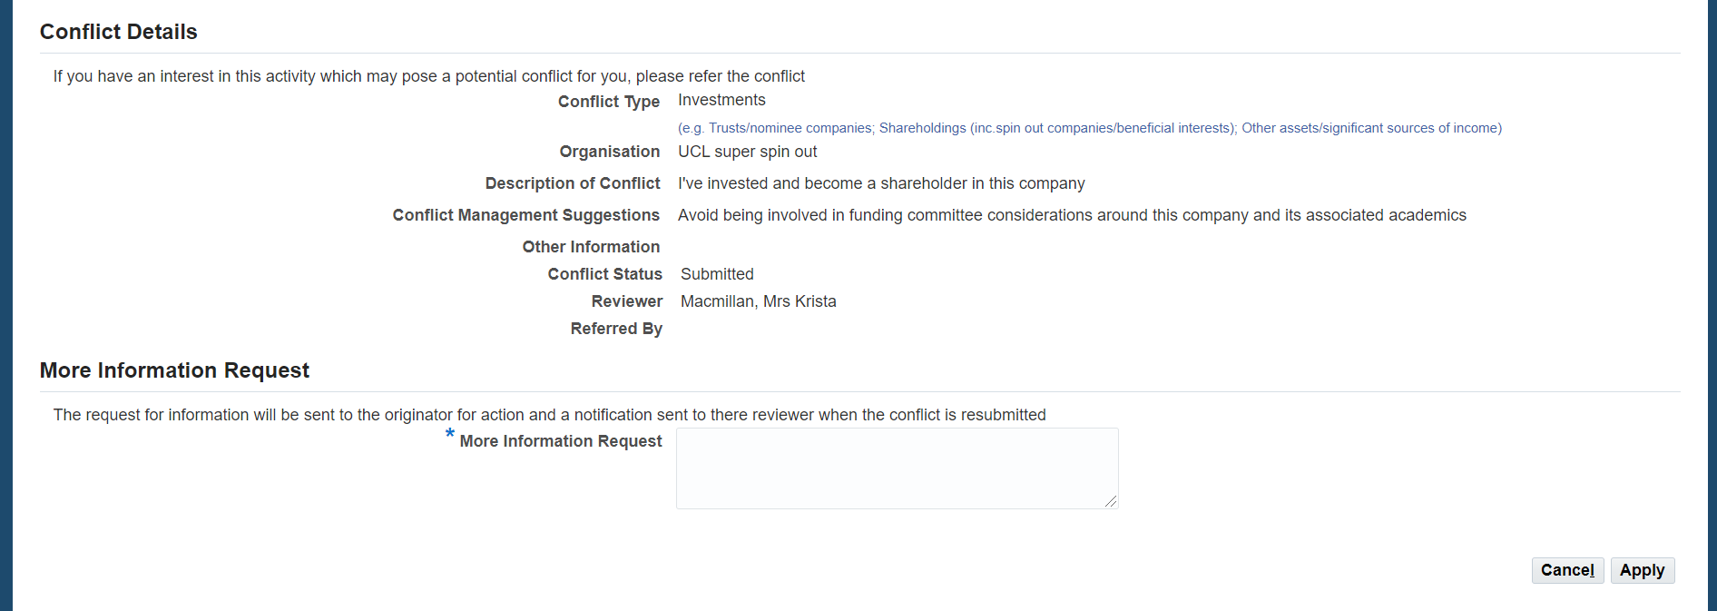
The discloser will receive a notification and once they have provided the additional information, they can submit the conflict again for review (the reviewer will receive an email notification). The conflict will appear on the list of conflicts for that employee with conflict status ‘Returned’.
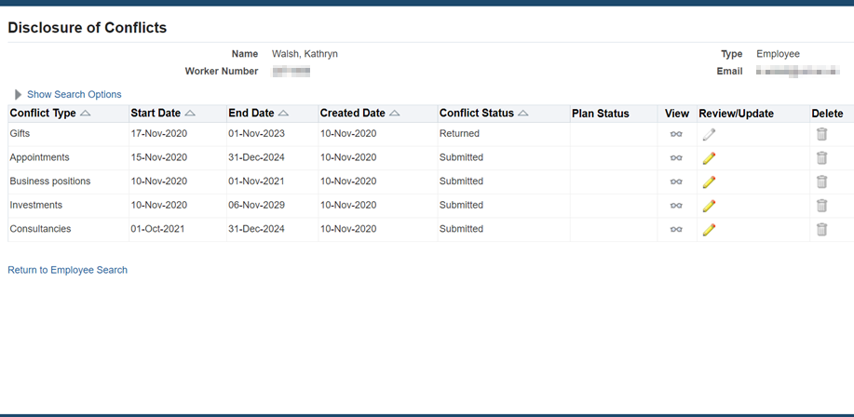

Close a submitted conflict (no conflict identified)
To open the conflict record, follow the guidance to ‘View a conflict’ in section 3.4. Once you have reviewed the submitted conflict and determined that there is no actual, potential or perceived conflict, you can close the conflict. Select 'No Conflict - Close' from the top or bottom right hand corner of the page.
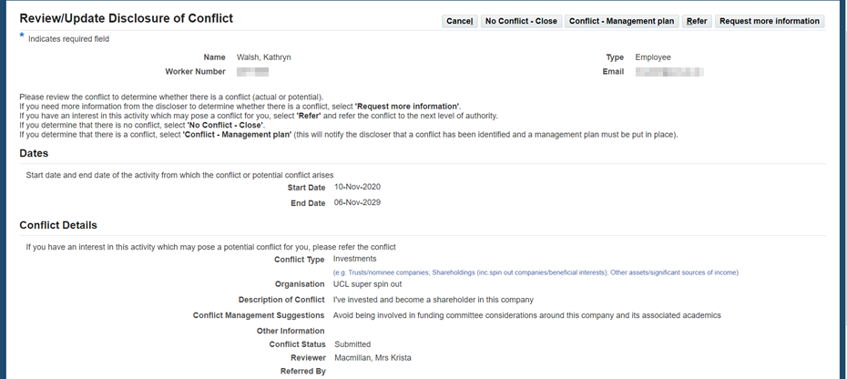
This will display the No-conflict close options on the conflict record. If required, add more information about why the conflict was closed and select ‘Apply’.
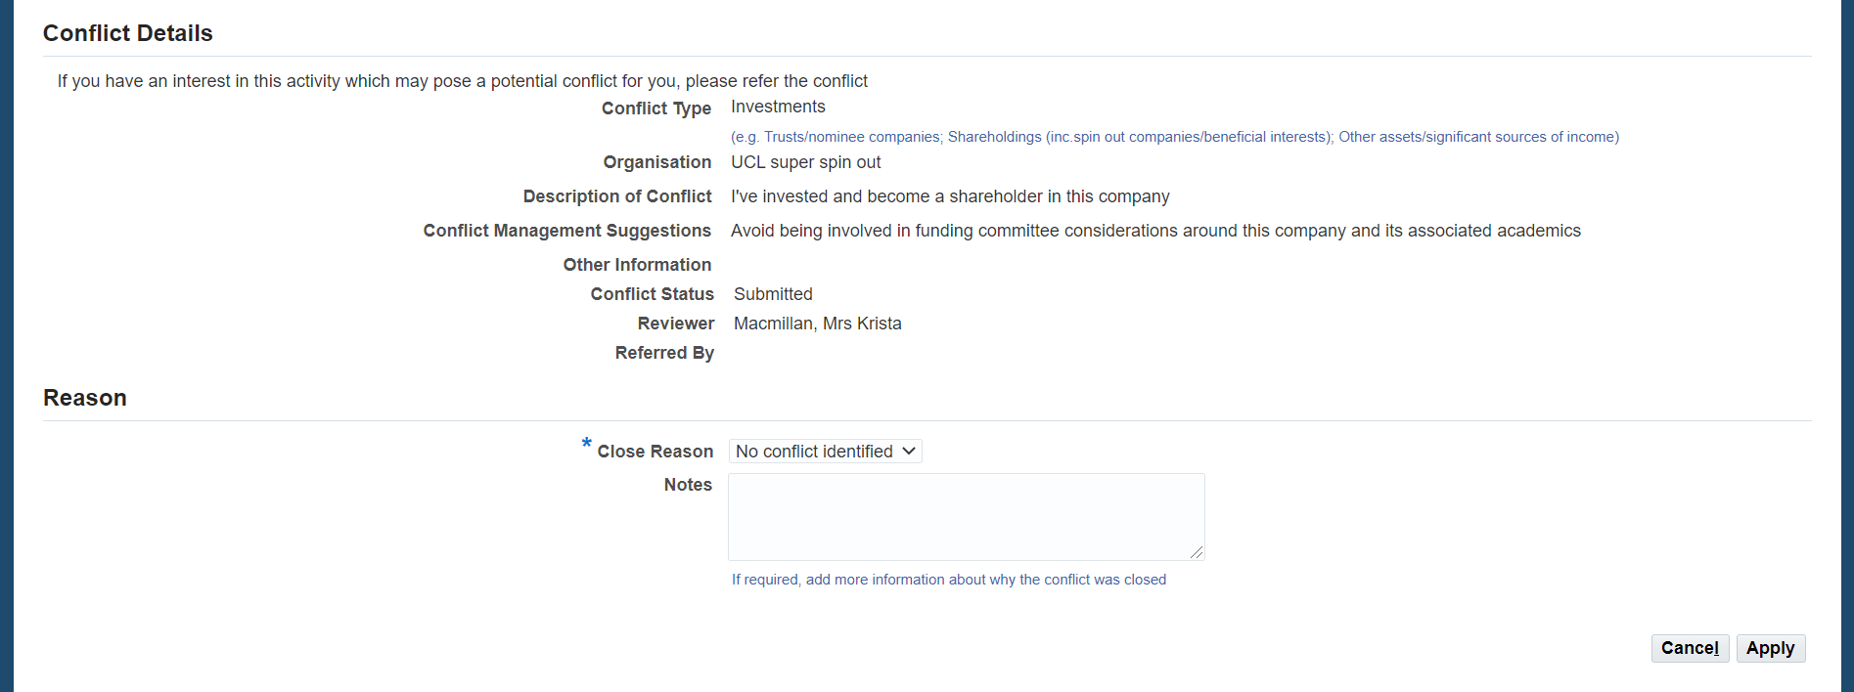
When prompted to close the conflict, select ‘Yes’.
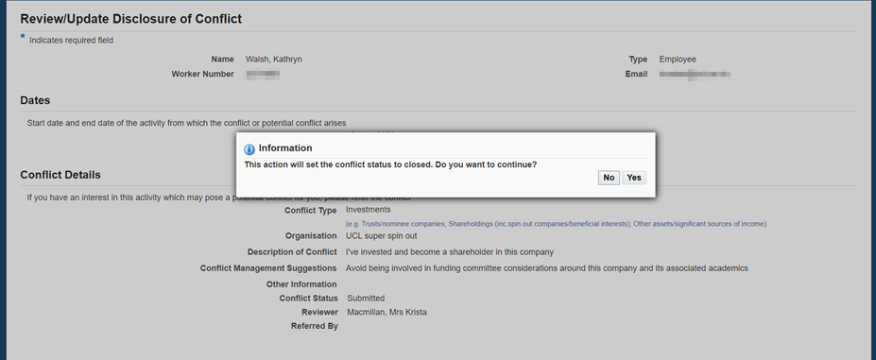
A notification will be sent to the discloser and the conflict will appear on the list of conflicts for that employee with the conflict status ‘Closed - No conflict’.
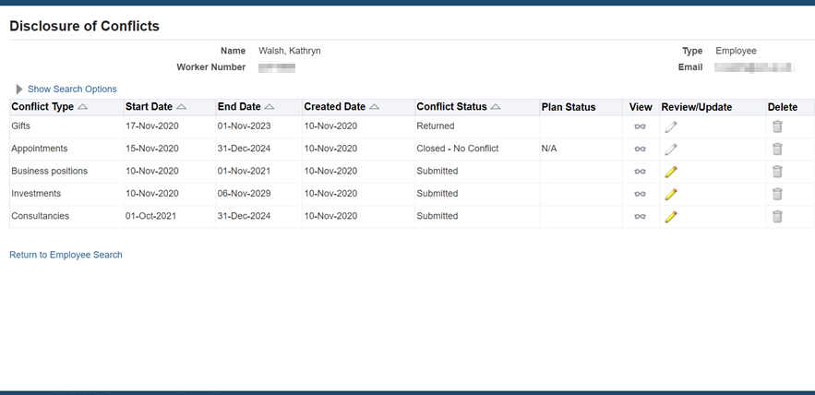

Confirm conflict (pending Conflict Management Plan)
To open the conflict, follow the guidance to ‘View a conflict’ in section 3.4. Once you have reviewed the submitted conflict and determined that there is an actual, potential or perceived conflict, you will need to confirm this on the system and put in place a Conflict Management plan. To do this, select 'Conflict - Management plan' from the top or bottom right hand corner of the screen.
This will display the conflict management plan options on the conflict record.
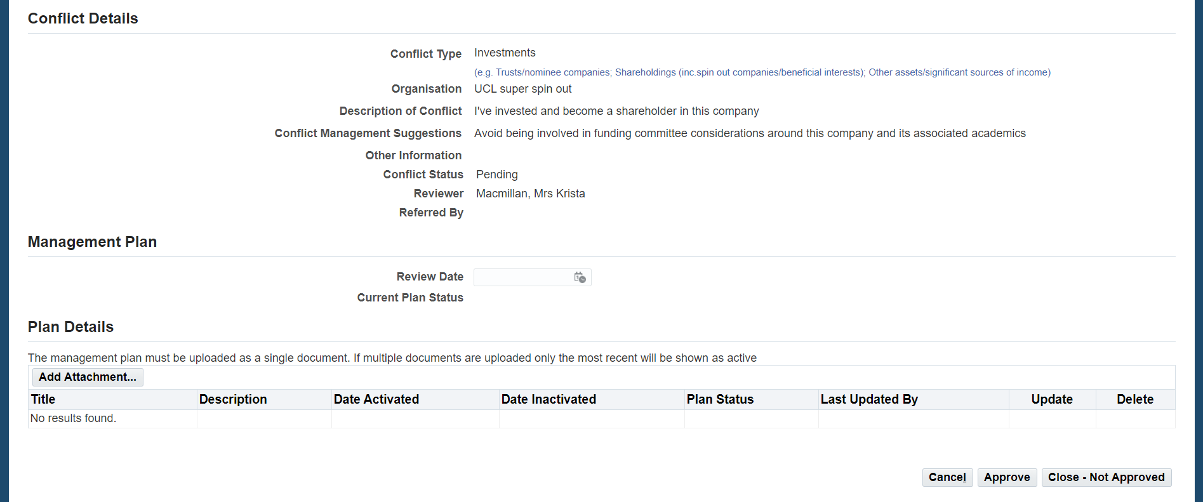
The conflict management plan should be developed in agreement with the discloser outside of the system.
To exit the conflict record at this stage, select ‘Cancel’. This will update the conflict status to ‘Pending’ and a notification will be sent to the discloser that a conflict has been identified and a management plan will need to be put in place.
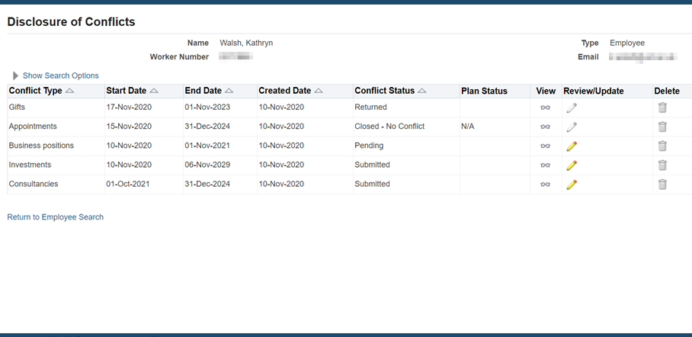
Once the plan is created, return to the conflict and follow the process in section 3.10 to approve a conflict with a management plan or section 3.13 to close the conflict as not approved because agreement on how to manage the conflict could not be reached.

Approve a conflict with a management plan
Follow the guidance for ‘Confirm conflict (pending Conflict Management Plan)’. Click on Review/Update to open the relevant conflict record (with Conflict status ‘Pending’).
Under the Management Plan section of the conflict, select ‘Add Attachment’.
This will open a pop up box. Search for a file, add a title and description and select ‘Apply’.
Note: the system will allow you to add more than one file. Only the most recent attachment will be active. All other files will be set to inactive. Please ensure a conflict management plan is a single document.
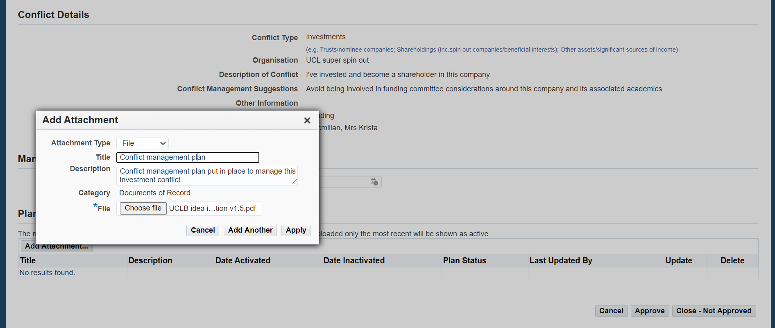
Once you have uploaded the conflict management plan, select a review date from the calendar. This is not a mandatory field, but is highly recommended as it allows the conflict to be actively and appropriately managed. The reviewer and discloser will receive email notifications of approaching review dates (at 4 and 2 weeks before the review date).
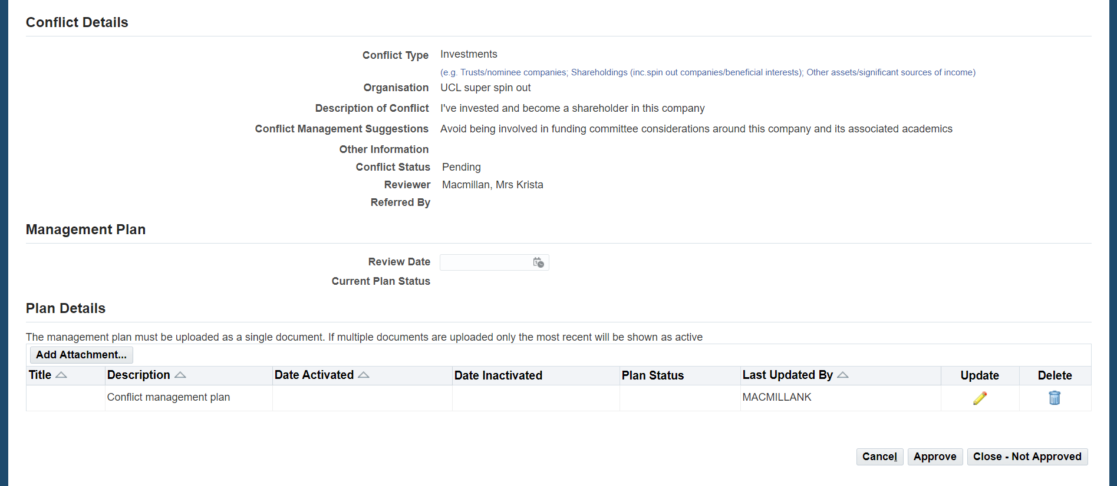
To approve the conflict with the active management plan, select ‘Approve’.
This will open a pop up confirmation. This is important, as you are confirming that the conflict management plan has been agreed with the discloser. Click ‘Agree’ to confirm and this will approve the conflict.
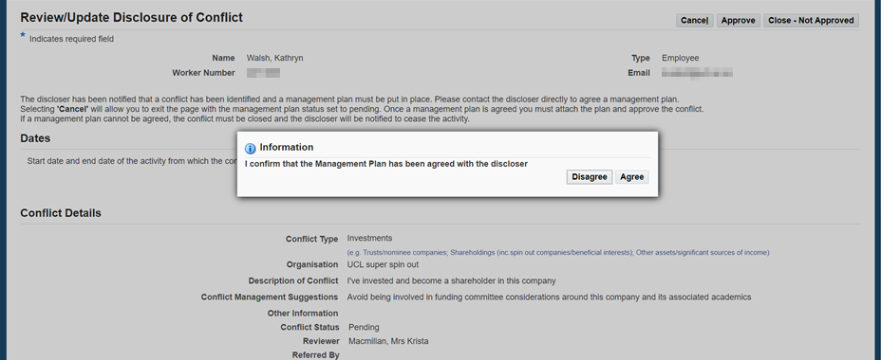
The conflict will now appear on the homepage with conflict status ‘Approved’ and an active management plan attached as a supporting document. The discloser will receive notification that the conflict has been approved and will be able to view the conflict management plan.
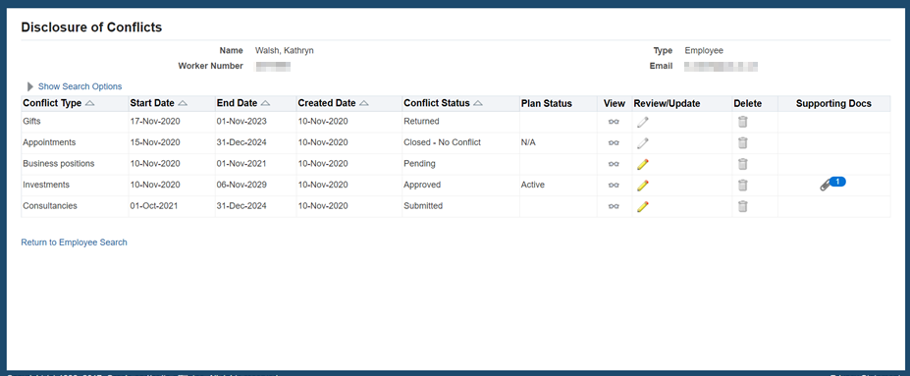
Note: If the conflict management plan cannot be agreed between the reviewer and the discloser, the conflict must be closed and the activity from which the actual, potential or perceived conflict arises must cease. Follow the ‘Close the conflict (management plan cannot be agreed)’.

Amend an existing management plan
To open the conflict, follow the guidance to ‘View a conflict’ in section 3.4. Select ‘Amend Plan’.
Note: To amend a plan the conflict will already have to have been through the ‘Approve a Conflict with a Management Plan’ process in section 3.10 and have a Conflict Status of ‘Approved’ and a Plan Status of ‘Active’.
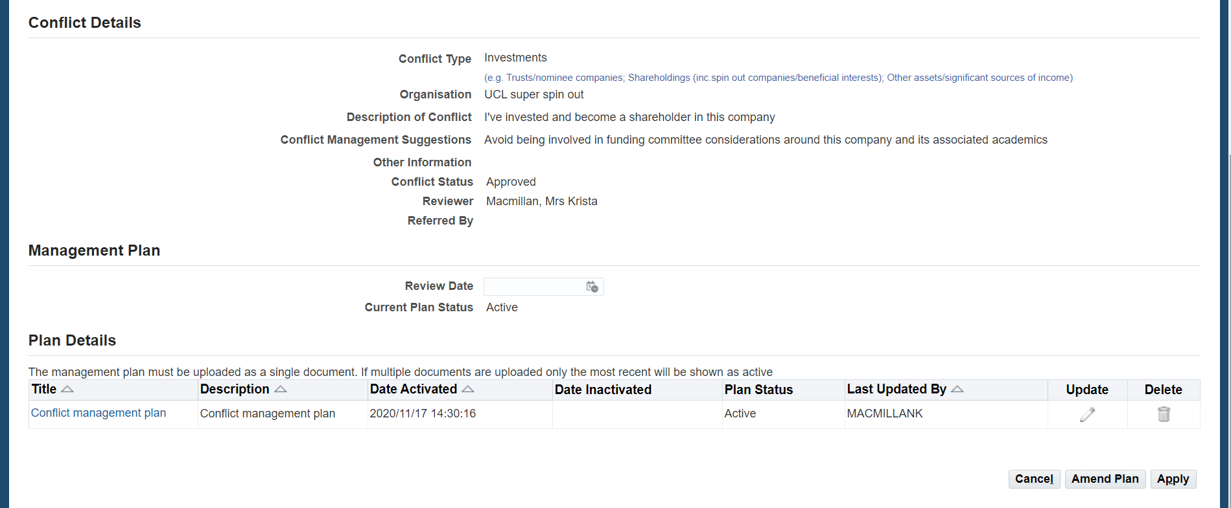
Once you have selected ‘Amend Plan’ follow the ‘Approve a Conflict with a Management Plan’ process in section 3.10 to add and approve a new conflict management plan. The discloser will receive notification that the conflict has been approved with a new conflict management plan and will be able to view the plan.
Note: If the new conflict management plan cannot be agreed between the reviewer and the discloser, the conflict must be closed and the activity from which the actual, potential or perceived conflict arises must cease. To do this, follow the ‘Close the conflict (management plan not agreed)’ process in section 3.13.

Assign or amend a review date for an approved conflict
To open the conflict, follow the guidance to ‘View a conflict’ in section 3.4. On the conflict record, select a ‘Review Date’ and ‘Apply’.
A notification (and subsequent reminders) will be sent to both the reviewer and discloser when the review date for a conflict is approaching. If the review date passes with no action being taken then the conflict will be closed and a notification will be sent to the discloser to cease the activity. It is therefore important that the review date is assigned and amended appropriately.
Note: Select a ‘Review Date’ that is after the conflict start date and prior to the conflict end date.
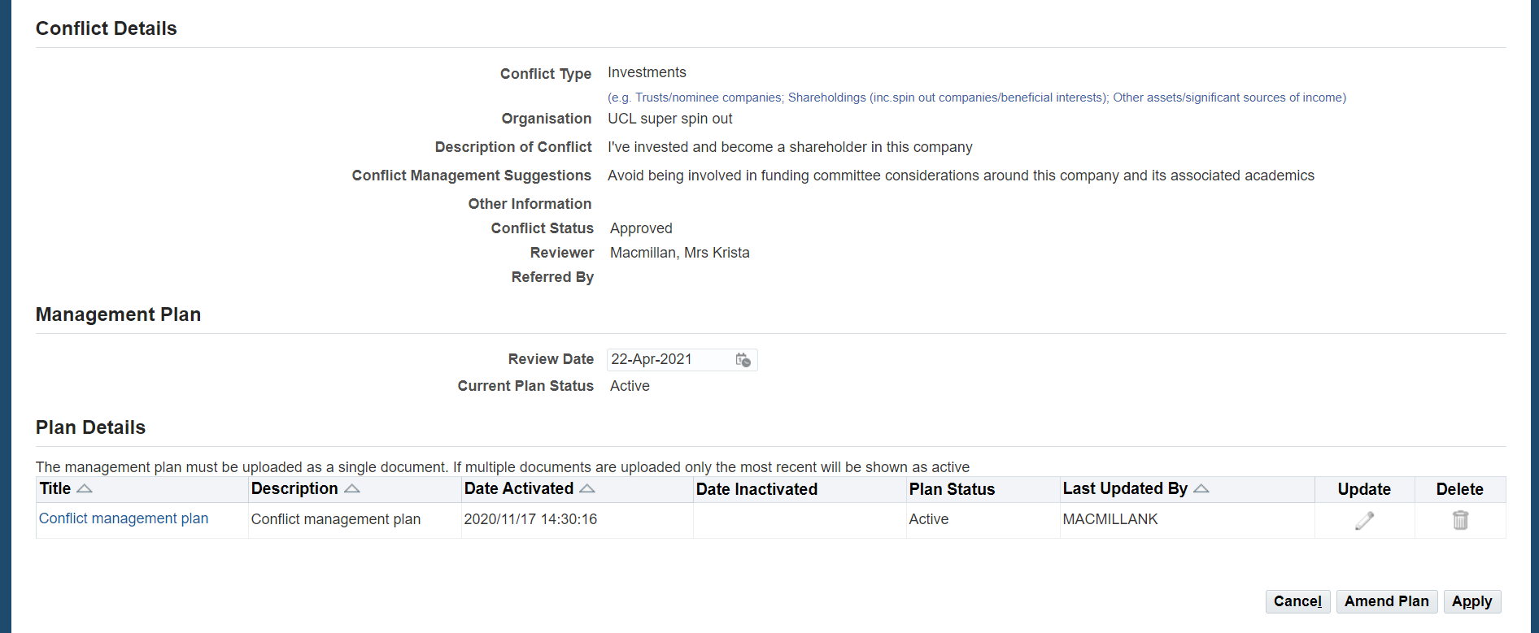

Close the conflict (management plan cannot be agreed)
If a management plan cannot be agreed between the reviewer and the discloser, the conflict must be closed and the activity from which the actual, potential or perceived conflict arises must cease.
To do this, follow the process for ‘Confirm conflict (pending Conflict Management Plan)’ in section 3.10. If the management plan cannot be agreed and the conflict must be closed select ‘Close – not approved’ on the conflict record.
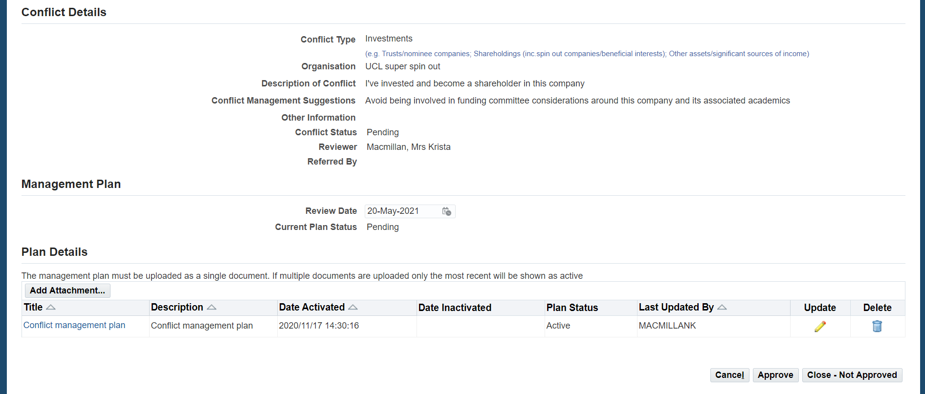
A pop up confirmation screen will be displayed. Select ‘Yes’ to close the conflict.
Note: When the conflict is closed, a notification will be sent to the discloser to inform them and to confirm that the activity from which the actual, potential or perceived conflict arises must cease.
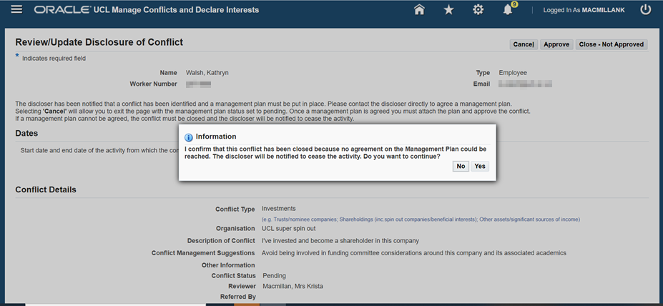
The conflict will appear on the list of conflicts for the employee with the conflict status ‘Closed – Not approved’. You will no longer be able to update the conflict record but it can still be viewed.
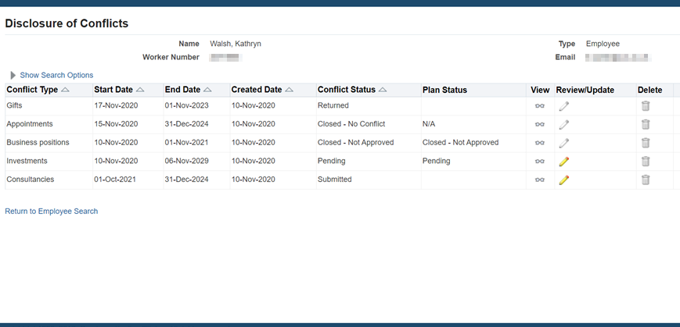

More information
If you encounter any issues with the system let us know via RemedyForce.
For more information regarding the Disclosure of Conflicts policy or process, please contact UCL Innovation & Enterprise at discloseconflicts@ucl.ac.uk
UCL Disclosure of Conflicts and Declaration of Interests policy and guidance

