Declaration of interests: user guidance (version 1.0)
Contents
1. Overview 2
2. Access the system 4
3. Declare an interest 4
4. Nothing to declare 9
5. Update an interest 14
6. More information 16

Overview
All relevant UCL staff are required by the UCL Disclosure of Conflict and Declaration of Interest Policy to make an annual declaration of interests.
From 1 December 2020 this must be done via the ‘UCL Manage Conflicts and Declare Interests’ system.
Even if you have nothing to declare, you are still required to make a nil declaration for the current Financial Year (FY).
Declaring all relevant interests is an important requirement of the UCL Disclosure of Conflict and Declaration of Interest policy. Please take time to declare all interests or make a nil declaration. If further interests arise within the year, these will also need to be declared.

Relevant staff
The ‘UCL Disclosure of Conflicts and Declaration of Interests’ policy defines all relevant UCL staff as the following: Provost, Vice-Provosts, COO, SMT, Heads of Division and Heads of Department, individuals with delegated authority of £75k and above, other members of staff at Grade 10 or above, Directors of subsidiary companies of UCL, other senior staff as specified by Provost of Vice-Provost.

External interests
An external interest is where a senior member of staff is involved with any organisation or person not legally associated with UCL, where they have one of the following:
- a remunerated position
- an honorary position
- a material financial interest
- a consulting arrangement

Interests are categorised as:
- business positions (e.g. Executive and non-Executive Directorships, partnerships, ancillary employment in other businesses)
- appointments (e.g. trustee in charitable organisation, school governor, appointment with a funding body or in other organisations)
- consultancies (whether through UCL Consultants or any other route)
- investments (e.g. shareholdings (including spinout companies) or beneficial interests in shareholdings, trusts/nominee companies, other assets or significant sources of income)
- gifts (e.g. reportable gifts such as substantial travel, hospitality or other forms of valuable benefit)
- other personal interests which could constitute a potential conflict of interest situation

Access the system
The ‘UCL Manage Conflicts and Declare Interests’ system is accessed via www.ucl.ac.uk/myhr
Log into the system using your UCL credentials. Select the Menu button in the top left-hand corner. From your list of options, select ‘UCL Manage Conflicts and Declare Interests’ then ‘Declaration of Interests’.
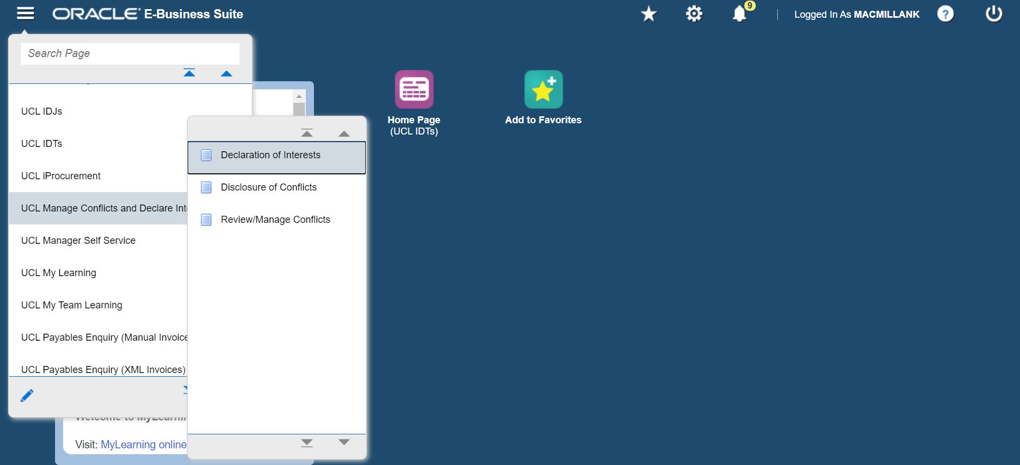

Declare an interest
Selecting ‘Declarations of Interest’ on the menu will take you to the ‘Declarations of Interest: Extra Information’ page. Click on the ‘Add’ button.
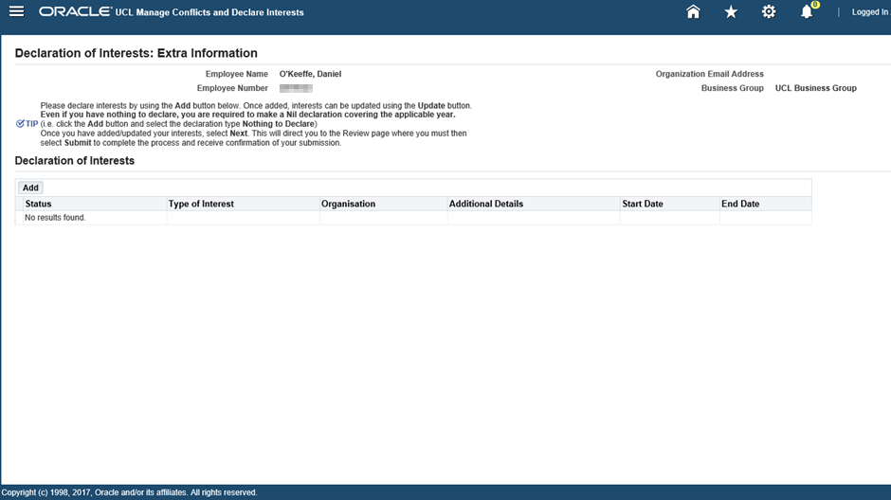
If you have an interest or interests to declare, you can select the magnifying glass for ‘Type of Interest’ to bring up the ‘Search and Select: Type of Interest’ page where you can select the relevant interest type.
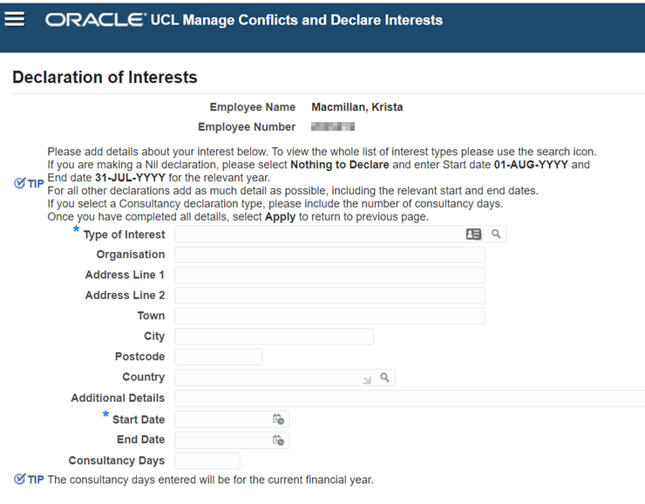
Ensure that the search box is blank and click ‘Go’. This will bring up a set of options for you to select the appropriate type of interest from the list:
After selecting the relevant option, simply complete the ‘Declaration of Interests’ fields with as much detail as possible, including the relevant start and end dates.
Note: If the interest type selected is ‘Consultancies’ include the number of days in the ‘Consultancy days’ field.

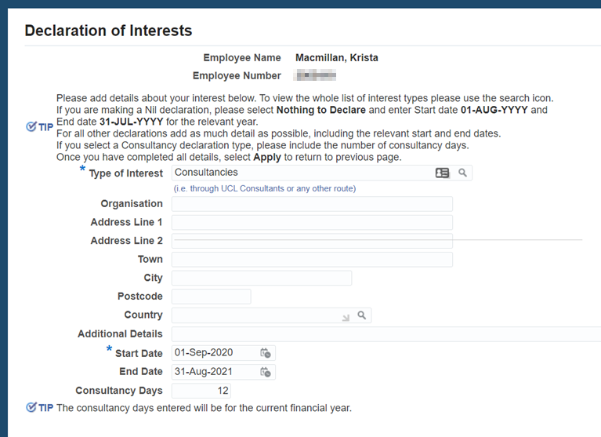
Once you have completed all the relevant fields for your interest, select ‘Apply’
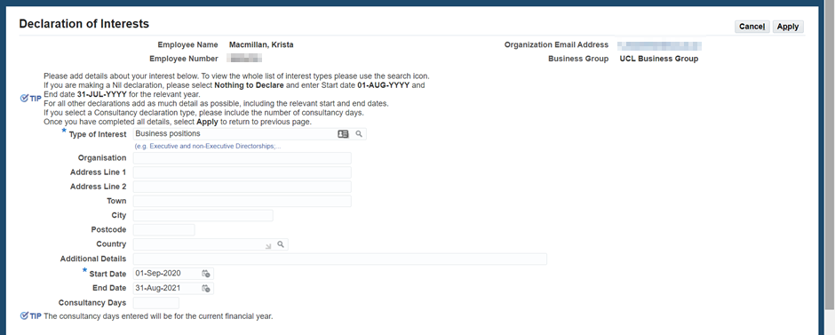
This will bring up the next screen where your interest will be displayed with Status ‘New’. Select ‘Next’.
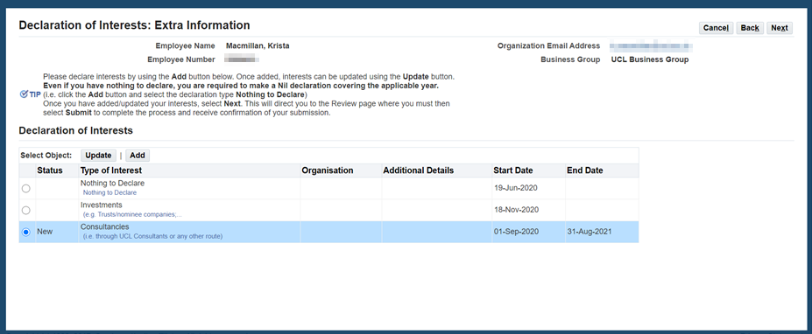
On the following ‘Declaration of Interests: Review’ screen you can review your changes and select ‘Submit’.
Note: If you do not click ‘Submit’ the interest will not be saved.
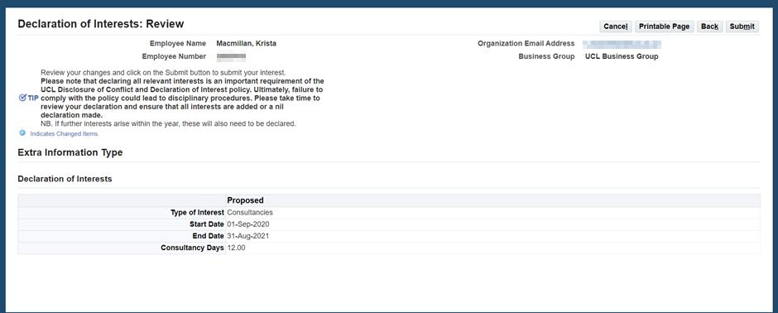
Note: Please take time to review your declaration and ensure that all interests are added or a nil declaration made (see section 4. Nothing to Declare). If further interests arise within the year, these will also need to be declared.
Once you have submitted your interest you will then see a confirmation message.

Nothing to declare
If you have nothing to declare, you must still make an annual declaration.
Follow the guidance in section 2. Access the system. Selecting ‘Declarations of Interest’ on the menu will take you to the ‘Declarations of Interest: Extra Information’ page. Click on the ‘Add’ button.
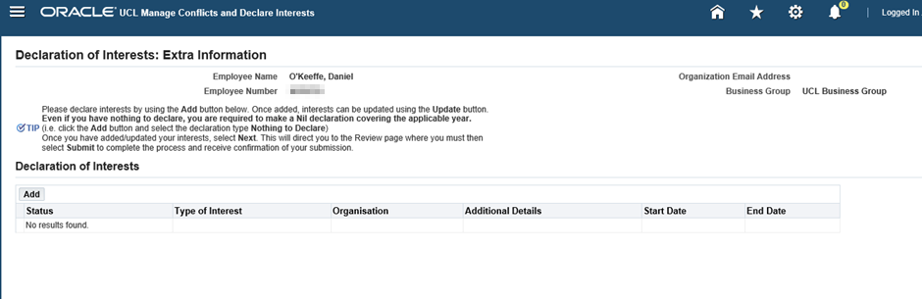
To select ‘Nothing to declare’ as the ‘Type of Interest’, you can use the magnifying glass to bring up the ‘Search and Select: Type of Interest’ page where you can select the relevant interest type.
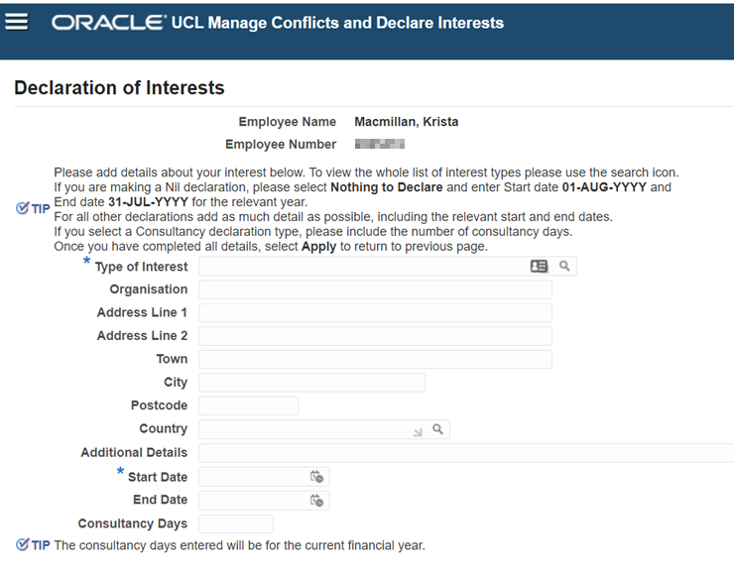
Ensure that the search box is blank and click ‘Go’ to bring up a set of options. Select ‘Nothing to Declare’ from the list.
Enter the ‘Start Date’ as 01 August, and the end date as 31 July for the appropriate declaration year.
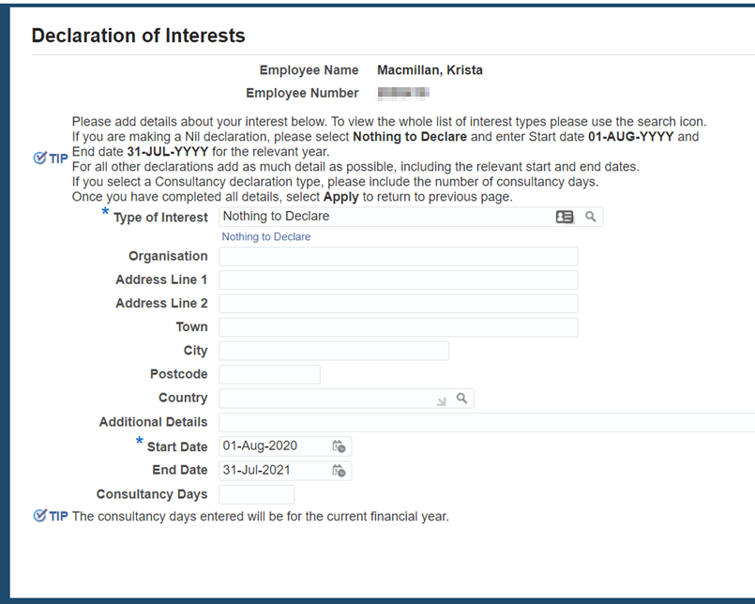
Once you have completed all the relevant fields, select ‘Apply’.
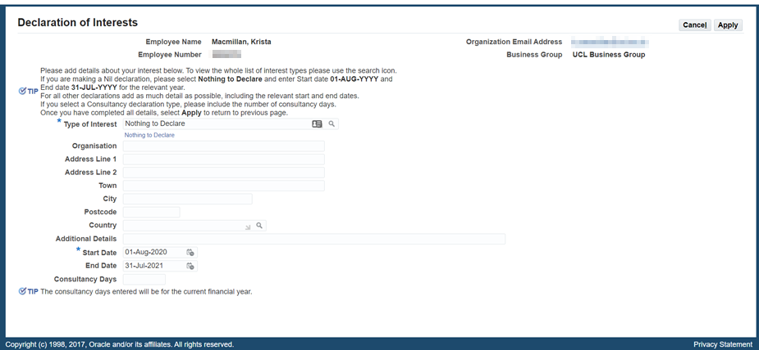
This will bring up the next screen where your interest will be displayed with Status ‘New’. Select ‘Next’.

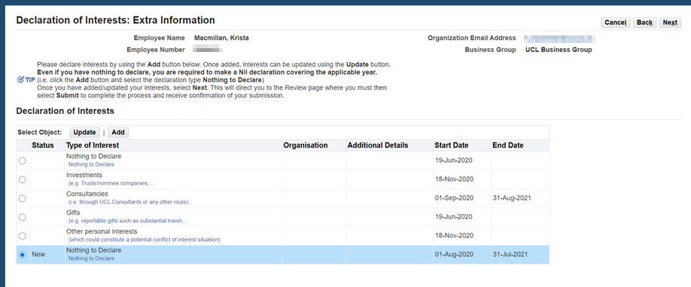
On the following ‘Declaration of Interests: Review’ screen you can review your changes and select ‘Submit’.
Note: If you do not click ‘Submit’ the declaration will not be saved.
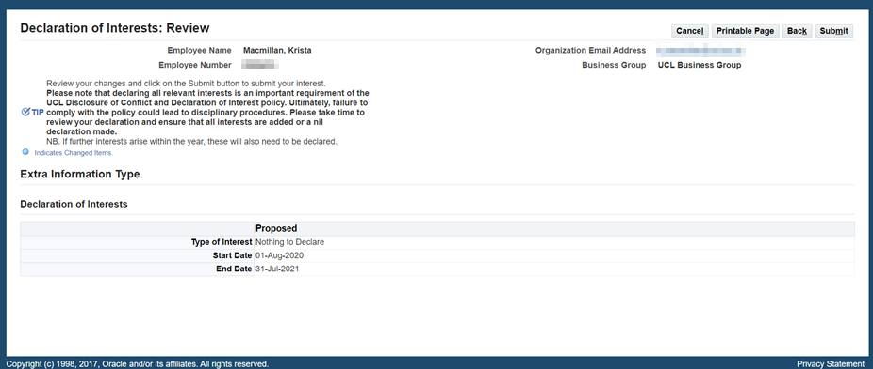
Note: Please take time to review your declaration. If further interests arise within the year, these will need to be declared.
Once you have submitted your interest as ‘Nothing to Declare’ you will then see a confirmation message.

Update an interest
You can still amend an interest after it has been submitted. On the ‘Declarations of Interest: Extra Information’ page, select the relevant interest and click ‘Update’.
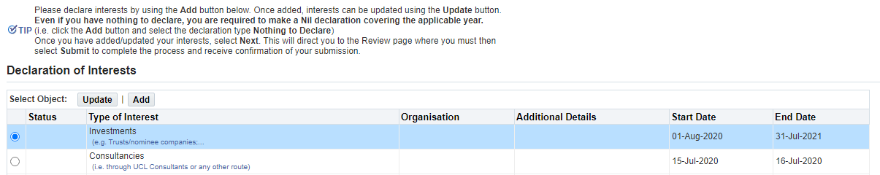
This will give you the option to amend the details. When you are happy with the changes, select ‘Apply’.
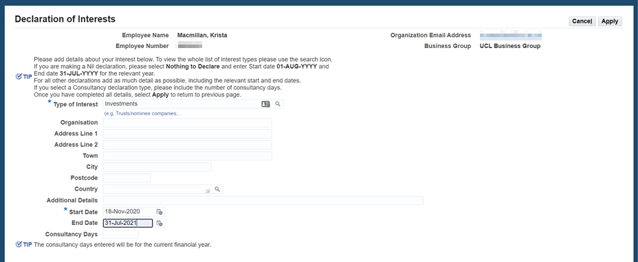
You will then see the interest displayed with the Status showing as ‘Updated’. To finalise the changes, click ‘Next’,
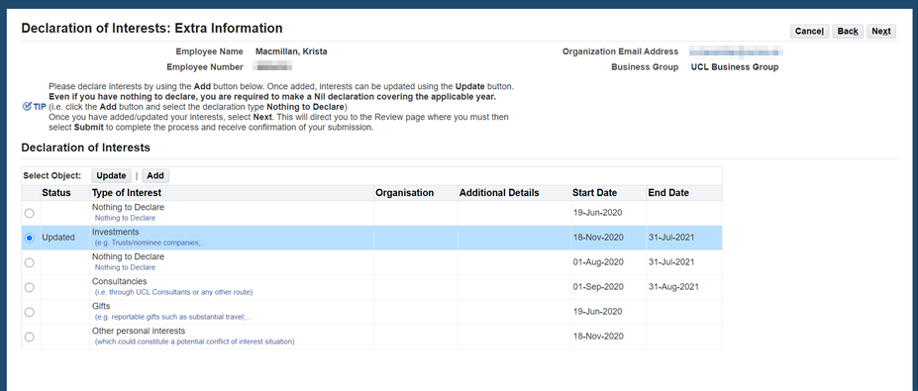
You will then be able to review the ‘Current’ version and ‘Proposed’ amendments. Please review the changes you have made before clicking ‘Submit’.
Note: If you do not select ‘Submit’ the changes will not be saved.
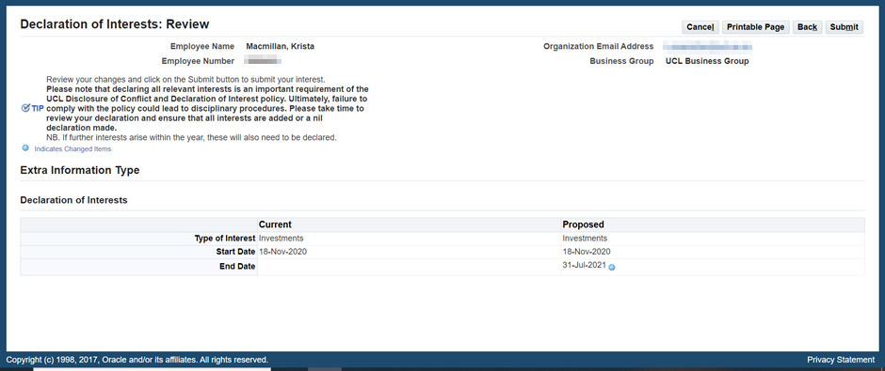
You will then receive the following notification:
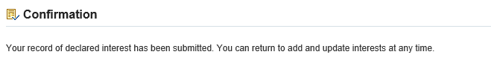
Please note that you should keep your interests up-to-date and declare any new interests as required over the course of the FY.
If you are required to make a declaration as per the policy, you will be sent an email notification on 1 August every year asking you to declare your interest(s) for the FY. Once you have declared, you will also receive an email outlining the interest(s) you have declared for that year.

More information
For more information regarding the Declarations of Interest process, please contact UCL Innovation & Enterprise at: declareinterests@ucl.ac.uk
UCL Disclosure of Conflict and Declaration of Interest Policy
If you have any queries about the ‘UCL Manage Conflicts and Declare Interests’ system please use RemedyForce self-service to raise a ticket.

