UCL INNOVATION & ENTERPRISE
UCL I&E
Knowledge Exchange & Innovation Funding
Web Form User Guide
V1.1

UCL INNOVATION & ENTERPRISE

Introduction
This document is to help you to prepare your Knowledge Exchange application using our web forms.
Please email us at knowledge.exchange@ucl.ac.uk if you have questions or feedback on the web forms.
We would welcome your feedback on the functionality of the system. With your input we can compile a list of necessary improvements but note that we may be restricted in what we can adjust.
Note that where we discuss ‘scheme guidance’ in this document, we are referring to a separate guidance document that provides detailed information on the requirements of the scheme you’re applying to – these are available on the relevant scheme’s webpage under ‘How to apply’.

Contents
Introduction 2
Contents 3
Overall outline of the process 4
Preparing and submitting your application 4
After submission 4
Before you start 5
Accessing the web form system 6
Logging in 6
Knowledge Exchange Funding menu: 8
Filling in the form 11
Progressing through application form 11
Copying and pasting 11
Searching 11
Saving your application 11
Including images 11
Attachment format 12
Viewing and printing your application 12
Sharing the application 13
Section note: Partner organisation 13
Section note: Resources 13

Overall outline of the process

Preparing and submitting your application
- Gather any information needed for your application, including that listed in ‘Before you Start’ below. If desired, prepare your application using the Word template on the scheme page (see ‘How to apply’).
- Go to the relevant web form (via link on scheme webpage), select your scheme and begin an application.
- Progress through the form page by page (you cannot skip pages or required questions). Note that if you are copying and pasting, there are character limits and your text may be truncated, though you will usually receive an alert when you try to continue to the next page. The character limits are listed in the scheme guidance, part B.
- On the final page, you will be able to attach all required supporting files or images etc. that you could not embed in the main question. You must indicate whether they have been attached by answering the questions. You can also use this section to attach other supporting files but please seek approval from the Knowledge Exchange team if you wish to do this as these will only be sent to the reviewers where essential for understanding.
- Submit your application. If you wish, ask us to send you a Word version of the submission.

After submission
- Once the application is submitted and checked, we may contact you with queries and allow you 24 hours to alert us to any errors. This will take several days after the submission deadline.
- When the files have been checked and all necessary information is confirmed, we will trigger a request for approval to your Departmental Manager and Head of Department.
It will be your responsibility to chase this approval; we cannot fund your application until approval is confirmed.
- All other correspondence – decision, award etc. – will follow via email.

Before you start
You will need to answer all required questions to progress through each page (answers are saved as you progress). The application can only be edited, submitted and accessed through a single UCL log-in. With this in mind, we strongly recommend you gather all information and choose carefully who will submit before starting your online application. You can check the information that is required using the Word templates provided on the scheme webpage. In particular, you will need the following:
As you go through:
- UPI numbers for all UCL staff and PhD students who are listed in the application
- This includes the Principal Investigator, Co-Investigator, secondee, secondee’s supervisor, staff being funded, Departmental Manager, Head of Department.
- The number is shown on staff ID cards and are in the form AAAAAXX (A = letter, X = number) – e.g., SHACK22.
- You can also find them through the UCL Directory – note that you must log in using your UCL username and password in order to view the UPI number.
- Email addresses for key participants
(as above as well as Industrial expert-in-Residence and lead contacts for partner organisations).
- Addresses for external partner organisations
At a minimum we will need the region (UK) or country (international).
For the final page (refer to scheme guidance if marked ‘where applicable’):
- Worktribe budget where applicable (you will also need your Worktribe ID)
- Letters of support where applicable
- Approval emails where applicable
- Any images or other attachments that you need to include (note that appendices are not generally allowed so these should be limited to Gantt charts and essential images unless prior approval has been given)
- Costing tool where applicable
If preferred, you may use the Word templates available on the website to prepare the application and then copy the answers across when your application is ready. Note that there are character limits in the web form (these are given in part B of the scheme guidance).

Accessing the web form system

Logging in
Click on ‘Sign in’ on the top right corner of the screen:
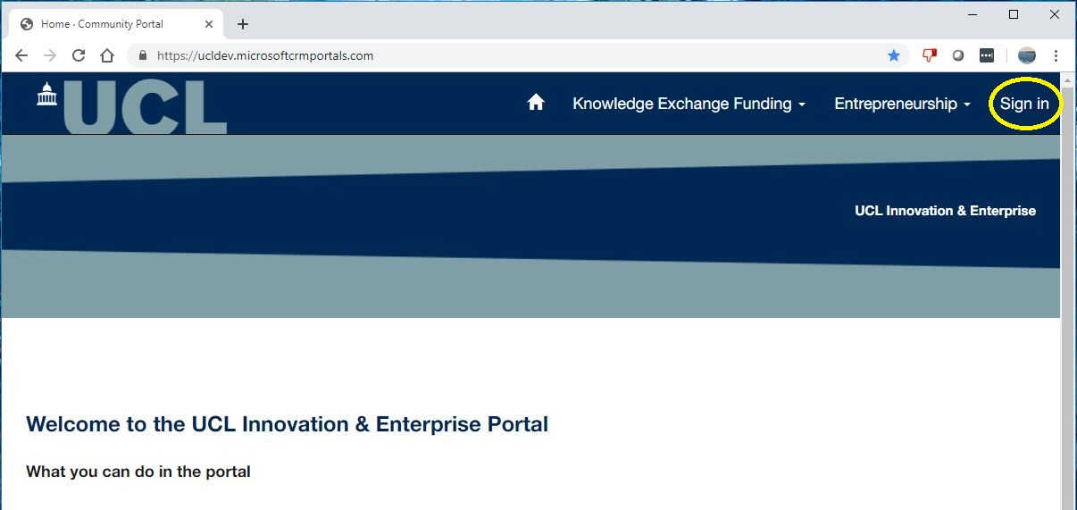

In the following screen, choose the button that reads ‘UCL University Login’, under ‘UCL staff/students: sign in’. Using the other option, or incorrectly entering your password too many times, may lead to your account being locked out – please contact knowledge.exchange@ucl.ac.uk if you have any problems.

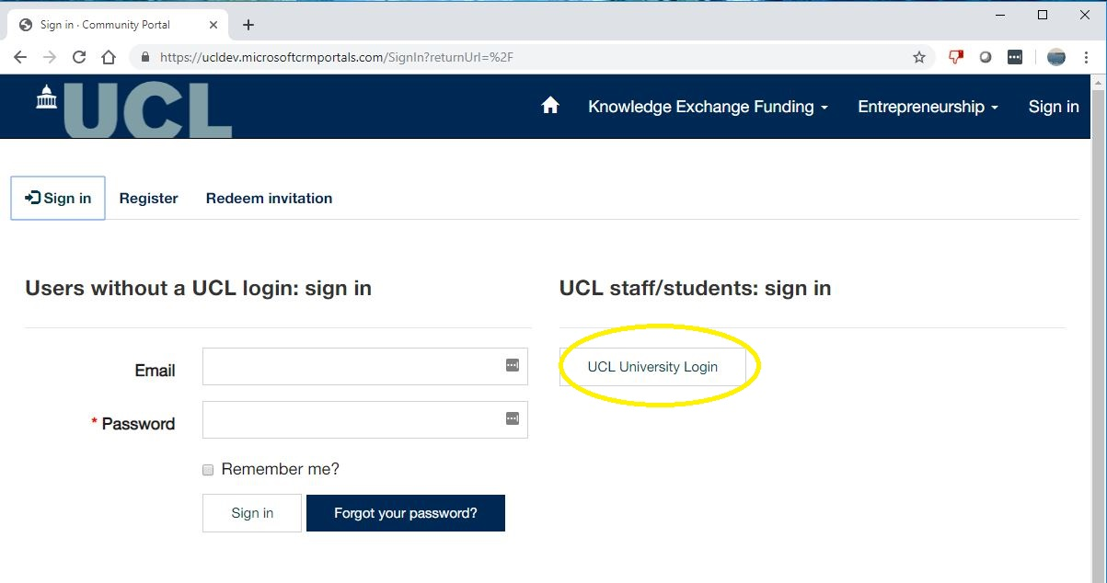
You can then sign in using your UCL credentials, as you would with any Microsoft product, as shown in the picture below:
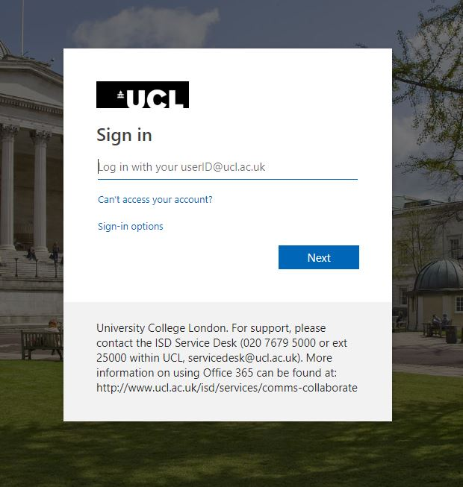

Knowledge Exchange Funding menu:
The Knowledge Exchange Funding menu is at the top of the screen, next to the Home symbol.
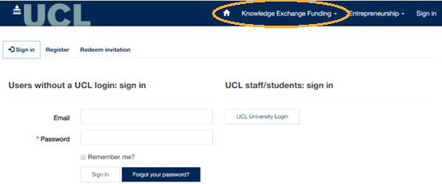

You will see the following options when you click on this:
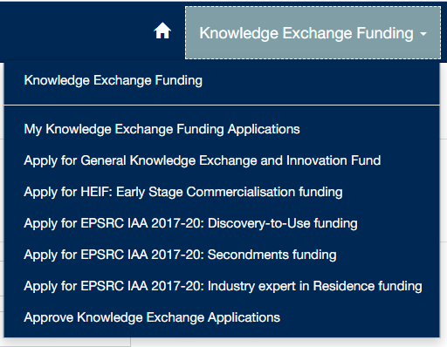
You can either click on Knowledge Exchange Funding to be brought to a summary screen of these options, or you can go directly to each screen. The options are as follows:
- My Knowledge Exchange Funding Applications
Here you will find applications that you have started or submitted. There are two screens that you select from the dropdown menu, as shown in the screenshot below.
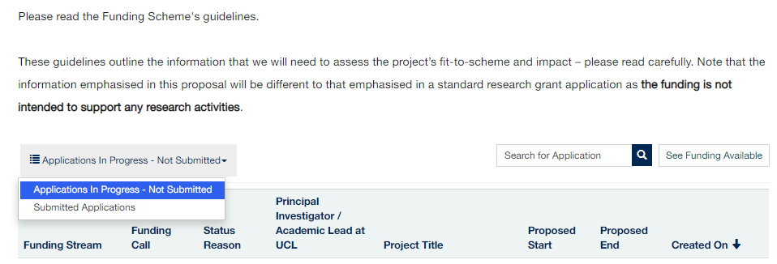
To the right of this dropdown, you’ll note there’s a search box (in which you can search for text from any of the headings shown – ensure that you use the wildcard (*) before your search term).
If you click ‘See Funding Available’ it will take you back to the Knowledge Exchange Funding summary screen where you can see the full menu again.
- Applications in Progress – Not submitted
Shows all applications that you are currently preparing. If we change the status of a submitted application back to ‘In Progress’ because we require further information, it will appear in this section (we will email you to let you know).
To edit your application you can either click on any part of the row or use the dropdown arrow on the right of the row and choose Edit Application. This will bring you back to the last page you were working on.
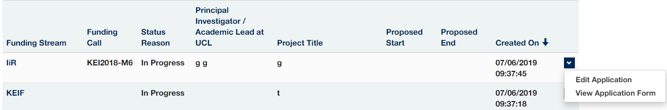
- Submitted applications
Contains all applications that you have previously submitted. You can click on these to view the information you submitted but note that in this view there will be sections that may seem incomplete as they are not relevant to the scheme you applied for. If you are concerned that you have missed a question, you may contact us for a Word version of your form.
Please do not place too much emphasis on the ‘Status Reason’ column after submission. The statuses available are limited and do not usually give an accurate picture of progress. We are working on this.
- Apply for…
Click on the appropriate heading and you will be brought to the start screen for the scheme you wish to apply for.
- General Knowledge Exchange and Innovation Fund
For general knowledge exchange initiatives under EPSRC IAA, BBSRC IAA, AHRC IAA, STFC IAA and HEIF.
- HEIF: Early Stage Commercialisation funding
Previously known as the Pre-commercialisation scheme.
- EPSRC IAA : Discovery-to-Use funding
Also referred to as ‘Applying research in industry’.
- EPSRC IAA : Secondments funding
Select this to apply for either Enterprise or Policy Secondments.
If your project is not linked to EPSRC research outputs and you have discussed alternative sources of funds with us, please select this option and mark ‘n/a’ when asked for your EPSRC research grant number.
- EPSRC IAA : Industry expert in Residence funding
Previously known as Innovator-in-Residence.
- Approve Knowledge Exchange Applications
This is for Heads of Department and Departmental Managers (those with budgetary responsibility for the relevant Department) and replaces the previous method of emails of approval.
They will be sent an alert by the Knowledge Exchange team to let them know that their approval is needed. They will have access to all application information for review and will then need to confirm or decline their approval by a simple click of a button.
It is important that the correct email address is entered for your Head of Department and Departmental Manager as the system identifies users through the email address.

Filling in the form
There are certain options and restrictions to the system of which you should be aware. Some of these are listed below. If you have any other questions that are not answered here, please get in touch with the Knowledge Exchange team at knowledge.exchange@ucl.ac.uk.

Progressing through application form
You must move through the application page by page both in forward and reverse directions. For example, you will not be able to jump from page 1 to page 4 or vice versa.
Some questions are marked as required and you will not be able to continue to the next page until you have answered them.
If you need to continue but are missing some information, you may enter any filler text – e.g., ‘x’ – but please keep in mind that the system will not alert you to incomplete questions so you should check through the full application before submitting.
You should answer all questions relevant to your chosen scheme even if they are not marked required. Due to system limitations, it was not possible to mark all questions as required.

Copying and pasting
All boxes have character limits and only allow plain text.
Character limits are designed to leave you plenty of space to answer the questions but please be aware that if you copy and paste, the text may be truncated.
The limits are listed in the scheme guidance (but do note that these are limits rather than targets – please be as succinct as you can and do not feel you have to use all available space).

Searching
It is recommended that you always search using the wildcard (*) before your search term as the search tool is very specific – e.g., searching for ‘Bartlett’ brings up no results as it is listed as ‘The Bartlett…’ Note that you only need to use the * at the beginning of the search term and not at the end.

Saving your application
You may save and come back to your application at any point.
See above for information on where to find your form at each stage of preparation and submission. Note that you can only save by moving on to the next page – i.e., clicking ‘save and continue’.

Including images
You cannot include images in text boxes. If you would like to attach a Gantt chart or another approved file (keeping in mind that appendices are normally restricted to only one page), you may do so on the final page of the form.
You cannot include images in text boxes. If you would like to attach a Gantt chart or another approved file (keeping in mind that appendices are normally restricted to only one page), you may do so on the final page of the form.
Please include a short description – e.g., Worktribe report, Letter of Support, costing spreadsheet/tool, Gantt chart etc.

Attachment format
The system will accept attachments of any size or format.

Viewing and printing your application
Note that the system does not have the functionality for a final overview of your application before you click submit.
You can save a PDF file of your submitted application
select ‘My Knowledge Exchange Funding Applications’ and using the drop down arrow select ‘Submitted Applications’
From the list of submitted applications, using the dropdown arrow on the right of the screen to ‘View application Form’.
From the open application form, right mouse click to ‘Print to PDF’.
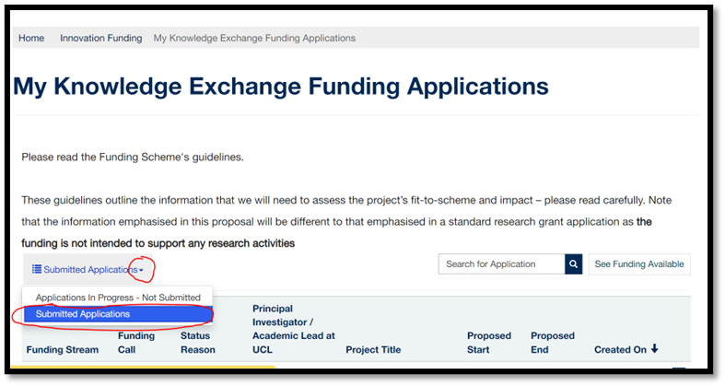
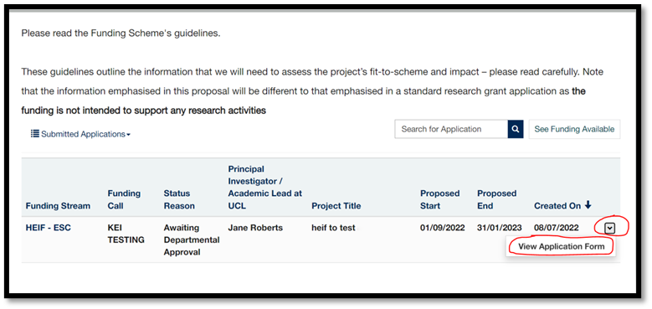
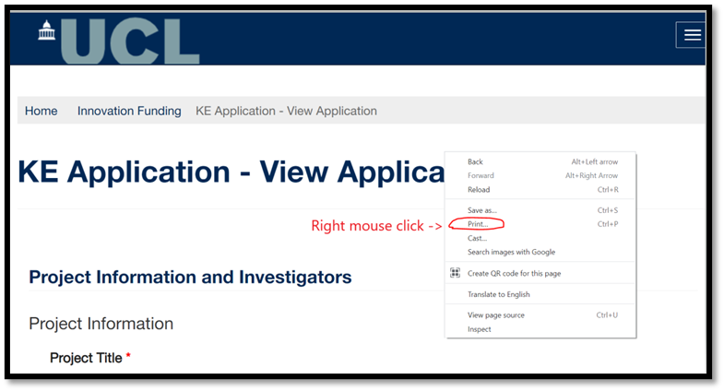

Sharing the application
Only one person can access the application on the submission system.
There is a Word template on the website if you would like to co-develop the application in the Word form.

Section note: Partner organisation

Address
Some fields will be required – if you do not have the relevant information please just enter ‘unknown’ or ‘n/a’ as applicable. You must enter region (UK) or country (international) at a minimum.

Sector
We note that the sector list on the site is more extensive than our list (as shown in the Word form), and is not in the expected order. While we are fixing this, please choose as best you can but do not spend too much time searching for your sectors.

Section note: Resources

Financial year breakdown
Financial Year 1 must be answered and the total value across both financial years must exactly match the total amount you have requested.
If you are not applying for HEIF funding, you do not need to be specific in this question and can just select any financial year and enter the total value your are requesting. If you are applying for HEIF funding, you must be as accurate as possible – please see the scheme guidance for more information.

