Paper for the UCL International conference on Access to Justice and Legal Services:
Customer journey research in Legal Aid in the Netherlands
Peters, S. L. and Combrink, L. – Legal Aid Board, the Netherlands
Which road a client takes to solve his judicial problem varies per client and per problem. Because we wanted to know more about the journey the clients undertake and how they have experienced this, we have talked with clients within the legal aid system. This customer journey research has led to more understanding of the needs of the clients, the journeys they took to solve their judicial problems, the possibilities they had (or had not), the choices they made, the experiences they had, and the solutions they sought. For every interview we have sketched a so-called ‘heartbeat chart’, with all the negative and positive things they experienced in their journey. Also, we have identified the difficulties they encountered, either in the system or with their service provider or solicitor.
In this paper we would like to share some of the findings in our customer journey research. Also we would like to show a couple of ‘heartbeat chart’ and how to read them. It has shown to be a very important way to come to a better understanding of our clients and their needs.

The Dutch Legal Aid system
Short introduction of the Dutch legal aid system
In The Netherlands, legal aid is provided by a public first-line provision (the Legal Services Counters) and by private second-line help (private solicitors and mediators). At Legal Services Counters in the ‘front office’ information and advice is given to clients, but they also refer clients to a private solicitor or mediator. Clients may also apply for help from a subsidized solicitor or mediator directly. These private solicitors and mediators provide legal aid in the form of certificates.
Cutbacks in the system
Compared to 2000, public expenditure on legal aid was increasing over the years. Therefore, in 2008, the government decided to cut the budget for legal aid by 50 million euros, both in 2008 as well as in 2010. Several budget cuts were implemented, like stimulating alternative ways of dispute settlement. Mediation and the ‘Roadmap to Justice’ (Rechtwijzer) were major steps in that direction. Also client’s contributions were increased, especially in divorce cases.
The financial pressure on the system has increased even more due to the legal precedent that was set following the Salduz case. Following this judgment of the European Court in 2009, suspects will be entitled, prior to their questioning by the police, to consult a solicitor.
In 2013, the State Secretary for Security and Justice believed that the system of legal aid needed to be reviewed in due course. Therefore a policy was developed that should result in structural savings of 85 million euros annually. Several measures took effect in 2015, like the reduction of the hourly legal aid rate. However, most cutbacks have been suspended because the Senate filed a number of motions in 2015. A commission was established that issued an opinion after extensive research.

Commission Wolfsen
In 2015 the Government of the Netherlands set up the Commission for Legal Aid, chaired by Aleid Wolfsen. Although the Netherlands already has a good system for legal aid, the question under investigation was whether it could be done better and more durably.
In November 2015 the Wolfsen Commission submitted a report to the Dutch Minister of Security and Justice entitled ‘Reassessing Legal Aid Towards a Durable System for Legal Aid’. The Commission indicated that reassessment of the system was in fact necessary so that the right legal aid provider can be assigned the right work, citizen access to the law can be improved, and tax revenues can be allocated in a more targeted way. In order to achieve these things it is important to strengthen the administration of the system and to take care of problem points. The Commission brought forward a large number of proposals that are both cohesive and mutually reinforcing; taken altogether they will ensure a better and more durable system for legal aid in the long term.
In its investigations the Wolfsen Commission analysed a number of weak points or problem points in the system, including the lack of proper coordination; flaws in the exchange of information between different parties and authorities; and the systemic failure of solicitors when it comes to collecting the personal contribution from their legal aid clients. The Commission referred to the number of those actively offering legal aid within the system as ‘generous’ in relation to demand. Regarding quality, the Commission noted that there is a very large group of highly dedicated legal aid providers who are delivering the so often indispensable legal aid at a qualitatively high level to those who are financially challenged. Nevertheless, the Commission received signals from different quarters that the level of quality is often still variable or sometimes even below par.
Proposals for Improvement
The Commission’s proposals for improvement deal with areas such as these weak points. For example, in the area of improvement of quality, they propose that the Netherlands Bar Association (Nederlandse Orde van Advocaten) and the Legal Aid Board (LAB) must jointly take care of providing proper qualitative requirements within the system, and that expertise requirements in the different specialised areas of law have to be brought up to a higher level all across the board. The Commission also proposes the implementation of a peer review process all across the board, as well as periodic independent investigations into the quality of solicitors. In addition, the fixed fee system needs to be reassessed so that legal aid providers receive proper remuneration.
In the area of administration the Commission proposes that the administration has to be strengthened and that the direction lies with the LAB. The LAB has to deliver customised solutions, particularly for citizens who have many interrelated problems, as well as for those in divorce proceedings. According to the Wolfsen Commission, more checks must be made than is currently the practice as to whether citizens can apply to legal expenses insurance, a union or another organisation of which they are members, prior to the decision granting subsidised legal aid. By their very nature situations consisting of multiple problems cannot be solved, or at least completely solved, within the system of legal aid; in addition to legal guidance, assistance will nearly always be required from partnering organisations outside the system, mostly from those in the social welfare field. Better cooperation and exchange of information between legal aid providers is a precondition for early stage recognition and analysis of multiple problem situations. Another condition is that the legal aid client has to collaborate in finding a structural solution to the problem. Finally, the Commission advises a more intense collaboration between LAB and the Legal Service Counter (LSC) in order to promote consistency in administration.
Many of the proposals of the Wolfsen Commission contribute to better cost management of the system. According to the Commission, the proposals in the report improve access to the law, in the sense that legal aid clients will receive assistance, including legal assistance that is more appropriate to their particular, actual needs. The proposals make legal aid more durable and more balanced. Furthermore, it is the Commission’s expectation that they will ensure a more targeted expenditure of funds to the system.
Status of the Legal Aid System: baseline measurement
The Ministry of Justice and Security is still reflecting on which measures to take. In the meantime the LAB coordinates research to determine the status of the legal aid system. In order to know whether future measures take effect, one should know what the current status of the system is; there should be a baseline measurement. In this baseline measurement the focus lies on three themes: quality of service delivery, needs of the clients, and efficacy of the system.
The baseline measurement should give information about these three topics in order to establish the status of the current legal aid system. In order to collect this information the researchers of the LAB conducted and supervised several studies: surveys among clients, solicitors/mediators, and first line service providers, focus groups and interviews among judges, prosecutors, and other partners, and customer journey research.
In this paper the focus lies solely on the topic needs of the clients that was measured by means of customer journey research.
(Legal) needs and suitable solutions
A major recommendation of the Commission Wolfsen was to look better at the needs of people: What kind of help do they actually need? To what account are these needs legal, or might people actually need another kind of help? The provision of legal aid should (in all stages) be aligned with the problems and needs of the clients. In that way, solutions will be more suitable and therefore more sustainable.
If in the near future measures will be taken to look better at the needs of people and deliver more suitable solutions, one would like to know whether these measures will take effect. To determine this, one needs a baseline measurement at this moment, before changes are made in the system. To determine the way in which needs of people are met in the system of legal aid at this moment, customer journey research was conducted, among other things.

Customer Journey research
A customer journey visually represents the different phases customers experience based on a variety of dimensions, including customer sentiment, goals, and touchpoints. That way a customer journey visualizes the customer’s experience. Customer journey puts the user in the center of the organization’s thinking. Customer journey research is being used by a lot of organizations which deliver services of all kinds. Often the aim is to create a smooth process for (different kinds of) clients. In customer journey research the journey clients take in a certain process or organization is described. In this case the journey begins at the origin of the realization of a problem and ends when the problem is solved (or not solved). In this research the researchers of the LAB have talked with many clients within the legal aid system.
By definition, customer journey research is not quantitative and representative. Customer journey research is not designed to represent a 100% real experience with all its nuances and is therefore not going to be 100% accurate. Therefore the results will be qualitative by nature. These results will be used as a supplement to many other data that are collected as part of the baseline measurement, like client satisfaction research via surveys. Customer journey research is very valuable in a qualitative way, because it zooms in on every specific client and can uncover needs that won’t be revealed by surveys.
Which road a client takes to solve his judicial problem varies per client and per problem. Customer journey research can teach more about the journey the clients undertake and how they have experienced this. This way one is able to better understand the choices clients made, as well as their journeys, the possibilities they had (or had not), the experiences they had, and the solutions they sought. For every interview one can sketch a so-called ‘heartbeat chart’, with all the negative and positive things they experienced in their journey. Also, the difficulties people encounter can be identified, either in the system or with their service provider or solicitor.
Method of Customer Journey research
The research comprises of interview with clients who have received legal aid, either at the Legal Services Counters of from private solicitors or mediators. The interviews were semi-structured; most took place face to face, some took place by phone. Respondents received a small incentive for their time or travel costs. These respondents were partly recruited via their solicitors, who were asked to suggest potential clients. Because the solicitors might especially suggest clients who are satisfied about their performance (which in fact was not always the case), respondents of a client survey were also contacted directly. Thirdly respondents that contacted the LAB directly by phone were recruited. The number of interviews was not decided beforehand, because it depended on the content of the interviews when there would be enough information to recognize patterns and draw conclusions. In this stage, the focus was mainly on three fields of law: social security, criminal, and labour/employment cases.
The social security cases were chosen because of the expectation that this group of clients would be quite homogeneous and therefore patterns would be more easily found. Often these clients experience problems with their local municipalities, for which they need the help of a solicitor. 11 Clients with a certificate for legal aid for a social security problem were interviewed. Also certificate users with criminal problems were interviewed. Interviews took place both in and out of prison. 21 Clients with a certificate for a criminal problem were interviewed. Thirdly, 7 clients with a certificate in the area of labour/employment were interviewed. Other interviews (11) concerned housing, family, administrative and consumer cases. A total of 50 interviews were being held.
Results of the CJ research: heartbeat charts
Every interview leads to a description of the specific journey the client took, from the moment he realized he had a (legal) problem until the moment the problem was solved (or not). This description can be visualized in a heartbeat chart (see figure 1, 2, and 3 below), in which the emotions of the client are depicted.
Figure 1 Heartbeat chart of a client who experienced problems with her welfare benefits
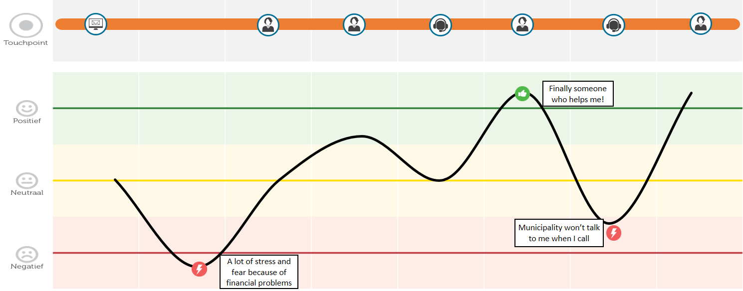

For the welfare cases, most of the clients started with a very negative emotion because of the financial problems they encountered as a result of the rejection of their welfare benefit and the conflicts they experienced with the municipality. Often clients felt thankful for the interference of the solicitor, because there was someone who listened to them and helped them. Mostly just after contacting a solicitor you can see an optimum in the curve. This strongly depends on the type of case. When people are fighting big (governmental) parties there appears to be a stronger need of assistance. In the case depicted above the solicitor managed to get in contact with the municipality and was listened to by the municipality, in contrast with the experiences of the clients themselves who couldn’t get a hold of someone within the municipality office. In welfare cases there are often difficulties along the way, for example waiting time, but most of the time the journey ends with an attribution of welfare benefit and therefore a positive feeling of being helped.
In Figure 2 the heartbeat chart of a detainee is depicted. This man was invited to come to the police station. The interview that was being held there lead to a request for a solicitor because things seemed more serious than he thought in advance. His first solicitor had to give up the case because of a conflict of interest and therefore there was a change of solicitors. He felt really positive about his second solicitor. She listened to him and did everything she could to minimize the sentence, and that was all she could do according to him. After the verdict she even called him to ask how he was. He felt really helped by her.
In criminal cases it can happen that a prisoner changes his opinion about the solicitor after talking to other prisoners. Then someone becomes less satisfied with the help he received. Quite often this leads to a change of solicitors.
Figure 2 Heartbeat chart of a detainee who switched solicitors
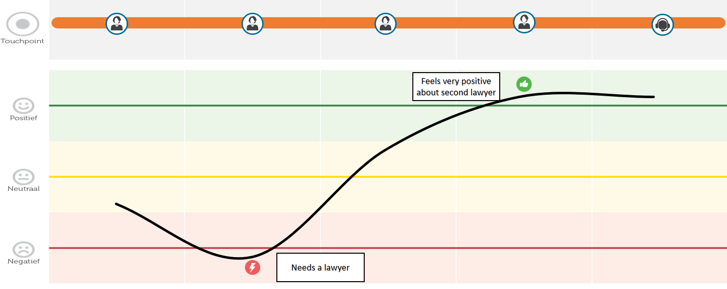

In Figure 3 the heartbeat of a dismissal case is depicted. In this case a chef was dismissed for unclear reasons. He found his solicitor via his ex-colleague who was also dismissed. After an intake and a telephone appointment, the ex-chef went to the LSC for the discount on his own contribution. Then his solicitor wrote a letter to his employer. After that his solicitor didn’t want to take any action. The ex-chef did not understand why and he had the feeling that he is deprived of his ‘day in court’. He is very unsatisfied with his solicitor and feels in no way helped. Above all, he had to pay his solicitor a small amount of money (which in fact was a lot for this particular client because he has debts). In the meantime the ex-chef has started a lawsuit together with some ex-colleagues. It will take a while before anything happens in that lawsuit (it was not made clear why this is the case).
Figure 3 Heartbeat chart of a dismissal case
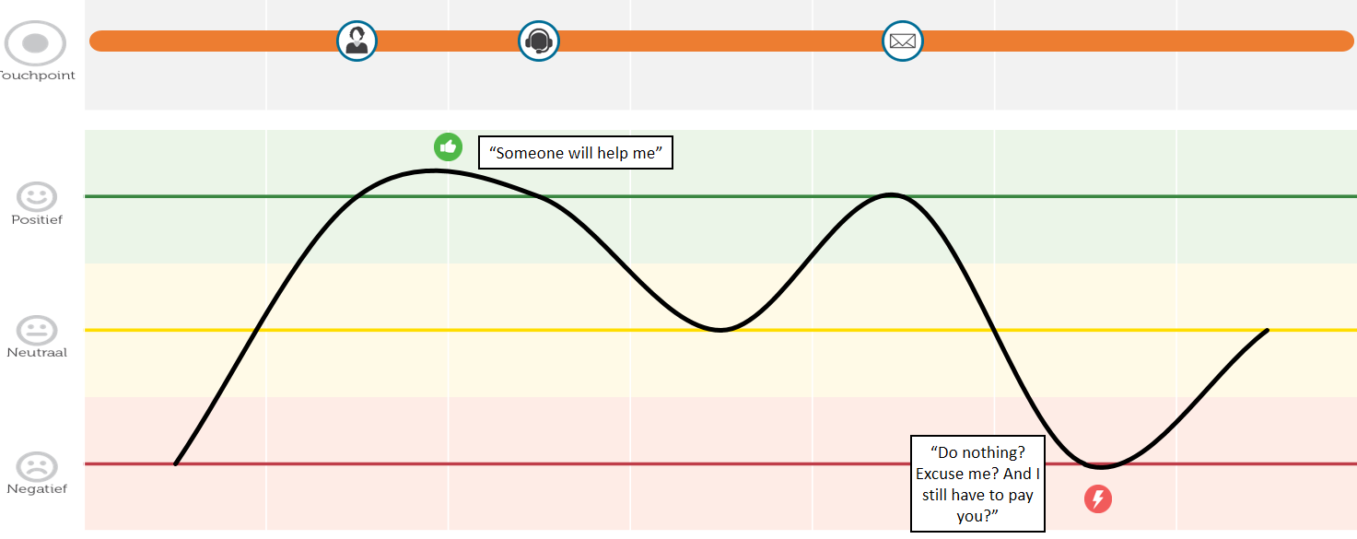

More generally, the interviews for the customer journey research have shown that most customers of the Legal Services Counters (in the first line) felt that the journey they undertook and the help they received suited their needs. Whether someone’s needs are met is to a great extent dependent on their expectations. That is, when expectations (either correct or too high) are not met, clients seem to be less satisfied and therefore less positive about the meeting of their needs. For a small group of people that really depended on being taken by the hand, the LSC met their needs to a lesser extent. The website of the LSC was sufficient when people seek advice, but is less suitable when people want to be referred to secondary help. Generally, clients of the LSC are (greatly) satisfied about the help they received.
The interviews with certificate holders (second line) have shown that the journey these people undertook seem to be suitable, because there are not many obstacles. Some of the obstacles that were mentioned were the redundant steps that people had to take, like having to go to the LSC to get a discount on their own contribution for a certificate or waiting for their new solicitor to get acquainted with the file (mostly for detainees).
Whether the needs of these people are met is to a great extent dependent on their ability to be self-sufficient and cope independently. Every client has his own ability, network, and knowledge and therefore every client has a specific way in which he can be helped in the best possible way. The delivered service should therefore be custom-made to have their needs met. In general certificate holders feel that the service they received from the solicitors and mediators who helped them met their needs. With respect to the solution of the problem, part of the certificate holders felt that this fitted their needs. For another part of the certificate holders the suitability of the solution could not yet be established. Also, there was a smaller group of certificate holders for whom the solution of the problem did not met their needs.

Concluding remarks
The needs of clients are not always determined by the service provider, or he will not always comply with them. As an example a detainee told us that his solicitor went into appeal while he didn’t want him to. In the end the appeal led to a favorable outcome, but it was not what the client wanted the solicitor to do. This example illustrates that the needs of a client may differ from the professional opinion of a service provider and/or his handling of the case. This can lead to a tension, what at least should be acknowledged by the service provider.
The waiting time for a procedure in court is sometimes complained about by clients. This may not comply with their needs of a fast solution of the problem. However, from a professional perspective one might argue that waiting time may lead to a certain kind of acceptance of the situation, where a fast procedure may lead to conflict escalation. It is the task of the service provider to take all perspectives into account and communicate with the client.
Due to this research, -in addition to the results of client satisfaction survey’s- it is better known whether or not the needs of the users of our legal aid system are met. There is a realization that the way in which their (legal) needs are met are to a great extent dependent on their expectations and their self-reliance. Every client has his own ability, network, and knowledge and therefore every client has specific needs in which he can be helped in the best possible way. The delivered service should therefore be custom-made to have their needs met.
With this knowledge, and preferably more research and more interviews with clients in more areas of justice, one could think about how we can organize our legal aid system in such a way, that it can be the most effective and that we can serve as many clients with judicial problems as really necessary. Not all clients need to be taken by hand. Not all clients need or want a court procedure. Not all clients need legal aid. Not all clients need a solicitor. But a number of them do.

Annex I The Dutch Legal Aid system
Under the European Convention on Human Rights and the Constitution of the Netherlands, each citizen of the Netherlands has the right to access courts, apply for legal advice and representation and, if means do not suffice, receive state-financed legal aid. The Dutch Legal Aid system provides legal aid to people of limited means. Anyone in need of professional legal aid but unable to (fully) bear the costs, is entitled to call upon the provisions as set down in the Legal Aid Act (in force since 1994; the last amendment in the regulations took effect on February 1st, 2015). The Legal Aid Act of 1994 replaced the prior statutory system that dealt with the supply of legal aid and dates back as far as 1957.
Given their financial means, approximately 39% of the Dutch population (with a total of 17 million people) would, according to the latest estimates, qualify for legal aid if circumstances so require. The legal aid itself is mainly financed by the state (the Legal Aid Fund) and only for a minor part by an income-related contribution of the individual client.
Residing under the competence of the Ministry of Justice & Security (J&S), an independent governing body called the Legal Aid Board (‘Raad voor Rechtsbijstand’, LAB) is entrusted with all matters concerning administration, supervision and expenditure as well as with the actual implementation of the Legal Aid System. This includes matching the availability of legal experts with the demand for legal aid, as well as the supervision and quality control of the actual services provided. Annually, a Monitor is published that reports on the previous five years’ situation. The LAB consists of five regional offices and one central office.
Being financed by the Ministry of J&S, the LAB accounts to this ministry for its budgetary allocations. The legal aid system operates according to an open end provision. In the past 20 years, spending on legal aid has more than doubled. However, this upward trend has come to an end in the last couple of years (see Table 1).
Table 1 Dutch population and expenditure on legal aid
 | 1994 | 1998 | 2002 | 2006 | 2010 | 2012 | 2014 | 2016
Total Dutch population* | 15,300 | 15,650 | 16,105 | 16,334 | 16,575 | 16,656 | 16,829 | 16,979
Total expenditure on legal aid in Euro* | 184,000 | 195,000 | 315,000 | 398,000 | 472,000 | 486,000 | 432,000 | 423,000
Expenditure per capita in Euro | 12 | 12 | 20 | 24 | 28 | 29 | 26 | 25
*in thousands

Threefold model
The Dutch legal aid system is basically a threefold model in that it encompasses three ‘lines’ that provide legal aid (see figure 1 for a schematic representation):
1. Online self-help, information and support is offered on the Rechtwijzer website (Rechtwijzer translates into Roadmap to Justice; see www.rechtwijzer.nl). Rechtwijzer is a preliminary provision and offers interactive ‘decision trees’ helping people to assess their situation. In addition Rechtwijzer provides easy-to-understand information and guidance on possible solutions for the most common legal problems. Separating couples were offered the online dispute resolution platform Rechtwijzer Uit elkaar. The innovation was piloted and implemented from 2014 to 2017, when it was taken over by a social business. The digital divorce platform will remain part of the services offered by Rechtwijzer.
The Legal Services Counters (see section 2 below) also have a website that can be seen as a preliminary provision.
2. The Legal Services Counters act as what is commonly known as the ‘front office’ (primary help). Legal matters are being clarified to clients and information and advice given. Clients may be referred to a private lawyer or mediator, who act as the secondary line of legal aid. Clients may also apply for help from a subsidised lawyer or mediator directly. If necessary, clients can also be referred to other professionals or support agencies.
3. Private lawyers and mediators provide legal aid in more complicated or time-consuming matters (secondary help) in the form of certificates. A lawyer (or mediator) submits an application to the LAB on behalf of his client. If legal aid is granted, a certificate is issued which allows the lawyer in question to deal with the case. Lawyers and mediators are paid by the LAB to provide their services to clients of limited means. Generally they are paid a fixed fee according to the type of case, although exceptions can be made for more time consuming cases.
The legal aid system, therefore, is a mixed model, consisting of a public preliminary provision, public first-line and private second-line help, as illustrated in Figure 1 below.
Figure 1 Schematic representation of the legal aid system
Solution to judicial problem

Potential client
Legal Services Counter
Rechtwijzer (Roadmap to Justice)

Private lawyer or mediator
To some extent, trade unions and consumer organisations also provide legal aid. The number of legal aid insurance policies continued to rise for a long time and has stabilized around 42% of the Dutch households since 2010.

A more detailed description of the Dutch system can be found in Annex I.
Constitution of the Netherlands Art. 17: ‘No one may be prevented against his will from being heard by the courts to which he is entitled to apply under the law’. Art. 18 ‘(1) everyone may be legally represented in legal and administrative proceedings. (2) Terms concerning the supply of legal aid to persons of limited means shall be laid down by Act of Parliament.’
Both in 2008 and in 2010, the Parliament of the Netherlands have decided to cut the costs of legal aid by € 50 million euros per year in order to prevent them from becoming even higher. In the last couple of years, new ideas for cutbacks have been made and are still being made. At the end of this brochure the plans for cost reduction will be discussed in greater detail.

