Economic History

Lecturer: Dr Ramin Nassehi

Typical Assessment:

-Essay (40% of your overall mark): students usually submit one essay no more than 2,000 words (excluding the bibliography).

-Final coursework (60% of your overall mark): there will be an “open-book” coursework during the main examination period in the summer.

- Affiliate students assessment is 100% essay.

Why study economic history?

Economic history not only makes us familiar with what has happened in the past, but also offers us a novel way of thinking about the economic world. By going deep into the context of important events such as the industrial revolution in the West or the East Asian economic miracle after WWII, economic history helps us appreciate the deep connection of any economy with its political, social and cultural environment. Secondly, by tracing events over time, this discipline helps us realise how our today’s economy is shaped by factors that have been long in motion from the past such as our culture or political institutions. Finally, economic history can potentially offer important lessons for today; after all, some of current economic problems may not be too different from the economic problems of our grandparents or ancestors.

This course is concerned with the history of economic growth and industrialisation from the late 19th century to the present day; the period when some countries rapidly became rich and generated massive divergence in the standard of livings around the globe. The aim here is to

explore factors that helped or hindered countries to become rich. These factors include demography, capital accumulation, trade policy, political institutions, culture and geography. By examining these factors, this course provides an insight into the complexity of long-run economic growth.

Learning outcomes:

- Becoming familiar with the possible causes of the Industrial Revolution in the West, the European reconstruction after the WWII, the American Golden Age and the East Asian economic miracle.

- Understanding the importance of demography, capital accumulation, trade policy, political institutions, culture, geography and foreign relations for long-run economic growth.

- Understanding the challenges of “catch-up” development.

- Realising the embeddedness of any economy in its political, social and cultural context.

- Appreciating the strong influence of self-reinforcing factors (i.e. path dependency) in promoting or hindering economic growth.

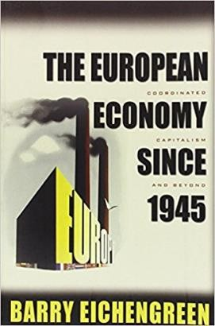Some recommended readings:
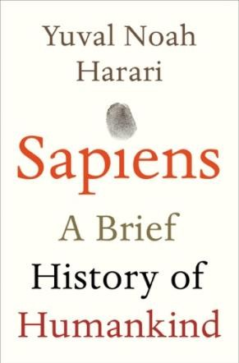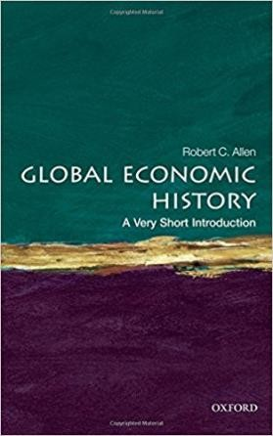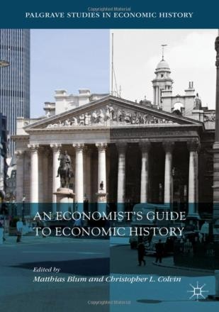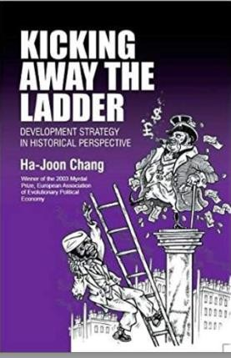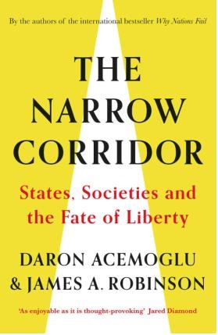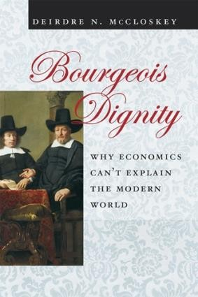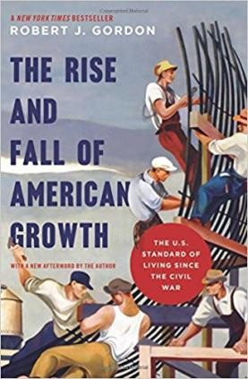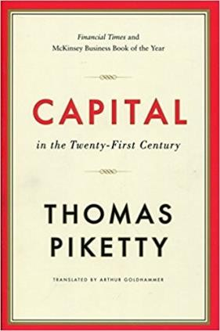

Readings with starts next to them (*) are essential. Week 1: A short history of industrialisation before 1870
*Allen, R. C. (2011). Why the industrial revolution was British: commerce, induced invention, and the scientific revolution. The Economic History Review, 64(2), 357-384.

* Mokyr, J. (2018). The past and the future of innovation: Some lessons from economic history.
Explorations in Economic History, 69, 13-26.

Acemoglu, D., & Restrepo, P. (2019). Automation and New Tasks: How Technology Displaces and Reinstates Labor. Journal of Economic Perspectives, 33(2), 3-30. doi:10.1257/jep.33.2.3

Week 2: A short history of industrialisation after 1870

*Allen, R, C (2011), Global Economic History: A Very Short Introduction, Oxford University Press. Read chapter 8.

*Eichengreen, B. (2007). The European economy since 1945: Coordinated capitalism and beyond (Princeton economic history of the Western world). Read the introduction.

Pritchett, L. (1997). 'Divergence, Big Time', Journal of Economics Perspectives, 11 (3): 3-17.

Week 3: Demographic transition

*Lee, R. (2003). The Demographic Transition: Three Centuries of Fundamental Change. The Journal of Economic Perspectives,17(4), 167-190. Retrieved from http://www.jstor.org/stable/3216936

*Bloom, D., & Williamson, J. (1998). Demographic Transitions and Economic Miracles in Emerging Asia. The World Bank Economic Review, 12(3), 419-455.

Guinnane, T. (2011). The Historical Fertility Transition: A Guide for Economists. Journal of Economic Literature, 49(3), 589-614. Retrieved from http://www.jstor.org/stable/23071723

Nancy Birdsall, Allen C. Kelley, and Steven W. Sinding. Population Matters: Demographic Change, Economic Growth, and Poverty in the Developing World. Oxford: Oxford University Press, 2001. Available online at UCL library: https://goo.gl/VtUAAb

Week 4: Capital accumulation and technological progress

*Crafts, Nicholas (2021), Artificial intelligence as a general-purpose technology: an historical perspective, Oxford Review of Economic Policy, 37: 521-36.

*Robert C. Allen (2012) ‘Technology and the Great Divergence: Global Economic Development Since 1820’. Explorations in Economic History 49 (1) (January): pp. 1–16.

*Easterly, W., & Fischer, S. (1995). The Soviet Economic Decline. The World Bank Economic Review, 9(3), 341-371. Retrieved from http://www.jstor.org/stable/3989846

Gordon, Robert, J. 2000. "Does the "New Economy" Measure Up to the Great Inventions of the Past?" Journal of Economic Perspectives, 14 (4): 49-74.

Crafts, N. (1999). Economic growth in the twentieth century. Oxford Review of Economic Policy, 15(4), 18-34. Retrieved from http://www.jstor.org/stable/23607032

Piketty, T., & Goldhammer, A. (2014). Capital in the twenty-first century: The dynamics of inequality, wealth, and growth. Cambridge Massachusetts: The Belknap Press of Harvard University Press. Read chapter 6. You can access the book online via UCL library.

Week 5: Structural change

*Rodrik, D. (2013). Unconditional Convergence in Manufacturing. The Quarterly Journal of Economics,128(1), 165.

*Adam Szirmai (2009), Industrialisation as an engine of growth in developing countries, UNU- WIDER Working Paper No. 2011/75.

Rodrik, D. (2015). Work and human development in a deindustrialising world, UNDP Human Development Report Office, Retrieved from http://hdr.undp.org/sites/default/files/rodrik_hdr_2015_final.pdf

Rodrik, D. (2016). Premature deindustrialization. Journal of Economic Growth, 21(1), 1-33.

Eichengreen, B., & Gupta, P. (2013). The two waves of service-sector growth. Oxford Economic Papers, 65(1), 96-123.

Week 6: Reading week

Week 7: State-led industrialisation

*Chang, H. (2002). Kicking away the ladder: Development strategy in historical perspective. London: Anthem Press. Read Introduction, chapters 1& 2.

*Rodrik, D., Grossman, G., & Norman, V. (1995). Getting Interventions Right: How South Korea and Taiwan Grew Rich. Economic Policy, 10(20), 55-107. doi:10.2307/1344538

Pack, H. (2006). Is There a Case for Industrial Policy? A Critical Survey. World Bank Research Observer, 21(2), 267-297. doi:10.1093/wbro/lkl001

Dani Rodrik (2009) Industrial Policy: Don’t Ask Why, Ask How, Middle East Development Journal, 1:1, 1-29, DOI: 10.1142/S1793812009000024

Joseph E. Stiglitz; Some lessons from the East Asian Miracle, The World Bank Research Observer, Volume 11, Issue 2, 1 August 1996, Pages 151–177, https://doi.org/10.1093/wbro/11.2.151

Week 8: Political institutions

*Acemoglu, D., Johnson, S., & Robinson, J. (2001). The Colonial Origins of Comparative Development: An Empirical Investigation. The American Economic Review, 91(5), 1369- 1401. Retrieved from http://www.jstor.org/stable/2677930

*Chang, H. (2011). Institutions and economic development: Theory, policy and history.
Journal of Institutional Economics, 7(4), 473-498. doi:10.1017/S1744137410000378

Evans, P (1998), Transferable lessons? Re-examining the institutional prerequisites of East Asian economic policies, Journal of Development Studies, Vol 34, No 6.

Dunning, T. (2011). Natural Experiments of History. Edited by Jared Diamond and James Robinson. Cambridge, MA: Harvard University Press, 2010. 288p. $29.95. Perspectives on Politics, 9(1), 201-202. doi:10.1017/S1537592710003968

Öniş, Z. (1991). The Logic of the Developmental State. Comparative Politics, 24(1), 109-126. doi:10.2307/422204

Week 9: Income inequality

*Piketty, T., & Goldhammer, A. (2014). Capital in the twenty-first century: The dynamics of inequality, wealth, and growth. Cambridge Massachusetts: The Belknap Press of Harvard University Press. Read Chapter 5 (p164-170) & Chapter 6 (p199-224). You can access the book online via UCL library.

*Summers, L. H. (2014). The inequality puzzle. Democracy, 33, 91-99.

Acemoglu, D., & Robinson, J. A. (2015). The Rise and Decline of General Laws of Capitalism.
Journal of Economic Perspectives, 29(1), 3-28. doi:doi: 10.1257/jep.29.1.3

Milanovic, B. (2014). The Return of "Patrimonial Capitalism": A Review of Thomas Piketty's Capital in the Twenty-First Century. Journal of Economic Literature, 52(2), 519-534. doi:doi: 10.1257/jel.52.2.519

Week 10: Natural resources

*Rosser, A (2006), The political economy of the resource curse: A literature survey, Institute for Development Studies working paper No 268.

*Torvik, R (2009), Why do some resource abundant countries succeed while others do not?,
Oxford Review of Economic Policy, Vol 25, No 2, pp 241-256.

Sachs, J.D. & A.M. Warner, Natural resource abundance and economic growth, NBER Working Paper No. 5398, 1995.

Ross, M. L. (2015). "What Have We Learned about the Resource Curse?", Annual Review of Political Science, 18(1): 239-259.

Cabrales, A. and Hauk, E. (2011), The Quality of Political Institutions and the Curse of Natural Resources. The Economic Journal, 121: 58-88. doi:10.1111/j.1468- 0297.2010.02390.x

Nassehi, R (2013), Book review: the oil curse, LSE review of books, May 2012, Accessible at: http://blogs.lse.ac.uk/lsereviewofbooks/2013/05/05/book-review-the-oil-curse-how- petroleum-wealth-shapes-the-development-of-nations/

Van der Ploeg, F. (2011). Natural Resources: Curse or Blessing? Journal of Economic Literature, 49(2), 366-420. Retrieved from http://www.jstor.org/stable/23071620

Week 11: Support lecture for essay writing

