Bachelor in Economics 2021-2022

UCL draft

“Can tobacco taxes reduce its consumption?: Analysis of the elasticities of consumption and participation.”

Gabriel Abilleira Rodríguez

Tutor
Sophie Pascale Thiébaut January 2023

ABSTRACT
Direct taxes on tobacco are a useful tool to reduce tobacco consumption and par- ticipation, as it raises the price for which the packs are sold, modifying the consump- tion decisions that individuals make. In order to evaluate the effect of this tool, this essay is centered around the estimation of the tobacco participation and consump- tion elasticities. To achieve this, three different models are presented: a linear one, estimated using Instrumental Variables for the restricted sample of smokers, a pro- bit and a negative binomial, both estimated using Maximum Likelihood and the full sample. To estimate these models, microdata obtained from a tobacco consumption survey in the U.S. combined with State-level price and tax data is used. Given the available data, estimations for different groups of age, education level, gender, ethnic group and income are presented. Estimated elasticities, which are more important in consumption than in participation, are in the medium-lower level compared to those found in the literature. These seem to show that, for certain groups, there is still some margin to influence these decisions by modifying these taxes and that, for oth- ers, an increase in these may lead to an increase in available public resources without generating a significant dead-weight loss.
Keywords:Direct taxes, Tobacco, Instrumental Variables, Probit, Negative Binomial, Elasticities

Contents
- Introduction 1
- Literature review 2
  - Theoretical models and empirical specifications 2
  - Explanatory factors 3
- Empirical strategy 3
  - Data 3
  - Econometric models 3
  - Elasticity estimation 4
    - Linear model 4
  - Negative binomial model 5
  - Probit model 6
- Results 6
  - Main results 6
  - Additional results 8
  - Practical application 10
- Conclusions 11
References 12

Introduction
Tobacco consumption is considered as one of the leading premature death causes on a global scale. In Spain, for example, it is estimated that prevalence for daily consumption is around 32.3 % and prevalence for at least once in a lifetime con- sumption is around 70% for people between 15 and 64 years old (OEDA, 2019). Furthermore, according to MSSSI, 2016, in Spain, between 2010 and 2014, an average of 51870 deaths related to causes derived from tobacco consumption oc- curred, which amounted, for example, 25% of the total deaths for people between 35 and 64 years of age and 12% for people older than 65. Additionally, tobacco consumption produces some other social costs.
This is why, amongst other reasons, that from the public sector several poli- cies are implemented in order to reduce the tobacco consumption, such as in- creasing the taxes that directly tax this consumption.
In order to evaluate the effect of an increase in such taxes, consumption and participation elasticities are estimated by the means of several econometric mod- els based on the use of microeconomic level data for price, consumption and taxes over tobacco for the U.S.

Literature review

There exists a great disparity between data used, theoretical models, specifica- tions and, as such, results. In the first category there are two types of analysis: the ones that use aggregated data of tobacco consumption, as Jiménez-Martín et al., 1998, and the ones that use microeconomic level data, mainly from surveys, as, for example, in Chaloupka, 1991.

Theoretical models and empirical specifications

Related to theoretical models, there are mainly three types: the ones that consider tobacco consumption like the one for any other good, as in Nonnemaker and Farrelly, 2011, the ones that consider this consumption as the one for an addictive good, but with individuals that do not take into account future consumption, as in Baltagi and Levin, 1986 and the ones that consider that this consumption is rational, that is, that it also anticipates future consumption, as in Chaloupka, 1991. In general, there is empirical evidence in favor of this last type of models (Chaloupka, 1991;Becker et al., 1994).
In relation to empirical specifications, there are, mainly: models that separate consumption and participation decision, as the one in Lewit and Coate, 1982 and models that estimate both decisions at the same time, as for example, in Wasserman et al., 1991.
The models presented below are based on the first theoretical model, as de- scribed above, and follow an empirical strategy similar to the one in Wasserman et al., 1991.

Explanatory factors

In order to build the econometric models presented in this essay, the most impor- tant explanatory factor had to be identified. These are the following: Chaloupka and Wechsler, 1997 and Nonnemaker and Farrelly, 2011 point out the impor- tance of age in order to explain tobacco consumption, as Chaloupka, 1991 does with education or Chaloupka, 1992 or Decker and Schwartz, 2000 with gender. Finally Townsend, 1987 shows the importance of income in relation to this con- sumption.

Empirical strategy

Data

Data for prices and taxes on a state level for the U.S. comes from the database of the Centers for Disease Control and Prevention (CDC) The Tax Burden on To- bacco, 1970-2019. These prices have then been transformed to constant dollars fro the year 2012. The rest of the data related to tobacco consumption and in- dividual characteristics comes from the survey carried out by the CDC National Adult Tobacco Survey 2012-2013.

Econometric models

In order to being able to estimate the price elasticity of the tobacco consumption three different models are used: a lineal model for which the dependent variable is the amount of cigarettes consumed in a monthly basis for the restricted sample of smokers, a probit model for which the dependent variable is a binary variable

that identifies if the individual is a smoker and a negative binomial model that has as dependent variable the number of cigarette packages consumed on a monthly basis. Different estimations are carried out for different groups of age, gender, education ethnic group and income.
For the lineal model, estimation by Ordinary Least Squares (OLS) may be biased, due to the problem of simultaneous causality. This is caused by the fact that equilibrium quantity and price are determined at the same time, so the factors that are not observed and affect the supply also affect the price. To solve this problem, an estimation by Instrumental Variables (IV) is carried out, using as instruments the present and past taxes over tobacco consumption. The other two models are estimated by maximum likelihood (ML).

Elasticity estimation

Finally, related to estimated elasticities, the ones for the lineal and negative bi- nomial models are consumption elasticities, while the one computed from the probit model is the elasticity of the participation in that consumption. Let us delve deeper into the estimation for each model:

Linear model

The elasticity of consumption computed using the linear model can be obtained, in population terms, by multiplying the marginal effect associated to a change in the price by the fraction of the expected value of the price by the expected value

of the quantity, using the following formula:
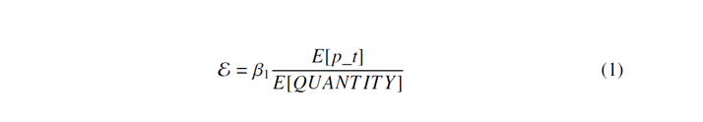
Where β₁ is the parameter related to the price, p_t is the variable that measures the price and QUANTITY is the variable that measures cigarette consumption.
Standard deviation, in population terms, can be computed in the following

way:

Where sd(β₁) is the standard deviation of the estimator.

Negative binomial model

The elasticity of consumption computed using the negative binomial model can be obtained, in population terms and for the average individual and average marginal effect, since now it is no longer constant, in the following way:

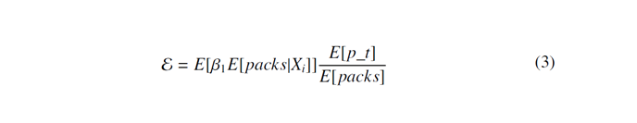
Where β₁ is the parameter related to the price and packs is the variable that measures the number of cigarette packages consumed on a monthly basis. Since now this expression is much more complicated than the one presented above, standard deviation is computed using non-parametric bootstrap.

Probit model

The elasticity of participation computed using the probit model can be obtained, in population terms and for the average individual and average marginal effect, since, same as before, it is not constant, in the following way:
Where ϕ is the normal density function, S MOKNOW is the binary variable that measures if the individual is a smoker, Xi′β refers to the linear equation inside the probit model and β₁ is the parameter associated to the price. Once again, given
the complexity of the expression presented above, the standard deviation is also computed using non-parametric bootstrap.

Results

Main results
As can be observed in Figure 1 ¹, the estimated consumption elasticities vary between the two models and are in the medium-low part compared to the ones that can be found in the literature (Becker et al., 1994 or Chaloupka, 1991).

1Confidence intervals are computed for a significance level of 95%

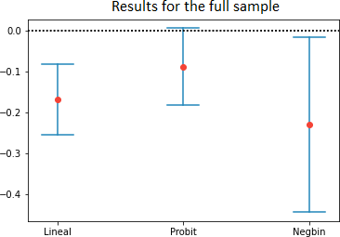

Figure 1: Elasticities estimated for the full sample

In relation to the participation elasticity, it is lower in comparison (in fact, it is not statistically significant). This contrasts considerably with the results shown in the literature, where most of the change in tobacco consumption is related to the participation decision and not to the consumption one (Grossman et al., 1993).
For the results related to the different age groups (Figure 2), it seems that youngsters are more sensitive to price changes, both for the participation and consumption decision. This result is quite important in terms of improving the general health of the population by these means.
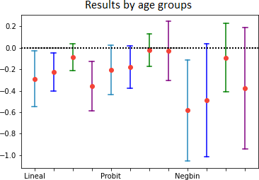

Figure 2: Elasticities estimated for the age groups

These results are similar with the ones found in the literature (Chaloupka and Wechsler, 1997 and Nonnemaker and Farrelly, 2011). It is interesting to point out that consumption elasticity for people older that 66 seems to be quite large. This may be due to the implications that tobacco consumption has over the health.

Additional results

Related to income (refer to Figure 3), it seems that individuals that are more sen- sitive to price changes are the ones that have a medium-level income. These re- sults are different than the ones found in the literature (Townsend, 1987). On the other hand, this has some implications over the progressivenes of the tax, since if low income individuals barely modify their consumption decision at changes in the price, they will suffer the majority of the tax burden, which would make the tax more regressive.
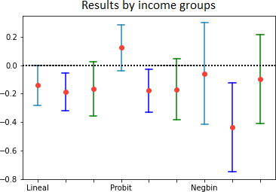

Figure 3: Elasticities estimated for the income groups

Related to gender, as can be seen in Figure 4, it seems that men are quite more sensitive to price changes for either decision compared to women. This would be related to the results found in the literature (Chaloupka, 1992) an with

the consideration of women as social smokers (Decker and Schwartz, 2000).

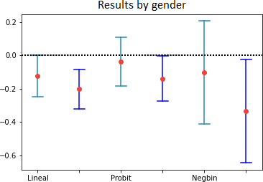

Figure 4: Elasticities estimated for the gender groups

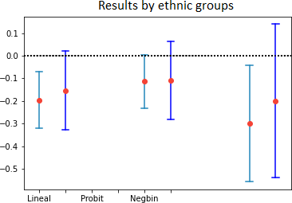
Finally, looking at the results for the different ethnic groups in Figure 5, it seems that individuals belonging to minorities are much less sensitive to price changes, compared to the individuals that belong to the white ethnic group. This may be due to the relation that these groups have with other socioeconomic vari- ables, such as income or education.

Figure 5: Elasticities estimated for the ethnic groups

Practical application

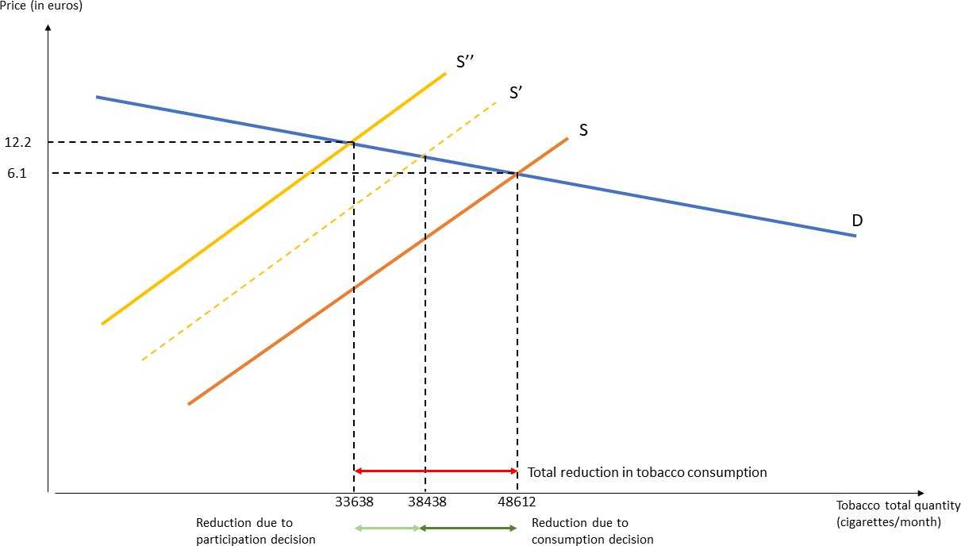
Given the current situation in Spain with the Ley del Mercado de Tabacos (here), it would be interesting to use the estimated elasticities for simulating the re- duction on the tobacco consumption given a price increment on tobacco (for example, of a 100%)²:
Figure 6: Reduction over tobacco consumption due to an increment of the price

As can be observed in Figure 6, an increment of 100% in the price would cause an average reduction of 14974 cigarettes on a monthly basis, of which 4800 are related to the participation decision, and the rest to the consumption one, which means that the change related to the consumption decision is higher compared to the participation one.
On the other hand, this simulation shows that an increment of the price of to- bacco derived by a rise in the direct tax imposed on it can still effectively reduce tobacco consumption, which in turn can help to improve the general health of the population. However, since this reduction would heavily rely in the consumption
decision and not in the participation one, this improvement may be smaller than

2These results have been obtained simulating 100 times a sample of 500 individuals, given a prevalence of consumption of 32.3 %, a price of 6.1 €, an average individual consumption of 300 cigarettes on a monthly basis and the elasticities estimated with the full sample.

expected, as individuals may compensate this reduction in consumption by con- suming cigarettes that have greater amounts of nicotine or tar, as stated in Evans and Farrelly, 1998. In this sense, as seen in Grossman et al., 1993, it would be better that the most relevant decision were the participation one.

Conclusions

Overall, it seems that, for certain groups, there is still margin to act over tobacco consumption. This is specially relevant for young people, since in the long term a reduction in their consumption can produce a significant general health im- provement of the population, which in turn has many implications over several different factors, such as premature death or work productivity. On the other hand, there are certain groups for which the usage of these tools may be more effective from the point of view of optimal taxation, since the decisions of these individuals would barely change, thus generating an almost null efficiency loss. Finally, it is convenient to point out that these results may be related to some other taxes aimed to reduce the consumption of some unhealthy goods, such as sugar or fizzy drinks, since their effectiveness would also be rooted within the consumption and participation elasticities, specially, as has already been ex-
plained, the ones related to youngsters.

References
Baltagi, B. H., & Levin, D. (1986). Estimating dynamic demand for cigarettes using panel data: The effects of bootlegging, taxation and advertising reconsidered. The Re- view of Economics and Statistics, 68(1), 148–155. https://www.jstor.org/stable/ 1924938
Becker, G. S., Grossman, M., & Murphy, K. M. (1994). An empirical analysis of cigarette addiction. The American Economic Review, 84(3), 396–418. https://www.jstor. org/stable/2118059
Chaloupka, F. (1991). Rational addictive behavior and cigarette smoking. Journal of Po- litical Economy, 99(4), 722–742. https://www.jstor.org%20/stable/2937778
Chaloupka, F. (1992). Clean indoor air laws, addiction and cigarette smoking. Applied
Economics, 24(2), 193–205. https://doi.org/10.1080/%2000036849200000118 Chaloupka, F., & Wechsler, H. (1997). Price, tobacco control policies and smoking among
young adults. Journal of Health Economics, 3(16), 359–373. https://doi.org/10. 1016/S0167-6296(96)00530-9
Decker, S. L., & Schwartz, A. E. (2000). Cigarettes and alcohol: Substitutes or comple- ments? (Tech. rep.). http://www.nber.org/papers/w7535
Evans, W. N., & Farrelly, M. C. (1998). The compensating behavior of smokers: Taxes,
tar, and nicotine. The RAND Journal of Economics, 29(3), 578–595. https://www. jstor.org/stable/2556105
Grossman, M., Sindelar, J. L., Mullahy, J., & Anderson, R. (1993). Alcohol and cigarette taxes. Journal of Economic Perspectives, 7(4), 211–222. DOI:%2010.1257/jep.7. 4.211
Jiménez-Martín, S., Labeaga, J. M., & López, A. (1998). Participation, heterogeneity and dynamics in tobacco consumption: Evidence from cohort data. Health Economics, 7(5), 401–414. https:// doi. org/ 10 . 1002 /%20(SICI) 1099 - 1050(199808 ) 7 : 5 %
3C401::AID-HEC361%3E3.0.CO;2-27
Lewit, E., & Coate, D. (1982). The potential for using excise taxes to reduce smoking. Journal of Health Economics, 2(1), 121–145. https://doi.org/%2010.1016/0167- 6296(82)90011-X
MSSSI. (2016). Muertes atribuibles al consumo de tabaco en españa, 2000-2014. Minis- terio de Sanidad, Servicios Sociales e Igualdad.

Nonnemaker, J. M., & Farrelly, M. C. (2011). Smoking initiation among youth: The role of cigarette excise taxes and prices by race/ethnicity and gender. Journal of Health Economics, 30, 560–567. https://doi.org/10.1016/%20j.jhealeco.2011.03.002
OEDA. (2019). Encuesta sobre alcohol y drogas en españa (edades), 1995-2017. Minis- terio de Sanidad, Consumo y Bienestar Social.
Townsend, J. L. (1987). Cigarette tax, economic welfare and social class patterns of smok- ing. Applied Economics, 19, 355–365. https://doi.org/10.1080/00036848700000007
Wasserman, J., Manning, W., Newhouse, J., & Winkler, J. (1991). The effects of excise
taxes and regulations on cigarette smoking. Journal of Health Economics, 1(10), 43–64. https://doi.org/10.1016/0167-6296(91)90016-G

