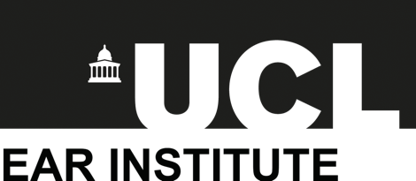

UCL Ear Institute
MSc Excellence Scholarships
2024-25
Application Form
Deadline 31 July 2024

Application Form
Personal data given to the UCL Ear Institute will be processed in accordance with the UK Data Protection Act 2018 which incorporates the General Data Protection Regulations (GDPR). The information you give will be used for the following purposes:
- to enable UCL Ear Institute to create a record of your application
- to enable the application to be processed
The information will be kept securely and will be kept no longer than necessary.
Part 1: Personal details
This section will not influence the outcome of your application.
Title (Ms, Miss, Mrs, Mr etc)
Full name
Date of birth
UCL Student ID
Please state which MSc programme you are applying for
Nationality
Email address
Contact number

Part 2: Personal Statement

This section will influence the outcome of your application. You are advised not to copy and paste content from your Personal Statement

Please write 400 words on why you are applying for a bursary. Please tell us about the following:
- Why you want to study and work in audiology
- What steps you have taken to find out about the profession (or, if you are already an audiologist, what steps you have taken to improve your knowledge and skills).
- Any activities or projects you have been involved in outside your work or core studies which have enabled you to develop skills required of an audiologist (these could be people skills or scientific enquiry skills)
- Why financial assistance will be particularly beneficial for you.
Your academic results (or predicted results) will also be taken into account.
We particularly welcome applications from people with caring responsibilities, people returning to study later in life and people from countries in which audiology is less developed.

You can save your statement as a Word/PDF file if you prefer and email it to ear.education@ucl.ac.uk. Please make sure the file name includes “UCL Ear Institute MSc Excellence Scholarship” and your full name.

