UCL Centre for Co-production in Health Research: the story so far…

The UCL Centre for Co-production in Health Research exists to support co-production in health research, innovation and practice, especially in relation to the needs and priorities of less-often heard communities. We do this through bringing together a diverse network of expertise and experience (researchers, patients, practitioners, carers and community members) to generate and share learning around co-production, facilitate co-production projects and build the co-production movement.
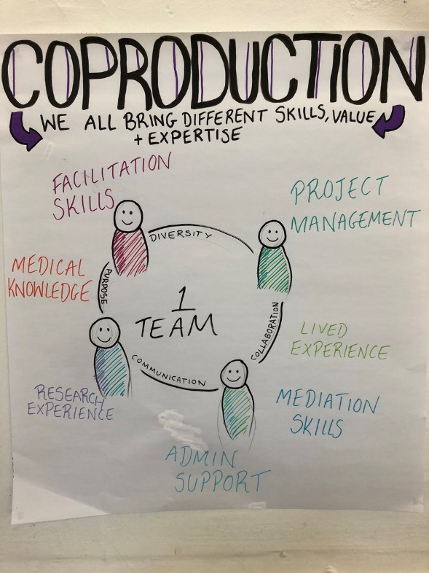
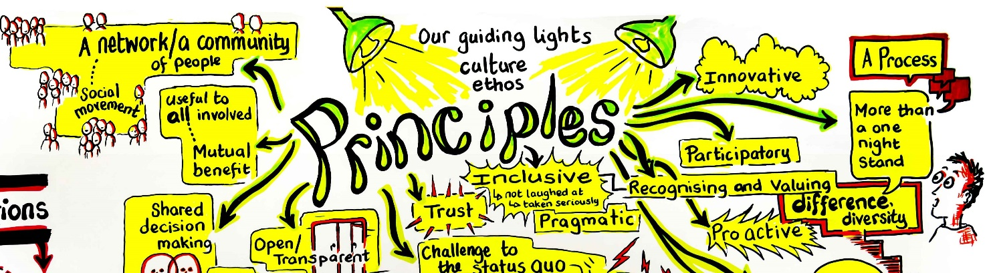
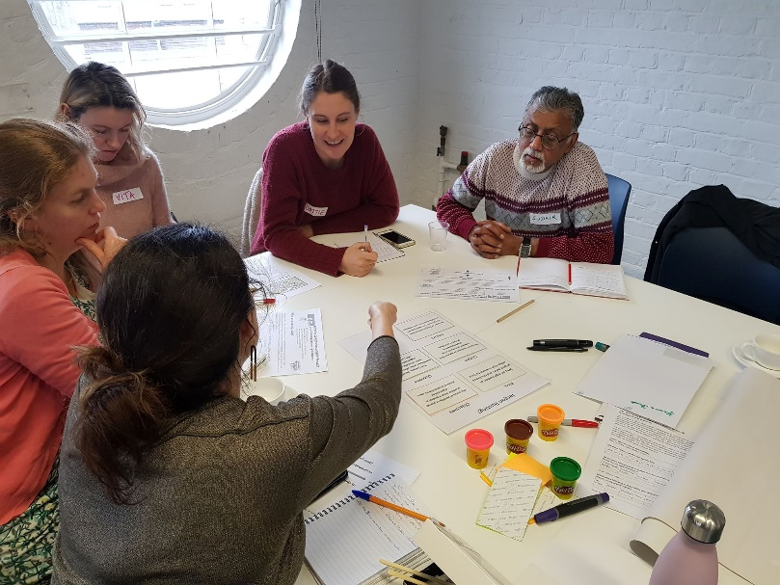
Approx. 160 co-producers contributed to these sessions. For those we have monitoring information about:
- 39% identify as having a disability
- 54% are from white backgrounds
- 33% are aged under 35
34% are aged 35-55
33% are aged over 55

2020
2019
2018
2017
Over 700 followers in 6 months.
19K reach

5 co-production projects funded up to £5K per project, over 4 months.
Action Youth Boxing Intervention co-produced an evaluation plan and theory of change for their wellbeing programme. By co-producing with researchers, staff and young people, they:
- identified unexpected outcomes
- tested and refined their evaluation approach
- built the skills and capacity of team members
- developed programme improvements
- generated evidence of impact
They have since secured further funding and commissions, raised their profile and grown their activity.

they have since won the UCL Public Engagement Community Award, secured further funding, and grown the programme.

Informed by learning from Phase 1,
4 co-production projects supported with bigger grants over a longer period – up to £15K per project over 7 months (end Feb 2020)

“I realised that co-production could be done, and it was more than a concept – there was a pragmatic and focused role it could play in my work.”
PPI Manager and co-producer
“The session made me more confident to be more flexible/creative. It energised and encouraged me.”
Centre community member
“Opened my mind to different views, and learning from experience.”
Centre community member

