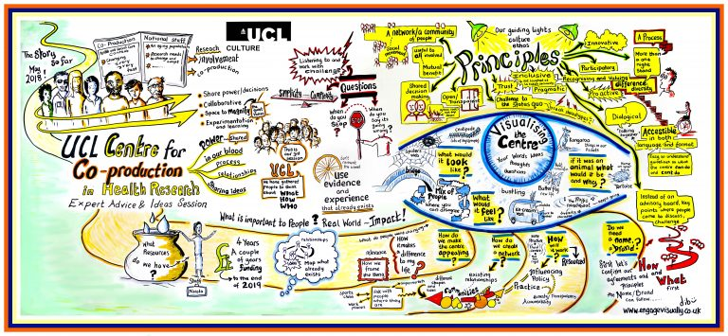
Figure 1: Graphic illustration of UCL Centre Co-production story so far, principles and some thoughts on what it might look like
Our principles to live by - UCL Centre for Co-production in Health Research

All interaction will be based on the principles we as a Centre want to live by.

These are:

- Respect for diversity of experience and perspective
- Collective decision-making
- Commitment to addressing power imbalances
- Understanding the meaning of and fostering authentic co-production
- Commitment to challenge the status quo
- Be accessible to and inclusive of all
- Ensure mutual benefit for all
- Be open, transparent and honest - yet pragmatic and real
- Check & challenge throughout
- Encourage innovative practice
- Ensure sufficient resourcing & sustainability

