

**UCL CULTURE**

**­**

**The Petrie Museum of Egyptian Archaeology**

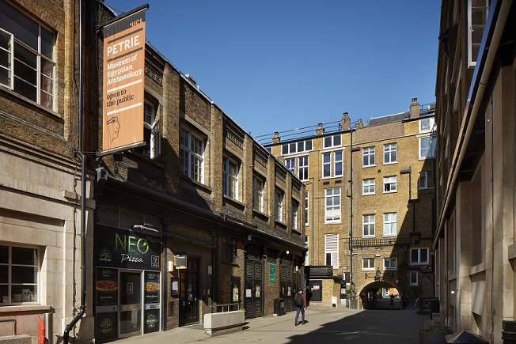

**Teachers’ Pack**

This pack supports primary school teachers planning a visit to UCL’s Petrie Museum of Egyptian Archaeology.

The pack has been developed with these key objectives in mind:

1. To promote learning about Egypt and to offer new perspectives on daily life in ancient Egypt. The Petrie Museum specialises in objects about daily life. We want to extend learning beyond popular themes of mummies, Tutankhamun, pyramids, and the afterlife.
2. To promote an investigative approach that encourages pupils to observe, think, make choices and draw conclusions. The Petrie Museum is a university museum and supports UCL’s Widening Participation mission to raise young people’s aspirations towards Higher Education.
3. To place the visit in context and maximise learning by encouraging appropriate pre-visit work, activities that make the most of your visit at the museum, and meaningful follow-up activities.

**Contents**

Page 2-3 Things to think about when studying ancient Egypt

Page 3 Recommended reference websites

Page 4 During your visit, including how to read a label

Page 5 Why a preliminary visit is important, setting objectives

Page 6-7 Pre-visit activity suggestions

Page 8 Background information: About UCL

What is special about the Petrie Museum?

Page 9 Visitor information and map

Page 10 Timeline

Page 11-12 Museum floor plan and key

Page 13 Investigating objects worksheet

Page 14 True or False activity

**Things to think about when studying ancient Egypt**

1. Egypt is in Africa.

It may seem obvious but it is amazing how many people do not realise Egypt is in Africa. Any study of Egypt begins with its geography. Egypt is located in North East Africa, with access to both the Mediterranean Sea and the Red Sea.

Today, Egypt is a modern, thriving country with a unique and vibrant culture. Modern Egyptians speak and write Arabic. The main religion in Egypt today is Islam, with many other faiths co-existing.

2. Ancient Egyptian civilisation changed enormously over time.

Throughout its history there were many different cultures that made up what we call ancient Egyptian civilisation. Egyptians who lived during the reign of Tutankhamun were as far away in time from the Egyptians who built the pyramids as we are to the Vikings or William the Conqueror. Tutankhamun’s subjects may have found the pyramid age as unfamiliar as we do. It is important to remember that things we often group as belonging to ancient Egypt may have been produced hundreds or thousands of years apart and do not represent a single culture.

3. We cannot be sure what the ancient Egyptians looked like; we can assume they had black or brown skin.

We get information about the way ancient Egyptians looked from a range of representations: people made countless images of themselves on wall paintings, inscriptions, in sculpture. They followed a strict visual code for portraying themselves at the peak of health and beauty. Paintings and sculpture do not necessarily represent reality and should not be taken literally.

There is debate about the ancestral origins of the ancient Egyptians. There are three main views:

1. The modern Egyptian view is that the ancient Egyptians are the same group of

people as the modern Egyptians

1. The Afrocentric view is that the ancient Egyptians were black Africans, displaced by

later movements of peoples, by Macedonian, Roman and Arab conquests

1. The Eurocentric view is that the ancient Egyptians are ancestral to modern Europe

Although the debate is ongoing, we know they were NOT white and there was an enduring black presence in Egyptian culture. Evidence of the earliest Egyptian civilisation was found in Upper Egypt (near Sudan) and was therefore likely to have been black. At various times black people ruled Egypt, such as the Nubian pharaohs of the 7th and 8th centuries BCE.

4. It is hard to agree on dates for the start and finish of ancient Egypt.

The year 3100 BCE is one date traditionally used to mark ancient Egypt’s beginning. This

was when Upper and Lower Egypt are thought to have been united as a single kingdom under the first recorded Pharaoh of Egypt, Narmer. The end of ancient Egypt is set sometimes at the death of Cleopatra in 30 BCE, when Egypt became part of the Roman Empire, or in the early 4th Century CE, when Egypt became widely Christianised.

5. Many powerful images we have of ancient Egypt come from fictional sources like books, Hollywood films, and advertising. These images stop us from appreciating the reality of life in ancient Egypt.

Archaeology deals with physical evidence from the past, which can be used to challenge assumptions and raise questions about images we get from fictional sources. It is important that we encourage young people to look beyond the stereotypes and to draw their own conclusions from the objects they can see at the Petrie Museum.

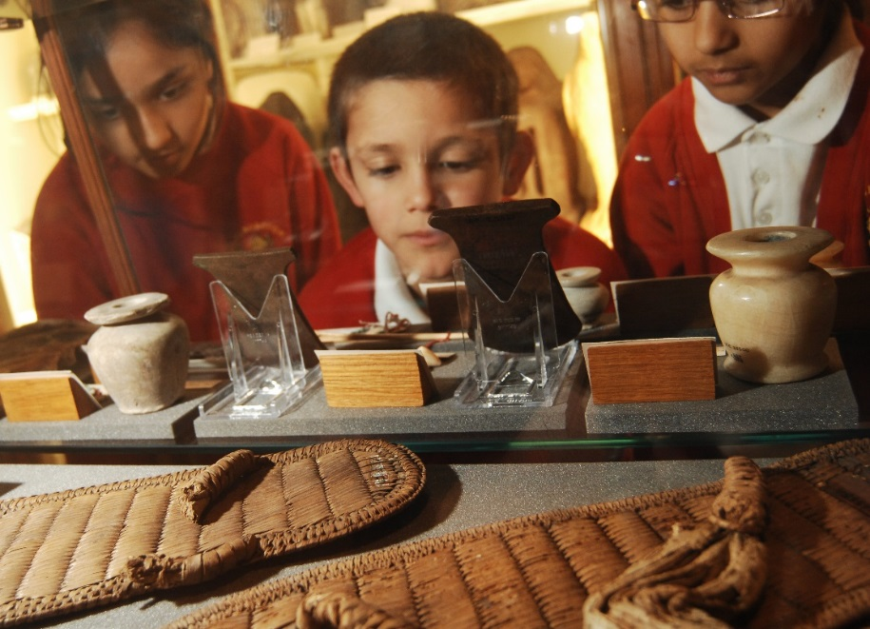

**Recommended reference websites**

<http://petriecat.museums.ucl.ac.uk> There is an online catalogue here of images and information about all 80,000 objects in the Petrie Museum. It is ideal for researching a topic, downloading pictures or getting pupils to create their own online gallery.

[www.ancientegypt.co.uk](http://www.ancientegypt.co.uk/) The British Museum’s website on ancient Egypt for children. It has a good range of activities including information about Egyptian life and death, and a comparison of the life of a rich and a poor Egyptian.

[www.discoveringegypt.com](http://www.discoveringegypt.com/) A colourful American website that provides information about Egyptian kings and queens, pyramids and temples and hieroglyphs. Pupils can also send ancient Egyptian e-cards.

<http://www.ucl.ac.uk/museums-static/digitalegypt//> A learning resource developed by UCL for the Petrie Museum, including art and architecture, communications technology, archaeological records, ideology and beliefs, social history, sciences and timelines.

**During your visit**

We can accommodate one or two classes at a time. When your group has arrived and placed their belongings on the central table, they sit down and one of our Visitor Services Assistants will give a brief introduction. The introduction includes:

* Who was Flinders Petrie
* What are archaeologists and Egyptologists
* Hieroglyphs

They Visitor Services Assistant also goes through the museum rules, which include:

* No running
* No shouting
* No touching the glass
* No going over, under or behind the hand rails
* Only adults can pull out the drawers

Please be aware that there is *absolutely* ***no eating or drinking*** *in the museum*.

After the introduction teachers lead their students’ visit. Please remember to bring any resources for your students to use, you are welcome to bring resources of your own and we have some activities you can download from our website:

[www.ucl.ac.uk/culture/petrie-museum/research-learning-petrie-museum](http://www.ucl.ac.uk/culture/petrie-museum/research-learning-petrie-museum)

The visit ends with a brief plenary with a Visitor Services Assistant where the children can share comments about what they have seen during their visit.

**How to read a label**

All objects on display have a label. These labels are made to help you – each label will tell you important information about each object displayed in the museum. It is important to understand how to read the label for an object. Below is an example of an object label with arrows indicating how to read it.

Where the object was found

Museum object number

Object description

Age of the object

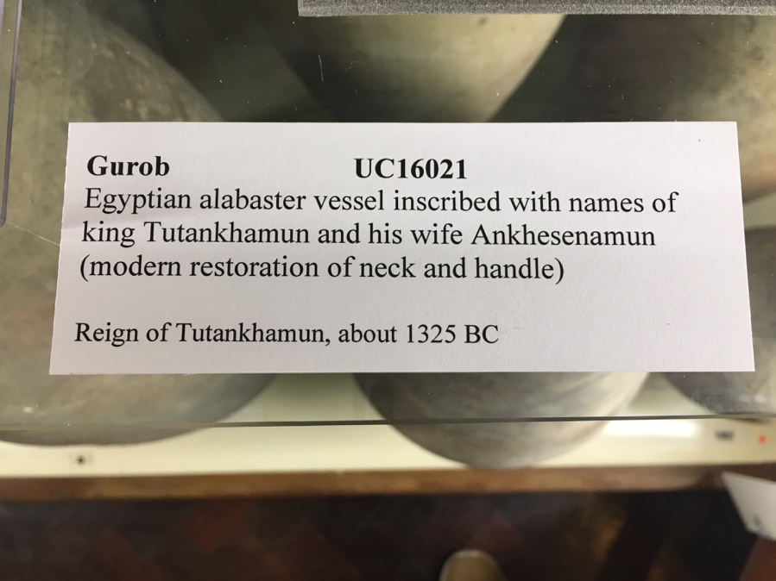

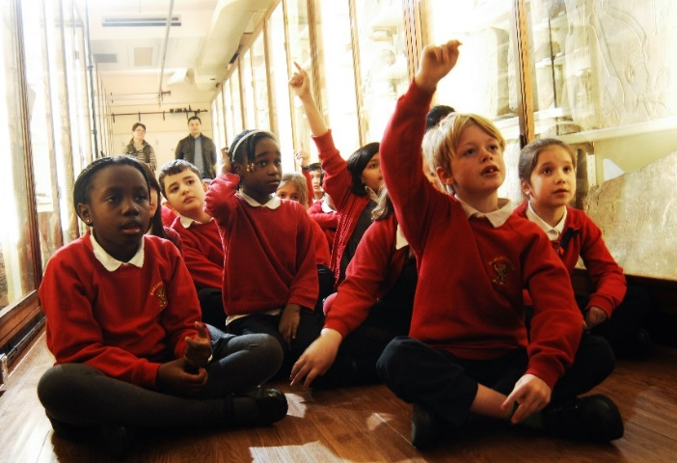**Why a preliminary visit is important**

We recommend you visit the Petrie Museum prior to your class visit.The museum is located within a large university so it is important you are familiar with its location when you visit with your group. Your familiarity with the museum, important exhibits, and the location of key facilities such as toilets, will ensure the visit runs smoothly. A pre-visit means you will be prepared and know where to take your class as a group.

We do **not have a lunchroom**. You are advised to find in advance a suitable place for lunch. Weather permitting there are a number of squares with gardens near the museum.

**Setting objectives for the visit**

The activities you give pupils to do during the visit will determine what and how effectively they learn. You could think about setting objectives in three areas:

* Improving knowledge and understanding e.g. of archaeology, life in ancient Egypt, using museums, what is university.
* Developing key/transferable skillse.g. team-work, problem solving, learning how to look at objects, literacy.
* Encouraging personal developmente.g. increasing confidence, changing views about history, encouraging extended learning by visiting other museums or bringing their families.

The Petrie Museum is ideally placed to support a range of learning objectives such as:

* Learning how to use museums
* Thinking differently about Egypt and Africa
* Developing a view on ethical and political issues
* Learning about universities

When planning the activities your students will undertake during their visit it may be useful to consider the resources on our website

[www.ucl.ac.uk/culture/petrie-museum/research-learning-petrie-museum](https://www.ucl.ac.uk/culture/petrie-museum/research-learning-petrie-museum).

We recommend setting yourself a reminder to print out copies, bring pencils and whatever you need for your class visit.

**Pre-visit activity suggestions**

**Ask pupils key questions in class which will generate interest and discussion.**

Questions might include:

* Where in the world is Egypt?
* What objects do you think survive today from ancient Egypt?
* What do you think an archaeologist does?
* How are we similar to the ancient Egyptians? (think of 2 ways)
* How are we different from the ancient Egyptians? (think of 2 ways)
* Would you have liked to live in ancient Egypt? (say why or why not)
* Do you think it is right for museums to display human remains?
* Do you think museums in Britain should return ancient Egyptian artefacts to Egypt?

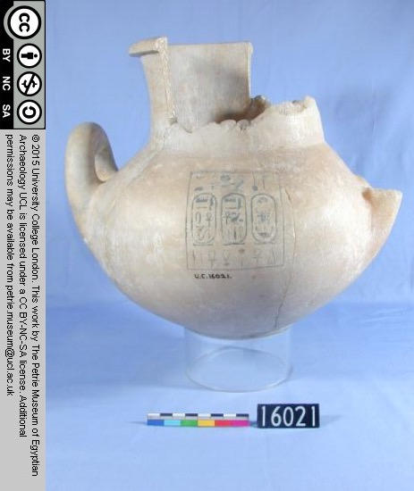**Investigating the museum online**

Using the Petrie Museum’s online catalogue <http://petriecat.museums.ucl.ac.uk> pupils can browse the collection in advance. They can create their own virtual gallery or find objects that interest them.

**To find out more about the objects in the Petrie Museum using the online catalogue**

1. Go to: <http://petriecat.museums.ucl.ac.uk/>
2. Choose Simple Search
3. In the “type a word or phrase” field, enter one type of object

e.g. axes, canopic jars, coffins, mirror, mummy bandages, sandals, writing equipment

1. Then click **Search**
2. A group of objects will appear on your screen
3. Choose an object by clicking on it, a photo with information will appear

It is possible to search with a museum number:

in the field type the entire number including UC, for example UC16021, so you could make a note of object numbers when you see them in the museum and look them up online after your visit.

**Learning to look at objects**

Learning to look at objects for information is a very important skill. You can prepare pupils to look at objects in the museum and help them develop their visual literacy by using everyday objects in the classroom before the visit e.g. a pencil, an exercise book, a football.

Ask pupils to do an object investigation on everyday objects in small groups. They could use the same worksheets or investigations in the museum with artefacts. There is one in this pack.

**Researching Flinders Petrie**

Pupils could find out about Flinders Petrie, the archaeologist who founded the museum:

The Petrie Museum is named after archaeologist

Sir William Matthew Flinders Petrie (1853 – 1942).

Flinders Petrie is thought to have discovered well over a million objects during the course of his archaeological career. He excavated many sites in Egypt, Sudan, and Palestine. He became the first professor of Egyptology in England in 1892. Most archaeologists before Petrie had only been interested in large monuments and treasures from Egypt, but Petrie liked small objects because they showed how ancient Egyptians lived.

One of the reasons Petrie formed the collection was as a resource for teaching and research. Petrie hoped that by bringing objects back to England he could study them thoroughly and improve his and others’ understanding of ancient Egypt. Petrie dedicated himself to making sure the public knew about ancient Egyptian culture and the need for conserving what artefacts had been found by archaeologists.

**Identifying Stereotypes**

Read out the statements from the True or False Quiz, which is at the back of this pack and available to download from our web site

[www.ucl.ac.uk/culture/petrie-museum/research-learning-petrie-museum](https://www.ucl.ac.uk/culture/petrie-museum/research-learning-petrie-museum).

After each statement, give pupils a chance to call out ‘True’ or ‘False’. This will allow you to see what they already know but also will help to challenge their assumptions and stereotypes about ancient and modern Egypt.

Activities to support your visit are available to download from our web site at

[www.ucl.ac.uk/culture/petrie-museum/research-learning-petrie-museum](https://www.ucl.ac.uk/culture/petrie-museum/research-learning-petrie-museum)

They are:

* Schools visit scavenger hunt
* Investigating objects worksheet*
* Comparing everyday life then and now activity
* True or false activity *
* Gods, goddesses and religion activity
* Narmer palette activity

* these activities are also included at the end of this pack

**Background information**

**About UCL**

The Petrie Museum is part of University College London and provides an excellent opportunity to introduce pupils to the concept of Higher Education. **UCL** is one of the three oldest universities in England, founded almost 200 years ago. Established to admit students no matter what their race, religion or class, it was also the first to admit women students.

UCL is committed to giving opportunities to the best students from all backgrounds by supporting them from primary school, secondary school, at UCL and into their careers. The university offers a range of activities through its Access & Widening Participation teams. To find out more see the website[www.ucl.ac.uk/widening-participation/about-us](http://www.ucl.ac.uk/widening-participation/about-us)

**What is special about the Petrie Museum of Egyptian Archaeology?**

The Petrie Museum of Egyptian Archaeology has one of the most important collections of ancient Egyptian objects in the world.

The museum contains about 80,000 objects and these objects represent the development of daily life in and around the Nile Valley. There are plenty of easily recognisable objects to see such as mummy cases and death masks. But there are also rich examples of objects illustrating daily life, from earrings and hair curlers to wooden mallets and weights and measures.

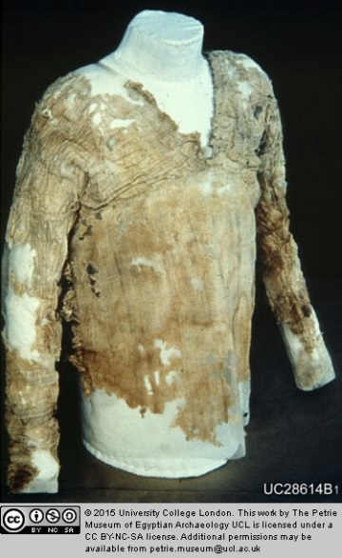The age range of objects spans from the very earliest times of settlement in the Nile Valley 6,000 years ago, to the Greek, Roman and Arabic influences on Egypt, 1,800 years ago up to the present day.

Highlights of the collection include:

* the earliest linen clothing in the world (over 5,000 years old) pictured here
* a bead net dress, one of only two in the world
* objects from the most famous period of Egypt’s history, from the site of Amarna, the city of Pharaoh Akhenaten and his wife Nefertiti. This is where Tutankhamun would have spent his early years
* stone blocks with hieroglyphic inscriptions

**Visitor information**

Petrie Museum of Egyptian Archaeology

University College London

Malet Place

London WC1E 6BT

Tel: 020 7679 2884

Email: [museums@ucl.ac.uk](mailto:museums@ucl.ac.uk)

Website: [www.ucl.ac.uk/culture/petrie-museum](http://www.ucl.ac.uk/culture/petrie-museum)

Public Transport  
Train station: Euston  
Underground stations: Euston, Euston Square, Warren Street, Russell Square, Goodge Street  
Buses: 10, 18, 30, 73, 205, 390 to Euston Square Station; 10, 14, 24, 29, 73,134, 390, to Gower Street

Lunch  
We do not have a lunchroom, you are advised to find in advance a suitable place for lunch. Weather permitting there are a number of squares with gardens close-by.

Combining your visit

You could combine your visit with a visit to the British Museum or the Wellcome Collection which are nearby. The Grant Museum of Zoology at UCL also occasionally hosts pre-arranged school visits for one class at a time. Your Visitor Services contact for the Petrie Museum visit can help with this.

Map

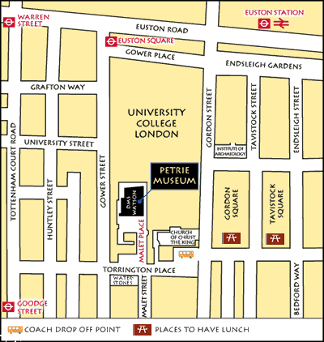

|  |  |  |
| --- | --- | --- |
| **Date** | **Period** | **Rulers** |
| Before 8000 BC | Palaeolithic |  |
| 5200-4000 BC | Fayum Neolithic |  |
| 3500-3100 BC | Naqada Period |  |
| 3100-2686 BC | Early Dynastic Period:  Dynasties 1-2 (Dynasties I-II) | Narmer |
| 2686- 2181 BC | Old Kingdom:  Dynasties 3-6 (Dynasties III-VI) | Khufu |
| 2181-2025 BC | First Intermediate Period:  Dynasties 7-10 (Dynasties VII-X) |  |
| 2025-1700 BC | Middle Kingdom:  Dynasties 11-13 (Dynasties XI-XIII) |  |
| 1700-1550 BC | Second Intermediate Period:  Dynasties 13-17 (Dynasties XIII-XVII) |  |
| 1550- 1069 BC | New Kingdom:  Dynasties 18-20 (Dynasties XVIII- XX) | Akhenaten  Tutankhamun  Ramses II |
| 1069-664 BC | Third Intermediate Period:  Dynasties 21-25 (Dynasties XXI-XXV) |  |
| 664-525 BC | Late Period:  Dynasty 26 (Dynasty XXVI) |  |
| 525- 404 BC | Persian Period:  Dynasty 27 (Dynasty XXVII) |  |
| 404-332 BC | Late Dynastic Period:  Dynasties 28-31 (Dynasties XXVIII-XXXI) (332-323) | Alexander the Great |
| 323-30 BC | Ptolemaic Period | Cleopatra |
| 30 BC- AD 640 | Roman Period | Constantine |
| AD 640- present | Islamic Period | Saladin |

**Egyptian History Timeline**

**Museum Floor Plan – see over for key**

**Museum Floor Plan Key**

Main room (up the stairs)  
On the left-hand side you will find 19 Inscription cases (IC). These are full of stone reliefs usually with writing and pictures carved on them. Like the pots they range in date and the writing ranges from Hieroglyphs, through Greek and ending with Arabic.

Cases A - H

These contain the earliest objects found in Egypt from the Palaeolithic time, through to the Middle Kingdom. You will find examples of flints, palettes, bowls and stone vessels.  
  
On the right of the gallery you will find Cases A – H and WEC11. These contain a range of objects from the Old Kingdom through to the Roman period in Egypt. You will find weights and measures, small sculpture, tools and weapons and objects of daily use. There is also a selection of Roman mummy portraits and a mummy case.   
  
Through the white doors  
Here you will find cases containing figurines, soul houses and model boats.

Pottery room  
Petrie was called the ‘father of pots’ because he discovered so many different types. The earliest pots start in pottery case 2 (PC) and date from 7,000 years ago and they end in PC 37 with pottery about 1,500 years old. Also, in this gallery you will find linen tunics and a bead net dress. These all come from the Old Kingdom around the time of the Great Pyramid.

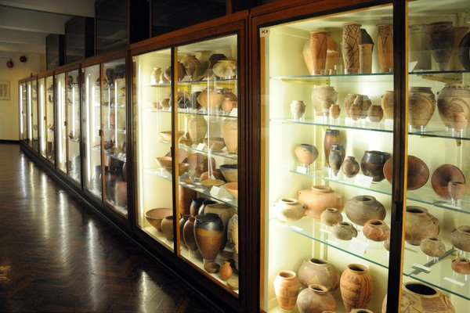



**UCL CULTURE**

**Investigating Objects**

Description

What **size** is it? _____________________________________________

What **colour** is it? ___________________________________________

What **material** is it made of? *(for example: glass, clay, wood, stone, paper, or metal)*______________________________________________________

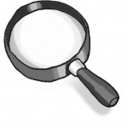What **shape** is it? ____________________________________________

Draw **What** does it look like? Use

**What** do you think it is?

__________________________

__________________________

__________________________

**Who** do you think used it?

__________________________

__________________________

__________________________

**How** do you think it was used?

__________________________

__________________________

__________________________

**When** do you think it was used?

__________________________

__________________________

__________________________

By: J. Gibbon

**True or False?**

**UCL CULTURE**

**Petrie Museum of Egyptian Archaeology**

**Facts and misunderstandings**

**about Egyptians**

|  |  |
| --- | --- |
| **Egyptians today still mummify their dead.** | True / False |
| **The ancient Egyptians wrote on papyrus.** | True / False |
| **The mummy’s curse does exist.** | True / False |
| **Egyptians today still read and write in hieroglyphs and Egyptian children learn it in schools.** | True / False |
| **The period known as ‘ancient’ Egypt lasted 300 years.** | True / False |
| **Nearly 100 million people live in Egypt today.** | True / False |
| **The ancient Egyptians worshipped many different**  **gods and goddesses.** | True / False |
| **At one time the capital city of Egypt was Memphis.**  **Today, it is Cairo.** | True / False |
| **All the pharaohs of ancient Egypt were men.** | True / False |
| **The ancient Egyptians were excellent at maths and this helped them to build the pyramids.** | True / False |
| **The River Thames flows through Egypt.** | True / False |
| **The pyramids were built as royal palaces for the Pharaohs.** | True / False |
| **Ancient Egyptian children played with toys**  **and even grown-ups played games.** | True / False |