

**UCL CULTURE**

**The Narmer Palette** object number UC80630

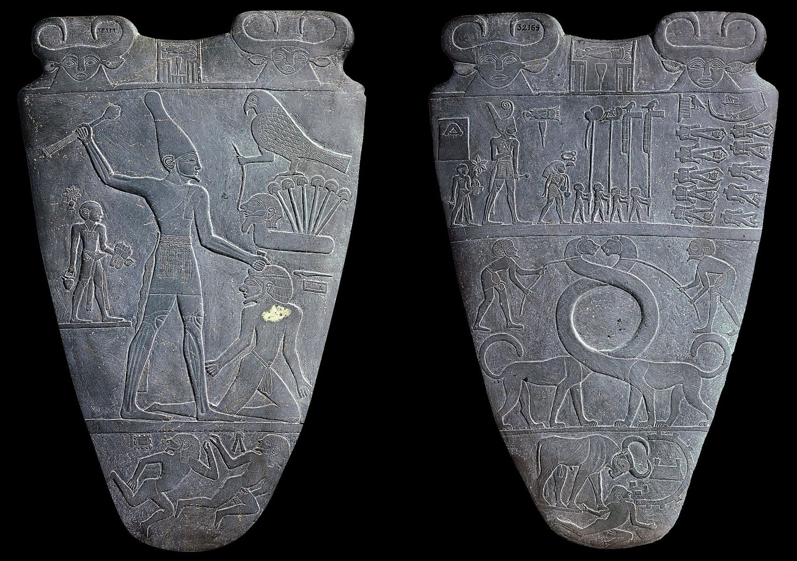

Hello, I am the Narmer Palette! I am important in Egyptian history because I celebrate the victory of King Narmer uniting Upper and Lower Egypt. The hieroglyphic inscriptions on me are some of the oldest ever found. I date to 3200 BCE. Whilst the original is in Cairo, there is a replica located at the Petrie Museum. Can you find me?

Hint: I am near stairs.

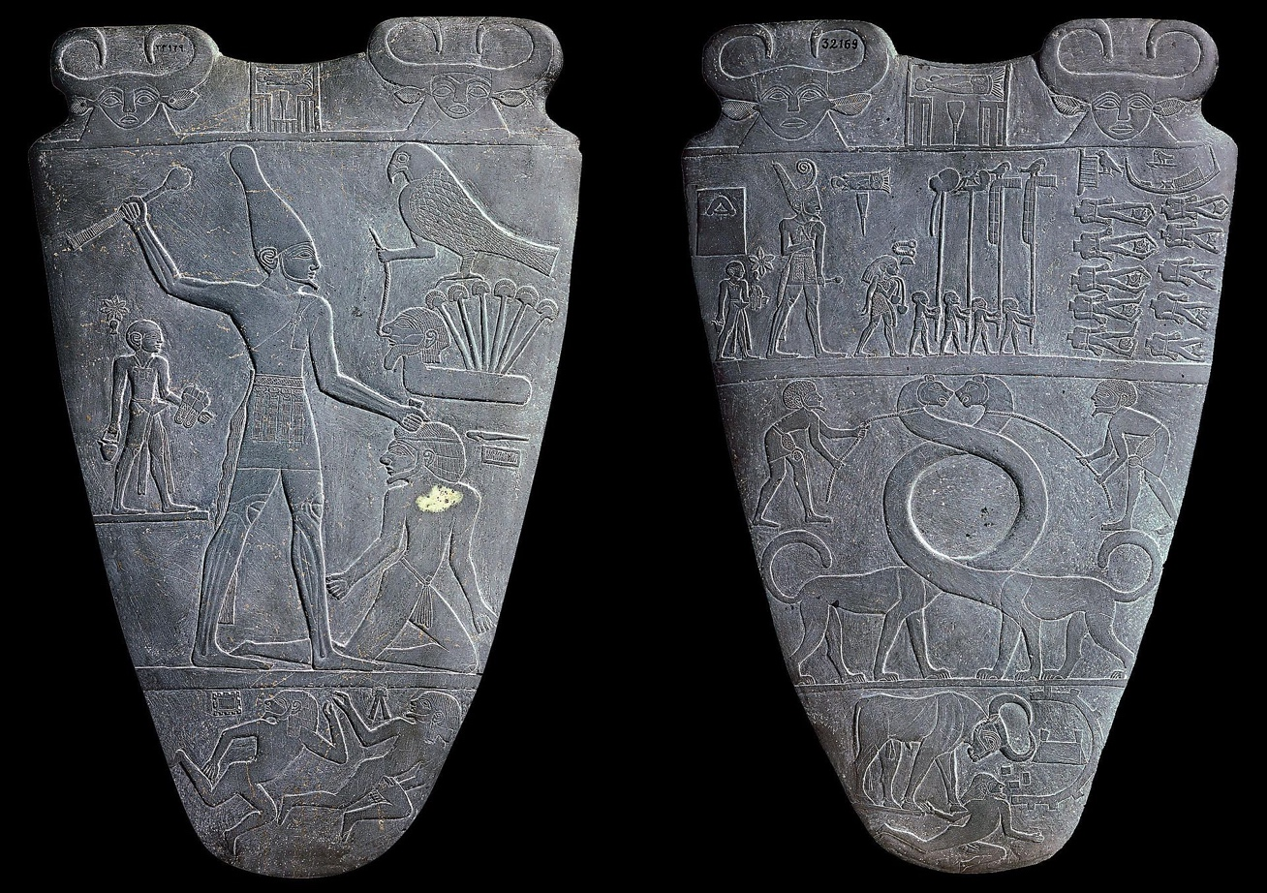

As a palette, I am decorated on both sides. The images represent the story of the unification of Egypt. Each object or hieroglyph means something important to the story.

Palettes were typically used to grind food or cosmetics; however, it is likely that I was a ceremonial object.

**My Personal Palette**

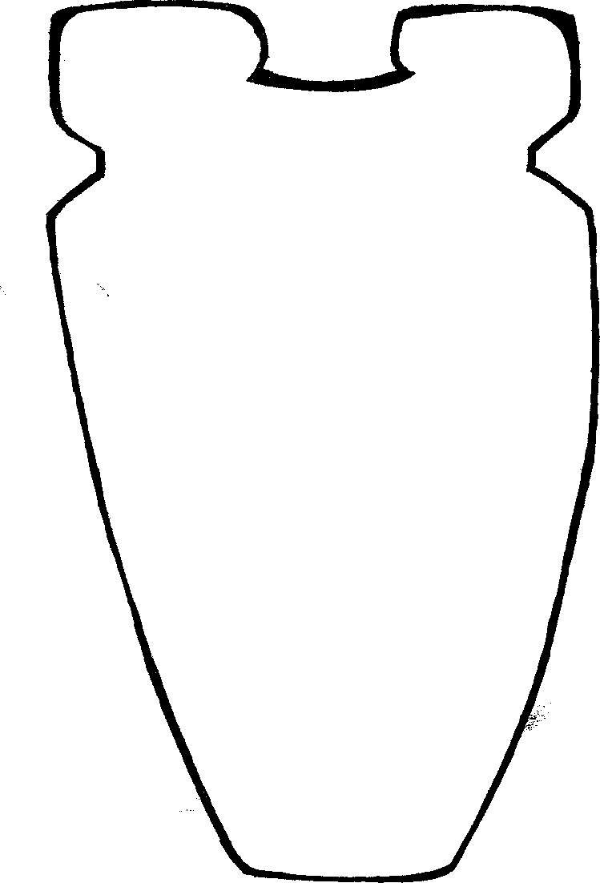

What would your palette look like?

Would it be used for food or cosmetics?

What images would you want on it?

Take a moment and think about what

your life would be like if you lived in ancient Egypt.

Below draw what you believe your palette would look like if you lived in Ancient Egypt. Draw items that you believe would be important in your daily life.