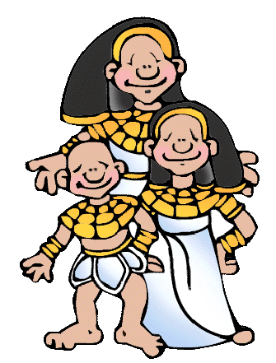
Comparing Everyday Life Then and Now
Select two objects from the museum that
you can compare with items you use today.

Object 1
- Name of Object ____________________________________________

- Object number UC__________________________________________

- Description of the object and what it was used for__________________
__________________________________________________________
__________________________________________________________

- How is it similar/different to something you might use today?

____________________________________________________________
____________________________________________________________
____________________________________________________________
____________________________________________________________

Object 2
- Name of Object ____________________________________________

- Object number UC__________________________________________

- Description of the object and what it was used for__________________
__________________________________________________________
__________________________________________________________

- How is it similar/different to something you might use today?

____________________________________________________________
____________________________________________________________
____________________________________________________________
____________________________________________________________
By: J. Gibbon

Comparing Everyday Life Then and Now
Think about your daily life and imagine what life was like in ancient Egypt.
Fill out the diagram below to see the similarities and differences.

My Life

Similarities

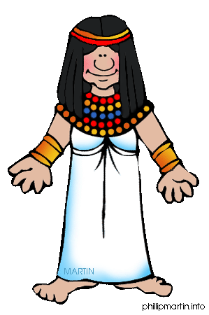

Life in ancient Egypt

By: J. Gibbon

