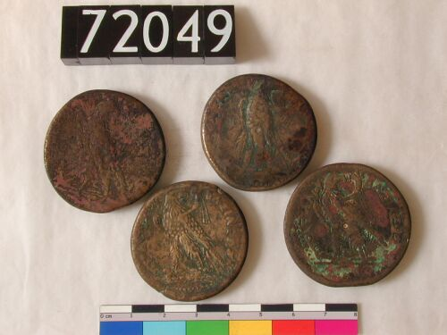**Coins, Coins, and more Coins!**

**UCL CULTURE**

**The Ptolemies**

The first coins in Egypt date back to the Late Dynastic Period. They were most likely produced to pay Greek soldiers serving the Egyptian king. There were also Persian coins that were created by the Persian king Artaxerxes III. From the Ptolemaic Period onwards, coins were regularly made in Egypt.

Since Egypt has no great silver mines and gold coinage was not very practical for daily use, the Ptolemies used bronze coins. These coins were usually used at the local market and were not likely to travel outside Egypt.

**The Main Greek Currency (in silver)**

|  |  |  |
| --- | --- | --- |
| Tetradrachma | Equals 4 drachmae | About 14-17 grams |
| Didrachma-stater | Equals 2 drachmae | About 6-8.5 grams |
| Drachma | Equals 1 drachmae | 3-4.2 grams |
| Obol | Equals 1/6 drachmae | 0.5-0.7 grams |

If you have 6 Obol coins, how many Drachmae coins would that equal?

_________________________________________________________

About how heavy would it to be to carry 3 Tetradrachma coins in your pocket? (round to the nearest number) _________________________________________________________

_________________________________________________________

**Coins, Coins, and more Coins!**

In Egypt, Roman coinage was based on the Ptolemaic system until 296 CE. Many Roman coins depict the portrait of the emperor or members of his family.

The symbol “L” on the coins is usually used for the word year and is followed by the year the Emperor issued the coins. Knowing the years of an emperor’s rule, it is possible to calculate the year the coins were made.

***Why would this be significant to know?***

If you were Emperor what would your coin look like? What year would it be made in?

Draw what your coin would look like and discuss with the class why you chose to draw it this way.

In 296 CE the Emperor Diocletian changed the coinage system in the entire empire. Old coins were now gone!

Then under Heraclius (610-640 CE during the Byzantine period) a new system was introduced:

**One gold bullion tetradrachm = 6 bronze drachms**

**6 bronze drachms = 12 bronze diobols**

**12 bronze diobols = 24 bronze obols**

How many bronze obols equals one gold bullion tetradrachm?

_____________

***True or False***: Does 6 bronze drachms equal 20 bronze obols?

______________