[](http://www.ucl.ac.uk/)**Document 2**

**Centre for Co-production in Health Research Pilots**

**\*\*FAQs – Call for Pilot Projects & Centre Collaborators\*\***   
  
The UCL Centre for Co-production in Health Research has reached a stage in its development where we are looking to identify Pilot projects to test and refine our approach. We are looking for collaborators (organisations or individuals), to join us and be at the cutting edge of this new way of approaching health and social care research.

**Q: How can I help?**

Are you (or do you know anyone/any organisation that may be) interested in collaborating with us to bring the Prep for Pilots work or Pilots outlined below to life?

If yes, please pass on this

info and/or get in touch!

[n.pascal@ucl.ac.uk](mailto:n.pascal@ucl.ac.uk)

0203 108 6534

**Q: What is the Centre for Co-production?**

Our vision is that the Centre will…

* Provide space or spaces (physical and/or virtual) where everyone involved is part of the crowdsourcing of project ideas
* [](http://www.ucl.ac.uk/)Focus on co-producing health research which addresses the health and social care priorities of less often heard voices/communities
* Deliver a series of innovations, products or interventions that will improve health and wellbeing
* Develop accessible online communities and interactive resources that will help facilitate exchange of knowledge between those involved
* Reflect, evaluate and share its learning to improve the way the health and social care research is designed, delivered and disseminated

Figure - Box with contact details (also listed in the main body of text later in the document)

[](http://www.ucl.ac.uk/)

**Q: What do we mean by co-production?**

*“Co-producing research is an approach to research in which researchers, practitioners and public work together, sharing power and responsibility from the start to the end of a research project, including the generation of knowledge” (INVOLVE 2018).*

**Q: Why are we planning this series of Pilots?**

We are currently working to co-produce the development of the UCL Centre for Co-production in Health Research and to bring it to life! As part of this development work, we are conducting a series of Pilots to test our plans for the Centre. These Pilots (described in detail below) will help us to:

* Identify how the Centre will strengthen and improve health research design and delivery
* Bring the Centre to life by starting to build resources, toolkits and a visual identity
* Decide upon future ways of working in terms of both the processes which underpin our operations and the training in co-production we offer all involved

Before you read on though, **please note…** we are not your average research Centre. We are aiming to do things **DIFFERENTLY!** You will notice this reflected in the principles we live by as a Centre (see next FAQ) and in our approach to the development of the Centre so far – please do have a look at the work we have done to date ([Debbie’s graphic illustration](http://blogs.ucl.ac.uk/public-engagement/files/2018/07/DebbieGraphic.pdf)). As you will see we aim to focus on quality of life and people’s views of the best way to maximise it rather than statistics or morbidity.

We are just starting out and don’t have all the answers, hence this invitation to potential partners to help us develop what we do. But… we are very passionate and dedicated! Still interested? Great! Please read on.

[](http://www.ucl.ac.uk/)**Q: What are the Principles that underpin the UCL Centre for Co-production?**

All interaction will be based on the principles we as a Centre want to live by. These are:

* Respect for diversity of experience and perspective
* Collective decision-making
* Commitment to addressing power imbalances
* Understanding the meaning of and fostering authentic co-production
* Challenge the status quo
* Be accessible to and inclusive of all
* Ensure mutual benefit for all
* Be open, transparent and honest - yet pragmatic and real
* Check & challenge throughout
* Encourage innovative practice
* Ensure sufficient resourcing & sustainability

**Q: Who can get involved? What skills and expertise are you looking for?**

Anyone who is interested in being part of the Centre movement to rethink the way health research is developed. And who would like to include genuine collaboration and co-production between communities, researchers and healthcare professionals in what they do can get involved. We would love to hear from you!

Perhaps you are…

* A co-production trainer, or have expertise in the evaluation of community based research projects
* Or have ideas of your own, we would love to hear these too!

If yes to any of the above please get in touch! We particularly welcome interest from individuals and organisations from the community local to UCL, the London borough of Camden and projects which focus on less often-heard voices from this area.

**Q: How can I get involved?**   
Outlined on Page 4 are our plans for preparing for the pilots – the ‘Prep for Pilots work’ (what we believe is required to prepare for the launch of the Pilots) and the Pilots themselves (Pilots 1, 2, 3 and 4) please have a read. For further information, also see the Timelines on Pages 5 and 6 that provide more detail in relation to our plans.

Please consult all of the information provided and identify where you can help then get in touch. See the **What’s next?** section on Page 7 for further information on how to do this.

**Q: What if I would just like to kept up to date on your progress?**

This is no problem, please email [n.pascal@ucl.ac.uk](mailto:n.pascal@ucl.ac.uk?subject=UCL%20Centre%20for%20Co-production%20-%20please%20keep%20me%20up%20to%20date). We will be sharing regular newsletter updates via email, webinars and other events.

**The plan for the Pilots**

Figure - Key for the ‘Plan for the Pilots’ diagram (please ask if you would like this diagram explained in more detail)

**Q: What does this diagram show?**  
This diagram outlines the plans for the UCL Centre for Co-production Prep for Pilots and Pilots work

**KEY**

* Planned Prep for Pilots work (Jul-Aug 18)
* Planned Pilots work (Sep-Dec 18)
* The yellow arrows indicate that evaluation will be a key part of the pilots, feeding learning in continually as we go
* The red arrows show how the Prep 4 Pilots work feeds into the Pilots themselves

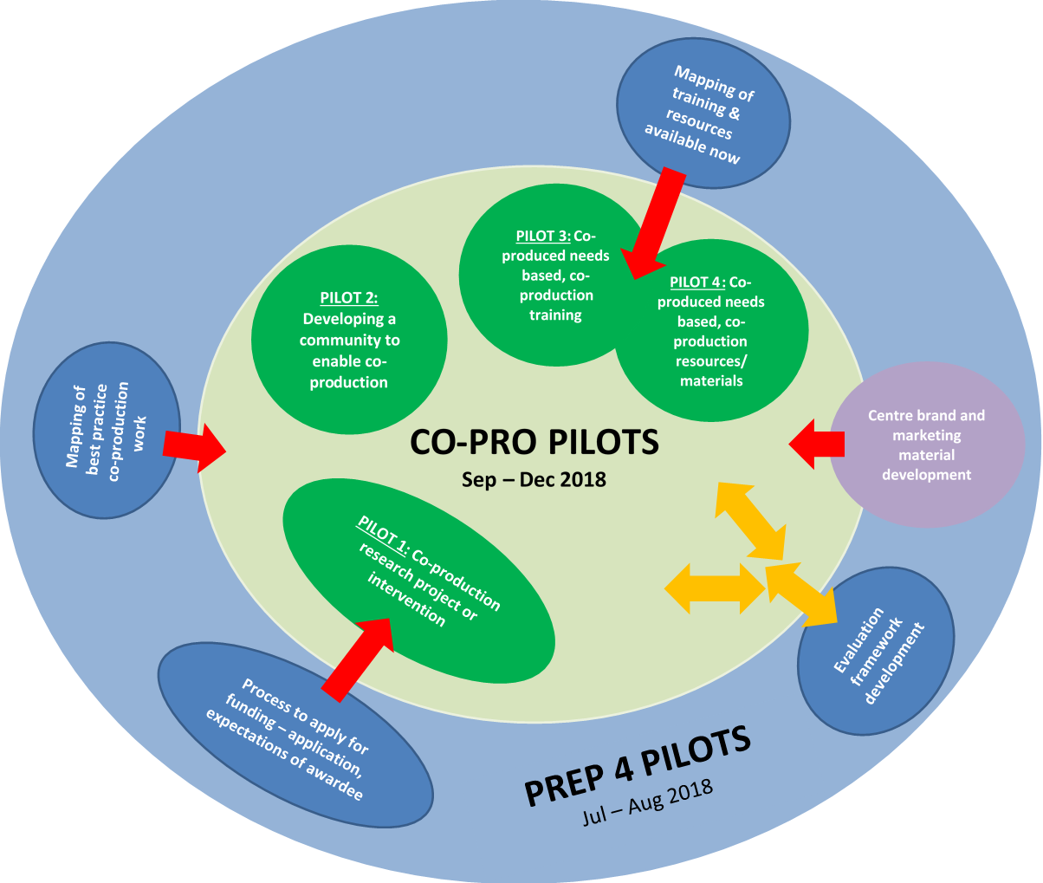

|  |  |  |  |  |
| --- | --- | --- | --- | --- |
|  | **Prep work required** | **July 18** | **Aug 18** | **Sep – Dec 18** |
| **PREP FOR PILOTS work** | Map **best practice** co-production research currently taking place  Map co-production **training & tools/resources** currently available | 1. Launch call for expressions of interest (deadline 22 July18) 2. Commission organisation to complete the work – mid Aug | Mapping work takes place to identify:   1. Best practice (build on mapping work already in progress) 2. Co-production training & resources available in UK/online | Produce report - feed learning into centre development and **PILOTS 3 & 4** |
| **Evaluation** Framework development | 1. Launch call for expressions of interest to undertake this work (deadline 22 July18) 2. Commission organisation to complete the work – mid Aug | Evaluation development prep work takes place including:   1. Framework development with organisation chosen and Centre collaborators 2. Evaluation framework complete | Test framework by using it to evaluate **ALL PILOTS** |
| Develop Centre **brand and marketing** material | 1. Launch call for expressions of interest to undertake this work (deadline 12 Aug18) | 1. Commission organisation to complete the work 2. Development work takes place with organisation chosen and Centre collaborators | Launch draft brand, website ideas (if appropriate) and continue to develop with Centre collaborators during the Pilots phase (Sept-Dec 18) |

Figure - Table outlining the detailed timeline for the Prep for Pilots work (please ask is you would like this explained in more detail)

**Our timeline for the Prep for Pilots work** – below is the work we plan to complete by month

**Our timeline for the Pilots work** – below is the work we plan to complete by month

|  |  |  |  |  |
| --- | --- | --- | --- | --- |
|  | **Pilot name** | **July 18** | **Aug 18** | **Sep – Dec 18** |
| **PILOT 1** | **Co-production innovation, research or intervention** project | 1. Launch application form – 2 Jul18 2. Support research groups/individuals to apply | 1. Applications received by 12 Aug18 2. Applications reviewed by panel – end of Aug18 3. Notification of decisions – early Sept 18 4. Funding awarded – mid/end Sept 18 | **PILOTS are live!\***  Prep for Pilots Report (findings from work completed) will be shared with all pilot and Centre collaborators  [Image result for hero](http://www.ucl.ac.uk/)*(All pilot collaborators to take part in co-production training session before works starts) |
| **PILOT 2** | **Community network** development to enable co-production | 1. Launch call for expressions of interest – 2 Jul18 2. Develop partnership for joint development work – end Aug18 | Work takes place with partner and Centre collaborators to test out how to develop a network |
| **PILOT 3** | Needs based **co-production training development** | 1. Launch call for expressions of interest – 2 Jul18 2. Commission organisation to complete the work – end Aug18 | Development work takes place with organisation chosen and Centre collaborators |
| **PILOT 4** | Needs based **co-production resources/materials development** |

Figure - Table outlining the detailed timeline for the Pilots work (please ask is you would like this explained in more detail)

**Q: What’s next?**

**Q: Is there any budget available to support this work?**

* Yes there is approximately £3000-5000 available per Pilot
* There is also some budget available for the Prep for Pilots work – to be discussed, dependent upon work to be conducted

There are 3 different ways to get involved in the UCL Centre for Co-production in Health research Pilots. They are:

1. **By applying for funding (£3000-5000) to deliver a co-production project** (innovation, research or intervention) – this is Pilot 1. Please complete the attached Application Form (Document 3) and email your submission to [n.pascal@ucl.ac.uk](mailto:n.pascal@ucl.ac.uk?subject=UCL%20Centre%20for%20Co-production%20Application)
2. **By partnering with the Centre to co-deliver some of the preparation work or one of the Pilots** – this is Prep for Pilots work and Pilot 2. Please email [n.pascal@ucl.ac.uk](mailto:n.pascal@ucl.ac.uk?subject=UCL%20Centre%20for%20Co-production%20Application) to let her know you are interested and set up a time to explore options further.

[](http://www.engagevisually.co.uk/)

1. **By being commissioned to undertake some of the preparation work or one of the Pilot projects** – this is Prep for Pilots work and Pilots 3 or 4. Please email [n.pascal@ucl.ac.uk](mailto:n.pascal@ucl.ac.uk?subject=UCL%20Centre%20for%20Co-production%20Application) to let her know you are interested (if you would like to be considered to be commissioned we will send you an Invitation to Tender document to be filled out).

If you have any questions, feedback or would like assistance with applying please get in touch with [n.pascal@ucl.ac.uk](mailto:n.pascal@ucl.ac.uk) (0203 108 6534). The deadline for contacting us about the prep work or Pilots is **midnight on 12 August 2018** (unless you want to do Prep for Pilots work – this deadline is midnight on 22 July 2018).

We look forward to hearing from you! Thank you,

*Image credits – Engage Visually – Debbie Roberts, Google, Lifeofayouthpastor, lauriecoombs.org, bealearninghere.org*

**The UCL Centre for Co-production in Health Research Collaborators**