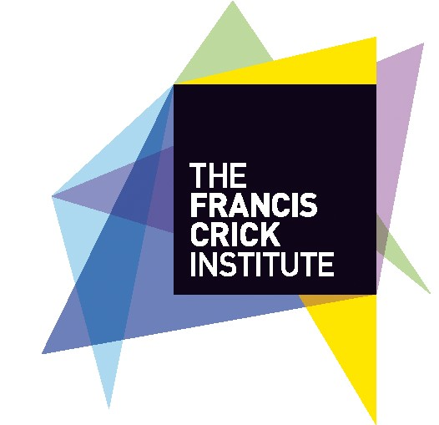
Application Form for Associate membership of the Francis Crick Institute’s Interest Groups

Name (of proposed associate IG member):
Department, Institute:
Current Position:
Request to join which Crick Interest Group (select one from dropdown):
Statement from proposed member on current research interest and benefit of affiliation with the Crick Interest Groups (200 words approx.):

3 exemplar publications:

1.
2.
3.

Name of Crick supporting Group Leader:

Please return this form to Crick by emailing to this address:
uni-partnership@crick.ac.uk
- the deadline for submission of this nomination form is the 30th April 2020

