BUSINESS CONTINUITY PLAN
ICTM
Version | Date | Author | Changes
2.3 | 02.2019 | Rachel Martino | Hugh Willoughby
2.4 | 09.03.2020 | Nick Thomas | Hugh Willoughby
2.5 | 23.06.2021 | Nick Thomas | Nick Thomas
2.6 | 08/06/2022 | Nick Thomas | Nick Thomas

The aim of the Business Continuity Plan (BCP) is to increase resilience for the core activities of the Institute of Clinical Trials and Methodology (ICTM), and to ensure that the Institute’s core activities are operational at least at a minimal level during a major incident or disaster. Core activities are identified as; primary research and business functions. This part of BCP has been designed to be used by the Business Continuity Team (BCT) following an incident that causes disruptions to the Institute’s operations.

CONTENTS

1. Introduction
2. Business Continuity Team
3. Activation
4. Recovery Sites
5. Communications
6. Action plan on meeting
6.1 Appoint someone to take notes
6.2 Review the extent of the disruption
6.3 Allocation of Business Continuity team roles and responsibilities
6.4 Confirm the ownership of the Business Continuity Team
6.5 Assign individuals to roles
6.6 Define objectives of the Business Continuity Team
6.7 Develop a response strategy
6.8 Agree actions arising and next meeting
7. Appendices
7.1 Roles and Responsibilities
7.2 Essential contact details
7.3 Directions to recovery site
7.4 Actions and decisions form
7.5 Lessons learned form
7.6 Scripts - add text templates, email templates

1. Introduction
The plan set out in the following document is intended to be used in the event of any major incident or disaster, which impacts the normal undertaking of our business, with the aim to minimise disruption and maximise safety.
ICTM has a duty to protect and promote the health and safety (H&S) of its staff, co-workers, collaborators and visitors in times of major incidents or disasters.
A major incident or disaster is defined as an event which poses a serious threat to the normal undertaking of research and other business activities of ICTM and its collaborators. Such incidents may require the whole or part evacuation of the premises, and may result in the suspension of core activities for a significant period.
The purpose of the BCP is:
- To increase resilience for the core activities of ICTM at the time of a major incident or disaster.
- To provide relevant information and guidance to staff members.
- To ensure the problem is contained and that contingency measures are in place to minimise the impact of the problem on ICTM and its staff members.
The BCP is written to deal with generic hazards and threats, and to enable ICTM to perform its core functions in relation to a wide range of possible scenarios. Core functions are identified as; primary research and critical business functions.
Many problems are dealt with on a day-to-day basis but a crisis (including major incident) could come from different sources, any of which could damage ICTM.
The overall framework is:
- If a problem can be dealt with at a team/departmental level, it should be. If not, it should be escalated.
- If a problem can be dealt with at institute/faculty level, it should be. If not, it should be escalated.
Every member of ICTM staff plays a vital role in ensuring a professional response to crisis. It is essential that you are familiar with how your team will operate during such an event, what role you may play, and the role of other organisations we will be working with.

2. Business Continuity Team
The ICTM’s Business Continuity Team (BCT) has the executive authority to act appropriately to respond to and deal with all aspects of a crisis. The BCT members are responsible for ensuring that the BCP is up to date, relevant and accurate in their area of responsibility. Any incidents or issues that are outside the scope of this plan must be escalated to the BCT.
Overview of the responsibilities and contact details for the Business continuity Team
(For further contact details, please refer to Appendices: 7.1 – roles and responsibilities)

BC Role | Name & Job Title | Contact no. | Email
Chair and Owner  Business Continuity | Max Parmar  ICTM Director | 020 7670 4729  07887 553992 | m.parmar@ucl.ac.uk
 | Nick Thomas  Institute Manager | 020 7670 4678  07471 032809  07702 163706 | Nicholas.thomas@ucl.ac.uk
Facilities Services  Estates, Safety Operations | Paul Hyams | 07983 299 516 | p.hyams@ucl.ac.uk
 | Andra Craciun-Frincu  Area Facilities Manager | 07341776067 | a.craciun-frincu@ucl.ac.uk
Information Services | Swaley Assam  IS Service Manager | 07967 886052 | s.assam@ucl.ac.uk
 | Alex O’Sullivan  Senior IS Officer | 020 7670 4779 | a.osullivan@ucl.ac.uk
Institute Administration | Nick Thomas  Institute Manager | 020 7670 4678  07471 032809  07702 163706 | Nicholas.thomas@ucl.ac.uk
 | Tufael Hussain  Institute Administrator | 020 7670 4605 | tufael.hussain@ucl.ac.uk
Human Resources | Carole Booth  Institute HR Manager | 020 7670 4603  07769 812268 | carole.booth@ucl.ac.uk
 | Vivian Nwadike-Efika  HR Administrator | 020 7670 4766 | v.nwadike-efika@ucl.ac.uk

Finance | Viran Dadlani  Finance Manager | 020 7670 4863  07912 071272 | v.dadlani@ucl.ac.uk
 | Lloyd Whittle  Finance Officer | 020 7670 4628 | l.whittle@ucl.ac.uk
MRC CTU Administration | Melanie Ferrao  Unit Manager | 020 7670 4855 | melanie.ferrao@ucl.ac.uk
MRC CTU Data Management Systems | Mary Rauchenberger  Head of Data Management Systems | 020 7670 4839  07759 146824 | m.rauchenberger@ucl.ac.uk
 | Nadine Van-Looy  Clinical Data Systems Manager | 020 7670 4836  07706 253854 | n.van-looy@ucl.ac.uk
MRC CTU Trials Administration | Fleur Hudson  Head of Operations, Clinical Project Manager | 020 7670 4782  01277 229501  07500 284849 | f.hudson@ucl.ac.uk
 | Karen Sanders  Clinical Project Manager | 020 7670 4826  07808481460 | karen.sanders@ucl.ac.uk
MRC CTU External Communications | Annabelle South  Policy, Communications & Research Impact Coordinator | 020 7670 4827  07855 327559 | a.south@ucl.ac.uk
 | Berta Terre-Torras  Science Communications Officer | 020 7670 4601 | b.torras@ucl.ac.uk
CCTU | Nicholas Freemantle  CCTU - Unit Director | 020 3549 5017  07966 939568 | nicholas.freemantle@ucl.ac.uk
 | Gemma Jones  Head of Clinical Trials Operations | 020 3108 6833 | gemma.jones@ucl.ac.uk
Vacant tbc
Unit Co-Ordinator (Interim)

3. Activation
The BCP can be activated by any member of the Business Continuity Team (BCT).
The BCP should be activated if the Business Continuity Team is required to provide support to the recovery of ICTM core functions that have been disrupted, or if an incident occurs that looks likely to cause serious disruption to the core functions in the scope of the plan.
The BCT can be notified/contacted via:
- ICTM.BCT@ucl.ac.uk
- ICTM BCT WhatsApp Group
- BCP SMS GROUP – (via ICTM Facilities or MRC CTU Unit Manager only)

Step 1: Agree an initial Teams Conference call to evaluate the situation.
Step 2: BCT to commence the communication cascade to their areas of responsibility by phone call, e-mail or SMS.
Step 3: Facilities Team to contact recovery sites for activations required, or to confirm a work from home instruction
(For further contact details, please refer to Appendices: 7.3 – Recovery Sites)

If the recovery sites are also affected and not available, the Facilities Team should consult with other Business Continuity Team members on deciding the best command centre where the team will meet. The command centre should be easily accessible and as close to 90 High Holborn as possible but at a safe distance (i.e. a coffee shop or similar).

4. Recovery Sites
Staff members attending the recovery site must have their UCL staff identification cards with them when entering the site and have them visible throughout their stay.

4.1 Find out what is available at each site at the time of crisis.

For contact details of recover sites, please see section 8
For directions to recovery sites, please see section 9

4.2 Sites and what they can offer:
Name of Site | Meeting rooms | Work stations | Catering | Other
MRC Head Office | Yes
Farr Institute |  | Yes
Priment |  | Yes

INTRANET
http://ctuintranet/how_do_i/Admin/book_hospitality

5. Communications
Good communications are a critical part of ensuring that ICTM responds effectively to a disruptive event. The objectives of communication will be to:
- Support an effective response within the organisation.
- Efficiently keep staff up to date and ensure they know how to manage the effects of the incident.
- Inform collaborators/other relevant stakeholders of the impact of the incident on the organisation, if required.
Internal communication
Internal communication channels will include, as appropriate:
- SMS text messaging system
- Email
- Intranet(s)
Every effort will be made by the Facilities team, Institute Manager and Unit Manager to ensure that all staff members are contacted via text messaging system at first instance which will be followed by more detailed e-mail from one of the Business Continuity Team members. A text message and an e-mail will be sent every day at 5pm to all staff members to inform them of the present situation and any other relevant information. Communications should be sent out daily even if there are no developments in the situation. Additional text messages and e-mails should be sent to all staff as soon as there are any significant changes.
Team Leaders and Line Managers will be responsible for gathering information about staff absences and the impact on service delivery, reporting to the Business Continuity Team as appropriate. They will also be responsible to ensure all team members are receiving key messages from BCT.
Sample scripts for SMS and email may be referenced in section 7.5

External communication
Every effort will be made to minimise disruption to the business, though should the impact of the disruption be significant enough, notification to external stakeholders may be deemed to be appropriate.
External communication channels will include, as appropriate:
- External websites
- Email
- Press office
Individual Communications

Working Remotely – please use the following link to ensure that you can work remotely.
https://liveuclac.sharepoint.com/sites/ICTM/SitePages/BC.aspx

6. Action Plan – Meeting Agenda
6.1 Appoint someone to take notes of decisions made and actions taken (record using form 7.4)

6.2 Confirm/re-assign roles/responsibilities for this incident
- Is the incident of sufficient impact or potential impact to require full Business Continuity Team involvement
- Long-term incidents, including pandemic and other large-scale infectious disease activity, will demand the answer to large-scale management questions
- Ensure individuals understand the role to which they have been assigned
- Ensure individuals review and update their own Action Plan
Info/facts | - Find out the basics: the who, what, why, where, when and how  - Expected duration of the acute phase of the incident
Impact | - Health and safety; impact on people (welfare, infectious disease, transport)  - Impact on buildings and property (accessibility, status, critical systems, security, cordons)  - Impact on IT and communications (critical systems, network, telephony, communications)  - Impact on research operations (process peaks, resources, facilities)  - Impact on business support operations (process peaks, regulatory regime, environmental considerations)  - Possible future outcomes  - Examine the scope of the issue and potential implications.  - Scrutinise incident updates and scale of damage.  - Evaluate short-term impact of the incident.  Long term:  - Can we keep all activities going?  - Have we got the resources?  - How soon can we get back to normal?
Assistance | - Could other services help (e.g. local authority, police, fire and rescue)?  - How soon could suppliers (e.g. gas suppliers, BT) help? Are there alternative suppliers?  - Ascertain what support mechanisms may be needed for all stakeholders and when access to the incident site may be available.  Long term:  - Are we in charge or is another agency?  - Escalate to UCL Major Incident Plan?
Communication | - Who needs to know about the disruption? – Communicate it – which areas have priority?

6.3 Clarify key priorities for this incident (for further details see Appendices: 7.1 – Roles and responsibilities)
Core objectives which are aligned with UCL’s Major Incident Plan: ensure the wellbeing of staff, students and visitors, minimise disruption and loss to both teaching and research, maintain the university’s reputation, secure assets and infrastructure, and inform all stakeholders.
- What are the priorities at this time? (Randomisation, telephones, e-fax, trial databases, e-mail, ‘N’ and ‘S’ drives, VPN , remote working, alternative offices, printing, service desk operation, data entry, communications)
- What parameters and constraints does the Business Continuity Team need to work within?
- What are the possible long-term effects of the incident?
- Determine Business Continuity Team objectives to align with above.
- Ensure objectives are Specific, Measurable, Achievable, Realistic and Time framed (SMART).

6.4 Response Plan (including actions)
- A number of strategies may emerge during the initial stages but agreement has to be reached on determining the most appropriate to adopt.
- Updates from the Communications Team will be important, as will the agreement and approval of press statements and releases.
- Recommendations for reallocation and relocation should be considered.
- Consider benefits and drawbacks of each strategy.
- Select a response strategy.

6.5 Next meeting
- Actions will be based on the adopted strategy and the Business Continuity Team Action Checklists.
- The checklists may also be used to record some of the key actions taken. The Business Continuity Team may decide to arrange meetings of smaller sub-sets of people which may happen prior to the next full Business Continuity Team meeting.
- Determine the schedule of meetings and roster for Business Continuity Team, date and time of the next meeting to be recorded.

7. Appendices
7.1 Roles and Responsibilities
Role | Description | Primary Lead UCL | Person(s) assigned
Business Continuity Lead | Responsible for all actions of the Business Continuity Team in the fulfilling of their objectives. Overall executive control. | Vice Provost – ops | Max Parmar
Finance Lead | Responsible for all aspects of business recovery continuity and for the planning aspects for establishing business recovery. | Director of Finance  PA to Vice Provost - OPS | Nick Thomas
Communications Lead | Responsible for all information releases and manages internal communications. Monitors press/media coverage and takes action as required. | Director of Communications  PA to Vice Provost - OPS | Nick Thomas internal communications  Annabelle South, external communications MRC CTU
People Lead | Keeps status of the workers affected updated, including their identities, provide next of kin details to the emergency services. | Director of HR,  Director of Registry and Academic Services and  Dean of Students Welfare | Carole Booth
IT Lead | Responsible for all aspects involving Information Technology or Information Services. | Director of Information Services | Swaley Assam
MRC CTU Trials Lead | Responsible for coordinating the prioritisation of trial and study tasks to meet regulatory and patient safety requirements during the recovery and establishment of business continuity. Responsible for communications with collaborators. | Head of Operations | Fleur Hudson
Estates Lead | Responsible for all estates infrastructure issues. Checks the damaged location, deals with security and the emergency services, and ensures the welfare of individuals’ e.g. basic facilities. | Director of Estates  Ms Francesca Fryer | Paul Hyams
Safety Lead | Responsible for ensuring health and safety of all persons at any affected locations is considered. Assess and provides expert advice in relation to specific hazards. | Head of Safety  Mr Paul Stirk | Paul Hyams
Operations Lead  UCL: Director of Estates, Head of Safety, head of Facilities Services | All facilities services and the welfare of all individuals.  Responsible for Logistics and supply coordination - relevant to incident type 0and scale. Makes initial judgments based on availability and reliability of information from these sources.  Responsible for all estates infrastructure issues. Checks the damaged location, deals with Security and the Emergency Services, and ensures the welfare of individuals’ e.g. basic facilities.  Responsible for ensuring health and safety of all persons at any affected locations is considered. Assess and provides expert advice in relation to specific hazards. | Head of Facilities Services | Paul Hyams
Administration Lead | Coordinate all administration functions | PA to Vice Provost (Operations) | Nick Thomas
MRC CTU Data Management Systems Lead | Responsible for systems developed for trial and study processes. |  | Mary Rauchenberger
Others as needed

7.2 Essential contact details
Name |  | Contact details |  | Notes
Farr Institute  Pablo Fernandez Medina, 222 Euston Road, London NW1 2DA | p.medina@ucl.ac.uk  02035495319  (x65319) |  | May be able to provide temporary workstations if needed
Priment/Primary Care & Population Health  Irwin Nazareth  Greta Rait  UCL Medical School, Royal Free Hospital Campus  London, NW3 2PF | i.nazareth@ucl.ac.uk  g.rait@ucl.ac.uk  02074726878
MRC Head Office  Julia Sharp  58 Victoria Embankment  London  EC4Y 0DS | Bookings@headoffice.mrc.ac.uk  02073952331  07788345590  (Switchboard 01793 416200) |  | Conference Centre  External user code: MRCUL03
90 High Holborn Head of Security | sec.manager90HH@hotmail.com  02072424252  0797350644
90 High Holborn Reception | reception@90hh.co.uk  020 7242 4252
Landlord at 90 High Holborn  Jair de Freitas Building Manager | Jair.DeFreitas@colliers.com  Direct: +44 2072424033  Mobile: +44 7586584810
UCL Estates | 24/7 Helpdesk: 02076790000  Area Manager: Andra Craciun-Frincu  a.craciun-frincu@ucl.ac.uk 07341776067

Ansaback  Service Delivery Manager  Mark Stannard | Mark.stannard@ansaback.co.uk  03445449858  07595071389
Image Office Cleaning | Yeimy Gomez (Mrs) Y.gomez@imageofficecleaning.co.uk  020 7790 7400  07766 050 309
Employee Assistance | info@care-first.co.uk  08001974510

7.3 Directions to Recovery sites:
The Farr Institute of Health Informatics Research

222 Euston Road, London NW1 2DA

Nearest Tube Station:
Euston Square - Circle Line, Hammersmith & City Line
Nearest Railway Station: Euston Station

From 90 High Holborn:

- Exit the building and turn right, heading east
- Turn right on Southampton Row, continue for approx. 16mins
- Turn left onto Euston Road, and cross onto right side of road
- Continue until destination will be on the right

Please report to Reception upon entering the building in order to be directed to the allocated space.

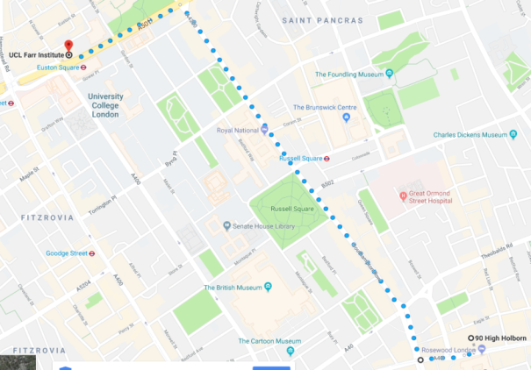

Department of Primary Care and Population Health

UCL Medical School, Royal Free Hospital Campus
London, NW3 2PF
Map showing journey from Belsize Park Station

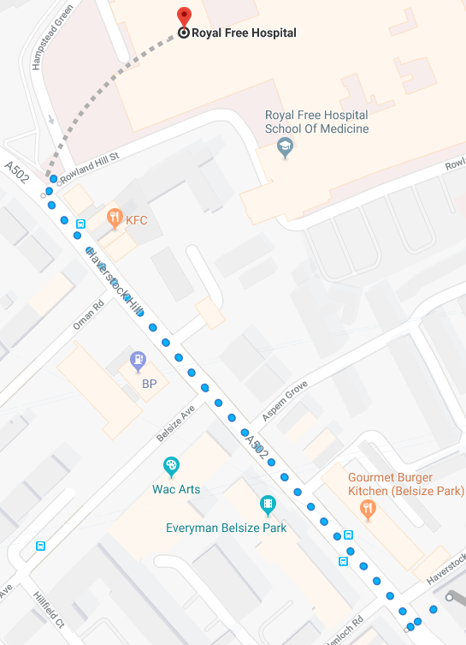
Nearest Tube Station:
Belsize Park - Northern Line, Edgware branch
Nearest Overground Stations:
Hampstead Heath (5 minute walk) and Gospel Oak
(15 minute walk)

From 90 High Holborn:

- Exit the building and turn right, heading east
- After 2mins, on your left you will see Holborn Station
- Take the Piccadilly Line to Kings Cross St Pancras Station
- Take the Northern Line to Belsize Park
- Exit the station and turn left
- Turn right onto Haverstock Hill and continue
- Turn right onto Rowland Hill Street
- Take the first left, destination should be on the right

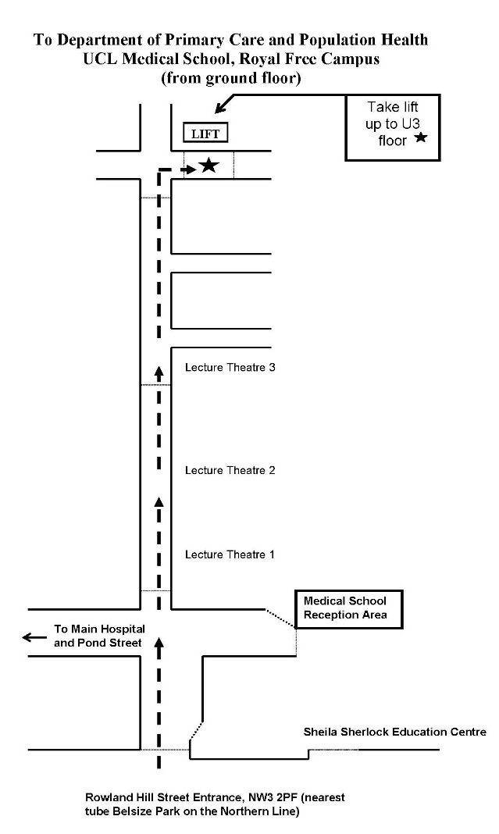

The Department of Primary Care and Population Health is on
the upper third floor of the medical school wing.
To find us, use the hospital entrance on Rowland Hill
Street and follow the map on the right.

Take the lift to U3. Turn right out of the lift to enter the department.
To gain access, use the phone mounted on the wall to call the extension of the person you are meeting.

MRC Head Office

Medical Research Council
58 Victoria Embankment
London
EC4Y 0DS

From 90 High Holborn:
- Walk east on High Holborn/A40 towards Holborn Pl. 0.2 mi
- Turn right onto Chancery Ln/B400. 0.3 mi
- Turn right onto Fleet St/Strand/A4. 112 ft
- Turn left onto Middle Temple Ln. 0.2 mi
- Turn left onto Victoria Embankment/A3211 Destination will be on the left in 0.1 mi
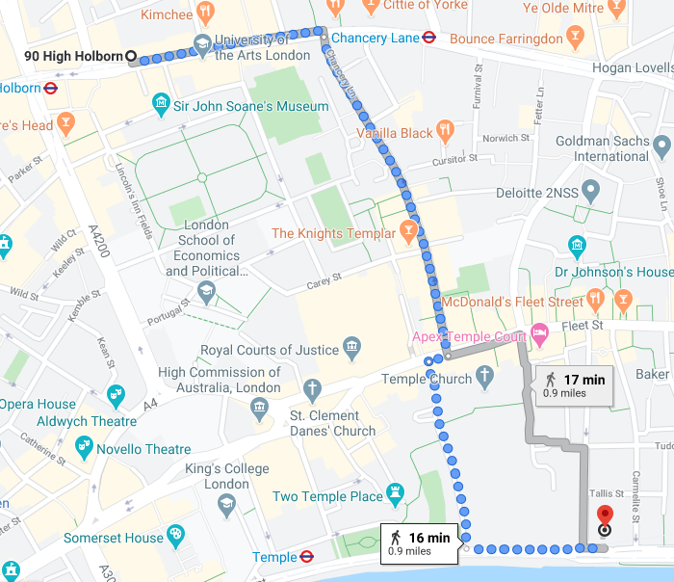
7.4 DECISIONS AND ACTIONS FORM
Action | Owner | Priority / Timescale

7.5 Communication Scripts/Templates

SMS TEMPLATES
SMS templates programmed into FastSMS, which may be set as-is or modified, and operated by ICTM Facilities:
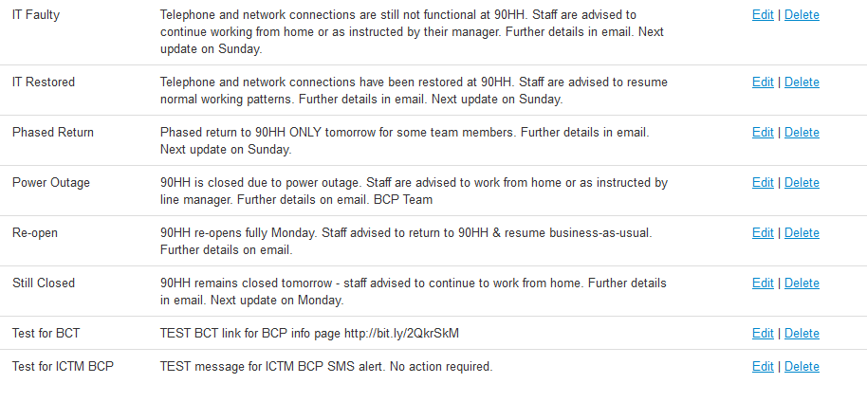

EMAIL TEMPLATES
DAY 1 - FIRST INSTANCE OF CRISIS
The email template example below captures all the key information required:
- Introduction to Business Continuity
- Current status of crisis
- What has happened
- Advisory information for staff members
- Time of next expected information update
EXAMPLE EMAIL 1
Dear all staff,

90 High Holborn is currently closed.
The building lost power twice today and we’ve been evacuated until it’s repaired.

We’ve asked all team members to work from home or another UCL location where possible for business continuity. If you are unable to, please speak with your line manager.

Key services, IS and randomisation team, will be running from MRC LHA today.

We will be cascading a text message to all staff shortly to echo this message & will send another update by close of business today.

DAY 1 – FINAL EMAIL
Please note: The template format will usually remain the same for the rest of the BC period.
The template example below captures all the key information required:
- Introduction to Business Continuity
- Current status of crisis
- Advisory information for all staff members
- Technical support information & contact details
- Confirmation of text message cascade update
- Time of next expected information update

EXAMPLE EMAIL 2
Dear all staff,
We have a few updates for you, below:
90 High Holborn is still closed and will remain closed tomorrow.
The building will let us know when they have rectified the power issue.

Please continue to work from home where possible for business continuity.
Please make sure all arrangements are agreed with your Line Manager.

Problems with VPN? See below with further instructions attached.
You only need VPN for access to randomisation, databases, intranet or website updating software.
Please use Cisco AnyConnect or UCL Desktop Anywhere for S & N drives and email.

Need technical support? You can reach the team on 02076704750 or mrcctu.isservicedesk@ucl.ac.uk

A text message cascade was sent earlier, did you receive it?
If so, wonderful. If not, please reply to me with the best mobile number and I will ensure you’re added.

Next update will be on Monday
… unless there are any major changes.

Thank you everyone.

7.6 LESSONS LEARNED FORM
KNOWLEDGE  Provide scope of issue area | WHAT WORKED WELL | LESSON LEARNED  Recommendation for improvement

Version Control.
Version | Date | Author | Changes
1.1 | 01.06.2014 | Mikko Wikstrom
1.2 | 10.09.2015 | Mikko Wikstrom | Mikko Wikstrom
1.3 | 14.06.2016 | Mikko Wikstrom | Mark O’Neill
2.0 | 26.06.2018 | Rachel Martino | Shamima Shobnom
2.1 | 03.09.2018 | Rachel Martino | Rachel Martino
2.2 |  | Rachel Martino | Rachel Martino
2.3 | 02.2019 | Rachel Martino | Hugh Willoughby
2.4 | 09.03.2020 | Nick Thomas | Hugh Willoughby

