Accessing the ETFS Remotely via UCL’s Desktop Anywhere
The below is intended as a guide for logging onto the ETFS outside of UCL, by first logging into UCL’s Desktop Anywhere. Please note the system is fairly slow to start with, so give it a few moments to allow pop-up’s to come-up and take effect.
1). Firstly, please go to: https://www.ucl.ac.uk/isd/services/desktops, which should take you to the below. Once opened, please click ‘Log in to desktop@UCL via your browser’.
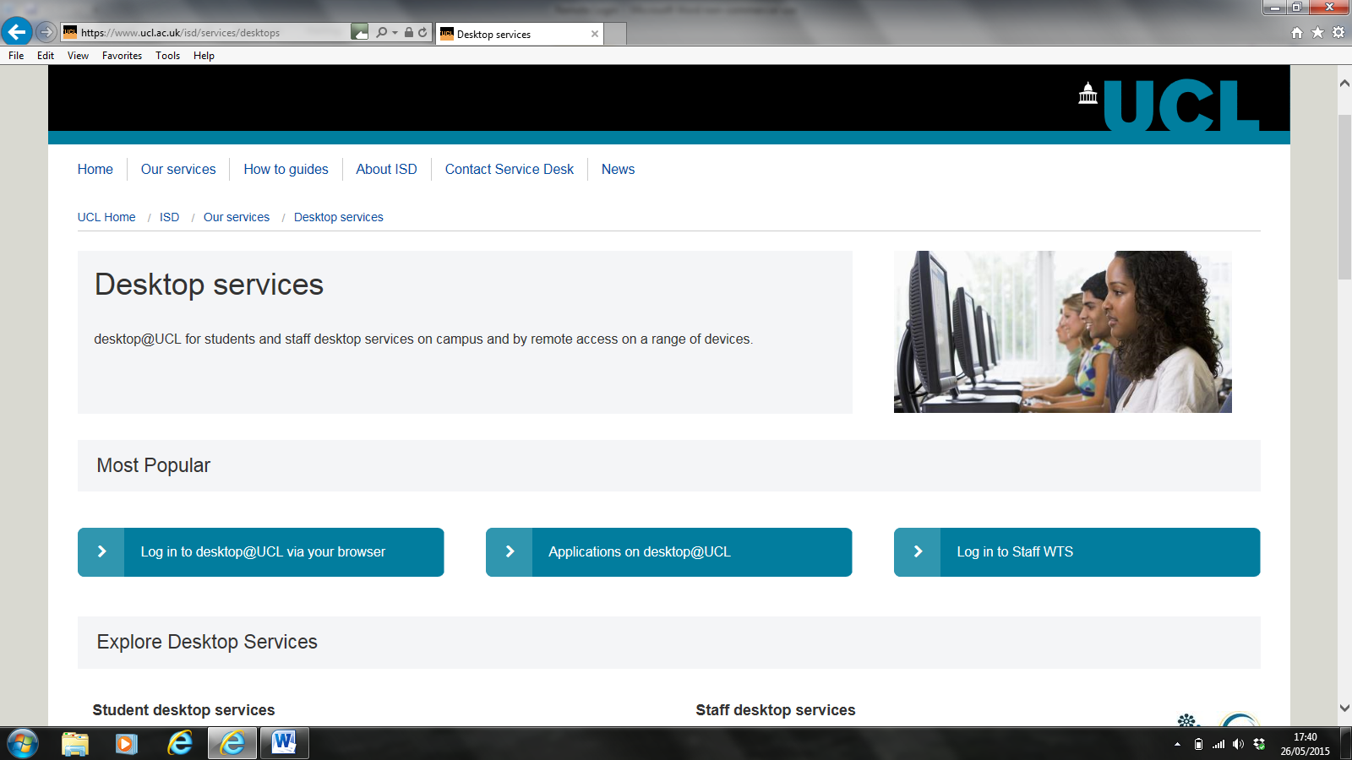
2). Use your standard UCL login details (i.e ucj-type number and UCL password) to access the system
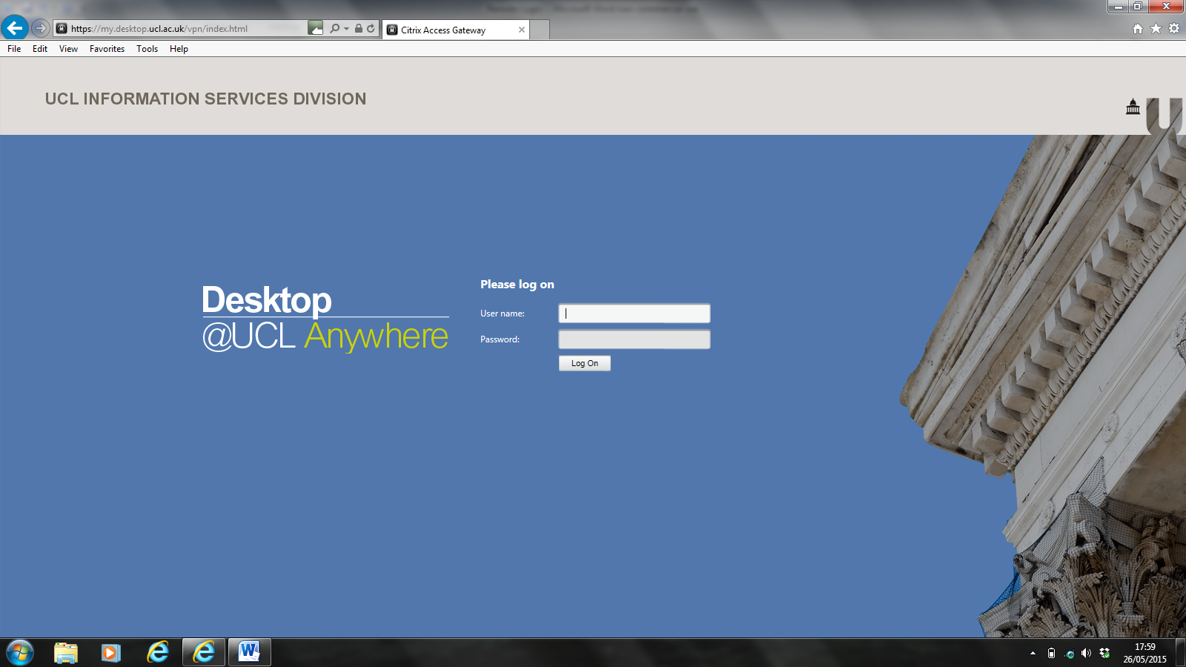
Note: Steps 3 through 5 should only relate to you if this is your first time installing Citrix; if you already have this installed, you should move straight to step 6.
3). Once logged in, the below page should appear; please tick to agree for installing Citrix on your computer, then click ‘Install’.
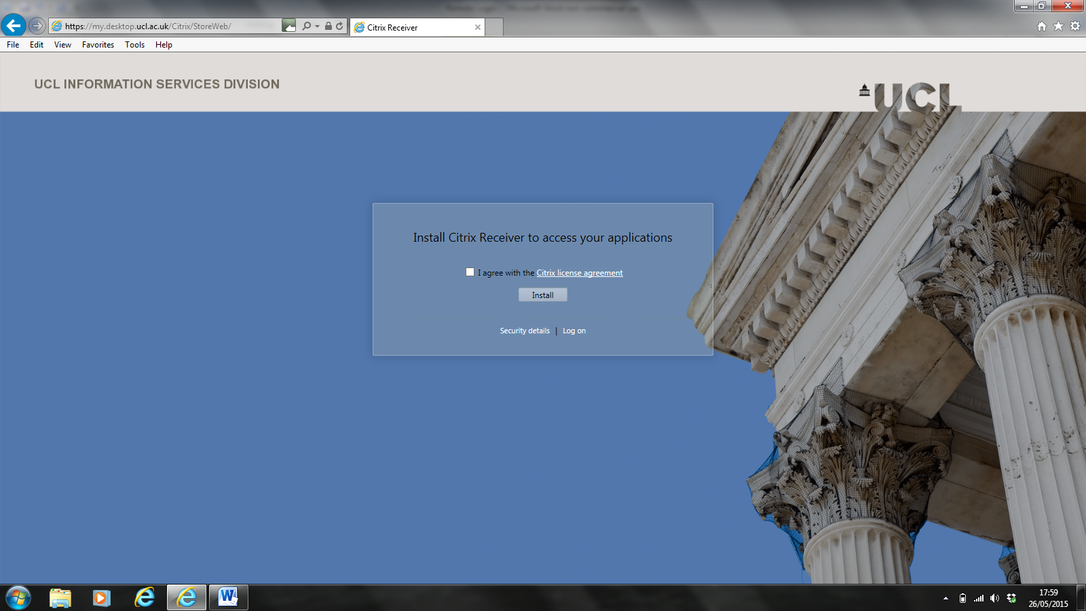

4). You may receive a ‘pop-up’ like the below with relation to installing Citrix; ‘Run’ the download to install Citrix.
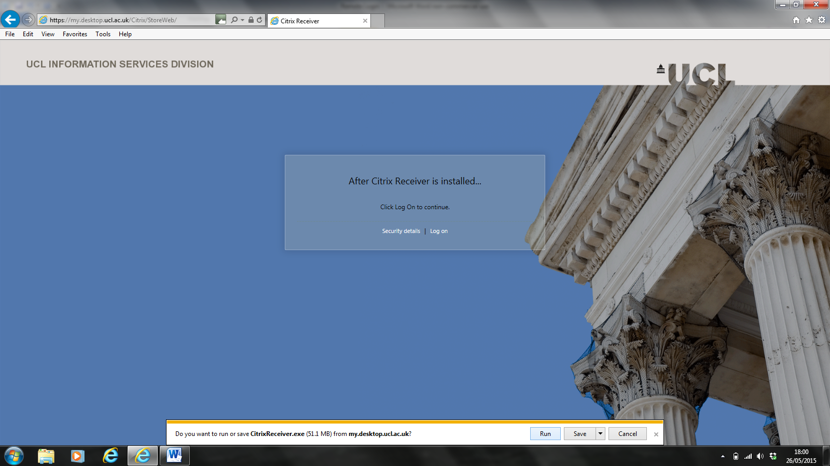

5). Follow any further guidance on the download (e.g. as below); this may take several minutes to complete.
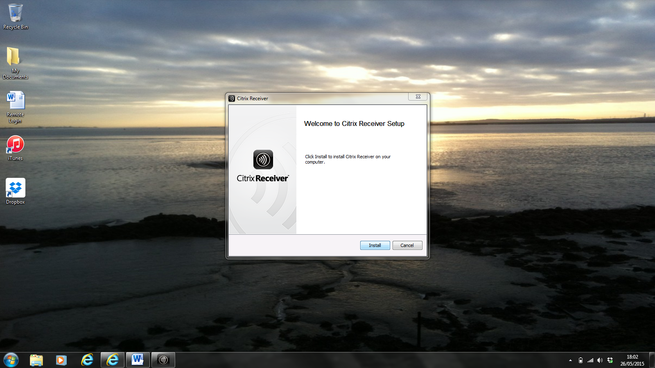
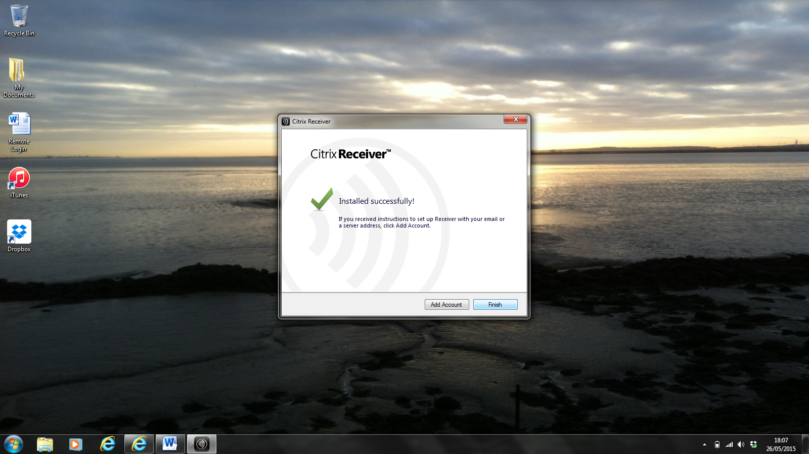
Click ‘Finish’ when the download is complete.

6). If you get pop-ups for Citrix Systems like the below when on the browser screen, click ‘Allow’.
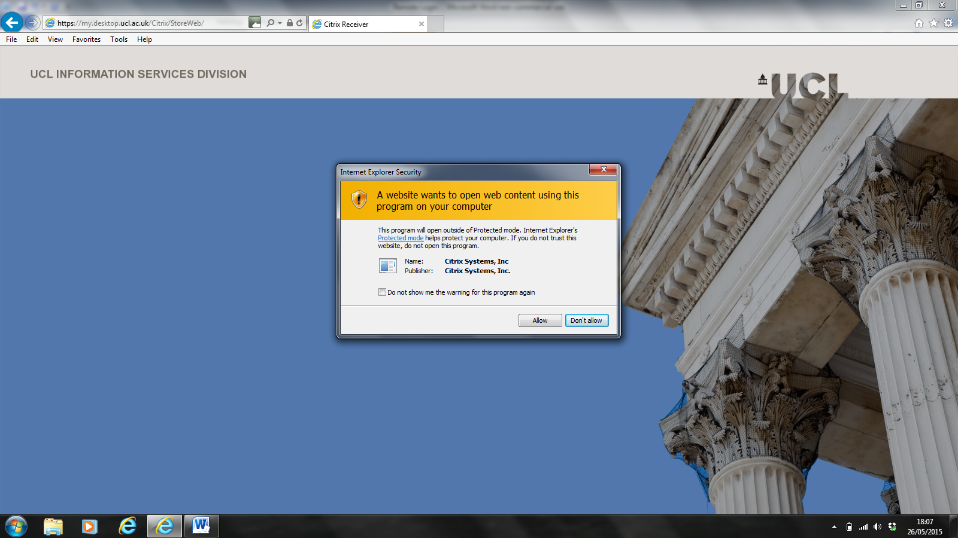

7). Make sure the ‘Desktops’ tab is clicked at the bottom of the screen. You should then be able to access MyDesktop by clicking on the ‘Desktop – Anywhere’ icon in the centre of the screen (as below).
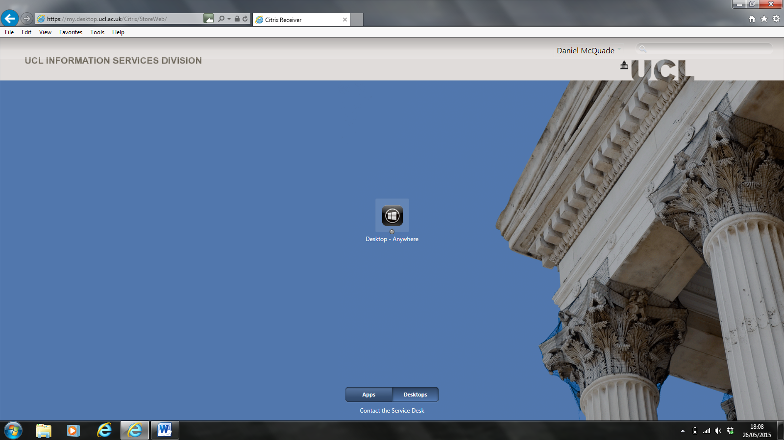

8). ‘Ok’ the below pop-up
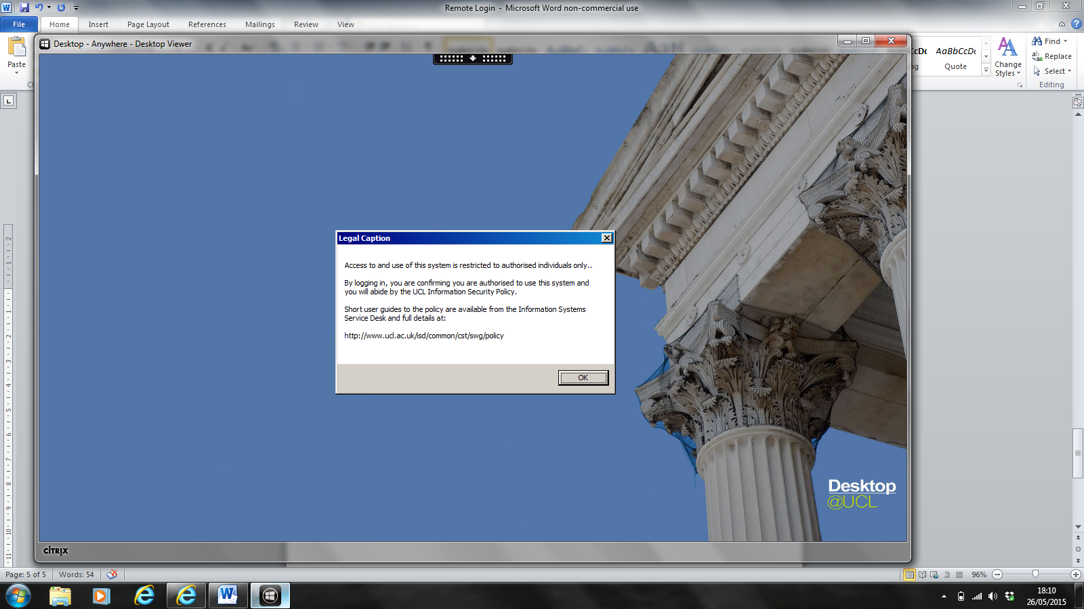
9). Using the black-bar at the top/centre of the screen, access the ‘Preferences’ tab and go to ‘My Accounts’; under ‘File Access’ change to ‘Read and write’, then ‘Apply’ and ‘Ok’.
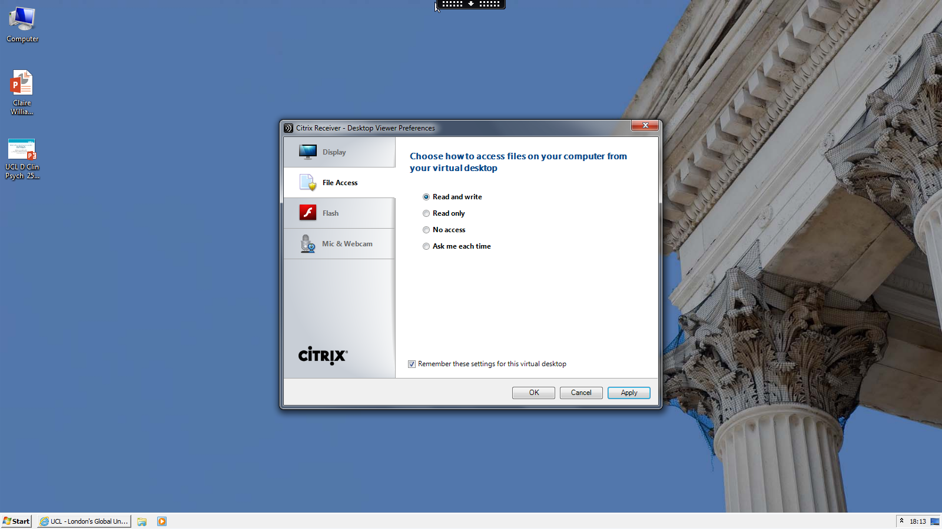
You can also use the ‘Window’ option via the black-bar in order to minimize/maximise MyDesktop to allow you to get back to your normal computer desktop.

10). Using the Internet Explorer icon in the bottom-left corner, you can connect to the internet as if in college. Once a window is open, go to the DClinPsy website, accessing the ETFS via the ‘Quick Links’ tab on the left-hand side (see below).
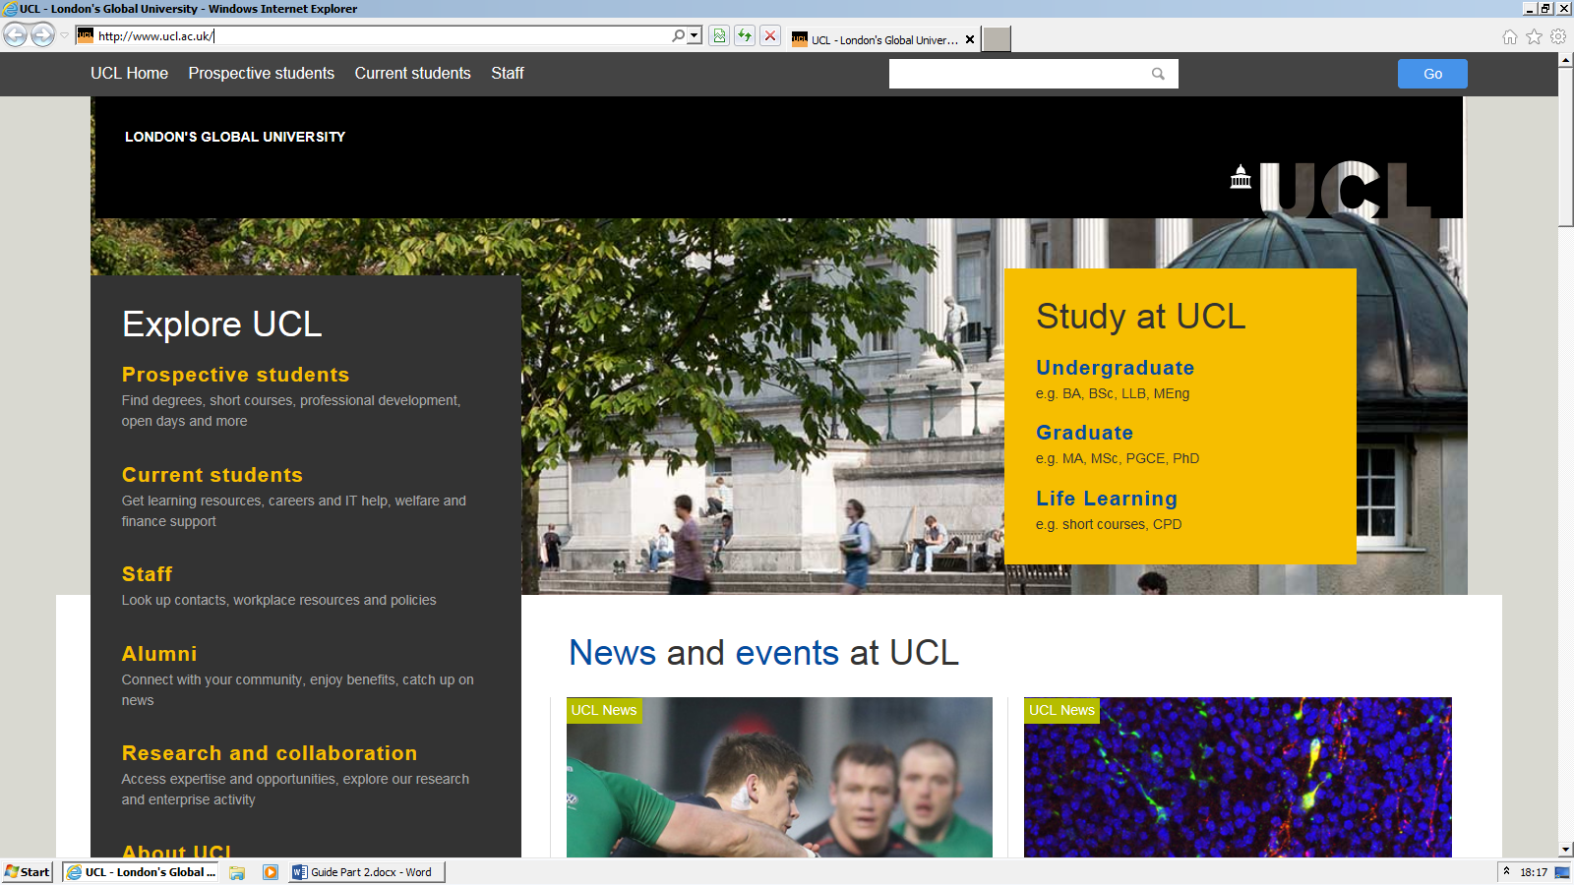
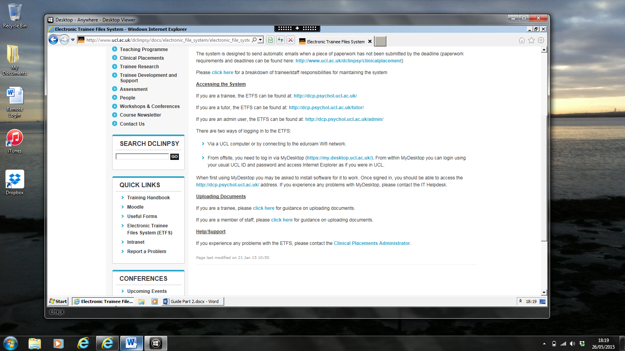
Use whatever link under ‘Accessing the System’ that is appropriate to you.

11). Once logged into the ETFS, you will be able to download/upload documents to/from your computer, as if you were on a UCL computer/connected to Eduroam (as below).
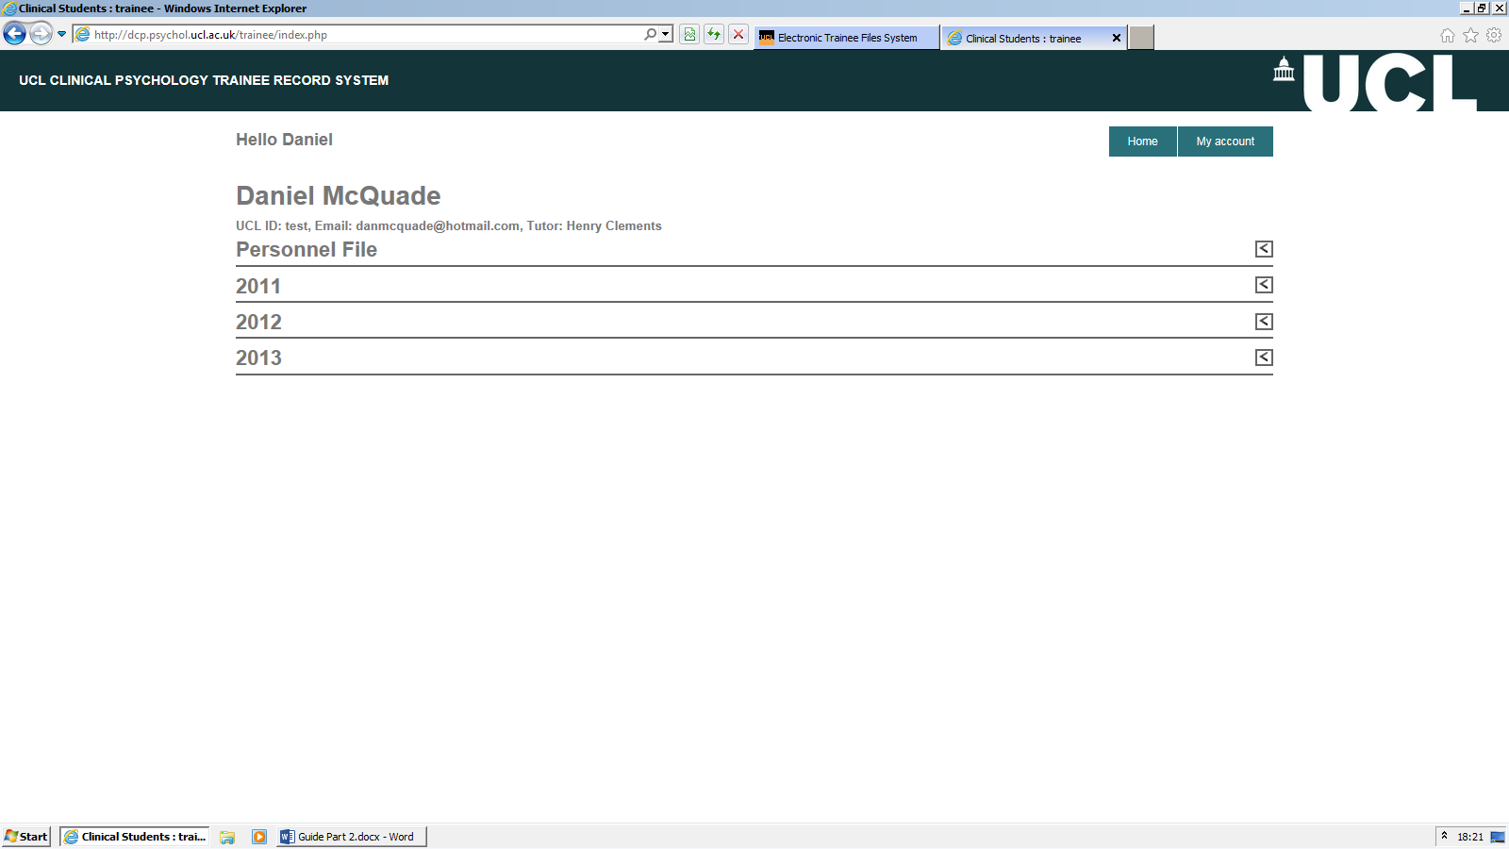
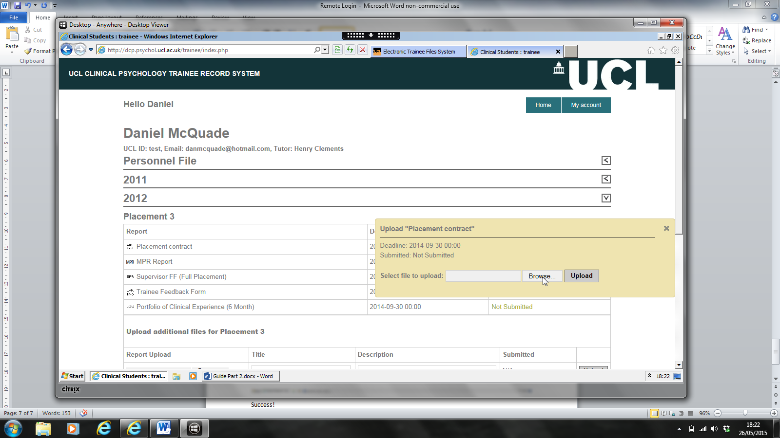
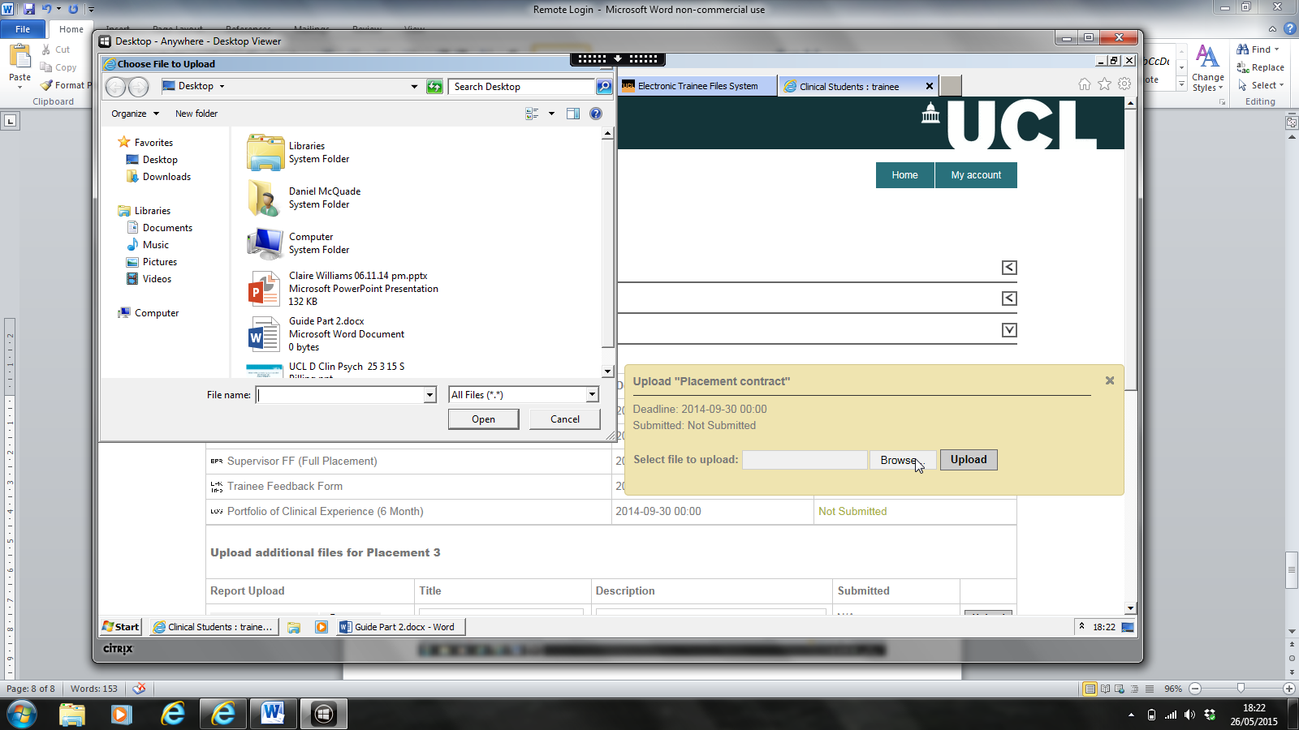
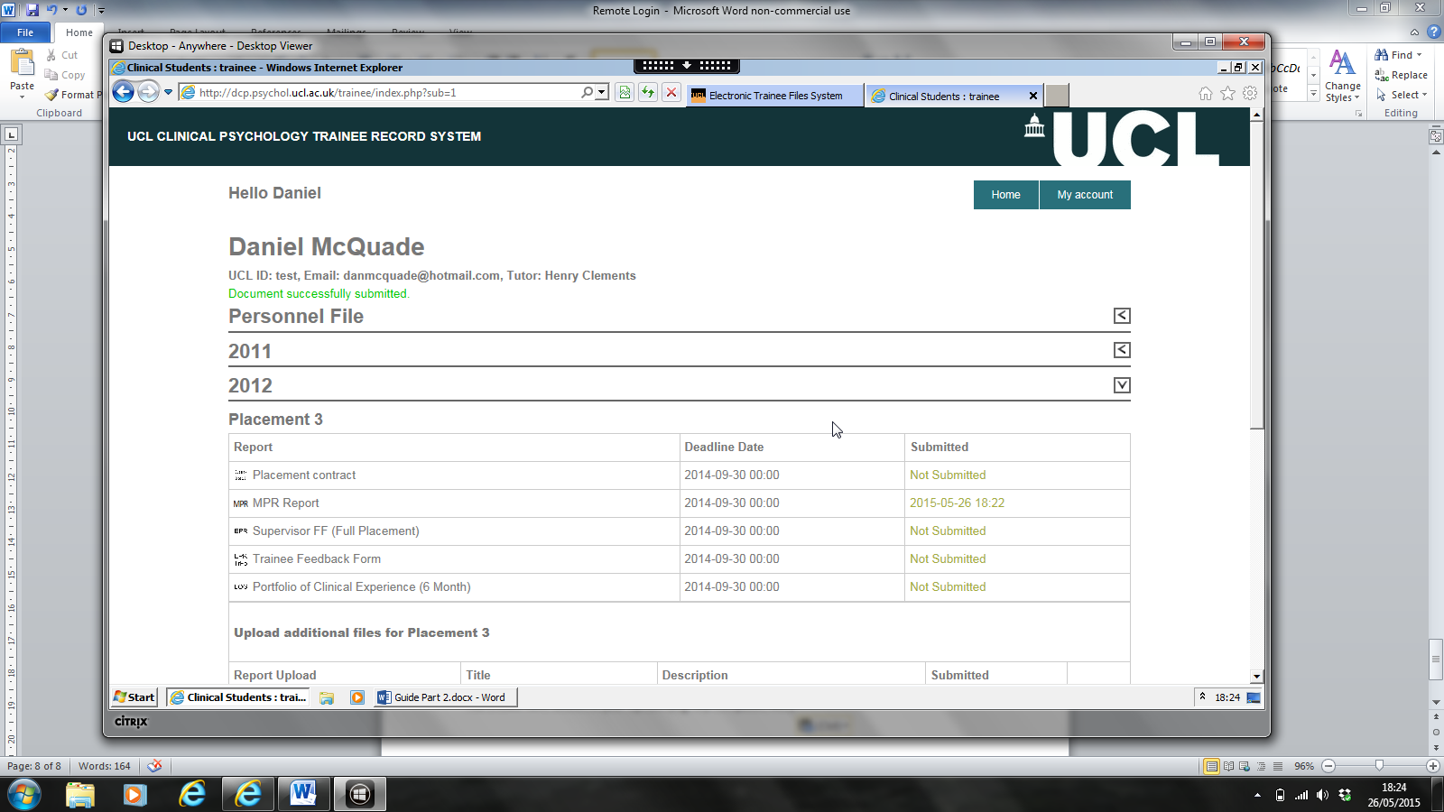

Should you continue to have problems with accessing the ETFS remotely, please contact the Clinical Placements Administrator on placements-admin@ucl.ac.uk.

