Approaches to the Reception of the Classical World (18-19)
CLAS0116 (intercoll. 40 credits) / CLAS 0117 (intercoll. 20 credits)
CLAS0143 or 0139 (UCL 30 credits) / CLAS0118 (UCL 20 credits)
course directors: Miriam Leonard (term 1, m.leonard@ucl.ac.uk)
and Maria Wyke (term 2, m.wyke@ucl.ac.uk)
with a team of course tutors
UCL, Gordon House G09, Thursdays 2-4pm
https://moodle.ucl.ac.uk/course/view.php?id=3063
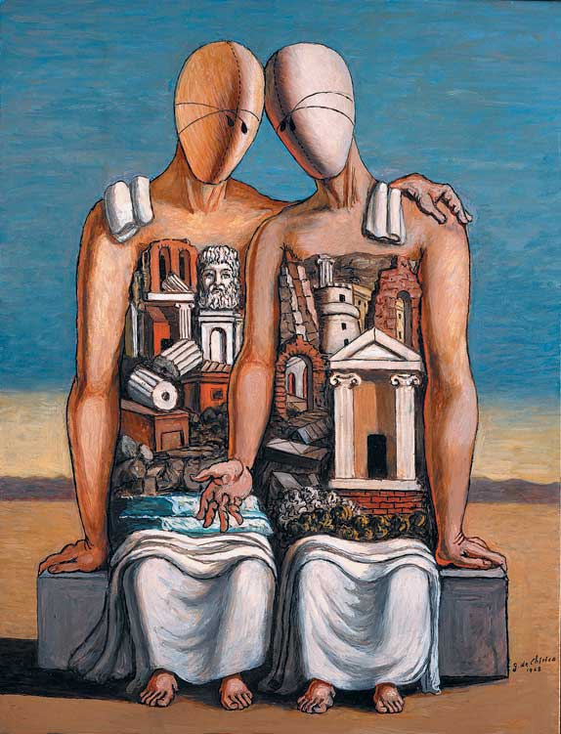

Aims
The course aims to introduce students to the principal issues, ideas and methods involved in studying the reception of the classical world across a range of periods, societies, and media. It will provide key illustrations of different responses to classical cultures in action and demonstrate how later cultures have viewed and made use of the classical world from their own historically situated standpoint. It also aims to equip students with the tools for further research in the reception of the classical world by developing their critical and conceptual understanding in this field.
The course is taught by a range of experts in classical reception. It addresses theory, the history of reception (from within antiquity to the twenty-first century, from the Mediterranean to the Caribbean). The course also explores the engagements of classical antiquity throughout the centuries with issues of gender, class, race, politics and national identity.
In term 1, ‘reception studies’ and its theoretical approaches are introduced. Case studies of reception are then explored within antiquity and beyond up to the early modern period, with a focus mainly on literary reception. In term 2, case studies of reception are explored from the Renaissance up to the present day, with an emphasis on material culture, art, museums, performance, film and political thought (and includes tours of the Petrie and the British Museums). MA Reception students take the whole course (40 credits intercollegiate. Other MA students may take the whole module or just the term 1 as a half module (CLAS0117, 20 credits intercollegiate; or CLAS0118, 15 credits UCL).

Autumn 2018
1. History and value of reception studies (ML) 4 October
2. Key theories and methods for reception studies (PV) 11 October
3. Reception histories in antiquity: Euripides’ Bacchae (FMG) 18 October
4. Author / Text / Reader: Ovid (FMG) 25 October
5. The Homeric tradition in Byzantium (AM) 1 November
6. Transmission (MN) 15 November
7. From the Middle Ages to Renaissance Humanism: Dante and Petrarch (CK) 22 November
8. Renaissance artists and the antique (RD) 29 November
9. Manuscripts & printed books (UCL Special Collections) 6 December
10. The Warburg Library as representation of the afterlife of the Classical World (CW) 13 December

Spring 2019
11. Antiquity in Opera (GM) 10 January
12. Material and visual culture (RD) 17 January
13. Collecting and displaying: visit to the Petrie Museum (AG) 24 January
14. Museology & the enlightenment: visit to the British Museum (IJ) 31 January
15. Classics and the birth of modernity (ML) 7 February
16. Greek drama on the modern stage (ML) 21 February
17. Fascism and Romanità (MW) 28 February
18. Reception and Revisionism: Black Athena (PV) 7 March
19. Homer on Film (AM) 14 March
20. Reception and the non-European: India, Africa and the Caribbean (PV) 21 March

