STEPHEN INSTONE TRAVEL REPORT 2023
Introduction
My application for the Stephen Instone travel fund was quite unorthodox in its nature. Rather than a sightseeing trip through the archaeological sites of Ancient Greece or Rome, I opted for a linguistic journey into rural Arcadia, a region of Greece that throughout history, and especially now, has mostly remained off the map and out of the reach of tourists. What attracted me to this region, and specifically a small part of it known as Southern Kynouria, or Tsakonia, is the little-known dialect spoken throughout its valleys. This region has remained extremely isolated throughout history; for example, electricity only made it there in the 1970s. This had led to the conservation of its language, Tsakonian. Only partly to Modern Greek, Tsakonian is the modern evolution of the Laconian dialect of Ancient Greek. Having developed separately from Koine Greek, whence Modern Greek stems, Tsakonian has evolved independently for over 2000 years and is today quite different from the Standard language. Under Dr. Weeden and Prof. Colvin’s suggestion, I decided to turn this trip into a research trip, whose ultimate goal was phonetic and linguistic data collection. All of this was made possible by my ability to speak Modern Greek, which I learned in Athens over a period of two years throughout high school. I also, however, took the chance to go sightseeing in Athens and its surroundings out of my own pocket for a few days, before making the trip to Arcadia.
12th of September
The plane landed at late at the Eleftherios Venizelos airport, when I finally made it to Central Athens, I dropped my bags and trekked up the Areopagus hill to be reconciled with a familiar view of the Acropolis.
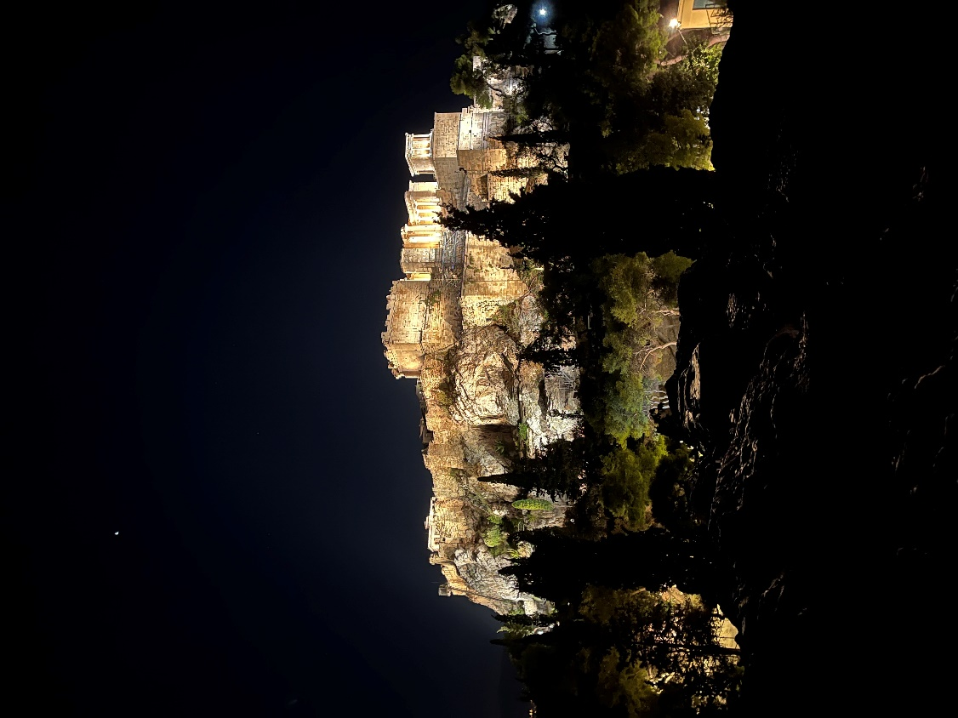
View of the Acropolis from the Areopagus
13th of September
The second day was mostly dedicated to Athenian sights. Starting from the Roman agora and Hadrian’s library, I then made my way to the Ancient Agora and made good use of Rick Steves’ free guided tour available on the App Store.
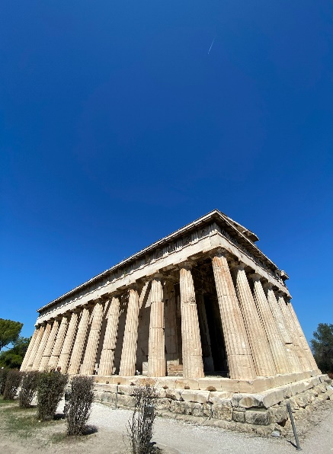
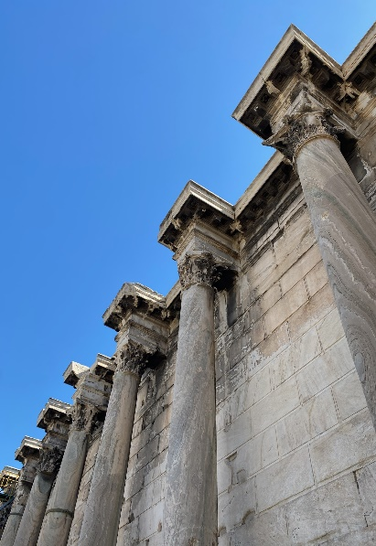
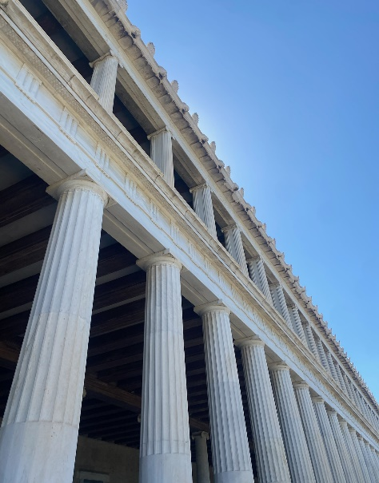
Stoa of Attalus III
Hadrian’s Library
Temple of Hephaestus
I then visited the Acropolis Museum and, when my time slot finally came, walked up to the Acropolis. The marbles of the Acropolis shone beautifully in the evening sun.
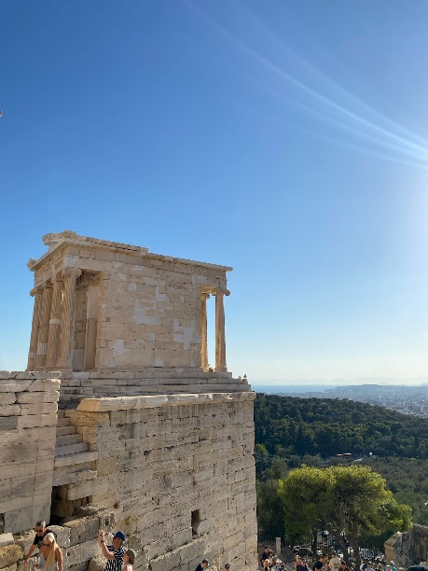
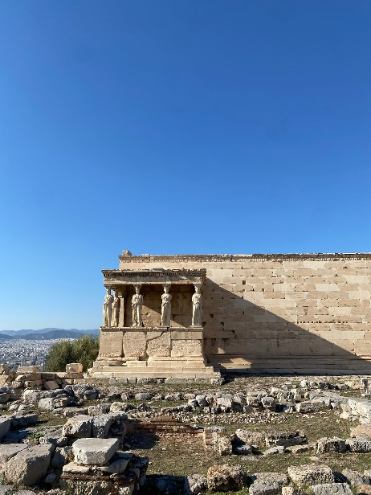
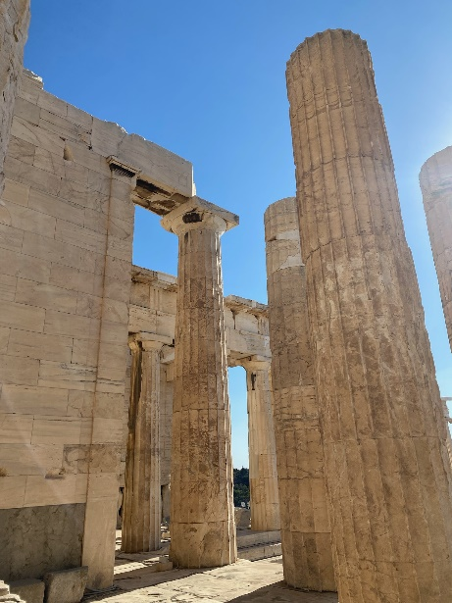
The Propylaea
The Temple of Athena Nike
The Erechtheion
14th of September
Being too lazy to get a driving license, I had to rely on organized day tours quite heavily. The second day of sightseeing was dedicated to Argolis. In the morning, me and my fellow travelers were taken to the Corinth Canal and, the theater of Epidaurus and the sanctuary of Asclepius.
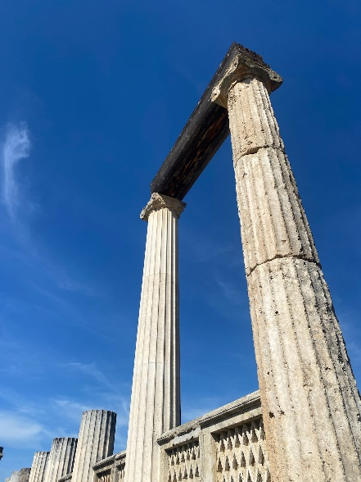
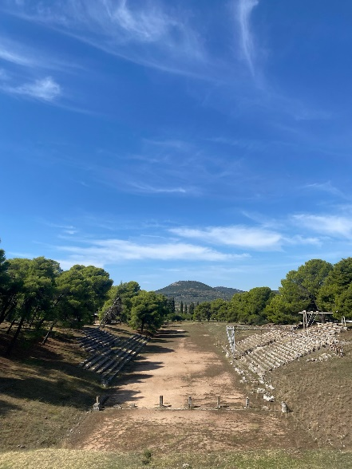
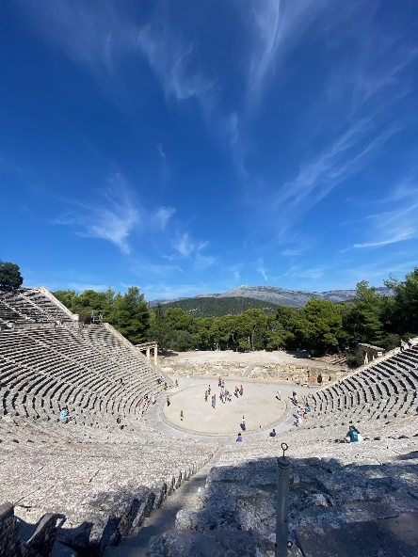
Theater of Epidaurus
Stadium of Epidaurus
Temple of Asclepius
Later, we were taken to Nafplio, where I truly felt at home, finding the traces left by my Venetian ancestors. The marvelous seafront and tight alleys took me back to my homeland and brought me a sense of nostalgia for the bygone days of the Serene Republic. I also visited the church where the Greco-Venetian politician and founder of the Greek state, Ioannis Capodistrias, was shot dead by political rivals.
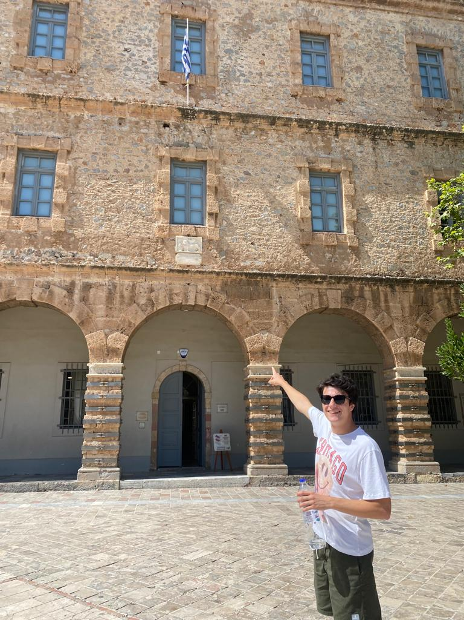
Me finding the Lion of St Mark, Patron of Venice and the Venetian people, in the main square of Nafplio.
The final destination was Mycenae, where I’d been before as a child but could not remember well. The cyclopean walls never fail to impress. The treasure of Atreus took my breath just like it had done ten years before. Luckily, we also managed to see Tiryns, though only from the outside.
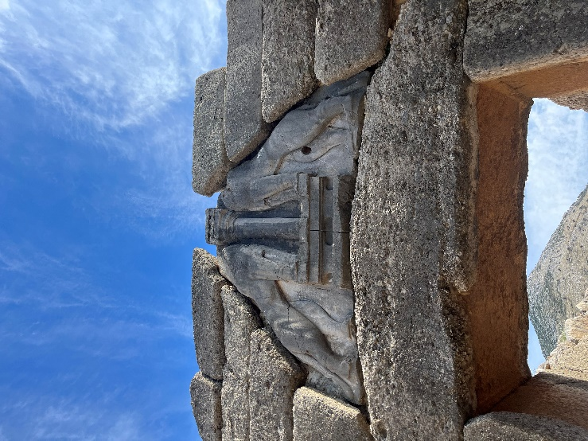
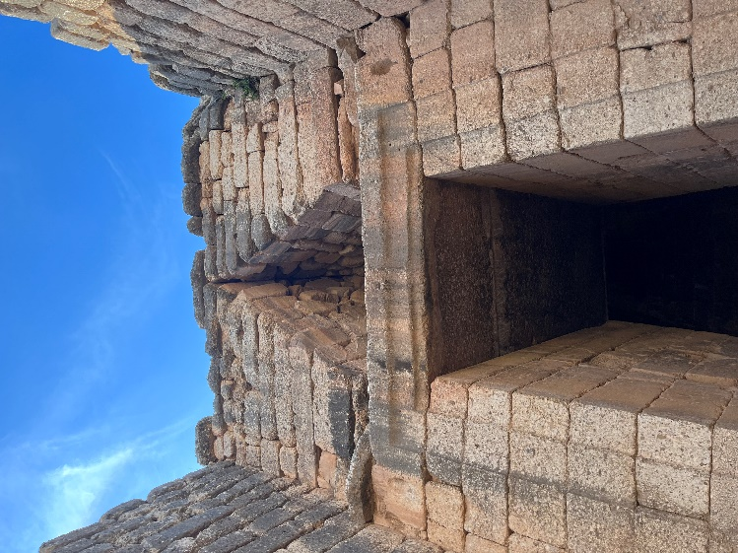
Treasure of Atreus
The Gate of Lions
15th of September
On the morning of the third day of sightseeing, I made my way to the Keramikos archaeological site and found that it has been curiously colonized by tortoises! Who could blame them? That necropolis surely houses some marvelous pieces of sculpture. I then walked to the National Archaeological Museum, which has been recently renovated. The Mycenean jewelry there was simply majestic! It really surprises me that no Greek jeweler has caught on the timelessness of those artifacts yet!
In the evening I availed myself of yet another organized tour to reach Cape Sounion. The first stop, however was the theater of Thoricus, oldest preserved theater in the world, and the ancient silver mines of Lavrio.
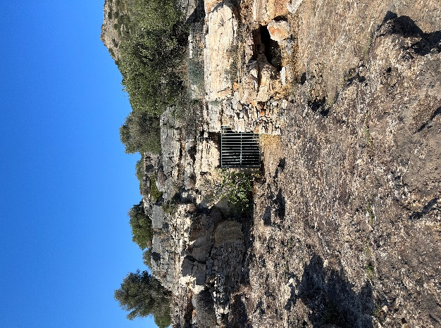
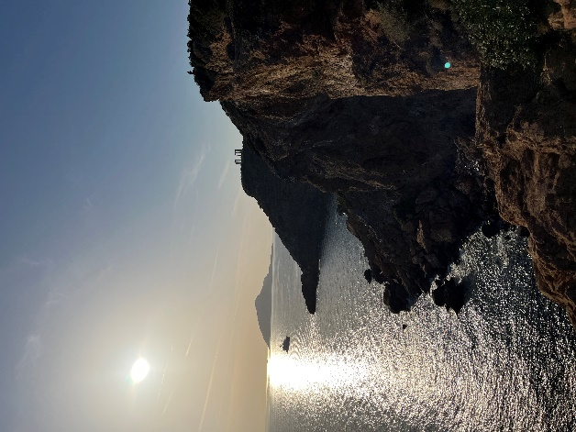
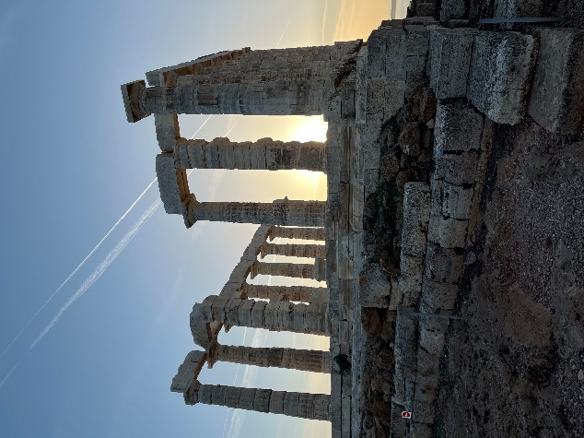
The temple of Poseidon
A silver mine in Thoricus
The cliffs of Sounio
In Sounio, I had the privilege to watch the sunset from the temple of Poseidon, sitting on the rock where -as the myth tells – Aegeus waited for the return of his son. Unfortunately, the beauty of the moment was ruined by some annoying tourist who found it appropriate to incessantly fly their very loud drone around the archaeological site.
16th of September
After waking up at dawn and getting scammed and yelled at by a dishonest taxi driver, I finally reached the very poorly connected Ktel bus station, where I embarked into the bus to Leonidio. The drive down to Arcadia is most impressive, almost resembling a mythical journey. From Athens to the Isthmus, the bus passes by the Acrocorinth, which stands tall in the distance, then by Nemea and the temple of Hercules, to then drive through Argos and by its Heraion. After Argos the mythical locations diminish in number, giving room to lesser-known settlements on the coast. From Astros all the way to Leonidio, the panoramic drive is breathtaking. After 3.5 hours, the red cliffs of Leonidio finally appeared. Never had I imagined they would be so awe-inspiring. They are visible from anywhere in town and a fairly popular destination for rock climbers. Immediately, we were greeted by Tsakonian road signs.
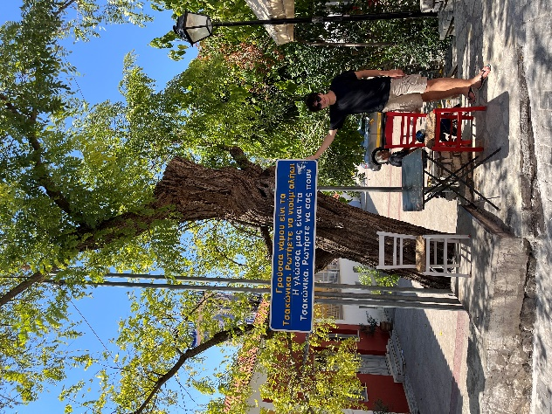
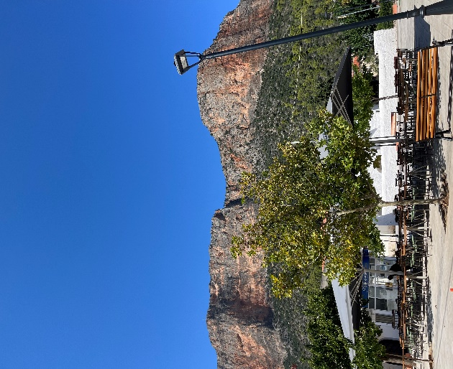
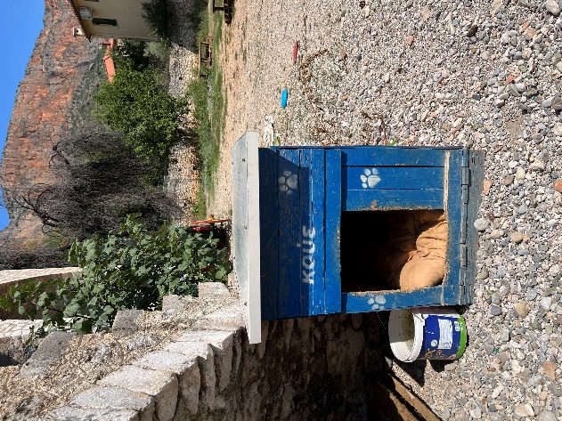
A Tsakonian dog’s bed
One of the many bilingual signs
The red rocks of Leonidio
In the afternoon, I conducted my first two scheduled interviews with Tsakonian speakers. The former, Eleni Manou, was my main contact in the area and helped me finalize my interview structure. She is greatly passionate about her language and often organizes and takes part in local cultural festivals. Later, I walked around town asking in every café if anyone spoke Tsakonian and if they were available for an interview. This proved to be more effective than I imagined, as I managed to conduct three interviews. My struggling Greek was doubly challenged by the strong accent the people of Arcadia have in their speech, which I was entirely unused to, having only ever spoken to people from Attica. This, combined with my unfamiliarity with Tsakonian, led to several hilariously awkward situations, where I simply had no clue what my interviewee had been talking about for the past five minutes (I now think it was some fable about a cicada and three other animals I am yet to identify). The fact the overwhelming majority 21/24 did not speak English certainly did not make it easier.
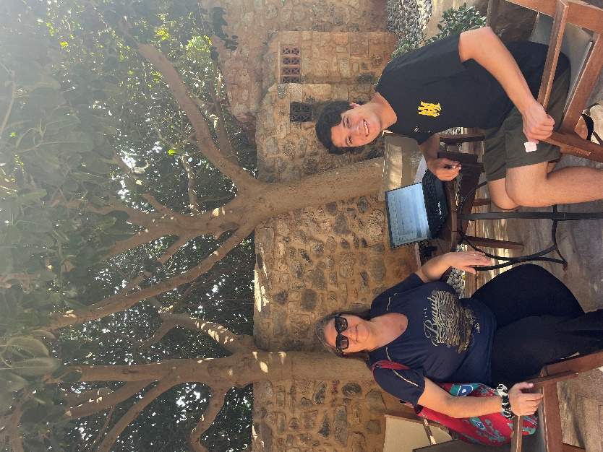
Me with my second interviewee, Thomai Kyriou
I also met a Flemish librarian named Johan, former Mycenean philologist, who spends every summer in Tsakonia, due to his love for its language and people. He turned out to be a great fan of both Stephen Colvin’s linguistic research, and – to my delight – Stephen Instone’s research on Pindar!
17th of September
On the second day I conducted my first interviews at the Tsakonian Archive, a non-profit organization trying to keep alive the language and cultural heritage of Tsakonia. Speakers from the surrounding villages answered my call and were so kind to offer their help with my research.
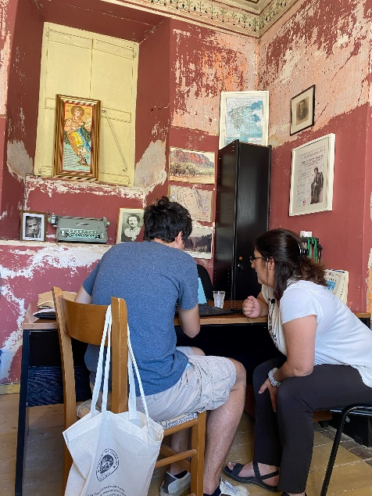
Me in the middle of an interview at the Tsakonian Archive
After completing the interviews, I decided to take some time off and head for the beach. Though setting out on foot both ways, I never had the time to take 20 steps without a car stopping and offering me a ride to my destination.
18th of September
After running into Johan multiple times (the town is indeed quite small), he offered to drive me to the nearby Tsakonian-speaking villages of Melana and Sapounakeika. So, after completing the morning interviews in the Tsakonian Archive, I hopped onto his “Mercedes Jeep” (A Suzuki Jeep with fake Mercedes stickers all over and inside it) and was driven to Melana. There, I was greeted by Tsakonian signs at the local “Καφούτσι” and interviewed three speakers.
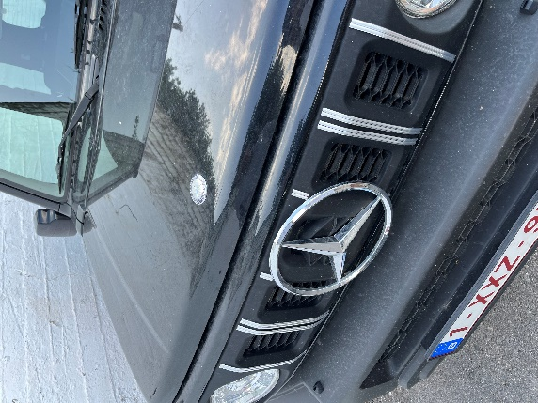
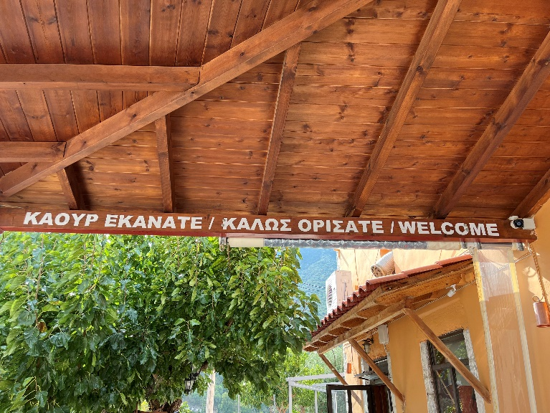
Johan’s customized Suzuki
Trilingual sign in Melana
Later we drove to Sapounakeika, where I interviewed three generations of owners of the local taverna, “το κονάτσι” (“the rabbit” in Tsakonian). The tavern’s view over the nearby town of Tyros was truly mesmerizing!
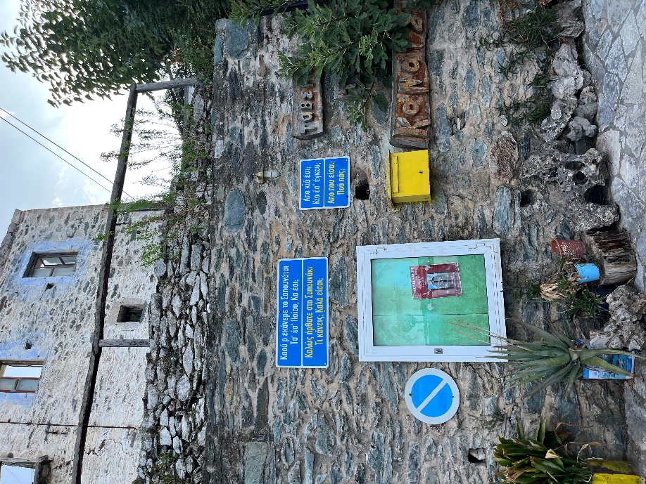
Bilingual signs welcome travelers to the tavern “The Rabbit”
The locals truly love and care about their language and heritage, yet they have a great deal of trouble in passing it onto their offspring. Due to lack of teachers, they often turn to researchers and foreign speakers to teach their language. A particularly touching moment was when, in Sapounakeika, I was asked “After this study, you will learn Tsakonian, come back and teach our children, right?” I could not answer.
19th of September
On my last day in Leonidio, I carried out the final interview at the Tsakonian archive and was given an impressive number of freebies. At 2 pm I left for my final destination, Tyros. In the evening, I met Panos Marneris. Born in Tyros, Mr. Marneris moved to America to seek fortune. After a familial loss, he moved back to Greece and started a non-profit organization called “Tsakonoparea”. He teaches Tsakonian classes to the children of Tyros and runs yearly cultural festivals where kids sing Tsakonian songs and prepare essays and tales in Tsakonian for public reading. He is very passionate about his mission was very happy to help me with my research.
20th of September
After a morning hike up to the ruins of Ancient Tyros, I conducted three interviews with speakers sourced by Mr. Marneris. After returning to “το κονάτσι” for dinner, I found out that the owner of the hotel I stayed at was a Tsakonian speaker herself, so I completed a final interview on the hotel front terrace, just meters away from the splashing of the waves.
21st of September
It was finally time to go back. I caught the bus from the beach stop (quite literally on the beach) at 9 am and made my way back to Athens. After reaching the Greek capital, I found out that the metro was on strike. Luckily, airport shuttles departed from the exact same bus station I had arrived to. Thus, I spent the rest of the day in the airport, waiting for my 10 pm delayed EasyJet flight, writing this report.

