Report

I applied for the Stephen Instone Award so that I could visit Delphi as research for my MA dissertation. My topic is the role of the body in the Delphic Festivals (1927 and 30). The Festivals were set up Eva Palmer and Angelos Sikelianos and consisted of performances of Aeschylus’ Prometheus Bound and Suppliant Women as well as re-enactments of various ancient traditions, lectures and a craft fair. Materiality plays a large part in my discussions and so I decided to apply for the grant to go and see where the Festivals took place - the ancient sanctuary of Apollo at Delphi. The modern village of Delphi also contains the Museum of the Delphic Festivals which has an excellent collection of photographs and costumes from the events. In what follows, I describe my trip to Delphi, which was followed by a day in Athens.

Day 1 - Travelling

My trip unfortunately began with a delayed EasyJet flight. However, as soon as I stepped out of Athens airport, the time I’d spent very slowly choosing mini toiletries in the Gatwick departure lounge quickly became a distant memory. The air was hot, I had a spinach and feta pie in my hand and I was full of excitement for a trip to see some of the sites I’d been reading about in libraries for the last six years.

Day 2 - Traveling to and exploring Delphi

Day 2 started early but energetically thanks to my coach for Delphi leaving at 8.30 am and some excellent Greek custard pastries (bougatsa). I then met my tour group at a central hotel. The coach trip alone was such an experience in itself I thanked myself that I hadn’t decided to take the cross-country bus to Delphi. Our guide was very informative and gave us lots of information about Greek history and culture, from the ancient to contemporary times. The latter was especially interesting to me as she spoke about how the financial crisis had effected her personally. I had written a piece of coursework on the art festival Documenta 14 that took place in Athens (as well as Kassel, its usual location) in 2017 and was entitled ‘Learning from Athens’. One of the main issues addressed in the festival was the financial crisis and my essay explored how this was done. It was therefore really interesting to hear a local perspective on the financial troubles. I also enjoyed hearing about, and seeing, the crops that were grown in the local area. I learnt that cotton was grown around Mount Parnassus (where Delphi is located). This made sense considering how much cotton was used in the traditional weaving of Eva Palmer and in the traditional fashion of the local villagers. Indeed, the textile work of the villagers was displayed in a craft fair at the Festivals. The landscape, which became more dramatic as we started to reach the mountains, also kept me staring out of the window throughout the journey.

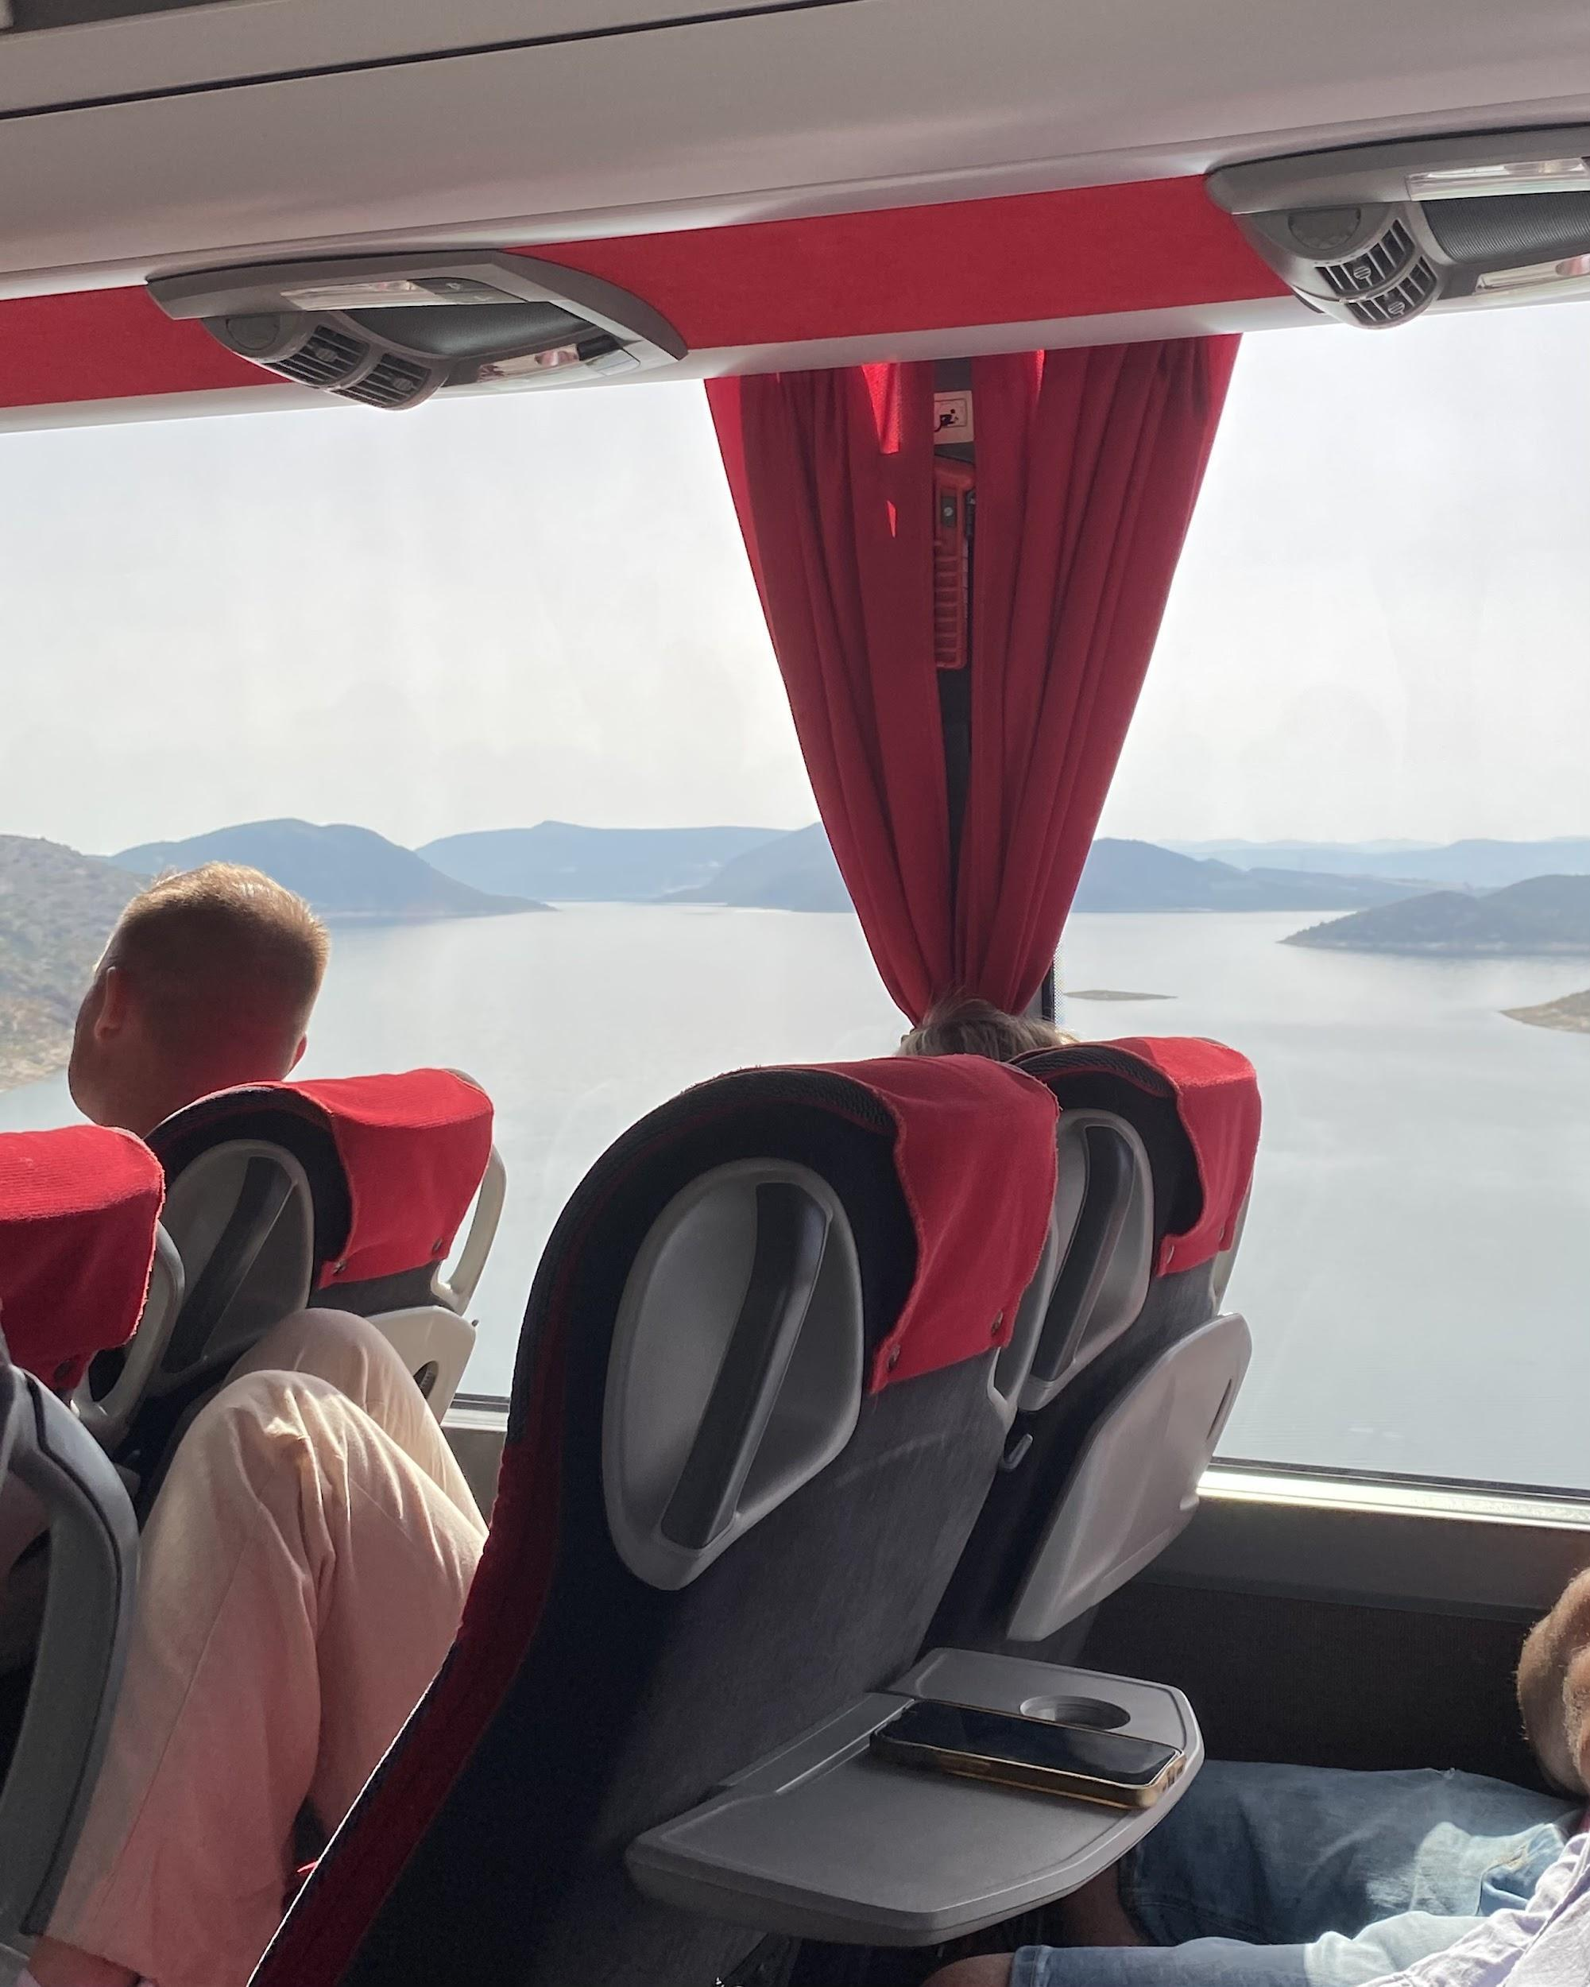
Views from the coach ride to Delphi

When we reached Delphi, the first place we headed to was the archeological site of the sanctuary of Apollo. In this trip, which was with the tour, we only covered the main archeological site although there were a couple of other points of interest separate from the main site that I explored the next day. The sanctuary of Apollo consists of the Roman agora, the sacred way (where you can see remains of various treasuries and monuments dedicated to Apollo), the ancient theatre and the ancient stadium. All of this is settled into the mountain of Parnassus and, in the usual way of sanctuaries, works its way up the slope to a high point. Unusually, at Delphi, the stadium is at the uppermost point as this was usually where the main temple was. This trip was quite quick and very busy but it allowed me to get a good sense of orientation so that the next day I could soak up the whole experience of being in the site.

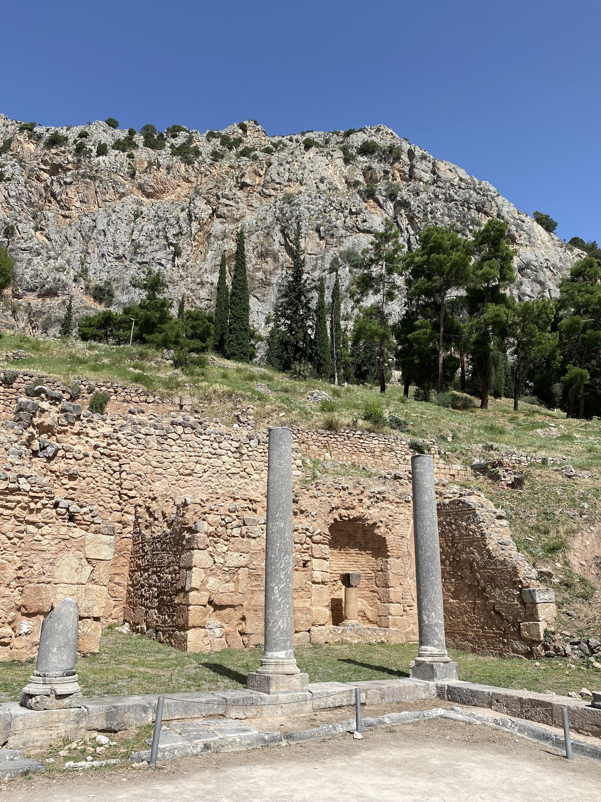
Remains of the Roman Agora at the entrance to the Sanctuary of Apollo at Delphi

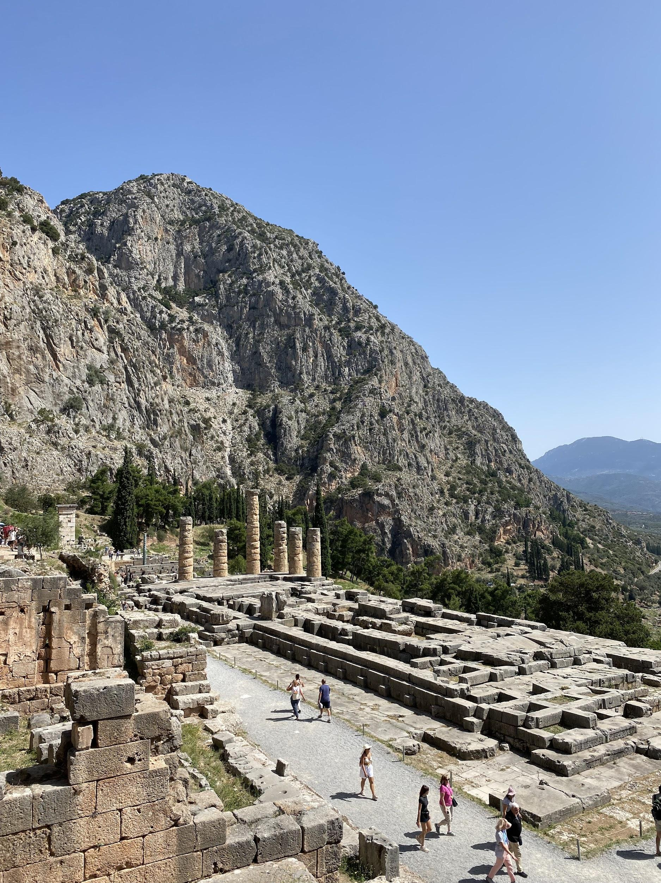
Remains of the Temple of Apollo at Delphi

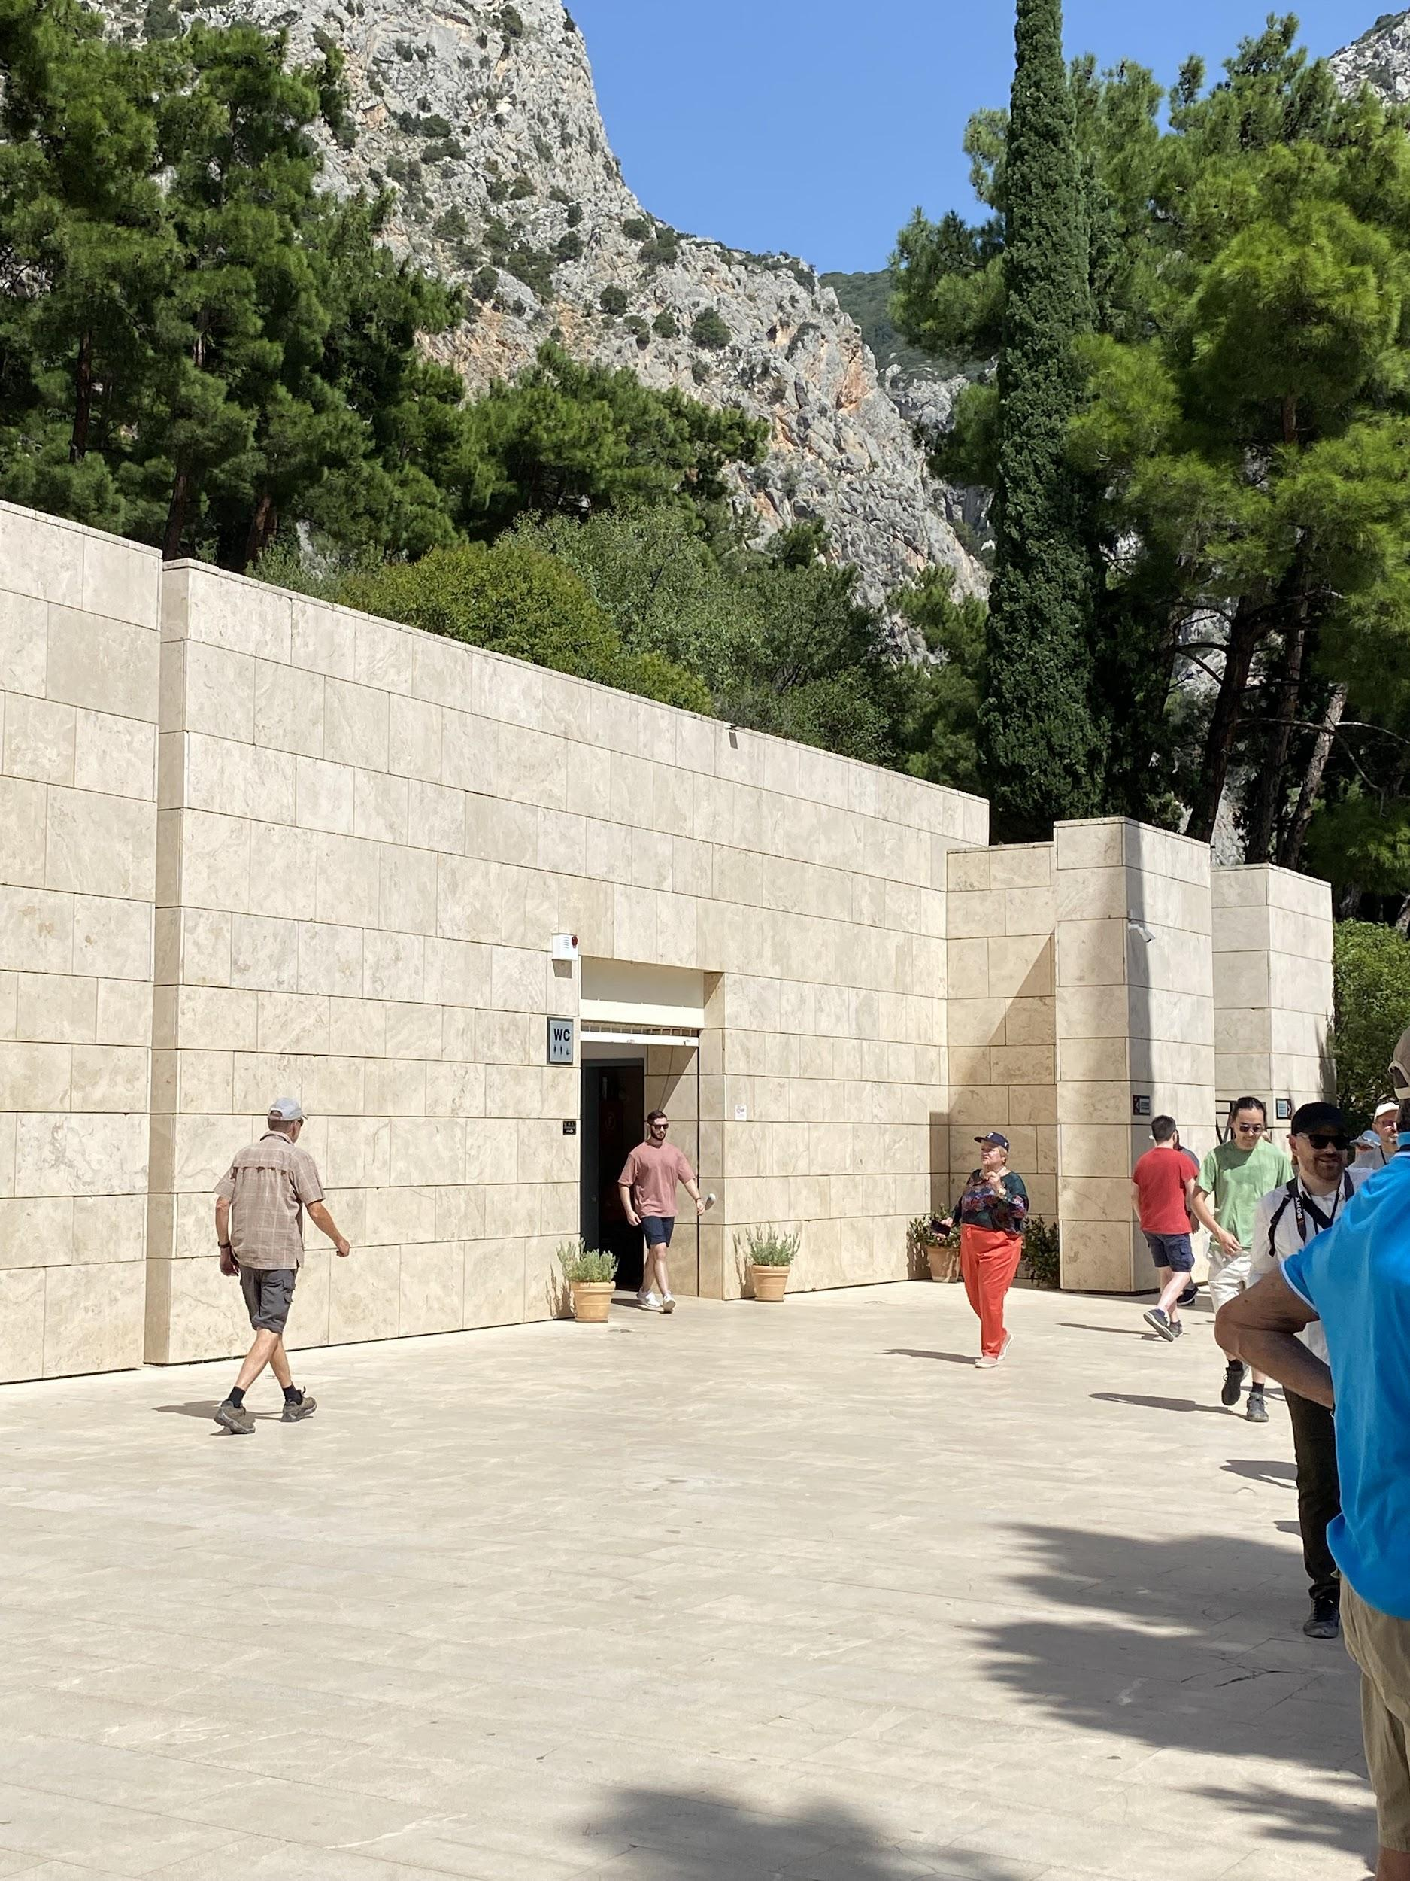
The exterior of the Archeological Museum at Delphi

After this, we went to the Delphi Archeological Museum. Again, it was a brief visit but very worthwhile because the next day when I returned to the site I could really imagine the various artefacts we saw in the museum (which had been found at the sanctuary) in situ. I particularly enjoyed seeing the statue of the Delphic Charioteer which I studied in some detail as an undergraduate. He also features in my MA dissertation in my section on modern fashions inspired by ancient sources. In 1907, the Italian designer Fortuny created his ‘Delphos’ dress which was modelled on the fine pleated tunic that the Delphic Charioteer wears. Something else that really struck me about this statue, which I hadn’t ever noticed to the same extent in photos, was the tension the artist managed to convey in the body of the statue. Another highlight was the fragments of chryselephantine statues on display, alongside a vast array of golden objects. These were thought to have been dedicated by some of the kings of Asia Minor, where gold is found. Sadly these statues suffered serious burns, turning the ivory to black, but it was still amazing to see examples of a material that we know was often used in Ancient Greece but which we have very little material evidence of.

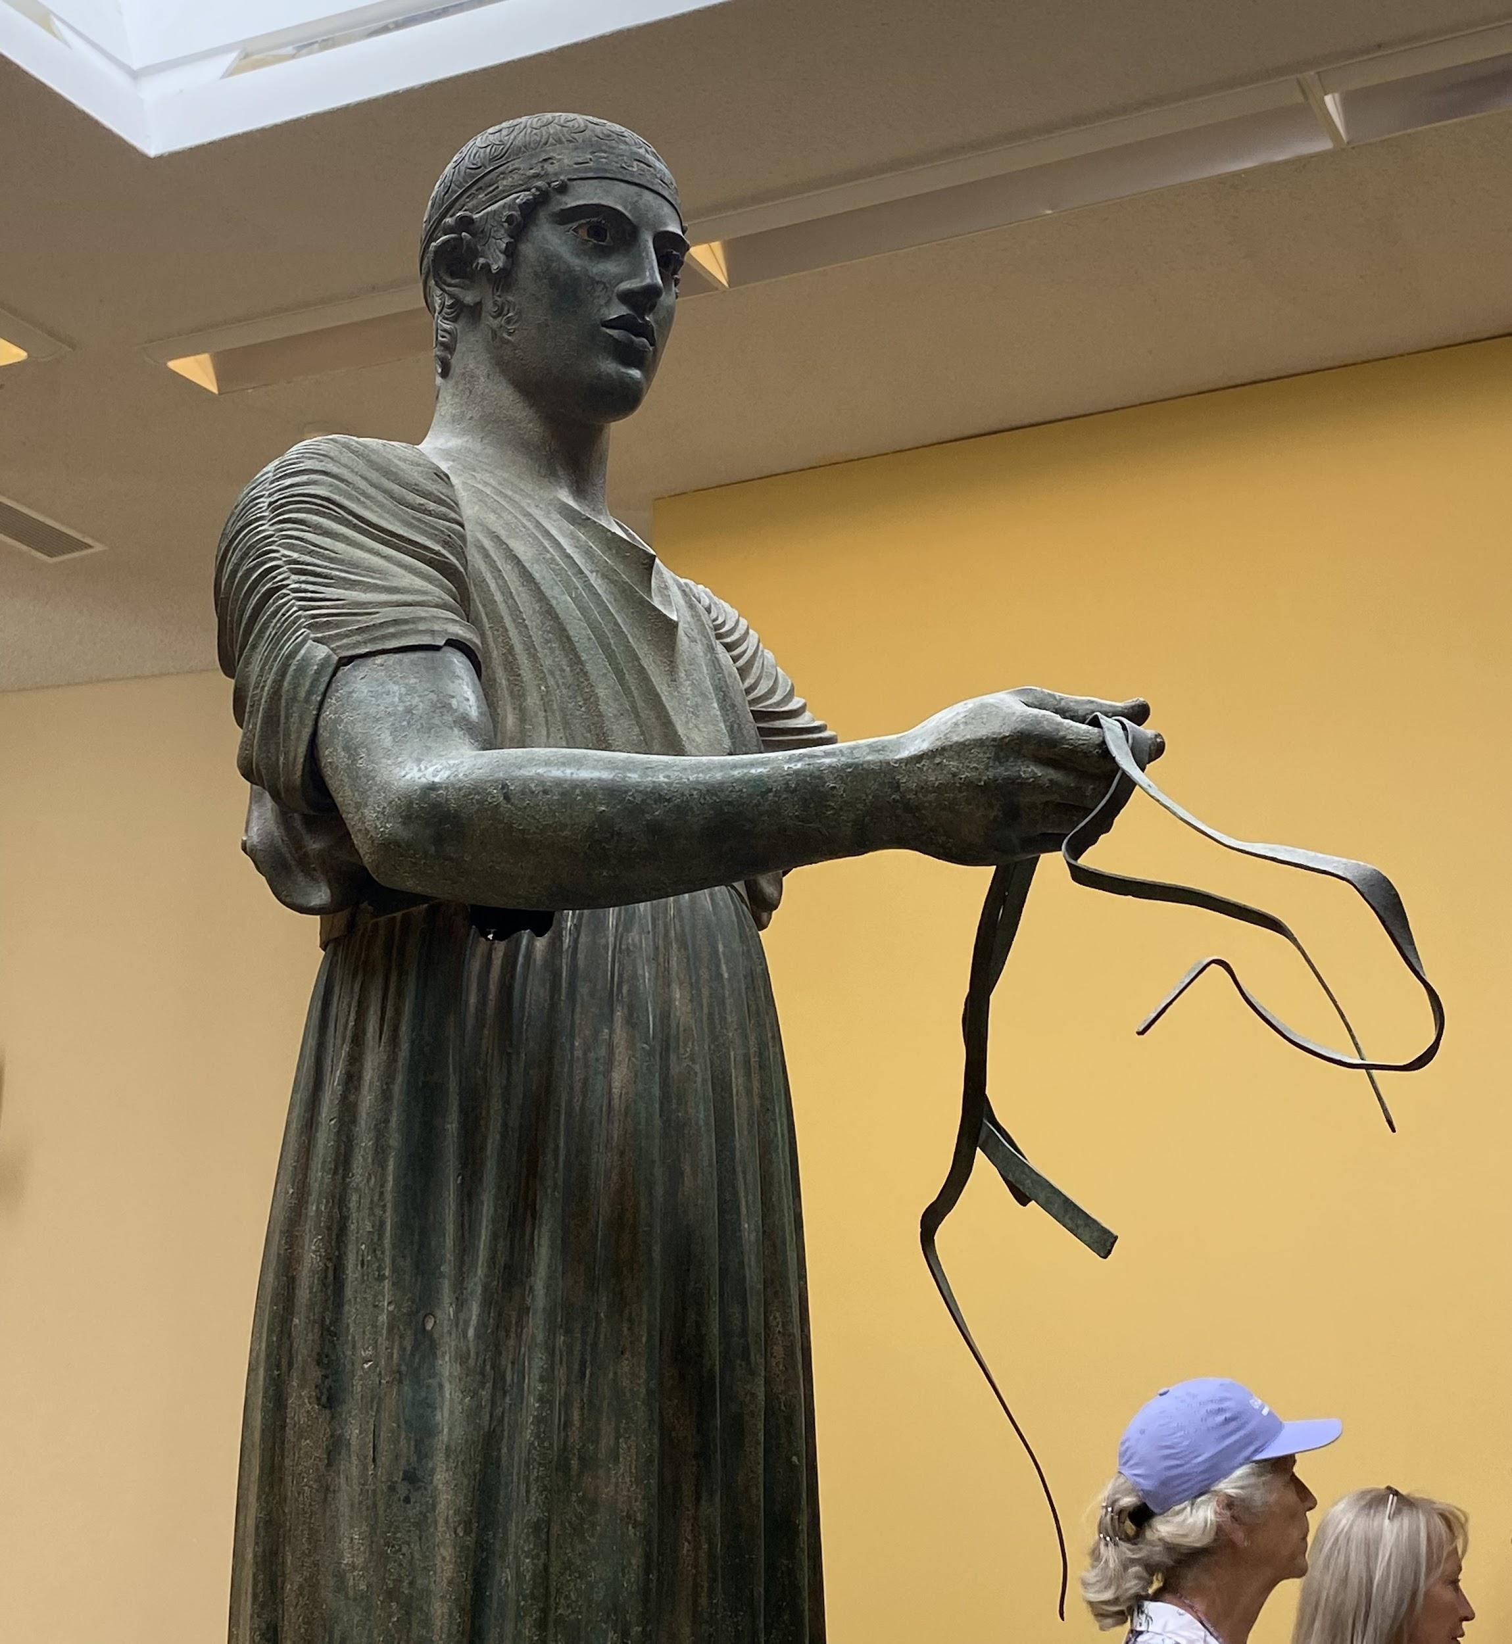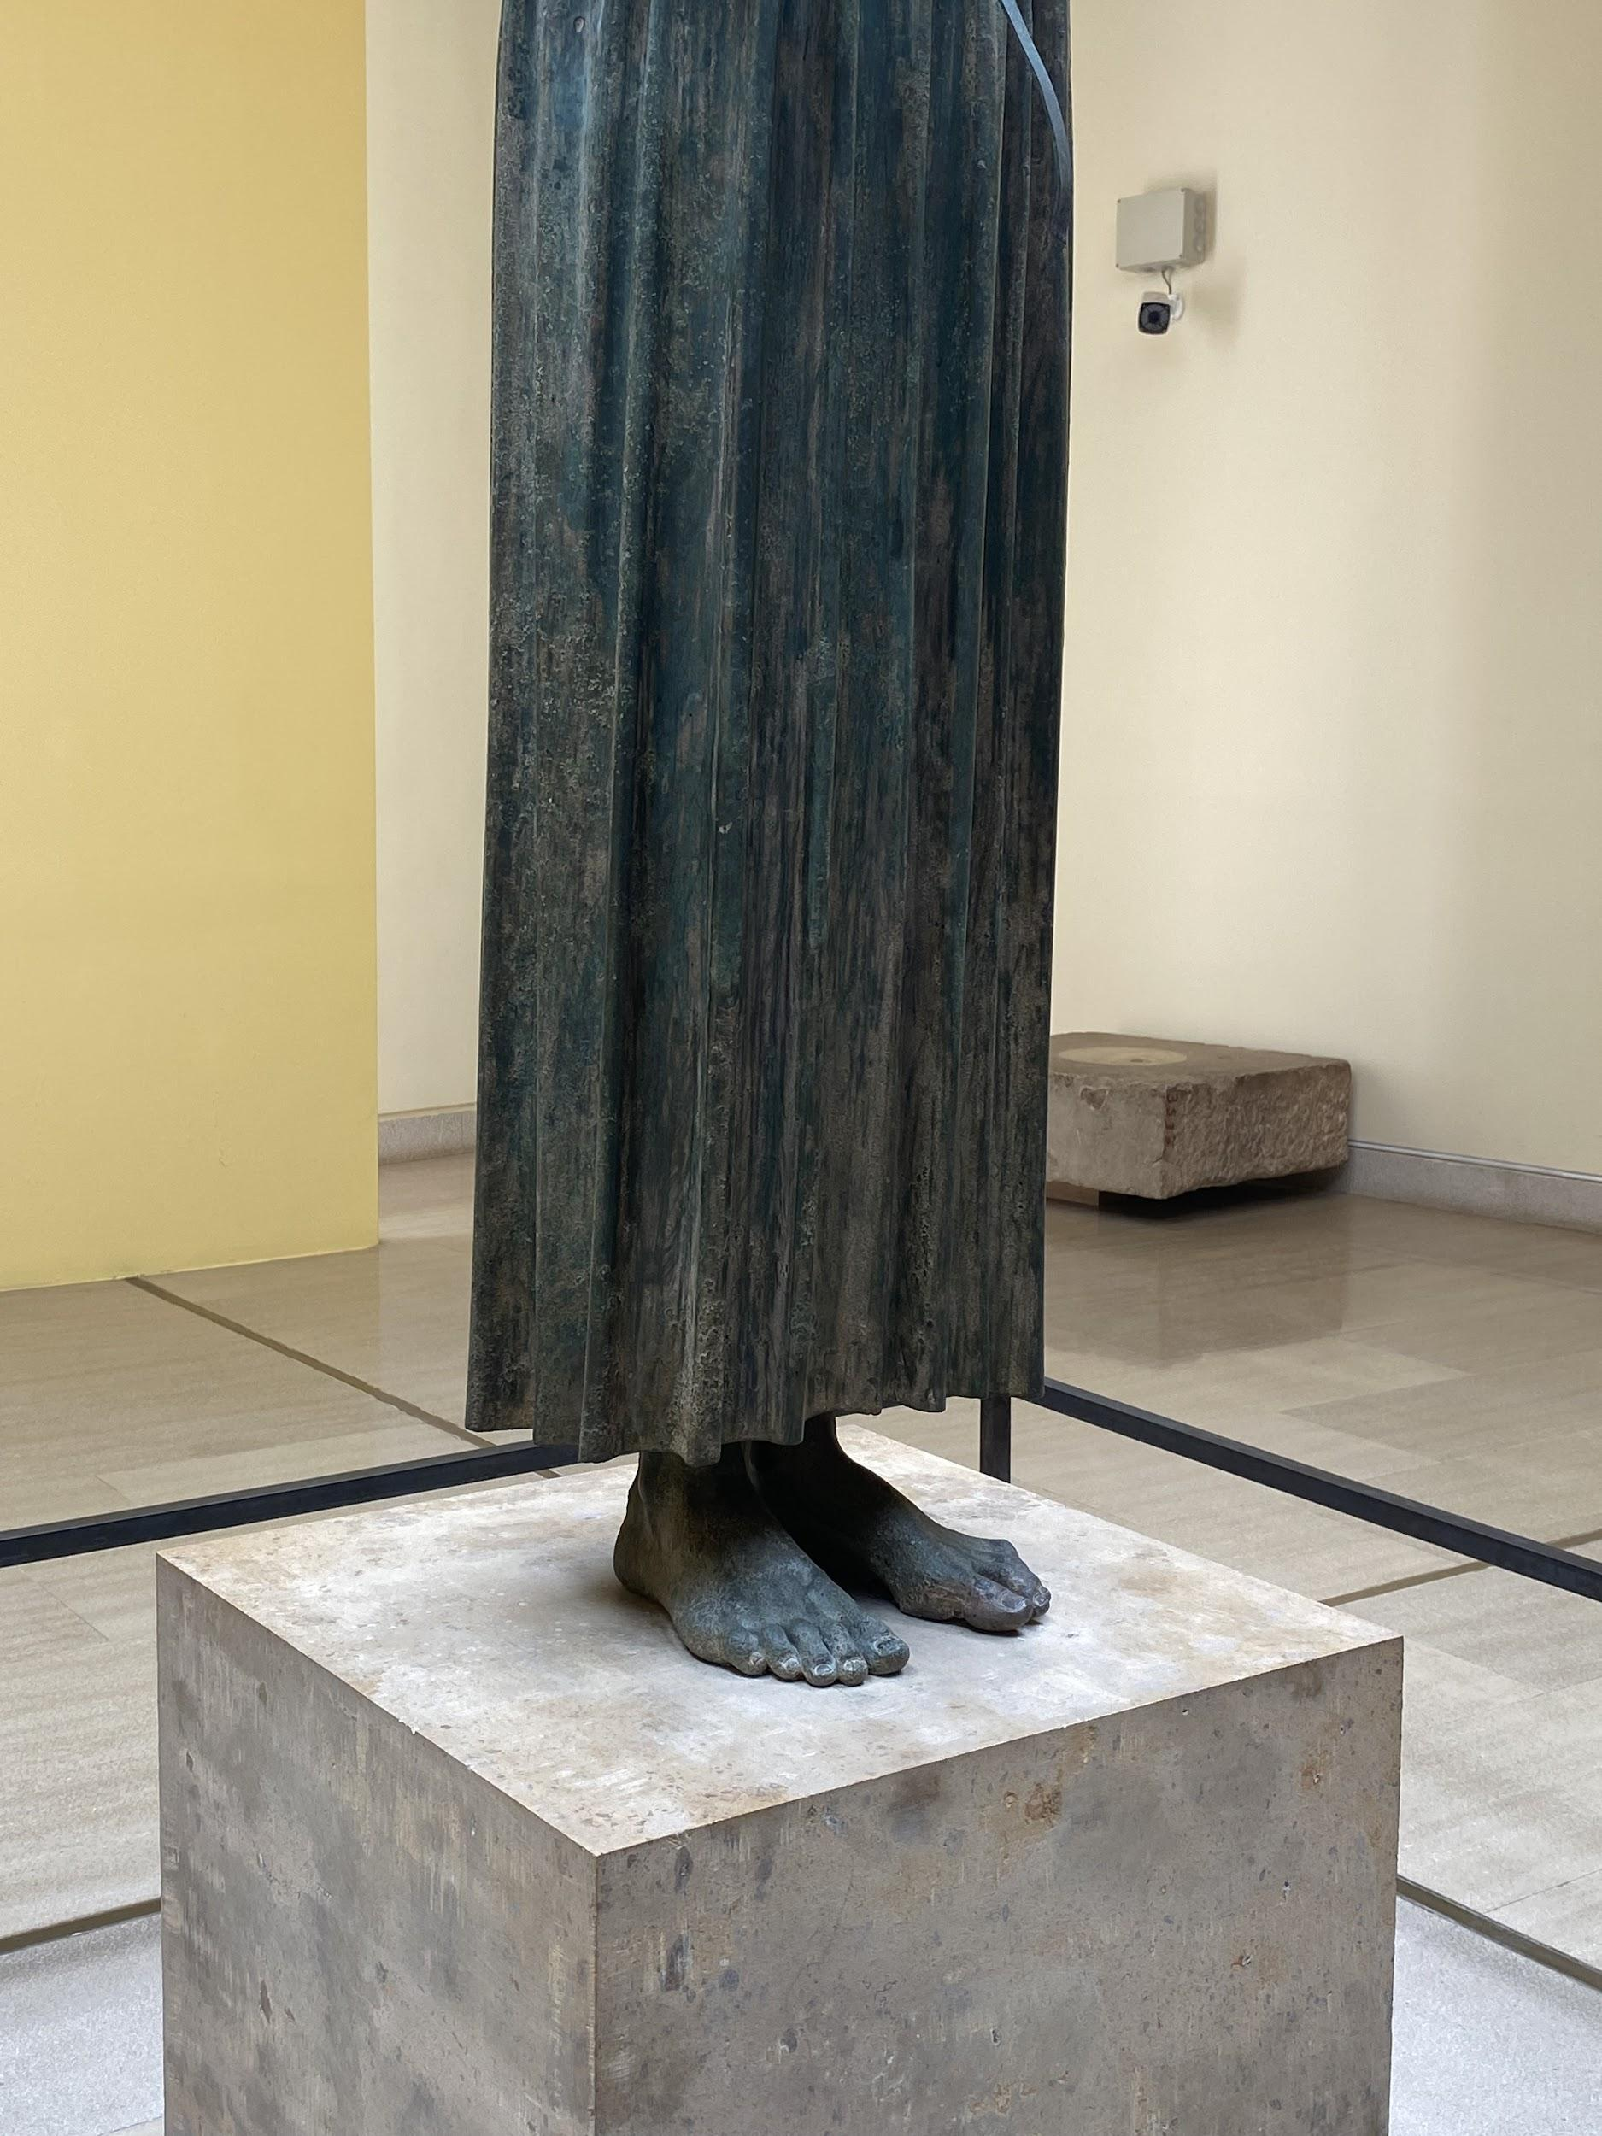
The Delphic Charioteer

In the afternoon, I stayed in my hotel. This was the Amalia Hotel, a 1960s brutalist building nestled into the hills. The view was incredible and I really like brutalist architecture so this was the perfect location for me. I spent my time reflecting on my day and reading on my balcony in the warmth. I could have spent ages just staring out at the mountains as they meet the sea that leads to the Gulf of Corinth. Before I left for Delphi, many had told me about its indescribable magic and sitting there made me realise exactly what they were talking about.

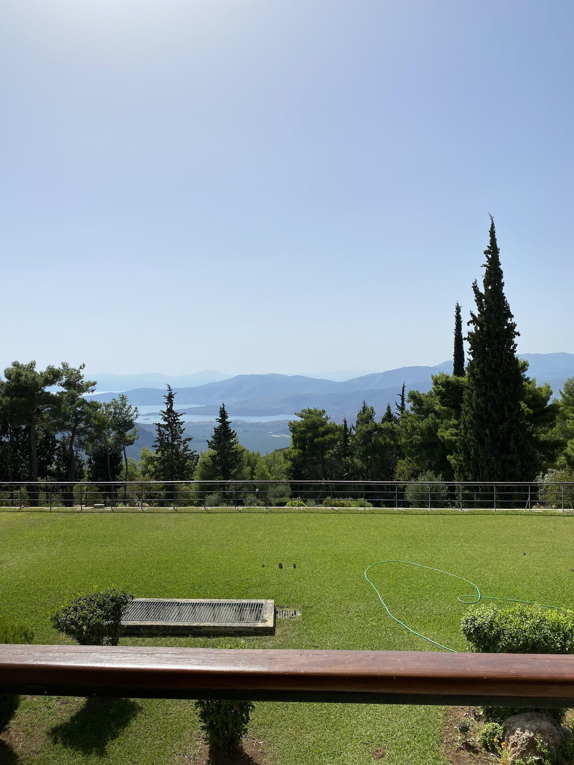
The view from my balcony

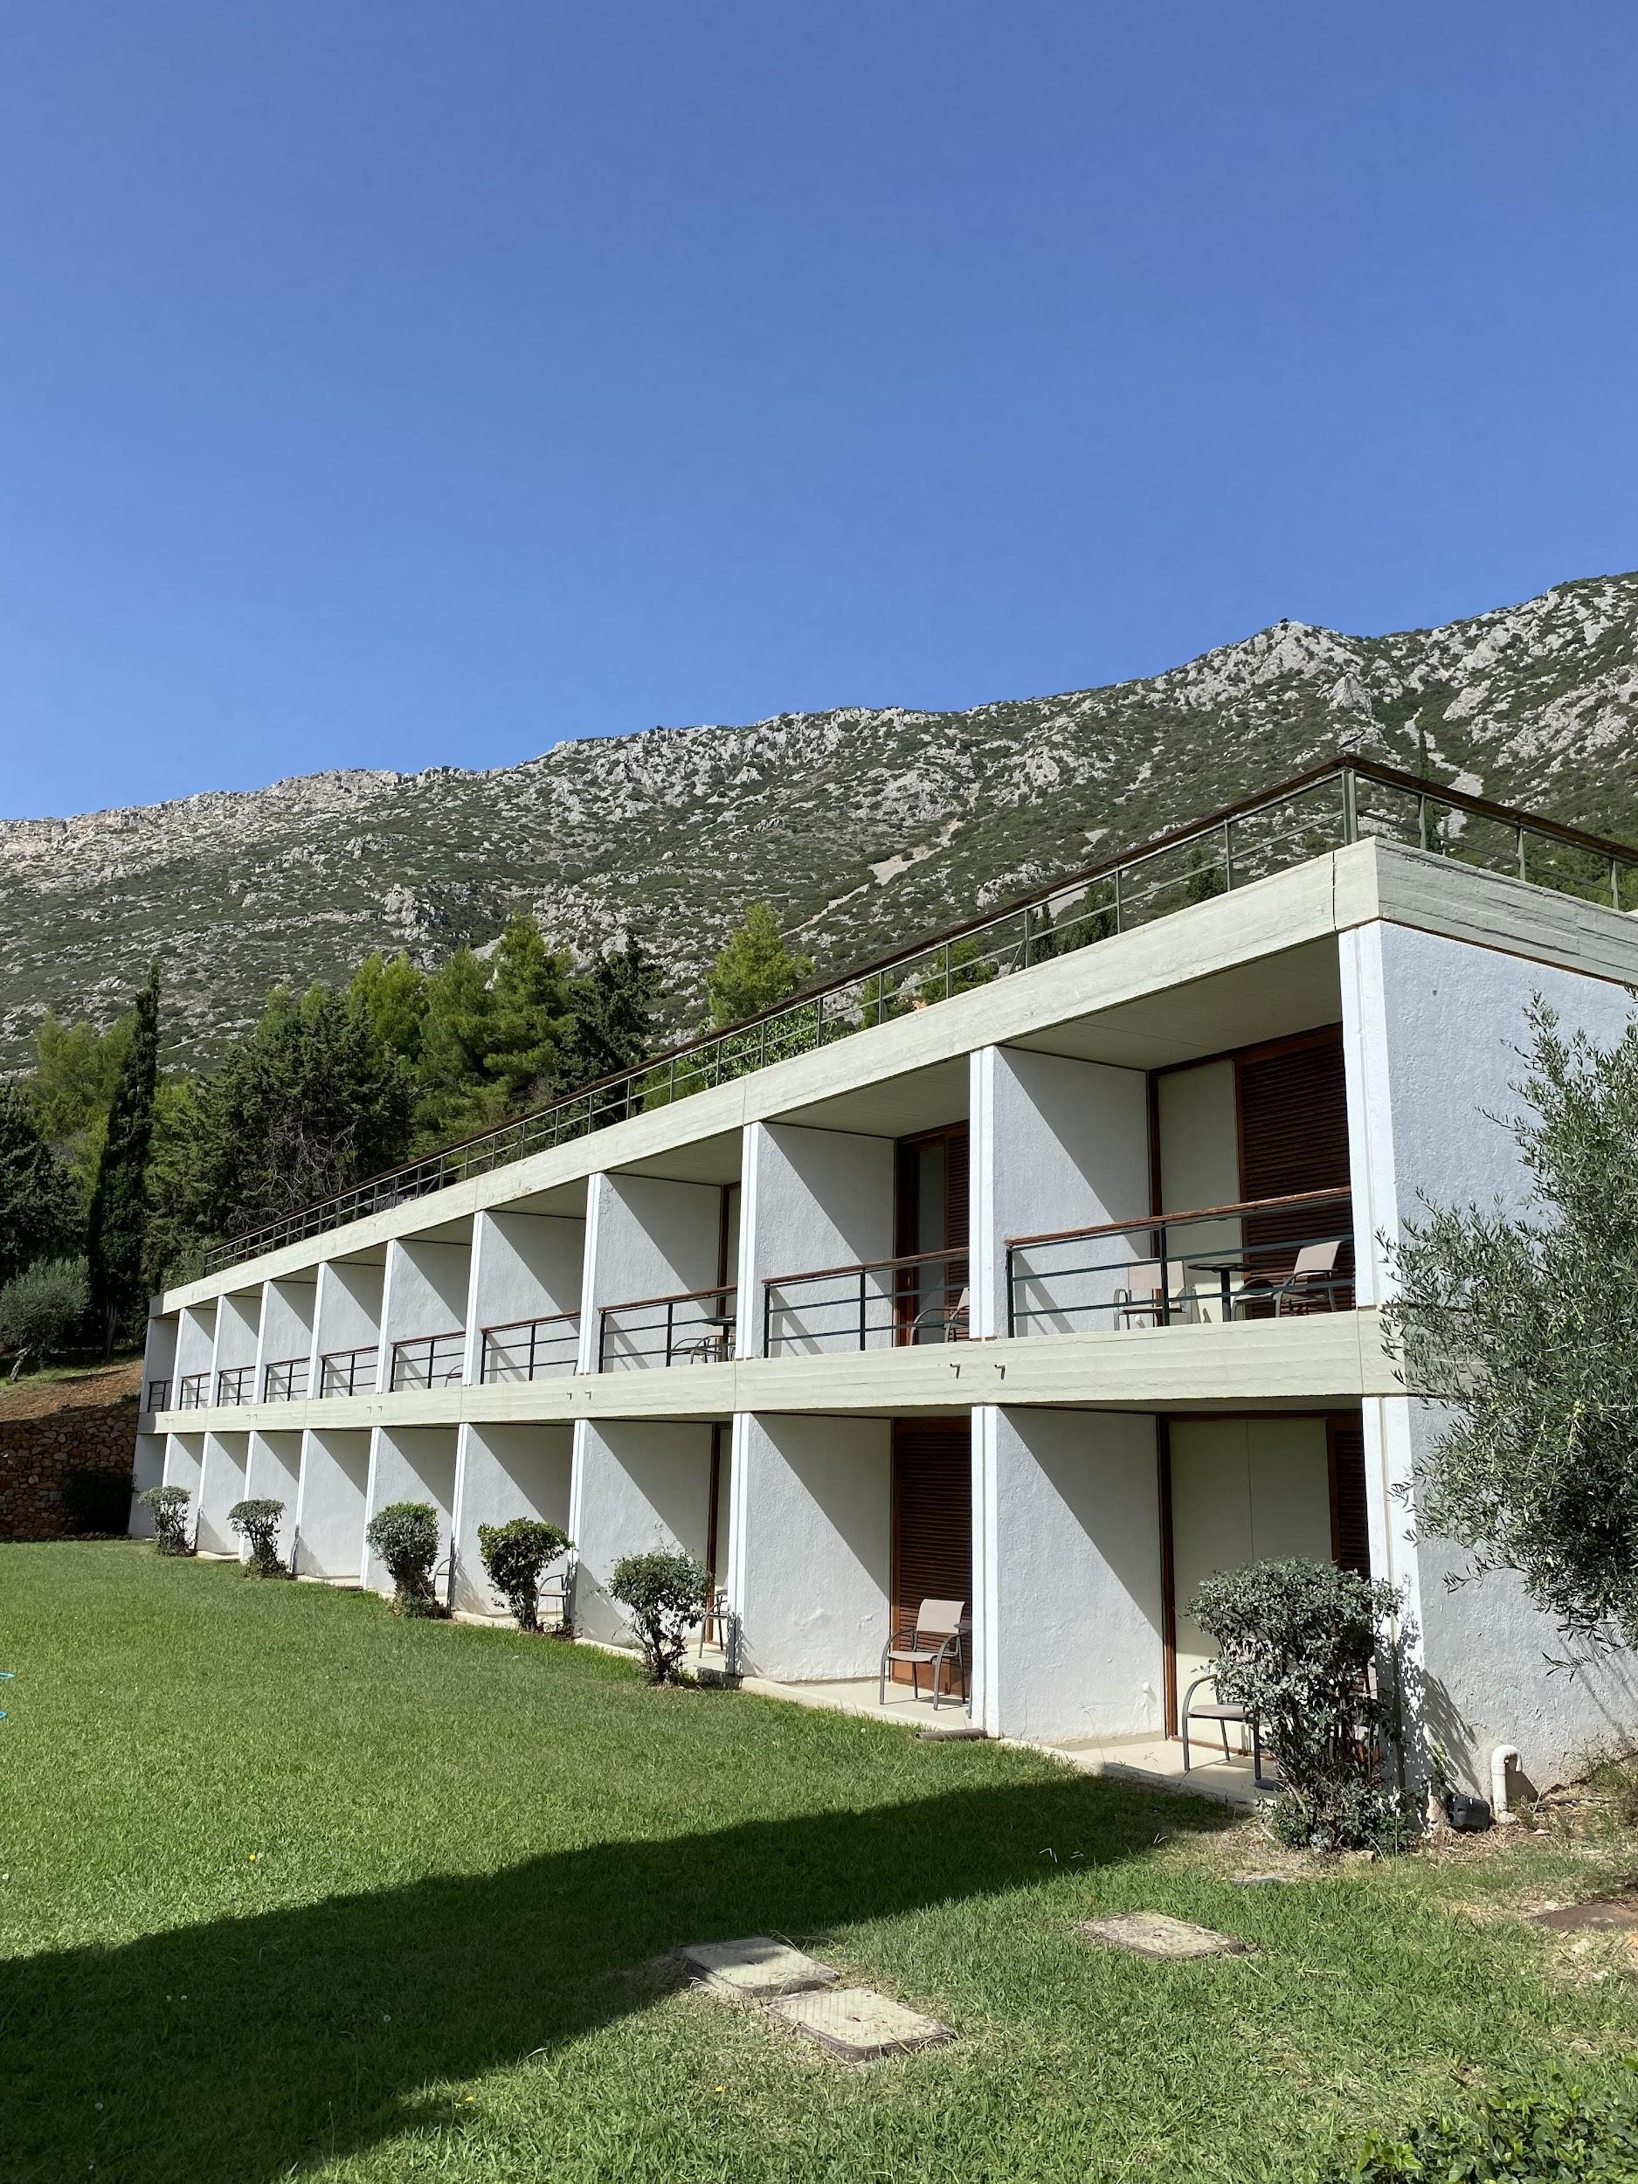
The hotel

Day 3 - Exploring Delphi and travelling back to Athens

Today started with another early morning to beat the heat and the crowds as I headed to the archeological sites and museums. I began my day with a beautiful walk along the mountainside from the hotel, through the modern village of Delphi, to the sanctuary of Apollo. The road was almost deserted, the light was absolutely stunning in the morning and I had a very clear view out to the sea.

When I arrived at the sanctuary of Apollo, I headed straight to the top to get a better view of the ancient stadium. I only had a chance to get a brief glimpse of this the day before but it played an important role in the Delphic Festivals and so I wanted to get a better look. One of the events of the Festivals was a reenactment of the Pythian games which involved a series of athletic contests. The stadium also hosted a performance of the Pyhrric dance, an ancient warrior dance which was re-created using soldiers from the Greek army and costumes modelled on armour in the Greek National Archeological Museum in Athens. The stadium is still quite well preserved and so you really get a sense of its great size as it hugs the mountainside.

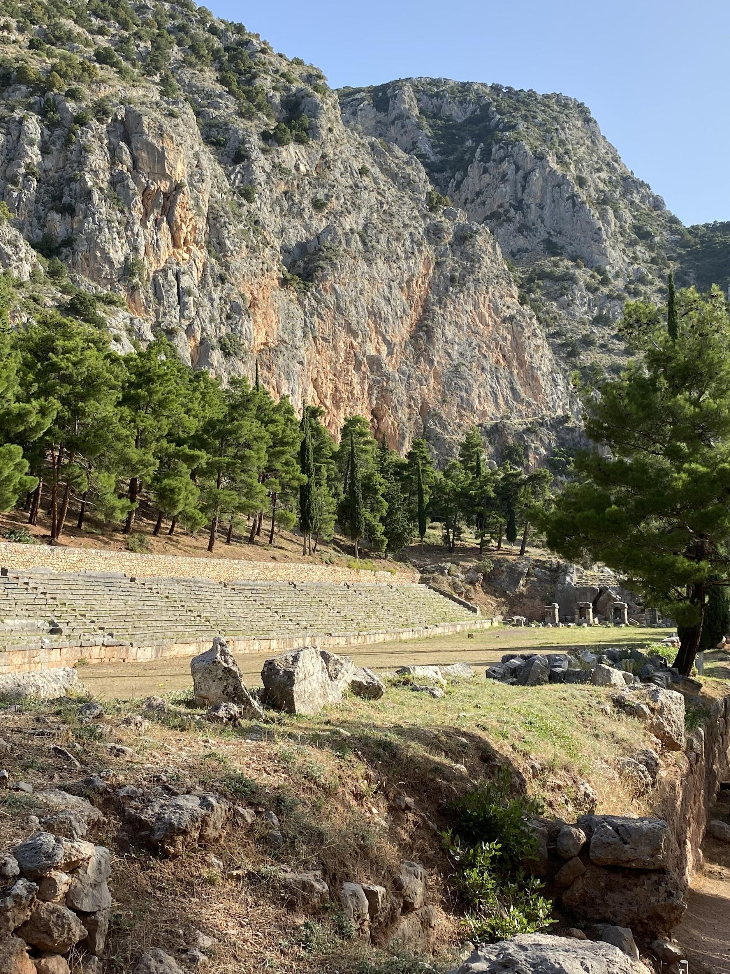
The stadium

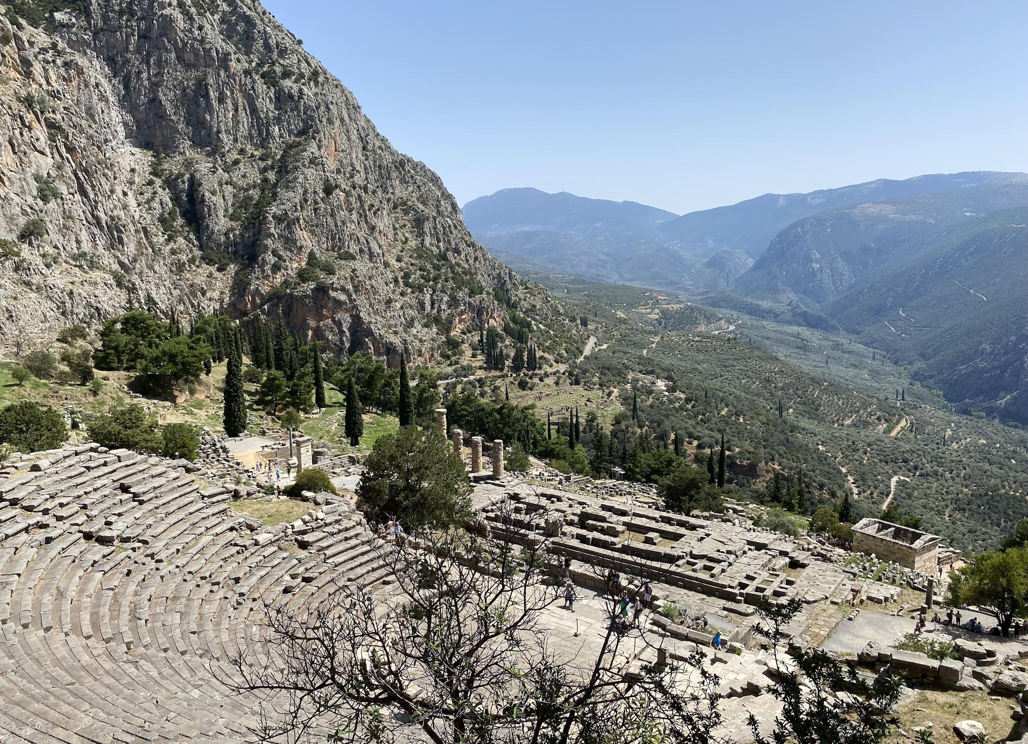
The ancient theatre, where the productions of the Delphic Festivals took place

I also spent quite a lot of time during this visit just walking leisurely around the site, absorbing the way the ruins sat within the surroundings. It was very spectacular to see the smooth and shapely cream and white marble up against the ragged cliffs some of which were mottled with an orangey, red colour due to oxidation. I think what surprised me the most was actually the size of the ancient theatre. Despite knowing better, my modern mind must have subconsciously become attuned to the huge stadiums we have today. However, its location within the centre of the sanctuary and looking onto the mountains meant its size did not detract from any sense of drama or grandeur. Indeed, I can imagine that the size would have created an intensity to the experience of watching a performance there.

In particular, the Delphic productions greatly exploited the dramatic potential of the orchestra since Palmer was fascinated by the ancient chorus. Again, the orchestra in the Delphic theatre was not large but I found it had a certain magnetism when you looked at the theatre from the top, just behind where the highest seats were (as you can’t actually walk on the stones of the theatre itself nowadays). In an essay by Gonda Van Steen (a KCL tutor whose module on the intercollegiate MA actually introduced me to the Delphic Festivals), the circle is emphasised as a focal point both materially and metaphorically in Palmer’s work for the Festivals. It was therefore really exciting to see this, and Delphi’s ancient nickname of the ‘bellybutton’ of the world, came to life very effectively.

I then walked about ten minutes from the sanctuary of Apollo further round the cliff to the temple of Athena Pronaios and the gymnasium, passing the spring of Kastalia (where the sanctuaries’ visitors would wash themselves before entering). I hadn’t been able to visit this archeological site the day before and so I was very happy to have some time to myself to see it. The Athena Pronaios, named as such because it was the temple before the temple to Poseidon on that site, is a splendid example of a rare form of ancient architecture - the tholos (a round temple). After thinking about circles in the ancient theatre, this felt like it lead on very nicely. It was also interesting to see the landscape from a different perspective as the temple is lower than the sanctuary of Apollo, and so closer to the valley below, creating a more intimate, quiet atmosphere. You can therefore see how it would have helped build up the sense of drama as visitors would have stopped here before they continued on to the main sanctuary.

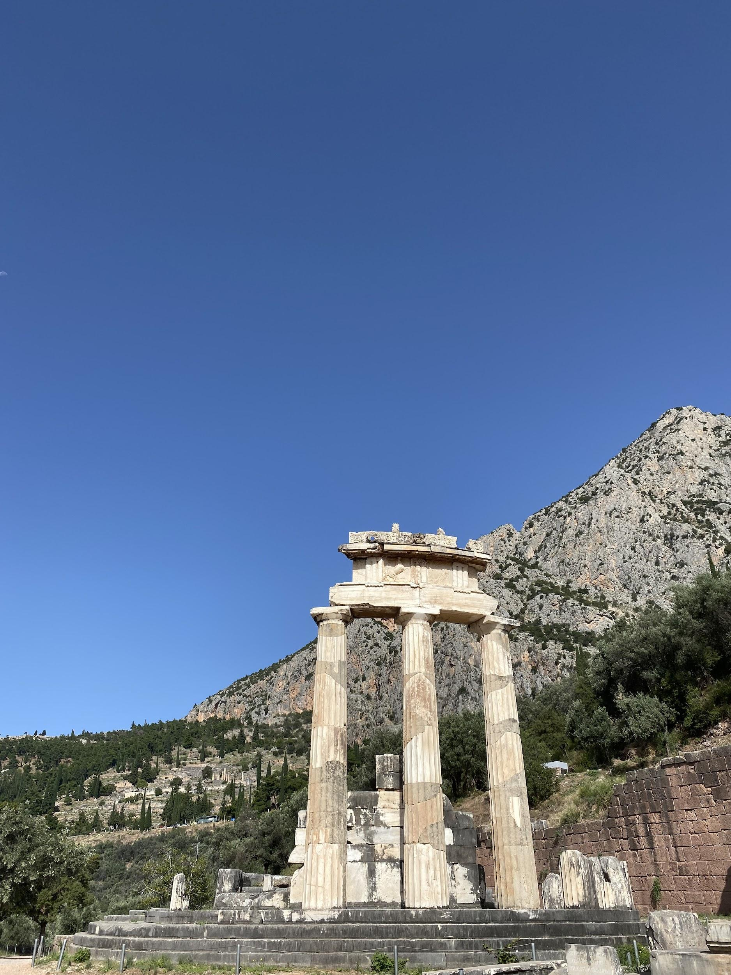
The remains of the temple of Athena Pronaios

I then stopped quickly in the archeological museum to have another look at the chryselephantine statues which I hadn’t been able to see in much detail the day before. I then continued my day by heading to the Museum of the Delphi Festivals in the modern village of Delphi. This may have been the highest point that I reached during my trip as the museum sits on the mountainside, at the uppermost point of the village. The museum is housed in the house that Angelos and Eva used to live in when they were at Delphi. This is a beautiful 19th century building with unusual arches and a lovely spiral staircase on the outside. It also has very pretty gardens around the outside (where you can see sculptures and reliefs of the couple) which was good for resting in after the hike up there. The museum itself was so amazing to see because again the ideas and evidence that I had been discussing in my dissertation were now right in front of me. Unsurprisingly, I also had the museum all to myself which was very welcome after the crowds of the previous day.

The museum has an excellent website and has digitised a great deal of its content and so some photographs and objects were familiar to me. However, there were many new finds to discover. For example, the Byzantine style organ that Palmer had commissioned for the Festivals’ composer, photos from the performance of the Suppliant Women and photos of the traditional costumes displayed at the craft fair. The fact that the museum was in the couples’ house was also really interesting. Its amazing views over the sea and the mountains again made me feel like I came some way in further understanding their infatuation with Delphi. I was also lucky enough to pick up some postcards of the images used in the Festivals’ promotional material when I was exploring the modern village. I then spent the next few hours getting some refreshments and souvenirs and then swimming at the hotel as I was being picked up at 3pm to get the coach back to Athens. By the time we’d got back to the capital it was time for a quick dinner on the rooftop terrace of my hotel (with a view of the Acropolis!) and an early night.

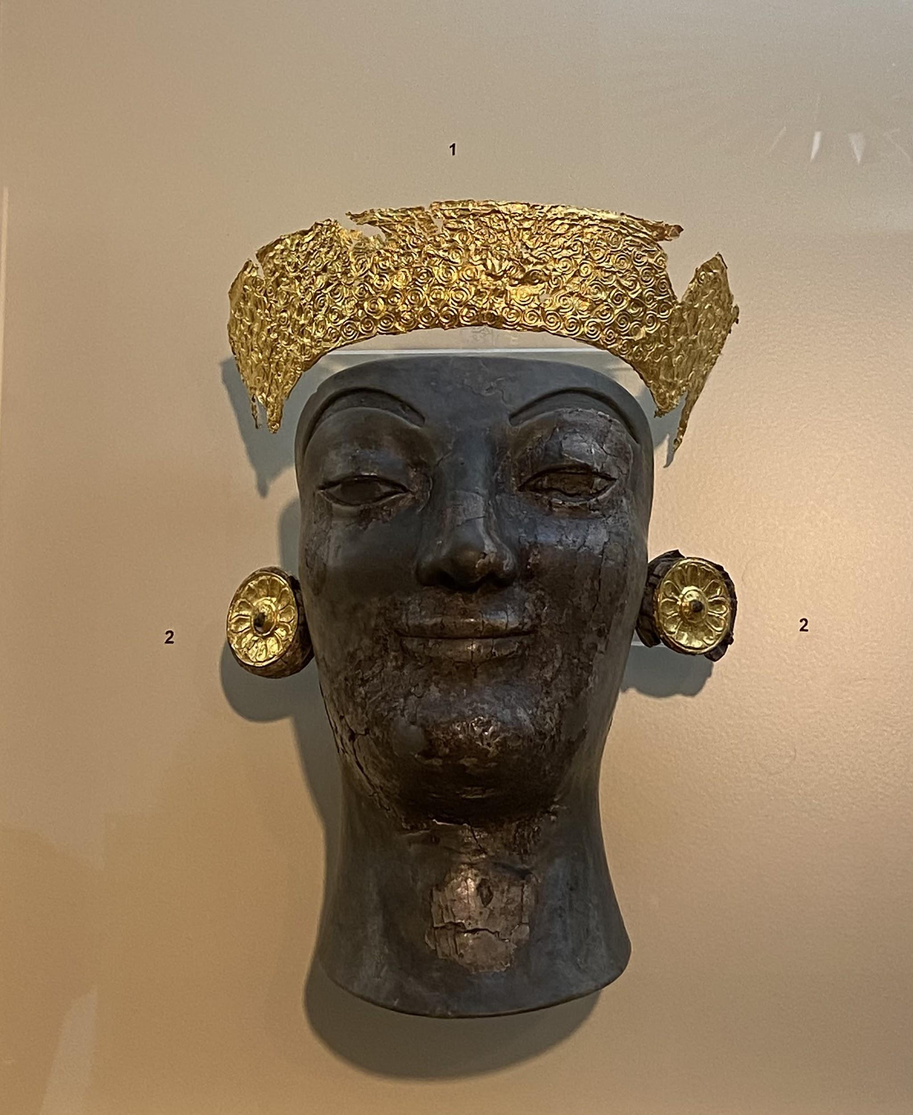
The remains of the chryselephantine statues

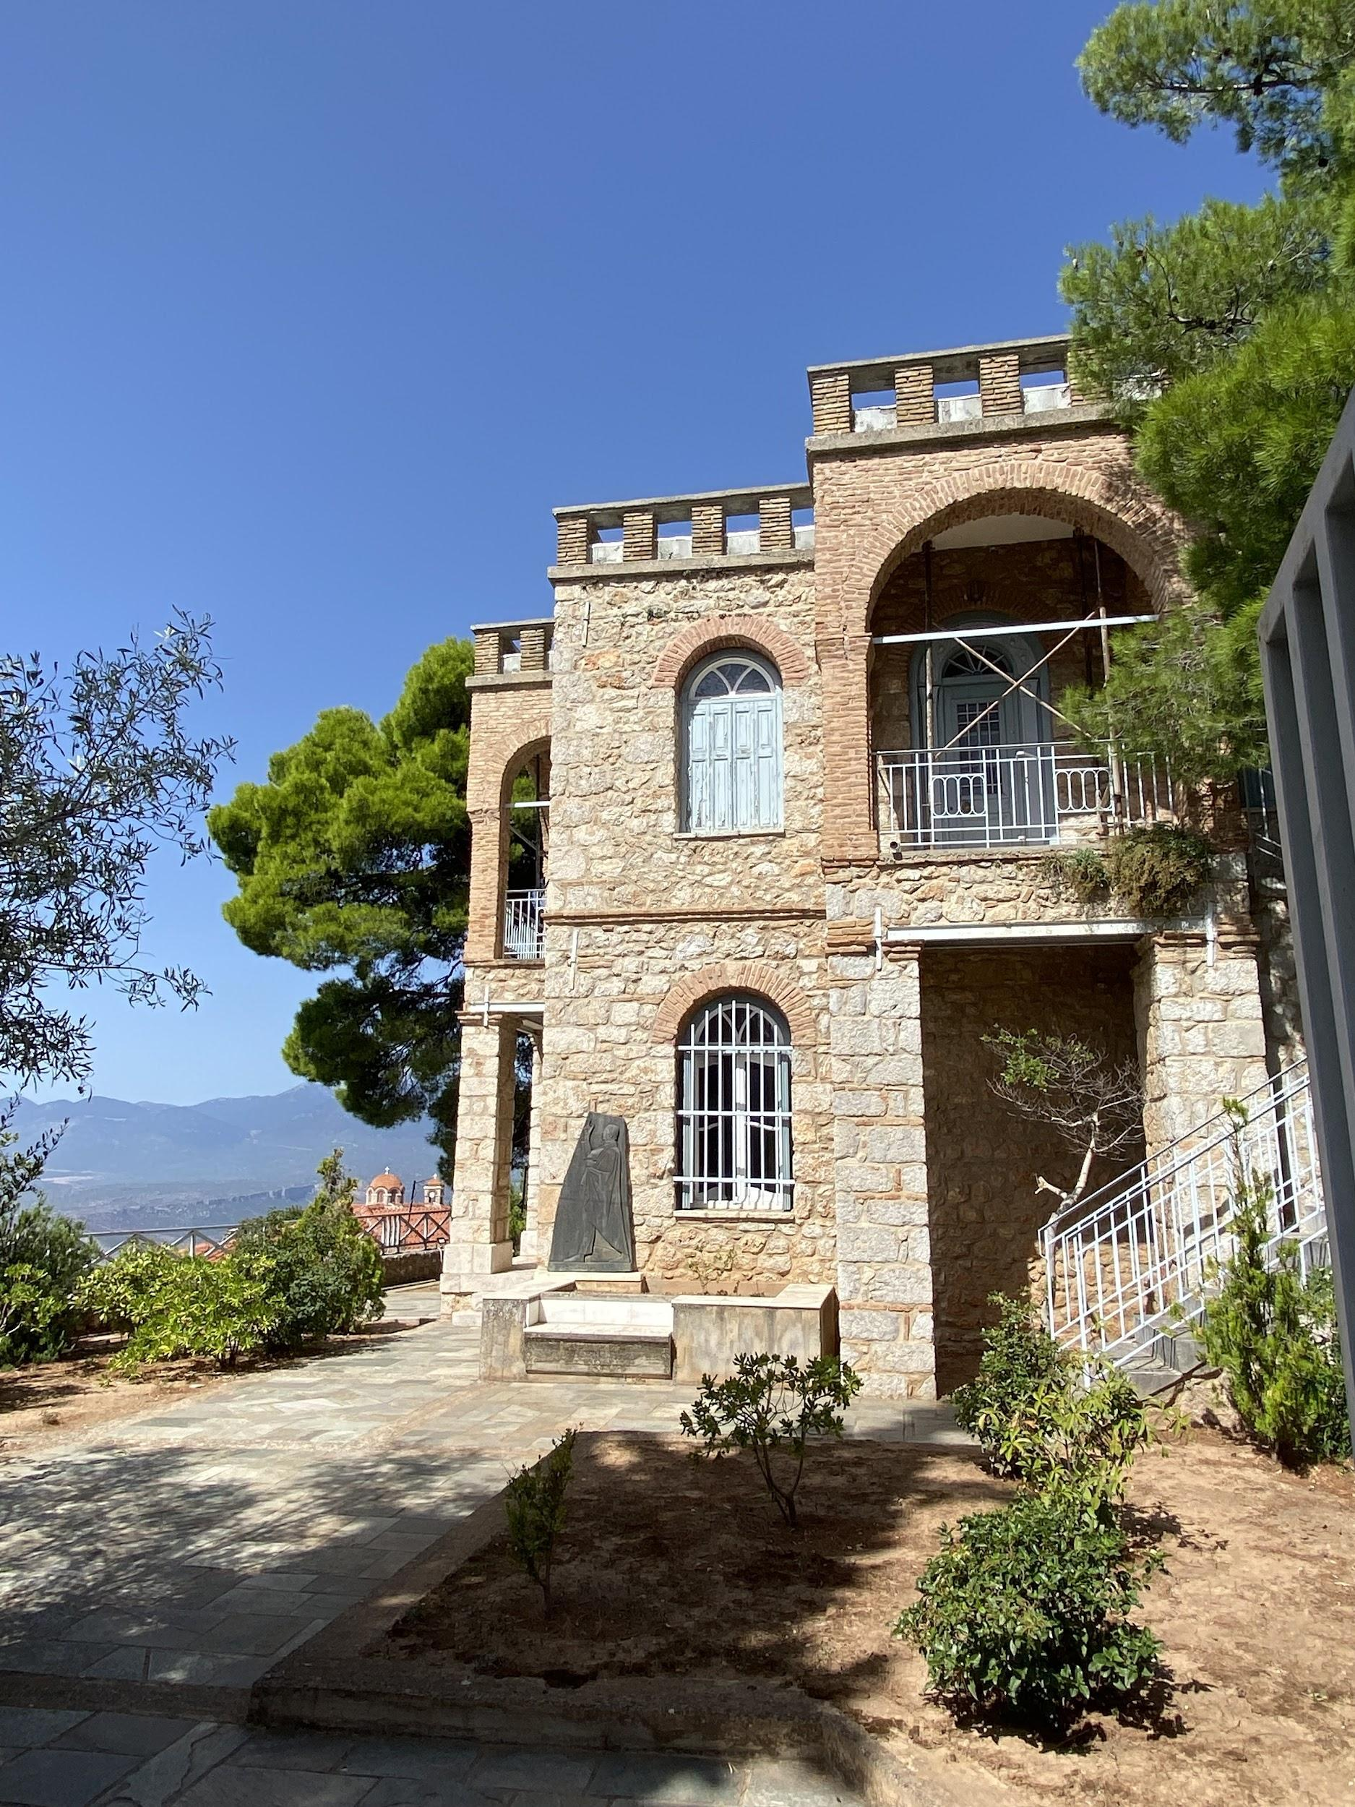
The museum of the Delphic Festivals; exterior, garden and view from the hallway

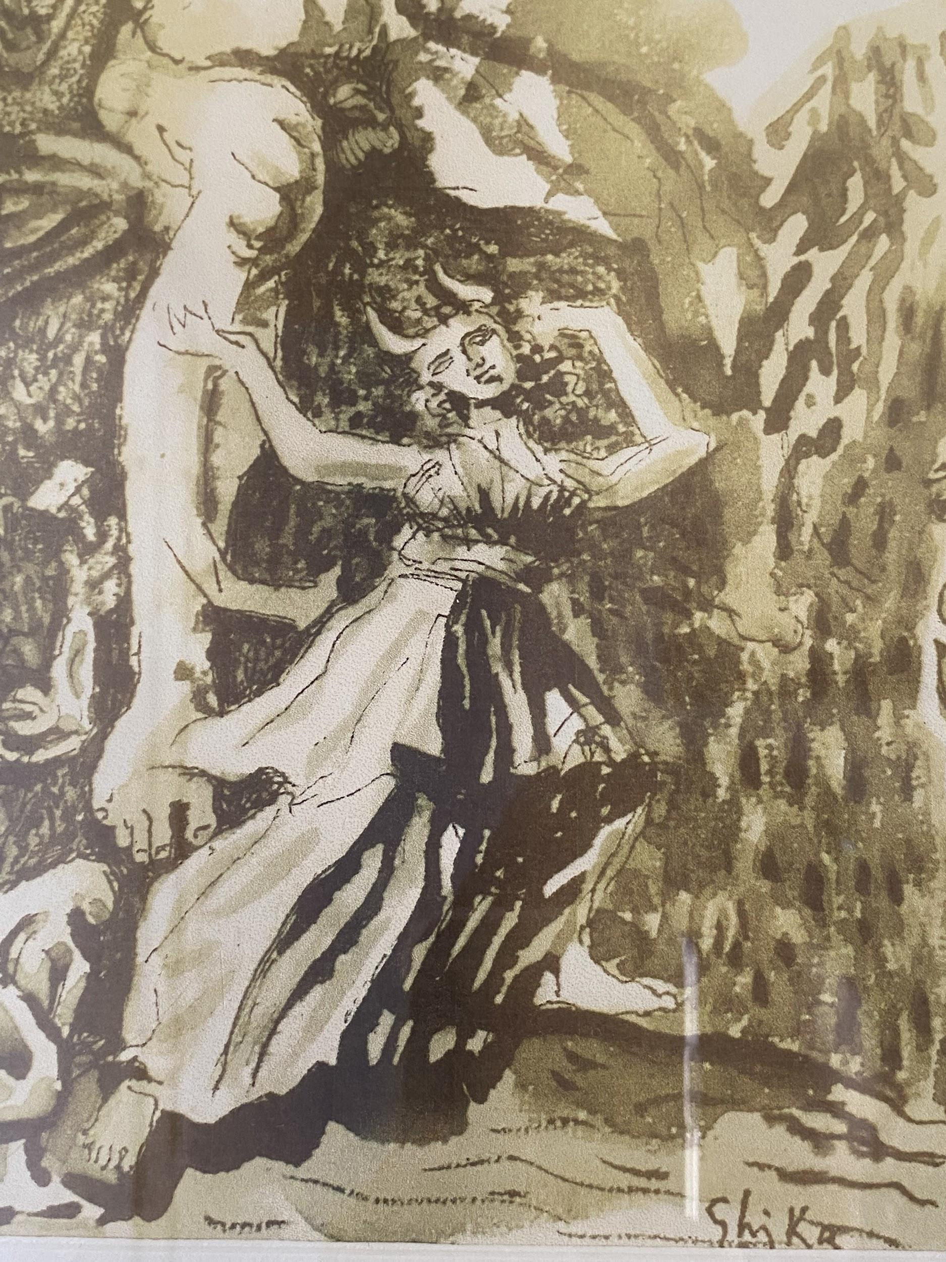
Closeup of Io (one of the characters in Prometheus Bound which was performed at Festivals) in a painting by Ghika, inspired by the Festivals

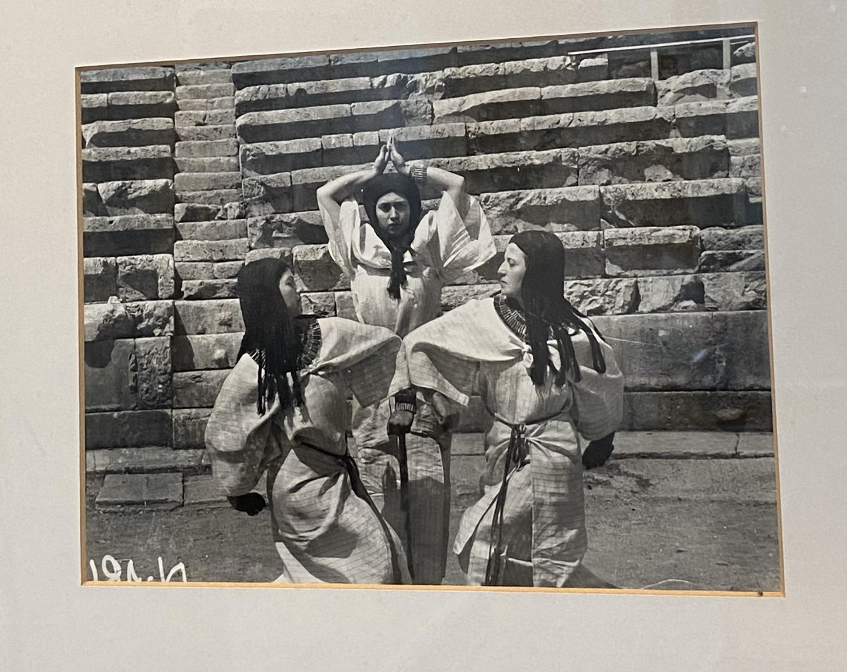
Photographs of the Danaids in the performance of the Suppliant Women at the 1930 Festival

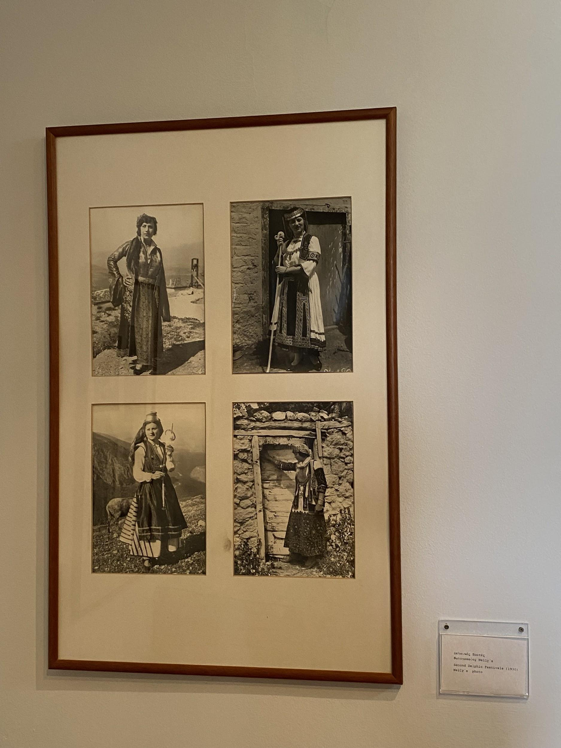
Photos of traditional Greek costume from the participants of the craft fair

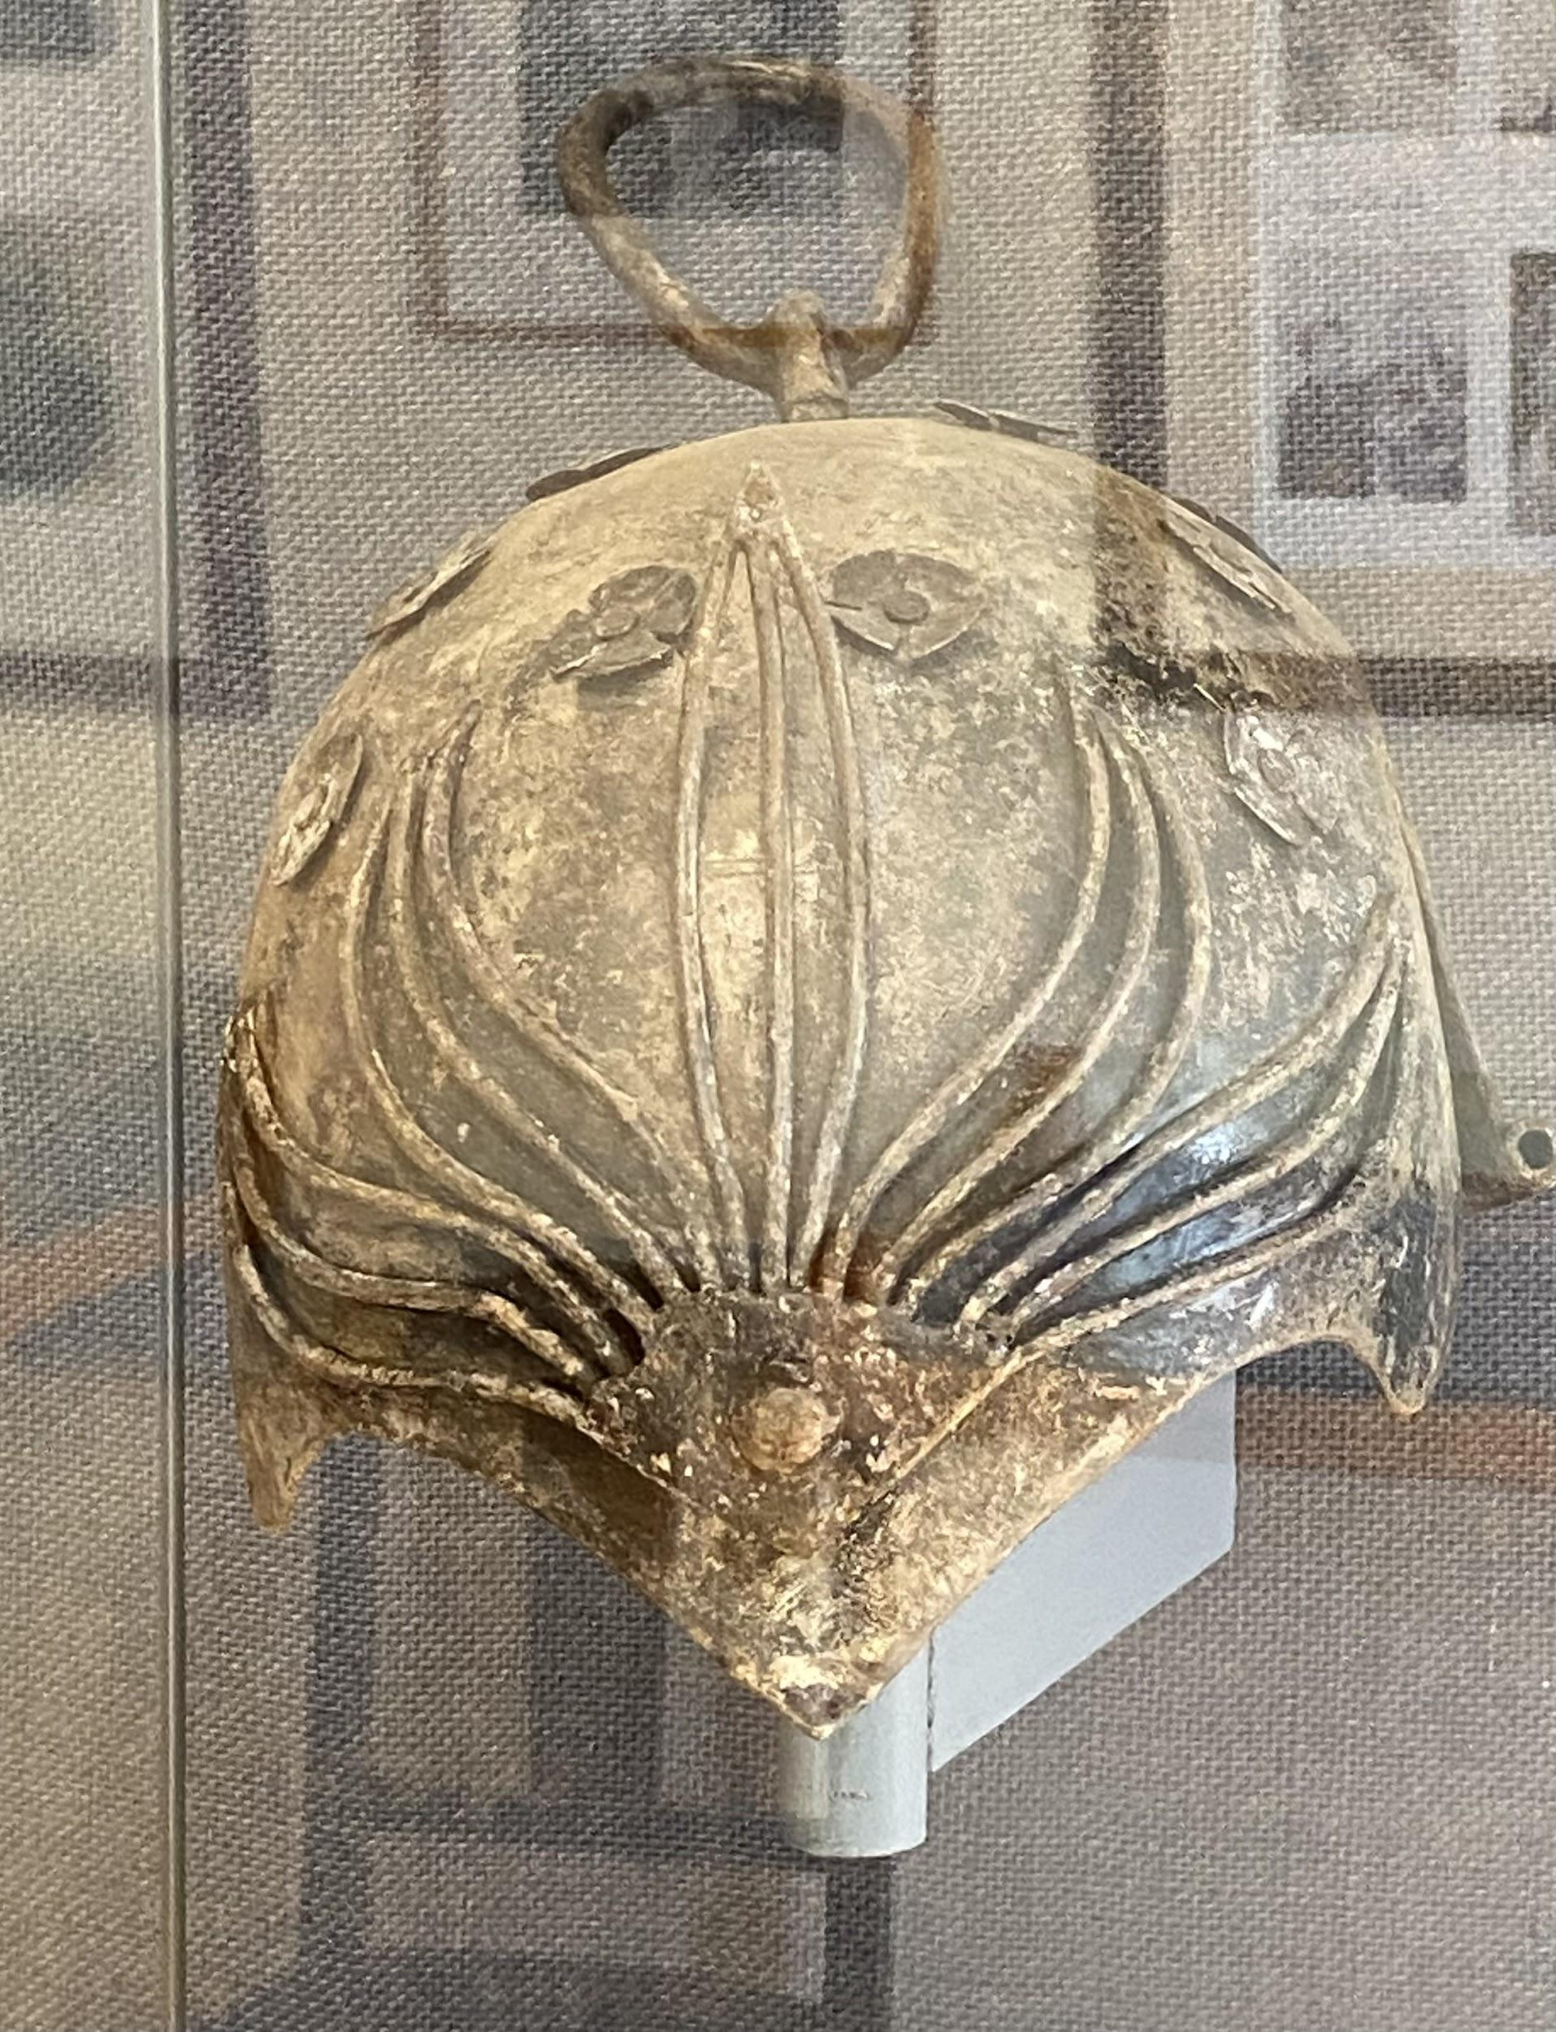
Costume helmet for the Pyhrric dance

Day 4 - Full day in Athens

Today was my only full day in Athens and so I naturally wanted to pack as much in as possible. I was informed by some members of the tour that it was best to get to the Acropolis when it opened (8am), in order to beat the sun and the crowds. Mission accomplished, I was walking up to the Acropolis, after a very short queue, at 8.15am! I was so glad I did this as, like in Delphi, I got the beautiful morning light. I’m definitely not the first to say this but I was blown away by the light in Greece, especially as it hit the marble of the Acropolis buildings. Not even the tourists with their selfie sticks and the attendants telling you not to touch the marble can take away from the sense of awe and grandeur I felt walking through the Propylaea

It was also very exciting to see the Erechtheum since I have quite a personal connection with this building. In July this year, I staged an experimental performance inspired by the myth of Hecuba at the Crypt Gallery, Euston. The architecture for the porches on the east and west side of the church, where you enter the Gallery, copies the Caryatids on the Erechtheum. The architecture played an important role in the inspiration for the writing and set design for the performance and so it was very exciting to see the actual ancient temple itself.

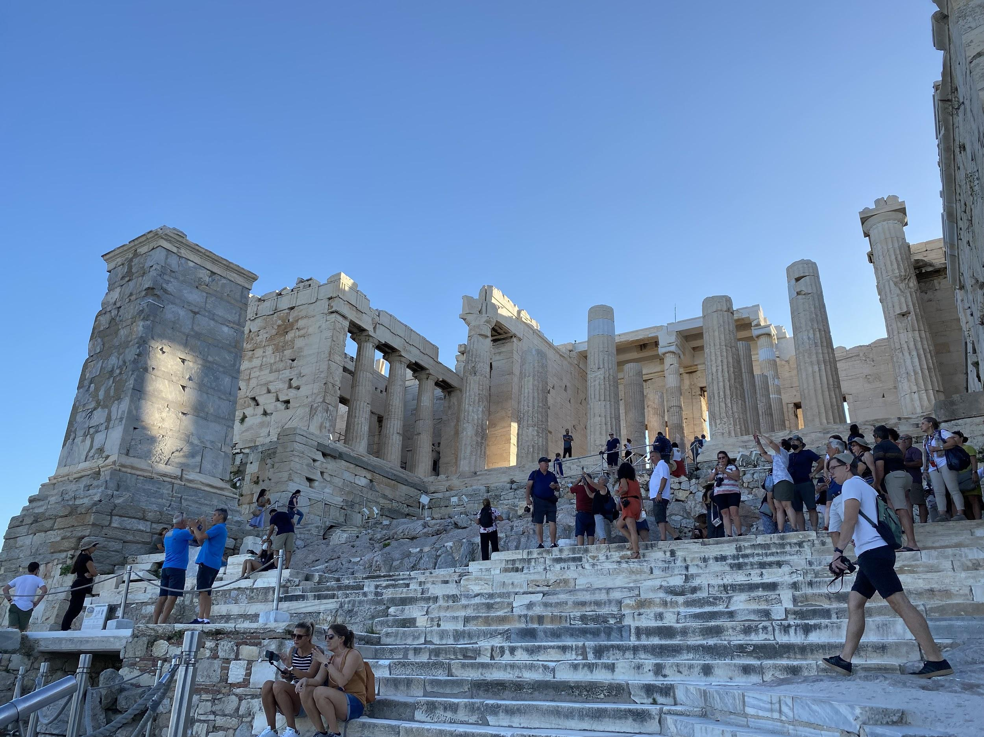
The Propylea

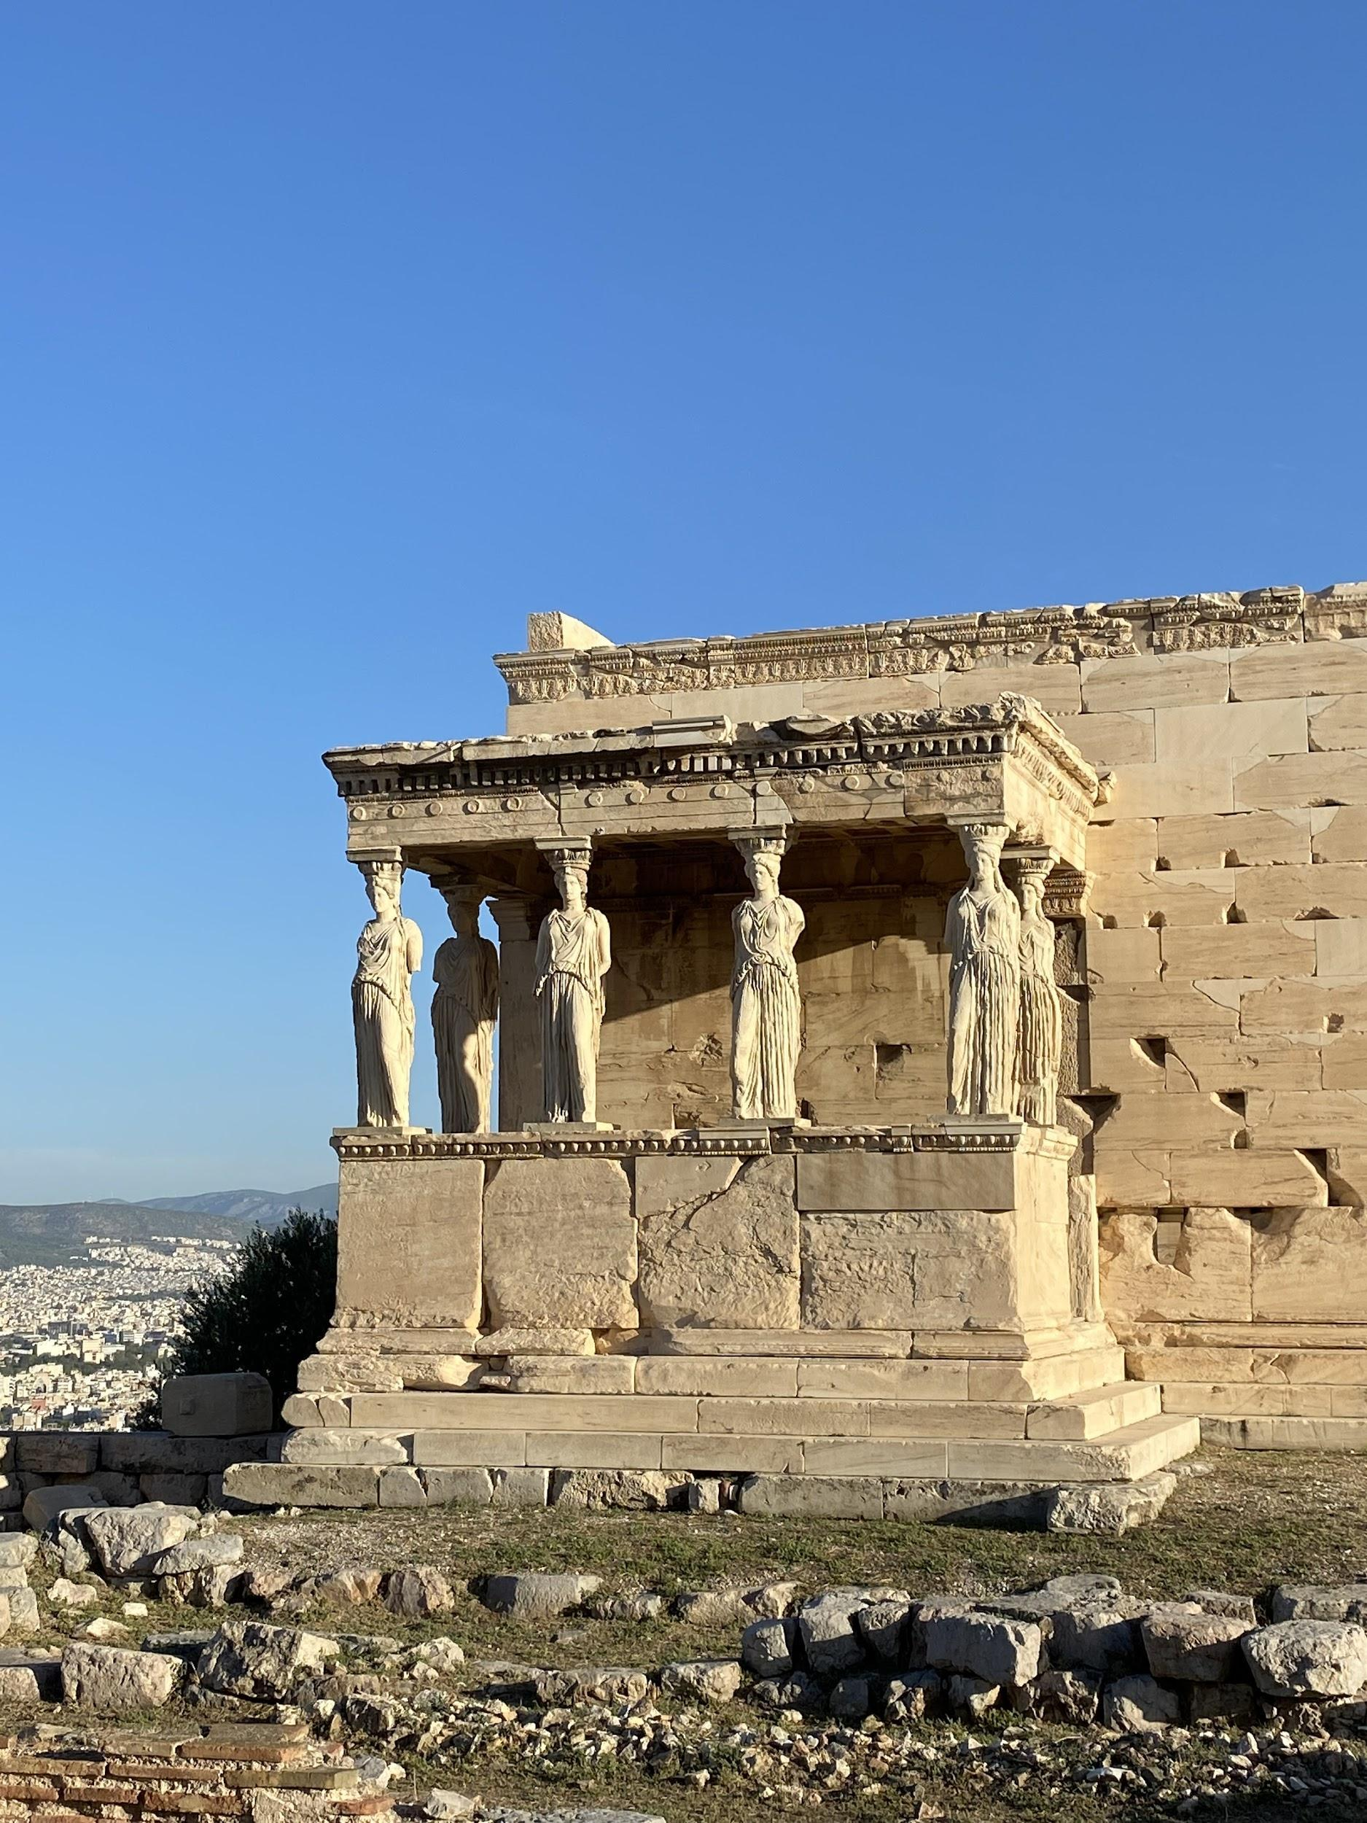
The Erechtheum

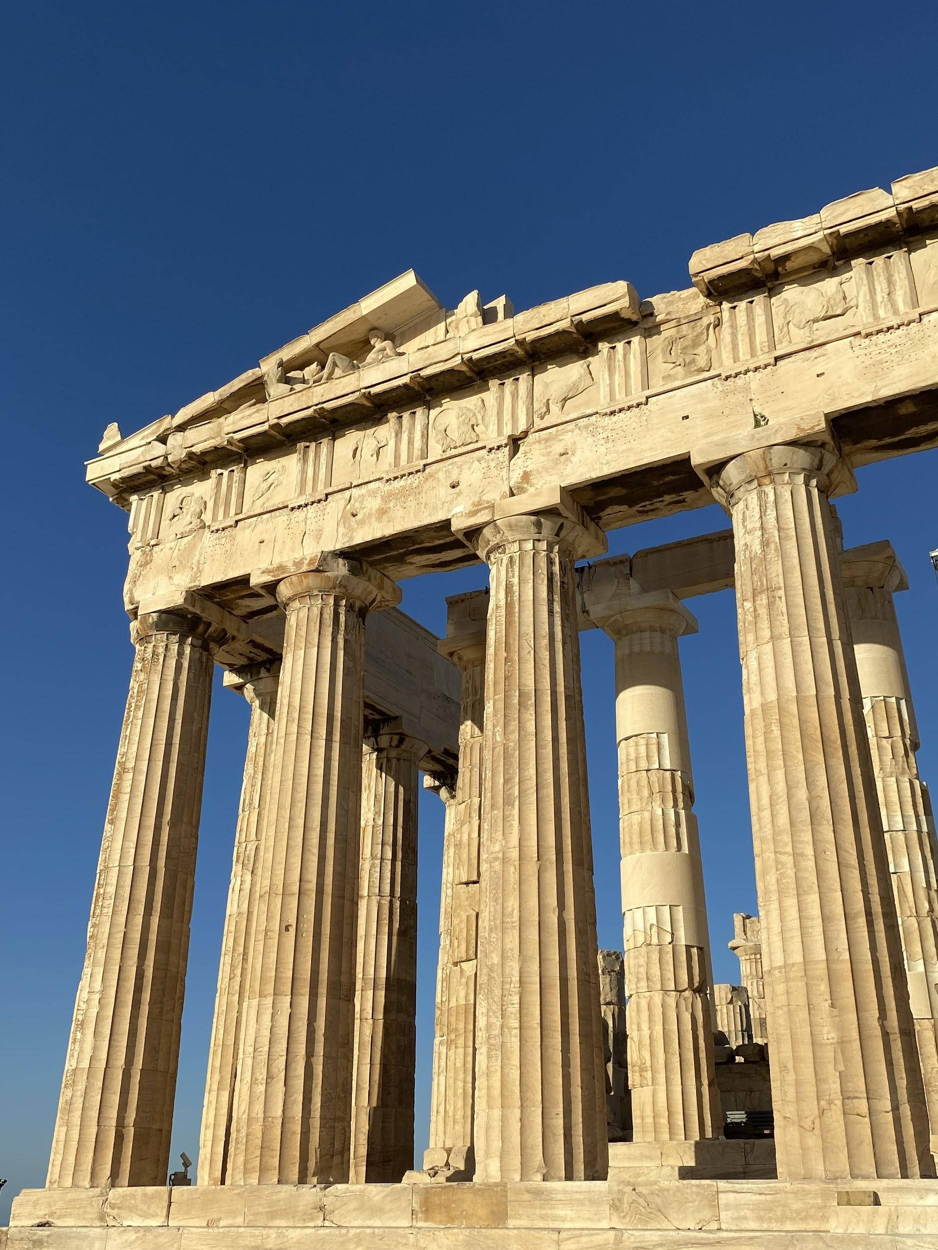
The Parthenon

Although I’ve always been in favour of the repatriation of the Parthenon frieze, seeing the building on the Acropolis gave a more emotional dimension to my engagement with the debate. Whether it was being surrounded by the buzz of modern Athens and hearing the way Greeks relate to their ancient past, the summer light or the physical location high up on the land overlooking the sea, there is no doubt that the sculptures cannot be experienced with the same richness in a London museum.

However, this is not to say that museums don’t have their place in our experience of ancient sites. The new Acropolis museum, my next stop, was a prime example of how enriching and powerful museums can be. I was amazed by the new renovation which has made it a place to go and admire both modern and ancient architecture. The museum is light and airy, making you feel less and less like you’re in a museum but rather outside in the open air, mirroring the way many of the artefacts would initially have been seen. I particularly enjoyed seeing examples of statuary with the remains of the polychromy and learning more about the pigments that were used. The Acropolis viewing gallery is excellently done with floor to ceiling glass walls allowing you to look straight across to the Acropolis on one side while, on the other, you look at what remains of the Parthenon frieze in Athens. This, of course, is very little and so the gaps are filled in with casts.

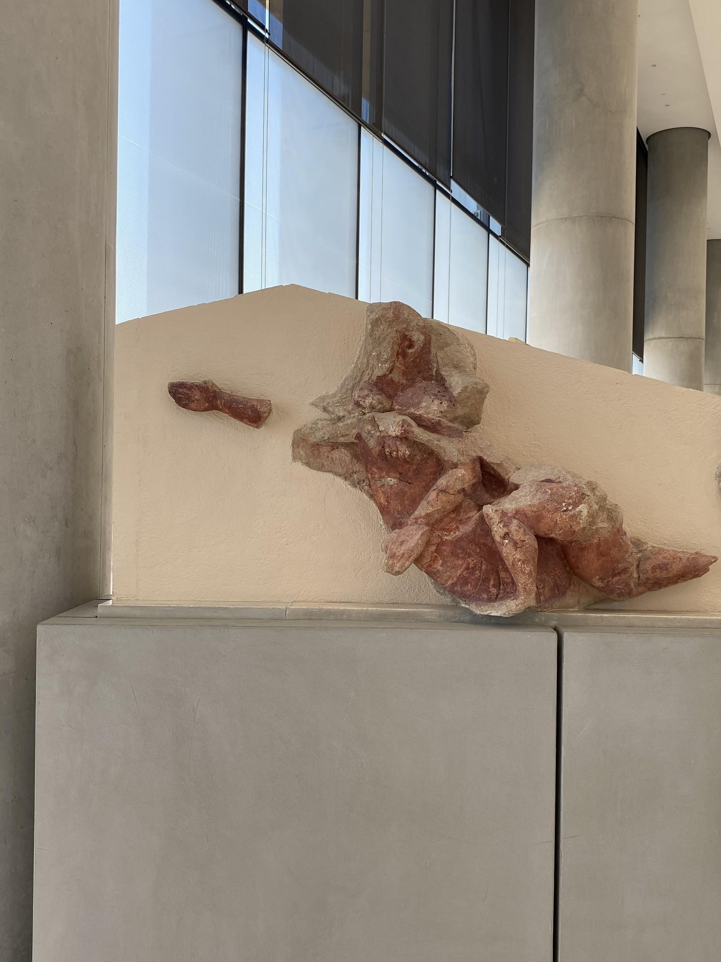
An example of polychromy

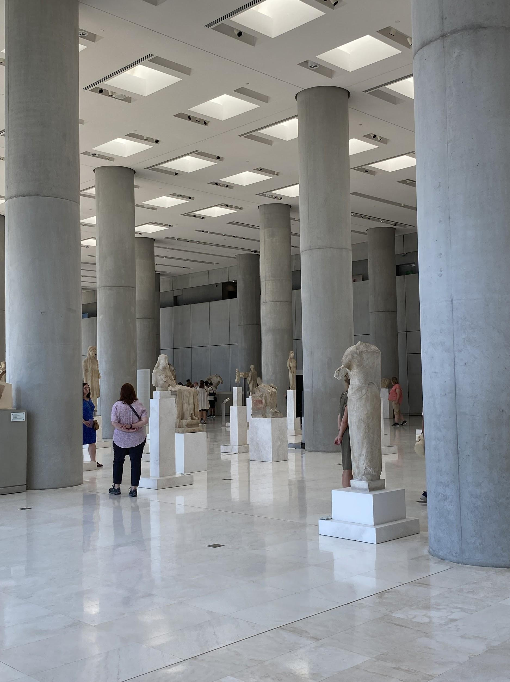
The second floor of the museum

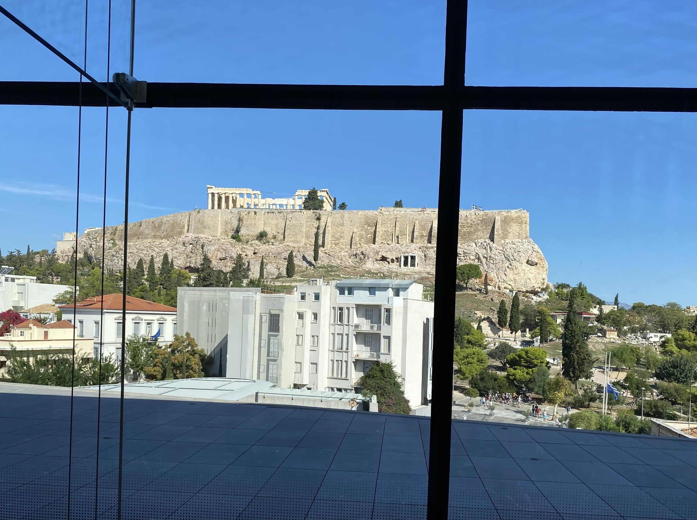
The Acropolis viewing gallery

I then wandered through the districts near the Acropolis, Plaka and Monastiraki. Since it was Sunday morning, I stumbled across a couple of Orthodox Greek church services taking place. Both churches had kept their doors open and so I was able to hear the music and chanting that was used in the services. This was particularly interesting for me because the Byzantine-style music used in the Greek Orthodox Church played an important role in the Delphic Festivals. Palmer was very interested in the music and its relationship to ancient music. She therefore commissioned music to be composed in this style for the choral odes in the tragedies performed at the Festivals.

I then reached the Benaki Museum, where I went to see the displays of traditional folk crafts. This was a very rich collection indeed and it was wonderful to see the traditional costumes from across different parts of Greece. I am very interested in vintage clothing and the emphasis on textiles in the Festivals is part of the reason why I was drawn to choosing them as the topic of my dissertation. I therefore really enjoyed seeing the beautiful and intricate fabrics and designs on display. I also encountered various items that were used in the production of these garments. I saw a traditional loom, which was the kind of loom Palmer used. She was an avid weaver and in fact wove all the costumes for the Festivals. I also saw a display of ornately-carved distaffs which looked identical to those depicted on the cover of the pamphlet that was produced for the Festivals to accompany the craft fair.

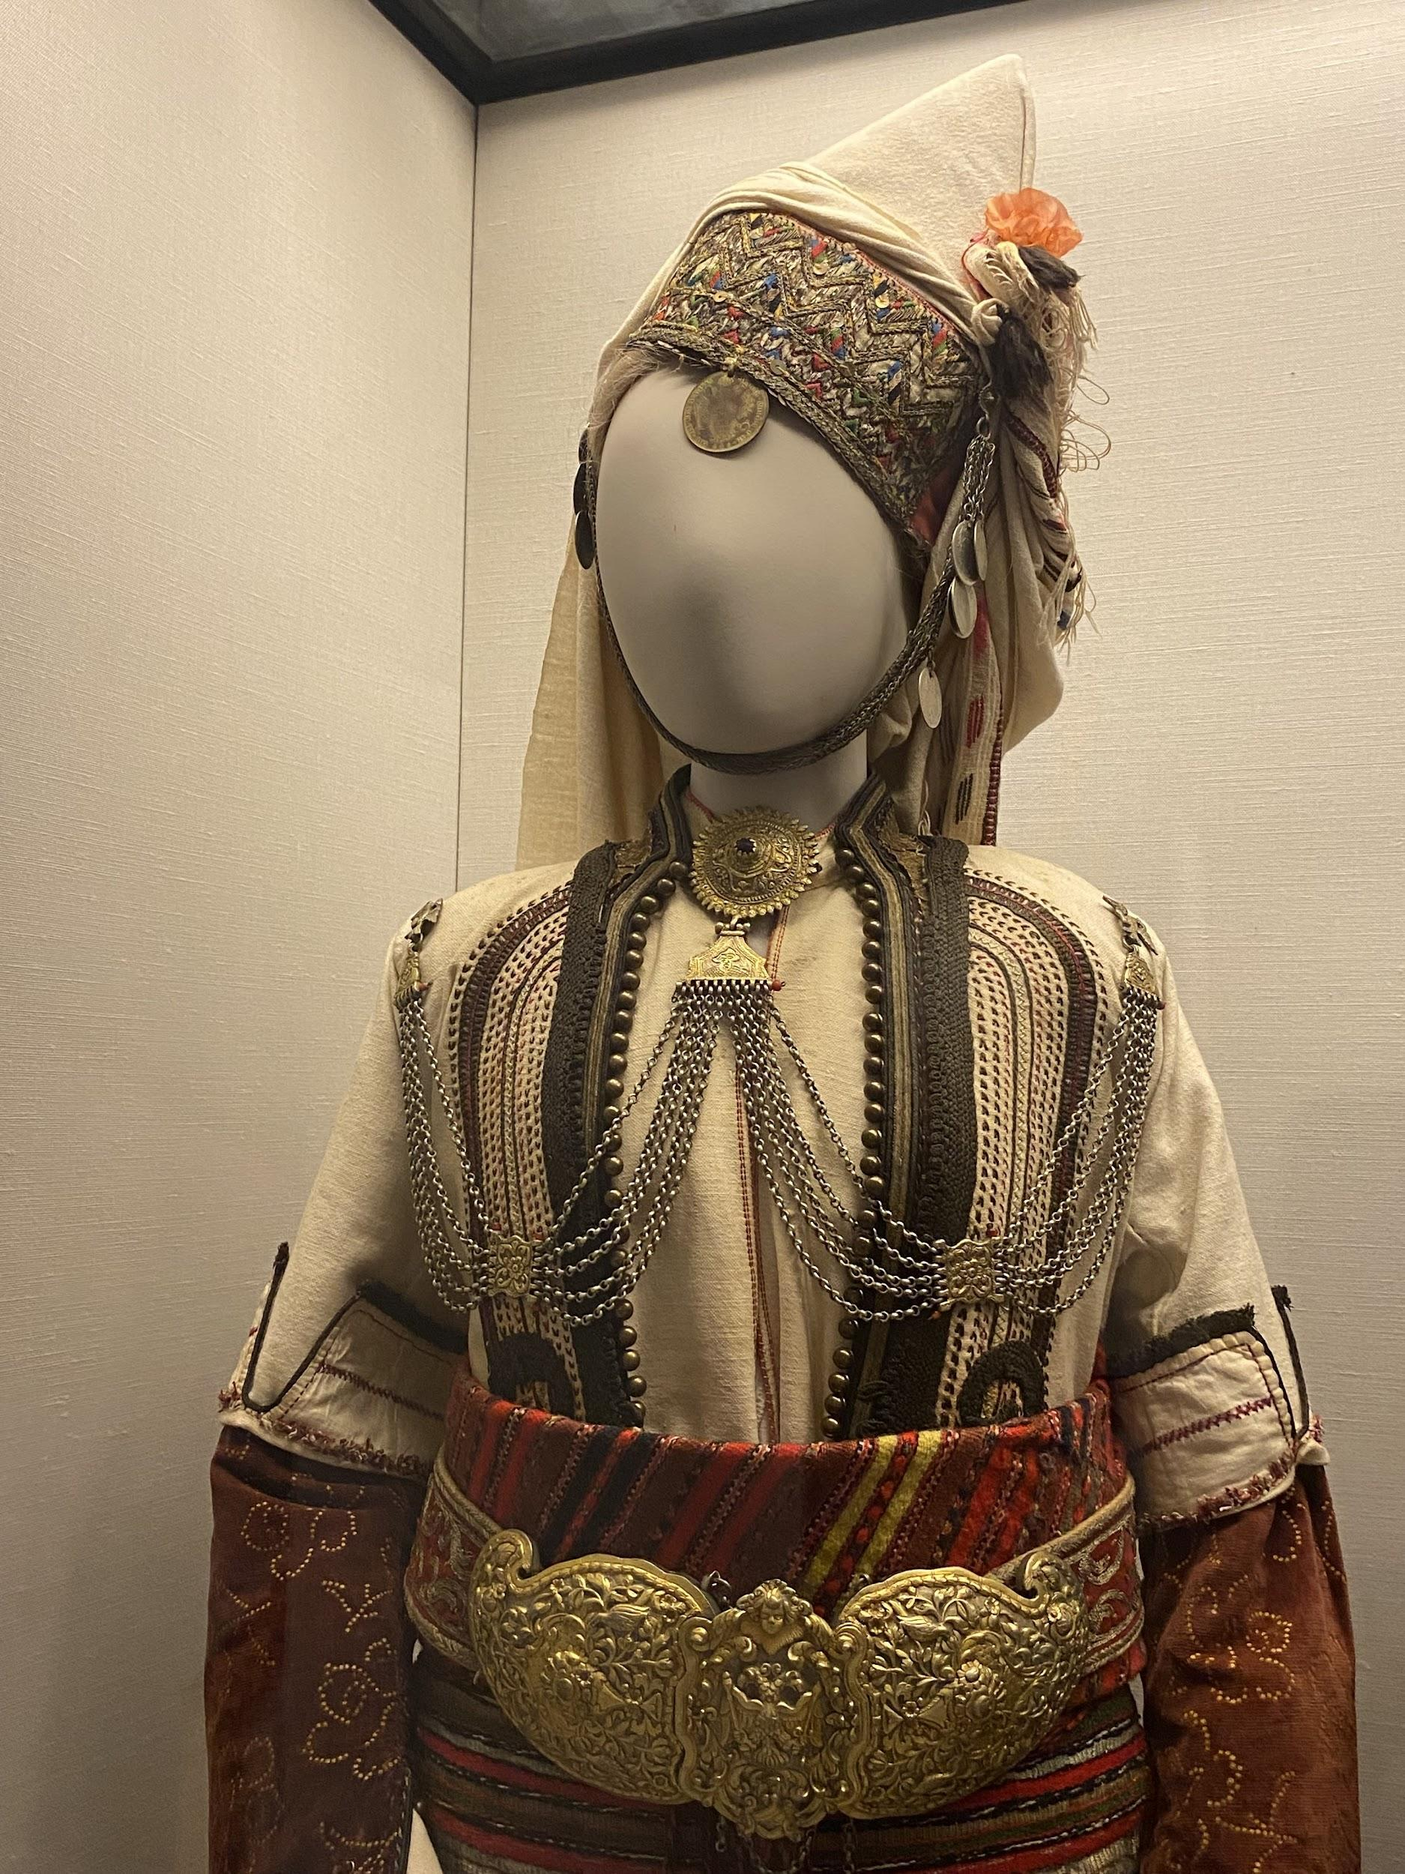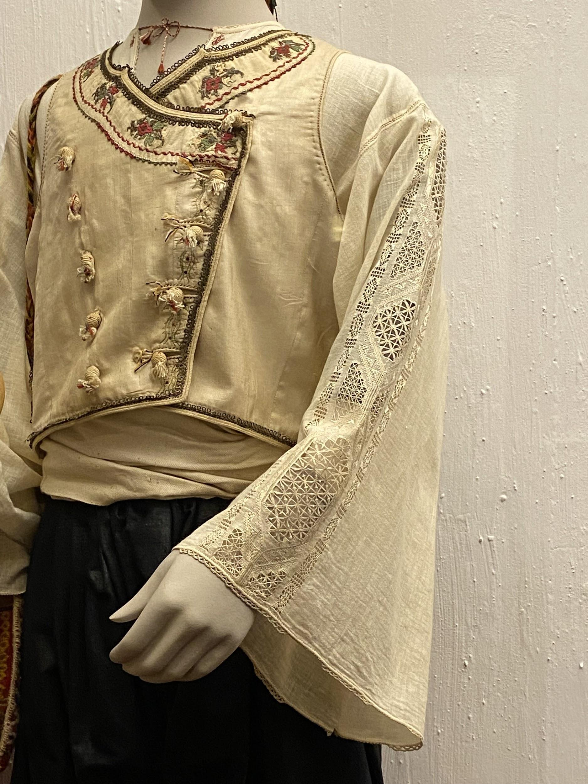
Traditional costumes

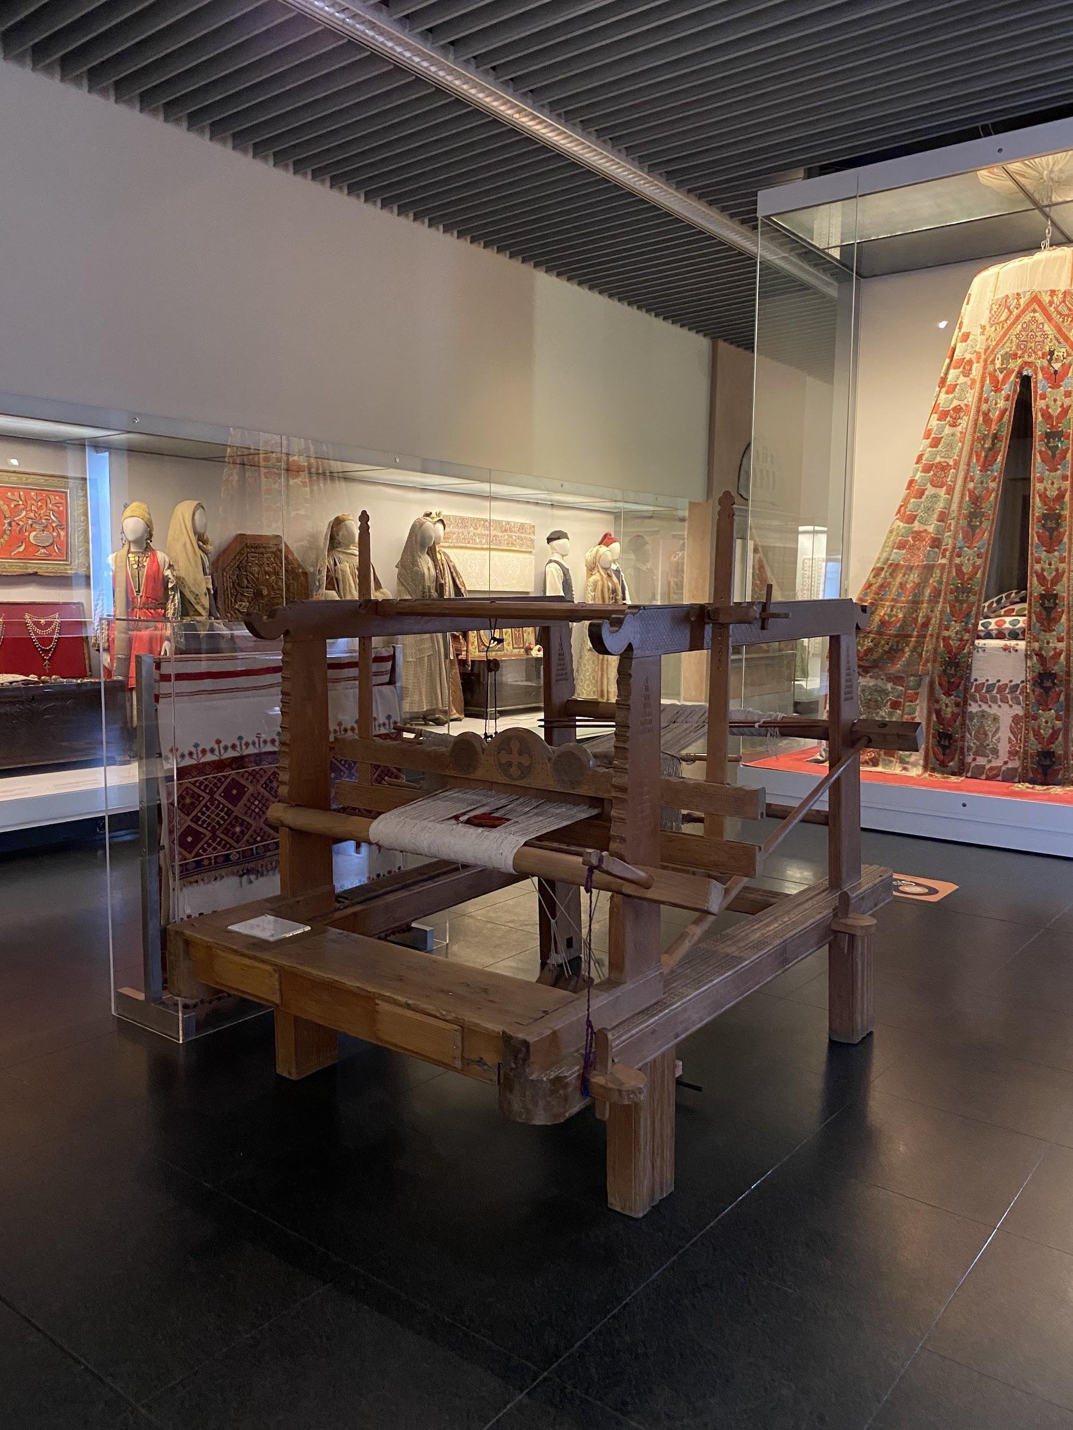
The loom in the Benaki Museum

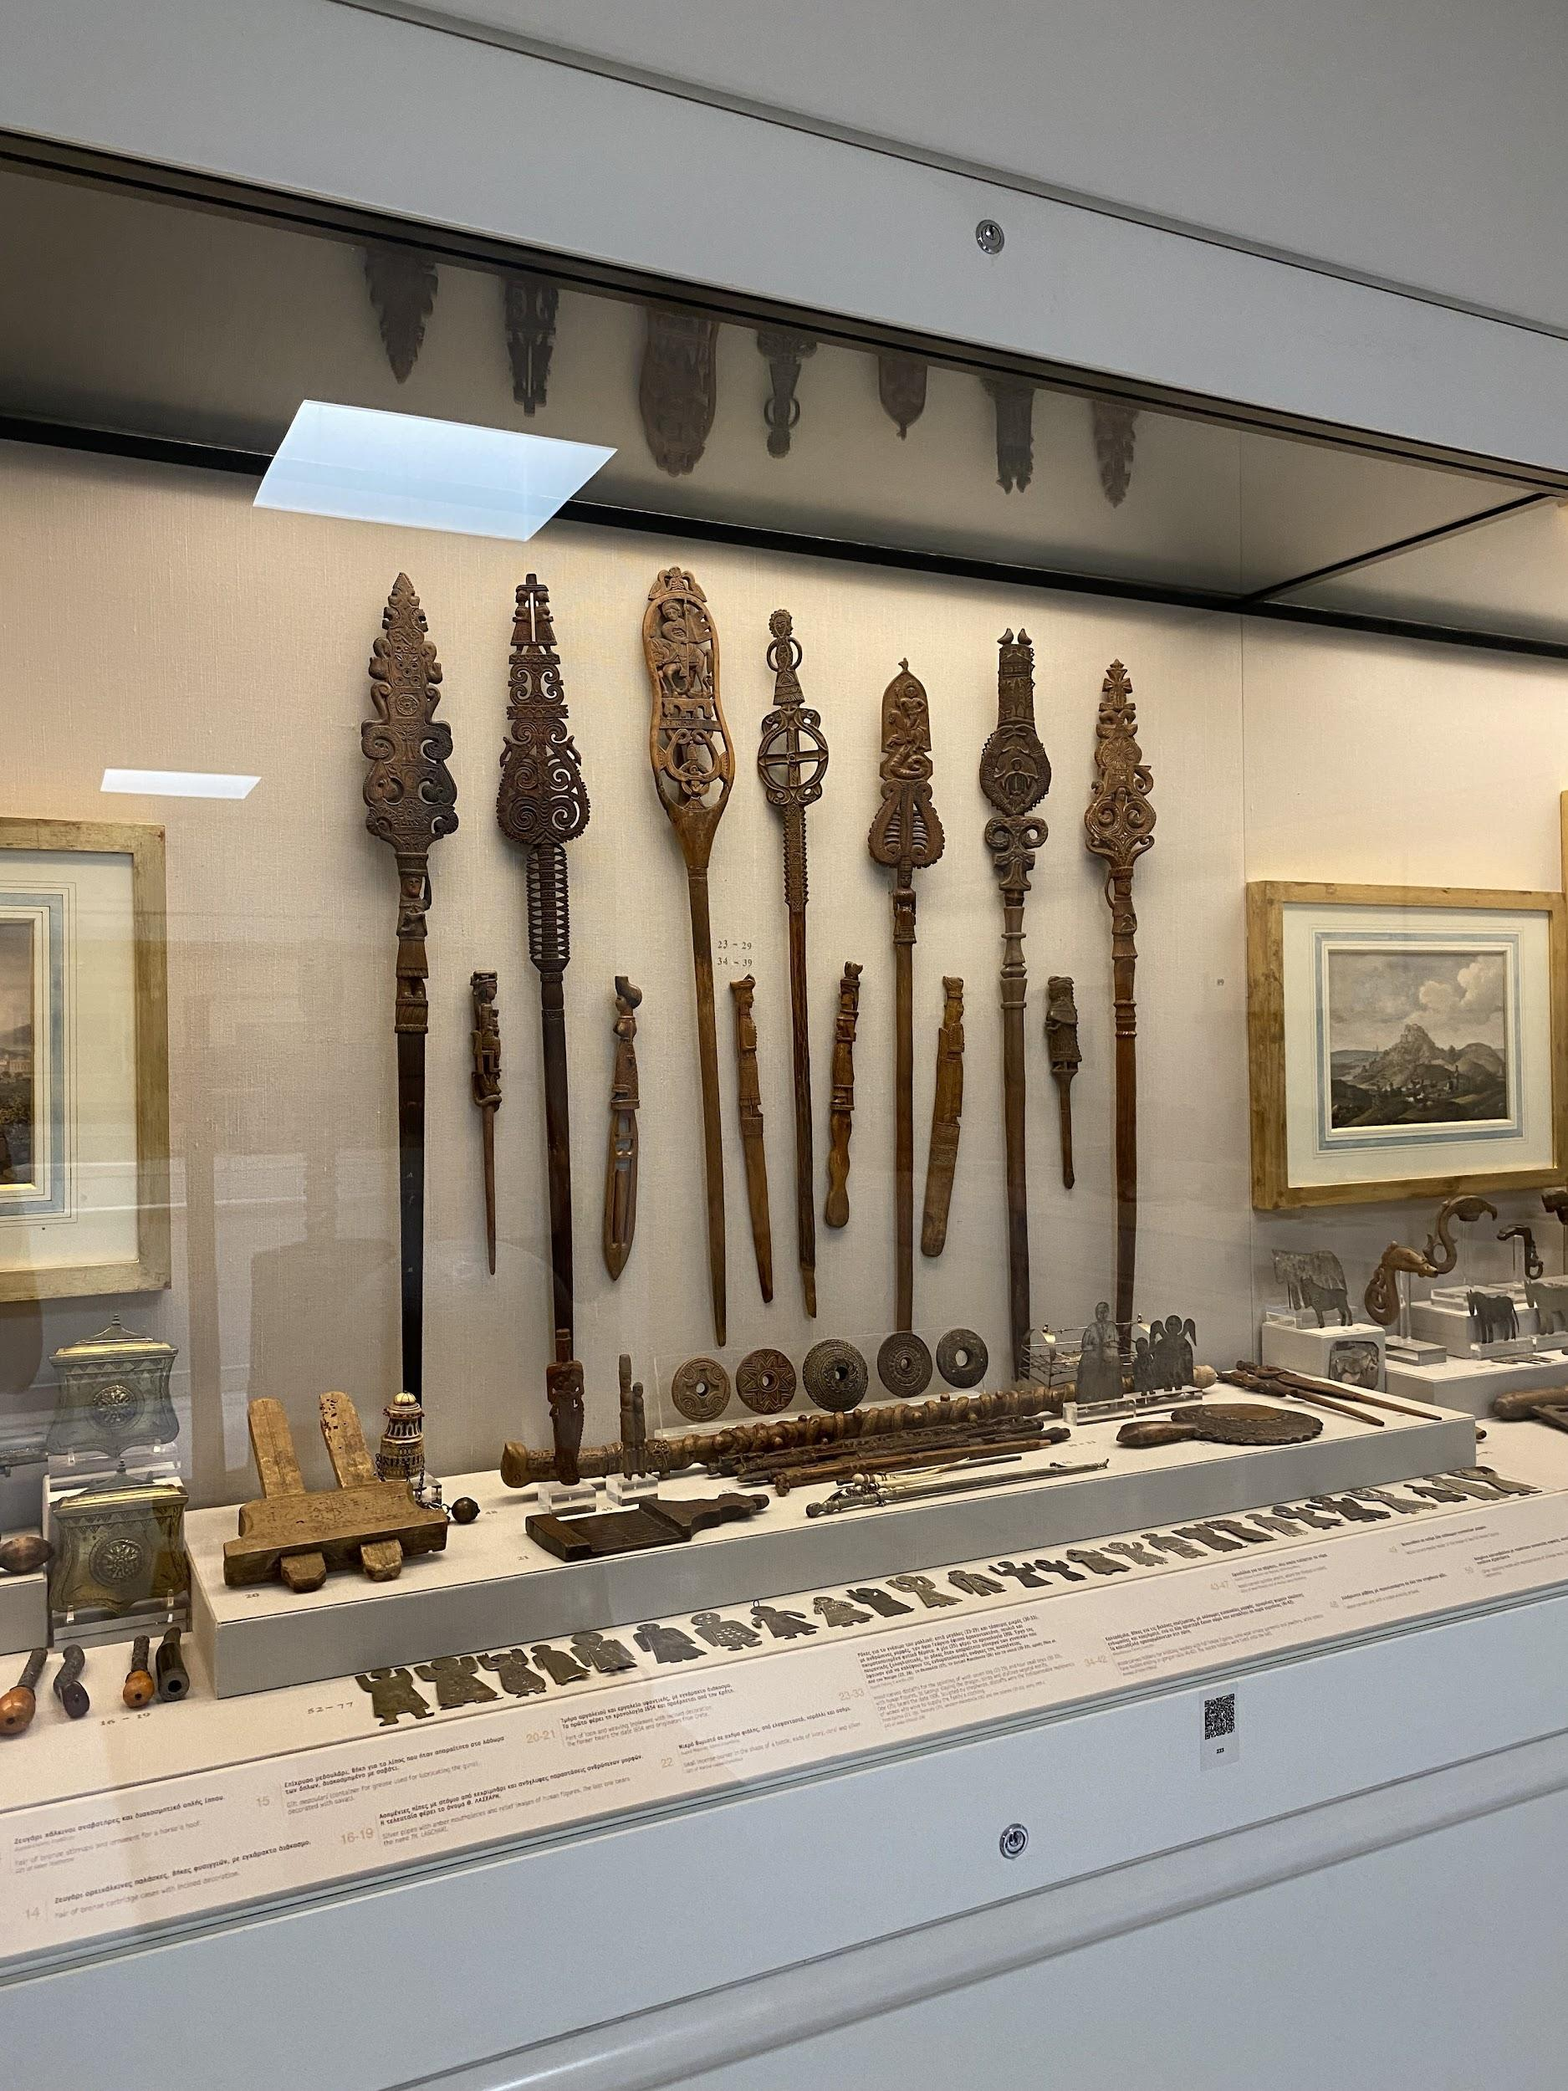
The display of distaffs

I then managed to catch the changing of the guard by the Tomb of the Unknown Soldier (a monument for the Greek War of Independence) outside the Hellenic Parliament in Syntagma Square. Then, I rested for a while and sheltered from the heat in the National Gardens round the corner before heading to the Museum of Cycladic Art.

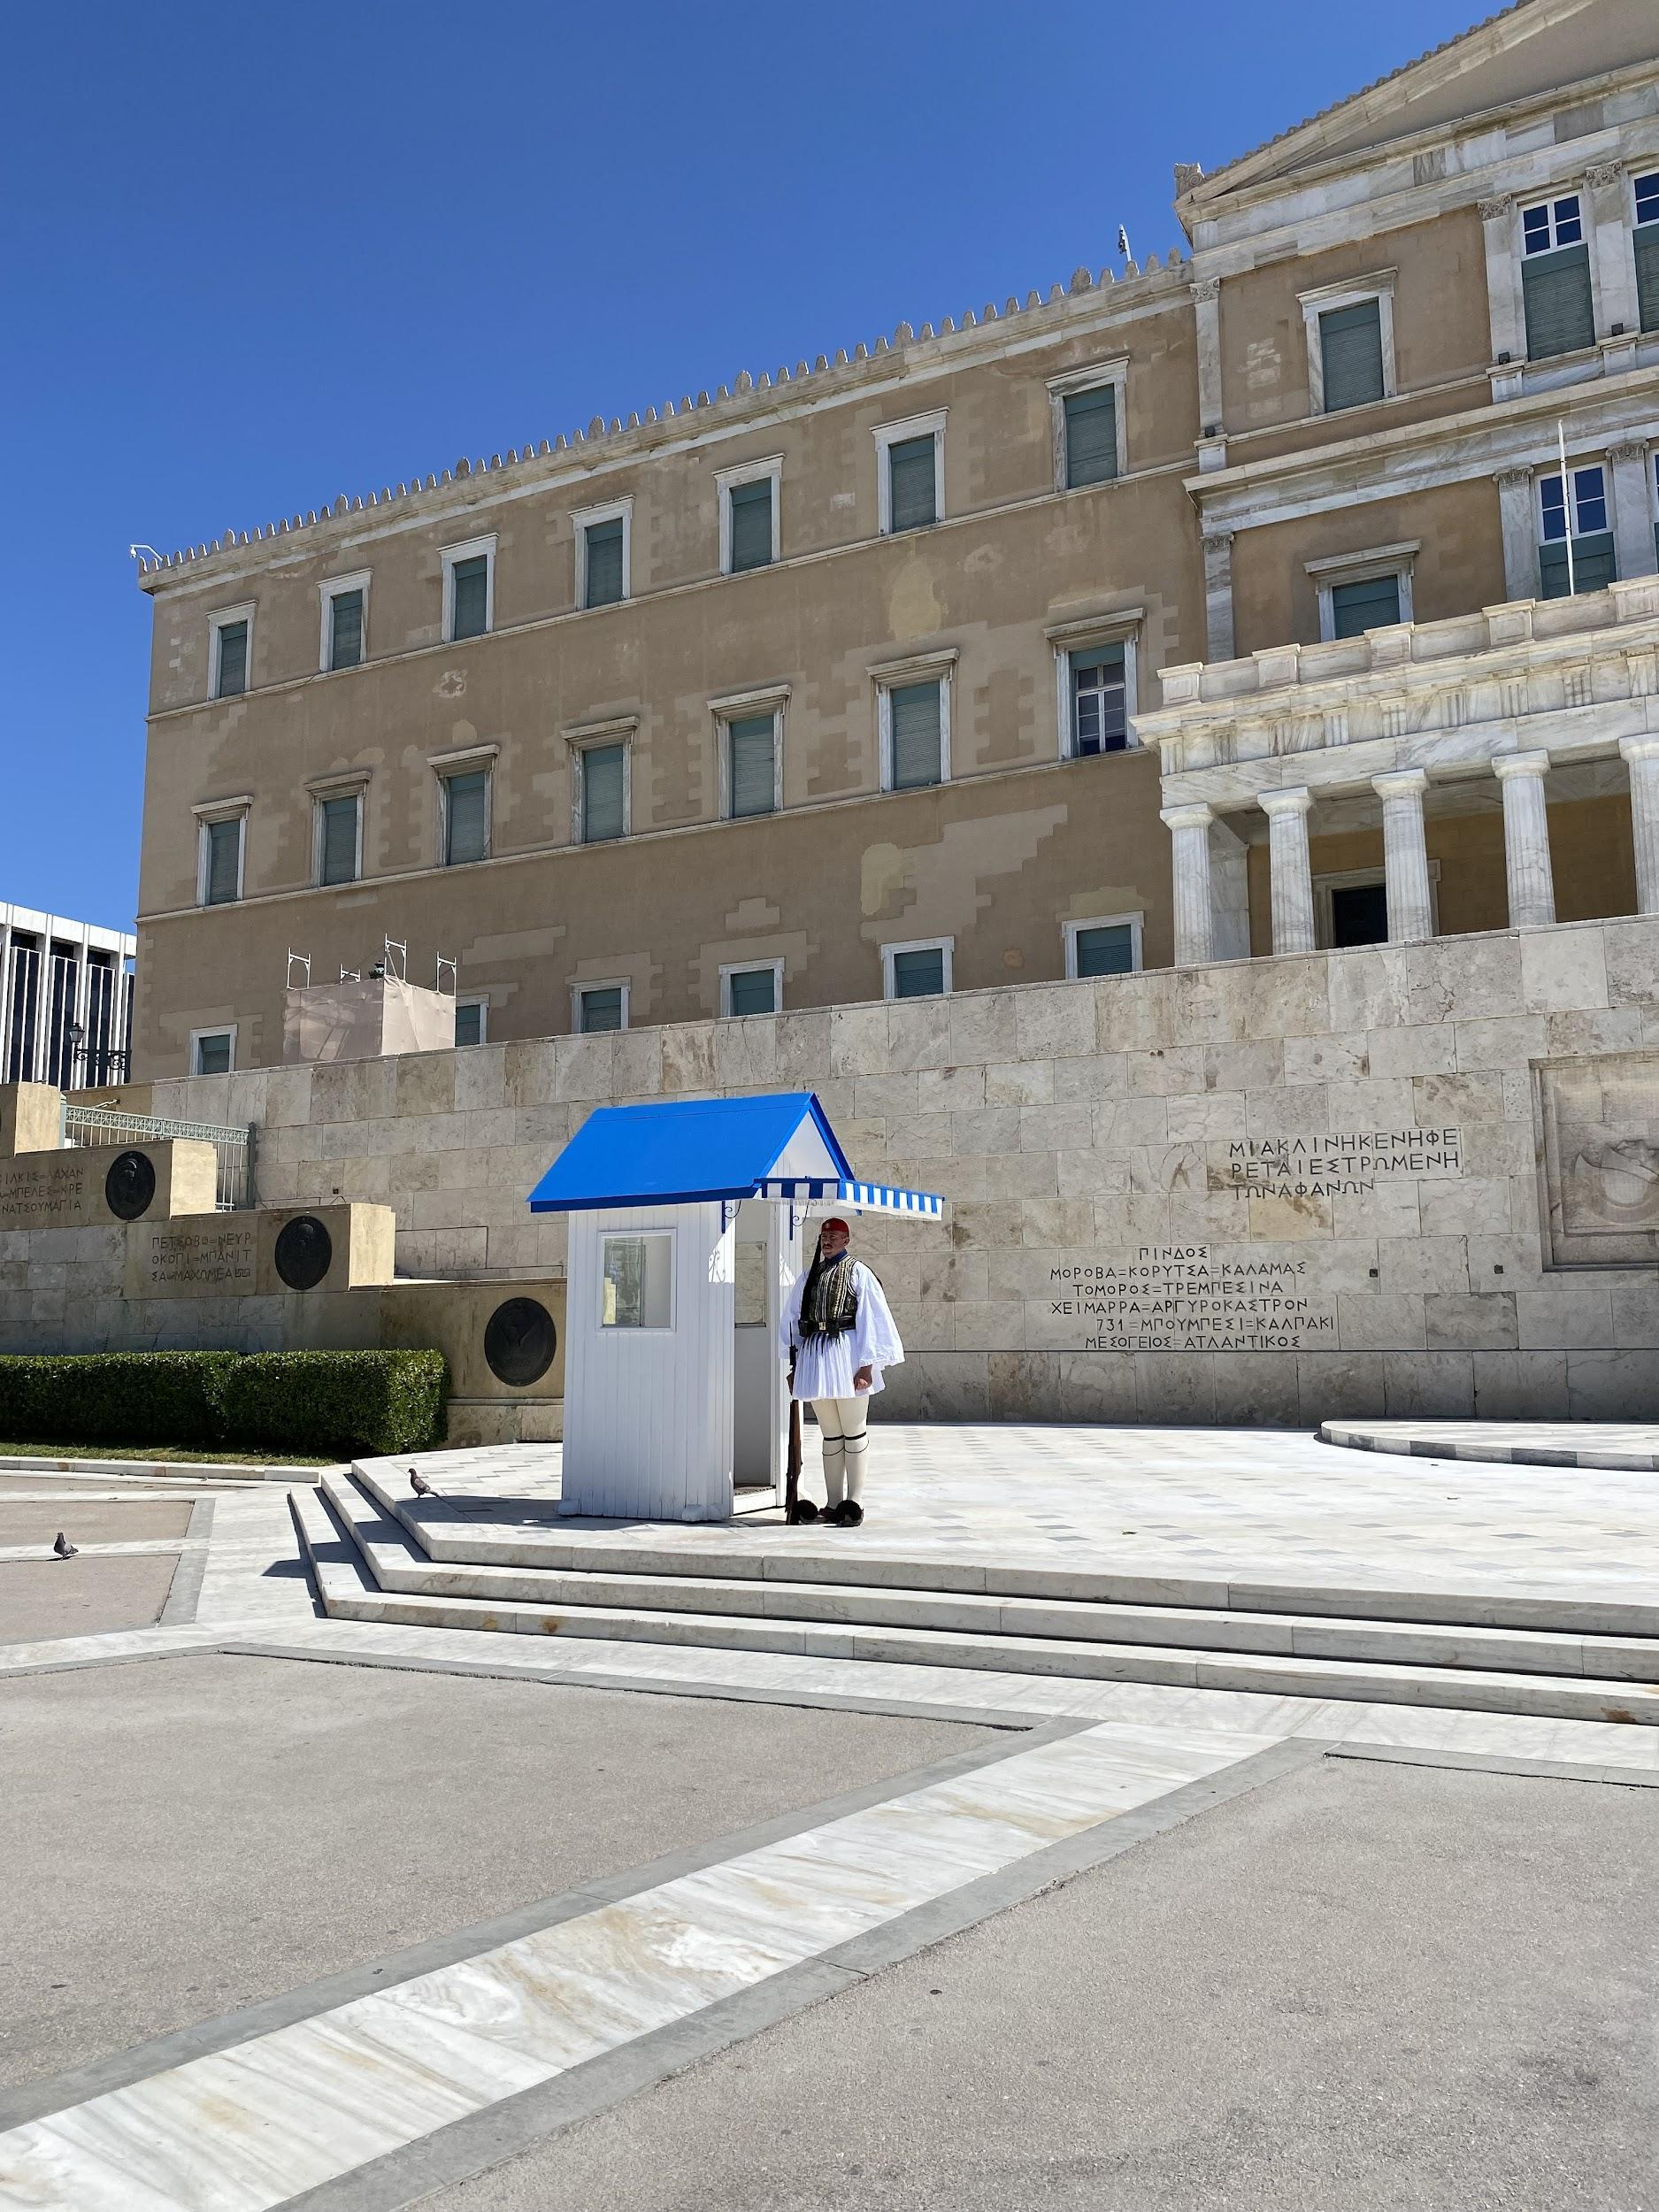
Changing of the guard

At the Cycladic Museum, I went to an exhibition entitled ‘Brice Marden and Antiquity’. This contained works by the contemporary artist which were inspired by items from the museum’s collection and displayed alongside them. I am very interested in contemporary art in general and, in particular, artists who engage with antiquity so this was perfect for me. It was also exciting to see the museum as it had hosted the exhibition of works by the contemporary artist Paul Chan, which I had written about for my undergraduate dissertation. I wasn’t familiar with Marden’s work but I was very impressed by the pieces in the exhibition and also with its curation. The old mansion in which some of the museum is housed was used in a way that really complimented the art. Marden’s minimalist style and use of colour (inspired by the Greek light as he lives on Hydra) also made me think of Alice Oswald’s poem ‘Nobody’, inspired by Homer’s Odyssey. This is a connection I’d like to explore further and so gave me plenty of food for thought.

Indeed, reflection seemed to be a major theme on this trip. Perhaps it was because it was my first time travelling alone or perhaps the Delphic maxim ‘Know thyself’ was beginning to sink in. Either way, I am incredibly grateful for having the opportunity to undertake this trip. I’m very excited for how I feel it has enriched my dissertation and for all the ways I will continue to use my experiences in Greece in future projects.

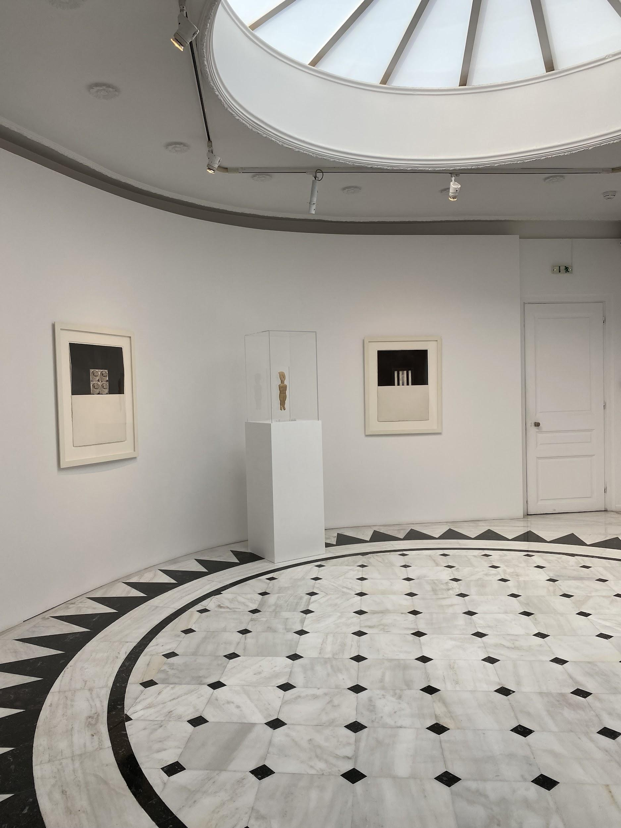
Brice Marden at the Museum of Cycladic Art

