Stephen Instone Award Report- My wanderings in Turkey
Since an early age I have always been fascinated with the Byzantine Empire and how it served as a continuation of the Roman Empire even going on into the mid-15th century! As a result, I have studied many aspects of the empire, from its religion to its military and its architecture. These all intersect in the capital of this empire- Constantinople or Istanbul as it is now known. Thanks to the Stephen Instone Award from UCL I was privileged to be granted the opportunity to visit this city to see the Byzantine monuments and ruins that still remain there. At the top of my list of things to see were the churches and the Theodosian Walls. I achieved both these goals, and I was especially taken away by the sheer size of perhaps the most famous Byzantine church- the Hagia Sophia, built in just 5 years from 532 to 537AD. This former church with its formidable architecture amazed me through its sheer size and impressive mosaics, and it was breathtaking to wander around such a historic building that I’d read so much about.
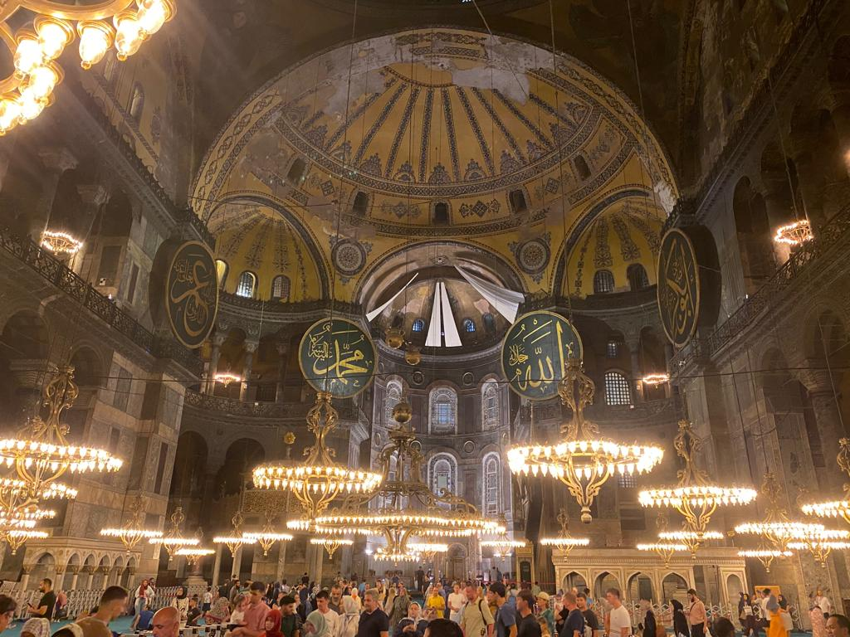
The voluminous interior of Hagia Sophia- unfortunately some of the Byzantine mosaics were covered up by the authorities as it was recently turned back into a mosque.
After that, I went to see the Theodosian Walls- the famous defences of the city which withstood a great many sieges over a period spanning a thousand years. They largely survive to this day in their original place, albeit in some areas they are ruined whereas in other locations they have been restored and repaired. I therefore determined to walk the entire circuit of the walls from west to east to trace this boundary between the city and see the impressive gates and fortresses that have survived as well, ensconced within the walls. Along the way I fortuitously stumbled upon the remains of one of the imperial palaces at Blachernae and the present seat of the Orthodox Patriarchate at the Church of St George.
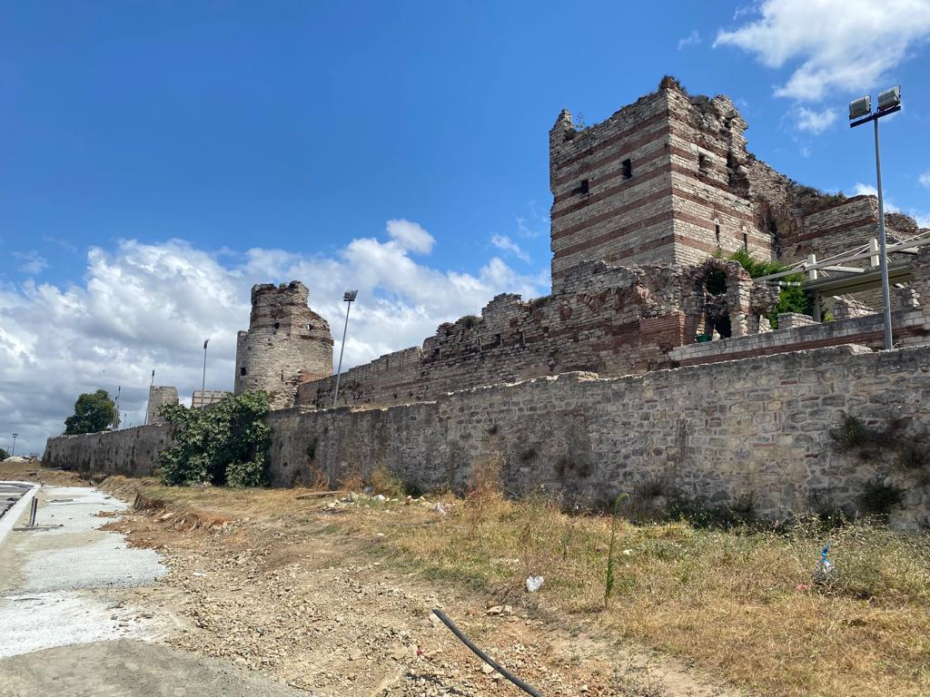
A section of the Theodosian Walls that has not been reconstructed.
The rest of my stay in Istanbul was taken up with seeing the many famous sites around the original core of the city, as there are still some remains of the hippodrome and various forums. It was great to encounter the various exotic structures in the hippodrome such as an Egyptian obelisk as well as the Serpent Column which Constantine had nicked from Delphi to adorn his new capital with. Having already been to the original site of this at Delphi, it was good to come full circle and finally see where it was! However, the most stunning sight in this regard was certainly the Basilica Cistern- substantially reconstructed and enlarged by Justinian in the sixth century AD. Designed to hold a huge amount of water, this cavernous structure was extremely atmospheric now and thrilling to wander around and marvel at.
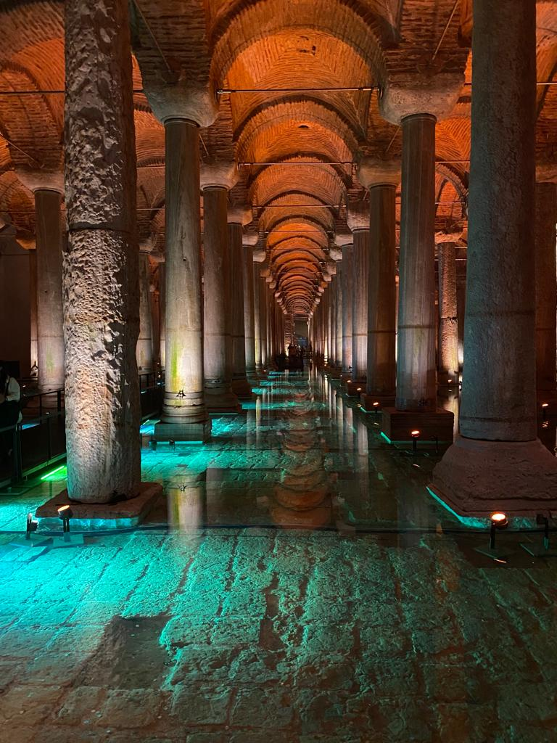
The Basilica Cistern
I then went on a day trip to Nicaea- the site of one of the most famous church councils in 325AD, where the eponymous Nicene Creed was decided. Although, there wasn’t as much to see here, the walls were the best-preserved part and indeed the structure of the town has remained within the Roman walls, so it is still in its square layout with the four gates of the city (in each direction) all still there. This was far less of a touristy site and indeed the concierge of my hotel in Istanbul reacted with amazement when I asked him the best way to get to Nicaea as he said no one ever goes there. However, I was determined to go there for its religious significance while I also knew that both Catullus and Pliny the Younger had been there and I had even read a letter from Pliny to Trajan (Epist. 10.39) where he decried the theatre being built there. He described it as having already cost 10 million sesterces but was already not fit for purpose as the craftsmanship was shoddy and it was being built in a marsh! Naturally therefore, I had to find the theatre which I duly did, and indeed it was in a dilapidated state so perhaps Pliny was right.
Once I had seen all there was to see in Istanbul, I figured that while I was there, it would be a great chance to see some other sites from antiquity as Turkey is filled with amazing Greek and Roman ruins. Therefore, I went to go and see many ancient cities on Turkey’s Aegean Coast in the ancient region of Ionia. I saw Troy, Pergamum, Ephesus, and Hierapolis on this tour. All of these cities held fantastic ruins, but I was especially blown away by how much survives at Ephesus including a substantial library as well as many Roman streets which you can still walk down in their original form! Moreover, the city has great biblical significance as Saint Paul was said to have preached there and it is one of the seven cities addressed in the Book of Revelation. This led me to go and visit the supposed spot of the cave of the Seven Sleepers- a legend about a group of Christians who suffered persecution in the mid-3rd century AD. As a result of this they were supposedly hounded out of the city and forced to seek refuge in a cave. There they fell asleep, and once they woke up, one of them went to Ephesus to buy supplies. However, there he discovered that the city was now completely Christian with crosses on display and churches everywhere. Indeed, it turned out that they had slept for over 100 years, enough time to witness a complete reversal as the empire became Christianised. Since then, a religious complex was built on the apparent site, and these are the ruins I saw. Finally, a visit to Ephesus wouldn’t be complete without going to see the remains of the Temple of Artemis nearby as it is one of the seven ancient wonders of the world. Although, there is not much there now, the surviving foundations hint at the sheer size of the temple in its heyday.
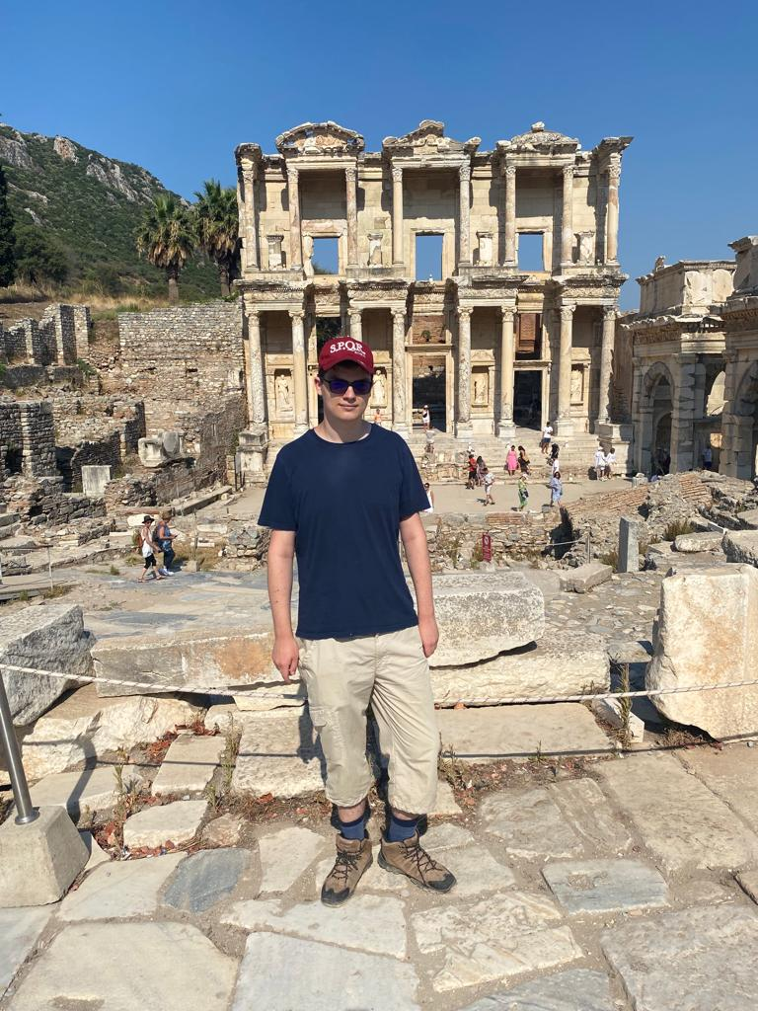
Me by the Library of Celsus in Ephesus
Another highlight in this regard was of course visiting the city of Troy. Having read the Iliad and Odyssey, it was amazing to see where potential myth and reality intersect in the ruins that can still be seen today. You get a great sense of how the city developed over time with the fact that you can actually see the different layers of the city all (there are at least 10), sometimes literally on top of one another in some instances. Indeed, to me it was a fascinating display of the importance of archaeology and how it helped determine the chronology of each layer, to try and identify the one that could most readily be associated with the Troy of myth!

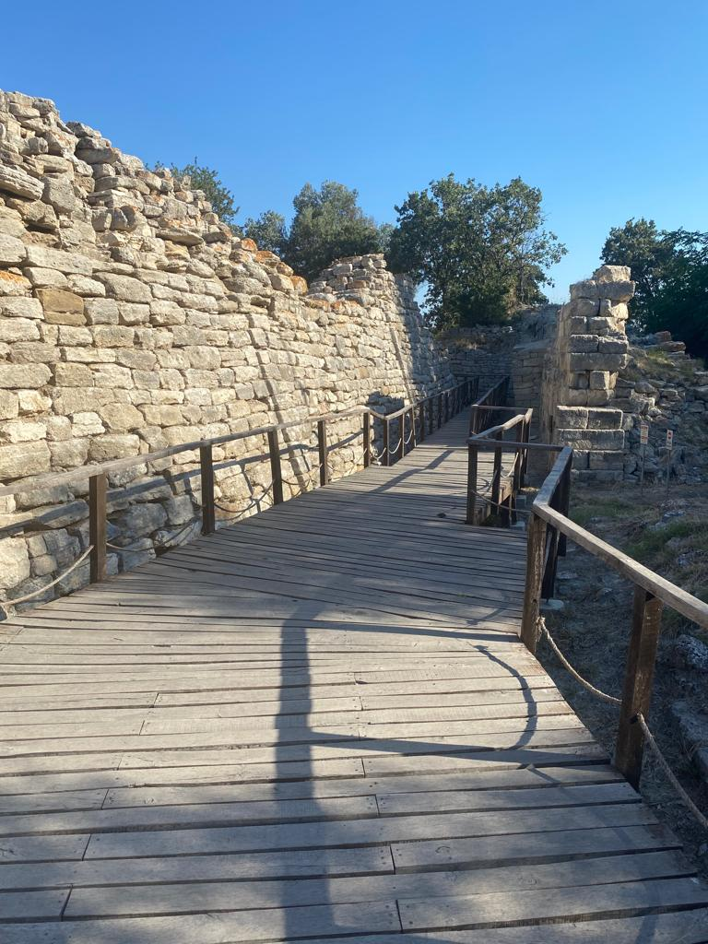
The walls of Troy
Finally, I saw the cities of Pergamum and Hierapolis. Both impressive sites in their own right, actually getting to the acropolis of Pergamum was interesting as it is so high up that you have to get into a cable car to actually get there! Thanking the fact that I didn’t have to climb up a mountain, the ruins were well worth the trip as they are so extensive and well preserved while you get some great views over the surrounding valley. Indeed, the temple complex to Trajan was perhaps the most impressive aspect as the sheer size of it is mind-blowing. Additionally, I saw the foundations of the most famous structure in Pergamum- the Great Altar, which is now fully housed in a museum in Berlin.
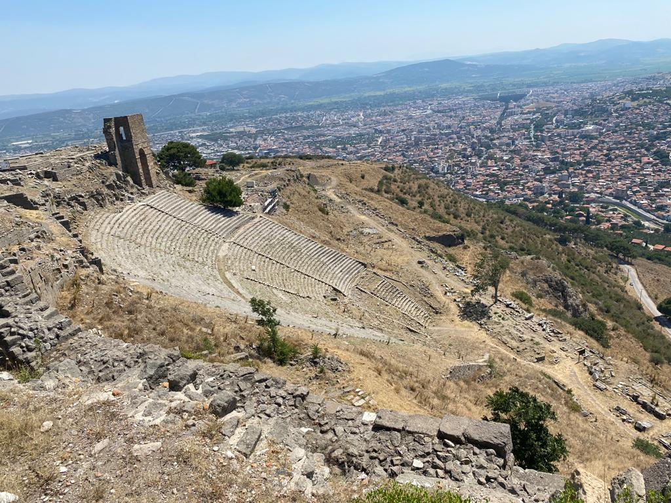
The view from the Acropolis in Pergamum
My last stop at Hierapolis uncovered another hidden gem as it was famous in antiquity for its hot springs and indeed many people still visit for these waters at the numerous health spas and resorts there. Because of this it has some spectacular white limestone terraces. Moreover, it had a huge theatre as well as a temple to Pluto which was a rarity as I had never come across one dedicated to him before. This led me to then discover the supposed tomb of St Phillip- one of the original 12 apostles of Jesus, which I had certainly not expected to find there!
All in all, I am extremely grateful for the opportunities this trip allowed and I thoroughly enjoyed seeing so many sites I’d read about and studied beforehand. Thank you very much to the Instone family and the UCL Greek and Latin department for helping to facilitate this trip in the first place. It was a thrilling experience from start to finish and I learnt a great deal about not only the Byzantine period, but also the Hellenistic and Roman periods as well.
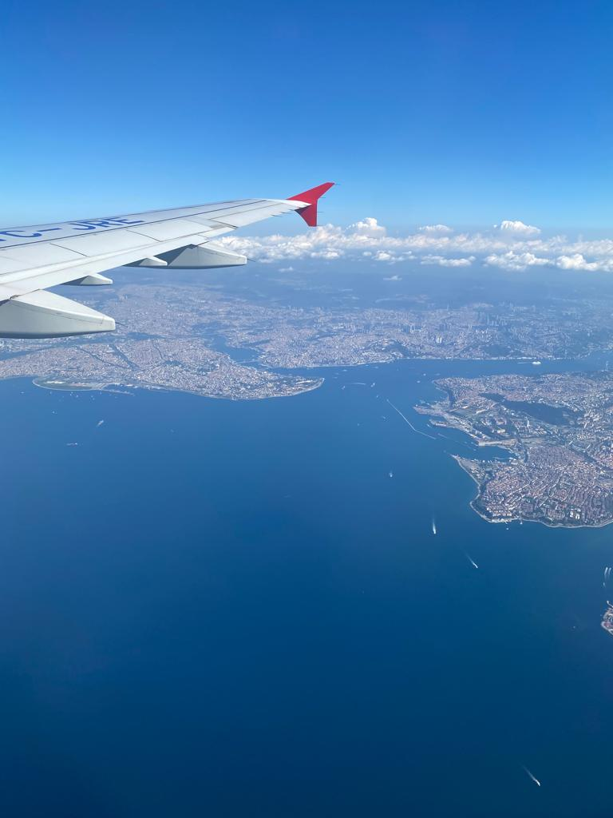
An aerial view of Istanbul, this is probably my favourite picture of the whole trip as it captures the location of the original city of Constantinople on the left with the three waterways that underpin the city- the Sea of Marmara, the Golden Horn, and the Bosporus.

