Four years ago, on a school trip in Greece, a spat broke out between myself and my teacher. Certainly, he had due cause to hassle me; herding 30 juvenile delinquents onto a coach in Greek midsummer heat is a hellish task. But one should really show more decorum than to reproach a man marvelling at the Delphic charioteer.
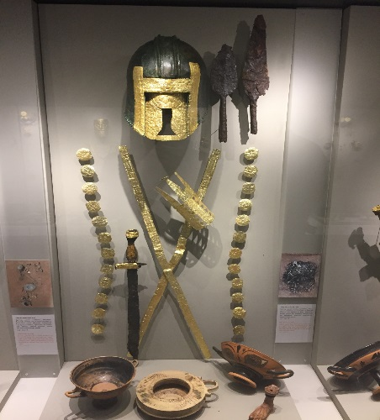
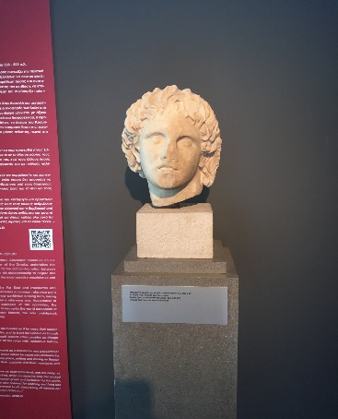
His winged words, that the trip was “only an introduction” did not fall on deaf ears; indeed, it was a foray which left me with far more questions than answers. And so this summer, with my questions refined and multiplied by another 4 years of classical study, my good friend Ed and I set off on an anabasis to rival that of Xenophon. It was to be a journey that would take us from the Northern plains of Ancient Macedonia to the Southern crags of Spartan Mt. Taygetus, from Mycenaean palaces to Hellenistic tombs, and from the lofty seats of ancient government to the dusty fields on which democracy was fought for; all through the incredibly generous aid of the Instone family and the UCL Classics department.
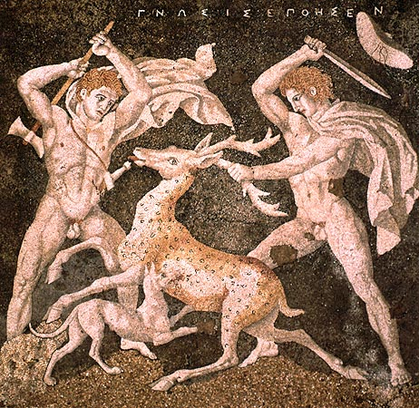
Flying into Thessaloniki, on day 1 we were confronted with a journey into the heartland of Ancient Macedon; a prospect I found most exciting due to my particular interest in Alexander the Great. Our first site, Pella (the capital of Macedon and Alexander’s birthplace) did not disappoint. An iconic bust of the conqueror’s face received visitors at the entrance of the museum with a serene stare. Among the most impressive exhibits were the lavish burial goods of seven Archaic period nobles, and the instantly recognizable Hellenistic “stag hunt” mosaic.
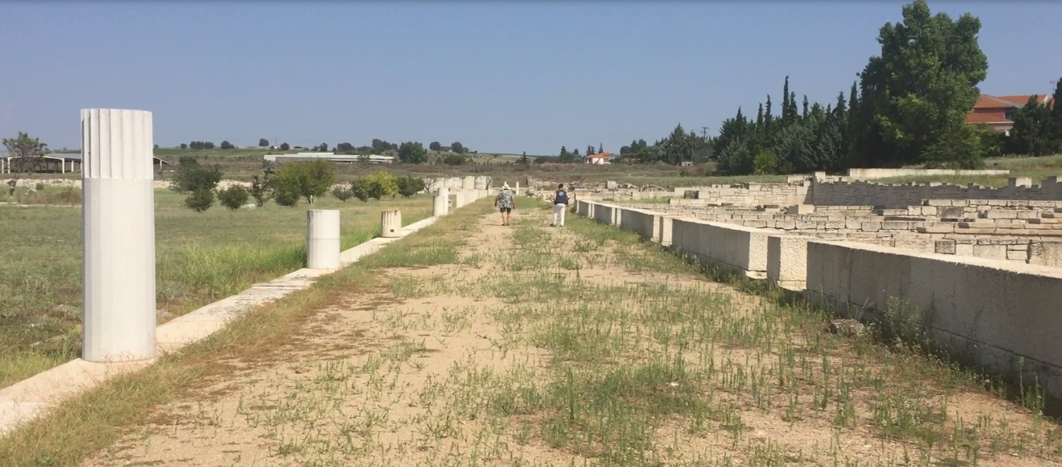
The archaeological site was equally impressive; the portico columns of the agora rose dramatically from the surrounding farmland, giving a stark impression of the city’s lost opulence. This was eerily enhanced by the perfect grid plan of nine meter wide city streets (yes, nine meters!) and the vestiges of a well organised public sewer system. It almost felt as if we were walking in the ruins of a small modern city!

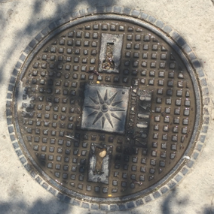
It was a truly thrilling morning, in which we got a privileged view into the transformation of Macedon from a barbarous kingdom on Greece’s northern fringe to the fabulously wealthy power which subjugated Greece and spread Greek culture to the ends of the known world. Indeed, modern Pellans venerate their ancient past as an inextricable part of their modern identity. On my way to lunch in “taverna Alexander” (itself situated in “Alexander square”) I noticed that the manhole covers bore the royal crest of Alexander’s line. Somewhat more pressing, however, was the group of local motorbike enthusiasts spending their Sunday morning surrounding the 10 meter high statue of the ancient ruler with flares and Greek flags. It was a compelling sight; Alexander won immortality across the world in the legends told of him to this day by the countless peoples of the realms he affected, and the tangibility of his origins in this town was sublime. I considered what equivalent Britain may have; I found Tintagel, the mythic birthplace of King Arthur- a loosely commemorated figure some 800 years Alexander’s junior- a far less thrilling visit.
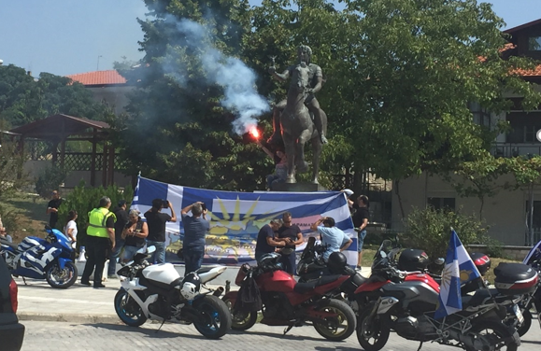

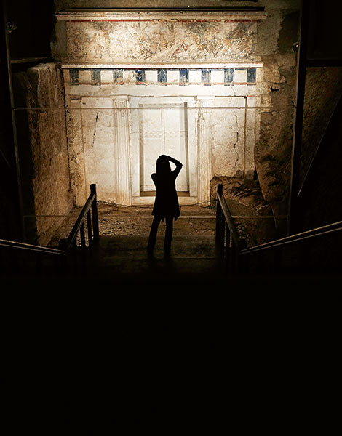

The tangibility of legends mounted after we had polished off our souvlaki, as we headed 70 km south to Aigai- the royal seat and old capital of Macedon. I had spent many happy hours reading of the unbelievable, Indiana Jones-esque discovery made here in the 1970s, but I was far from prepared for what awaited us. Descending into a museum built into a towering tumulus, we followed winding passages of exhibits until we faced the solemnly imposing, painted entrance of a tomb. The very tomb in which the remains of Philip II, Alexander’s father, were laid to rest in the year 336BC. Many consider the king to have been easily as remarkable as his son. Philip’s untimely assassination meant that Alexander inherited a campaign into Asia which his father had already started, and prepared for over decades of brilliant social and military reform. Hence, it took some time for me to recover my senses from the gravity of what I was seeing, and indulge myself in examining the miraculously un-looted grave goods which had lain in wait for millennia. Among the wonders were an immaculately detailed gold quiver, a robust gold box in which the king’s bones had been housed, and the remains of no fewer than 3 suits of armour!
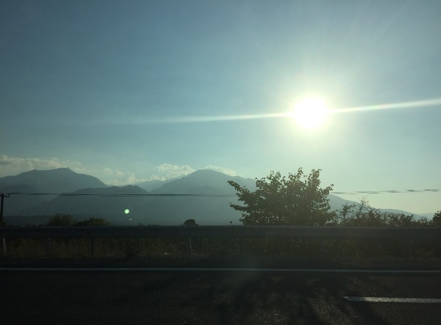
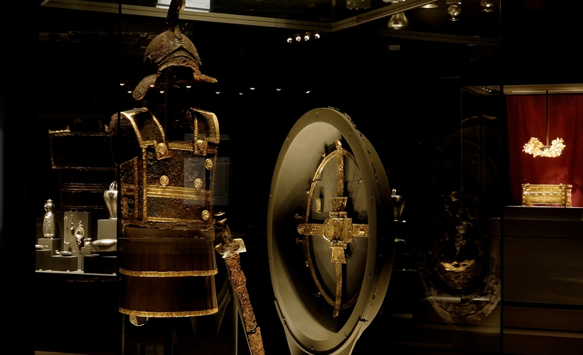
Our journey that evening produced a new barrage of marvels. “Pydna”- the site of the climactic Roman defeat of Macedonian hegemony in Greece- warranted a small brown sign at the side of the road, as did Mt. Olympus (you know, home of the gods.)
Finally the seemingly incessant string of breath-taking mountains gave way to a small plain, where we stayed in the city of Lamia for the night. Making this journey illustrated the lost significance of the city. With a commanding position over the eastern passes into the rest of mainland Greece, it had once been the site of a protracted siege which ended with a brief spell of Greek independence from Macedon. Mt. Olympus
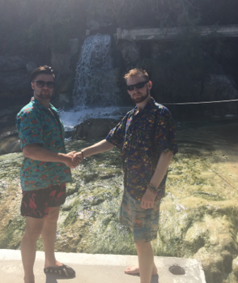
The strategic importance of the area was certainly not forgotten the next day, which we kicked off with a dip in the hot spring of Thermopylae. Refreshed, we crossed the road to the world famous battlefield.
The fatal defence of this pass by 300 Spartans has provided the West with a paradigm of heroic sacrifice, and undoubtedly hordes of tourists visit the site every year. Undoubtedly, hordes of tourists expecting to find a site which matches the dramatism of orientalising Hollywood CGI leave disappointed.
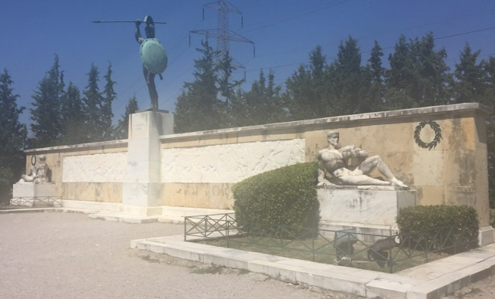
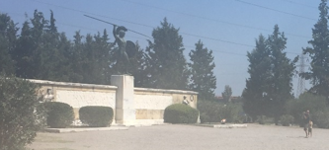
Despite the Greek state’s best efforts (Leonidas’ monument is profound in its own right), the site is entirely unremarkable. The battlefield is split between an expanse of gravel in front of the monument, the road, and the carpark on the far side of the road. Furthermore, the stretch of sea which protected the Greeks’ right flank has silted up, so that the events are difficult to visualise. Difficult, but far from impossible; physically standing on the spot where those crucial events unfolded 2498 years ago powerfully filled a conceptual gap in my understanding of the wider Ancient Greek world. I imagine hordes of Classicists leave contented for the same reason.
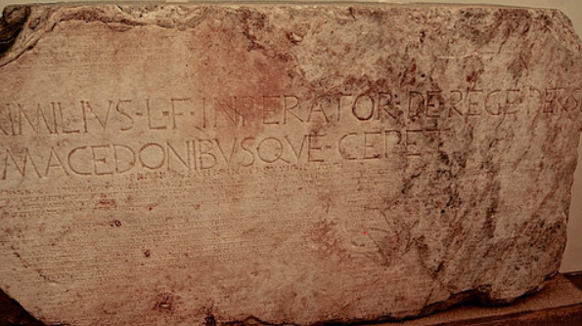
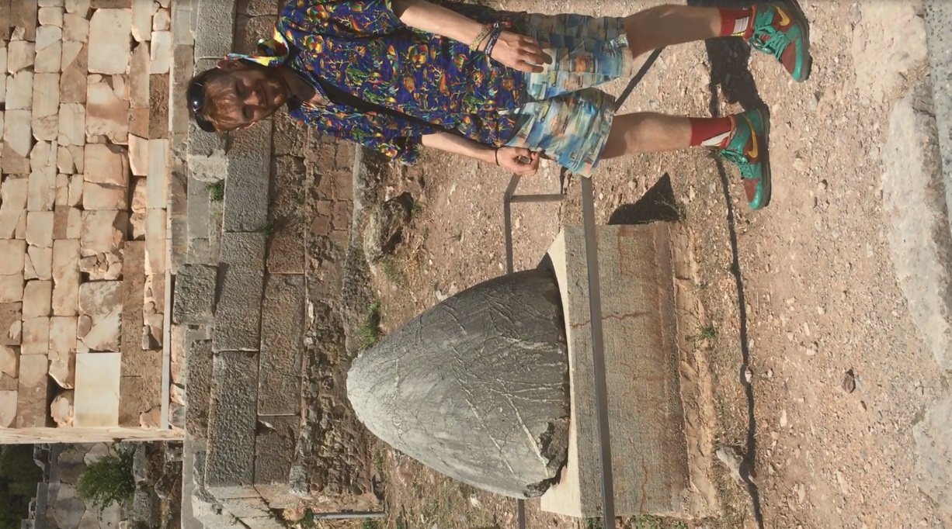
Passing through rather more easily than the Persians were able, we travelled via an astounding mountain path to the scene of the crime; Delphi. The beauty of this site is no secret, and it was wonderful to return. The centrality of the site to the Greek world is manifested in the stone “Omphalos” pictured; a conceptual “bellybutton” of the earth. Indeed, it is easy to picture the Greek world in its entirety jostling for space here; among my favourite artefacts was the Aimilius Paulus monument (the square marble pillar pictured below.) Having defeated the Macedonian king Perseus at Pydna, the Roman general celebrated his victory by putting his image atop a pillar dedicated by Perseus. On the pedestal, the stark statement “Lucius Aimilius Luci filius imperator de rege Perse Macedonibusque cepet”, carved haphazardly into the centre of Perseus’ long, elegant Greek inscription, poignantly announced the new preponderance of Rome over Greek affairs.

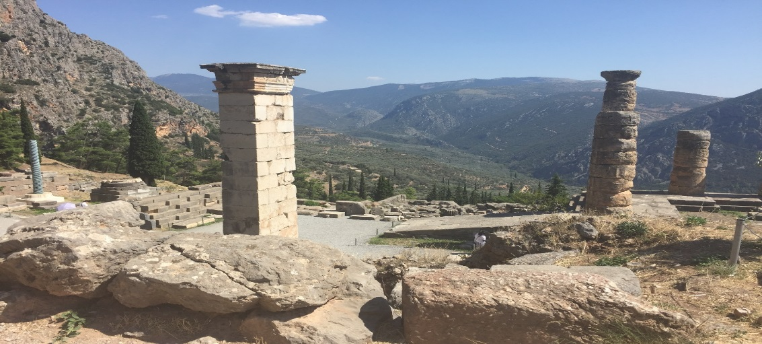
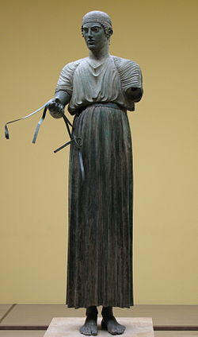
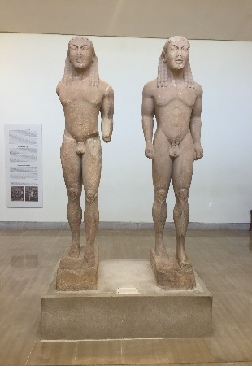
It must be said, the kouroi attributed to Cleobis and Biton hold a special place in my heart as a physical manifestation of the immortality Herodotus reports the twins to have attained at Delphi. Needless to say, I cherished my time with the charioteer.

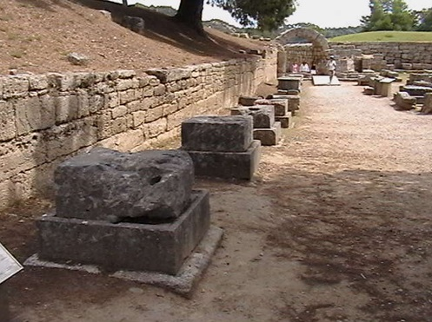
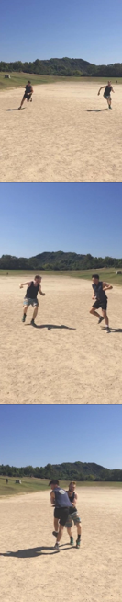
The next day, we crossed into the Peloponnese. At Olympia, we learnt about the Zanes. These statues of Zeus which lined the entrance to the stadium were paid for by athletes caught cheating. To their immense shame, the athlete’s name and offence were listed on the plinth for all to see as a deterrent for future athletes in following suit. I wonder if such a practice could help fight the current doping crisis in sport, or if at least it could have averted the flagrant behaviour of my competitor which cost me a victory in the 24 stade.
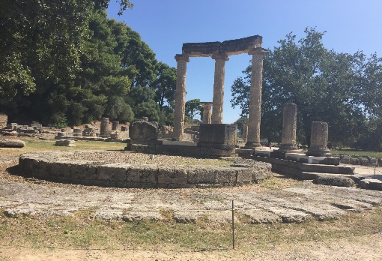
It was also interesting to note the development of Macedonian power manifested in the Philippeion. Built by Philip II to mark his subjugation of Greece after the battle of Chaeronea, he dedicated the structure to his family. Hence, he imposed on Olympia’s inner precinct the only building dedicated to a human; a display of the heavy handed diplomacy his son would continue.
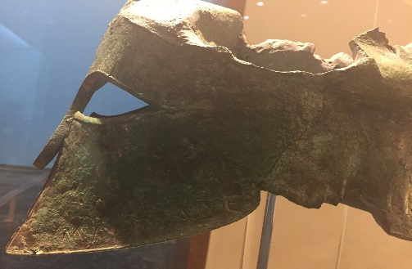
We enjoyed the museum’s wonderful collection of dedicatory artefacts. Among the most gripping was a Corinthian helmet dedicated by “Miltiades”- thought to be the very same who commanded the Athenians at Marathon.
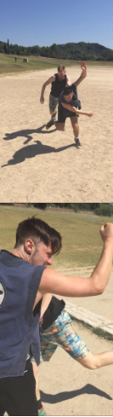
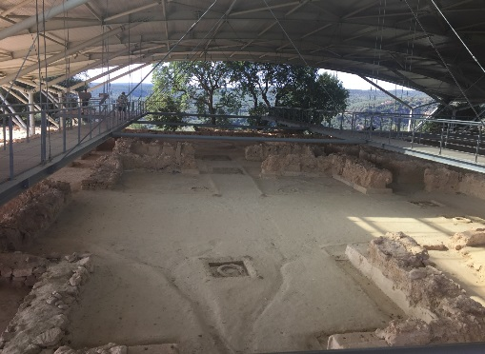
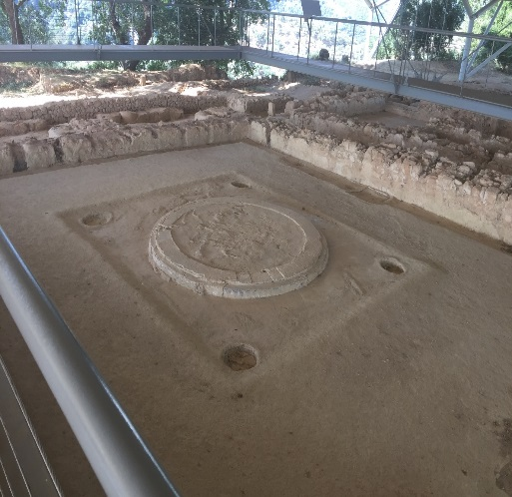
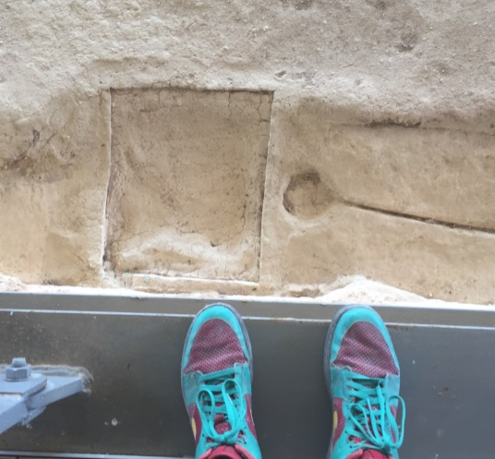
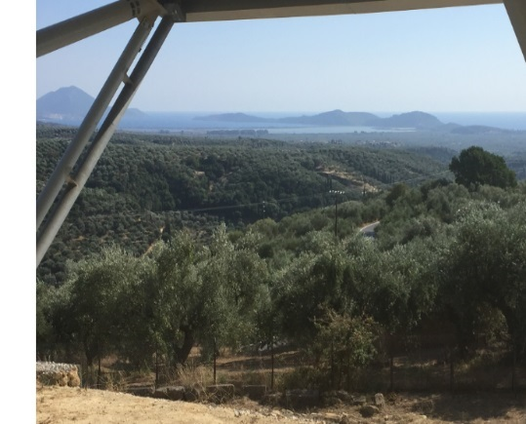
Nestor’s Palace in Pylos, our next stop, was truly captivating. The commanding view the citadel held over the bay below immediately evoked the power of the Anax who had presided here, as did the palace’s size. Most dramatically, we were able to see amphorae and even part of a kylix protruding from the ground, baked hard by the very fire that had destroyed the palace. Luckily this fire had the same effect on the palace’s archives, preserving its 1000 clay tablets to give us the majority of Mycenaean literate culture. We were amazed to find this huge number only accounted for 1 years worth of records. As soon became a theme of the next few days, I was amazed at how advanced Mycenaean culture appeared, and could barely contain my excitement when standing above the space of Nestor’s throne in the great hall.
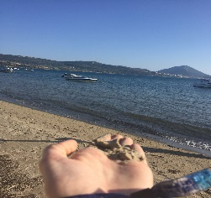
Quitting such lofty heights, we sampled the beach of sandy Pylos.

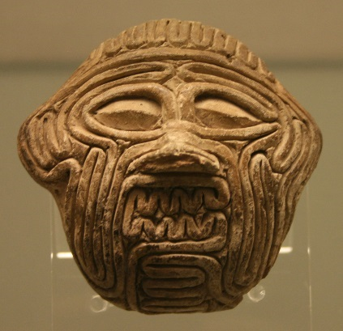
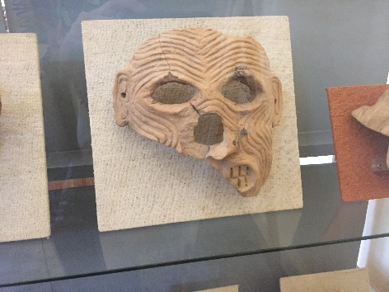
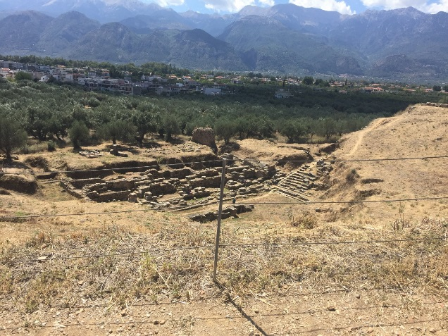
On the next day we visited Sparta. Though the acropolis boasted little more than a theatre, its view of the surrounding landscape gave me valuable insight into the ancient city. Sparta’s refusal to build city walls could well have relied rather less on the esteem she placed on her menfolk’s martial skill, and a little more on the natural wall of the formidable mountains which encircle the city.
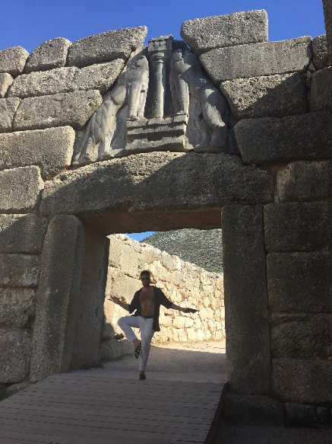
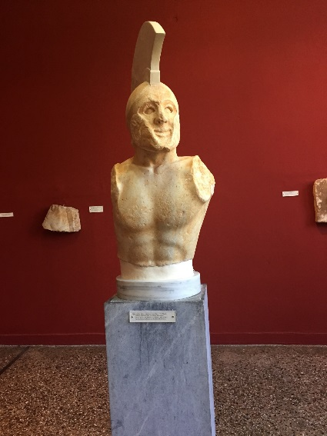
As I had been warned, Spartan material culture proved to be- well, Spartan, though the museum did boast some interesting pieces. Among which was the “Leonidas” marble bust of a hoplite, and numerous clay masks involved in the local cult of Artemis Orthia. Of these, I thought one bore a distinct resemblance to a bronze age Near Eastern clay mask I’d seen in the British Museum of Gilgamesh’s demonic adversary Humbaba (pictured bottom right). Perhaps a topic for future enquiry.
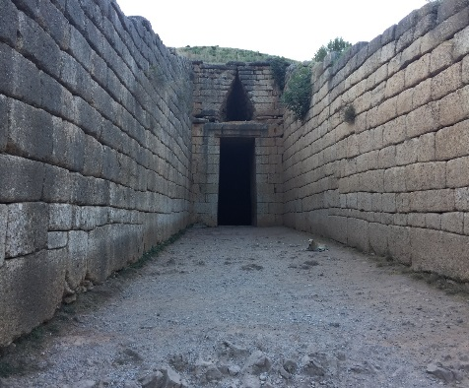
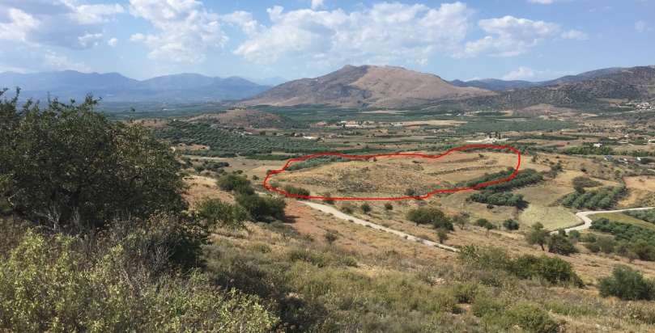
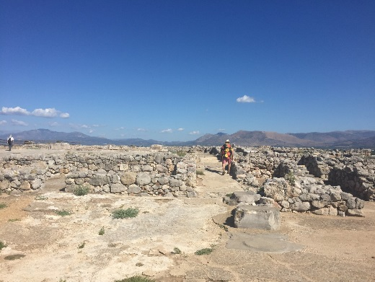
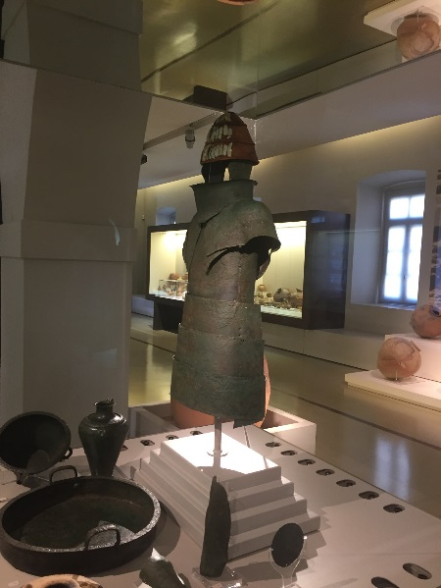
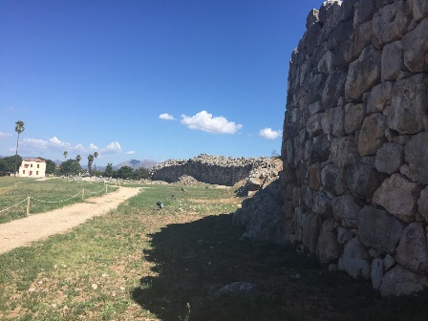
We spent the next two days on a Mycenaean sojourn in the gulf of Argos. The fortresses of “Great walled Tiryns” and “Rich in gold Mycenae” amazed us beyond measure. In particular, a map showing the origins of the grave goods found at Mycenae impressed on me how advanced, and perhaps even how globalised, bronze age trade was. The distance between the pieces of British amber and the Afghan Lapis Lazuli more or less still presented the bounds of the known world to Alexander a whole millennium later. Quite how old Mycenaean culture is was brought home to us in the Archaeological Museum of Naplio, where the stunning 15th century BC Dendra Panoply was displayed on the same floor as a 6th century BC Corinthian helmet. I was again struck by a sense of the Mycenaean period being a lost golden age on my return, when I came across an article on a 3.5cm intricately carved agate found in Pylos, the artifice of which was only matched in the classical age 1000 years later. Indeed, I have returned with an ardent new interest. The Mycenaean bronze age still holds many secrets; perhaps some answers await beneath this mound we spotted from the acropolis of Midea?

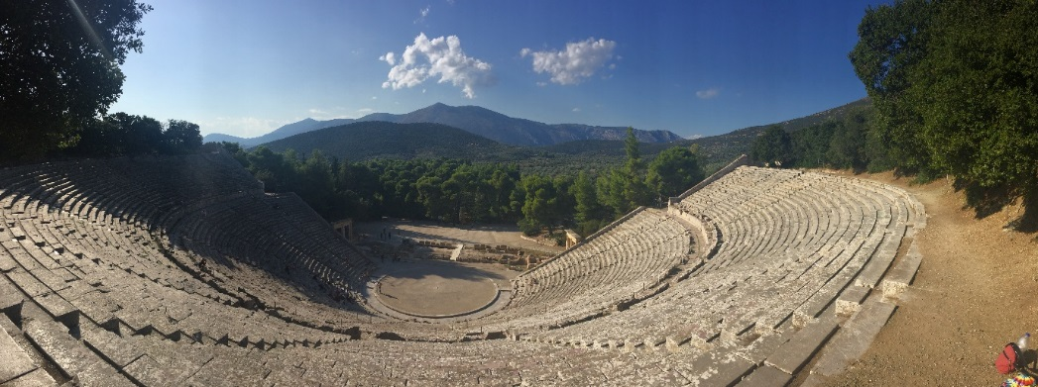
Passing by the vast theatre of Epidauros, we reached Athens at dusk- just in time to catch the illumination of the Parthenon.

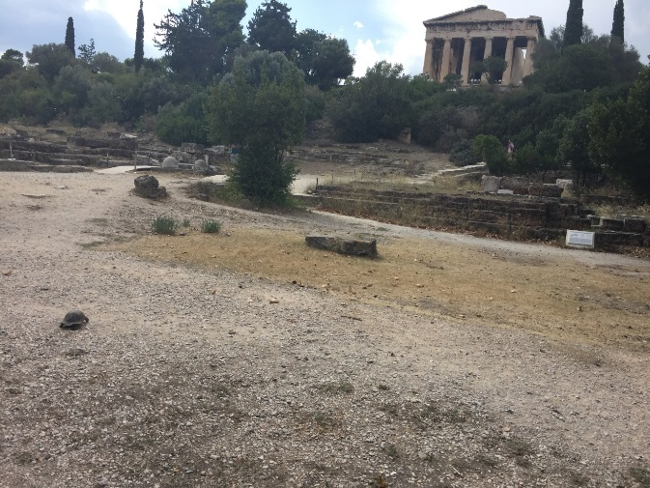
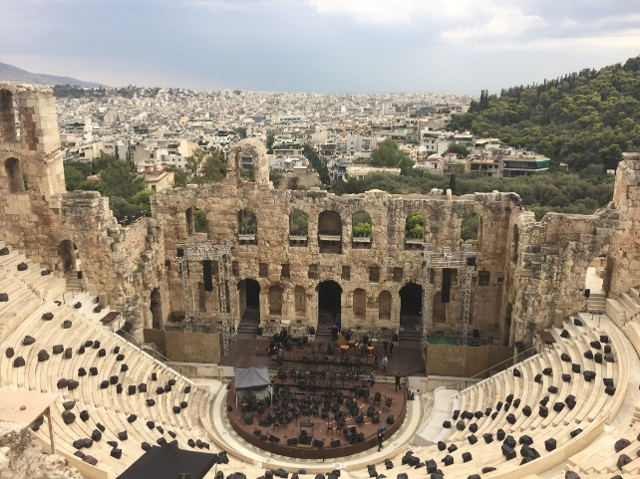
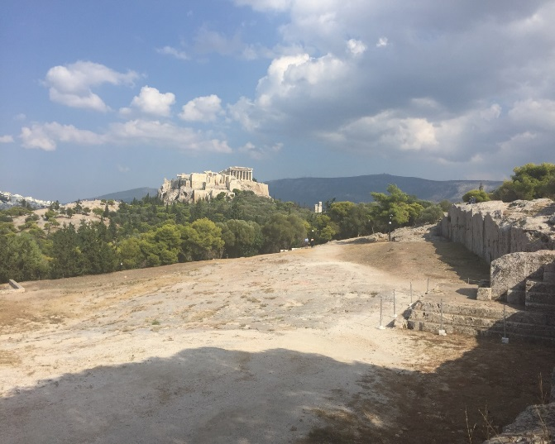
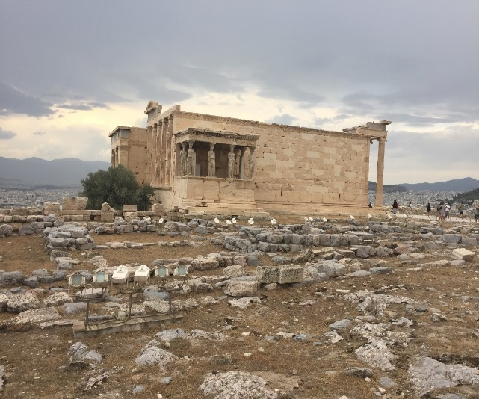
We spent two breathless days rushing between the Pynx, Aristotle’s Lyceum, the Agora, the Theatre of Dionysus and the Parthenon.
At the end of each day, when it seemed our legs could carry us no further, we floundered our way around the National Archaeological Museum. We stood open mouthed at the range of antiquities from both from sites we had encountered, and those further afield.

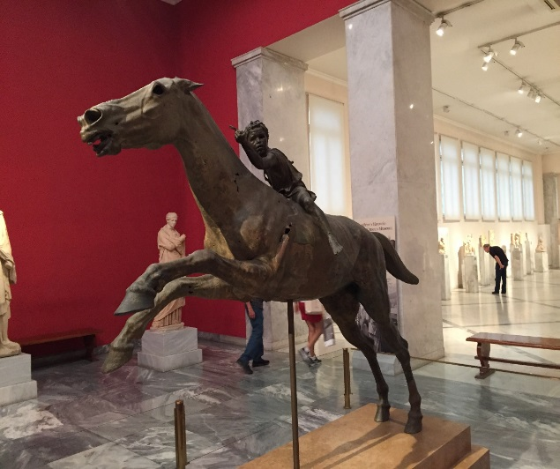
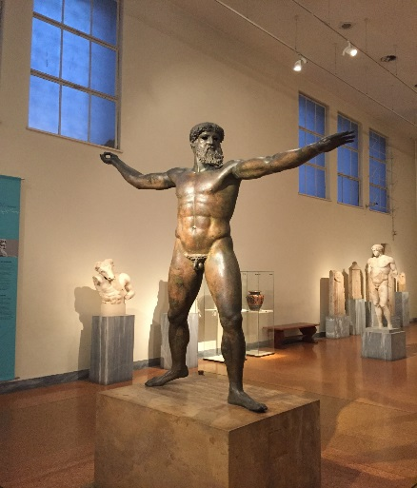
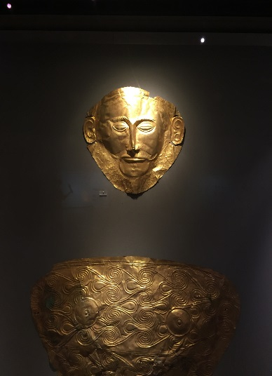
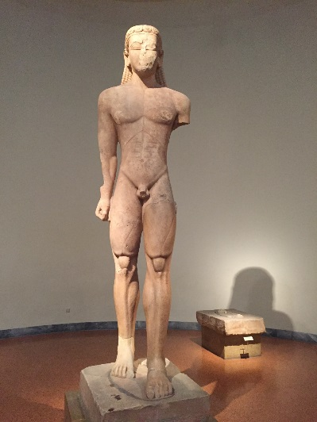
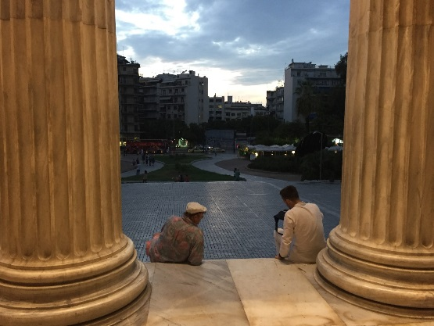
And so it seemed fitting that we ended our archaeological tour on the steps of the museum, with some answers closer in sight and a myriad of new questions staring us straight in the face. We headed to the sandy shores of Tinos for a few days of contemplation, before embarking on our airborne nostos home.
My heartfelt gratitude to the Instone family and the UCL Classics department for making this incredible experience possible, and my sincere encouragement to all enthusiasts of the ancient world to follow their wanderlust.
Sam Cohen

