Bacchae Tour 2015
The department of Greek and Latin at UCL annually present a classical play at the Bloomsbury theatre in February of that academic year. When we made a bid for Euripides’ Bacchae a year ago we had no idea how far this show would take us. Following sold out performances in the Bloomsbury and rave reviews, we were selected for the National Student Drama Festival in Scarborough, and obtained a place at the Fourth International Student Festival of Ancient Drama in Messene, Greece. In addition, the British Museum invited us to perform at the museum as part of their Defining Beauty exhibition. With so much to fund, we began promoting a Kickstarter page, selling CDs and doing bake sales to raise money, to prevent any member of our excellent cast to be priced out of what affectionately began to be known as ‘BacchaeTour2015’.
This is where the Stephen Instone Travel award came in - specifically for our trip to Greece, on which we took 25 students. Without this award it would have been impossible to complete the trip.
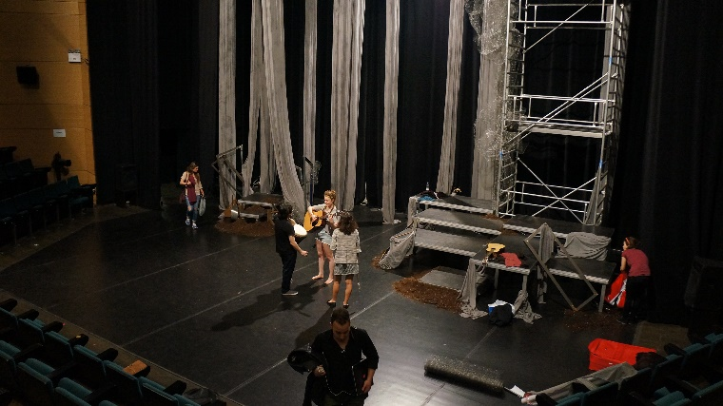
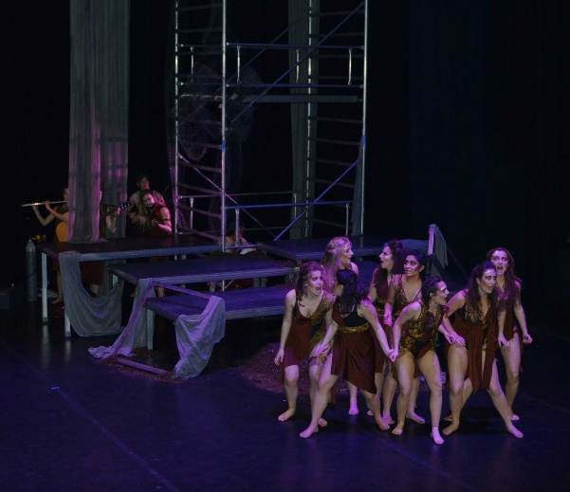
Having realised we would have to fly to Athens, we decided to perform in a theatre there (The Michael Cacoyannis Foundation Theatre) in another attempt to fund our trip, and we were also invited to perform at the ACS School in Athens. Therefore, after a few hectic weeks of final rehearsals and ensuring everyone had the correct costume, we met at Gatwick Airport at around 3am. Despite the early hour everyone was very excited! Arriving in Athens a few hours later, we were taken to our Hostel, right next to the Acropolis! Having dropped off suitcases, we headed down to our first theatre, where some of the production team (who had flown out earlier) were busy building set, hooking up microphones and plotting lights. After a very long day we tried the Gyros from next door, and thus began a love affair with the delicious, wonderfully cheap, meat-and-salad-and-chip filled pittas.
Building Set at the Michael Cacoyannis Foundation Theatre!
The next day we headed back down to the theatre for more tech and rehearsal (and some more Gyros and ice creams) to prepare for our first (sold out) show in Athens! The show, as ever, went fantastically, with the cast adapting to a new space effortlessly and despite the language barrier (we did have Greek subtitles!) the audience were spellbound and were very excited to meet the cast after the show. Having very quickly taken our set down (we were getting quite good at doing this at speed after 3 different venues!) we headed out to appreciate Athenian nightlife and celebrate bringing this Ancient tragedy back to its birthplace.
Performing at the Michael Cacoyannis Foundation Theatre
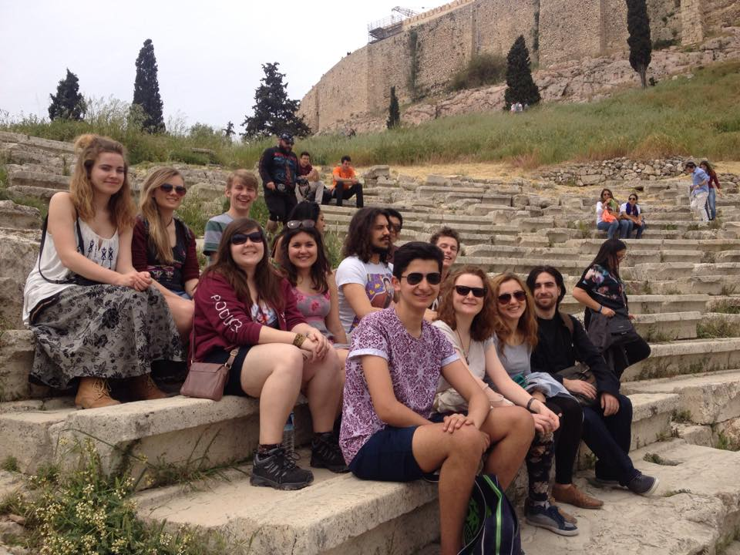
We then had a few days over the weekend to enjoy the sights of Athens, and the first thing on everyone’s agenda was heading straight up to the Acropolis. With a ripple of excitement every time something relating to Dionysus was found, we quickly congregated in the Theatre of Dionysus, where Bacchae was first performed nearly two and a half millennia ago. I can’t even describe how that felt – just amazing! Soon enough we reached the Parthenon, where those of us doing Greek Art and Architecture explained to a captive audience about the entasis, column orders used and a brief history of the buildings purposes! We also explored the Temple of Olympian Zeus, Hadrian’s Arch and the various museums – the National Archaeological Museum of Athens was a particular favourite and great revision! Some even went so far as Pireus, and got a ferry over to the Island of Aegina. Putting places to the names from lectures was such a great feeling!
Some of the Cast and Crew at the Theatre of Dionysus – where Bacchae was first performed in the 5th Century BC!
On the Monday we had our show at the American Community School, an international school in Athens. Performing to exclusively young people aged around 16-18 made the show a very different experience, with the theatre staff being impressed at how well we engaged the students. Again, we had a very tight turnaround, building set, teching and performing on the same day. The cast adapted excellently to a smaller space with a slightly different set and lights despite having very little time to rehearse in the space.
Immediately after the show, we all jumped on a coach and began the four-hour trip to Messene in the Peloponnese, providing some excellent panoramic views of Greece as the sun set. Arriving at the hotel kindly provided by the festival at Messene, we had a quick explore and ended the night in a traditional taverna with real Greek food (delicious) and local wine (2 euros a jug!).
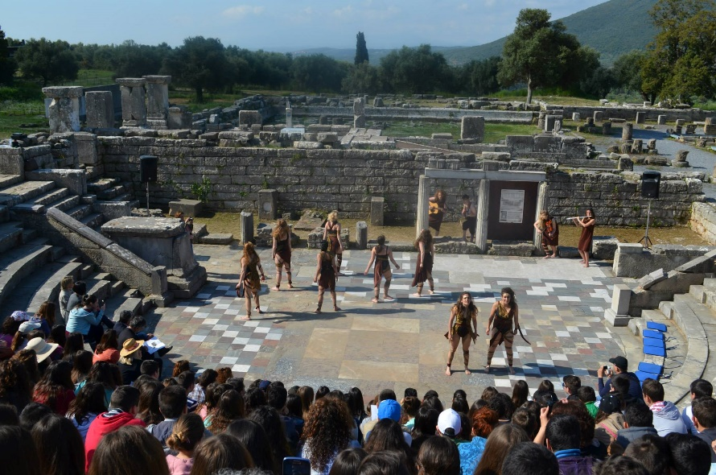
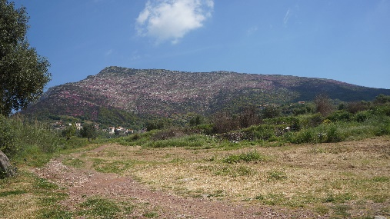
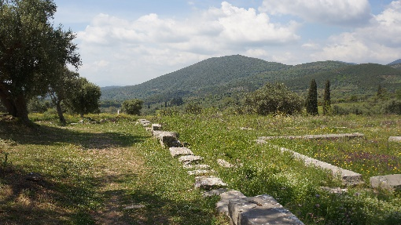
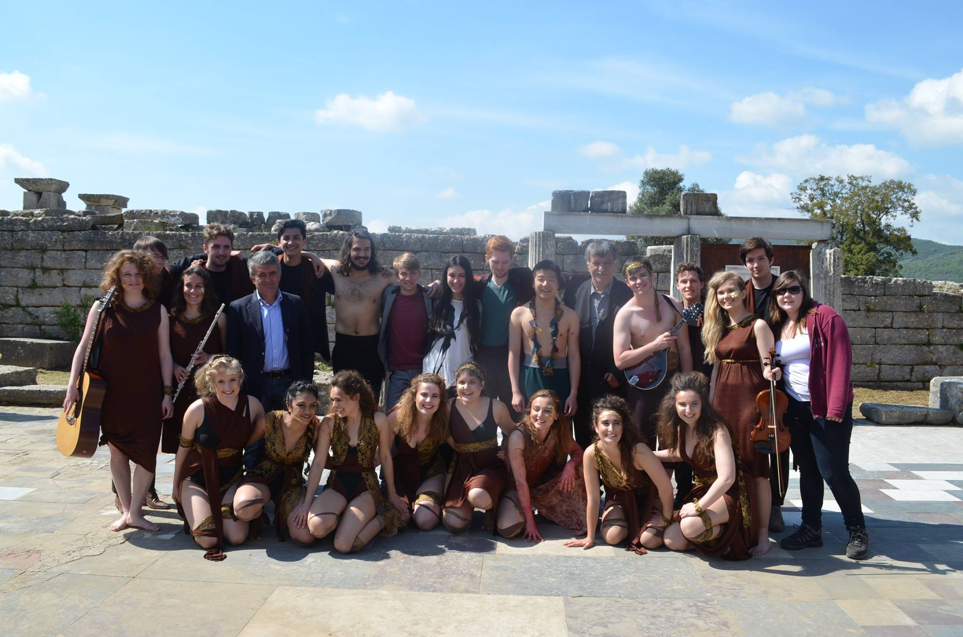
The next day we headed over to the site at Messene for the opening of the festival and our first look at where we would be performing the next day. RADA, our neighbours back in London joined us on the coach and performed their version of Eumenides after the opening ceremony, which featured hymns in Greek calling upon the Muses. With a panoramic backdrop, the smell of incense, Greek language and traditional dress, coupled with being sat in the stone theatre created an incredible atmosphere. I felt as though I had been transported back a few thousand years! Having seen RADA’s play in the theatre and getting a feel for how the audience would react, we had a few hours to rehearse before the site shut for the afternoon. We had decided to strip away everything, with no set, no pre-recorded music and natural lighting, relying on the actors’ ability to convey the story with nothing except their voices and physicality. Everyone was now so confident with the show they were able to play with the staging and engage with the audience on a deeper level. Incredibly different from our run at the Bloomsbury, everyone agrees the show at Messene was frankly incredible, both to watch and perform; it was at once fresh and nostalgic. Performing this ancient text at an ancient site, in the morning sun, with the mountains behind and ruins all down the valley was something I don’t think any of us will ever forget.
Bacchae in the Theatre and views from Ancient Messene and the International Student Festival of Ancient Drama
The Bacchae Company with festival organisers after our performance in the Odeon of Ancient Messene!
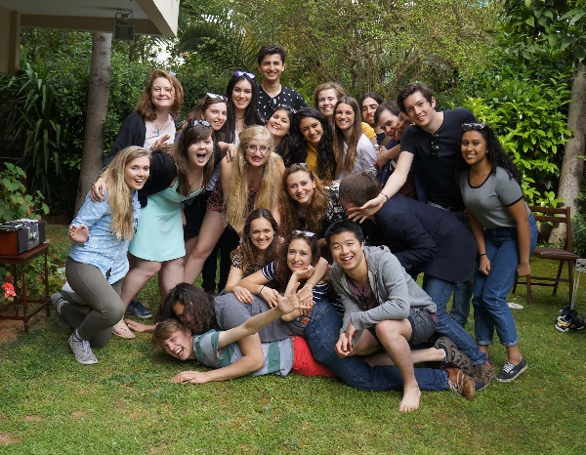
Following our show, the many students flooded down into the theatre, desperate to meet the cast and congratulate them. Many asked for photos and high fives, giving us a taste for fame! The festival organisers then took us out for lunch; a traditional buffet with the other casts who had performed that day (each day two shows performed, one at 9am, one at 11.30am). Once the lovely food was eaten, our musicians were requested to play, and led the room in a version of a self-composed bacchaetour theme song. This was soon replaced by traditional Greek music, and the other (Greek) cast quickly began to dance. Enthusiastically we began trying to join in, and they led us in a huge circle around the restaurant until we realised we needed to be on our way back to the airport to fly home! Leaving was very sad, with everyone full of adrenaline from the morning’s show and fun!
Overall, our trip to Greece was one of the most incredible experiences, combing classical sites with classical drama and a whole lot of fun! It was unforgettable, and we would like to thank everyone who made it possible; our department and the support from the Steven Instone Travel Award, and we look forward to our final show at the British Museum in July!

By Hayley Russell and the Bacchae Cast and Crew
A big thank you from us!

