The British School at Rome Summer School (2-16 September 2015)
As a classicist who had never previously been to Rome, I am profoundly grateful both the BSR course and the grant that part-funded it. The aim of the course was to provide a thorough grounding in Roman topography, taking in Roman history and archaeology from early Republican to late antique times. To do this, a full timetable of two weeks of lectures and site visits was organised, including numerous sites only accessible with specific governmental permission.
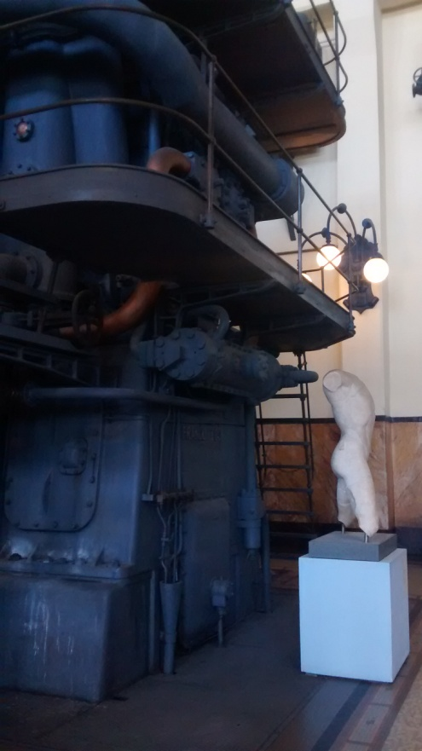
On the first full day in Rome, the theme for the day was ‘the Tiber’. We considered the two temples in the Forum Boarium and its prehistory as one of the earliest settlements around Rome, and looked out onto the Palatine and the Lupercal, site of Romulus and Remus’ childhood. We then toured the nearby archaeological site at S. Omobono, which has foundations and altar bases of twin temples to Fortuna and Mater Matuta. This was invaluable because we were there accompanied by a local archaeologist, who described the site’s history from archaic times in great detail. We then walked to the Arch of the Argentarii, with the reminders of the vagaries of Roman propaganda in the excision of Geta’s portrait and name from the decoration. We were also allowed into the crypt of S. Maria in Cosmedin (more usually known for the drain cover displayed in its front portico as ‘la Bocca della Verità’), which was hewn out of the base of a the Temple of Hercules. But the highlight of the day for me was our visit to Monte Testaccio, a vast hill of amphora shards dating from the Augustan age to the rule of Gallienus, three hundred years later. The sheer scale is hard to describe, as was the sense (present throughout the trip but particularly strong here) of quite literally walking on history. It also served as a reminder that despite the staticness of what survives, in the form of temples and palaces, the Roman Empire was also alive and full of movement: of goods, of people, and of the power both provided.
The following day was devoted to the many and various fora, chief among them the Forum Romanum. We were allowed into the restored Curia Iulia, a huge and very atmospheric building where some Hadrianic reliefs were also displayed. The course leaders emphasised how here and in other alterations to the Forum, the transition to a principiate was stamped onto traditionally republican places through improvement works and new buildings, making this change seem like part of the natural order. We also visited the Markets of Trajan, which are an extraordinarily well-preserved Antonine structure now used as a museum of Roman sculpture and an exhibition space (somewhat bafflingly, food-themed modern fashion design was on show next to Roman columns and pilasters). This was also the day of our first Roman thunderstorm, a rather unforgettable experience much capitalised on by the street vendors who switched with apparent seamlessness from selling selfie sticks to brightly coloured ponchos.
Next up was ‘triumph day’: following the route republican triumphators would have taken through the city from the area near the pantheon to the celebrations in the forum, culminating in a visit to the dark, damp Mamertine prison where so many famous ‘public enemies’ like Vercingetorix and Jugurtha met their end. The numerous triumphal arches and other manubial structures like the Theatre of Pompey were a recurring theme throughout, a reminder of the religious aspect of the triumph. The four temples at Torre Argentina were also the site of a cat sanctuary, a fact which both distracted me somewhat from the accompanying talk and exemplified the many and interesting ways sites in Rome can be repurposed (see also: the McDonald’s in Termini containing parts of the Servian Walls).
That Sunday we spent the day in the Capitoline Museums. After visiting important exhibits like the bronze statue of Marcus Aurelius and the Fasti Consulares and Triumphales, we were let loose in the museum by ourselves. My favourite part was the huge collection of inscriptions (mostly epitaphs) displayed in the basement and the Palazzo dei Conservatori, including epigraphy in Greek and Hebrew.
On Monday the theme was ‘Princeps, Domus and the Res Publica’. To that end we visited the Palatine and the Houses of Augustus and Livia (both with beautiful and well-preserved frescoes) and the potential site of Nero’s revolving dining room, as well as imperial monuments to the arguably defunct, or at least much evolved, res publica in the form of Trajan’s Column and the Ara Pacis. We also visited the Mausoleum of Augustus with the archaeologist Elisabetta Carnabuci, where the relationship between Fascist Italy with Roman archaeology was brought home by the evidence of the then government’s hamfisted attempts at restoring it from its concert hall days.
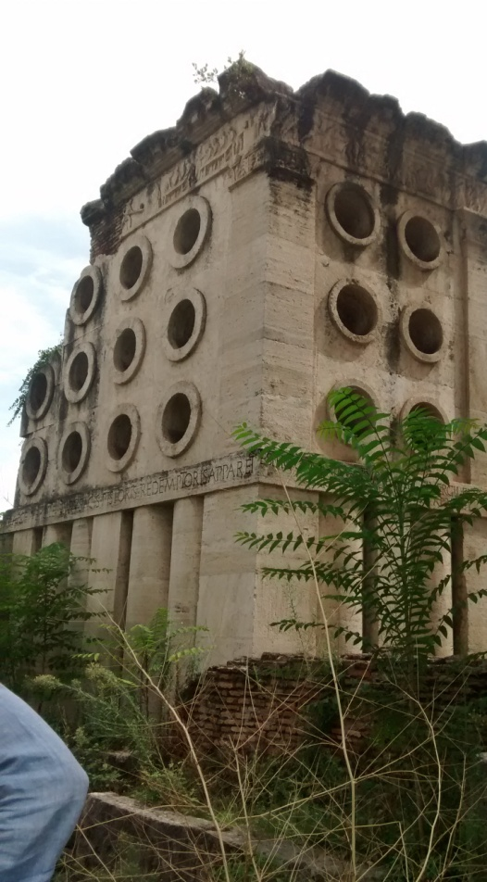
Death was the order of the day on Tuesday: we walked the length of a section of the Appian Way, seeing the tomb of Caecilia Metella, the Tomb of the Scipios, the Circus of Maxentius and the mausoleum of his son Romulus along the way. The mysteriously never-used columbarium in the tomb of the Scipios was particularly striking, especially in the scope given for personalisation of tombs even in the little nooks by allowing space for names and portraits. We then caught a bus towards Porta Maggiore and saw the aqueducts and the famous baking-themed tomb of Eurysaces.
Then came what for me was the most impressive part of the trip – we took a coach to Ostia Antica and spent the day wandering the site. We summer school students as a whole seemed to make it our mission to find the most obscure places possible, whether crossing an overgrown field to find the synagogue site or exploring the surviving tunnels and basements and stumbling on a Mithraeum. The sheer surreal joy of finding oneself in a ‘real Roman town’ was incredible. Even in a whole day I don’t think I managed to see everything and I will certainly try to return.
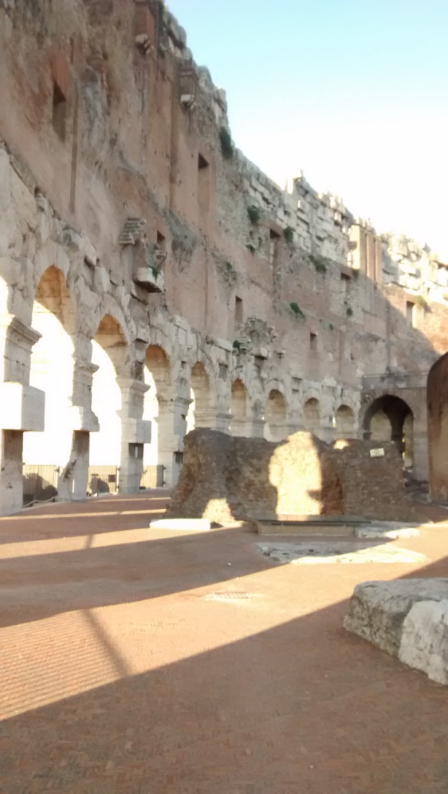
We then had a day off on Thursday, which (unsurprisingly) I took a bit more slowly, going for a short walk around the surrounding area and the parks around the Villa Borghese. Of course, it was back to business on the following day on the subject of ‘Horti Romani’. We saw the remnants of the Servian Walls near Termini, then walked to the Auditorium of Maecenas where we saw that shows were still being performed in the building where Virgil and Horace at least visited, if not performed themselves. We then went to the Montemartini museum on the Via Ostiense, a remarkable building which (much like the Tate Modern) is an ex-power station, but unlike the Tate has not had its internal machinery removed. The juxtaposition of marble sculpture and iron machinery was certainly something new and aesthetically interesting, and the sculptures themselves were often of immense historical interest too, including as they did various funerary sculptures and frescoes on the ground floor, and an entire Greek temple pediment found in Rome on the upper floor.
The following day we braved the crowds in more popular attractions: the Baths of Caracalla and the Colosseum. Their importance as examples par excellence of Roman use of otium is clear, but they also typify how Roman leisure activities had moved out from the Forum, the former centre of republican public life. Of particular interest at the Colosseum was the display of animal skulls found onsite, and the somewhat baffling popularity of the building as a location for wedding photos. I had also decided that morning to visit the nearby Etruscan museum at the Villa Giulia, which was a beautiful building and a very large set of artefacts.
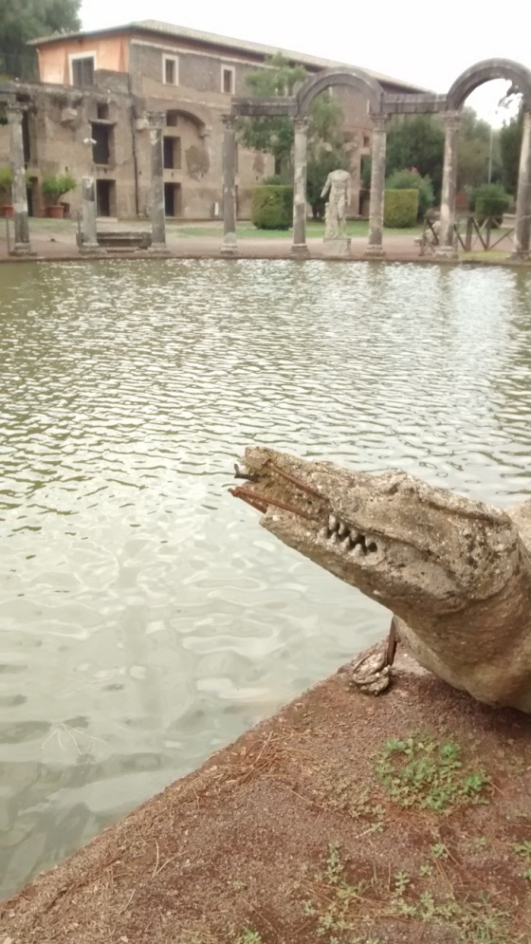
Sunday afternoon was our visit to the Domus Aurea. We were taken around halls in the process of restoration, including the huge octagonal domed dining room, and saw how the foundations of the baths of Trajan that were later built on the same site had altered it, as well as the conceptual significance of the emperor turning a private palace wing to public use in this way.
For the second coach excursion of the trip, we went to Tivoli and Hadrian’s villa, which showed on what scale Roman palaces could be constructed without the strictures that building in a city entailed. The ‘pumpkin’ designs of the domes (at least according to Apollodorus of Damascus) in the Canopus and the innovations of the (sadly temporarily closed) Maritime Theatre were of architectural interest, but it was also nice to see the way rich Romans treated the countryside and Roman hinterland as a holiday retreat.
We returned to the centre of Rome for the final day, investigating the structures surviving from late antiquity. The beautiful and incredibly rare frescoes of Santa Maria Antiqua were certainly a highlight, including speculation about one of the side chapels being used in a similar way to the temple of Aesculapius, with suppliants sleeping in it in the hope of being cured of illness. Among other churches, and the Museum of Crypta Balbi, we also looked in on S. Maria in Trastevere, where all the Roman inscriptions found in the paving slabs have been put on display and the columns were most likely taken from the Baths of Caracalla in medieval times.
The following morning I flew back to a Britain in the middle of a cold snap, significantly more sunburned and entirely overwhelmed with everything I had seen. Once again, I’m profoundly grateful to the Department of Greek and Latin and the family of Stephen Instone for making me able to go on this course. Being able to see for myself the physical underpinnings of a society and people I have studied was and will continue to be invaluable.
Barbara Roberts

