ROME: Rebecca Rothwell
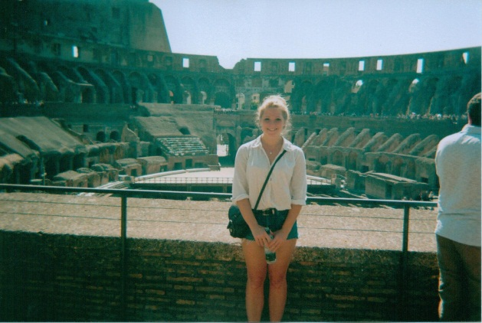
I was greatly excited about my trip to Rome as, due to both of my parents also being classicists, I have been privileged enough to visit several key classical sites, but never the one which was so important for understanding the roles of many of the rest. I arrived in Rome in the 3rd week of August in the ‘dies caniculares’ and was immediately confronted by a wall of burning heat. I went straight to drop my bags in the hotel, conveniently placed less than a minute’s walk away from the magnificent Santa Maria Maggiore, close to both Termini station and the metro. Ercole, the concierge, was invaluably helpful, providing me with a map which he quickly drew all over, circling the main attractions, his personal favourite places in Rome and the best places to eat. Thus, armed with my annotated map, I set out on a walking tour.
Having been told that Rome was going to be as busy as Oxford Street in every direction I turned and that I would be spending most of my days queuing rather than sight- seeing, my expectations of having an easy ride were low. Anticipating hours of standing in line and fighting heaving crowds I was overjoyed to find the streets largely empty, peppered only with small groups of Romans and the occasional tourist. I soon learnt that, like the French, from mid-July the Romans flee the city for cooler climes in the mountains or by the beach, leaving behind a sight-seeing haven for mild agoraphobes like me. As a result of the near bare streets, I quickly made my way through the city and was confronted by stunning views of the Colosseum by night, the forum and Piazza Venezia. Finally I arrived in vibrant and bustling Travestere where I remained for supper. On my way home I went via the Borghese Gardens.

My first day was taken up with my quest to see the ‘top 10’ things in the city. I started with the Colosseum and was not unimpressed. The magnitude of the place was quite incredible – apparently it seated up to 50,000 spectators – but also the craftsmanship. In an era where there was no electronic machinery to lift and carry the stones, the feat is quite unimaginable. I quickly moved on to the Palatine – the stadium and the Domus Augustana, the house of Livia and the huts of Romulus. Once again I was astounded by the enormity and complexity of the site (combined with the Forum Romanum) and one can only imagine the spectacle in ancient times. Despite the scorching heat I moved on to the Forum and I marvelled at how small it truly was when one thinks of how much the Via Sacra is mentioned in ancient literature and to think the one we see today could not possibly have withheld such large religious processions. I moved swiftly on to Trajan’s Colomn, the Pantheon, the Trevi fountain, Piazza Navona and the Campi di Fiori. Due to the incredible heat, I cracked at about 5pm and headed back to my hotel for a much needed lie down.
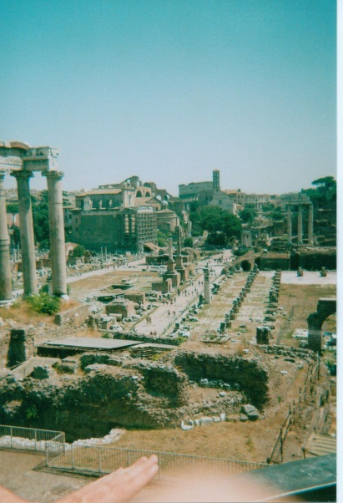
Although it is not classed as a must-see classical site, I spent my next day at the Vatican. Having been expressly warned by my mother that I would have to be there at 7am or I would have to wait for several hours, I managed to nonchalantly stroll into St Peter’s Basilica in less than 10 minutes (following a minor disagreement with the security guard about the length of my dress, whereby I had to furiously pull it down and pass security for a second time with my head bowed). The Vatican was as wonderful as I had been told. Quite rightly it is the centre of the Catholic Church. My only problem with my visit to the Vatican was my own doing. In the blistering 40 degree heat I thought it a good idea to climb the bell tower which gave stunning views over the whole city. The steps seemed endless and as I rose higher, the walls started slope and grow narrower, leaving me feel distinctly sick with only the slippery, condensation heavy walls to hold on to. Rather disappointingly, having made it to the top, perspiring heavily, instead of revelling in my achievement I remembered that I suffer from vertigo, scanned the view and promptly made my way back to the bottom.
Although there was still more to see in Rome, I felt with 2 days of hardcore sightseeing that I would venture out of the city. I headed to Ostia and was amazed to find that I could travel anywhere within Rome’s rail network for on €6. Ostia far surpassed my expectations. The sheer size of it was initially the most impressive thing, but adventuring further into it’s depths it provides probably the best experience of a Roman town I have seen. Streets of shops and flats next to the ruins of baths and the gymnasium which stands close to the theatre – which was just as impressive as the one at Epidaurus. I spent many hours wandering around the endless streets fully exploiting my free ticket – given to me as a student of Greek and Latin, although you also get in free if it is your birthday. Defeated by the heat, I headed back to central Rome. Since I was passing by the Circus Maximus I got off the train there and had a peek. While it may not be the best preserved site in Rome I found that it was wonderfully realistic as there was no pomp surrounding it, and although the seating has been destroyed, the outline of the central barrier still remains and provides an honest depiction of the size of it. Although it would have been far more grand in Roman times, it is still extraordinary to see it in its stripped back form.
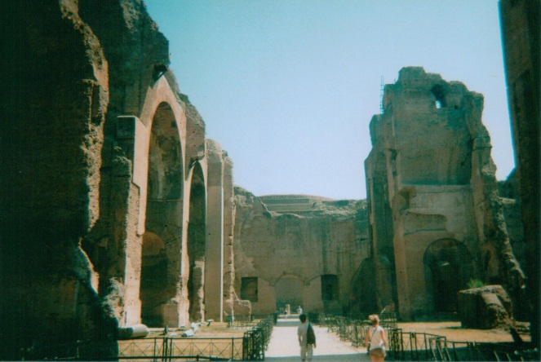
For my last day I had not made a definitive plan but would see where my travels took me. I started by visiting the tomb of the unknown soldier, more out of curiosity than anything else, in the Piazza Venezia, and from there I went to the Capitoline Museums. I then headed to the Baths of Caracalla. Initially I had overlooked the baths and instead had favoured the idea of a bike ride down the Appian Way. However, since it was so hot, I decided to tackle the Appian Way on foot and my first stop was the baths. The imposing buildings were a complete surprise which inspired me to make the trip further down the Appian way where I took in many catacombs, the tomb of Cecilia Metella and the Villa Quinitili, which, as I left, looked stunning up on the hill in the sunset.
I returned to Rome and spent my final evening lapping up the delights of the film festival on the banks of the Tiber before dashing off to the Spanish Steps when I realised that they were the one thing I had not completed on my itinerary. The trip was far from relaxing, but it was both fulfilling and incredibly interesting. I shall certainly be returning to Rome.

