WP2 Information about the project for children 7-11 years

Project title: Mental health in children with epilepsy trial

We work at the Institute of Child Health and Great Ormond Street Hospital. We are asking you and your parents/carer to take part in a project. This leaflet will tell you about the project.

Please read about the project with someone in your family / your carer. Take your time to decide if you want to take part.

Ask me if you have any questions.

What is this project and why are we doing it?

We know that having epilepsy can be often be difficult. Lots of children who have epilepsy sometimes feel sad or worried or angry. Some children feel sad or worried or angry quite a lot. We would like to help children who have epilepsy and feel sad, worried or angry quite a lot.

There are treatments that can help children who feel sad, worried or angry to feel better. We would like to see if these treatments can help children with epilepsy who feel sad, worried or angry feel better too. The treatments have worksheets that you and your parents/carer will read together. They also have some special fun tasks to do to help you with your feelings. There are no medicines or injections. If you want to, we can talk to you about the treatment.
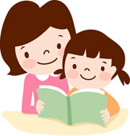

Why have I been asked to take part?

We are asking children who come to the epilepsy clinic at [enter site name] to take part in our study.

Do I have to take part?

No, you do not have to take part. If you decide not to take part in this study, you do not have to give a reason and no one will be upset or cross. You can change your mind at any time. You can stop being in the study even if you said yes at the beginning or if you have already started the treatment.

Will taking part help me?

We don’t know if the treatment you get will help you. We know that these treatments using special workbooks have helped other children to feel better and we hope that they will help you too.

What will I be asked to do if I take part?

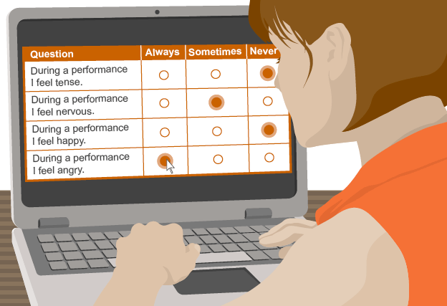
- If you and your parents/carer decide that you would like to take part, your parents/carer, and you if you want to, will fill in 2 questionnaires that will help us to know if you feel sad or worried or angry a lot of the time. There are no right or wrong answers to the questions.

- Then, you and your parents/carer will meet with a therapist who will talk to you about the questionnaires and the treatment.

- If you, your parents/carer and the therapist think it might be helpful for you, you will be given the treatment. This means that you and/or your parents/carer will speak to the therapist over the telephone and perhaps meet with them sometimes too. They might ask you to read some information, watch videos, or to complete some tasks at home. Usually, children find the treatment fun. Sometimes, only your parents/carer need to speak to the therapist.

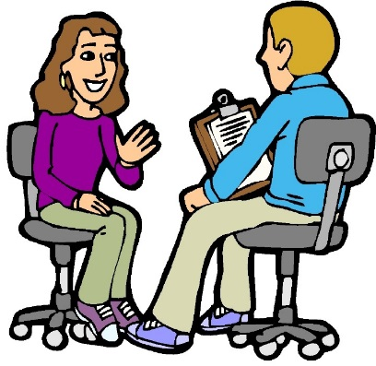
- While you are having the treatment, and just after it, we will ask you and your parents/carer what you think about the treatment. There are no right or wrong answers.

- You will also be asked to fill in the 2 questionnaires again 6 months after beginning the treatment, to help us find out more about whether the treatment helped you with your feelings.

Is there anything to be worried about if I take part?

Other children have told us that they enjoy the workbook treatments. Sometimes the tasks in the special books might be difficult or make you worried. If this happens, you should talk to your parents/carer or therapist. They will always talk to you about this. No one will make you talk about anything that you don’t want to, or make you do anything that you don’t want to.

If you are upset by taking part in the study, please speak to your parents/carer to begin with. If you would like to speak to someone else, your parents/carer know how to contact us and our address and phone number is at the end of this sheet. Your treatment will not be changed by taking part.

Who will know I am taking part in the study?

We will write about the study but no names will be used. We would keep your name, address and the scores from the questionnaires private. But if you said anything to us that made us think you or someone else could be harmed, we would have to tell others.

If you agreed then we will write to your doctors to let them know you are taking part. We will tell them the scores from the questionnaires and about your treatment.

What will happen to the results of the study?

When the study is finished we will write a letter to you to tell you about what we found.

Who has approved the research?

Before any research goes ahead, it has to be checked by a Research Ethics Committee. They make sure the research is fair. This project has been checked by the South Central – Oxford A Research Ethics Committee.

Who do I speak to if I have more questions or worries?

Your parents/carer also have information about the research project, so you can ask them if you have any questions or worries about the study. You can also contact the research team if you have any other questions.

Contact: Professor Roz Shafran
Address: UCL Great Ormond Street Institute of Child Health, 30 Guilford Street, London, WC1N 1EH
Email: gos-tr.mice@nhs.net
Telephone: 0207 905 2232

ENTER SITE PALS DETAILS BELOW

Contact: Patient Advice and Liaison Service (PALS)
Address:
Email:
Telephone:

This document presents independent research funded by the National Institute for Health Research (NIHR) under its Programme Grants for Applied Research Programme (Reference Number RP-PG-0616-20007). The views expressed are those of the author(s) and not necessarily those of the NHS, the NIHR or the Department of Health.

