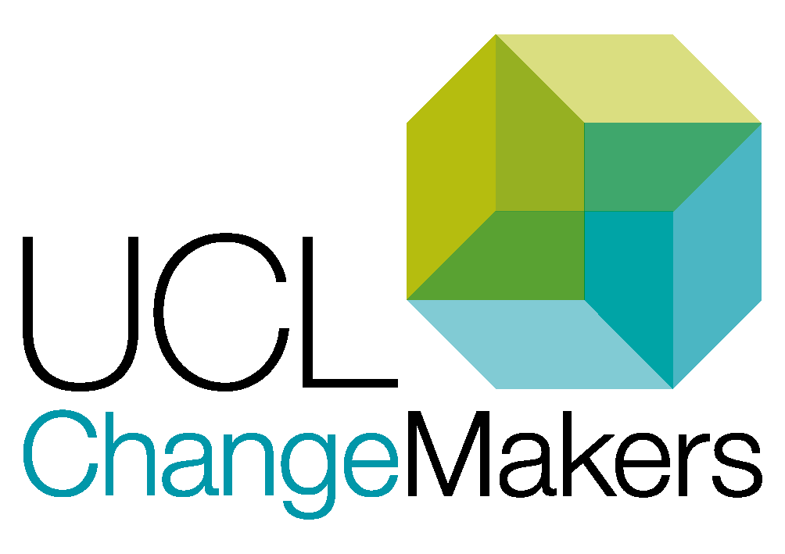UCL Header

Vice-Provost (Education & Student Experience)

UCL ChangeMakers

Project Proposal Form

Updated: JAN 2022

Please return your completed proposal form to: [changemakers@ucl.ac.uk](mailto:changemakers@ucl.ac.uk)

# Application guidance

Visit our [ChangeMakers Resource Bank](https://www.ucl.ac.uk/changemakers/changemakers-resource-bank) for accompanying guidance document and other resources to help you develop your proposal.

# Sessions to help you develop your project

We are putting on a number of sessions throughout January and February 2022 to help you develop your project and write a successful application. Sessions will be advertised on the [ChangeMakers website](https://www.ucl.ac.uk/changemakers/)

1-to-1 Project Advice:

15 min MS Teams chat with the ChangeMakers team about your project idea.

Theme workshops:

1-hour sessions based around some of our ChangeMakers themes. Get inspiration, hear about current and previous ChangeMakers projects and get advice from colleagues with expertise on that area. You don’t need to come the session with a project idea in mind, these sessions are to help you start to formulate an interesting project based on current thinking in the sector and to learn more about what other people are doing in this area. We will also signpost other Arena or UCL support for work happening related to this theme.

ChangeMakers ‘Developing your Application’ sessions:

1 hours sessions to get feedback on your application. Aimed more at students than staff but open to all. Be ready to give feedback to others on their drafts.

## Project Themes

Applicants must submit projects under a specific theme. This is to ensure that the projects are a good use of student and staff time and will address areas of most pressing concern.

### Change and Innovation Themes for 2021/22:

* Learning communities & belonging
* Inclusivity in the curriculum
* Developing authentic and inclusive assessment
* Academic development and support

### Research & Evaluation Theme for 2021/22 (pilot)

* Building on what we’ve learnt from remote and blended learning

## Project Criteria

1. Projects will improve the student experience, demonstrating an inclusive approach (for change & innovation projects); or, projects aim to understand the benefits to the student experience of particular learning approaches, demonstrating an inclusive and strengths-based approach (for the evaluation & research theme).
2. Projects are conducted in partnership between students and staff and the partnership aspect is vital to the success/outcomes of the project.
3. Projects can demonstrate why they are important to students, drawing on relevant existing data where possible.
4. Projects align with one of the project themes.
5. Project proposals have demonstrated how they intend to bring about longer-term impact beyond the funding period.
6. Projects are feasible given the timescale (around 12 weeks), level of funding and resourcing available (team, resources available in the department, etc.).

## Application deadlines:

19th November 2021, 23:59

25th February 2022, 23:59

# Contact the ChangeMakers team

If you have any questions regarding filling in the form or any other aspect of the application process, please contact Fiona Wilkie, ChangeMakers Manager, at: [changemakers@ucl.ac.uk](mailto:changemakers@ucl.ac.uk)

# Section One: Team details

ChangeMakers supports staff and students working together to bring about positive change to the education and the student experience at UCL. Staff-student partnerships recognise that both students and staff have an equally valuable albeit different roles to play on the projects and that these different perspective and expertise result in a collaboration that is vital to bringing about change that benefits all and is likely to have greater impact.

To help you think about the different roles that individuals can take on in the project, we recommend using our [partnership tool.](https://www.ucl.ac.uk/changemakers/sites/changemakers/files/participation_matrix_v1.docx) Students should be empowered to take on an active role in the project rather than just carrying out tasks set by the member of staff. Equally, it is important that staff have a specific role to play, even if for much of the project students are being encouraged to lead on a lot of the work. Staff, for example, have an important role to play in establishing context, have pedagogical expertise and should be advocates for the project in order to help the project make a lasting change.

|  |  |
| --- | --- |
| 1a. Names and UCL email addresses of lead project applicants:  Those listed here will be the main contacts for the project. There should be a member of staff listed here at the primary staff partner. We cannot consider applications without a named member of staff to give support to the project. |  |
| 1b. Department: |  |
| 1c. Details of others in the team:  Please provide details of those already on the project team, and an indication of any additional members you intend to recruit at a later stage. |  |
| 1d. Has anyone in your team been involved in a ChangeMakers project previously?  Please provide any details e.g. title of project, year etc. |  |
| 1e. In 2-3 sentences, please tell us how you see the collaboration between staff and students as being crucial to the success of your project: | |
|  | |
| 1f. Staff-student partnerships can sometimes unintentionally replicate, rather than address, inequitable practice by privileging the input and voices of students who are more able to take on leadership roles within the project. How will you ensure an inclusive approach either to the recruitment of students to the project team or involving students in the broader activities you will be undertaking as part of the project?  One thing to consider is having different ‘jump on’ points – e.g. could you build in opportunities for students to become more involved after they have engaged with the project in other ways? You could run an initial workshop (with nice catering!) to share the project, start to hear student (and staff?) opinions/experiences and begin to generate some ideas for taking the project forward. At this point you could see if any students then want to be involved in the project and in what ways. | |
|  | |

# Section Two: About your project

### For ‘Change & Innovation’ theme projects:

ChangeMakers projects are small-scale projects, ideally to provide some funding to help you pilot an idea or test out a potential change with a view to this being embedded within your departments/faculty etc. We recommend the bulk of time on the project is spent on bringing about change with data collection minimised in favour of more interactive opportunities that have the potential to involve a broader group of students in problem-solving activities.

If you do need to collect data in order to help you better understand what changes need to be made, you will need to make a clear case that the data doesn’t already exist. It may be that you need to fall under our ethics approval to carry out that work.

### For ‘Research & Evaluation’ theme projects:

The purpose of this theme is the better understand some of the emerging education trends either general to the sector or specific to your discipline with students to inform practice in your department. These projects will mostly involve better understanding new approaches – for example a more blended approach to education in your subject – with a focus on insights into the student experience.

It is expected that these projects will involve some data collection and we have ethics approval that you project may need to fall under in order for you to undertake these activities. Please see the information on our [ChangeMakers Ethics Moodle](https://moodle.ucl.ac.uk/course/view.php?id=13265), but note that we don’t expect you to have done anything prior to finding out whether your project has funding.

### Alternative formats for section 2

If you would prefer to talk about your project rather than write about it, you can submit a short video, slideshow or other media. Contact the changemakers team ([changemakers@ucl.ac.uk](mailto:changemakers@ucl.ac.uk)) for how to submit if you are unable to do so via email. All other sections do need to be submitted in written form at the moment.

|  |  |
| --- | --- |
| 2a. Project Title |  |
| Which theme does your project align with?  Please try to select the one theme your project most resonates with. There is no advantage or disadvantage in choosing one theme over any others. | Change & Innovation Learning communities and belonging  Inclusivity in the curriculum  Developing authentic and inclusive assessment  Academic development and support Research & Evaluation Building on what we’ve learnt from remote and blended learning |
| 2b. **In 2-3 sentences**, please summarise your project.  Assume we have no prior knowledge of your module, programme, depts etc. | |
|  | |
| 2c. Where did the idea originate?  Has this been raised at SSCC? As a result of module feedback? On Unitu? In response to survey data? Please also indicate here if this work builds on a previous ChangeMakers project. | |
|  | |
| 2d. Who is this project important to and how will they benefit?  If you can give an idea of numbers that would be great e.g. this project will benefit 80 student on the xx programme/module. It is better to identify a specific group of students & staff who will initially benefit than to go too broad. However, you can also give an idea if this is an approach/model that could be expanded to benefit a wider group of students e.g. initially the idea will be piloted on the xx module but would be of interest to xxx.  Projects that benefit a larger group of students are not privileged over smaller projects, it is more important to us that you are clear about who this project will benefit and why. | |
|  | |
| 2e. How does this project fits within either the context of your department or wider institutional aims?  Is this project linked with a specific module/programme? Is this part of an ambition to improve careers support or provide more extra-curricular activities? Has this been identified as on your department’s ASER action plan? Does the project link with wider faculty or institutional aims e.g. the sustainability agenda, the SU’s priorities for student wellbeing, eliminating the awarding gap etc.? | |
|  | |
| 2f. What is the purpose of your project? What is the most important thing or things that it needs to do?  This could be about producing a particular output, a behaviour change, curriculum change, creating or enhancing a co-curricular opportunity, learning how to work in partnership/co-create. | |
|  | |
| 2g. Please share any further important details that will help us understand what you are trying to achieve, but be as succinct as possible. It is fine to leave this section blank. | |
|  | |

# Section Three: Identifying and sharing your successes

Evaluating what you have done can sometimes be forgotten or planned too late into the project process. We want to get you thinking about your evaluation from the outset so that you can build it into your project design (next section). Purposeful evaluation helps you to critically analyse what has happened so that you can understand what happened and make improvements. Crucially, when you are trying to make a change, the data you gather can also help you influence decisions as you will have the data to hand to show the impact of your proposed change or enhancement.

|  |
| --- |
| 3a. What is the purpose of your evaluation? |
| Refer back to your answer to question 2f., where you described the most important thing(s) your project will achieve. Now complete the following statement based on what you said there:  “This evaluation will provide [which decision makers? Could even be the lead member of staff] with [what information] in order to [make which decisions] about [which issue].” |

3b. Based on your evaluation statement, what are your evaluation goals? These need to be built into your project design.

|  |  |  |  |
| --- | --- | --- | --- |
| Evaluation Questions | How can you answer that question? | Who needs to answer that question? | When does it need to be asked? |
| Example: increased student confidence in reading scientific papers as a result of attending peer tutor sessions. | 1. Evaluation Survey  2. Performance in seminars: quality of discussion, more students joining the discussion. | 1a. Survey to students participants.  1b. Reflections from peer tutors  2. Teacher observations. | 1a. Before and after peer tutor sessions.  1b. Debrief session at the end.  2. Ongoing. |
|  |  |  |  |
|  |  |  |  |
|  |  |  |  |
|  |  |  |  |

3c. How will you share the outcomes of your project with different stakeholders?

|  |  |  |
| --- | --- | --- |
| Audience | Purpose | Format |
| Example: Departmental leadership team. | Make the case for change. | Brief written summary of project and evaluation data. |
|  |  |  |
|  |  |  |
|  |  |  |

|  |
| --- |
| 3d. What longer-term impact would you like this project to have? |
|  |

# Section 4: Project design

This section has been designed to help you as a team think through the various stages of your project and the associated funding implications to help you achieve your aims. While this table is largely for you as a team to use and we accept there will be changes and unforeseen circumstances that might affect what you put down here. That is us. See this as a blueprint for how you’d lie to go about your project. It also gives us a really good indication of the feasibility of your project. We do not like to fund projects that we think are unachievable in the timeframe as that is disheartening for all involved. Our top advice is to do something small-scale and do it well, learn from it, and *then* think about building on it or expanding it in the future. We may even have additional funding to help you do that.

If you need any further help with funding, please see our guide on ‘[Using your funding](https://www.ucl.ac.uk/changemakers/changemakers-resource-bank/undertaking-your-project/using-your-funding)’.

4a. How will you go about your project?

Please use the table below to set out your project plan and note any funding implications. Please provide a total for your funding, noting that we fund projects of either £450 or £850.

|  |  |  |  |
| --- | --- | --- | --- |
| **Stage 1: Preparing for your project**  This stage includes things like: raising awareness of your project, recruiting students, looking at the data you already have, doing a sector or literature analysis, designing workshops and getting to know each other as a team. Also think about any training or development requirements. | | | |
| **Activity** | **When** | **Who** | **Funding Implications** |
| Example: plan initial training session | Week 5 | Whole project team | None |
|  |  |  |  |
|  |  |  |  |
|  |  |  |  |
| **Stage 2: Undertaking your project**  This is the ‘doing’ stage of your project. This will be when you run your sessions, create your resources, run your audits etc.  You will need to have thought about any evaluation you want to do to integrate with this stage, and so that you are ready to reflect on your learning, and be able to make a case for whether your intervention was successful. | | | |
| **Activity** | **When** | **Who** | **Funding Implications** |
| Example: Initial training session for student peer tutors. | Week 8 | Peer tutors, student leads | Tea, coffee & traybakes @ £3.75 pp x 10 = £37.50 |
|  |  |  |  |
|  |  |  |  |
| **Stage 3: Identifying and sharing your successes**  This stage is about learning from what you have done in the previous stage. It might involve getting participants back together to share their insights, looking at any evaluation data you have gathering and will certainly involve identifying next steps and looking at telling those who need to know that this has been successful. Talk to the ChangeMakers team if you are interested in opportunities to share what you’ve done elsewhere at UCL or even beyond. | | | |
| **Activity** | **When** | **Who** | **Funding Implications** |
| Example: debrief workshop for student peer tutors | April, after Easter closure | Project team, peer tutors | Tea, coffee & traybakes @ £3.75 pp x 10 = £37.50 |
|  |  |  |  |
|  |  |  |  |
|  |  |  |  |
| **Other funding e.g. stipends** | | | |
| Example: 2 x lead project stipends | Payment in May | Staff partner to arrange | 2 x £150 = £300 |
|  |  |  |  |
|  |  |  |  |
|  |  | Total Funding required: |  |

|  |
| --- |
| 4e. Will you be collecting any un-anonymised research data e.g. through focus groups? |
|  |
| 4f. If yes, please can you provide some additional details (what data, how and when will you collect it) and make a case for why this is necessary for your project. You may also need to fall under our ethics clearance. Please read through the information on our [ChangeMakers Ethics Moodle](https://moodle.ucl.ac.uk/course/view.php?id=13265) and we will discuss the process in full if your project is funded. There is no need to complete any of the forms in advance of getting your funding. |
|  |

# Section Five: Before you submit

### Checklist before you submit

We recommend you do the following before submitting an application:

* Read through the information on the UCL ChangeMakers website, specifically the info on [ChangeMakers projects](https://www.ucl.ac.uk/changemakers/changemakers-projects) and [applying for your project section](https://www.ucl.ac.uk/changemakers/changemakers-resource-bank/applying-your-project) of the [ChangeMakers Resource Bank](https://www.ucl.ac.uk/changemakers/changemakers-resource-bank)
* Attend at least one of the support sessions to help shape your project.
* Align the project with one of our strategic themes.
* Check you have addressed all the criteria (p2) for awarding funding.
* Make a case for why it is tackling an important issue for *your* students and the impact on their learning experience as a result.
* Ensure the application form is completed in full.
* Take into account current COVID guidance issued by the UK government or University Management Committee (UMC). Please note your project may need to be adapted if guidance changes.
* Ensure the application signed by a staff and student member for the team (if recruited), with a supporting statement from the lead member of staff.

### ChangeMakers agreements

By signing this project application form, you are confirming that:

1. There is support in your department for this project.
2. You will spend the funding in accordance with UCL finance and procurement policy.
3. If your project needs to fall under our ChangeMakers Ethics agreement, you will follow our guidance and procedures – including completing the relevant training – in order to comply with the conditions of our ethics approval. Failure to do so will mean your project will not be covered.
4. Should your project receive funding, you will notify us in the event that this project won’t go ahead this academic year so that we can recoup funds and hold them for you in order to defer the project to the following academic year. If you do not do this and unspent funding is lost at the end of the financial year, you will have to reapply for the project the following year.

|  |  |
| --- | --- |
| 5a. Lead applicant signatures  Typed signatures accepted but please make sure you send the proposal from a UCL email address.  One signature must be from the lead member of staff on the project. |  |
| 5b. Lead staff member  Please include a short statement of support for this project (100-150 words).  Please note, this isn’t required if the application comes solely from staff. |  |
| **Please state the budget code to transfer ChangeMakers funds.**  All funding, including payment of student stipends, must be spent by 31 July 2022.  Ask your Departmental Administrator/Finance Manager for this. It must include the Project, Task, Award and Expenditure codes. The award code must be **156780**. |  |

Please return your completed proposal form to: [changemakers@ucl.ac.uk](mailto:changemakers@ucl.ac.uk)

**Please submit your proposal as a Word doc and not a PDF**

# What happens now?

Your project application will be sent to two members of our staff/student panel to review against the project criteria (on p2.). Panel members will decide whether your projects meets, partially meets or fails to meet each criteria and, based on that, give your application a rating as follows:

**Green** = happy to fund this project. Proposal seems strong and meets the criteria for funding.

**Amber** = whilst mostly happy to fund this project, there are either some queries that need to be resolved in relation to the project criteria or the project team could do with some additional support before they begin their project. An initial meeting with the ChangeMakers team is required where the aim is to move the project from ‘amber’ to ‘green’. Some revisions to the application may be needed.

**Red** = recommend we don’t fund this project. The project fails to meet at least one or more of the project criteria.

Panel members will also give some feedback to project teams to help make projects more impactful. They also provide feedback to the ChangeMakers team for things we’d like to consider to improve the scheme and support offered to projects. All decisions are the reviewed and agreed at a panel.

This process usually takes around 10 working days, with a couple more days needed for us to consolidate the feedback and draft letters to projects teams. Expect to hear from us around 14 days after the submissions deadline.