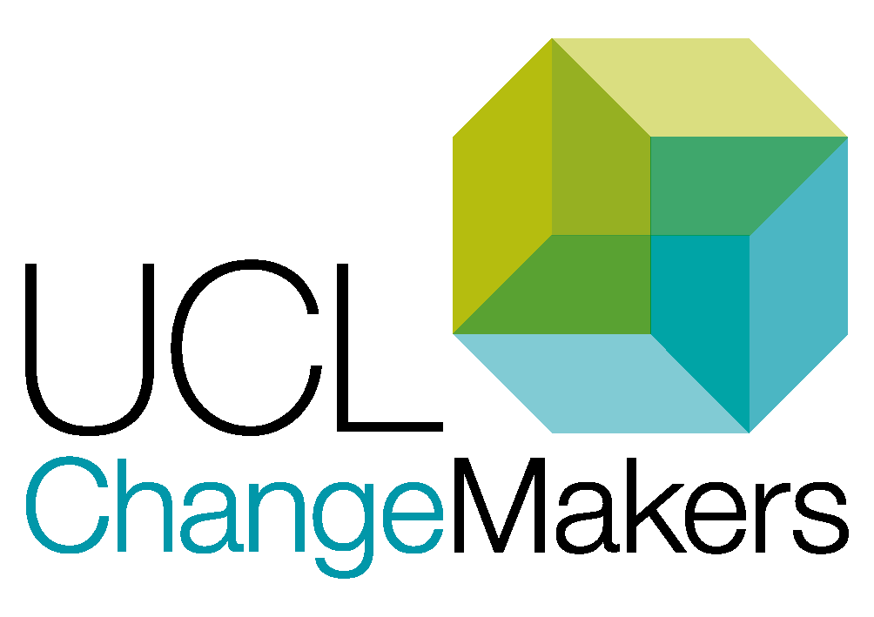UCL Header

**UCL ARENA CENTRE**

**UCL ChangeMakers**

Project Proposal Form

Please return your completed proposal form to: [changemakers@ucl.ac.uk](mailto:changemakers@ucl.ac.uk)

# Application guidance

Visit our [ChangeMakers Resource Bank](https://www.ucl.ac.uk/changemakers/changemakers-resource-bank) for accompanying guidance document and other resources to help you develop your proposal.

We recommend coming along to a drop-in session to discuss your idea with the ChangeMakers Team and other potential applicants. Online and face-to-face slots will be advertised on the [ChangeMakers website](https://www.ucl.ac.uk/changemakers/).

## Project Themes

Applicants must submit projects under a specific theme. This is to ensure that the projects are a good use of student and staff time and will address areas of most pressing concern.

### Change and Innovation Themes for 2021/22:

* Learning communities & belonging
* Inclusivity in the curriculum
* Developing authentic and inclusive assessment
* Academic development and support

### Research & Evaluation Theme for 2021/22 (pilot)

* Building on what we’ve learnt from remote and blended learning

## Project Criteria

1. Projects will improve the student experience, demonstrating an inclusive approach (for change & innovation projects); or, projects aim to understand the benefits to the student experience of particular learning approaches, demonstrating an inclusive and strengths-based approach (for the evaluation & research theme).
2. Projects are conducted in partnership between students and staff and the partnership aspect is vital to the success/outcomes of the project.
3. Projects can demonstrate why they are important to students, drawing on relevant existing data where possible.
4. Projects align with one of the project themes.
5. Project proposals have demonstrated how they intend to bring about longer-term impact beyond the funding period.
6. Projects are feasible given the timescale (around 12 weeks), level of funding and resourcing available (team, resources available in the department, etc.).

## Application deadlines:

19th November 2021, 23:59

25th February 2022, 23:59

# Checklist before you submit

We recommend you doing the following before submitting an application:

* We have read through the information on the UCL ChangeMakers website, specifically the info on [ChangeMakers projects](https://www.ucl.ac.uk/changemakers/changemakers-projects) and [applying for your project section](https://www.ucl.ac.uk/changemakers/changemakers-resource-bank/applying-your-project) of the [ChangeMakers Resource Bank](https://www.ucl.ac.uk/changemakers/changemakers-resource-bank)
* We have attended a drop-in session or emailed the ChangeMakers team with any questions.
* The application form is completed in full.
* The application is signed by a staff and student member for the team, with a supporting statement.
* The project aligns with one of our strategic themes.
* All applications take into account institutional, faculty and departmental ways of working for 2021-22.
* Applications make a case for why it is tackling an important issue for students and how it will improve the student learning experience as a result.

# Contact the ChangeMakers team

If you have any questions regarding filling in the form or any other aspect of the application process, please contact the ChangeMakers team: [changemakers@ucl.ac.uk](mailto:changemakers@ucl.ac.uk)

# Section One: Contact Details

To help you fill in this form, we recommend reading the [applying for your project section](https://www.ucl.ac.uk/changemakers/changemakers-resource-bank/applying-your-project) of the [ChangeMakers Resource Bank](https://www.ucl.ac.uk/changemakers/changemakers-resource-bank).

|  |  |
| --- | --- |
| Lead applicant full name: |  |
| UCL email address:  This email will be used for all primary correspondence with the ChangeMakers team. |  |
| Department and faculty |  |
| Level and year of study (student applications only) |  |
| Your role:  Are you a student or a member of staff? If the lead applicant is a student, they should list at least one member of staff in the next question. This member of staff should also sign the form and provide a statement of support. |  |
| Names of the other members of your team (please state whether they are staff or students):  Thinking about partnership values, please provide some brief detail on how students will be empowered to work in partnership with staff (and other students) and meaningfully contribute to the project.  We recommend that at least two students work with one member of staff.  Student roles can include: project lead, project support, treasurer, day helper (e.g., assisting in moderating an online event).  You might like to use the [Participation Matrix tool](https://www.ucl.ac.uk/changemakers/sites/changemakers/files/participation_matrix_v1.docx) to help you think through the roles that different groups will take on.  **Please note**, not all students likely to participate in the project have to be recruited in order to submit a proposal. |  |

# Section Two: Identifying Your Project

|  |  |
| --- | --- |
| Project Title |  |
| Brief description of project (100-150 words).  See our [Good Practice Guide](https://www.ucl.ac.uk/changemakers/changemakers-resource-bank/applying-your-project/good-practice-guide) for some insights into developing a good project. |  |
| Theme of project.  Delete as appropriate | Learning communities and belonging  Inclusivity in the curriculum  Developing authentic and inclusive assessment  Academic development and support  Building on what we’ve learnt from remote and blended learning |
| What are the project objectives, outputs and outcomes? (50-150 words or 5 bullet points).  **Objectives**: What do you hope to change? Describe the concrete and specific ways your goals will be achieved.  **Outputs**: What will be delivered on the road to completion of this activity or project? E.g. a booklet, blog, or ongoing series of events.  **Outcomes**: These are the expected results and benefits of your project, e.g. a greater sense of belonging, or more connections with alumni. You might also like to think about mechanisms for sharing the outcomes of the project more widely amongst students and staff in the faculty. |  |
| Who will benefit from the outputs/outcomes of this project?  E.g. UGs, PGTs, PGRs, department-wide, faculty-wide, or a specific group of students? |  |

# Section Three: Partnership

|  |  |
| --- | --- |
| How do you know this project is important to students? (100-150 words).  Did the idea arise as a possible solution to an issue raised via Unitu or from feedback or evaluation data?; an issue raised at Staff-Student Consultative Committee; data from a survey e.g. National Student Survey; an issue raised by a Student Rep as a result of conversation with other students; or as a result from evidence-informed literature or UCL case study. |  |
| In what ways is the partnership aspect vital to the success/outcomes of the project? (100-150 words).  What do you hope the benefits are or the impact will be from staff and students working together that might not be the case if staff or students were to take this forward on their own?  You might find our [Guide to Student-Staff Partnership](https://www.ucl.ac.uk/changemakers/changemakers-resource-bank/applying-your-project/guide-student-staff-partnership) or [Being a good partner: thoughts for staff](https://www.ucl.ac.uk/changemakers/changemakers-resource-bank/applying-your-project/being-good-partner) resource on the [ChangeMakers Resource Bank](https://www.ucl.ac.uk/changemakers/changemakers-resource-bank) useful for this question. |  |
| How will you foster inclusive partnerships? (50-150 words).  How will you ensure that different voices and perspectives are present on your project?  Our [Guide to Student-Staff Partnerships](https://www.ucl.ac.uk/changemakers/changemakers-resource-bank/applying-your-project/guide-student-staff-partnership) has a specific section on Inclusive Partnerships that you might like to look at. |  |

# Section Four: Project Design

|  |  |  |  |  |  |  |  |  |  |  |  |  |  |  |  |  |  |  |  |  |  |
| --- | --- | --- | --- | --- | --- | --- | --- | --- | --- | --- | --- | --- | --- | --- | --- | --- | --- | --- | --- | --- | --- |
| Please describe the main stages of your project, along with estimated dates (50-150 words).  Please break your project down into achievable steps, up to a maximum of ten.  We have provided examples in the grid to help you consider the feasibility of your project.  Please make your steps **SMART** (specific, measurable, achievable, relevant to the project, and time-specific). | |  |  | | --- | --- | | **When** | **Activity** | | e.g., First week of term two | e.g., Send out communications to department to let staff and students know about your project | | e.g., by mid-Jan | e.g., Recruit a support student to work on the project | | e.g., Before Feb reading week | e.g., Design and prepare a survey to be sent out to students in department | | e.g., Two weeks after Feb reading week | e.g., Analyse data gathered | | e.g., March - April | e.g., First draft of resource | | e.g., by mid-April | e.g., Focus group to discuss draft | | e.g., by mid-May | e.g., Final draft – present to senior staff | | e.g., by end June | e.g., Final report to ChangeMakers team | | e.g., by mid-July | e.g., Ensure all spending (stipends/vouchers) are complete. |   Delete the above examples before submitting this form. |
| Please identify the resources needed for this project, along with a cost estimate (50-150 words).  See the [Funding Guidance](https://www.ucl.ac.uk/changemakers/changemakers-resource-bank/project-funding) on the [UCL ChangeMakers Resource Bank](https://www.ucl.ac.uk/changemakers/changemakers-resource-bank) to help you cost out your project, and there are some examples in the grid. You can apply for £450 or £850, depending on the scope of your project.  Reward/recognition of students needs to be taken into account, and please note that we do not fund capital costs, i.e. equipment. | |  |  | | --- | --- | | **Activity & resource needed** | **Cost** | | e.g., Online focus groups for 10 first year students | e.g., 10 x £10 Love2Shop vouchers | | e.g., 2 lead student stipends | e.g., 2 x £150 | | e.g., 1 support student for focus group and data analysis | e.g., 1 x £50 | |  |  | |  |  | |  |  | |  | e.g., Total: £450 |   Delete the above examples before submitting this form. |

# Section Five: Ethics and Data Protection

|  |  |
| --- | --- |
| **Please confirm you and all members of your team have completed the****ethics training****on the ChangeMakers Ethics Moodle**  If you have any questions regarding ethics and data protection, please contact the team on [changemakers@ucl.ac.uk](mailto:changemakers@ucl.ac.uk) | Type **YES** or email us for more information and guidance. |
| For projects planning to run focus groups:  You are required to use the[Information Sheet](https://moodle.ucl.ac.uk/mod/resource/view.php?id=2350552) and [Consent Form](https://moodle.ucl.ac.uk/mod/resource/view.php?id=2350564) templates to inform participants of the use and storage of their data. These forms must be sent to [changemakers@ucl.ac.uk](mailto:changemakers@ucl.ac.uk) at the end of the project. If not, you will not be covered by [UCL Arena Centre's ethics agreement](https://moodle.ucl.ac.uk/mod/resource/view.php?id=2350535). | Type ‘**I agree’** or email us for more information and guidance. |
| **For projects planning to send out a survey:** Ensure that your survey abides by [UCL survey policy](https://moodle.ucl.ac.uk/mod/url/view.php?id=2766955). | Type ‘**I agree’** or email us for more information and guidance. |
| Please confirm you have read the [**Data Protection guidelines**](https://moodle.ucl.ac.uk/mod/resource/view.php?id=2621644) on the ChangeMakers Ethics Moodle | Type **YES** or email us for more information and guidance. |
| **If you are gathering data for any part of your project, the person responsible for the data must do the**[**Data Protection Online Training**](https://www.ucl.ac.uk/data-protection/data-protection-overview/online-training/data-protection-online-training)**.**  Please confirm that this has been done. | Type **YES** or email us for more information and guidance. |

# Section Six: Evaluation

|  |  |
| --- | --- |
| How will you know your project has made a difference? (50-150 words)  What are your success indicators and how will you measure them?  Bear in mind that different stakeholders/systems will value different mechanisms for reporting e.g. Departmental Teaching Committees might value metrics, whereas course leaders might prefer qualitative data to guide them on how to implement the change you are proposing. Think about who your stakeholders are and how you can prove success to them. |  |

# Section Seven: Dissemination

|  |  |
| --- | --- |
| Who needs to hear about your project in order for a sustainable change to be made? How will you win their support? (50-150 words).  We've got resources on the [Disseminating your project](https://www.ucl.ac.uk/changemakers/changemakers-resource-bank/disseminating-your-project) section of the [ChangeMakers Resource Bank](https://www.ucl.ac.uk/changemakers/changemakers-resource-bank) for more ideas on this. |  |
| How will you share what you have done within your department, and the wider university community? (50-150 words).  What mechanisms already exist that you can utilise? How do different groups prefer to be communicated by? Do you have funds in your budget for a launch event to introduce your change? |  |

# Section Eight: Before you submit

|  |  |
| --- | --- |
| **Lead applicant signature** (typed signatures accepted) |  |
| **2nd signature:**   * For student applications, this should be your staff partner. * For staff applications, this should be your lead student. |  |
| **Supportive statement from 2nd signatory:**  Please include a short statement of support for this project (100-150 words)  If you are a student, you are required to show you have support from a member of staff who will co-lead the project with you. If you are staff, you are required to show the project is important to students, and that you have student buy-in. |  |
| Please state the budget code to transfer ChangeMakers funds.  All funding, including payment of student stipends, must be spent by 31 July 2022.  Ask your Departmental Administrator/Finance Manager for this. It must include the Project, Task, Award and Expenditure codes. The award code must be **156780**. |  |

|  |  |
| --- | --- |
| Do you have any comments on the application form and the process of applying for ChangeMakers funding?  You are also welcome to email comments to the team on [changemakers@ucl.ac.uk](mailto:changemakers@ucl.ac.uk) |  |

Please return your completed proposal form to: [changemakers@ucl.ac.uk](mailto:changemakers@ucl.ac.uk)

**Please submit your proposal as a Word doc and not a PDF**